Supplementary Material for “Thermal optima of cercarial emergence in trematodes from a marine high-temperature ecosystem, the Persian Gulf”

Content:
- Supplementary Figures and legends
- Supplementary R Scripts

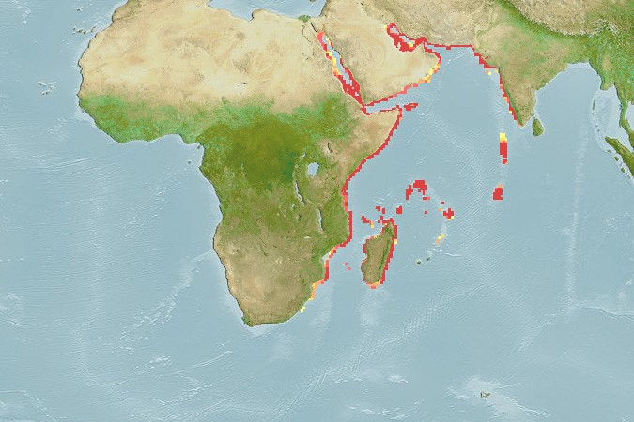
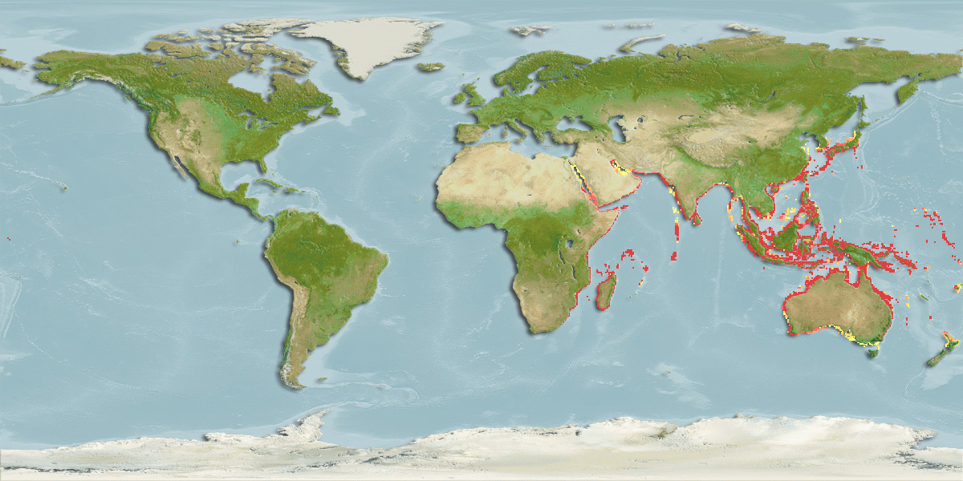
A
B
0.80 – 1.00
0.60 – 0.79
0.40 – 0.59
0.20 – 0.39
0.01 – 0.19
Relative probabilities
of occurrence

Supplementary Figure S1. Native habitat of Pirenella cingulata (A) and Aphanius dispar (B) based on IPCC RCP8.5 emission scenario Retrieved from https://www.aquamaps.org.
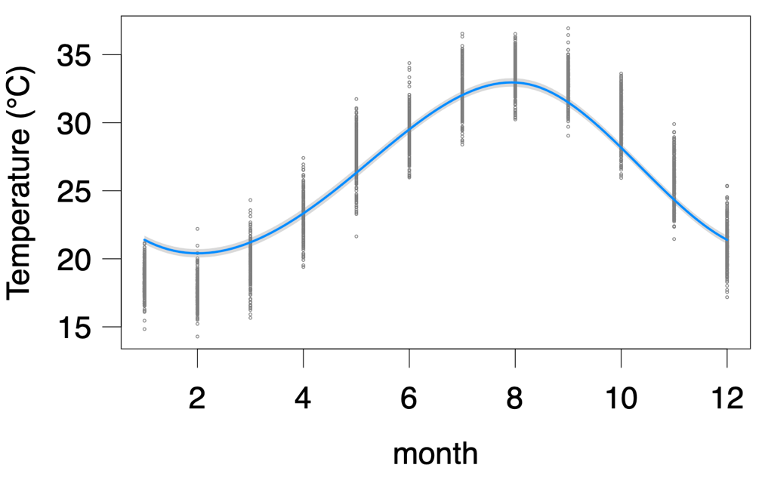
Supplementary Figure S2. Averaged monthly Aqua MODIS SST of the sampling locality (Genaveh in the Northern Persian Gulf; 29°33'14.022''N, 50°30'34.0416''E) from 2010-2022 (Data courtesy of NOAA coast watch (http://coastwatch.pfeg.noaa.gov/erddap)).
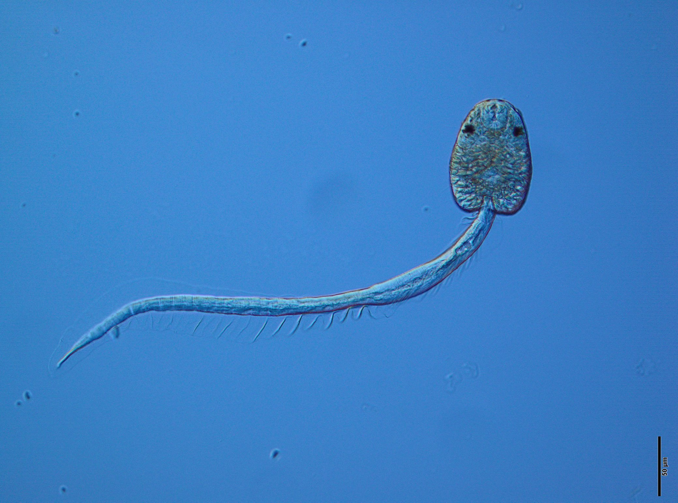
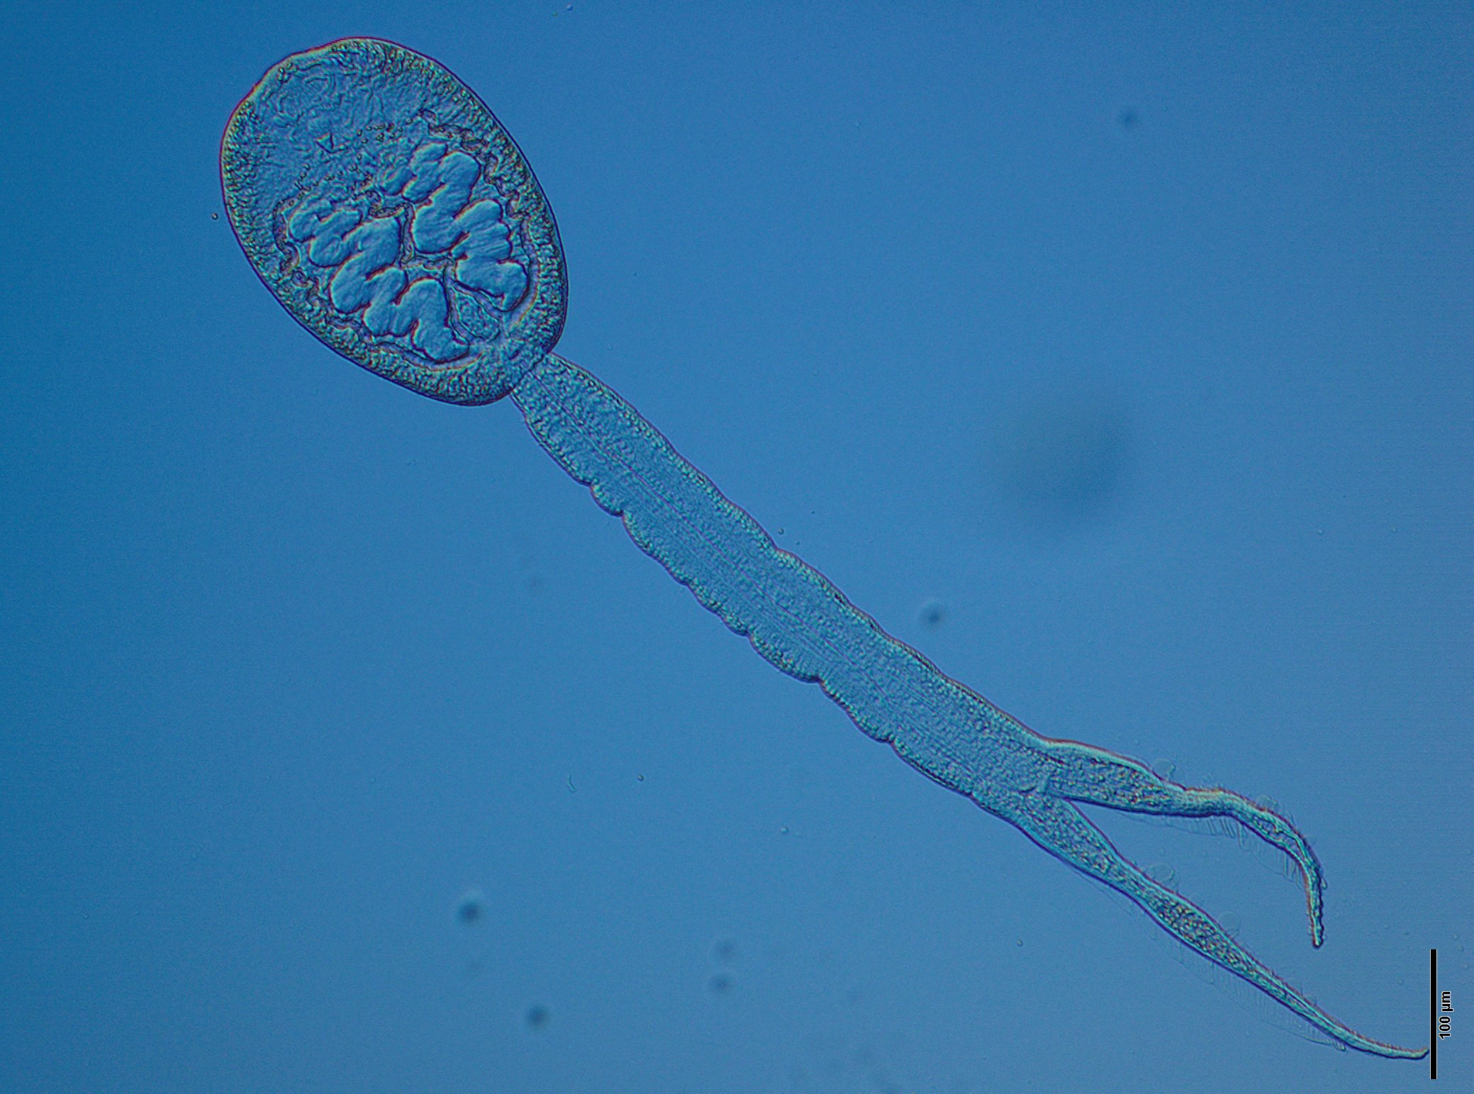
Supplementary Figure S3. Box plot compares the total number of the cercarial emergence during the acclimation phase in different temperature for Acanthotrema tridactyla (A) and Cyathocotylidae gen. sp. (B). Horizontal dash lines represent standard deviation.
Supplementary Figure S4. Picture of Acanthotrema tridactyla (A) and Cyathocotylidae gen. sp. (B) scale bar 50µm and 100µm, respectively.
A
B

R Scripts
###Import data frame----
address_main =
address_for_saving = paste()

shedding_total_h = read_excel(paste(address_main, "/shedding_total_h.xlsx", sep=""))
# Inspecting and revising the data frame
df <- shedding_total_h
df <- as.data.frame(df)
head(df)
str(df)
df$Day <- format(df$Date_time, format="%d")
# subset data set separate acclimation from the experiment----
df_accl = subset(df, total_hour <= 12)
df_accl_P = subset(df, total_hour <= 12& Ptype == 'P')
df_accl_F = subset(df, total_hour <= 12& Ptype == 'F')
#sum of emerged cercariae based on Tank during the acclimation----
sum_accl_P = aggregate( shedding ~Sample_ID, data = df_accl_P , FUN = "sum", simplify = TRUE, drop = TRUE)
colnames(sum_accl_P) <- c('Sample_ID','shedding_accl')
sum_accl_F = aggregate( shedding ~Sample_ID, data = df_accl_F , FUN = "sum", simplify = TRUE, drop = TRUE)
colnames(sum_accl_F) <- c('Sample_ID','shedding_accl')
head(sum_accl_F)
df_incu_P = subset(df, total_hour >= 24 & Ptype == 'P' & total_hour <= 84)
df_incu_F = subset(df, total_hour >= 24 & Ptype == 'F' & total_hour <= 84)
tail(df_incu_P)
###
df_incu_P = left_join(df_incu_P, sum_accl_P, by= 'Sample_ID')
df_incu_F = left_join(df_incu_F, sum_accl_F, by= 'Sample_ID')
###----
df_incu_P$Day <- format(df_incu_P$Date_time, format="%d")
number_day_P = aggregate( shedding ~ Day , data = df_incu_P , FUN = "sum", simplify = TRUE, drop = TRUE)
head(df_incu_P)
df_incu_F$Day <- format(df_incu_F$Date_time, format="%d")
number_day_F = aggregate( shedding ~ Day , data = df_incu_F , FUN = "sum", simplify = TRUE, drop = TRUE)
head(df_incu_F)

#Revising variable types
# factors:
df_incu_P$Sample_ID <- as.factor(df_incu_P$Sample_ID)
df_incu_P$Tank<- as.factor(df_incu_P$Tank)
df_incu_P$Light<- as.character(df_incu_P$Time)
df_incu_P$Light<- as.factor(df_incu_P$Light)
df_incu_P$Day<- as.factor(df_incu_P$Day)
df_incu_P$Day<- as.numeric(df_incu_P$Day)
unique(df_incu_P$Light)
##FORCO
df_incu_F$Sample_ID <- as.factor(df_incu_F$Sample_ID)
df_incu_F$Tank<- as.factor(df_incu_F$Tank)
df_incu_F$Light<- as.character(df_incu_F$Time)
df_incu_F$Light<- as.factor(df_incu_F$Light)
df_incu_F$Day<- as.numeric(df_incu_F$Day)
unique(df_incu_F$Light)
str(df_incu_F)

## test correlation of acclimation-phase emergence and exp_emergence for each temperature (3 plots for each species)----
head(df_incu_P)
df_P = aggregate(shedding ~ Sample_ID + shedding_accl + Temperature, data = df_incu_P , FUN = "sum", simplify = TRUE, drop = TRUE)
head(df_P)
dir_file_name = paste(address_for_saving, "cor_accl_incub_para", ".pdf", sep="")
pdf(file = dir_file_name, width = 10, height = 8)
par(mfrow=c(3,2), mar = c(2,3,2,2), cex=0.7,
mgp = c(1, 0.7, 0.1), las=1)
for(i in unique(df_P$Temperature)){
df_P_T = subset(df_P, Temperature == i)
print(i)
plot(df_P_T$shedding ~ df_P_T$shedding_accl, ylab = '', xlab = '')
lines(df_P_T$shedding_accl, predict(lm(df_P_T$shedding ~ df_P_T$shedding_accl)), col = 'grey')
title(main=paste('T =',i,'°C', ' R-squared =', round(cor(df_P_T$shedding, df_P_T$shedding_accl), 2), ' p-value =', round(cor.test(df_P_T$shedding, df_P_T$shedding_accl)$p.value, 2)))
}
dev.off()
ggscatter(subset(df_P, Temperature >=22), x = "shedding_accl", y = "shedding", add = "reg.line",
ylab = 'Experimental emergence', xlab = 'Acclimation-phase emergence') +
stat_cor(aes(label = paste(..rr.label.., ..p.label.., sep = "~`,`~")),
label.x = 3)
ggsave("scatter_para>22.pdf", width = 12, height = 12, units = "cm")
df_P_mean = aggregate(list(df_P$shedding, df_P$shedding_accl), by= list(df_P$Temperature), mean)
colnames(df_P_mean) = c('Temperature', 'shedding', 'shedding_accl')
ggscatter(subset(df_P_mean, Temperature >=22), x = "shedding_accl", y = "shedding", add = "reg.line",
ylab = 'Experimental emergence', xlab = 'Acclimation-phase emergence') +
stat_cor(aes(label = paste(..rr.label.., ..p.label.., sep = "~`,`~")),
label.x = 3)
ggsave("scatter_para_mean>22.pdf", width = 12, height = 12, units = "cm")
head(df_incu_F)
df_F = aggregate(shedding ~ Sample_ID + shedding_accl + Temperature, data = df_incu_F , FUN = "sum", simplify = TRUE, drop = TRUE)
head(df_F)
dir_file_name = paste(address_for_saving, "cor_accl_incub_Forco", ".pdf", sep="")
pdf(file = dir_file_name, width = 10, height = 8)
par(mfrow=c(3,2), mar = c(2,3,2,2), cex=0.7,
mgp = c(1, 0.7, 0.1), las=1)
for(i in unique(df_F$Temperature)){
df_F_T = subset(df_F, Temperature == i)
print(i)
plot(df_F_T$shedding ~ df_F_T$shedding_accl, ylab = '', xlab = '')
lines(df_F_T$shedding_accl, predict(lm(df_F_T$shedding ~ df_F_T$shedding_accl)), col = 'grey')
title(main=paste('T =',i,'°C', ' R-squared =', round(cor(df_F_T$shedding, df_F_T$shedding_accl), 2), ' p-value =', round(cor.test(df_F_T$shedding, df_F_T$shedding_accl)$p.value, 2)))
}
dev.off()
ggscatter(subset(df_F, Temperature >=22), x = "shedding_accl", y = "shedding", add = "reg.line",
ylab = 'Experimental emergence', xlab = 'Acclimation-phase emergence') +
stat_cor(aes(label = paste(..rr.label.., ..p.label.., sep = "~`,`~")),
label.x = 3)
ggsave("scatter_Forco>22.pdf", width = 12, height = 12, units = "cm")

df_F_mean = aggregate(list(df_F$shedding, df_F$shedding_accl), by= list(df_F$Temperature), mean)
colnames(df_F_mean) = c('Temperature', 'shedding', 'shedding_accl')
ggscatter(subset(df_F_mean, Temperature >=22), x = "shedding_accl", y = "shedding", add = "reg.line",
ylab = 'Experimental emergence', xlab = 'Acclimation-phase emergence') +
stat_cor(aes(label = paste(..rr.label.., ..p.label.., sep = "~`,`~")),
label.x = 3)
ggsave("scatter_Forco_mean>22.pdf", width = 12, height = 12, units = "cm")

## box plot of acclimation-phase emergence for each temperature----
accl_df_P = aggregate(shedding_accl ~ Sample_ID + Temperature, data = df_incu_P , FUN = "mean", simplify = TRUE, drop = TRUE)
accl_df_P$log10_shedding_accl = log10(accl_df_P$shedding_accl+0.001)
head(accl_df_P)
accl_df_Pa = subset(accl_df_P, Temperature >=22)
boxplot_P <-ggboxplot(accl_df_Pa, x = "Temperature", y = "log10_shedding_accl",add = "jitter")+#, main = 'Para', ) +
geom_hline(yintercept = mean(accl_df_P$log10_shedding_accl)+ 1*sd(accl_df_P$log10_shedding_accl), linetype = 2) + # Add horizontal line at base
geom_hline(yintercept = mean(accl_df_P$log10_shedding_accl)- 1*sd(accl_df_P$log10_shedding_accl), linetype = 2) + # Add horizontal line at base
stat_compare_means(method = "anova", label.y = 5) + # Add global p-value
stat_compare_means(label = "p.signif",method = "t.test", ref.group = ".all.", label.y = 4)
boxplot_P
ggsave("Box_plot_accl_Para.pdf", width = 24, height = 12, units = "cm")

accl_df_F = aggregate(shedding_accl ~ Sample_ID + Temperature, data = df_incu_F , FUN = "mean", simplify = TRUE, drop = TRUE)
accl_df_F$log10_shedding_accl = log10(accl_df_F$shedding_accl+0.001)
head(accl_df_F)
accl_df_Fo = subset(accl_df_F, Temperature >=22)
boxplot_F <-ggboxplot(accl_df_Fo, x = "Temperature", y = "log10_shedding_accl", add = "jitter") +#main = 'Forco',
geom_hline(yintercept = mean(accl_df_F$log10_shedding_accl)+ 1*sd(accl_df_F$log10_shedding_accl), linetype = 2) + # Add horizontal line at base
geom_hline(yintercept = mean(accl_df_F$log10_shedding_accl)- 1*sd(accl_df_F$log10_shedding_accl), linetype = 2) + # Add horizontal line at base
stat_compare_means(method = "anova", label.y = 4) + # Add global p-value
stat_compare_means(label = "p.signif",method = "t.test", ref.group = ".all.", label.y = 3)
boxplot_F
ggsave("Box_plot_accl_Forco.pdf", width = 24, height = 12, units = "cm")

####PARA_glmmTMB----
# full model
glmNBP_XXX = glmmTMB(shedding ~ Light + poly(Temperature,2) + poly(Day,2) + #poly(shedding_accl,2) +
Light*poly(Temperature,2)*poly(Day,2) + (1|Sample_ID),
family=nbinom1, data = df_incu_P, na.action = "na.fail")
summary(glmNBP_XXX)
pdf("Diagnostic_PARA_Full_glmNBP_XXX.pdf",width=9, height=5)
s=simulateResiduals(fittedModel=glmNBP_XXX,n=250)
s$scaledResiduals
par("mar")
plot(s)
dev.off()
acf(resid(glmNBP_XXX))
pacf(resid(glmNBP_XXX))
?trigamma
MuMIn::r.squaredGLMM(glmNBP_XXX)
pdf("dredge_full_para.pdf")
dr=MuMIn::dredge(glmNBP_XXX)
op <- par(mar=c(2,5,14,3))
plot(dr)
dev.off()
# best model based on AICc (dredge)
glmNBP_XXX = glmmTMB(shedding ~ Light + poly(Temperature,2) + poly(Day,2) +# poly(shedding_accl,2) +
Light*poly(Temperature,2) + Light*poly(Day,2) + poly(Day,2)*poly(Temperature,2) +
(1|Sample_ID), family=nbinom1, data = df_incu_P, na.action = "na.fail")

#AICc(glmNBP_XXX1,glmNBP_XXX)

apatheme=theme_bw(base_size = 11,base_family = "sans")+
theme(panel.grid.major=element_blank(),
panel.grid.minor=element_blank(),
panel.border=element_blank(),
axis.line=element_line())

P<-ggboxplot(df_incu_P, x = "Temperature", y = "shedding",color = "Light")+ facet_wrap("Day")+
scale_color_manual (values = c('#91bfdb','#ef8a62'),
breaks=c("8", "20"),
labels=c("Dark", "Light"), name = "Light regime")+
scale_fill_manual(values = c('#91bfdb','#ef8a62'),
breaks=c("8", "20"),
labels=c("Dark", "Light"),name = "Light regime") +apatheme
P
ggsave(file="Para_inc_box.pdf", width=20, height=10, dpi=1000, units = "cm")

summary(glmNBP_XXX)

sink("Summary_finalm_PARA.txt")
print(summary(glmNBP_XXX))
sink()

pdf("Diagnostic_PARA_FinalM.pdf",width=9, height=5)
s=simulateResiduals(fittedModel=glmNBP_XXX,n=250)
s$scaledResiduals
#graphics.off()
par("mar")
#par(mar=c(1,1,1,1))
plot(s)
dev.off()

MuMIn::r.squaredGLMM(glmNBP_XXX)
### predict and back transform because of log link function of full model----
newdata2 <- expand.grid(Temperature = seq(10,40, by = 0.5),
Light=unique(df_incu_P$Light),
Day=unique(df_incu_P$Day),
#shedding_accl=0,
Sample_ID=unique(df_incu_P$Sample_ID))
preds2 <- predict(glmNBP_XXX, newdata2, se.fit=T, allow.new.levels = F,
re.form=NA, type="link")
newdata2$pred = preds2$fit
newdata2$se = preds2$se.fit
newdata2$ulimit = exp(newdata2$pred + qnorm(0.975)*(newdata2$se))
newdata2$llimit = exp(newdata2$pred - qnorm(0.975)*(newdata2$se))
newdata2$pred = exp(newdata2$pred)
head(newdata2)
newdata2 <- as.data.frame(newdata2)
#take out the prediction for only temperature based on the model predict the max and plot it
df3=aggregate(x = newdata2[c('pred','se','ulimit','llimit')], by=list(newdata2$Temperature), mean)#aggregate based on temperature
df3<- as.data.frame(df3)
head(df3)

### Plotting the full Model PARA----
apatheme=theme_bw(base_size = 11,base_family = "sans")+
theme(panel.grid.major=element_blank(),
panel.grid.minor=element_blank(),
panel.border=element_blank(),
axis.line=element_line(),
axis.title.x=element_blank(),
axis.text.x=element_blank(),
axis.ticks.x=element_blank())

Day.labs = c('20' = "Day 1",'21'= "Day 2",'22'= "Day 3")
#names(Day.labs) =c('20' = "Day 1",'21'= "Day 2",'22'= "Day 3")
ggplot() +
geom_point(data = df_incu_P, aes(x = Temperature,y= shedding, colour=Light),
alpha=1, shape= 16, size=1, position=position_dodge(width=1)) +
geom_line(data= newdata2, aes(x = Temperature, y= pred, colour=Light), size=0.5) +
geom_ribbon(data= newdata2, aes(x = Temperature, y = pred, ymin = ulimit,
ymax =llimit, fill = Light), alpha = .3, colour = NA) +
ylim(-10, 500)+facet_wrap(~Day, labeller = labeller(Day = Day.labs))+
scale_x_continuous(breaks=c(10,16,22,28,34,40))+
scale_color_manual (values = c('#91bfdb','#ef8a62'),
breaks=c("8", "20"),
labels=c("Dark", "Light"), name = "Light regime")+
scale_fill_manual(values = c('#91bfdb','#ef8a62'),
breaks=c("8", "20"),
labels=c("Dark", "Light"),name = "Light regime") +
labs(y = 'Cercarial emergence (no. per snail)')+apatheme

ggsave(file="FinalM_PARA.pdf", width=20, height=7, dpi=1000, units = "cm")
dev.off()
###plot the model for PARA only temperature----
#obtain maximum value from model

apatheme= theme_bw(base_size = 11,base_family = "sans")+
theme(panel.grid.major=element_blank(),
panel.grid.minor=element_blank(),
panel.border=element_blank(),
axis.line=element_line(),
legend.position = "none")

T_opt = df3$Group.1[which.max(df3$pred)]#optimal temperature= 32°C
CE_max = max(df3$pred) # max cercarial release on average =94

plotemerg<-ggplot(df3, aes(x=Group.1, y=pred))+geom_line(color='#E1BE6A') +
geom_ribbon( aes(ymin = llimit, ymax = ulimit,
color=NULL), fill='#E1BE6A' ,alpha=0.25, size=0.5)+
apatheme+ geom_vline(xintercept=T_opt, lty = "dashed", col = "slategray3")+
geom_point(aes(x=T_opt, y= CE_max), colour="red")+
labs(x = 'Temperature (°C)', y = 'Cercarial emergence',
title=NULL,colour="Temperature (°C)")+
scale_x_continuous(breaks=c(10,16,22,28,34,40))
plotemerg
ggsave(file="Emerged cercariae para_temp.pdf", width=16, height=10, dpi=1000, units = "cm")

