Supplementary Information for “Evidence for gapless quantum spin liquid in a honeycomb lattice”

Chengpeng Tu¹, Dongzhe Dai¹, Xu Zhang¹, Chengcheng Zhao¹, Xiaobo Jin¹, Bin Gao², Tong Chen², Pengcheng Dai², and Shiyan Li^{1,3,4∗}

¹State Key Laboratory of Surface Physics, and Department of Physics, Fudan University, Shanghai 200438, China
²Department of Physics and Astronomy, Rice University, Houston, Texas 77005, USA
³Collaborative Innovation Center of Advanced Microstructures, Nanjing 210093, China
⁴Shanghai Research Center for Quantum Sciences, Shanghai 201315, China

Supplementary Note 1: X-ray diffraction measurement
The typical x-ray diffraction (XRD) data is plotted in Supplementary Fig. 1, determining the largest surface of the samples to be the (001) plane. The heat current and magnetic fields are applied in the (111) plane. The full width at half maximum (FWHM) is only 0.096°, indicating the high quality of our samples.
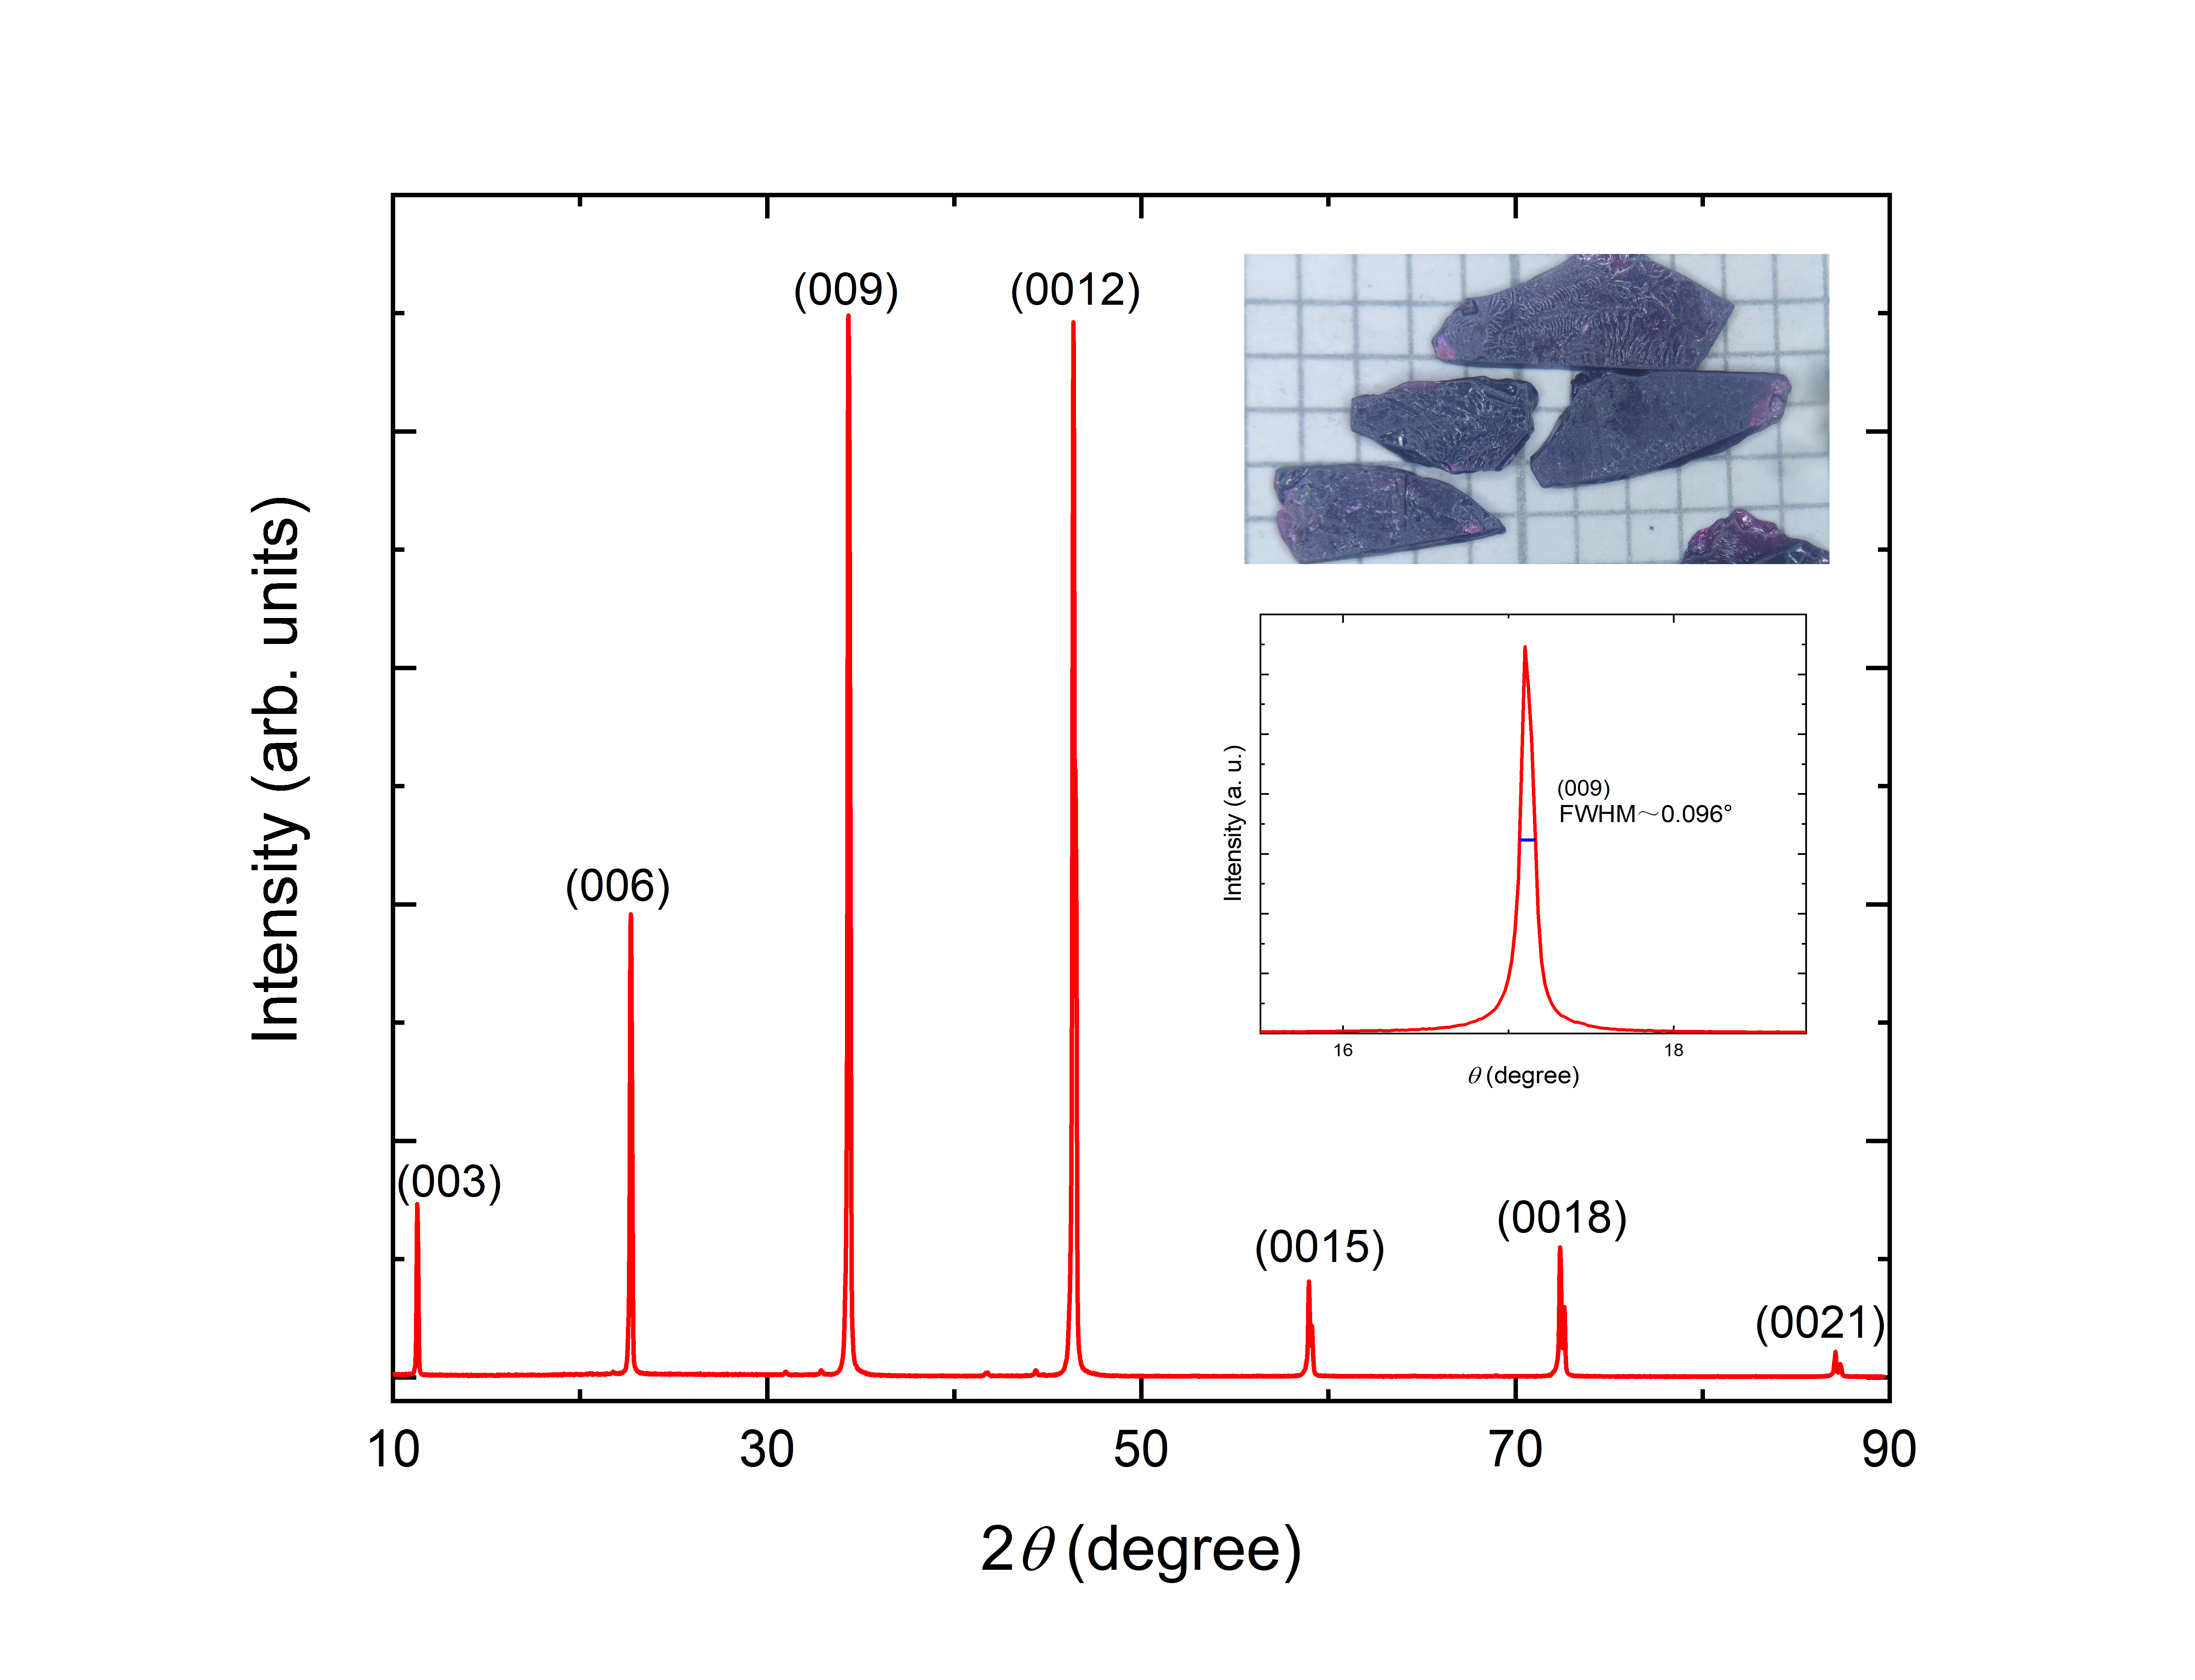

Supplementary Figure 1 | Typical x-ray diffraction pattern of the BaCo₂(AsO₄)₂ single crystal. The largest plane is determined to be the (001) plane.

Supplementary Note 2: Magnetization for H || a
Supplementary Fig. 2 depicts the magnetization from 2 to 20 K of BaCo₂(AsO₄)₂ single crystal in various magnetic fields parallel to the a axis. The whole behavior is similar to the case where fields are applied along the b axis, indicating weak in-plane anisotropy. The magnetic order vanishes at about 0.54 T, slightly larger than the critical field H_{c3} (0.53 T) for H || b, which can also be evidenced by magnetizations in Fig. 2b. Besides, the range of the spin spiral state is larger, from 0.11 to 0.26 T.
Supplementary Figure 2 | Low-temperature magnetization of the BaCo₂(AsO₄)₂ single crystal at various magnetic fields along a axis.

Supplementary Note 3: Low-temperature specific heat measurements for H || a
The temperature dependence of specific heat for H || a is plotted in Supplementary Fig. 3(a). At zero field, a λ-peak due to antiferromagnetic ordering is observed at T_{N2} = 5.15 K, which is then suppressed by a small in-plane field above 0.6 T. It is roughly consistent with the previous specific heat measurements^{S1,S2} and our magnetization results. As temperature decreases, the values of C_{p}/T exhibit a sudden upturn below about 1 K, which can be attributed to a high-temperature tail of a nuclear Schottky peak. To see this more clearly, we replot C_{p}/T below 4 K in Supplementary Fig. 3(b).

Supplementary Figure 3 | The low-temperature specific heat of the BaCo₂(AsO₄)₂ single crystal for H || a. (a) The temperature dependence of C_{p}/T below 10 K at several fields. At zero field, a clear phase transition occurs at T_{N2} = 5.15 K. (b) An abrupt upturn is observed below about 1K, which can be attributed to the nuclear Schottky contribution.

Supplementary References
S1. Regnault, L., Rossat-Mignod, J., Villain, J. & De Combarieu, A. Specific heat of the quasi 2D-XY helimagnets BaCo₂(AsO₄)₂ and BaCo₂(PO₄)₂. J. Phys., Colloq. 39, C6-759 (1978).
S2. Zhong, R., Gao, T., Ong, N. P. & Cava, R. J. Weak-field induced nonmagnetic state in a Co-based honeycomb. Sci. Adv. 6, eaay6953 (2020).

