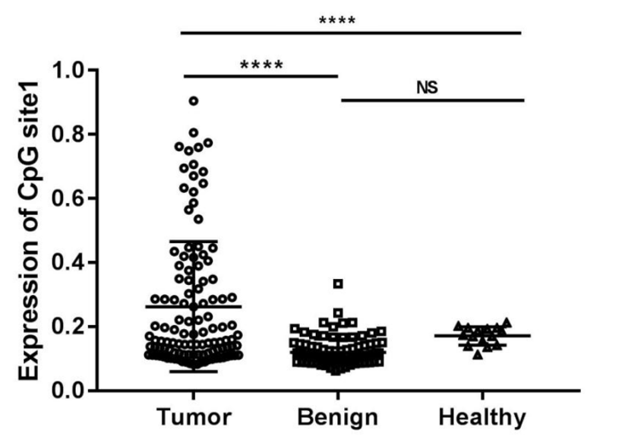
Supplement Figure 1: Methylation in tumor and normal tissue on site cg14826425 of participants. CpG site1：7:27232901-27233378|cg14826425；Tumor：HCC、Benign： liver cirrhosis；****：P＜0.0001；NS：no sense.

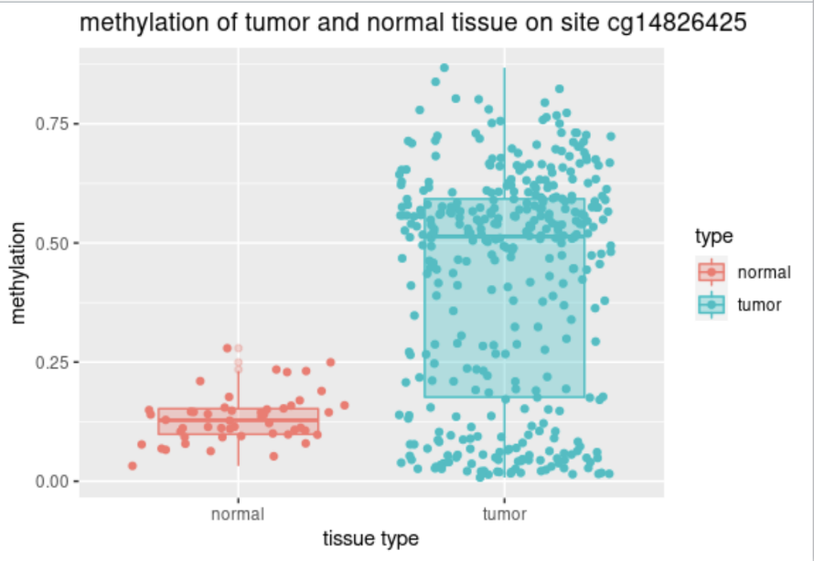
Supplement Figure 2: Methylation in tumor and normal tissue on site cg14826425 downloaded in TCGA. Tumor：HCC.

Supplement Table 1: The Clinical characteristics and pathological of HCC with tumor size smaller than 2cm and healthy individuals.
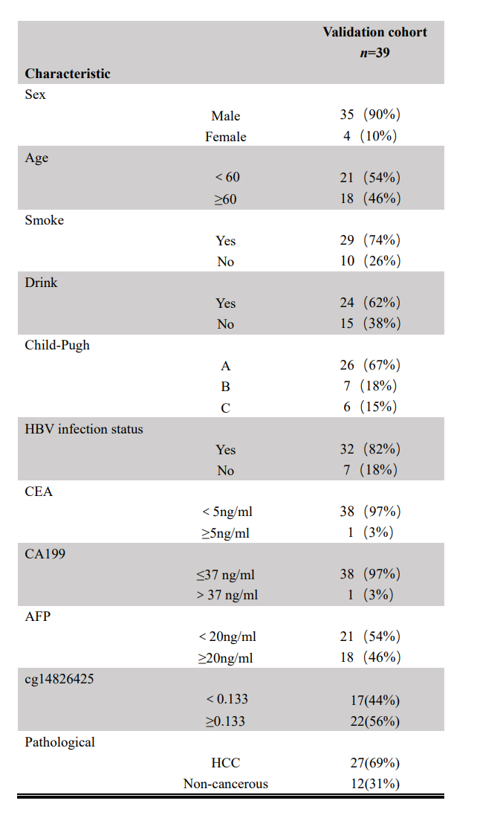

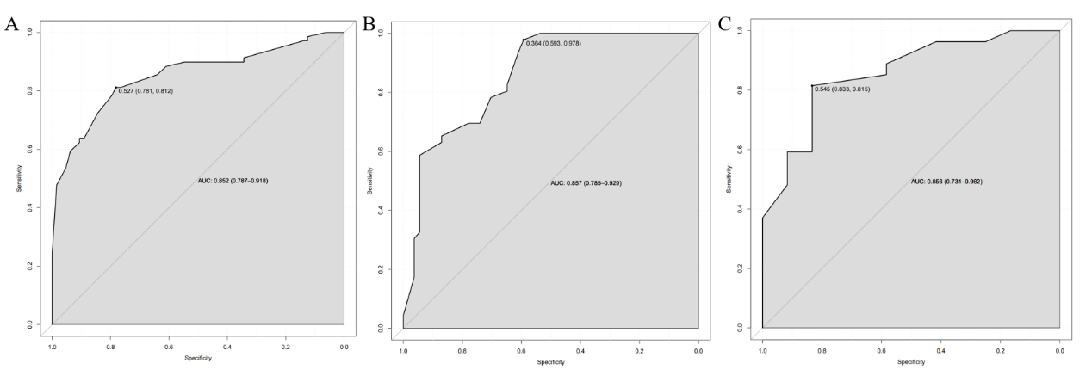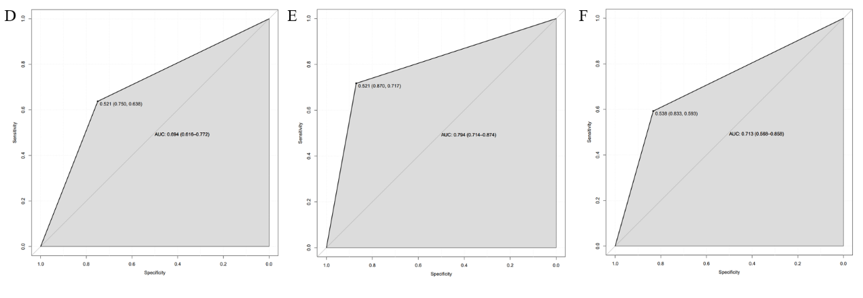
Supplement Figure 3: The diagnosis-dependent ROC curves analysis evaluates the accuracy of the nomograms and AFP. The Y-axis represents sensitivity, and the X-axis represents the specificity. A represents training cohort of nomogram; B represents validation cohort of nomogram. C represents validation cohort of earlier stage HCC patients. D, E, and F represents AFP value in training cohort, validation cohort and validation cohort of earlier stage HCC patients, respectively.

