Table 1
A list of the final selected compounds among the seven herbal medicines in BYHWD.
NO. | Compound | Structure | OB(%) | DL | Herbal medicine
1 | kaempferol | 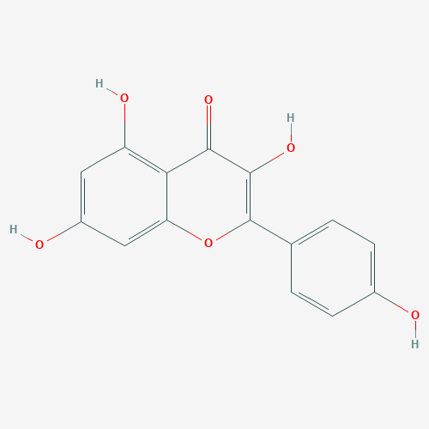 | 41.88 | 0.24 | Astragali Radix,Carthami Flos
2 | quercetin | 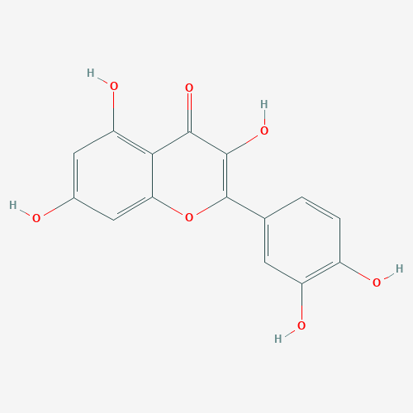 | 46.43 | 0.28 | Astragali Radix
3 | Mairin | 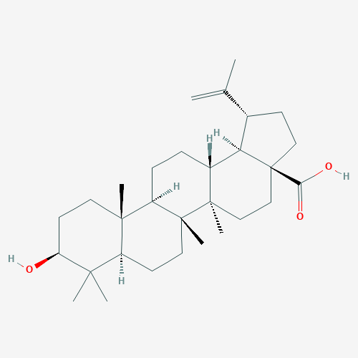 | 55.38 | 0.78 | Astragali Radix
4 | Jaranol | 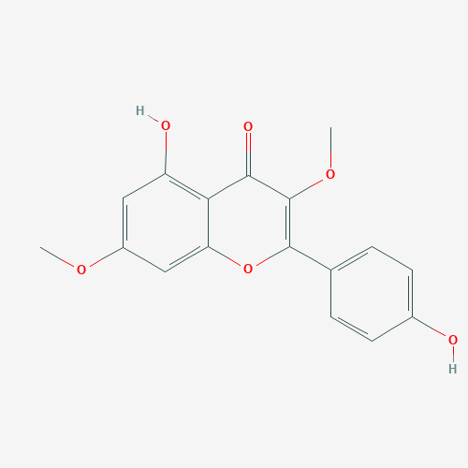 | 50.83 | 0.29 | Astragali Radix
5 | hederagenin | 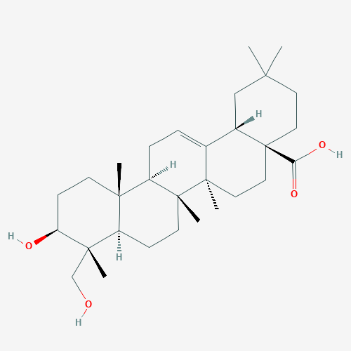 | 36.91 | 0.75 | Astragali Radix,Persicae Semen
6 | isorhamnetin | 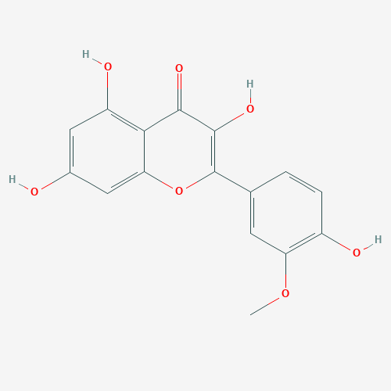 | 49.6 | 0.31 | Astragali Radix
7 | Bifendate | 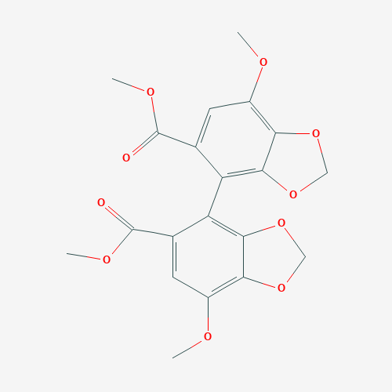 | 31.1 | 0.67 | Astragali Radix
8 | formononetin | 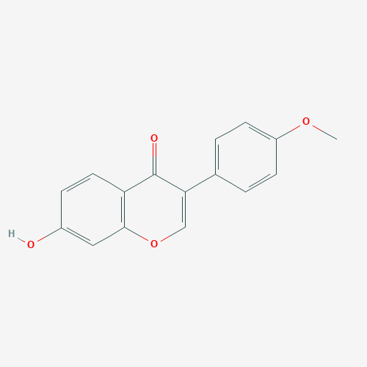 | 69.67 | 0.21 | Astragali Radix
9 | isoflavanone | 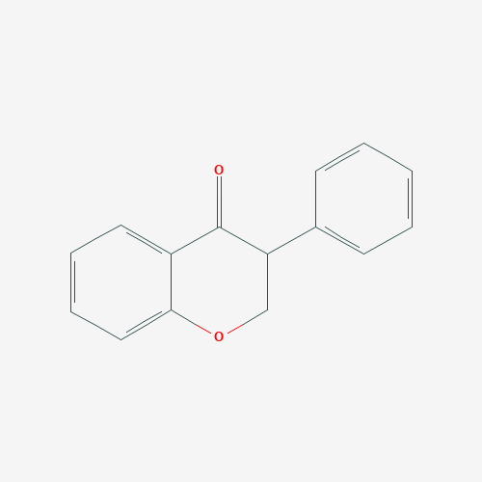 | 109.99 | 0.3 | Astragali Radix
10 | Calycosin | 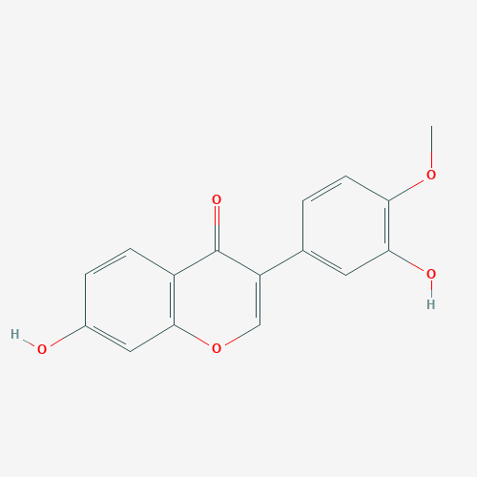 | 47.75 | 0.24 | Astragali Radix
11 | AstragalosideIV | 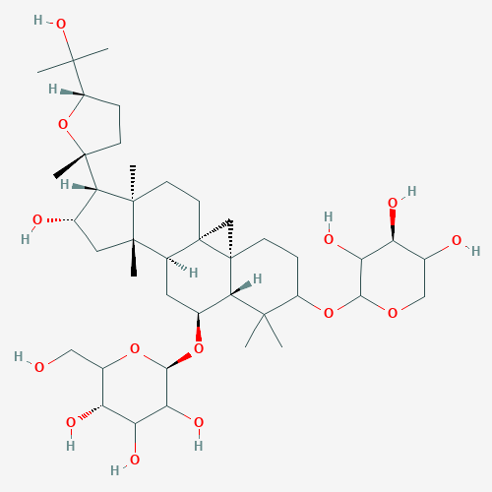 | 17.74 | 0.15 | Astragali Radix,Persicae Semen
12 | poriferast-5-en-3beta-ol | 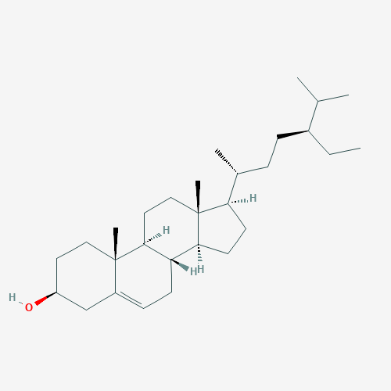 | 36.91 | 0.75 | Carthami Flos
13 | lignan | 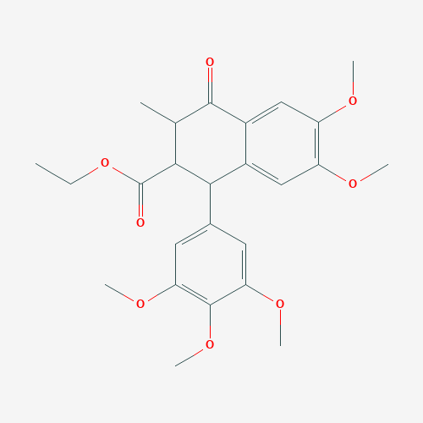 | 43.32 | 0.65 | Carthami Flos
14 | Phytoene | 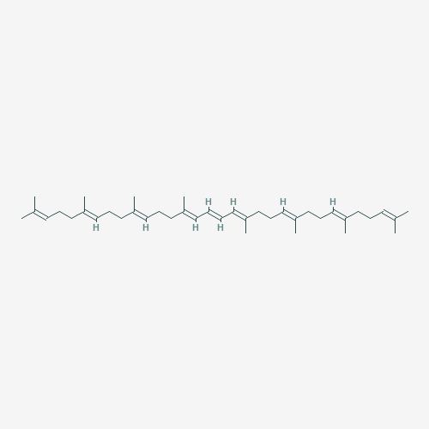 | 39.56 | 0.5 | Carthami Flos
15 | phytofluene | 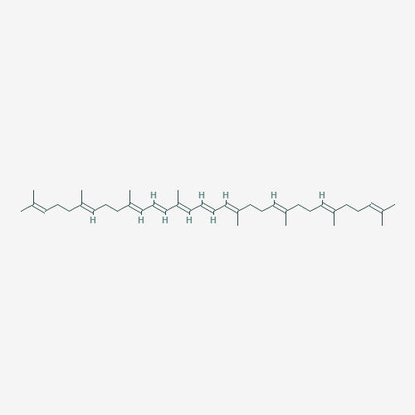 | 43.18 | 0.5 | Carthami Flos
16 | Pyrethrin II | 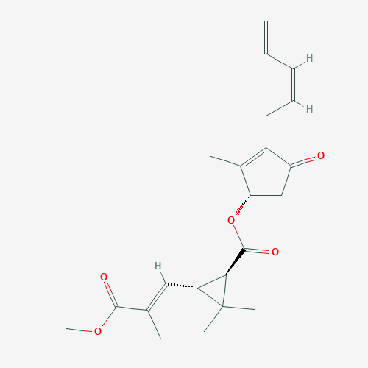 | 48.36 | 0.35 | Carthami Flos
17 | 6-Hydroxykaempferol | 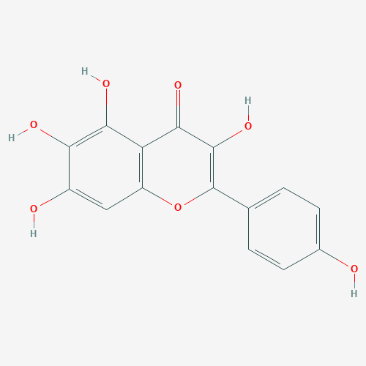 | 62.13 | 0.27 | Carthami Flos
18 | baicalein | 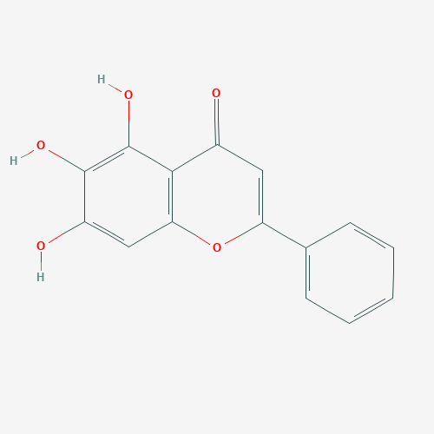 | 33.52 | 0.21 | Carthami Flos,Paeoniae Radix Rubra
19 | quercetagetin | 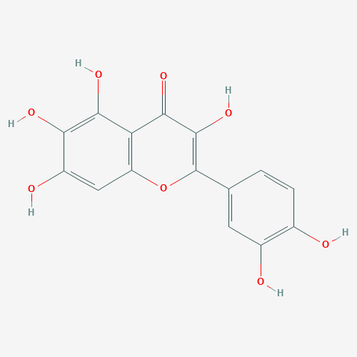 | 45.01 | 0.31 | Carthami Flos,Paeoniae Radix Rubra
20 | beta-carotene | 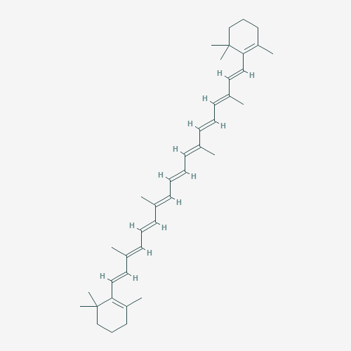 | 37.18 | 0.58 | Carthami Flos
21 | Baicalin | 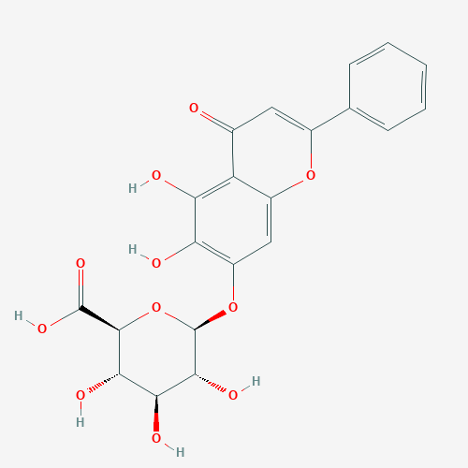 | 40.12 | 0.75 | Carthami Flos,Paeoniae Radix Rubra
22 | beta-sitosterol | 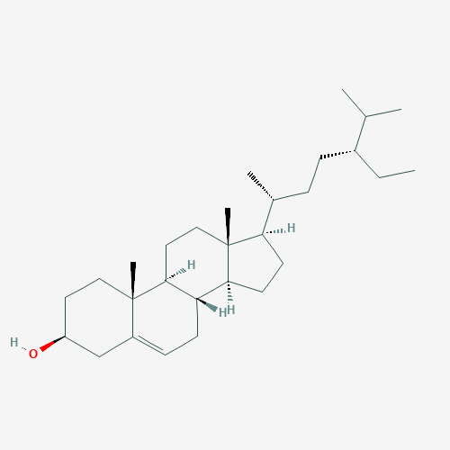 | 36.91 | 0.75 | Carthami Flos,Paeoniae Radix Rubra,Angelicae sinensis Radix
23 | Stigmasterol | 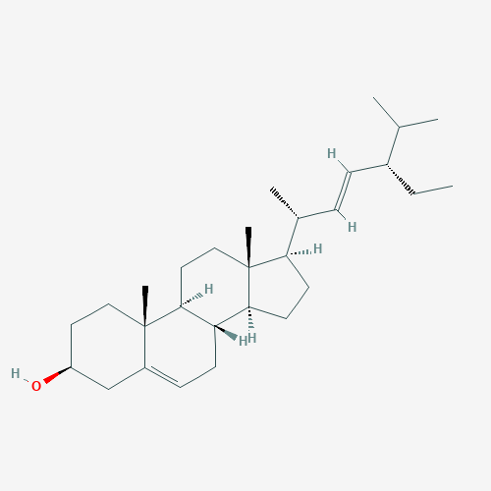 | 43.83 | 0.76 | Carthami Flos,Paeoniae Radix Rubra,Angelicae sinensis Radix
24 | luteolin | 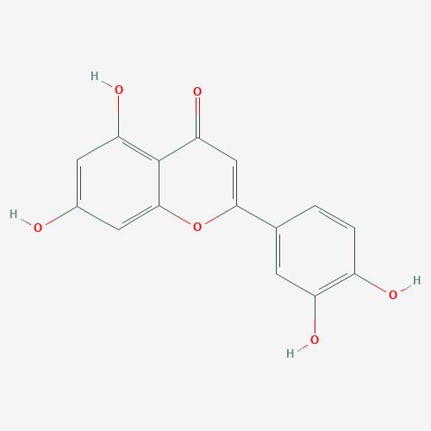 | 36.16 | 0.25 | Carthami Flos
25 | Ferulic acid | 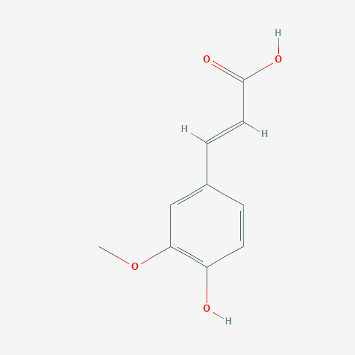 | 39.56 | 0.06 | Angelicae sinensis Radix
26 | cis-ligustilide | 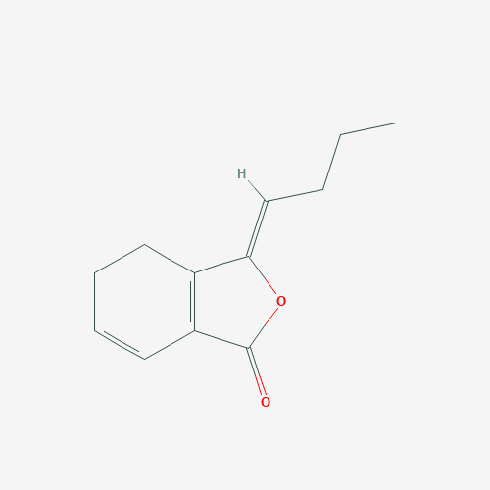 | 36.91 | 0.75 | Angelicae sinensis Radix
27 | ellagic acid | 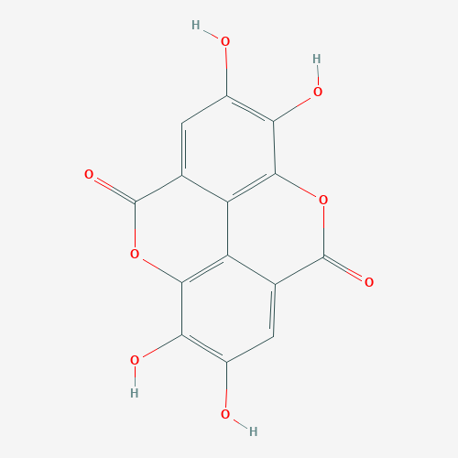 | 43.06 | 0.43 | Paeoniae Radix Rubra
28 | paeoniflorin | 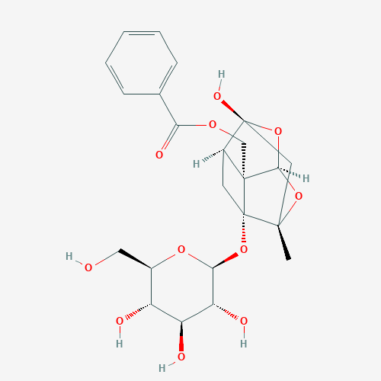 | 53.87 | 13.88 | Paeoniae Radix Rubra
29 | sitosterol |  | 36.91 | 0.75 | Paeoniae Radix Rubra,Chuangxiong Rhizoma
30 | Spinasterol | 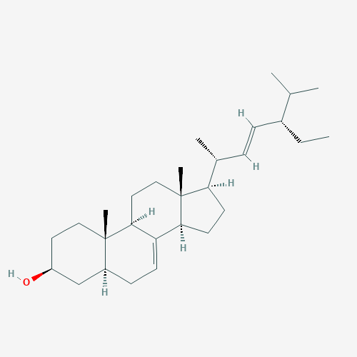 | 42.98 | 0.76 | Paeoniae Radix Rubra
31 | (+)-catechin | 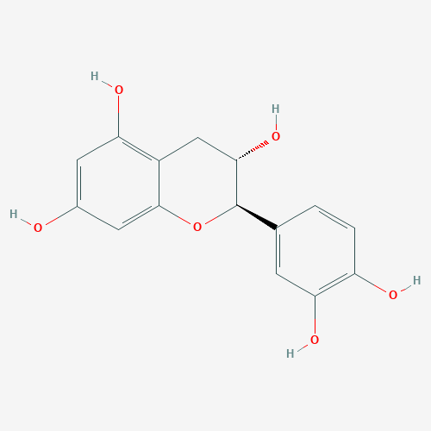 | 54.83 | 0.24 | Paeoniae Radix Rubra
32 | stigmast-7-en-3-ol | 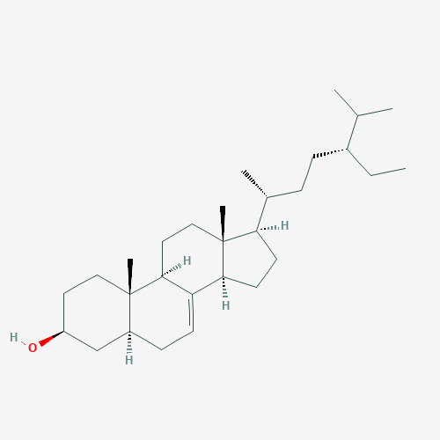 | 37.42 | 0.75 | Paeoniae Radix Rubra
33 | Ethyl oleate (NF) | 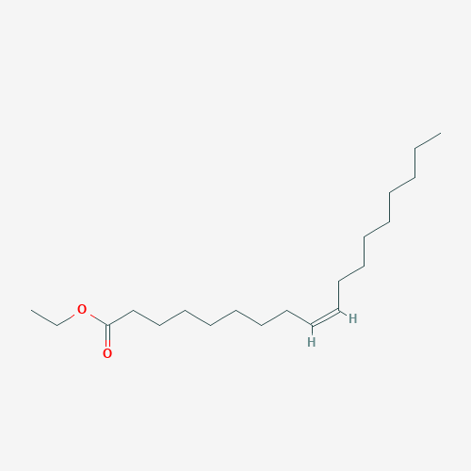 | 32.4 | 0.19 | Paeoniae Radix Rubra
34 | campest-5-en-3beta-ol | 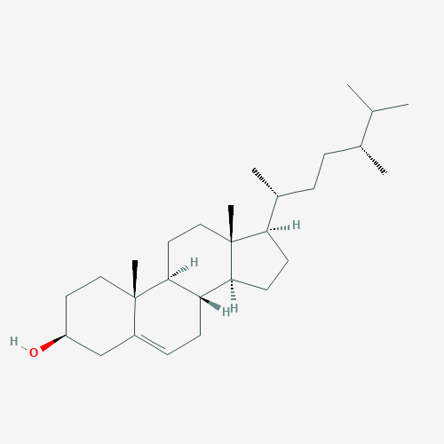 | 37.58 | 0.71 | Paeoniae Radix Rubra
35 | sitosterol |  | 36.91 | 0.75 | Chuangxiong Rhizoma
36 | Perlolyrine | 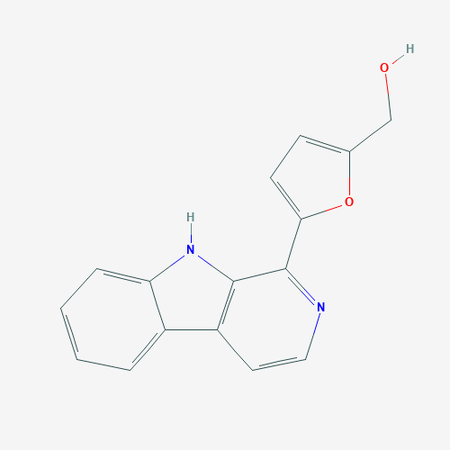 | 65.95 | 0.27 | Chuangxiong Rhizoma
37 | wallichilide | 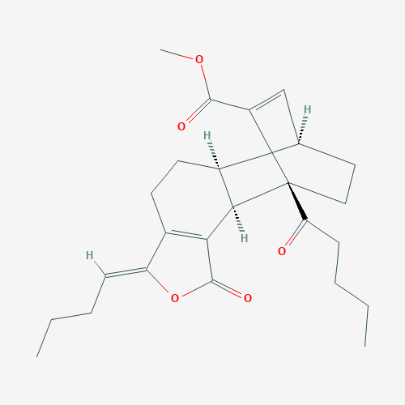 | 42.31 | 0.71 | Chuangxiong Rhizoma
38 | Ligustrazine | 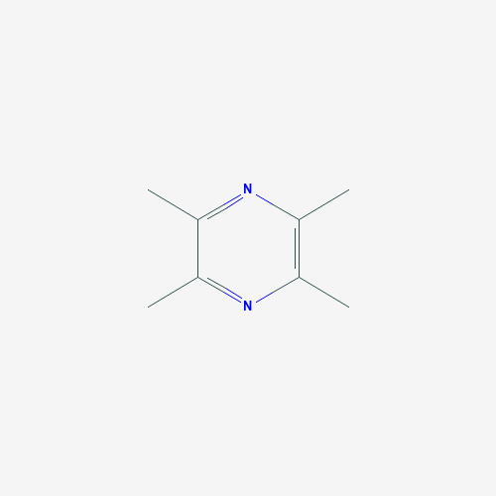 | 20.01 | 0.03 | Chuangxiong Rhizoma
39 | Z-ligustilide |  | 53.72 | 0.07 | Chuangxiong Rhizoma
40 | Sitosterol alpha1 | 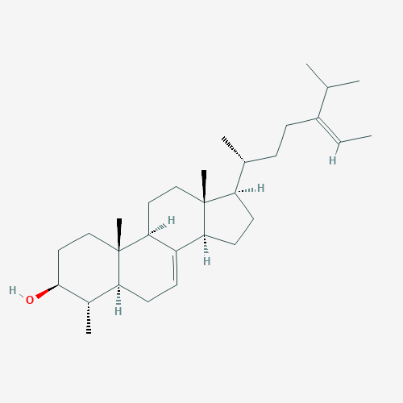 | 36.91 | 0.75 | Persicae Semen
41 | Gibberellin A44 | 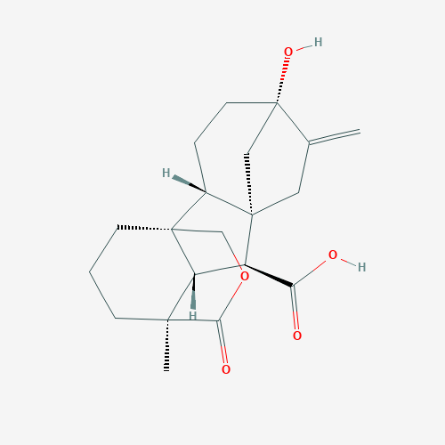 | 101.61 | 0.54 | Persicae Semen
42 | 3-O-p-coumaroylquinic acid | 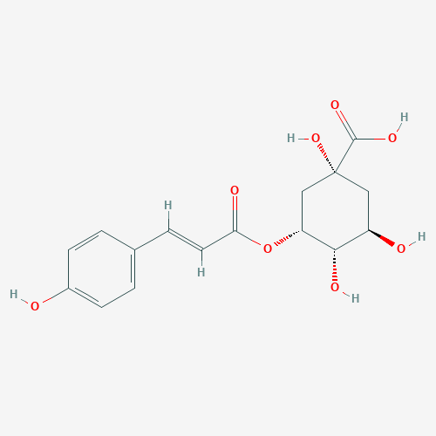 | 37.63 | 0.29 | Persicae Semen
43 | Folinic Acid |  | 68.96 | 0.71 | Persicae Semen
44 | Cholesterol | 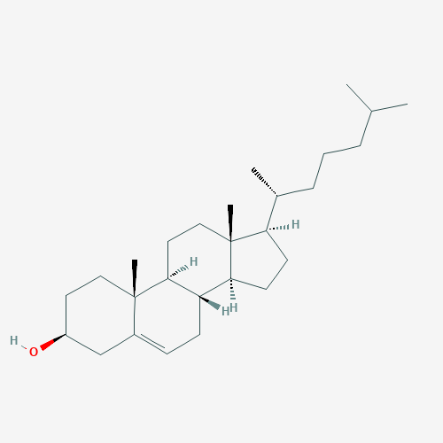 | 37.87 | 0.68 | Pheretima
45 | Linoleic acid | 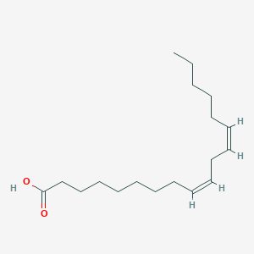 | 41.9 | 0.14 | Pheretima
46 | Arachidonic acid | 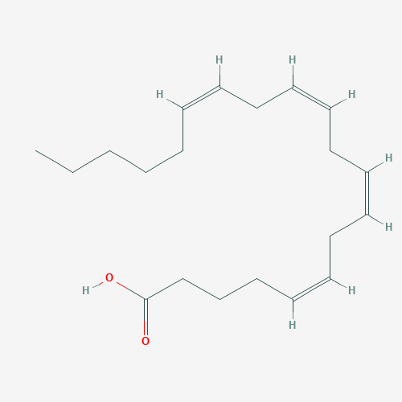 | 45.57 | 0.2 | Pheretima
47 | Dihydrocapsaicin | 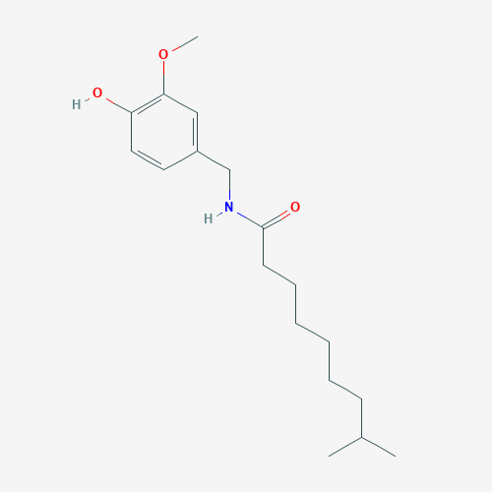 | 47.07 | 0.19 | Pheretima

Table 2
Biological processes of potential target genes based on GO enrichment analysis.
ID | Biological Process | Genes | P-Value
GO:0045944 | positive regulation of transcription from RNA polymerase II promoter | HMGB1,TNF,RELA,PPARG,TP53,IGF1, NFKBIA,RB1,CD40, SIRT1, IL10,VDR, IL17A, APP,HIF1A,SP1,POU5F1,RIPK1, JUN, MAPK3 | 6.60E-12
GO:0006954 | inflammatory response | PIK3CG, HMGB1, CCL2, PTGS2,RELA, TLR4, CD40, AGER, IL10, CXCL10, IL17A, JAK2, NFE2L2, CD14 | 7.35E-11
GO:0000122 | negative regulation of transcription from RNA polymerase II promoter | EGR1,VDR,TNF,POU5F1,RELA,JUN, PPARG, TP53, NFKB1, RB1, SIRT1, DDIT3, EPO | 3.56E-07
GO:0006351 | transcription, DNA-templated | EGR1,VDR,HIF1A,CEBPB,JUN,MAPK3, PPARG, TP53, STAT3 | 5.98E-05
GO:0043066 | negative regulation of apoptotic process | CASP3, ALB, BCL2, TP53, IGF1, CAT, SIRT1, STAT3 | 1.78E-04
GO:0045893 | positive regulation of transcription, DNA-templated | CEBPB,JUN, PPARG,NFKB1, NFE2L2, STAT3, EPO | 1.78E-04
GO:0031663 | lipopolysaccharide-mediated signaling pathway | MAPK1, CCL2, TNF, MAPK3, NFKBIA, NOS3, TLR4 | 7.02E-10
GO:0001525 | angiogenesis | PIK3CG,HIF1A,JUN,VEGFA,SERPINE, NOS3, SIRT1 | 2.14E-05
GO:0042127 | regulation of cell proliferation | JUN,NFKBIA,JAK2,NOS2,CD40,PLAU, CXCL10 | 8.12E-05
GO:0006357 | regulation of transcription from RNA polymerase II promoter | FOS,SP1,NFKB1, RB1, NFE2L2,STAT3, SOD2 | 0.001215038
GO:0001666 | response to hypoxia | PLAT,VEGFA,NOS2,AGER, PLAU,EPO | 1.96E-05
GO:0051092 | positive regulation of NF-kappaB transcription factor activity | TNF, RELA, RIPK1, CAT, CD40, AGER | 7.26E-05
GO:0006915 | apoptotic process | APP, RIPK1, CYCS, TP53, RB1, EPO | 2.98E-04
GO:0055114 | oxidation-reduction process | GPX1, NOS3, CAT, NOS2, SOD1, SOD2 | 0.001431211
GO:0006955 | immune response | CSF2, IL6, JUN, CD40, IL10, CXCL10 | 0.006954104
GO:0043491 | protein kinase B signaling | CSF2, CCL2, TNF, IGF1, CD40 | 1.21E-05
GO:0071356 | cellular response to lipopolysaccharide | JUN, SERPINE1, NOS2, IL10, CXCL10 | 1.82E-04
GO:0006979 | response to oxidative stress | GPX1, APP, PTGS2, APOE, MPO | 2.91E-04
GO:0045766 | positive regulation of angiogenesis | HIF1A, VEGFA, SERPINE1, NOS3, SIRT1 | 6.75E-04
GO:0043524 | negative regulation of neuron apoptotic process | CCL2, APOE, JUN, BCL2, SOD1 | 7.56E-04

Table 3
Functions of potential target genes based on KEGG pathway analysis.
ID | Pathway | Number of pathway gene | P-Value
hsa05167 | Kaposi sarcoma-associated herpesvirus infection | PTGS2/CALM1/PIK3CG/RELA/RB1/MAPK1/MAPK3/NFKBIA/CASP3/CSF2/CYCS/JUN/NFKB1/STAT3/TP53/VEGFA/IL6/CASP9/ICAM1/FOS/HIF1A/CREB1/JAK2 | 1.55E-19
hsa04668 | TNF signaling pathway | PTGS2/RELA/MMP9/MAPK1/MAPK3/NFKBIA/TNF/CASP3/CEBPB/CSF2/IL1B/JUN/NFKB1/IL6/ICAM1/CCL2/FOS/SELE/RIPK1/CXCL10/JUNB/CREB1 | 2.80E-23
hsa05163 | Human cytomegalovirus infection | PTGS2/CALM1/RELA/RB1/MAPK1/MAPK3/NFKBIA/TNF/CASP3/CYCS/IL1B/NFKB1/STAT3/TP53/VEGFA/IL6/CASP9/CCL2/RIPK1/SP1/CREB1/CCL3 | 1.83E-16
hsa04933 | AGE-RAGE signaling pathway in diabetic complications | RELA/MAPK1/MAPK3/TNF/BCL2/CASP3/IL1B/JUN/NFKB1/STAT3/VEGFA/IL6/ICAM1/CCL2/SELE/AGER/EGR1/NOS3/AGT/SERPINE1/JAK2 | 7.02E-23
hsa04657 | IL-17 signaling pathway | PTGS2/RELA/MMP9/MAPK1/MAPK3/NFKBIA/TNF/CASP3/CEBPB/CSF2/IL1B/JUN/NFKB1/IL6/CCL2/FOS/CXCL10/FOSB/IL17A/JUND | 5.04E-22
hsa05161 | Hepatitis B | RELA/MMP9/RB1/MAPK1/MAPK3/NFKBIA/TNF/BCL2/CASP3/CYCS/JUN/NFKB1/STAT3/TP53/IL6/TLR4/CASP9/FOS/CREB1/JAK2 | 6.08E-17
hsa05152 | Tuberculosis | CALM1/NOS2/RELA/MAPK1/MAPK3/TNF/BCL2/CASP3/CEBPB/CYCS/IL1B/NFKB1/IL6/TLR4/CASP9/CD14/VDR/IL10/CREB1/JAK2 | 3.94E-16
hsa05145 | Toxoplasmosis | NOS2/PIK3CG/RELA/MAPK1/MAPK3/NFKBIA/TNF/BCL2/CASP3/CYCS/NFKB1/STAT3/TLR4/CASP9/IL10/CD40/HSPA1A/JAK2 | 2.25E-17
hsa04210 | Apoptosis | RELA/MAPK1/MAPK3/NFKBIA/TNF/BCL2/CASP3/CYCS/JUN/NFKB1/TP53/CASP9/PARP1/BBC3/ATM/FOS/RIPK1/DDIT3 | 6.85E-16
hsa05142 | Chagas disease (American trypanosomiasis) | NOS2/RELA/MAPK1/MAPK3/NFKBIA/TNF/IL1B/JUN/NFKB1/IL6/TLR4/CCL2/FOS/IL10/ACE/SERPINE1/CCL3 | 1.03E-16
hsa05418 | Fluid shear stress and atherosclerosis | CALM1/RELA/MMP9/TNF/BCL2/IL1B/JUN/NFKB1/TP53/VEGFA/NFE2L2/ICAM1/CCL2/FOS/SELE/NOS3/PLAT | 1.87E-14
hsa05202 | Transcriptional misregulation in cancer | PPARG/RELA/MMP9/CEBPB/CSF2/IGF1/MPO/NFKB1/PLAU/TP53/IL6/ATM/CD14/CD40/SP1/DDIT3/PLAT | 2.41E-12
hsa05169 | Epstein-Barr virus infection | RELA/RB1/NFKBIA/TNF/BCL2/CASP3/CYCS/JUN/NFKB1/STAT3/TP53/IL6/CASP9/ICAM1/RIPK1/CD40/CXCL10 | 8.51E-12
hsa05166 | Human T-cell leukemia virus 1 infection | RELA/RB1/MAPK1/MAPK3/NFKBIA/TNF/CSF2/JUN/NFKB1/TP53/IL6/ICAM1/ATM/FOS/CD40/EGR1/CREB1 | 3.38E-11
hsa04151 | PI3K-Akt signaling pathway | PIK3CG/RELA/MAPK1/MAPK3/BCL2/IGF1/NFKB1/TP53/VEGFA/IL6/TLR4/CASP9/NOS3/CREB1/JAK2/EPO/CHRM1 | 5.39E-08
hsa04620 | Toll-like receptor signaling pathway | RELA/MAPK1/MAPK3/NFKBIA/TNF/IL1B/JUN/NFKB1/IL6/TLR4/CD14/FOS/RIPK1/CD40/CXCL10/CCL3 | 2.89E-15
hsa05162 | Measles | RELA/NFKBIA/BCL2/CASP3/CYCS/IL1B/JUN/NFKB1/STAT3/TP53/IL6/TLR4/CASP9/BBC3/FOS/HSPA1A | 2.81E-13
hsa05164 | Influenza A | RELA/MAPK1/MAPK3/NFKBIA/TNF/CASP3/CYCS/IL1B/NFKB1/IL6/TLR4/CASP9/ICAM1/CCL2/CXCL10/JAK2 | 5.60E-12
hsa05170 | Human immunodeficiency virus 1 infection | CALM1/RELA/MAPK1/MAPK3/NFKBIA/TNF/BCL2/CASP3/CYCS/JUN/NFKB1/TLR4/CASP9/ATM/FOS/RIPK1 | 2.12E-10
hsa04010 | MAPK signaling pathway | RELA/MAPK1/MAPK3/TNF/CASP3/IGF1/IL1B/JUN/NFKB1/TP53/VEGFA/CD14/FOS/JUND/DDIT3/HSPA1A | 2.60E-08
hsa05133 | Pertussis | CALM1/NOS2/RELA/MAPK1/MAPK3/TNF/CASP3/IL1B/JUN/NFKB1/IL6/TLR4/CD14/FOS/IL10 | 4.64E-16
hsa04064 | NF-kappa B signaling pathway | PTGS2/RELA/NFKBIA/TNF/BCL2/IL1B/NFKB1/PLAU/TLR4/PARP1/ICAM1/ATM/CD14/RIPK1/CD40 | 3.44E-14
hsa04066 | HIF-1 signaling pathway | NOS2/RELA/MAPK1/MAPK3/BCL2/IGF1/NFKB1/STAT3/VEGFA/IL6/TLR4/HIF1A/NOS3/SERPINE1/EPO | 1.29E-13

