Application of eDNA metabarcoding for assessment of the eukaryotic diversity of three hypersaline lakes in the Trans-Himalayan region of Ladakh
Phuntsog Dolma (ORCID ID 0000-0002-1003-0129) and
*Archana Chauhan (ORCID ID 0000-0002-6821-0464)
Department of Zoology, Panjab University, Sector 14, Chandigarh, India 160014
*Corresponding author archanagenomics@gmail.com , achauhan@pu.ac.in

List of Supplementary figures:
Figure: Uncropped gel images of Figure 3a: gDNA on 1.2% gel of Agarose depicting 18S rRNA gene. Lane 1 1kb ladder, lane no 2 Pangong lake, lane 3 Tsomoriri lake, lane 4 Tsokar lake. (3b). PCR amplicon showing a sharp band of 300bp with 100bp ladder.
Figure S1: OTU analysis showing the major domain in all the three hypersaline lakes and a very less percentage of the sequences were categorised as unclassified sequences.
Figure S2: Collected invertebrates from the three hypersaline lakes. a) Amphipod b) Daphnia c) Bug d) Platyhelminthes e) Amphipod
Figure S3: Stacked bar charts of relative abundance of major Eukaryotic class in all samples along percentage present in the three hypersaline lakes.
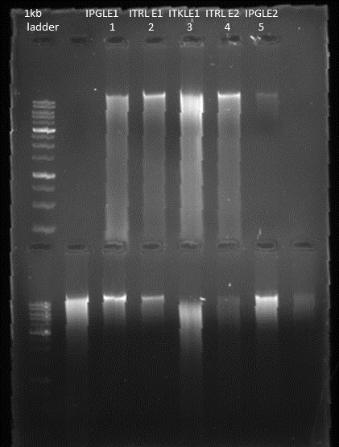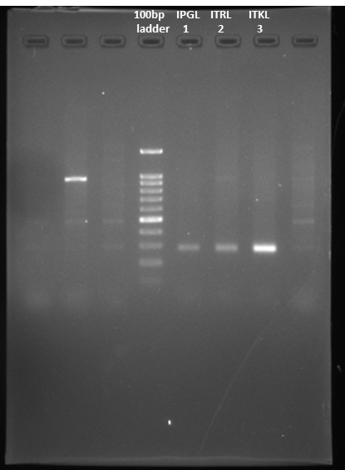
a b
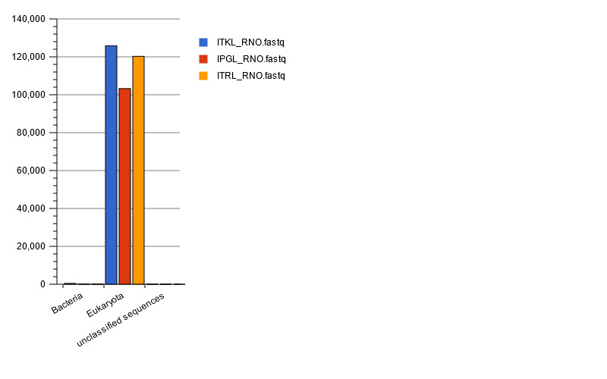
Figure S1
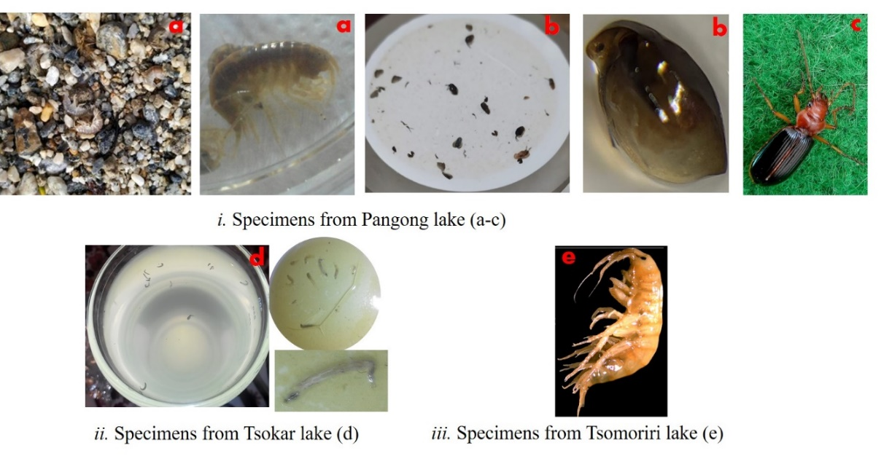
Figure S2
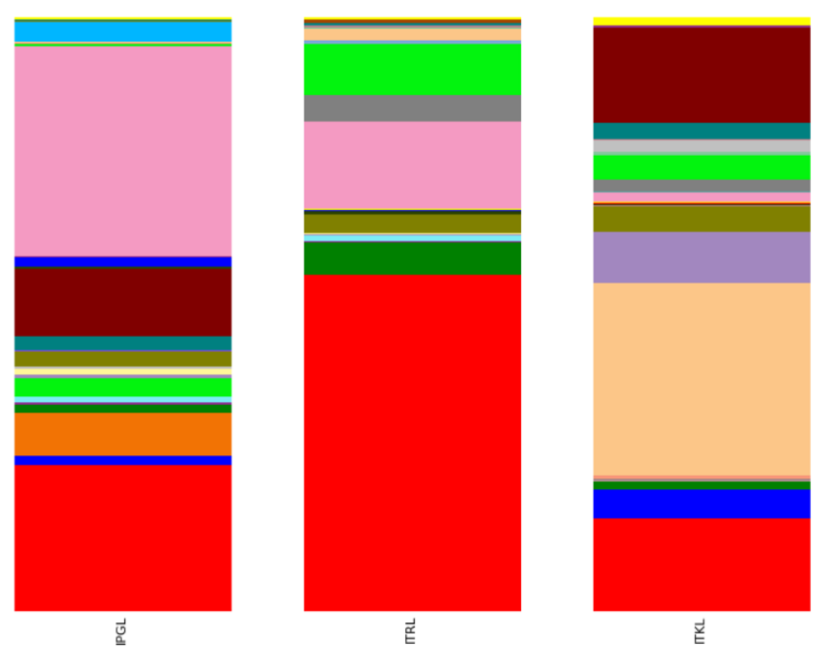
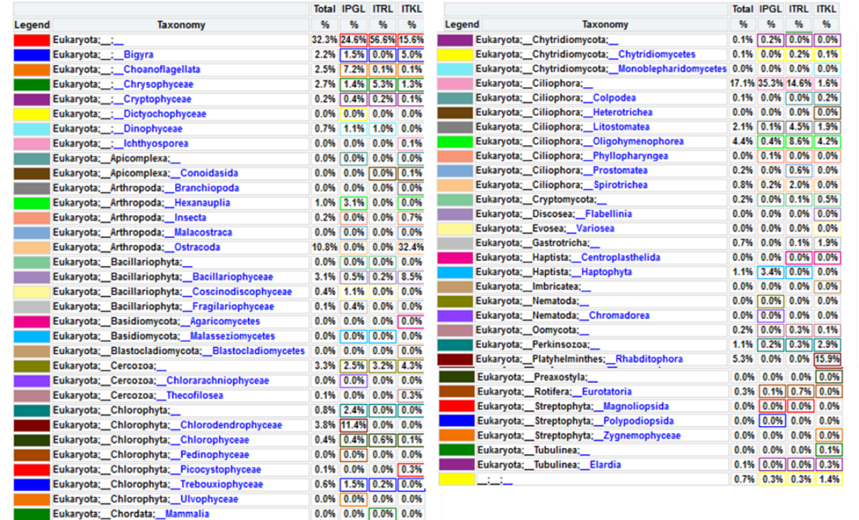
Figure S3

Table S1: Detail Micro Eukaryotic Diversity of the Ramsar wetlands of Ladakh (UT), India
Phylum | Class | Order | Family | Genus | Species | Origin/ Function/ characteristic | From this study
 |  |  |  |  |  |  | ITRL | IPGL | ITKL
Ochrophyta | Bacillariophyceae (Diatoms) | Bacillariales | Bacillariaceae | Nitzschia; Tryblionella | N. capitellata; N. cf; N.commutata; N. draveillensis; N. inconspicua; N. reskoi; Nitzschia. sp; uncultured Nitzchia; Tryblionella sp | Marine in origin, psychrophilic, salt tolerant; Non obligate, epiphytic; found mostly in littoral zone of lakes
Ochrophyta | Bacillariophyceae (Diatoms) | Cocconeidales | Achnanthidiaceae | Achnanthidium | A.pyrenacium | Slightly motile, benthic, mostly found at high altitude.
Ochrophyta | Bacillariophyceae (Diatoms) | Cymbellales | Anomoeoneidaceae | Anomoeoneis | A. sphaerophora; A. fogedii | Alkaliphilic, moist habitat, benthic, moderately motile, solitary colony
Ochrophyta | Bacillariophyceae (Diatoms) | Cymbellales | Cymbellaceae | Cymbella | C. Heterogibbosa | Freshwater habitat, alkaliphilic
Ochrophyta | Bacillariophyceae (Diatoms) | Cymbellales | Gomphonemataceae | Gomphonema | Gomphonema cf | Freshwater habitat, alkaliphilic
Ochrophyta | Bacillariophyceae (Diatoms) | Cymbellales | _ | _ | Cymbellales sp | Alkaliphilic; present in freshwater with low DO concentrations, high conductivity, and high nitrate concentrations.
Ochrophyta | Bacillariophyceae (Diatoms) | Mastogloiales | Mastogloiaceae | Aneumastus | A. subapiculatus | Cold tolerant
Ochrophyta | Bacillariophyceae (Diatoms) | Naviculales | Amphipleuraceae; Berkeleyaceae; Naviculaceae; Neidiacea; Pinnulariaceae; Pleurosigmataceae | Halamphora;Berkeleya; Dickieia; Fistulifera; Navicula; Seminavis; Neidium; Pinnularia; Gyrosigma | H. subtropica; B. rutilans; D.ulvacea; F. saprophila; Navicula sp.; N. veneta; S. robusta; N. affine; S. robusta; G. limosum | Marine in origin, psychrophilic, salt tolerant; epipelic microphytobenthos
Ochrophyta | Bacillariophyceae (Diatoms) | Naviculales | Stauroneidaceae | Craticula | C. buderi; Craticula cf | pH indifferent species; present in the Subantarctic and Antarctic Region
Ochrophyta | Bacillariophyceae (Diatoms) | Rhopalodiales | Rhopalodiaceae | Rhopalodia | Rhopalodia cf | Serve as important contributors to the nitrogen budgets of the habitat
Ochrophyta | Bacillariophyceae (Diatoms) | Surirellales | Surirellaceae | Surirella | Surirella sp. | Freshwater diatoms contributes in the total algal biovolume hence contribute in O₂ production.
Ochrophyta | Bacillariophyceae (Diatoms) | Thalassiophysales | Catenulaceae | Amphora | A. copulate; A. indistincta; A. sp. | Alkaliphiles; contributes in the total algal biovolume hence contribute in O₂ production.
Ochrophyta | Coscinodiscophyceae (Diatoms) | Chaetocerotales | Chaetocerotaceae | Chaetoceros | Chaetoceros sp. | cell wall composed of silica with setae; can withstand extreme conditions; Due to its high growth rates use in biotechnological field and in aquaculture industries.
Ochrophyta | Coscinodiscophyceae (Diatoms) | Coscinodiscales | Coscinodiscaceae | Lindavia | L. radiosa | non-marine; mostly found in cold temperature area
Ochrophyta | Coscinodiscophyceae (Diatoms) | Thalassiosirales | Stephanodiscaceae | Cyclotella | C. choctawhatcheeana | Often found in nutrient poor brackish environment with stagnant or near-stagnant waters and are immobile, genus is mostly use in biochemistry field as model organism
Ochrophyta | Fragilariophyceae (Diatoms) | Fragilariales | Fragilariaceae | Asterionella ; Gedaniella | A. Formosa; G. flavovirens | Salt tolerant, alkaliphiles, psychrophilic
Ochrophyta | Fragilariophyceae (Diatoms) | Licmophorales | Ulnariaceae | Ulnaria | U. acus | Found in alkaline freshwater (pH 8.3–8.5) with low-moderate conductivity
Ochrophyta | _ | _ | _ | Prestauroneis | P. integra | Cold tolerant and psychrophilic
Ochrophyta | _ | _ | _ | Gomphonella | G. acsiae | ”
Cryptophytes | Chrysophyceae (golden algae) | Chromulinales | Chromulinaceae; Chrysocapsaceae; Chrysolepidomonadaceae; Dinobryaceae; Oikomonadaceae | Chromulina; Chrysoxys; Ochromonas;Chrysochaete;Chrysolepidomonas; Epipyxis; Oikomonas | C. ochromonoides; C. sp.; O. triangulate; C. Britannica; C. dendrolepidota; C. sp.; E. aureus; Oikomonas sp. | Golden algae are single-celled biflagellates with two specialized flagella. Characterized by the pigment fucoxanthin and by the use of oil droplets as a food reserve
Cryptophytes | Chrysophyceae (golden algae) | Chromulinales | Paraphysomonadaceae | Paraphysomonas | P. butcheri; P. longispina; P. sp. | Ubiquitous phagotrophs with diverse silica scale, cold tolerant, found in brackish or marine waters
Cryptophytes | Chrysophyceae (golden algae) | Hydrurales |  |  | Unclltured Hydrurales
Cryptophytes | Chrysophyceae (golden algae) | Cryptomonadales | Cryptomonadaceae | Cryptomonas | Cryptomonas sp. | Mostly found in brackish water; use as model organism for evolution of secondary plastids.
Cryptophytes | Chrysophyceae (golden algae) | Cyathomonadacea | Goniomonadaceae | Goniomonas;Chroomonas | Goniomona sp.; C. coerulea; Chroomonas sp. | Serious pathogen of water
Cryptophytes | Chrysophyceae (golden algae) | Pyrenomonadales | Pyrenomonadaceae | Rhodomonas | R. minuta | Photosynthetic; marine environments; used as a live feed for various aquaculture species as they contain high fatty acid and protein content
Oomycota | Oomycetes | Lagenidiales | Haliphthoraceae | Haliphthoros | Haliphthoros sp. | Heterotrophic; feed by secreting enzymes that degrade polymers such as cellulose, lipids, and proteins, then import the resulting building blocks into their own growing cells.
Oomycota | Oomycetes | Pythiales | Pythiaceae | Pythium | P. monospermum; P. polare | Parasitic; Serious pathogen of pant and animals; amphibious
Oomycota | Oomycetes | Saprolegniales | Saprolegniaceae | Aphanomyces; Saprolegnia | Aphanomyces cf.; Saprolegnia sp. | Freshwater mould; use as model organism by mycologist
Bigyra | _ | _ | _ | _ | uncultured labyrinthulid
Bigyra | _ | Bicosoecida |  | Caecitellus | uncultured Bicosoecida; Caecitellus sp. | Free living with no chloroplast; halophilic bacterivorous nanoflagellate
Bigyra | _ | Bicosoecida | Siluaniidae | Otto; Paramonas; Siluania | O. terricolus; P. globose; S. monomastiga | Heterotrophic flagellate
Bigyra | _ | Labyrinthulida | Labyrinthulaceae | Labyrinthula | Labyrinthula sp. | Secretes ectoplasmic net- a specialized organelles called bothrosomes which surrounds the colony, parasitic symbiont in nature; also use to study certain seagrass diseases in marine ecosystem
Bigyra | _ | Thraustochytrida | Thraustochytriaceae | Aurantiochytrium; Thraustochytrium | Aurantiochytrium sp.; Thraustochytrium sp. | obligate, eukaryotic marine microorganisms; use as model organism for DHA extraction due to the presence of lipids
Myzozoa | Dinophyceae (Dinoflagellates) | Peridiniales | Peridiniopsidaceae | Peridiniopsis | P. borgei | Photosynthetic; heterokont algae lineage
Myzozoa | Dinophyceae (Dinoflagellates) | Suessiales | Suessiaceae | Asulcocephalium; Protodinium | A. miricentonis; P. simplex | Marine in origin; show symbiosis
Myzozoa | Apicomplexa | Conoidasida | Eucoccidiorida | Eimeriidae | uncultured Eimeriidae; uncultured apicomplexan | Non-photosynthetic; plastid - apicoplast; holoparasitic;
Ciliophora | Colpodea | Bryometopida | Kreyellidae |  | uncultured Bryometopida; uncultured Microdiaphanosoma | Mostly found in fresh water habitat.
Ciliophora | Colpodea | Cyrtolophosidida | Cyrtolophosididae | Cyrtolophosis | C.mucicola | ”
Ciliophora | Heterotrichea | Heterotrichida | Blepharismidae | Blepharisma | B. bimicronucleatum | Marine, fresh, terrestrial habitat
Ciliophora | Litostomatea | _ | _ | _ | Haptoria sp: uncultured Haptoria
Ciliophora | Litostomatea | Haptorida | Acropisthiidae; Dileptidae; Lacrymariidae; Paraspathidiidae; Spathidiida; Trachelophyllidae | Fuscheria; Dileptus; Phialina;Paraspathidium; Balantidion;Epispathidium; Spathidium; Foissnerides | F. terricola: D. terrenus; P. salinarum; P. apofuscum; B. pellucidum; Epispathidium sp.; S. muscicola; Foissnerides sp. | mostly carnivorous; preys primarily on the ciliate Paramecium; mostly endosymbionts in the digestive tracts of vertebrates
Ciliophora | Litostomatea | Pleurostomatida | Amphileptidae | Amphileptus | A. litonotiformis | Marine, fresh, terrestrial habitat
Ciliophora | Litostomatea | Pleurostomatida | Litonotidae | Loxophyllum | L. rostratum | Carnivorous; Marine, fresh, terrestrial habitat
Ciliophora | Oligohymenophorea | _ | _ | _ | Peritrichia sp.; uncultured Peritrichia | free-living; fresh-water, but many marine and symbiotic forms
Ciliophora | Oligohymenophorea | Hymenostomatida | _ | Ichthyophthirius; | I. multifiliis; Ichthyophthi sp. | free-living; fresh-water, parasitic on fish or aquatic invertebrates.
Ciliophora | Oligohymenophorea | Hymenostomatida | Tetrahymenidae | Tetrahymena | T. glochidiophila; T. pigmentosa | ”
Ciliophora | Oligohymenophorea | Peniculida | Frontoniidae; Parameciidae; Cinetochilidae; Pseudocohnilembidae | Frontonia; Paramecium; Cinetochilum; Pseudocohnilembus | F. anatolica; P. bursaria; P. caudatum; C. margaritaceum;P. longisetus | Freshwater forms that feed by sweeping smaller organisms
Ciliophora | Oligohymenophorea | Pleuronematida | Cyclidiidae | Cyclidium | C. glaucoma; C. plouneouri; C. vorax | Free-living ciliates
Ciliophora | Oligohymenophorea | Sessilida | Vorticellidae | Carchesium;Pseudovorticella; Vorticella | C. polypinum; P. annulate; P. sp.; V. campanula; V. convallaria; V. mayeri; V. natans | Heterotrophic feds on bacteria to small protozoans; act as biological indicator for pollution; use as model organism in pollution detection
Ciliophora | Phyllopharyngea | Chlamydodontida | Chilodonellidae | Phascolodon; Pseudochilodonopsis | P. vorticella; P. fluviatilis | parasitic ciliates; found in fresh water habitat
Ciliophora | Phyllopharyngea | Hypocomatida | Hypocomidae | Hypocoma | H. acinetarum
Ciliophora | Prostomatea | _ | _ | _ | Prostomatea sp.
Ciliophora | Prostomatea | Prorodontida | Colepidae | _ | Colepidae sp. | Marine, brackish, fresh, terrestrial
Ciliophora | Spirotrichea | Sporadotrichida | Oxytrichidae | Hemiurosomoida | H. longa | Free-living ciliates; Marine, brackish, fresh, terrestrial
Ciliophora | Spirotrichea | Sporadotrichida | Schmidingerotrichidae | Schmidingerothrix | S. elongata | ”
Ciliophora | Spirotrichea | Sporadotrichida | Spirofilidae | Stichotricha | S. aculeata | ”
Ciliophora | Spirotrichea | Urostylida | Bakuellidae | Bakuella | B. marina | ”
Cercozoa | _ | Cercomonadida | _ | Metabolomonas | C. environmental;M. insania | Biflagellate gliding bacterivorous protozoa, abundant and diverse in soil and freshwater
Cercozoa | _ | Cercomonadida | Cercomonadidae | Neocercomonas; Paracercomonas | Neocercomonas. sp.; Paracercomonas. sp. | ”
Cercozoa | _ | Cercomonadida | Heteromitidae |  | Heteromitidae sp. | ”
Cercozoa | _ | Glissomonadida | Viridiraptoridae | Bodomorpha | B. prolixa; Bodomorpha sp. | predominantly biflagellate gliding bacterivores found largely in soil and freshwater
Cercozoa | Chlorarachniophyceae | _ | _ | _ | Chlorarachniophyceae sp. | Exclusively marine algae; Mixotrophic; walled coccoid cells
Cercozoa | Thecofilosea | _ | _ | _ | uncultured Cryomonadida | Robust organic extracellular theca
Cercozoa | _ | Euglyphida | _ | _ | uncultured Euglyphida | Euglyphids are common in soils, marshes, and other organic-rich environments, feds on bacteria.
Chlorophyta (green algae) | Chlorodendrophyceae | Chlorodendrales | Chlorodendraceae | Tetraselmis | T. convolutae; T. cordiformis; Tetraselmis sp; uncultured Chlorophyta | Both marine and freshwater; Photosynthetic nature; useful for both research and industry as understanding plankton growth rates, and understanding the multicellularity evolution
Chlorophyta | Chlorophyceae | Chaetophorales | Chaetophoraceae | Stigeoclonium | S. variabile; uncultured Chlorophyceae | Both marine and freshwater; Photosynthetic nature
Chlorophyta | Chlorophyceae | Chlamydomonadales | Chlamydomonadaceae | Chlamydomonas; Oophila | C. proteus; C. raudensis; Chlamydomonas sp.; Oophila sp. | Nonobligate, loosely endozoic symbiosis; located in Quiet shallow littoral fringe of soft-water/neutral lakes
Chlorophyta | Chlorophyceae | Chlamydomonadales | Chlorococcaceae | Chlorococcum | Chlorococcum sp. | Rarely recorded; Alga useful in the flocculation of lipids from wastewater; natural sources of the astaxanthin
Chlorophyta | Chlorophyceae | Chlamydomonadales | Dunaliellaceae | Dunaliella | uncultured Dunaliella; Dunaliella sp. | Single-celled, photosynthetic; ability to outcompete other organisms and thrive in hypersaline environments with the accumulation of moderately large amounts of β-carotenoids and glycerol in very harsh growth conditions consisting of high light intensities, high salt concentrations, and limited oxygen and nitrogen levels
Chlorophyta | Chlorophyceae | Chlamydomonadales | Haematococcaceae | Chlorogonium | C. euchlorum | Green algae with mutualistic relationship with vertebrates especially amphibian
Chlorophyta | Chlorophyceae | Chlamydomonadales | Volvocaceae | Lobomonas; Pandorina | L. monstruosa; P. morum | Colonial and inhabit freshwater; capable of surviving in harsh environments due to zoospores.
Chlorophyta | Chlorophyceae | Protosiphonales | Protosiphonaceae | Spongiosarcinopsis; Protosiphon | S. terrestris; Protosiphon sp. | Contain naked biflagellate zoospores so as to adapt harsh environmental conditions
Chlorophyta | Chlorophyceae | Sphaeropleale | Mychonastaceae | Mychonastes | Mychonastes sp. | Photoautotroph; produces oxygen
Chlorophyta | Pedinophyceae | Pedinomonadales | Pedinomonadaceae | Pedinomonas | P. minor | ”
Chlorophyta | Picocystophyceae | Picocystales | Picocystaceae | Picocystis | P. salinarum | Found in saline or hypersaline alkaline environments; Changes its shape with respect to environmental condition; Contain chlorophyll a and b and the carotenoids violaxanthin, alloxanthin, monadoxanthin, neoxanthin, lutein, diatoxanthin and zeaxanthin
Chlorophyta | Trebouxiophyceae | Chlorellales | Chlorellaceae; Oocystaceae | Carolibrandtia; Oocystis | C. ciliaticola; O. marina | Endosymbiotic (intra- or extracellular; littoral zones of lakes
Chlorophyta | Ulvophyceae | Ulotrichales | Ulotrichaceae | Ulothrix | U. zonata | Thrive in the low temperatures; freshwater and marine
Centroplasthelida | Centrohelea | Pterocystida | Pterocystidae | Raineriophrys | Raineriophrys sp. | Found in Freshwater
Haptophyta | _ | Isochrysidales | Isochrysidaceae | Isochrysis | Isochrysis sp. | Marine origin; Widely used in the aquaculture industry to feed oyster and shrimp larvae as they contain polyunsaturated fatty acids
Haptophyta | _ | Pavlovales | _ | _ | Pavlovales sp.
Haptophyta | _ | Pavlovales | Pavlovaceae | Diacronema | D. vlkianum
Lobosa | Discosea | Dactylopodida | Paramoebidae | Korotnevella | K. fousta; K. novazelandica | Amoebae possessing broad, bluntly rounded pseudopod but lack cilia or flagella
 | Evosea | Protosteliida | Protosteliaceae | Schoutedamoeba | S. minuta | All species are microscopic and are typically found on dead plant matter where they consume bacteria, yeasts, and fungal spores.
Lobosa | Tubulinea (Elardia) | Arcellinida | Cryptodifflugiidae |  | uncultured Cryptodifflugia | Found on surface organic or with attached mineral particles.
Lobosa | Tubulinea (Elardia) | Arcellinida | Phryganellidae | Phryganella | P. paradoxa
Lobosa | Tubulinea (Elardia) | Euamoebida | Hartmannellidae |  | uncultured Saccamoeba | Usually found in soil
Lobosa | Tubulinea (Elardia) | Leptomyxida | Flabellulidae | Flabellula; Paraflabellula | uncultured Flabellulidae; F. pomeranica; P. hoguae | Also found in the depth of seawater
Basidiomycota | Agaricomycetes | Russulales | Auriscalpiaceae | Lentinellus | L. ursinus | white rot fungus, wood decay, lamellate agaric
Basidiomycota | Malasseziomycetes | Malasseziales | Malasseziaceae | Malassezia | M. globosa | Opportunistic infections; found on the skin surfaces of many animals, including humans.
Blastocladiomycota | Blastocladiomycetes | Blastocladiales |  | Catenaria | C. spinosa | zoosporic fungi inhabiting freshwater or soil. They are saprobic or parasitic on algae, land plants, invertebrates and fungi. Facultative anaerobes and grow under foul conditions.
Chytridiomycota | Chytridiomycetes | Chytridiales | Chytridiaceae | Catenomyces; Chytridium; Dangeardia | C. persicinus; uncultured Chytridiales; C. Lagenaria; D. mamillata | Marine, freshwater; | ×
Chytridiomycota | Chytridiomycetes | Lobulomycetales | Lobulomycetaceae | Clydaea | C. vesicula |  | ×
Chytridiomycota | Chytridiomycetes | Rhizophydiales | Alphamycetaceae; Angulomycetaceae | Betamyces;Angulomyces | uncultured Rhizophydiales; Betamyces sp.; A. argentinensis | Function as parasites and decomposers; role in natural control of aquatic populations | ×
Chytridiomycota | Chytridiomycetes | Spizellomycetales | Spizellomycetaceae | Gaertneriomyces | G. tenuis | Beneficial roles in the soil for nutrient recycling and as parasites of nematodes that attack plants, | ×
Chytridiomycota | Monoblepharidomycetes | Monoblepharidales |  | Hyaloraphidium | H. curvatum |  | ×
Choanoflagellata | _ | Acanthoecida | Acanthoecidae | Enibas | E. thessalia; E.tolerabilis
Choanoflagellata | _ | Craspedida | Salpingoecidae | Choanoeca; Codosiga; Desmarella | C. perplexa; Codosiga sp.; D. moniliformis
Gastrotricha | _ | Chaetonotida | Chaetonotidae | Chaetonotus; Heterolepidoderma | Chaetonotus aff.; Chaetonotus sp.; Chaetonotus subtilis; Heterolepidoderma macrops | Mostly benthic and live within the periphyton; They are themselves eaten by turbellarians and other small macrofauna.
Rotifera | Eurotatoria | Ploima | Asplanchnidae; Brachionidae; Lepadellidae; Synchaetidae | Asplanchna; Keratella; Colurella; Polyarthra | A. girodi; K. quadrata; C. colurus; P. euryptera | Fed on dead and decaying organic matter; primary as well as secondary consumers.
Nematoda | Chromadorea | Monhysterida | Monhysteridae | Eumonhystera | Monhysteridae sp.; E. filiformis | Adapted to harsh cold conditions; use as model organism to trace evolution of marine to freshwater taxa.
Platyhelminthes | Rhabditophora | Rhabdocoela | Dalyelliidae; Typhloplanidae | Gieysztoria; Krumbachia | G. cuspidate; Krumbachia sp. | Major diet of avian population visiting in the wetland ecosystem; heterotrophic mode of nutrition
Arthropoda | Branchiopoda | Diplostraca | Moinidae | Moina | Moina affinis | ” | ×
Arthropoda | Hexanauplia | Cyclopoida | Cyclopidae | Eucyclops; Thermocyclops | E. macruroides; T.decipiens | ” | ×
Arthropoda | Hexanauplia | Harpacticoida | Tisbidae | Volkmannia | V. attenuata | Decomposition of dead organic matter | ×
Arthropoda | Insecta | Diptera | Chironomidae | Tanytarsus | T. sinuatus | Occur in a wide range of freshwater habitats with some species being marine. | ×
Arthropoda | Insecta | Hymenoptera | Braconidae | Aphidius | A. gifuensis | Endoparasitoid that parasitizes aphids of various kinds; commonly utilised as a biological control agent in open fields to protect vegetables and tobaccos; control efficiency is mostly based on its host-seeking capacity. | ×
Arthropoda | Malacostraca | Decapoda | Penaeidae | Penaeus | P. vannamei | Major diet of avian population visiting in the wetland ecosystem; heterotrophic mode of nutrition | ×
Arthropoda | Ostracoda | Podocopida | Cypridida; Ilyocyprididae; Limnocytheridae | Heterocypri; Ilyocypris; Limnocythere | H. spadix; Ilyocypris sp.; L. inopinata | Major diet of avian population; heterotrophic mode of nutrition | ×

