Supplemental material
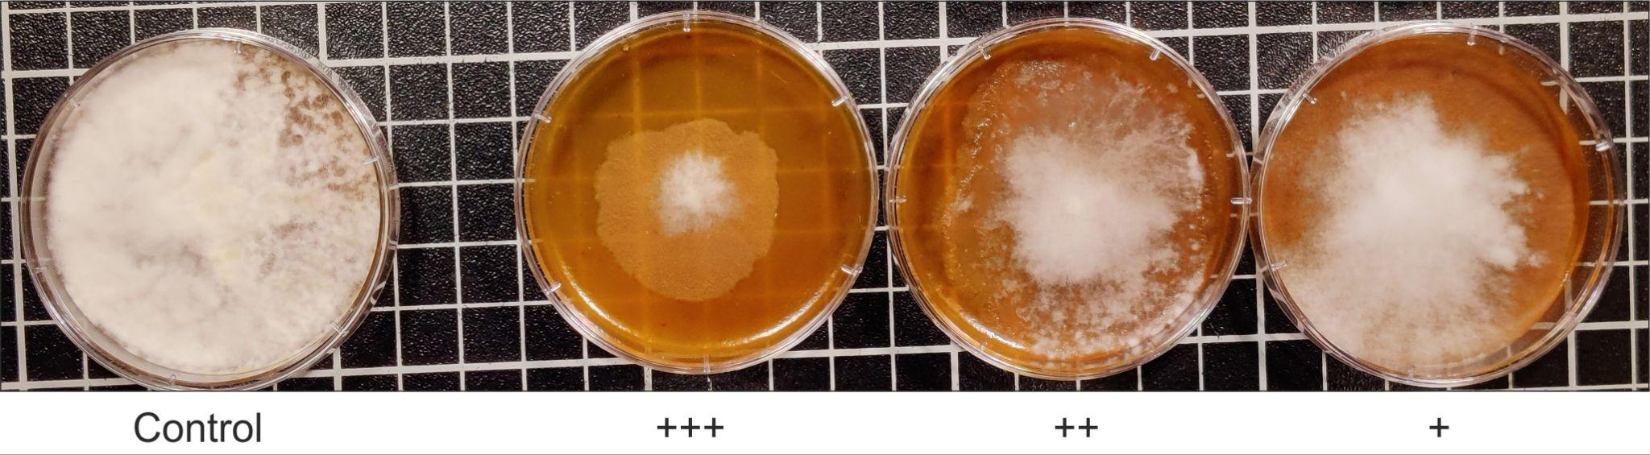
Supplemental figure S1: Exemplary growth inhibition scale for P. ultimum. PDA (+ tomato) plates were coated with crude microalgae extracts or MQ and mycelial discs of P. ultimum were placed in the middle. Fungal growth was compared on day 4 of cultivation in 25°C. The growth was measured as diameter (mm) of the culture and inhibition was categorized depending on the diameter of treated samples compared to MQ control (<50% growth inhibition = +, 50-70% growth inhibition = ++, and >70% growth inhibition = +++).
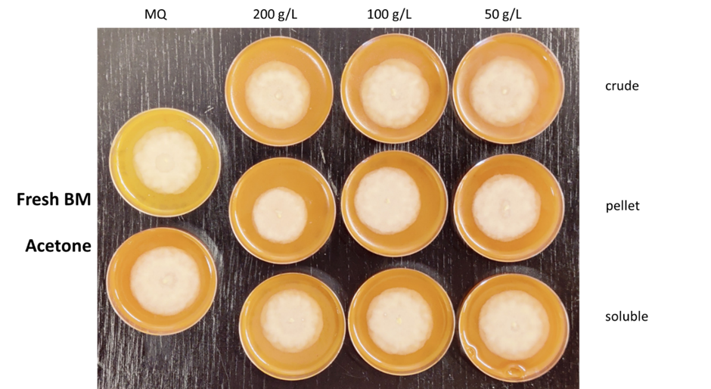
Supplemental figure S2: Antimicrobial test of C. sorokiniana acetone extracts obtained from wet biomass against P. cactorum. Different biomass concentrations (200, 100, and 50 g L⁻¹) were used for extraction and every extract has been fractionated into crude, pellet and soluble fractions. PDA + tomato plates were coated with 100 µl extracts or MQ as negative control and inhibition level is shown on day 4 of incubation at 25°C.

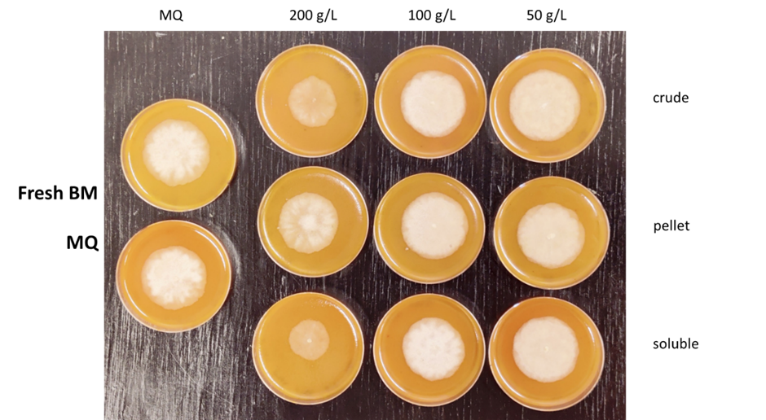
Supplemental figure S3: Antimicrobial test of C. sorokiniana aqueous extracts obtained from wet biomass against P. cactorum. Different biomass concentrations (200, 100, and 50 g L⁻¹) were used for extraction and every extract has been fractionated into crude, pellet and soluble fractions. PDA + tomato plates were coated with 100 µl extracts or MQ as negative control and inhibition level is shown on day 4 of incubation at 25°C.

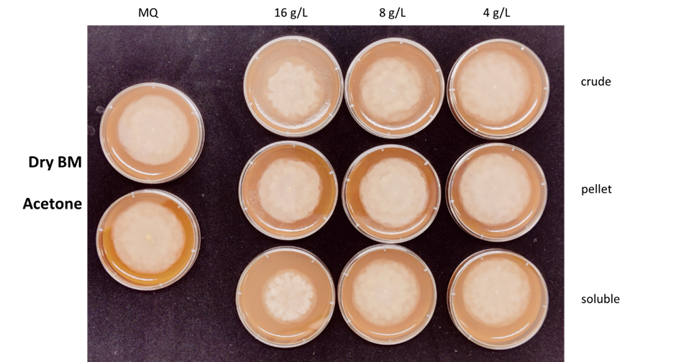
Supplemental figure S4: Antimicrobial test of C. sorokiniana acetone extracts obtained from dry biomass against P. cactorum. Different biomass concentrations (16, 8, and 4 g L⁻¹) were used for extraction and every extract has been fractionated into crude, pellet and soluble fractions. PDA + tomato plates were coated with 100 µl extracts or MQ as negative control and inhibition level is shown on day 4 of incubation at 25°C.

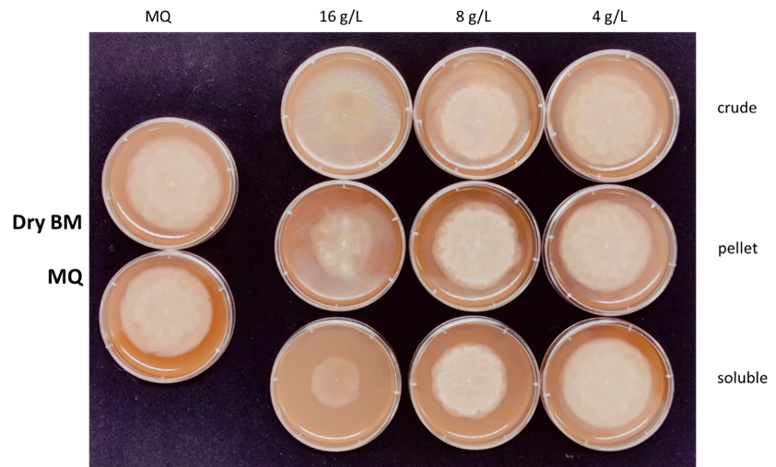
Supplemental figure S5: Antimicrobial test of C. sorokiniana aqueous extracts obtained from dry biomass against P. cactorum. Different biomass concentrations (16, 8, and 4 g L⁻¹) were used for extraction and every extract has been fractionated into crude, pellet and soluble fractions. PDA + tomato plates were coated with 100 µl extracts or MQ as negative control and inhibition level is shown on day 4 of incubation at 25°C.

Supplemental figure S6: Images of strawberry leaves on seventh day after infection used for calculations of Leaf damage index (LDI). Original images are in first row. Second and third row images depict Leaf area (LA) and Green area (GA), respectively, as analyzed by Image J software. (A) Negative control: leaves dipped in MQ-water. (B) Positive control: leaves dipped in MQ-water and infected with P. cactorum. (C-E; cont. on next page) Infected leaves previously treated with extracts of C. sorokinana (E1, E2, E3). LDI was calculated as the ratio of (LA-GA)/LA. Continuation on next page.

