Supplementary appendix

Authors: Amanuel T GEBREMEDHIN,^{1, *} Vera R MITTER,^{2,3} Bereket DUKO,¹ Gizachew A TESSEMA,¹ Gavin F PEREIRA^{1,4,5}

Author Affiliations:
¹ Curtin School of Population Health, Faculty of Health Sciences, Curtin University, Kent Street, Bentley WA 6102, Australia

² PharmacoEpidemiology and Drug Safety Research Group, Department of Pharmacy, and PharmaTox Strategic Research Initiative, Faculty of Mathematics and Natural Sciences, University of Oslo, Oslo, Norway.

³University Women's Hospital, Inselspital, Bern University Hospital, University of Bern, Bern, Switzerland.

⁴enAble Institute, Curtin University, Kent Street, Bentley, Western Australia 6102, Australia

⁵Centre for Fertility and Health (CeFH), Norwegian Institute of Public Health, Oslo, Norway

* Corresponding Author:
Dr Amanuel Tesfay Gebremedhin
Curtin School of Population Health, Curtin University
GPO Box U1987, Perth Western Australia 6845
Email: a.gebremedhin@curtin.edu.au
ORCID: 0000-0003-2459-1805

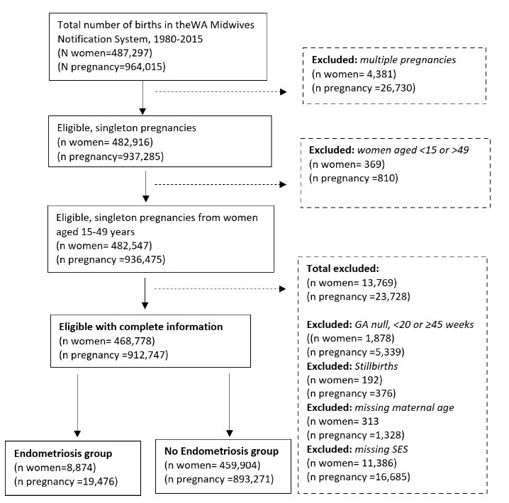

Fig. S1 Inclusions and exclusions for the study cohort

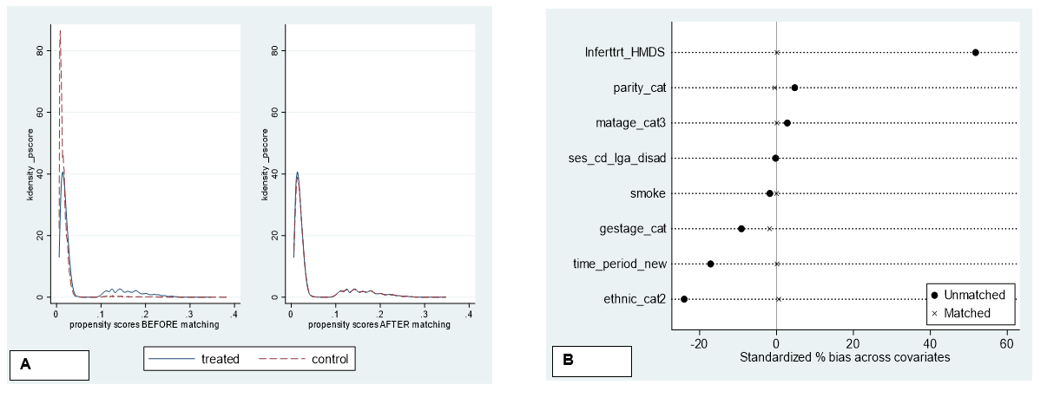

Fig. S2 Covariate balance before and after propensity-score matching (unmatched vs matched) using (a)density graph and (b) standardized % of bias across covariates. Standardized differences are calculated as the difference in means between treatment and control samples divided by the standard deviation of the treatment sample for each covariate. The standardized difference will approach zero when the distribution for a particular covariate is more similar between treatment (endometriosis) and control (no endometriosis) samples.
Fig. S3 Directed acyclic graph (DAG) representing the causal association between endometriosis and preterm birth
Outcome: Preterm birth; exposure: endometriosis. We assume that maternal age, birth year, SES, parity, Smoking, and ethnicity (race) are directly associated with the outcome. While, maternal age, birth year, SES, MAR, and ethnicity (race) are associated with the exposure.

Table S1. Maternal characteristics by the outcome of interest for women delivering singleton infants during 1980-2015 in WA (n=912,747 pregnancies)
 |  |  |  |  | Outcomes
Characteristics |  |  |  |  | PE |  |  |  | PTB |  |  | Placenta previa
 |  | Total |  | No |  | Yes |  | No |  | Yes | No |  | Yes
 |  | N=912,747 |  | N=857,181 |  | N=55,566 |  | N=848,052 |  | N=64,695 | N=903,482 |  | N=9,265
Endometriosis |  | 19,476 (2.1) |  | 18,008 (2.1) |  | 1,468 (2.6) |  | 17,487 (2.1) |  | 1,989 (3.1) | 19,112 (2.1) |  | 364 (3.9)
Maternal age, y | 15-24 | 225,204 (24.7) |  | 208,304 (24.3) |  | 16,900 (30.4) |  | 207,378 (24.5) |  | 17,826 (27.6) | 224,023 (24.8) |  | 1,181 (12.7)
 | 25-29 | 292,416 (32.0) |  | 274,518 (32.0) |  | 17,898 (32.2) |  | 273,534 (32.3) |  | 18,882 (29.2) | 289,891 (32.1) |  | 2,525 (27.3)
 | 30-34 | 260,947 (28.6) |  | 247,375 (28.9) |  | 13,572 (24.4) |  | 243,685 (28.7) |  | 17,262 (26.7) | 257,749 (28.5) |  | 3,198 (34.5)
 | 35-39 | 113,489 (12.4) |  | 107,603 (12.6) |  | 5,886 (10.6) |  | 104,750 (12.4) |  | 8,739 (13.5) | 111,613 (12.4) |  | 1,876 (20.2)
 | 40-49 | 20,691 (2.3) |  | 19,381 (2.3) |  | 1,310 (2.4) |  | 18,705 (2.2) |  | 1,986 (3.1) | 20,206 (2.2) |  | 485 (5.2)
SES in quintiles | <20th percentile | 181,980 (19.9) |  | 169,716 (19.8) |  | 12,264 (22.1) |  | 166,582 (19.6) |  | 15,398 (23.8) | 180,321 (20.0) |  | 1,659 (17.9)
 | 20-39th percentile | 182,472 (20.0) |  | 170,348 (19.9) |  | 12,124 (21.8) |  | 169,353 (20.0) |  | 13,119 (20.3) | 180,724 (20.0) |  | 1,748 (18.9)
 | 40-59th percentile | 182,685 (20.0) |  | 171,247 (20.0) |  | 11,438 (20.6) |  | 170,200 (20.1) |  | 12,485 (19.3) | 180,910 (20.0) |  | 1,775 (19.2)
 | 60-79th percentile | 182,731 (20.0) |  | 172,193 (20.1) |  | 10,538 (19.0) |  | 170,507 (20.1) |  | 12,224 (18.9) | 180,798 (20.0) |  | 1,933 (20.9)
 | >=80th percentile | 182,879 (20.0) |  | 173,677 (20.3) |  | 9,202 (16.6) |  | 171,410 (20.2) |  | 11,469 (17.7) | 180,729 (20.0) |  | 2,150 (23.2)
Time period of births | 1980-1984 | 102,077 (11.2) |  | 93,776 (10.9) |  | 8,301 (14.9) |  | 95,308 (11.2) |  | 6,769 (10.5) | 101,279 (11.2) |  | 798 (8.6)
 | 1985-1989 | 115,682 (12.7) |  | 106,369 (12.4) |  | 9,313 (16.8) |  | 107,915 (12.7) |  | 7,767 (12.0) | 114,719 (12.7) |  | 963 (10.4)
 | 1990-1994 | 121,186 (13.3) |  | 112,056 (13.1) |  | 9,130 (16.4) |  | 112,924 (13.3) |  | 8,262 (12.8) | 120,090 (13.3) |  | 1,096 (11.8)
 | 1995-1999 | 121,670 (13.3) |  | 111,916 (13.1) |  | 9,754 (17.6) |  | 113,113 (13.3) |  | 8,557 (13.2) | 120,415 (13.3) |  | 1,255 (13.5)
 | 2000-2004 | 119,334 (13.1) |  | 112,340 (13.1) |  | 6,994 (12.6) |  | 110,681 (13.1) |  | 8,653 (13.4) | 117,914 (13.1) |  | 1,420 (15.3)
 | 2005-2009 | 141,603 (15.5) |  | 135,926 (15.9) |  | 5,677 (10.2) |  | 131,018 (15.4) |  | 10,585 (16.4) | 139,918 (15.5) |  | 1,685 (18.2)
 | 2010-2015 | 191,195 (20.9) |  | 184,798 (21.6) |  | 6,397 (11.5) |  | 177,093 (20.9) |  | 14,102 (21.8) | 189,147 (20.9) |  | 2,048 (22.1)
Parity | first birth | 368,504 (40.4) |  | 335,184 (39.1) |  | 33,320 (60.0) |  | 340,383 (40.1) |  | 28,121 (43.5) | 365,310 (40.4) |  | 3,194 (34.5)
 | 2nd birth | 309,240 (33.9) |  | 296,667 (34.6) |  | 12,573 (22.6) |  | 290,499 (34.3) |  | 18,741 (29.0) | 305,887 (33.9) |  | 3,353 (36.2)
 | 3rd birth | 148,061 (16.2) |  | 142,184 (16.6) |  | 5,877 (10.6) |  | 138,329 (16.3) |  | 9,732 (15.0) | 146,491 (16.2) |  | 1,570 (16.9)
 | >=4 birth | 86,869 (9.5) |  | 83,086 (9.7) |  | 3,783 (6.8) |  | 78,773 (9.3) |  | 8,096 (12.5) | 85,721 (9.5) |  | 1,148 (12.4)
 | Missing | 73 (0.0) |  | 60 (0.0) |  | 13 (0.0) |  | 68 (0.0) |  | 5 (0.0) | 73 (0.0) |  | 0 (0.0)
MAR | No | 890,327 (97.5) |  | 836,231 (97.6) |  | 54,096 (97.4) |  | 828,059 (97.6) |  | 62,268 (96.2) | 881,544 (97.6) |  | 8,783 (94.8)
 | Yes | 22,420 (2.5) |  | 20,950 (2.4) |  | 1,470 (2.6) |  | 19,993 (2.4) |  | 2,427 (3.8) | 21,938 (2.4) |  | 482 (5.2)
Smoking during pregnancy | No | 427,544 (46.8) |  | 407,502 (47.5) |  | 20,042 (36.1) |  | 398,541 (47.0) |  | 29,003 (44.8) | 422,696 (46.8) |  | 4,848 (52.3)
 | Yes | 80,709 (8.8) |  | 77,470 (9.0) |  | 3,239 (5.8) |  | 72,495 (8.5) |  | 8,214 (12.7) | 79,752 (8.8) |  | 957 (10.3)
 | Missing | 404,494 (44.3) |  | 372,209 (43.4) |  | 32,285 (58.1) |  | 377,016 (44.5) |  | 27,478 (42.5) | 401,034 (44.4) |  | 3,460 (37.3)
Ethnicity (race) | Caucasian | 759,584 (83.2%) |  | 711,676 (83.0%) |  | 47,908 (86.2%) |  | 709,573 (83.7%) |  | 50,011 (77.3%) | 751,884 (83.2%) |  | 7,700 (83.1%)
 | Non-Caucasian | 153,163 (16.8%) |  | 145,505 (17.0%) |  | 7,658 (13.8%) |  | 138,479 (16.3%) |  | 14,684 (22.7%) | 151,598 (16.8%) |  | 1,565 (16.9%)
PE: preeclampsia; PP: placenta previa; PTB: Preterm birth; MAR: Medically Assisted Reproduction; SES: Socio-economic status

Table S2. Crude and adjusted Risk ratio (RR) and 95 % CI for each adverse pregnancy outcome for women with endometriosis according to different scenarios (sensitivity analyses) among singleton births in WA, 1980-2015
VARIABLES | Unadjusted | Model 1 | Model 2 | Model 3 | Model 4 | Model 5 | Model 6 | Model 7
 | Crude RR (95 % CI) | Adjusted RR (95 % CI) ª | Adjusted RR (95 % CI) ^{b} | Adjusted RR (95 % CI) ^{c} | Adjusted RR (95 % CI) ^{d} | Adjusted RR  (95 % CI) ^{e} | Adjusted RR  (95 % CI) ^{f} | Adjusted RR  (95 % CI) ^{g}
Preeclampsia
Endometriosis | 1.24 | 1.18 | 1.14 | 1.24 | 1.37 | 1.13 | 1.47 | 1.14
 | (1.18 - 1.31) | (1.11 - 1.26) | (1.06 - 1.23) | (1.14 - 1.35) | (1.09 - 1.72) | (1.00 – 1.27) | (1.15- 1.88) | (1.03- 1.26)
Preterm birth
Endometriosis | 1.45 | 1.45 | 1.32 | 1.56 | 1.61 | 1.62 | 1.95 | 1.57
 | (1.37 - 1.54) | (1.37 - 1.54) | (1.22 - 1.42) | (1.44 - 1.68) | (1.39- 1.86) | (1.48 – 1.76) | (1.61 – 2.36) | (1.45 - 1.69)
Placenta previa
Endometriosis | 1.88 | 1.60 | 1.69 | 1.85 | 1.59 | 1.63 | 2.15 | 1.67
 | (1.69 - 2.08) | (1.42 - 1.79) | (1.39 - 2.05) | (1.60 - 2.15) | (1.22 - 2.06) | (1.38 – 1.92) | (1.54 -3.00) | (1.43 - 1.94)
N | 912,747 | 912,747 | 368,504 | 912,747 | 508,253 | 508,253 | 508,253 | 508,253
n (endometriosis) | 19,476 | 19,476 | 7,516 | 10,075 | 3,113 | 11,995 | 2,182 | 9,321

All adjusted RRs (Model 1 to Model 5) presented in this table are estimated using a doubly robust estimation with the exposure model including maternal age, birth year (continuous), SES, ethnicity/race, and MAR treatment, and the outcome model including maternal age, birth year (continuous), SES, parity, and ethnicity/race. The outcome model for preeclampsia and placenta previa also included gestational age. ª includes all pregnancies without any restriction; ^{b} restricted to nulliparous women; ^{c} analysis from all pregnancies with a principal diagnosis of endometriosis; ^{d} analysis restricted to all pregnancies with any diagnosis of endometriosis before delivery; ^{e} analysis restricted to all pregnancies with an endometriosis diagnosis before delivery and up to five years after delivery; ^{f} analysis restricted to all pregnancies with an endometriosis diagnosis in the five years look up period with coding for endometriosis considered at more than one time point during the follow-up; ^{g} Model 1 plus smoking in the outcome model. SES: Socio-economic status; MAR: Medically Assisted Reproduction; RR: Risk Ratio; CI: Confidence interval; n: Total number of pregnancies from women with endometriosis

Table S3. Crude and adjusted Risk ratio (RR) and 95 % CI for moderate versus very preterm birth for women with endometriosis among 912,747 singleton births in WA, 1980-2015
Outcomes |  | No endometriosis (n=893,271) | Endometriosis (n=19,476) | Unadjusted RR (95 % CI) | Adjusted RR (95 % CI) using doubly robust estimation
Preterm |  | 62,706 (7.0) | 1,989 (10.2) | 1.45 (1.39, 1.52) |  | 1.45 (1.37, 1.54)
 | Moderate | 26,314 (2.9) | 788 (4.0) | 1.37 (1.28, 1.47) |  | 1.36 (1.26, 1.48)
 | Very | 11,087 (1.2) | 412 (2.1) | 1.70 (1.55, 1.88) |  | 1.55 (1.39, 1.73)
Doubly robust estimation: the exposure model included maternal age, birth year (continuous), SES, ethnicity/race, and MAR treatment, and the outcome model included maternal age, birth year (continuous), SES, parity, and ethnicity/race. SES: Socio economic status; MAR: Medically Assisted Reproduction; RR: Risk Ratio; CI: Confidence interval

Table S4. Causal Mediation Analysis of the association between endometriosis and pregnancy outcomes [Relative risk (RR) (95% CI]

Effect | PE | PP | PTB
Effect | RR (95% CI)
Natural direct effect (NDE) | 1.19 (1.09 -1.31) | 1.73 (1.48 -2.04) | 1.56 (1.46 -1.68)
Natural Indirect Effect (NIE) | 0.96 (0.93 - 0.98) | 1.01 (0.96-1.07) | 1.03 (1.01-1.06)
Marginal total effect | 1.15 (1.05 -1.25) | 1.76 (1.53 -2.03) | 1.62 (1.52 -1.72)
Proportion mediated by MAR =(NDE*(NIE-1)) / (NDE*NIE -1) | a | 0.03 (3%) | 0.08 (8%)

The causal mediation analyses estimate two models: a model for MAR (mediator) conditional on endometriosis(exposure) and covariates, and a model for each outcome conditional on exposure, the mediator, and covariates. Covariates were maternal age, birth year (continuous), SES, parity, smoking, and ethnicity/race. SES: Socio economic status; MAR: Medically Assisted Reproduction; RR: Risk Ratio; CI: Confidence interval; ª small protective effect of mediator observed.

Table S5. ICD-9/10 codes used to define variables for analysis
ICD-9 code | ICD-10 | code description | Type
Preeclampsia
642.7 | O11 | Preeclampsia with pre-existing hypertension | Any diagnosis; principal diagnosis
642.4-642.5 | O14 | Gestational hypertension with significant proteinuria | Any diagnosis; principal diagnosis
Placenta previa
641.0- 641.1 | O44 | Placenta previa with or without hemorrhage | Any diagnosis; principal diagnosis
Endometriosis
617.0 | N80.0 | Endometriosis of the uterus (includes adenomyosis) | Any diagnosis; principal diagnosis
617.1 | N80.1 | Endometriosis of ovary | Any diagnosis; principal diagnosis
617.2 | N80.2 | Endometriosis of fallopian tube | Any diagnosis; principal diagnosis
617.3 | N80.3 | Endometriosis of pelvic peritoneum | Any diagnosis; principal diagnosis
617.4 | N80.4 | Endometriosis of rectovaginal septum and vagina | Any diagnosis; principal diagnosis
617.5 | N80.5 | Endometriosis of intestine | Any diagnosis; principal diagnosis
617.6 | N80.6 | Endometriosis in cutaneous scar | Any diagnosis; principal diagnosis
617.8 | N80.8 | Other endometriosis | Any diagnosis; principal diagnosis
617.9 | N80.9 | Endometriosis, unspecified | Any diagnosis; principal diagnosis
Treatment of infertility (Assisted Reproductive Technology)
628.0 | N97.0 | Female infertility associated with anovulation | Any diagnosis; principal diagnosis
628.2 | N97.1 | Female infertility of tubal origin | Any diagnosis; principal diagnosis
628.3 | N97.2 | Female infertility of uterine origin | Any diagnosis; principal diagnosis
628.4 | N97.3 | Female infertility of cervical origin | Any diagnosis; principal diagnosis
628.4 | N97.4 | Female infertility associated with male factors | Any diagnosis; principal diagnosis
628.4; 628.8 | N97.8 | Female infertility of other origins | Any diagnosis; principal diagnosis
628.9¥ | N97.9¥ | Female infertility, unspecified | Any diagnosis; principal diagnosis
V26.1 | Z31.1 | Artificial insemination | Any diagnosis; principal diagnosis
- | Z31.2¥ | In vitro fertilization | Any diagnosis; principal diagnosis
- | Z31.3 | Other assisted fertilization methods (including ICSI) | Any diagnosis; principal diagnosis
V26.2 | Z31.4 | Procreative investigation and testing | Any diagnosis; principal diagnosis
V26.3 | Z31.5 | Genetic counseling | Any diagnosis; principal diagnosis
V26.4 | Z31.6 | General counseling and advice on procreation | Any diagnosis; principal diagnosis
V26.8 | Z31.8 | Other procreative management | Any diagnosis; principal diagnosis
V26.9 | Z31.9 | Procreative management, unspecified | Any diagnosis; principal diagnosis
V26.5 | - | Sterilization status | Any diagnosis; principal diagnosis
ACHI codes with description for endometriosis-related procedures
35630-00: Diagnostic hysteroscopy
35640-00: Dilation and curettage of uterus [D&C]
35637-10: Laparoscopic excision of lesion of pelvic cavity
30393-00: Laparoscopic division of abdominal adhesions
35637-02: Laparoscopic diathermy of lesion of pelvic cavity
35703-00: Test for tubal patency
35503-00: Insertion of intrauterine devic [IUD]
36812-00: Cytoscopy
95550-03: Allied health intervention, physiotherapy
35638-04: Laparoscopic ovarian cystectomy, unilateral
Procedure (Australian Classification of Health Intervention ;ACHI code with description) for MAR
13212-00: Transvaginal oocyte retrieval
13212-01: Transabdominal oocyte retrieval
13215-00: Gamete intrafallopian transfer [GIFT]
13215-01: Embryo transfer to uterus
13215-02: Embryo transfer to fallopian tube
13218-00: Fresh, frozen, thawed embryo transfer to uterus
13218-01: Fresh, frozen, thawed embryo transfer to Fallopian tube
13251-00: Intracytoplasmic sperm injection (ICSI)
¥ Among the cohort with MAR diagnosis, the following were the major ICD codes: N97.9, Z31.2, 628.9 with 47%, 38% and 21% respectively: all others in the table contributed <5%.The proportion is not mutually exclusive.

Table S6. E-values to quantify the minimum strength of association that unmeasured confounders would need to have with both endometriosis and each outcome, conditional on the measured covariates, to fully explain the observed association between endometriosis and pregnancy outcomes.

Outcomes |  | No endometriosis (n=893,271) | Endometriosis (n=19,476) | Unadjusted RR (95 % CI) | Adjusted RR  (95 % CI) | E-value for RR (E- value for CI)
Preeclampsia |  | 54,098 (6.1) | 1,468 (7.5) | 1.24 (1.18, 1.31) | 1.18 (1.11, 1.26) | 1.64 (1.46)
Placenta previa |  | 8,901 (1.0) | 364 (1.9) | 1.88 (1.69, 2.08) | 1.60 (1.42, 1.79) | 2.58 (2.19)
Preterm |  | 62,706 (7.0) | 1,989 (10.2) | 1.45 (1.39, 1.52) | 1.45 (1.37, 1.54) | 2.26 (2.08)
 | Spontaneous | 36,034 (4.0) | 978 (5.0) | 1.27 (1.16, 1.38) | 1.40 (1.27, 1.56) | 2.15 (1.85)
 | Indicated | 26,671 (3.0) | 1,011 (5.2) | 1.62 (1.48, 1.78) | 1.74 (1.58, 1.93) | 2.87 (2.54)
Doubly robust estimation: the exposure model included maternal age, birth year (continuous), SES, ethnicity/race, and MAR treatment, and the outcome model included maternal age, birth year (continuous), SES, parity, and ethnicity/race. The outcome model for preeclampsia and placenta previa also included gestational age. SES: Socio economic status; MAR: Medically Assisted Reproduction; RR: Risk Ratio; CI: Confidence interval

