Table 1. Classification of the churches in post-Byzantine period
Type  Version | Single-Naved (T1) | Cross-in Squared (T2) | Basilicas (T3)
Version-1
Version-2
Version-3
Version-4

Table 4. S₁₂ and S22 stresses for the structural elements
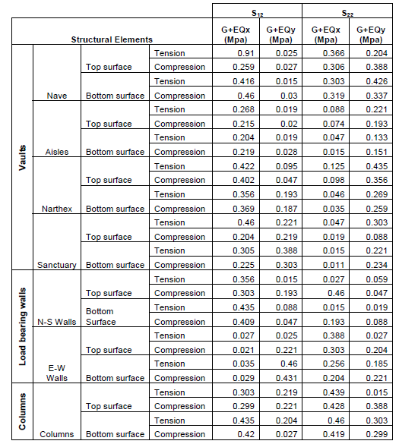

Table 5. Maximum and minimum stresses due to G+EQ_{x} and G+EQ_{y}
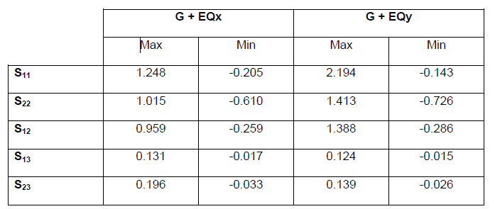

Table 6. Maximum displacement values
