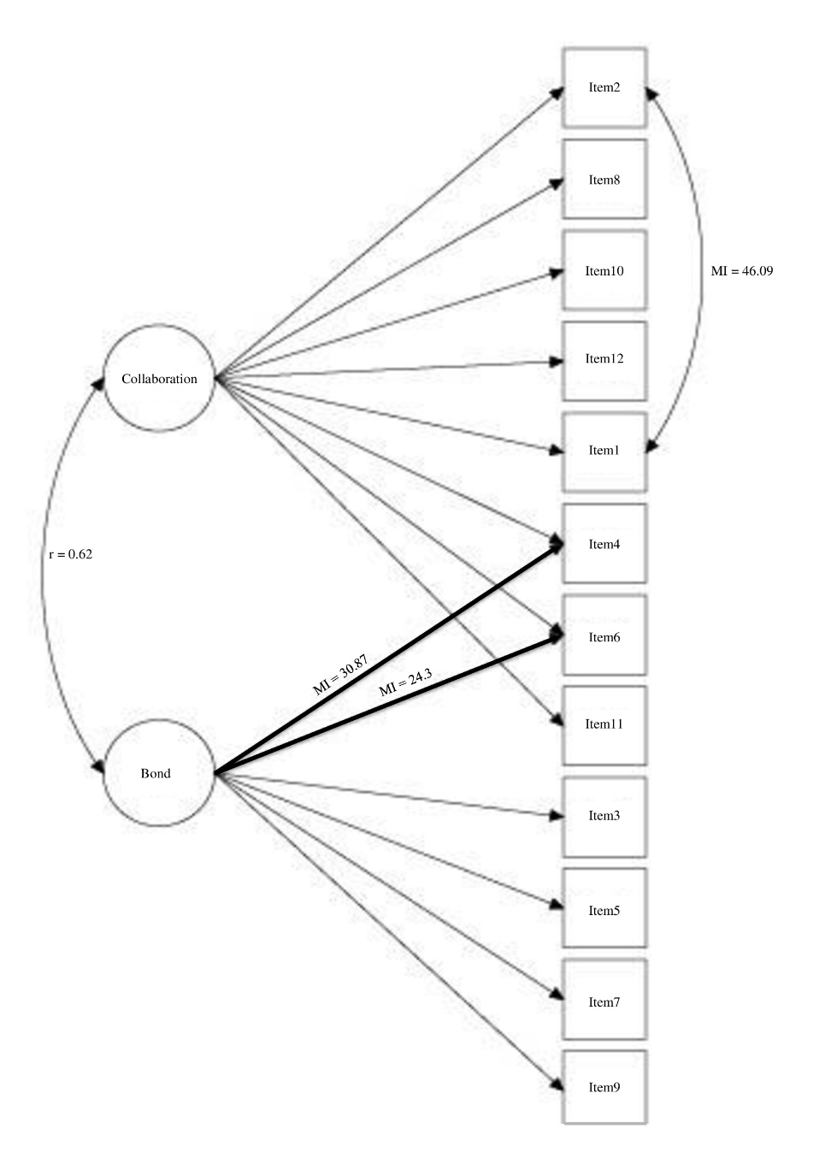
Figure S1. WAI-SR youth modified two-factor model first session
Note. In each figure, Circles = latent variables; Rectangles = measure variables; Double-headed curved arrow between latent-variables = correlated; Double-headed curved arrow between measure variables= residuals correlated; Bold arrow = dual loading.

