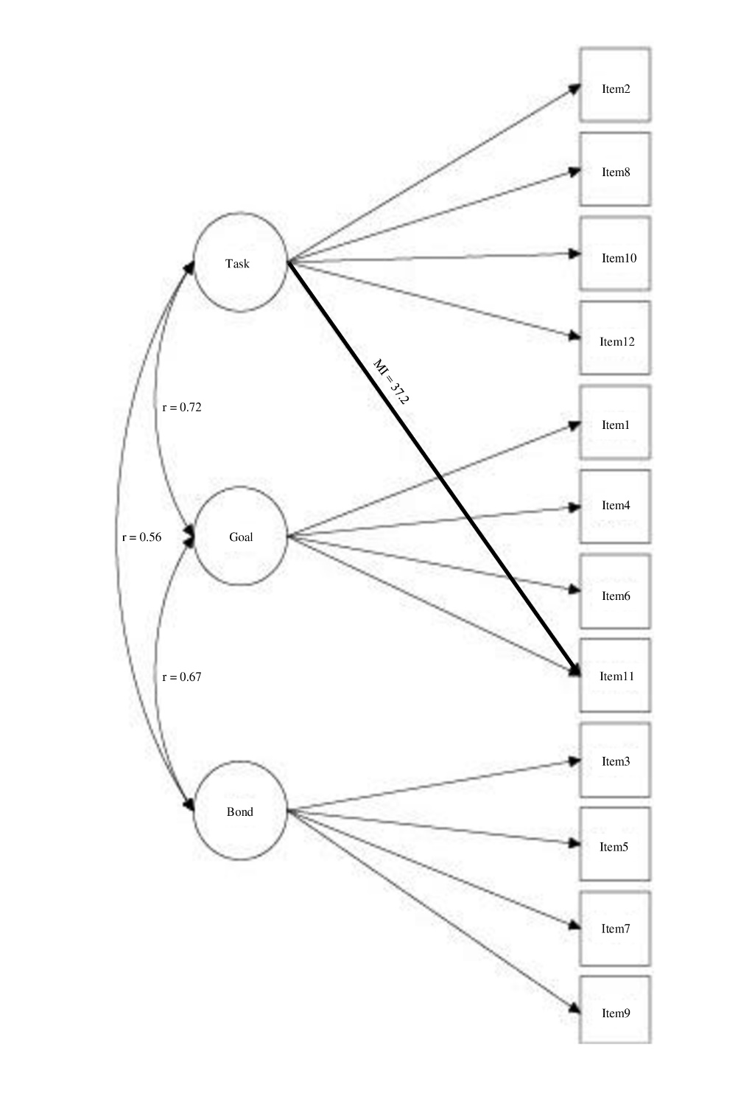
Figure S3. WAI-SR therapist modified three-factor model first-session

