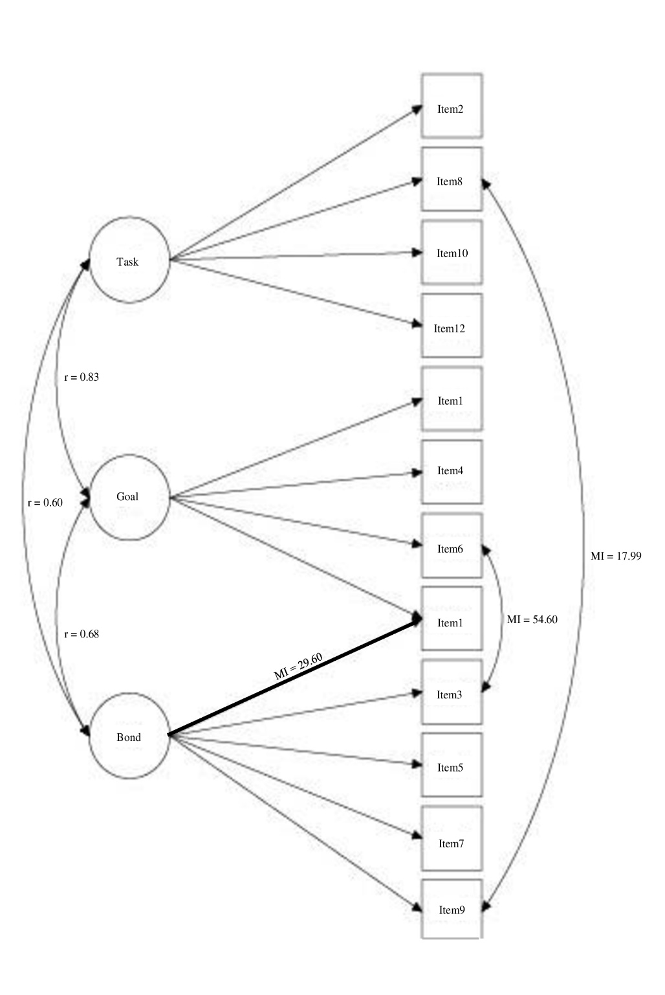
Figure S4. WAI-SR Youth modified three-factor model 2-months

