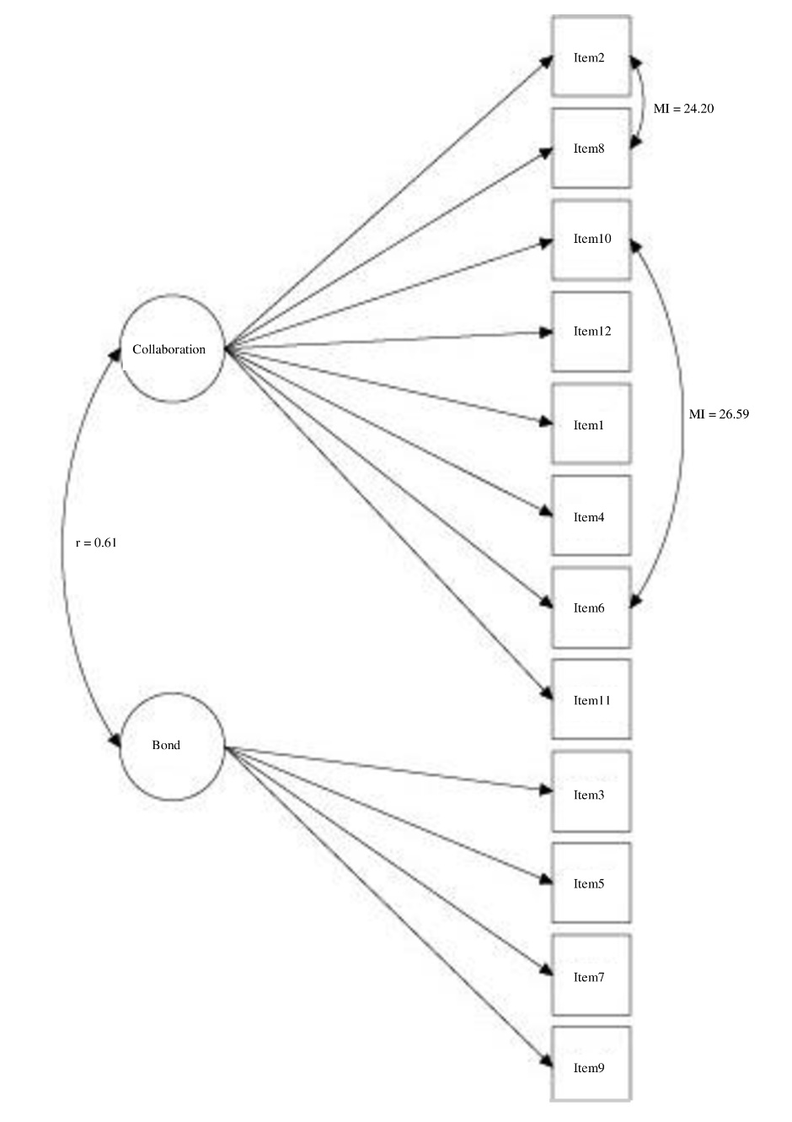
Figure S2. WAI-SR youth modified two-factor model 2-months

