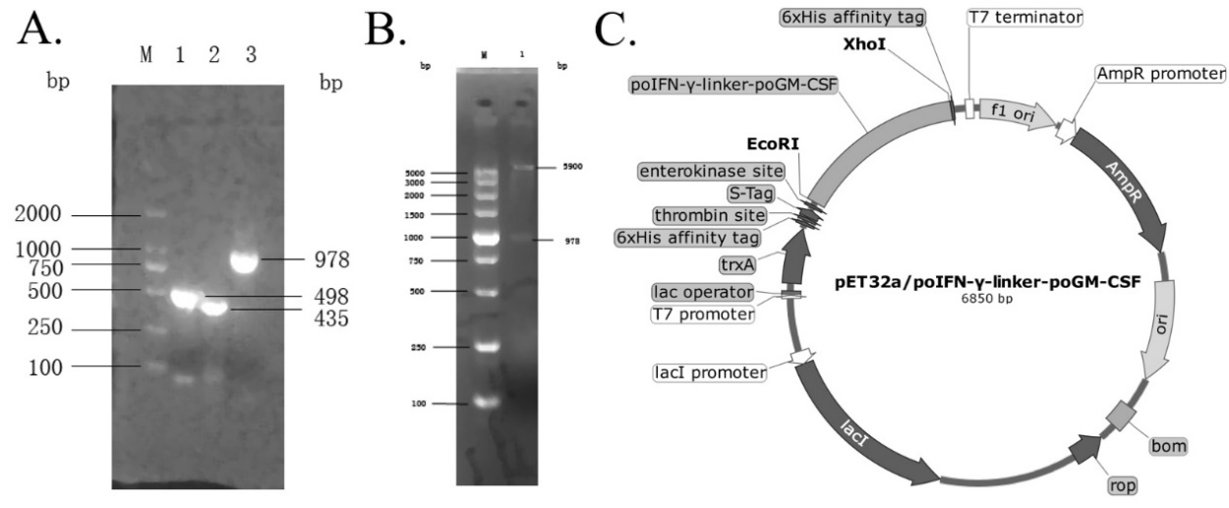

Fig. 2 poIFN-γ-linker-poGM-CSF prokaryotic expression vector construction. (A) poIFN-γ, poGM-CSF, and poIFN-γ-linker-poGM-CSF fusion gene products following SOE-based amplification from serum samples. Lane 1, poIFN-γ; lane 2, poGM-CSF; lane 3, poIFN-γ-linker-poGM-CSF; M, DL2000 DNA markers. (B) Restriction enzyme digestion. M, DL-5000 DNA markers; lane 1, poIFN-γ-linker-poGM-CSF plasmid following digestion using EcoR I and Xho I. (C) Structure of the pET32a-poIFN-γ-linker-poGM-CSF vector. The poIFN-γ-linker-poGM-CSF fusion gene was fused with a His-tag at the 5′-terminus while the 3′-terminus was under the control of the T7 promoter.

