Table.2 Summary of potential small molecule pharmaceuticals
Ligand | 2D Structure | Canonical SMILES | Molecular Formula | Molecular Weight(g/mol) | CAS
Vorinostat | 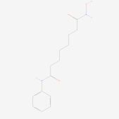 | C1=CC=C(C=C1)NC(=O)CCCCCCC(=O)NO | C₁₄H₂₀N₂O₃ | 264.32 | 149647-78-9
Romidepsin | 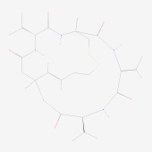 | CC=C1C(=O)NC(C(=O)OC2CC(=O)NC(C(=O)NC(CSSCCC=C2)C(=O)N1)C(C)C)C(C)C | C₂₄H₃₆N₄O₆S₂ | 540.7 | 128517-07-7
Panobinostat | 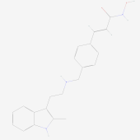 | CC1=C(C2=CC=CC=C2N1)CCNCC3=CC=C(C=C3)C=CC(=O)NO | C₂₁H₂₃N₃O₂ | 349.4 | 404950-80-7
Belinostat | 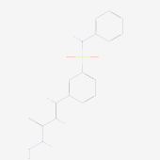 | C1=CC=C(C=C1)NS(=O)(=O)C2=CC=CC(=C2)C=CC(=O)NO | C₁₅H₁₄N₂O₄S | 318.3 | 866323-14-0
JNJ-26481585 | 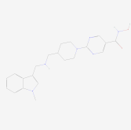 | CN1C=C(C2=CC=CC=C21)CNCC3CCN(CC3)C4=NC=C(C=N4)C(=O)NO | C₂₁H₂₆N₆O₂ | 394.5 | 875320-29-9
Sunitinib | 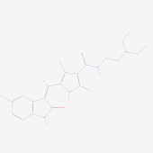 | CCN(CC)CCNC(=O)C1=C(NC(=C1C)C=C2C3=C(C=CC(=C3)F)NC2=O)C | C₂₂H₂₇FN₄O₂ | 398.5 | 557795-19-4
TG-101348 | 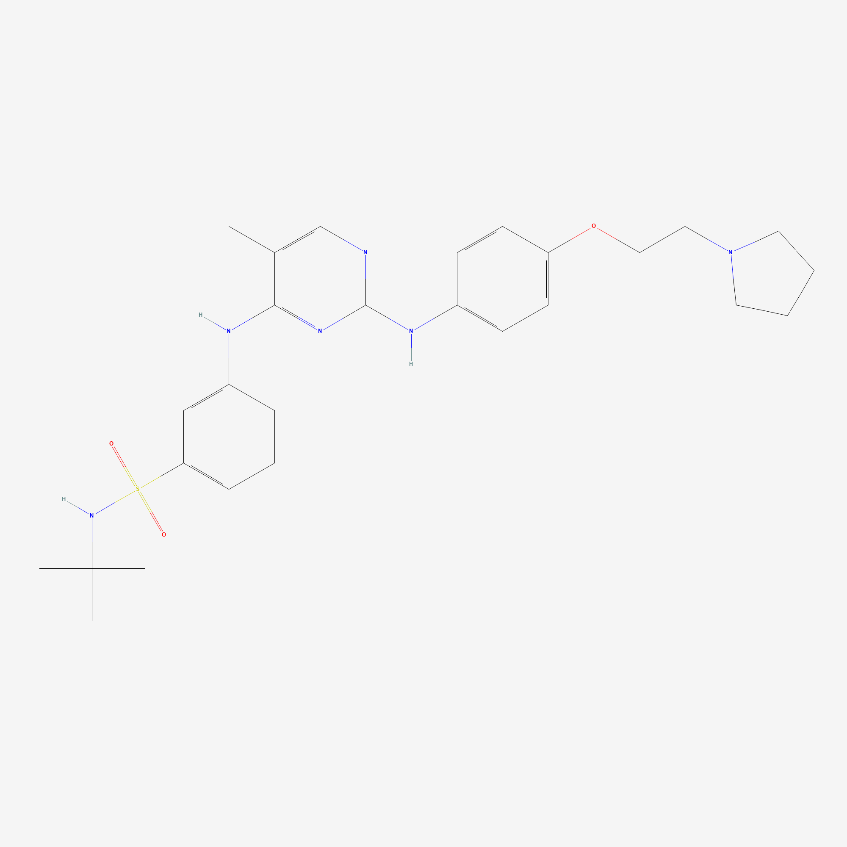 | CC1=CN=C(N=C1NC2=CC(=CC=C2)S(=O)(=O)NC(C)(C)C)NC3=CC=C(C=C3)OCCN4CCCC4 | C₂₇H₃₆N₆O₃S | 524.7 | 936091-26-8
PCI-24781 | 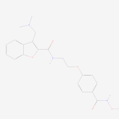 | CN(C)CC1=C(OC2=CC=CC=C21)C(=O)NCCOC3=CC=C(C=C3)C(=O)NO | C₂₁H₂₃N₃O₅ | 397.4 | 783355-60-2
Tramadol | 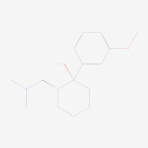 | CN(C)CC1CCCCC1(C2=CC(=CC=C2)OC)O | C₁₆H₂₅NO₂ | 263.37 | 123154-38-1;  27203-92-5;  2914-77-4
Enzastaurin | 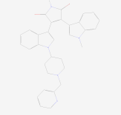 | CN1C=C(C2=CC=CC=C21)C3=C(C(=O)NC3=O)C4=CN(C5=CC=CC=C54)C6CCN(CC6)CC7=CC=CC=N7 | C₃₂H₂₉N₅O₂ | 515.6 | 170364-57-5

