Fig S1. The structures, names and assigned number of chemicals with C01~C20 of detected steroid metabolites in asparagus. Each box represents a type of compound with a similar structure. The red labels indicate the aglycones of saponins. The light green box on the top right corner indicates the full name of the sugar groups.
Fig S2. Transcriptome and metabolome analyses. A, the PCA of all metabolites detected in metabolome; B, C and D, the KEGG enrichment analyses among GRs vs PRs, GSs vs PSs and GFs vs PFs; E, the venn diagrams of differential metabolites (DMs, the left) and differentially expressed genes (DEGs, the right) in GRs vs PRs, GSs vs PSs and GFs vs PFs, respectively; F and G, the venn diagrams of DMs and DEGs in GRs vs GSs, GRs vs GFs, PRs vs PSs, PRs vs PFs respectively.
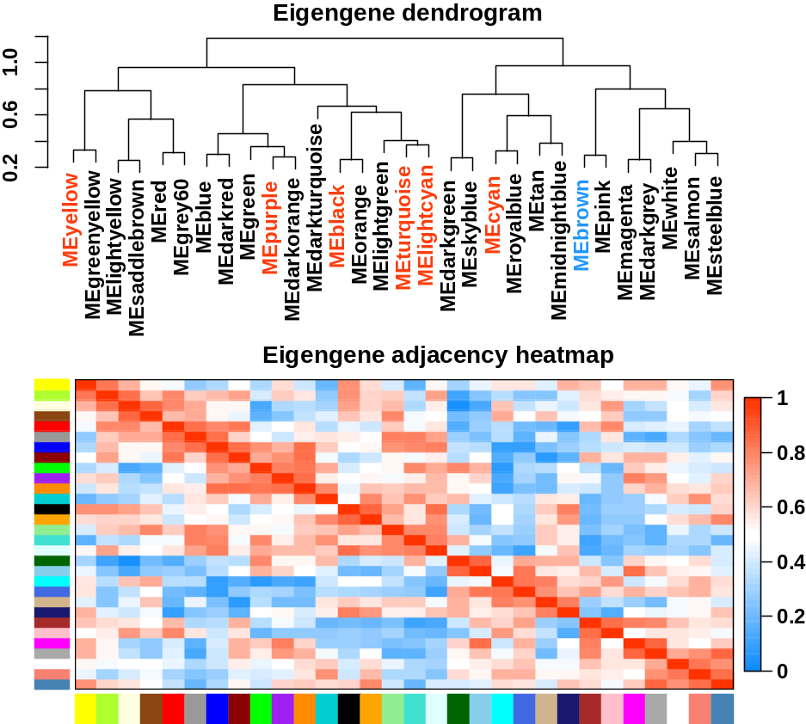
Fig S3. The co-expression gene module and correlation among modules. the clustering dendrogram of WGCNA gene modules was showed in above; the correlation heatmaps of WGCNA gene modules based on Spearman method was showed below; note, the positive modules were highlighted with red while the negative was highlighted with blue, each co-expression gene modules is represented by different square colors.

Fig S4. The clustering trees of cholesterol synthetic genes in asparagus. The tree was constructed with the functionally confirmed protein sequences of cholesterol biosynthesis by MEGAX with NJ. The IDs of downloaded proteins listed as protein symbols followed NCBI access No. and organism name, while the asparagus Protein Id listed as Phytozoon downloaded protein id followed gene symbols.

Fig S5 The phylogenetic tree of CY450s superfamilies in asparagus(AoCYP450s) related to DSSP. The tree was constructed using AoCYP450 genes that belonged to the intersect genes and functionally characterized CYP450s involved in steroidsC16& C22 (CYP90G) and C26 hydroxylation (CYP94 and CYP72) based on protein sequence similarity with MEGAX by NJ.

Fig S6. The multiple sequence alignment (MSA) of CYP90Bs. The multiple sequence alignments of 03.2646 and 03.698 with BR-related and saponin-related CYP90Bs with Jalview. The darker the color, the more conservative it is. The differentially conserved amino acid residues are highlighted in red.

Fig S7. The multiple sequence alignment of CYP90Gs. The MSA of 03.2424 with functionally characterized CYP90Gs with C16S hydroxylase and C22-keto oxidase for sterol. The darker the color, the more conservative it is. The important conserved amino acid residues among sequences were highlighted in red.

Fig S8 Identification of C16 hydroxylase in asparagus. The tree was constructed using TBtools with protein motif predicted by MMEM, and the MSA was constructed with 16DOXs of potato and tomato using Jalviwe. The key domains were heighted in red.

Fig S9. The cis-active elements prediction of all steroid-related genes’ and TFs’ promoters was performed using TBtools.

Fig S10 The chromosome location and fusions genes of SSP detected with Pacbio RNAseq data. The fused genes were highlighted in red linker with the blue ids.

