Supplement files
Table.S1 Comparative table of 24 soil samples.
Sample ID | Sampling time | Sample number | Soil depth
M01 | June | CK†-1 | 0-20cm
M02 | June | CK-2 | 0-20cm
M03 | June | CK-3 | 0-20cm
M04 | June | RTL‡-1 | 20-40cm
M05 | June | RTL-2 | 20-40cm
M06 | June | RTL-3 | 20-40cm
M07 | June | CK-1 | 0-20cm
M08 | June | CK-2 | 0-20cm
M09 | June | CK-3 | 0-20cm
M10 | June | RTL-1 | 20-40cm
M11 | June | RTL-2 | 20-40cm
M12 | June | RTL-3 | 20-40cm
M13 | August | CK-1 | 0-20cm
M14 | August | CK-2 | 0-20cm
M15 | August | CK-3 | 0-20cm
M16 | August | RTL-1 | 20-40cm
M17 | August | RTL-2 | 20-40cm
M18 | August | RTL-3 | 20-40cm
M19 | August | CK-1 | 0-20cm
M20 | August | CK-2 | 0-20cm
M21 | August | CK-3 | 0-20cm
M22 | August | RTL-1 | 20-40cm
M23 | August | RTL-2 | 20-40cm
M24 | August | RTL-3 | 20-40cm
†CK: Control
‡RTL: restructuring tilth layers

Table S2 Quality control report of bacterial
Sample ID | PE Reads | Raw Tags | Clean Tags | Effective Tags | Average Length(bp) | GC (%) | Q20(%) | Q30(%) | Effective(%)
M01 | 80101 | 77233 | 72370 | 71357 | 421 | 58.07 | 97.45 | 94.94 | 89.08
M02 | 80216 | 77780 | 73570 | 72264 | 421 | 57.83 | 97.55 | 95.11 | 90.09
M03 | 80062 | 77339 | 72584 | 71628 | 420 | 57.85 | 97.41 | 94.86 | 89.47
M04 | 80030 | 77964 | 74176 | 71351 | 421 | 57.07 | 97.61 | 95.30 | 89.16
M05 | 79884 | 76139 | 70548 | 69044 | 421 | 58.14 | 97.35 | 94.77 | 86.43
M06 | 80031 | 76646 | 71601 | 70033 | 421 | 58.05 | 97.51 | 95.08 | 87.51
M07 | 79760 | 76092 | 70791 | 68746 | 420 | 58.28 | 97.40 | 94.87 | 86.19
M08 | 79668 | 75724 | 69761 | 68880 | 421 | 58.30 | 97.30 | 94.67 | 86.46
M09 | 79873 | 75684 | 69624 | 68912 | 421 | 58.44 | 97.27 | 94.61 | 86.28
M10 | 79989 | 76448 | 71222 | 70125 | 421 | 57.85 | 97.39 | 94.86 | 87.67
M11 | 79958 | 76066 | 70202 | 69208 | 421 | 57.85 | 97.26 | 94.60 | 86.56
M12 | 79970 | 76749 | 71650 | 70540 | 421 | 57.74 | 97.48 | 95.04 | 88.21
M13 | 80103 | 77422 | 72968 | 71702 | 421 | 57.95 | 97.58 | 95.20 | 89.51
M14 | 79787 | 77606 | 73770 | 72274 | 421 | 57.85 | 97.72 | 95.46 | 90.58
M15 | 79929 | 77349 | 73147 | 71668 | 421 | 57.92 | 97.59 | 95.21 | 89.66
M16 | 80087 | 77568 | 73242 | 70500 | 420 | 57.34 | 97.51 | 95.09 | 88.03
M17 | 80200 | 77592 | 73162 | 71780 | 420 | 57.72 | 97.52 | 95.09 | 89.50
M18 | 80338 | 78105 | 74329 | 72588 | 420 | 57.25 | 97.61 | 95.28 | 90.35
M19 | 79977 | 77280 | 72625 | 72091 | 422 | 58.65 | 97.47 | 94.96 | 90.14
M20 | 80084 | 78251 | 74645 | 73951 | 420 | 57.92 | 97.74 | 95.51 | 92.34
M21 | 80571 | 77738 | 72820 | 72036 | 421 | 58.88 | 97.48 | 94.98 | 89.41
M22 | 80136 | 77685 | 73388 | 72192 | 420 | 58.15 | 97.62 | 95.26 | 90.09
M23 | 80480 | 77625 | 72840 | 71627 | 421 | 58.10 | 97.46 | 94.97 | 89.00
M24 | 79884 | 76879 | 72063 | 71328 | 420 | 58.04 | 97.43 | 94.92 | 89.29

Table S3 Quality control report of fungal
Sample ID | PE Reads | Raw Tags | Clean Tags | Effective Tags | Average Length(bp) | GC (%) | Q20(%) | Q30(%) | Effective (%)
M01 | 79990 | 69962 | 69931 | 69869 | 262 | 48.53 | 99.15 | 96.73 | 87.35
M02 | 79767 | 70304 | 70289 | 70124 | 262 | 49.34 | 99.19 | 96.71 | 87.91
M03 | 79705 | 68180 | 68164 | 68099 | 253 | 48.16 | 99.23 | 96.85 | 85.44
M04 | 79997 | 69847 | 69815 | 69681 | 271 | 50.05 | 98.96 | 96.15 | 87.10
M05 | 79691 | 69937 | 69884 | 69800 | 248 | 48.47 | 99.37 | 97.36 | 87.59
M06 | 79748 | 71206 | 71157 | 71058 | 249 | 46.40 | 99.42 | 97.63 | 89.10
M07 | 79987 | 68458 | 68413 | 68361 | 259 | 48.36 | 99.23 | 96.94 | 85.47
M08 | 80015 | 71463 | 71302 | 71156 | 239 | 48.03 | 99.52 | 97.93 | 88.93
M09 | 80021 | 70955 | 70821 | 70646 | 236 | 48.68 | 99.52 | 97.83 | 88.28
M10 | 80007 | 70259 | 70158 | 69886 | 248 | 49.87 | 99.35 | 97.24 | 87.35
M11 | 79604 | 70143 | 69997 | 69851 | 250 | 49.82 | 99.30 | 97.21 | 87.75
M12 | 80027 | 71155 | 71083 | 70883 | 241 | 48.90 | 99.49 | 97.70 | 88.57
M13 | 79811 | 71447 | 71349 | 71240 | 242 | 48.59 | 99.47 | 97.70 | 89.26
M14 | 80016 | 70249 | 70172 | 70010 | 250 | 48.45 | 99.36 | 97.37 | 87.50
M15 | 79622 | 70646 | 70591 | 70466 | 239 | 48.02 | 99.48 | 97.77 | 88.50
M16 | 79799 | 69852 | 69790 | 69658 | 247 | 49.69 | 99.44 | 97.57 | 87.29
M17 | 79995 | 70228 | 70175 | 70034 | 245 | 50.48 | 99.47 | 97.67 | 87.55
M18 | 79643 | 71826 | 71742 | 71516 | 236 | 48.77 | 99.66 | 98.22 | 89.80
M19 | 79994 | 71621 | 71583 | 71357 | 236 | 48.65 | 99.64 | 98.07 | 89.20
M20 | 79809 | 72850 | 72792 | 72668 | 237 | 48.50 | 99.62 | 98.28 | 91.05
M21 | 80003 | 72713 | 72617 | 72479 | 236 | 48.64 | 99.60 | 98.06 | 90.60
M22 | 79994 | 67804 | 67733 | 67610 | 237 | 48.76 | 99.60 | 98.14 | 84.52
M23 | 79922 | 70918 | 70816 | 70720 | 237 | 48.64 | 99.59 | 98.15 | 88.49
M24 | 80001 | 71280 | 71209 | 71080 | 237 | 49.15 | 99.60 | 98.06 | 88.85

Table S4 OTU numbers of bacterial and fungal
Treatment |  |  | Bacterial |  | Fungal
 |  |  | OTU numbers | Sequence numbers | OTU numbers | Sequence numbers
June | CK | 0-20cm | 2131 | 157937 | 627 | 62745
June | RTL | 0-20cm | 2190 | 159348 | 675 | 64940
June | CK | 20-40cm | 2152 | 153525 | 748 | 63811
June | RTL | 20-40cm | 2215 | 152340 | 788 | 64064
August | CK | 0-20cm | 2143 | 135535 | 879 | 64542
August | RTL | 0-20cm | 2243 | 145411 | 796 | 64840
August | CK | 20-40cm | 2042 | 173817 | 751 | 70146
 | RTL | 20-40cm | 2206 | 151074 | 795 | 67735
Total |  |  | 2257 | 1228987 | 1358 | 1568465

Table S6 Differential families of bacteria between control (CK) and restructuring tilth layers (RTL) treatment
Stage | 0-20cm soil depth |  |  | 20-40cm soil depth
Stage | CK vs RTL |  |  | CK vs RTL
Stage | Differential families | P-value | Fold change |  | Differential families | P-value | Fold change
June | Sphingobacteriaceae | 0.005 | 2.16 |  | - | - | -
June | Nitrospiraceae | 0.011 | 1.75 |  | - | - | -
June | Pyrinomonadaceae | 0.024 | 0.38 |  | - | - | -
August | Nitrosomonadaceae | 0.003 | 0.69 |  | Sphingomonadaceae | 0.001 | 3.26
August | Pyrinomonadaceae | 0.009 | 0.43 |  | Gemmatimonadaceae | 0.019 | 0.78
August | - | - | - |  | Nitrospiraceae | 0.006 | 0.63

Table S7 Different families of fungal between control and RTL treatment
Stage | 0-20cm soil depth |  |  | 20-40cm soil depth
Stage | CK vs RTL |  |  | CK vs RTL
Stage | Differential families | P-value | Fold change | Differential families | P-value | Fold change
June | Pleosporaceae | 0.001 | 2.81 | Aspergillaceae | 0.010 | 1.83
June | Plectosphaerellaceae | 0.048 | 0.64 | Mortierellaceae | 0.022 | 0.47
June | Clavicipitaceae | 0.029 | 0.29 | - | - | -
August | Lasiosphaeriaceae | 0.038 | 0.37 | Chaetomiaceae | 0.043 | 1.82
August | - | - | - | Plectosphaerellaceae | 0.001 | 1.18

Table S8 Correlation among biocontrol bacteria, soil borne pathogen and environmental variables in June identified by Monte Carlo permutation tests.
Environment | r² | P-value
SBD | 0.4135 | 0.091
TSP | 0.2361 | 0.312
NCP | 0.3105 | 0.177
SMC | 0.0388 | 0.872
AT | 0.0565 | 0.735
*P < 0.05.

Table S9 Correlation among biocontrol bacteria, soil borne pathogen and environmental variables in June and August identified by Monte Carlo permutation tests.
Environment | r² | P-value
SBD | 0.2137 | 0.061
TSP | 0.0772 | 0.419
NCP | 0.1426 | 0.157
SMC | 0.5766 | 0.001*
AT | 0.7038 | 0.001*
*P < 0.05.

FigS1 Schematic diagram of soil disturbance caused by different tillage methods. (a)Soil structure of 0-40cm before tillage; (b)Soil structure of 0-40cm after rotary tillage, tillage depth is 15cm; (c)Soil structure of 0-40cm after restructure tilth layers, 0-20cm soil layer and 20-40cm soil layer are exchanged; (d)Soil structure of 0-40cm after deep tillage, tillage depth is about 40cm, 0-20cm soil layer and 20-40cm soil layer are mixed. Solid hexagon represents 0-20cm soil layer, white triangle represents 20-40cm soil layer.
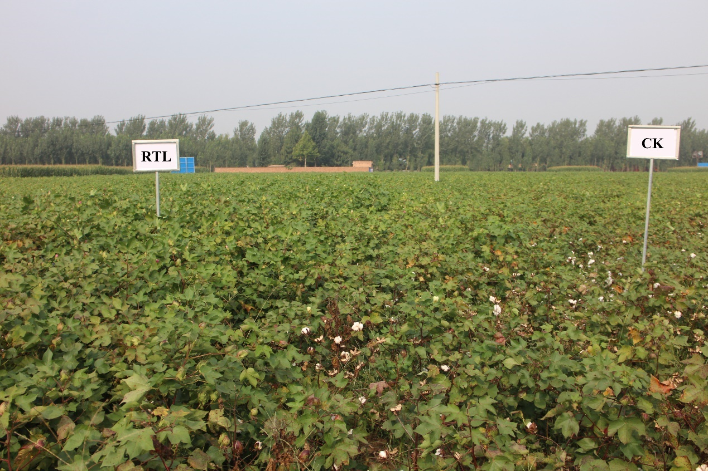
FigS2 Effects of RTL and CK on cotton Verticillium wilt.
FigS3 Redundancy analysis (RDA) used to analysis the relationship between microbial community and soil properties. (a)The relationship between microbial community and soil properties of samples in June. (b) The relationship between microbial community and soil properties of samples in June and August.

