Supplementary information
Monolayer-interface-driven strain-free heteroepitaxy for single-crystal Ag thin films

Su Jae Kim^{1,8}, Seon Je Kim^{2,8}, Young-Hoon Kim^{2,8}, Jongkyoon Park³, Min-Hyoung Jung², Yousil Lee¹, Miyeon Cheon¹, Jegon Lee⁴, Yu-Seong Seo⁴, Hu Young Jeong⁵, Woo Seok Choi⁴, Jungseek Hwang⁴, Seungchul Kim^{3,6*}, Se-Young Jeong^{3,6*}, and Young-Min Kim^{2,7*}

¹Crystal Bank Research Institute, Pusan National University, Busan 46241, Republic of Korea.
²Department of Energy Science, Sungkyunkwan University, Suwon 16419, Republic of Korea.
³Department of Cogno-mechatronics Engineering, Pusan National University, Busan 46241, Republic of Korea.
⁴Department of Physics, Sungkyunkwan University, Suwon 16419, Republic of Korea.
⁵Graduate School of Semiconductor Materials and Devices Engineering, Ulsan National Institute of Science and Technology (UNIST), Ulsan 44919, Republic of Korea.
⁶Department of Optics and Mechatronics Engineering, Pusan National University, Busan 46241, Republic of Korea.
⁷Center for Integrated Nanostructure Physics, Institute for Basic Science (IBS), Sungkyunkwan University, Suwon 16419, Republic of Korea.
⁸These authors contributed equally to this work.

*Corresponding authors:
E-mail: s.kim@pusan.ac.kr (S. Kim); syjeong@pusan.ac.kr (S.-Y. Jeong); youngmk@skku.edu (Y.-M. Kim)

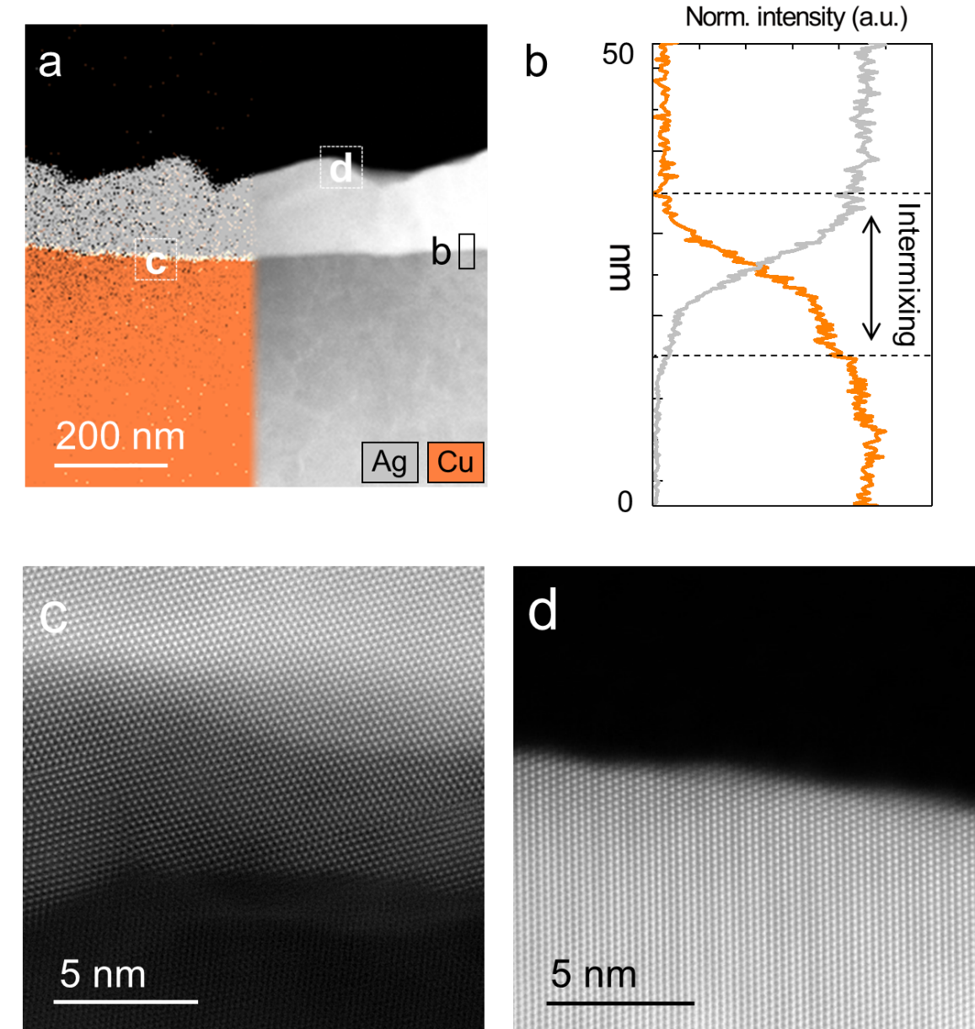
Supplementary Figure 1 | Interfacial and surface structures of conventional polycrystalline Ag thin films grown on polycrystalline Cu buffer layers. a, Energy dispersive X-ray spectroscopy (EDX) elemental maps (left panel) and Annular dark field (ADF) in the scanning transmission electron microscopy (STEM) image (right panel) of Ag and Cu in a polycrystalline Ag/Cu heterostructure. b, EDX intensity profiles of Ag (grey) and Cu (orange) across the interface, showing the presence of the Ag–Cu intermixing layer. c, d, High-resolution STEM images of the rough intermixing layer at the interface of the polycrystalline Ag/Cu heterostructure and the curved surface structure of the grown Ag film, respectively.

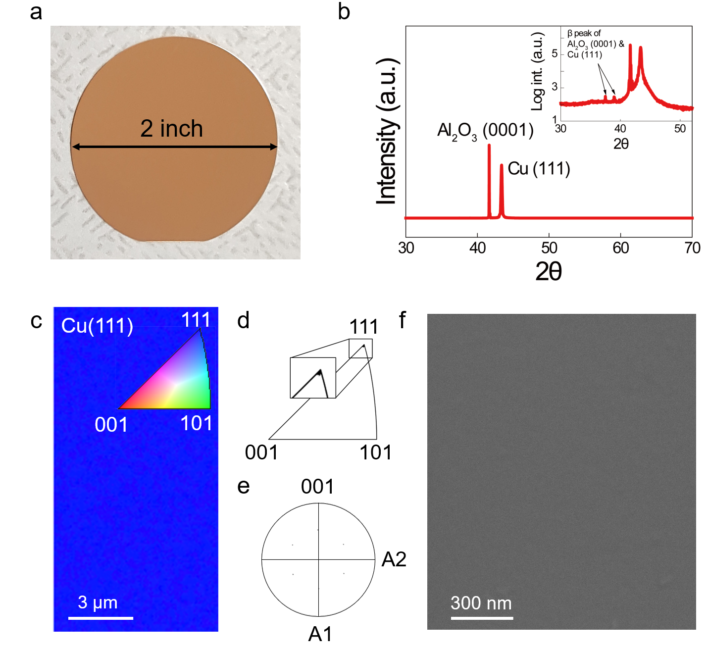
Supplementary Figure 2 | Single-crystal Cu thin film (SCCF) used as the buffer layer for Ag thin film growth. a, Photograph of the SCCF grown on the Al₂O₃ substrate. b, X-ray diffraction (XRD) pattern of the SCCF. c, Electron backscatter diffraction (EBSD) map showing perfect alignment along the [111] direction. c, d, Inverse pole figure (IPF) showing the sole spot associated with the Cu(111) plane and pole figure (PF) showing the sixfold symmetry of the (111) plane, respectively. f, Scanning electron microscopy (SEM) surface image of the SCCF, showing no grain boundaries.

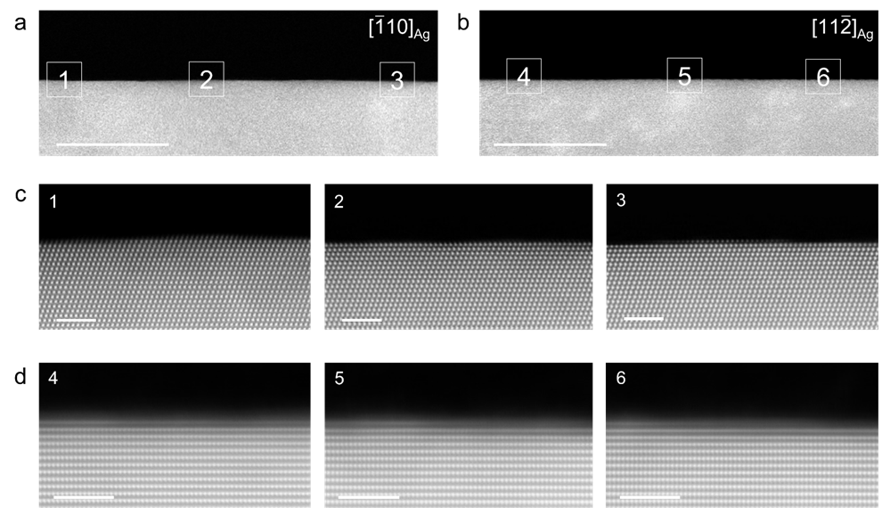
Supplementary Figure 3 | Cross-sectional ultraflat Ag thin film surface of two orientations. a, b, Low-magnification cross-sectional focused ion beam (FIB) sample images of Ag with orientation in [$\overline{1}10$] and [$11\overline{2}$], respectively. Scale bars are 50 nm. c, d, Ag surface images in the [$\overline{1}10$] and [$11\overline{2}$] directions, respectively. Scale bars are 2 nm.

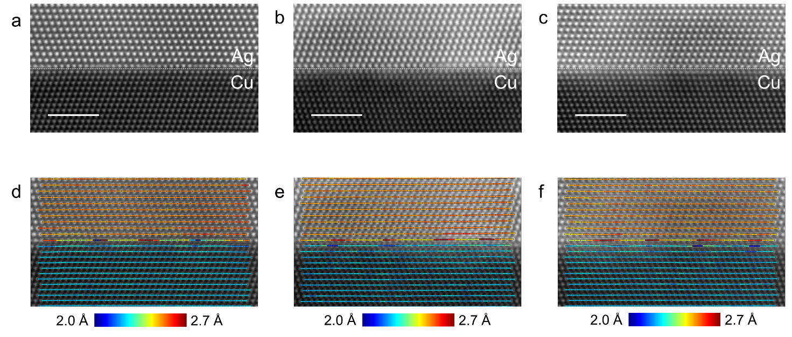
Supplementary Figure 4 | Representative examples of projected atomic distance (PAD) measurements for in-plane atomic arrays of Ag(111)/Cu(111) heterostructure. a–c, HAADF STEM images taken from different TEM samples for the interface regions of the Ag/Cu heterostructure. Scale bars are 2 nm. d–f, In-plane PAD maps computed from the above HAADF STEM images. Note that the histogram results of the in-plane PADs shown in Fig. 3b were obtained from the measurements with 10 HAADF STEM images of different Ag/Cu interface regions.

