Prediction of habitat complexity using a trait-based approach on coral reefs in Guam

Authors: Sofia B. Ferreira^{1, *}, John H.R. Burns¹, Kailey H. Pascoe², Clifford A. Kapono², Andres J. Reyes³, Atsuko Fukunaga².
Affiliations:
- Marine Science Department, University of Hawai’i at Hilo, Hilo, HI 96720, USA.
- Center for Global Discovery and Conservation Science, Arizona State University, Hilo HI 96720, USA.
- Marine Scientist, NAVFAC Systems Command Marianas, Joint Region Marianas, Santa Rita, GU 96915, USA. (ALTHOUGH THE MATTER HEREIN MAY DEAL WITH ONGOING OR ANNOUNCED POLICIES AND PROGRAMS OF THE NAVY, CONTRIBUTIONS BY THIS COAUTHOR ARE THE AUTHOR’S PERSONAL VIEWS AND NOT NECESSARILY THOSE OF THE DEPARTMENT OF DEFENSE OR ITS COMPONENTS.)
* Correspondence: sofiaf@hawaii.edu; Tel.: +1-808-217-6482

Supplementary Information

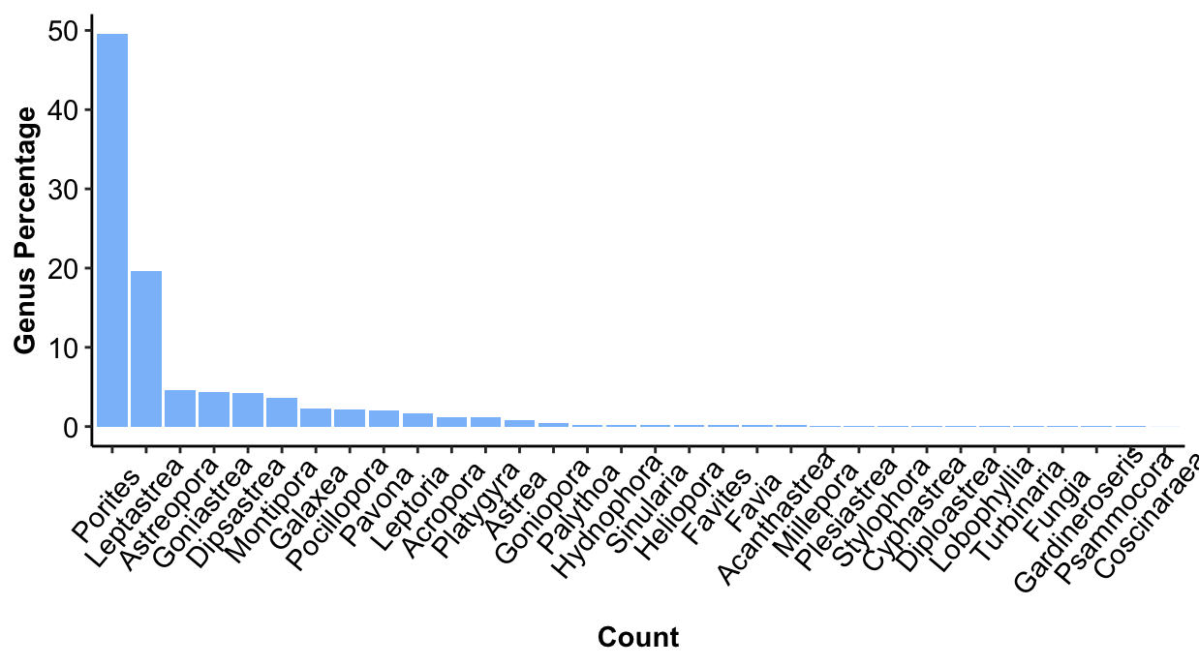
Supplementary Figure 1. Total proportion of each genus based on all 12,897 coral colonies surveyed.

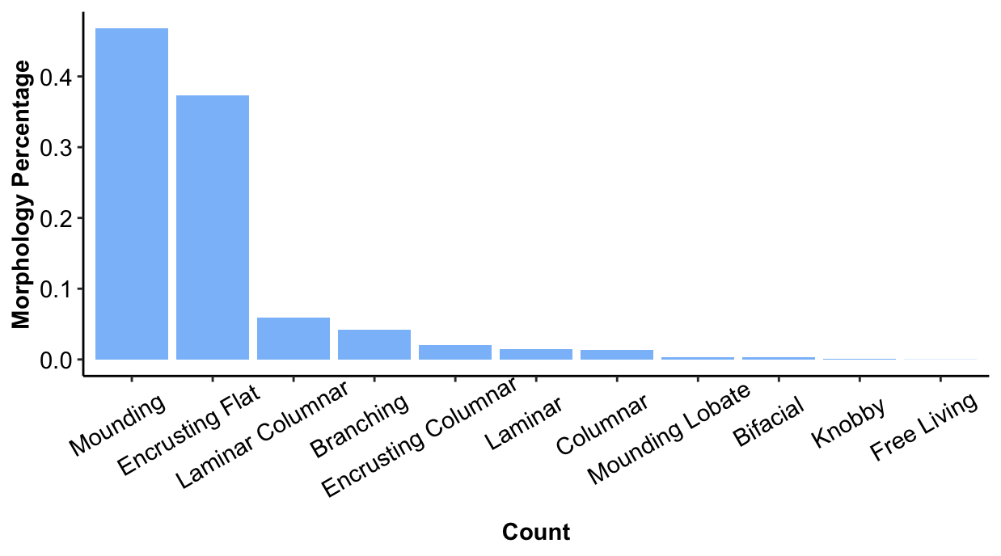
Supplementary Figure 2. Total proportion of each morphology based on all 12,897 coral colonies surveyed.

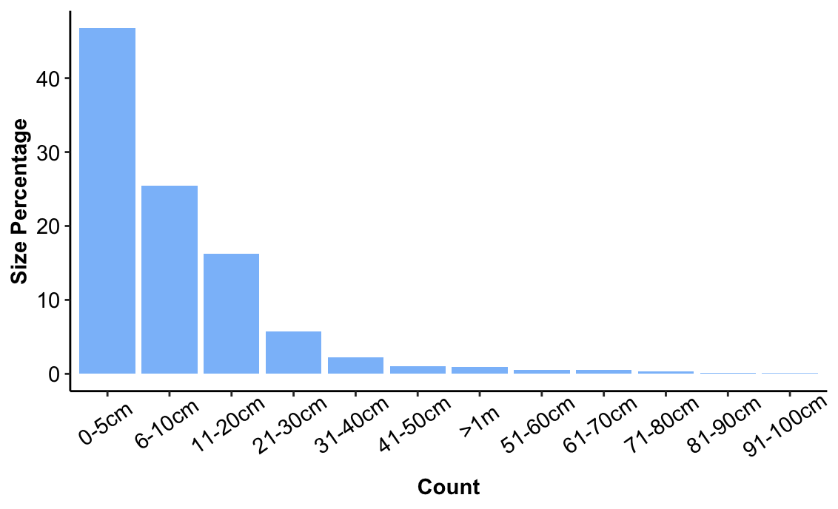
Supplementary Figure 3. Total proportion of each size category based on all 12,897 coral colonies surveyed.

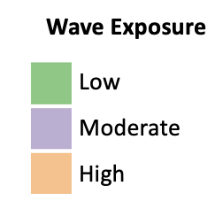
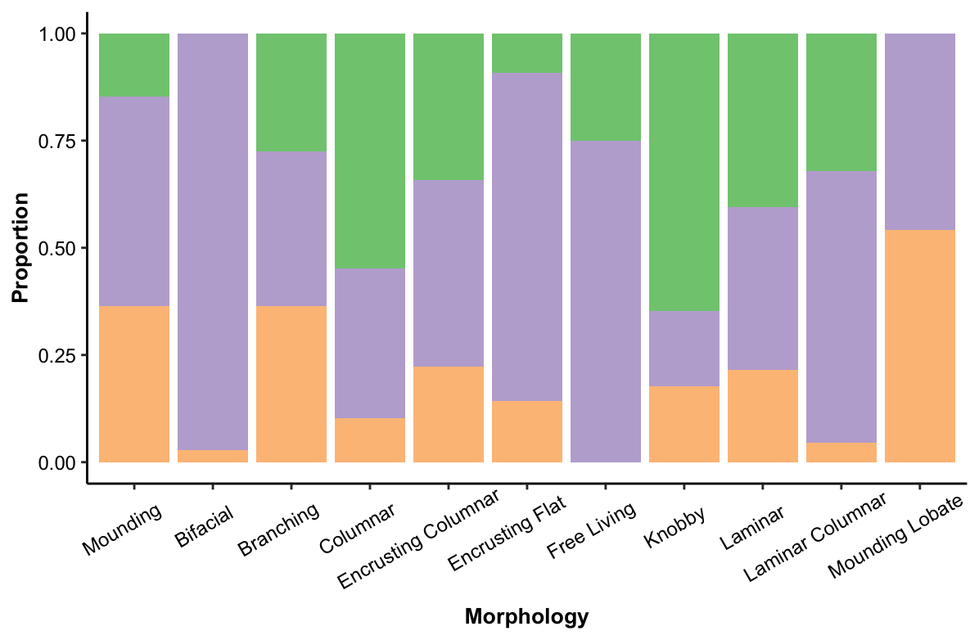
Supplementary Figure 4. Stacked bar chart showing proportion of each morphology category based on wave exposure levels.

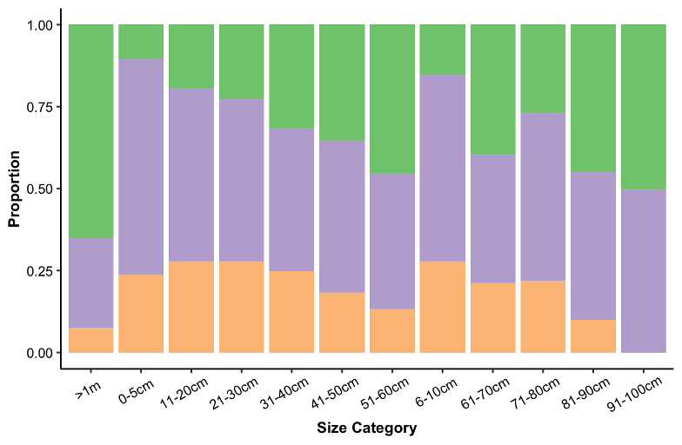
Supplementary Figure 5. Stacked bar chart showing proportion of each size category based on wave exposure levels.

