Supplemental Figures & Tables
S1. Indication for Postnatal Palliative Care Consult. Indications for postnatal consultation were reviewed in the 51 infants who were successfully followed after birth when family had prior perinatal palliative care involvement.
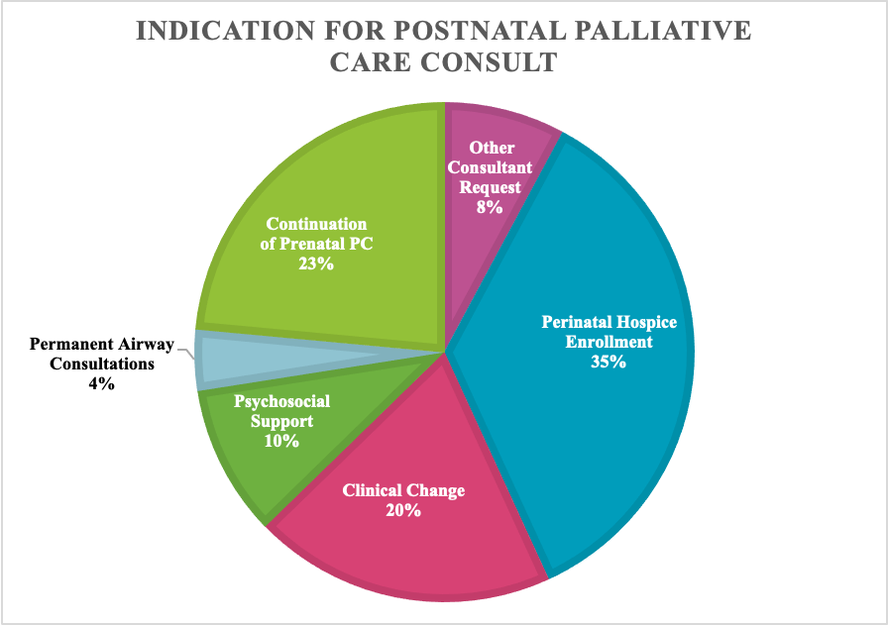

S2. Failure Analysis Cases. Descriptions of 10 random cases of failed continuity of perinatal palliative care in the postnatal period. Particular attention was paid to whether palliative care involvement in the prenatal period was denoted anywhere in the medical record. Root cause of the failures identified based on chart review
