Supporting Information

Halo
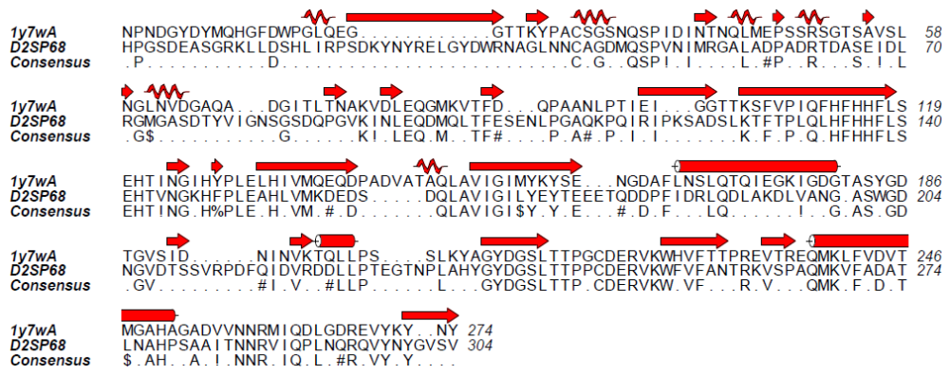
Figure 4 1Y7W Pairwise sequence alignment by salign() with D2SP68
coil, beta pleated sheet and alpha helices. Shows consensus pattern: ! hydrophobic, # Polar, % Aromatic
In 4CNX, 5HPJ and 5A25 a big gap exists in the beginning and has no secondary structure. Big gaps are visible throughout the sequence and identical amino acids are QSPV except 5HPJ and GSLTTPP. Most of the secondary structure regions are without gap. The catalytic region is almost consistent with few compatible changes Figure 5 to Figure 7.

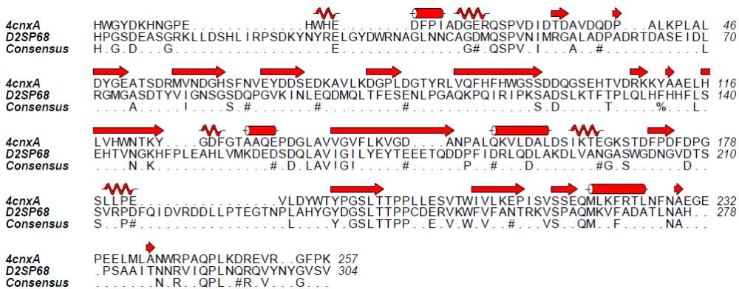
Figure 5 4CNX Pairwise sequence alignment by salign() with D2SP68
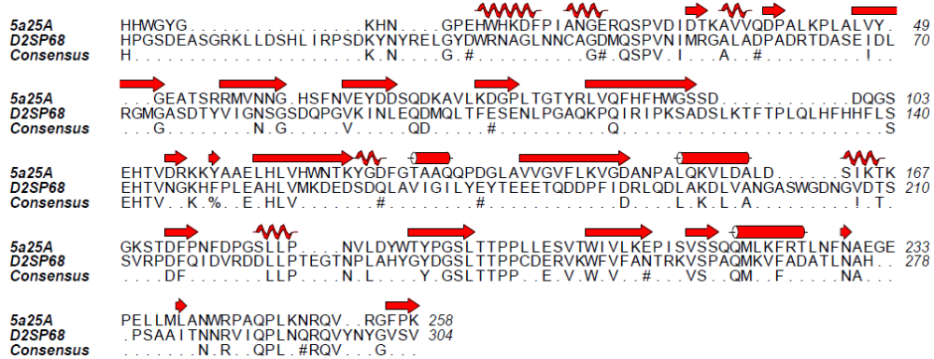
Figure 6 5A25 Pairwise sequence alignment by salign() with D2SP68

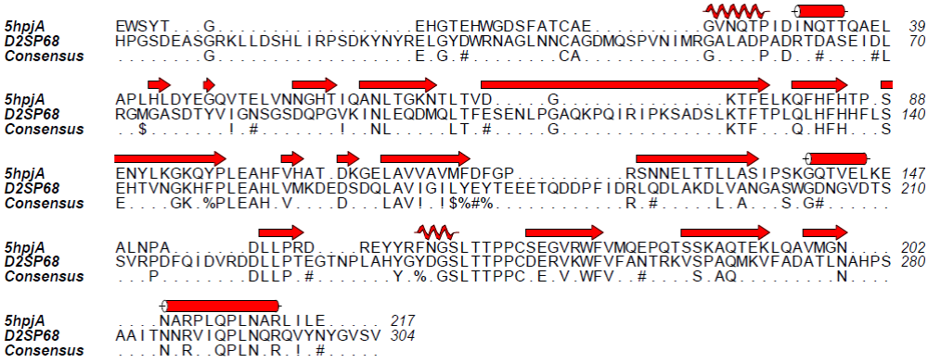
Figure 7 5HPJ Pairwise sequence alignment by salign() with D2SP68

In mesophilic more gaps are found compare to halotolerant category and in addition active site region consensus restricted to HFH / H Figure 8 to Figure 11.
Meso
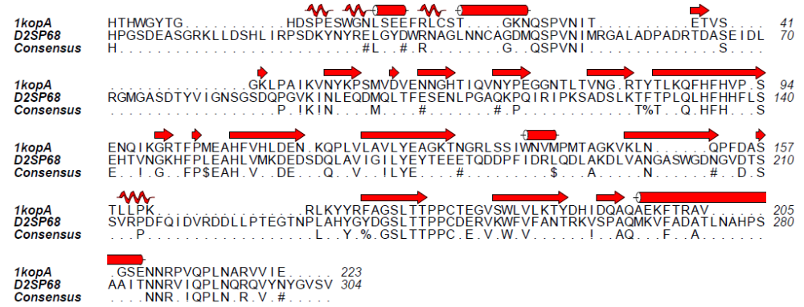
Figure 8 1KOP Pairwise sequence alignment by salign() with D2SP68

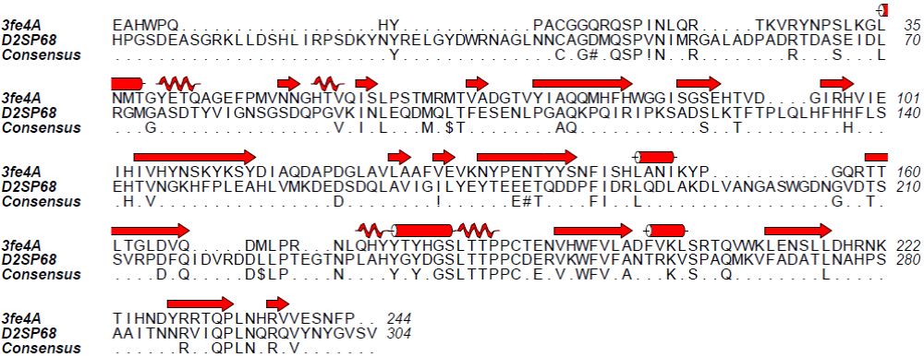
Figure 9 3FE4 Pairwise sequence alignment by salign() with D2SP68

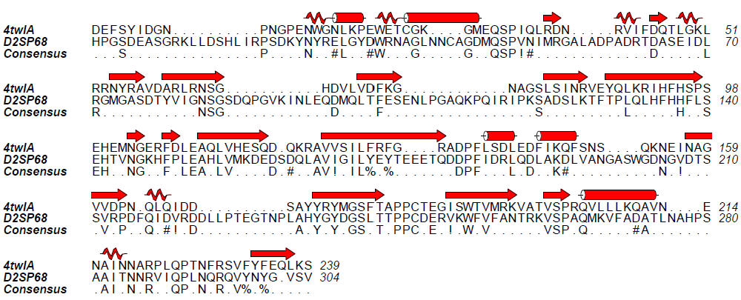
Figure 10 4TWL Pairwise sequence alignment by salign() with D2SP68
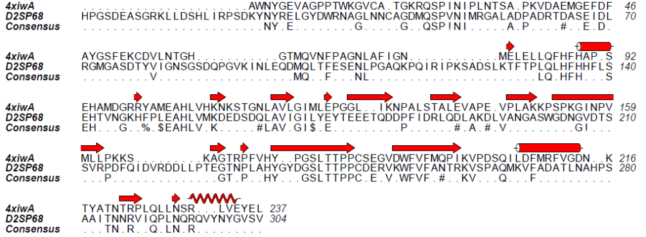
Figure 11 4XIW Pairwise sequence alignment by salign() with D2SP68
In thermophilic QSP and GSLTTPPC are consensus region and the active site patch is limited to HFH sequence Figure 12 to Figure 14.
Thermo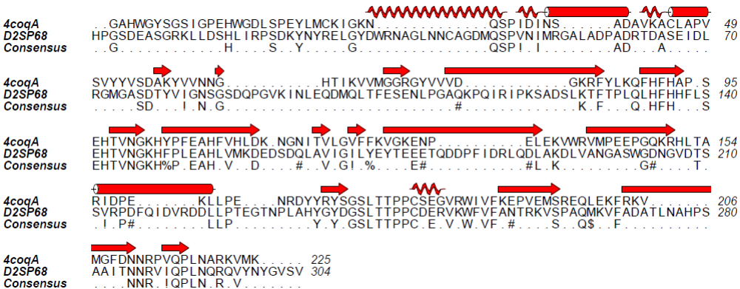
Figure 12 4COQ. Pairwise sequence alignment by salign() with D2SP68
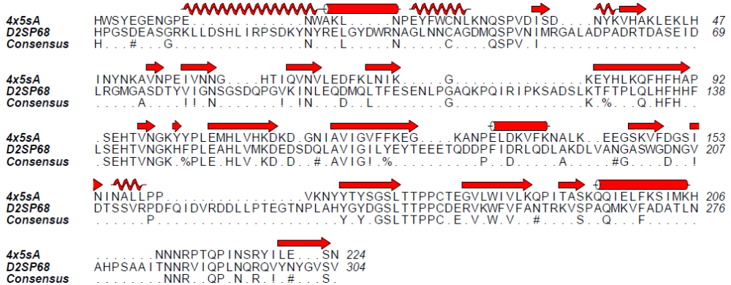
Figure 13 4X5S Pairwise sequence alignment by salign() with D2SP68

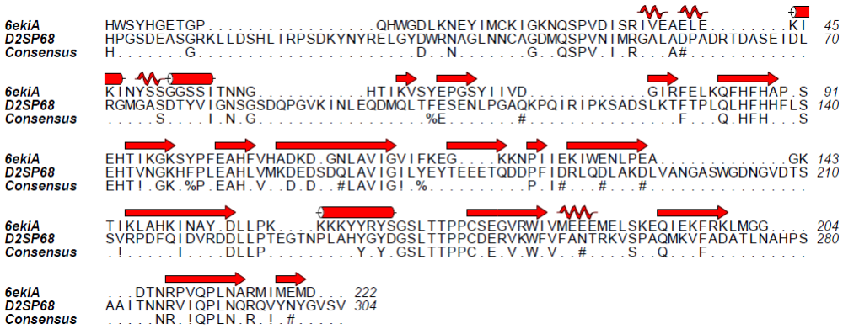
Figure 14 6EKI. Pairwise sequence alignment with D2SP68
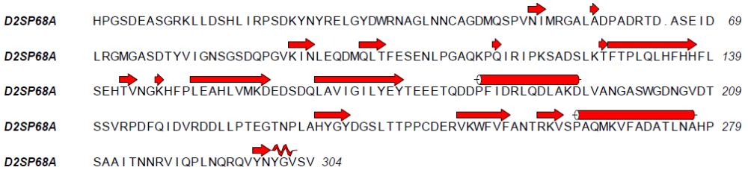
Figure 15 D2SP68 secondary structure information calculated by DSSP
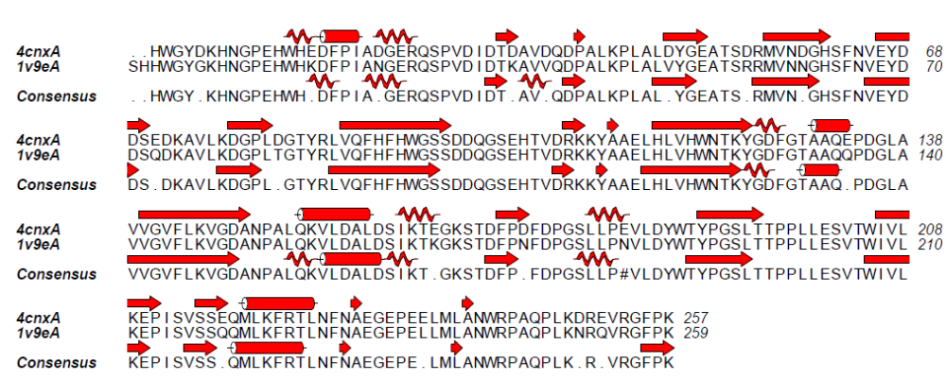
Figure 16 4cnx (halotolerant engineered) and Iv9e (mesophilic) secondary structure information calculated by DSSP

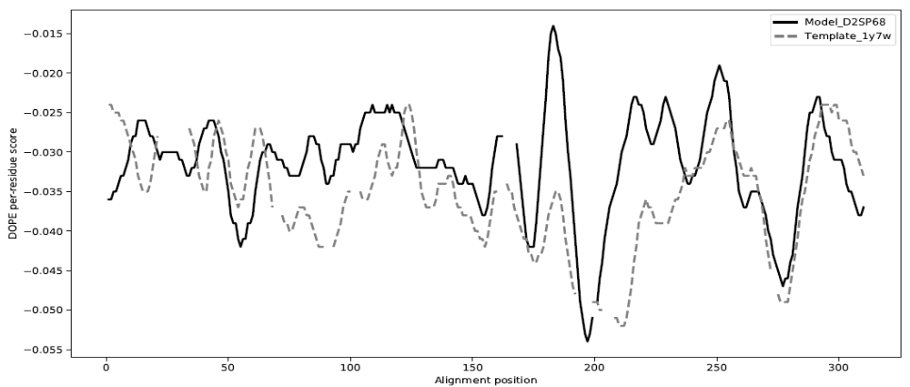
Figure 21 DOPE score of D2SP68 and 1Y7W (window size 15), broken lines show gap in alignment
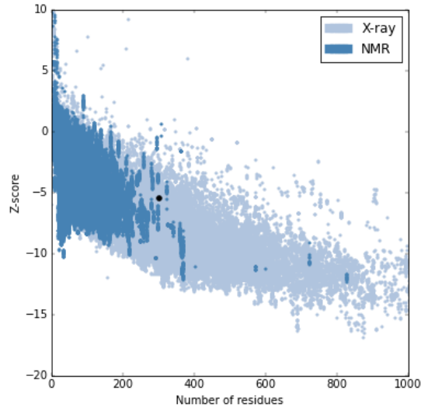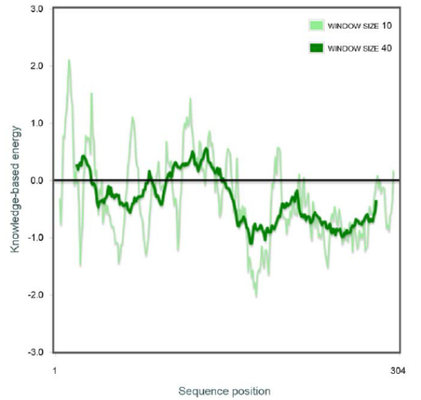
Figure 22 PROSA web Model Quality score, Z score of model is -5.43 and knowledge base energy profile with respect to sequence (window size 10 and 40) (Wiederstein & Sippl, 2007)

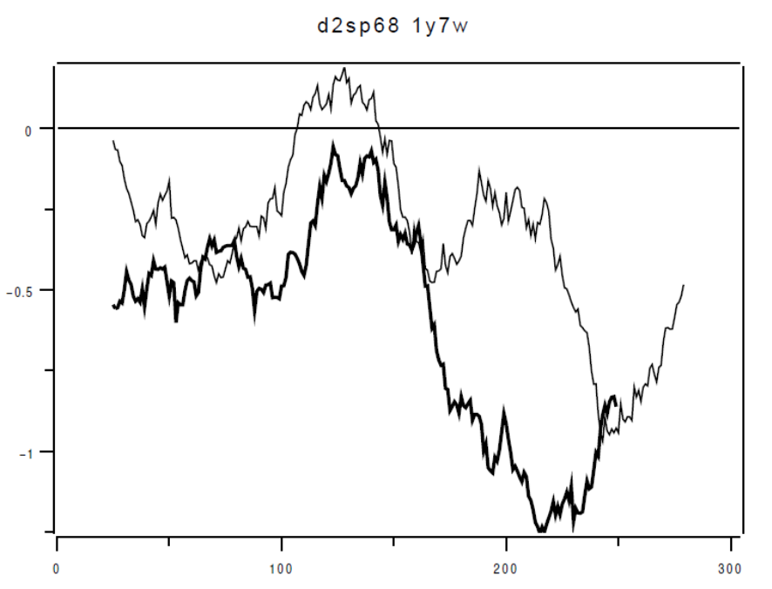
Figure 23 PROSA energy profile with respect to sequence D2SP68 and 1Y7W (window size 50)

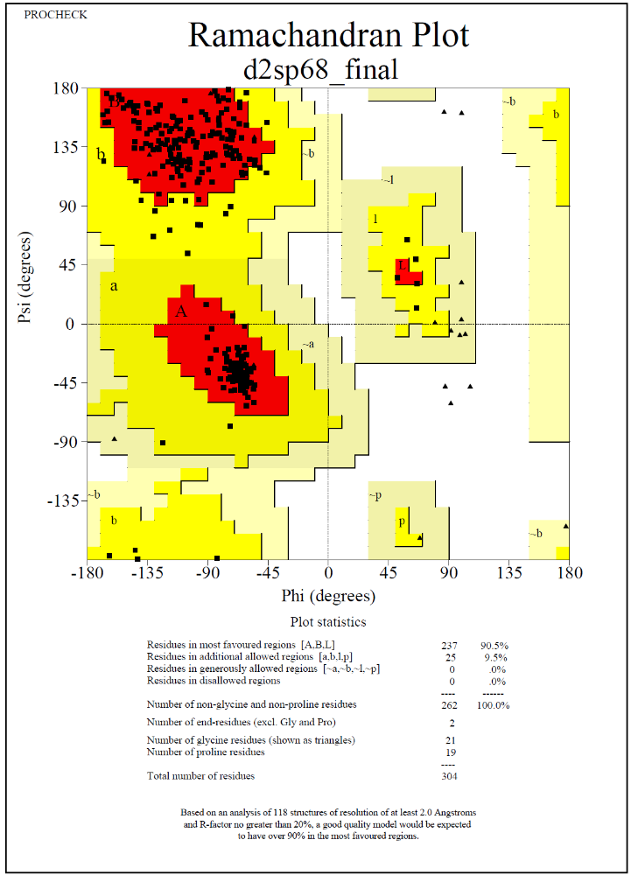
Figure 24 Stereo-chemistry evaluation by Procheck Model meets the evaluation criteria

