Cerebrospinal Fluid Lipidomic Fingerprint of Obstructive Sleep Apnoea in Alzheimer’s Disease
Farida Dakterzada¹, Iván D. Benítez^{2,3}, Adriano Targa^{2,3}, Anna Carnes¹, Montse Pujol², Mariona Jové⁴, Olga Mínguez², Rafi Vaca², Manuel Sánchez-de-la-Torre⁵, Ferran Barbé^{2,3}, Reinald Pamplona⁴ and Gerard Piñol-Ripoll¹*
- Unitat Trastorns Cognitius, Clinical Neuroscience Research, IRBLleida-Santa Maria Lleida University Hospital, Lleida, Spain
- Group of Translational Research in Respiratory Medicine, Hospital Universitari Arnau de Vilanova and Santa Maria, IRBLleida, Lleida, Spain
- Center for Biomedical Research in Respiratory Diseases Network (CIBERES), Madrid, Spain
- Department of Experimental Medicine, University of Lleida-Biomedical Research Institute of Lleida (UdLIRBLleida), Lleida, Spain
- Department of Nursing and Physiotherapy, Group of Precision Medicine in Chronic Diseases, University Hospital Arnau de Vilanova and Santa María, IRBLleida, Faculty of Nursing and Physiotherapy, University of Lleida, Lleida, Spain
* Corresponding author:
Gerard Piñol-Ripoll
Cognitive Disorders Unit
Hospital Universitari Santa Maria.
Rovira Roure n° 44. 25198. Lleida. Spain
Telephone: 34-937-727222. Ext. 173. Fax: 34-976-727366
E-mail: gerard_437302@hotmail.com

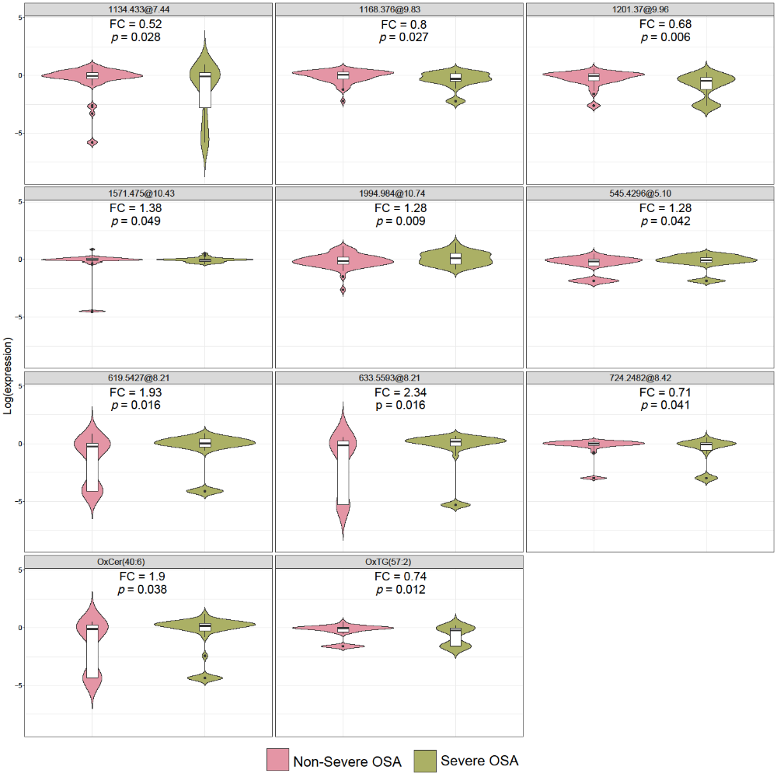

Supplementary Figure 1. Lipid features that significantly differentially expressed between AD patients with and without sever OSA. The unknown features are shown as mass at retention time. FC: fold change; OxCer: oxidized ceramide; OxTG: oxidized triglyceride

