Table 1 FLT3 inhibitors approved or in clinical trials
Inhibitor | Chemical structure | FLT3 kinase inhibitionª | The latest status in AML
Sunitinib | 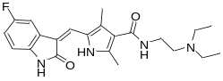 | FLT3-WT^{b}: 250nM  FLT3-ITD^{c}: 50 nM  FLT3-D835y^{d}: 30 nM | Phase 2  2008-2013
Midostaurin | 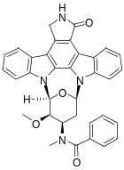 | FLT3-WT: 6.3 nM | Approved in 2017
Sorafenib | 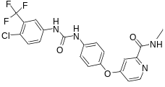 | FLT3-WT: 58 nM | Phase 2  2015-2019
Crenolanib | 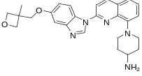 | FLT3-WT (in MV4-11 cells): 1.3 nM  FLT3-ITD (in Ba/F3 cells): 1.3 nM | Phase 3  Ongoing
Quizartinib | 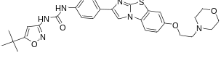 | FLT3-WT: 4.2 nM  FLT3-ITD: 1.1 nM | Approved in 2019
Gilteritinib | 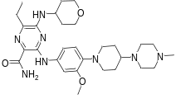 | FLT3-WT: 0.29 nM | Approved in 2019
Pexidartinib | 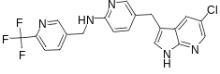 | FLT3-WT: 160 nM  FLT3-ITD: 11 nM | Phase 2  Ongoing
Pacritinib | 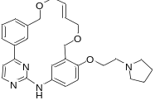 | FLT3-WT: 22 nM  FLT3-D835Y: 6 nM | Phase 2  Ongoing
SEL24-B489 | 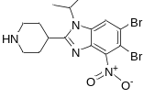 | FLT3-WT: 160 nM (Kd)  FLT3-ITD: 16 nM (Kd) | Phase 3  Ongoing
OTS167 | 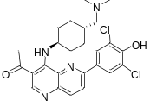 | FLT3-ITD: 4.9 nM | Phase 1  Ongoing
FF-10101 | 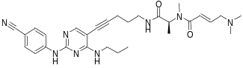 | FLT3-WT: 0.20 nM  FLT3-ITD: 0.16 nM | Phase 2  Ongoing
ª If not specified, all values are based on IC₅₀;
^{b} wild-type FLT3;
^{c} ITD mutant FLT3;
^{d} D835y mutant FLT3

