Table 8 The main scaffolds and the typical ECFP4 fragments in the 11 subsets
Subsetª | Main scaffolds | Fragments^{b}
Subset 1  (80/150) | 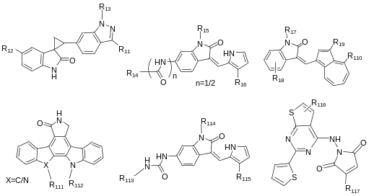
Subset 2  (174/241) | 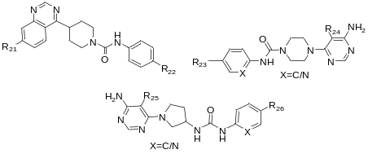
Subset 3  (184/226) | 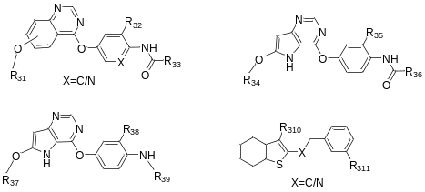
Subset 4  (439/2) | 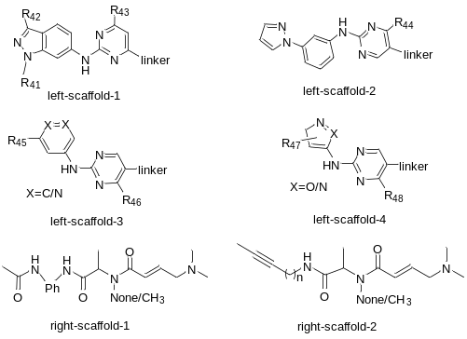
Subset 5  (121/112) | 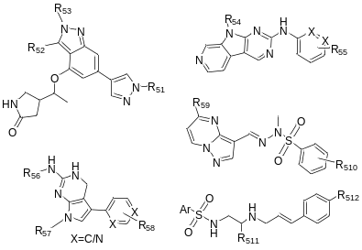
Subset 6  (158/221) | 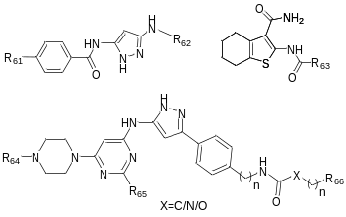
Subset 7  (146/271) | 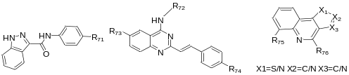
Subset 8  (177/136) | 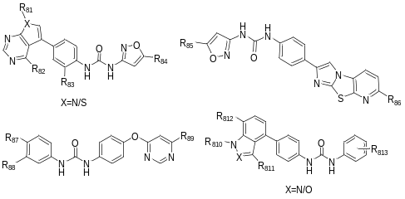
Subset 9  (130/106) | 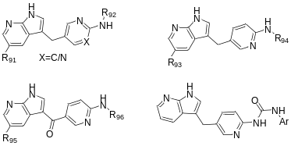
Subset 10  (130/60) | 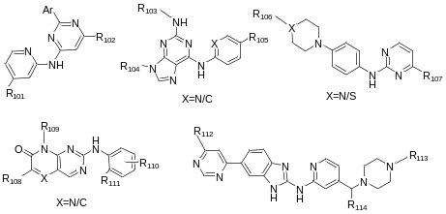
Subset 11  (64/90) | 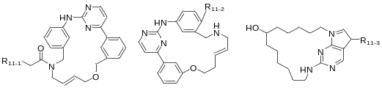
ª The numbers in the parentheses indicate the number of highly active inhibitors (left of the slash) and weakly active inhibitors (right of the slash) in the subset;
^{b} The number in front of the parentheses indicates the key of ECFP4 fingerprints. The numbers in parentheses indicate the frequency of the fragment in the highly active inhibitors (left of the slash) and the weakly active inhibitors (right of the slash).

