Table 6 Analyses of the top 16 ECFP4 fingerprints ranked by information gain (IG) values
descriptor | Representative substructure | IG value | p_high(%)^{b} | p_weak(%)^{c} | diff(%)^{d}
ECFP_983 | 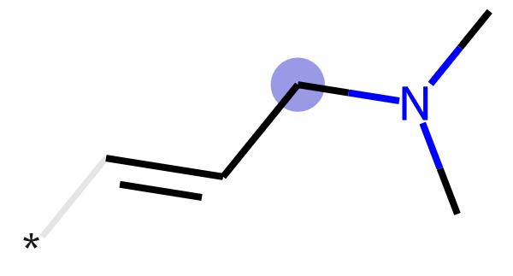 | 0.1282 | 25.87 | 0.45 | 25.41
ECFP_459 | 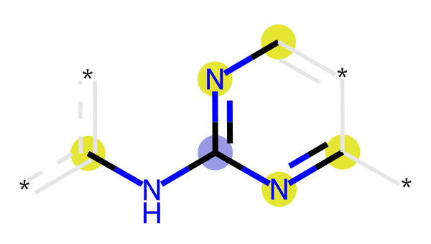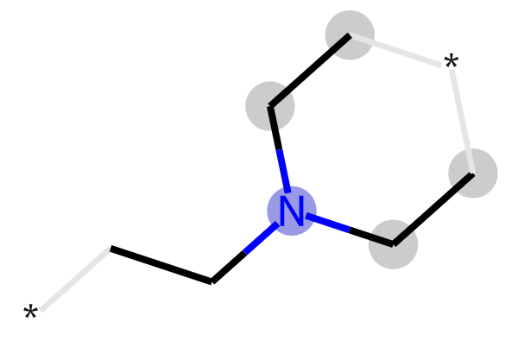 | 0.1115 | 41.01 | 8.25 | 32.76
ECFP_492 | 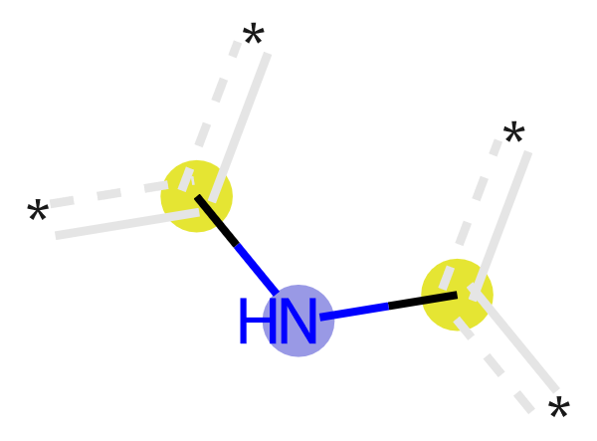 | 0.1102 | 41.66 | 8.77 | 32.88
ECFP_638 | 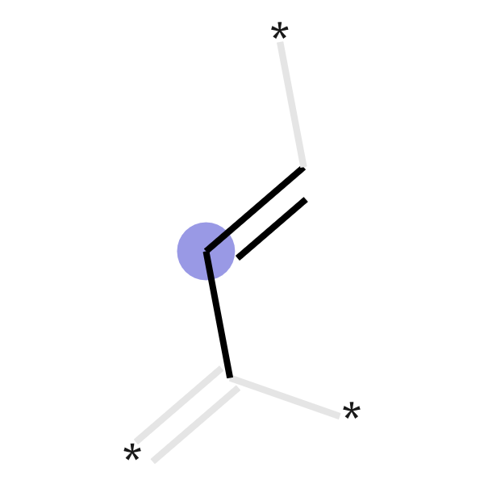 | 0.1076 | 28.75 | 2.53 | 26.22
ECFP_1003 | 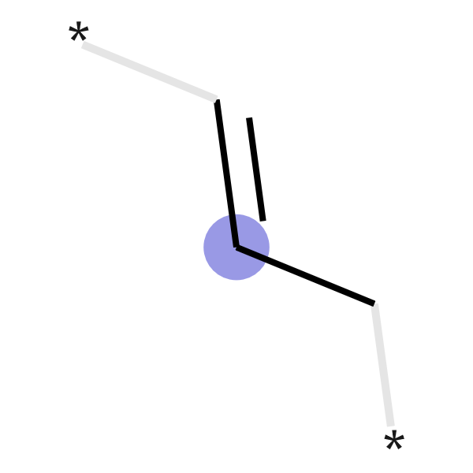 | 0.1001 | 27.73 | 2.66 | 25.06
ECFP_431 | 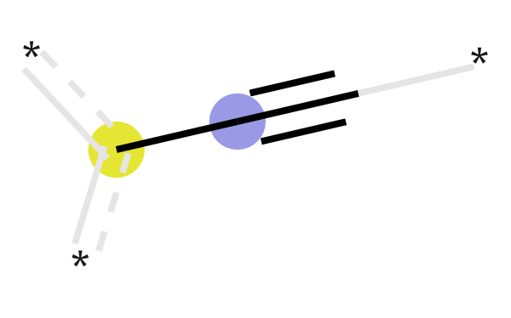 | 0.1000 | 23.17 | 1.04 | 22.13
ECFP_778 | 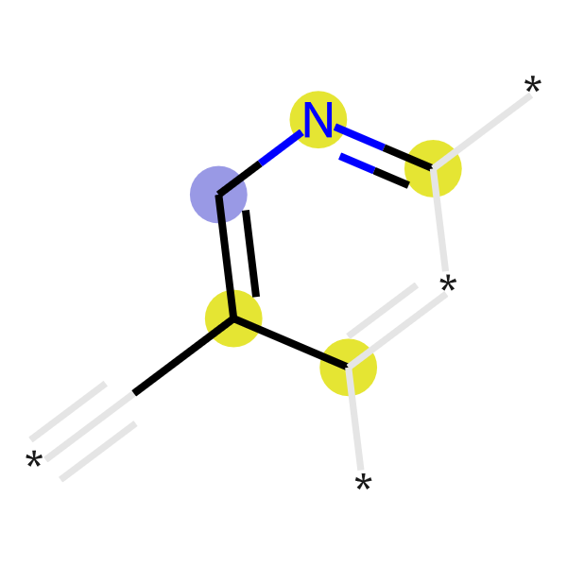 | 0.0975 | 22.72 | 1.04 | 21.68
ECFP_653 | 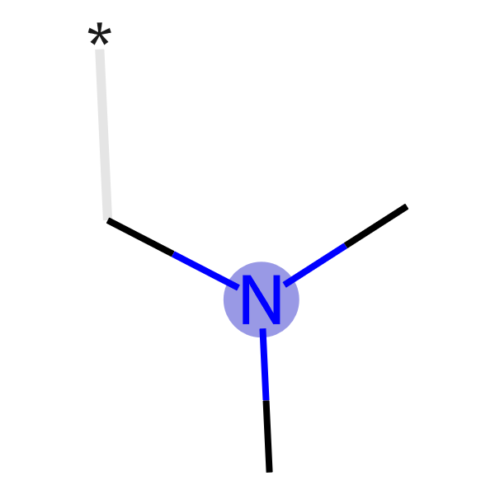 | 0.0961 | 35.94 | 7.02 | 28.93
ECFP_343 | 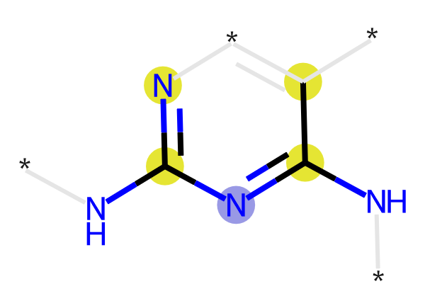 | 0.0930 | 27.66 | 3.18 | 24.48
ECFP_192 | 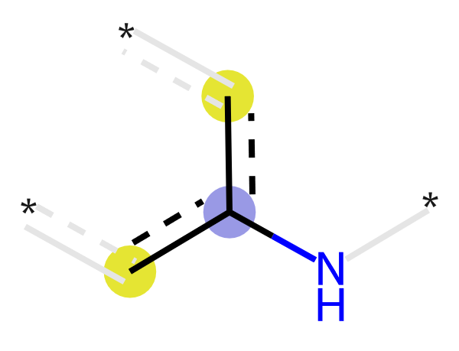 | 0.0901 | 73.23 | 38.53 | 34.70
ECFP_688 | 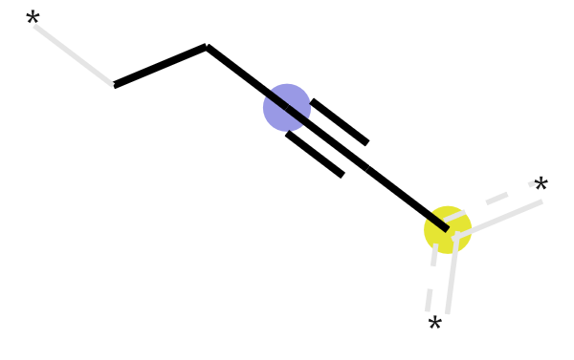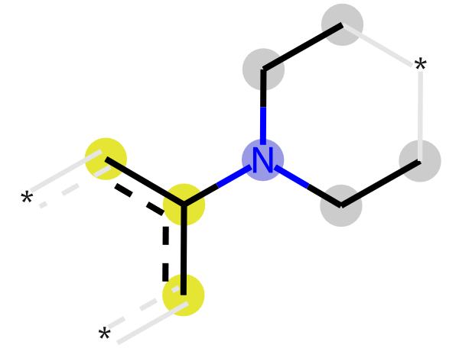 | 0.0852 | 34.15 | 7.21 | 26.93
ECFP_839 | 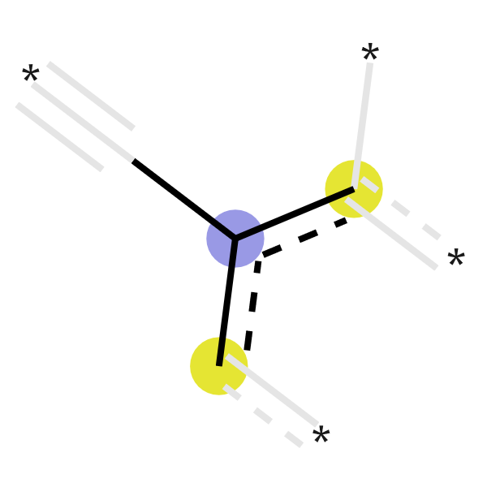 | 0.0847 | 23.23 | 2.01 | 21.22
ECFP_559 | 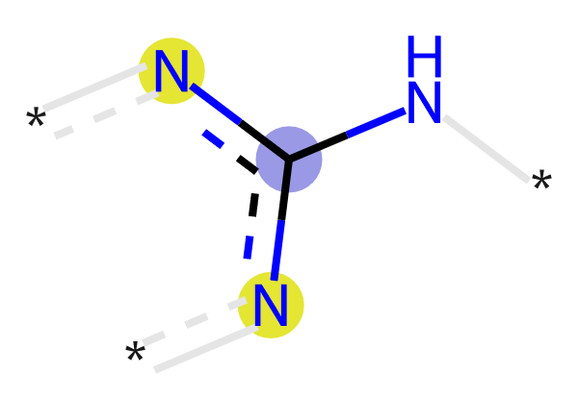 | 0.0833 | 39.22 | 10.53 | 28.69
ECFP_298 | 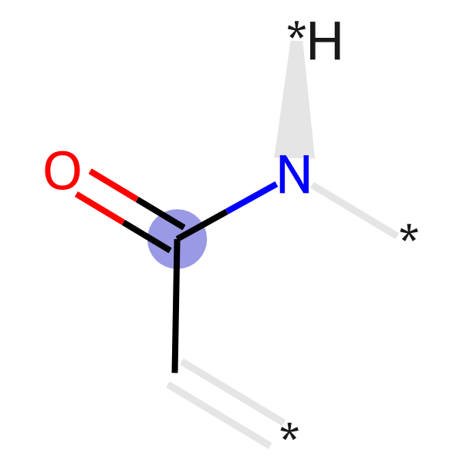 | 0.0833 | 20.15 | 1.04 | 19.11
ECFP_140 | 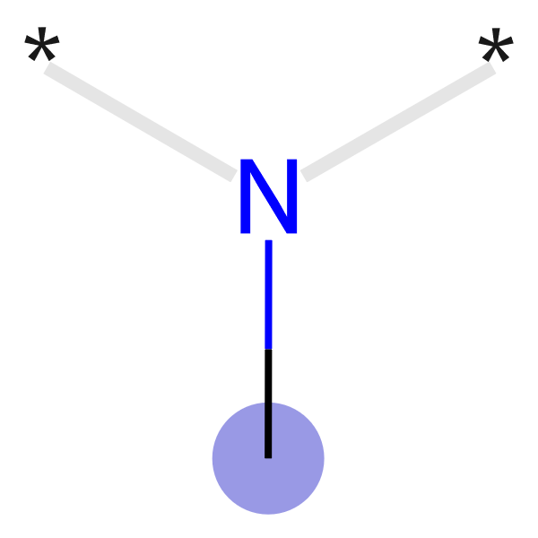 | 0.0822 | 31.19 | 5.91 | 25.28
ECFP_545 | 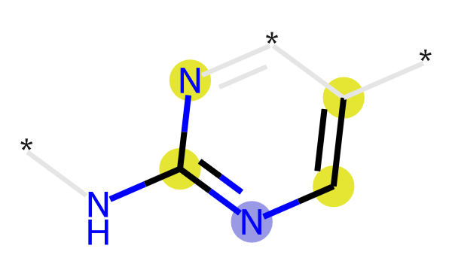 | 0.0809 | 35.37 | 8.45 | 26.92
ª The atoms marked by a purple, yellow and gray circle are the central atom, aromatic atom, and aliphatic hydrocarbon atom, respectively;
^{b} Proportion of fingerprints present in highly active inhibitors;
^{c} Proportion of fingerprints present in weakly active inhibitors;
^{d} Difference between p_high and p_weak;

