Supplementray

Table
Table S1: Zone of inhibition (mm) against bacteria and various concentration (10,20 and 30 µg) of Kanamycin, prepared leaf extract and NPs by disk diffusion method.

Organism | Amount of NPs (µg) | Kanamycin | Ag₂O |  | plant extract
P. aeruginosa |  | Zone of inhibition in mm
P. aeruginosa | 10 | 9±0.3 | 8±0.6 |  | 0.2±0.1
P. aeruginosa | 20 | 13±0.6 | 12±0.6 |  | 1.5±0.1
P. aeruginosa | 30 | 17±0.3 | 15±0.3 |  | 3±0.3
S. aureus |  | Zone of inhibition in mm
S. aureus | 10 | 7±0.5 | 0 |  | 0
S. aureus | 20 | 9.5±0.3 | 4±0.6 |  | 0
S. aureus | 30 | 12±0.5 | 8±0.4 |  | 2.3±0.3

Figures
Fig. S1. Minimum inhibitory concentration (5, 10,20,30,40 and 50)µg/mL Ag2O NPs against P. aeruginosa and S. aureus.

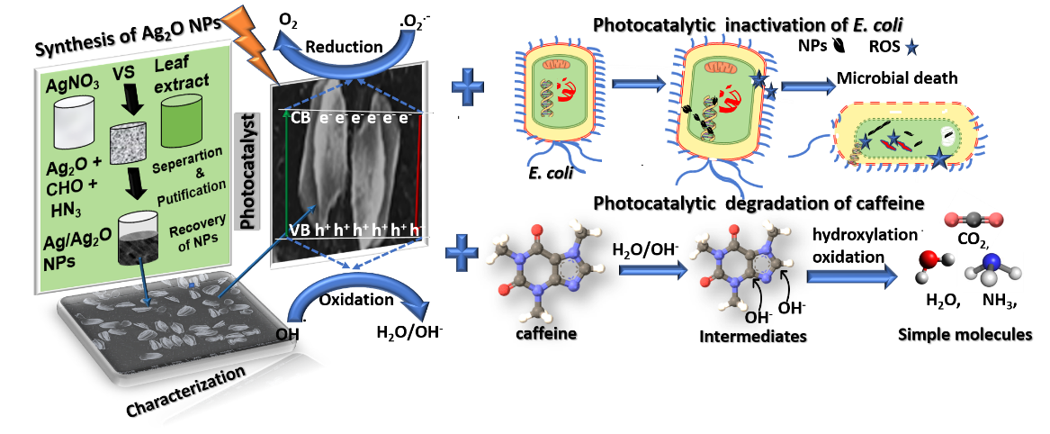
Fig. S2. Feasible photocatalytic degradation and inactivation mechanism of caffeine and E. coli

