Supplementary Information

Figure S1: Effect of dO₂ on DuckCelt®-T17 cells’ metabolism in a 3L bioreactor. Time evolution of glutamine (a), ammonium (b), glucose (c) and lactate (d) concentrations in the culture medium. Results are presented as means ± SD (n=3 for 30 and 50 % dO₂ and n=2 for 10 % dO₂).

Figure S2: Time evolution in cell-free OptiPROTM SFM medium of ammonium (dotted line) and glutamine (solid line) concentrations as glutamine (blue) or glutamax (orange) was used as medium supplement.

Figure S3: Effect of medium supplementation strategies D, E, H, I and J combining glutamine and/or glutamax as compared to the reference strategy A in shake flasks. Time evolution of viable cell concentration (a) and viability percentage (b). Results are presented as means ± SD (n=6 for strategies A, D, E and J, n=3 for strategies H and I).

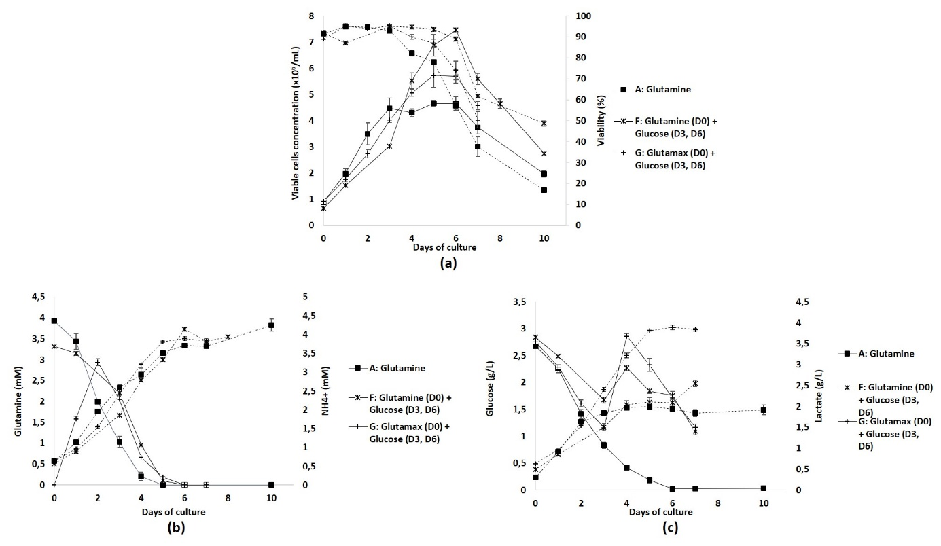
Figure S4: Effect of the addition of glucose on days 3 and 6 in the OptiPROTM SFM medium supplemented with glutamine (strategy F) or glutamax (strategy G) in shake flasks. Time evolution of cell growth (solid line) and viability percentage (dotted line) (a), of cell requirements for metabolites involved in glutaminolysis (b) and glycolysis (c). Results are presented as means ± SD (n=6 for the reference strategy A, n=3 for strategies F and G).

