Supply Material Figure.1
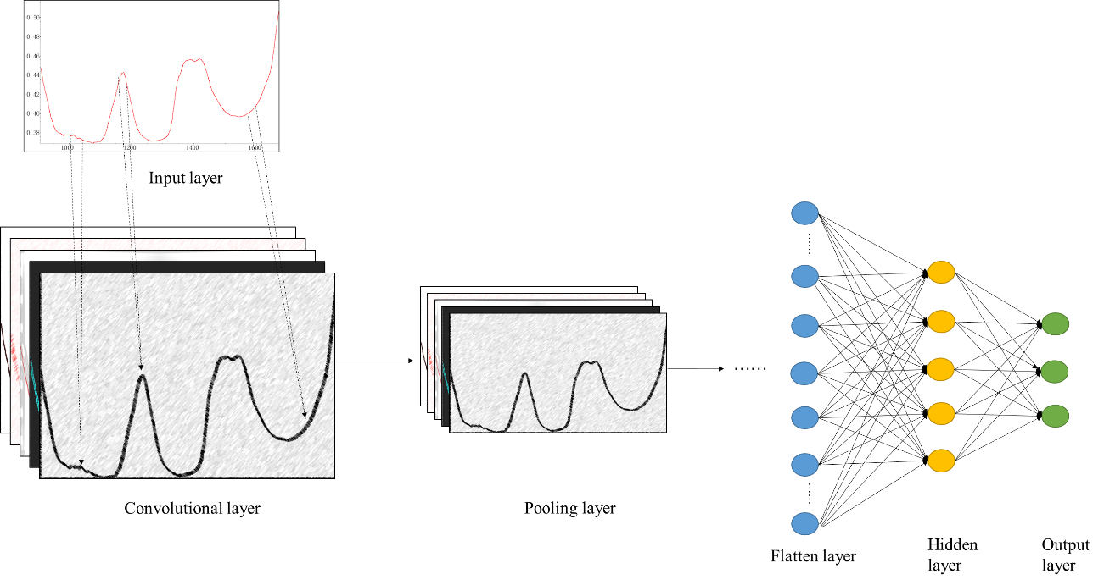
Fig. 1. Architecture of a convolutional neural network.

Supply Material Table.1.
 |  | Raw data | Normalization | S-G  (1_{st} polynomial) (7) | SNV | SNV+S-G  (1_{st} polynomial) (7) | S-G  (1_{st}polynomial) (7)  +SNV | S-G  (2_{nd} polynomial) (7) | S-G  (2_{nd} polynomial) (7)  +SNV
PLS-DA | Training set | 0.5671 | 0.5755 | 0.5453 | 0.5889 | 0.5369 | 0.5336 | 0.5336 | 0.5973
PLS-DA | Test set | 0.4598 | 0.5126 | 0.4925 | 0.5628 | 0.5176 | 0.5025 | 0.5126 | 0.5779
SIMCA | Training set | 0.5578 | 0.5570 | 0.5678 | 0.7248 | 0.7047 | 0.7628 | 0.5738 | 0.7181
SIMCA | Test set | 0.5386 | 0.4975 | 0.5587 | 0.6281 | 0.6482 | 0.6998 | 0.5477 | 0.6382
LDA | Training set | 0.5252 | 0.4874 | 0.5319 | 0.5647 | 0.5470 | 0.5470 | 0.5302 | 0.5453
LDA | Test set | 0.4724 | 0.5419 | 0.4774 | 0.5436 | 0.5176 | 0.5176 | 0.4724 | 0.5176

Supply Material Table.2.
Table.2 The detail architecture of CNN model
