Supplementary data
Table S1: Molecular identification of isolated P solubilizing bacteria in Rhebu and Oceanview Soils
Rhebu |  |  |  | Oceanview
Strain | Accession number | Similarity (%) |  | Strain | Accession number | Similarity (%)
Pseudomonas koreensis | NR_025228.1 |  | 99.96 | Lysobacter panacisoli | NR_134075.1 | 99.65
Caballeronia fortuita | NR_145600.1 |  | 98.48 | Pseudomonas cissicola | NR_112071.1 | 85.73
Paraburkholderia steynii | NR_164972.1 |  | 89.42 | Paraburkholderia steynii | NR_164972.1 | 99.73
Pseudomonas migulae | NR_114223,1 |  | 99.05 | Variovorax paradoxus | NR_113736.1 | 90.60
Paraburkholderia terricola | NR_118079.1 |  | 85.60 | Hymenobacter xinjiangensis | NR_044003.1 | 86.32
Burkholderia ambifaria | NR_074687.1 |  | 89.71
Pseudomonas mosselii | NR_024924.1 |  | 82.69
Novosphingobium barchaimii | NR_118314.1 |  | 99.00

Table S2: Molecular identification of isolated N-cycling in Rhebu and Oceanview soils
Rhebu |  |  | Oceanview
Strain | Accession number | Similarity (%) | Strain | Accession number | Similarity (%)
Pseudomonas fulva | NR_104280.1 | 99.65 | Pseudomonas putida | NR_114479.1 | 98.20
Pseudomonas koreensis | NR_025228.1 | 89.57 | Paraburkholderia steynii | NR_164972.1 | 99.65
Variovorax guangxiensis | NR_134828.1 | 99.38 | Bacillus ginsengisoli | NR_109068.1 | 89.73
Pseudomonas mosselii | NR_024924.1 | 98.01 | Cupriavidus oxalaticus | NR_113619.1 | 95.64
Caulobacter rhizosphaerae | NR_156992.1 | 91.77 | Chitinophaga pinensis | NR_074566.1 | 90.10
Olivibacter domesticus | NR_042571.2 | 99.20 | Dyella marensis | NR_042691.1 | 98.51
Acinetobacter oleivorans | NR_102814.1 | 98.65 | Paenarthrobacter aurescens | NR_026233.1 | 86.32
Variovorax boronicumulans | NR_114214.1 | 90.41
Paraburkholderia steynii | NR_164972.1 | 97.62
Caballeronia fortuita | NR_145600.1 | 85.82

Table S3: Molecular identification of isolated N-fixing in Rhebu and Oceanview soils
Rhizosphere |  |  | Surrounding soils
Strain | Accession number | Similarity (%) | Strain | Accession number | Similarity (%)
Cupriavidus oxalaticus | NR_113619.1 | 96.92 | Paenibacillus maysiensis | NR_165764.1 | 84.07
Pseudomonas migulae | NR_114223,1 | 99.57 | Bradyrhizobium elkanii | NR_114610.1 | 98.51
Paraburkholderia steynii | NR_164972.1 | 99.89 | Variovorax paradoxus | NR_113736.1 | 72.37
Burkholderia ambifaria | NR_074687.1 | 99.20 | Paraburkholderia steynii | NR_164972.1 | 99.01
Pseudomonas mosselii | NR_024924.1 | 87.52 | Bradyrhizobium embrapense | NR_145861.1 | 78.44
Novosphingobium resinovorum | NR_044045.1 | 92.59 | Pseudomonas putida | NR_114479.1 | 86.32
 |  |  | Stenotrophomonas maltophilia | NR_119220.1 | 95.27

Table S4: Molecular identification of bacteria isolated in the coralloid roots of Encephalartos villosus growing in Rhebu and Oceanview
Rhebu |  |  |  | Oceanview
Strain | Accession number | Similarity (%) | Function | Strain | Accession number | Similarity (%) | Function
Lysinibacillus xylanilyticus | KX254351.1 | 98.27 | P-solubilizing | Lysinibacillus fusiformis | CP041696.1 | 99.07 | P-solubilizing, N-fixing
Paenibacillus xylanilyticus | CP044310.1 | 99.30 | P-solubilizing | Bacillus sp. | KF010353.1 | 99.92 | P-solubilizing
Lysinibacillus sp. | MN911365.1 | 99.67 | P-solubilizing | Lysinibacillus xylanilyticus | MT332716.1 | 96.32 | P-solubilizing
Lysinibacillus parviboronicapiens | KY038664.1 | 99.09 | P-solubilizing | Lysinibacillus sp. | MF465572.1 | 91.00 | P-solubilizing
Brevibacterium frigoritolerans | MN710450.1 | 99.50 | P-solubilizing | Enterobacter cloacae | MK116463.1 | 98.92 | N-fixing
Stenotrophomonas sp. | MG725655.1 | 99.58 | N-cycling | Paenibacillus polymyxa | KT783525.1 | 99.15 | N-fixing
Lysinibacillus fusiformis | CP041696.1 | 99.9 | P-solubilizing,  N-fixing
Rhizobium huautlense | MG725655.1 | 98.41 | N-fixing
Lysinibacillus sp. | MG725655.1 | 97.38 | N-fixing

Table S5: Soil nutrient concentrations (mg/kg) in Encephalartos villosus rhizosphere soils in Rhebu and Oceanview, Eastern Cape. In each row, different letters denote significant differences in the nutrient concentrations of soil samples (independent samples t-test, p≤0.05, means±SE, n=15).
 | Parameter | Oceanview | Rhebu
Primary nutrients | P  K | 6.1±2.9ª  139.5±33.6^{b} | 22.95±5.9ª  330.0±100.9^{c}
Primary nutrients | N | 3093.7±741.9^{d} | 5189.3±297.9e
Intermediate nutrients | Ca | 1555.3±274.8ª | 1534.9±974.2ª
Intermediate nutrients | Mg | 454.7±46.1ª | 838.5±549.3ª
Soil nutrients | Mn | 55.3±21.1ª | 89.7±58.0ª
Soil nutrients | Zn | 2.2±0.1^{f} | 4.1±1.6^{g}
Soil nutrients | Cu | 1.1±0.2ª | 0.9±0.1ª
Table S6: Relative acidity in Encephalartos villosus rhizosphere soils collected in Rhebu and Oceanview, Eastern Cape. In each row, different letters denote significant differences (independent samples t-test, p≤0.05, means±SE, n=15).
Parameter | Oceanview | Rhebu
Exchange acidity (cmol/L) | 0.05±0.01ª | 1.46±1.42ª
Total cations (cmol/L) | 11.53±1.65ª | 15.26±8.13ª
pH | 5.43±0.41^{b} | 4.28±0.61^{c}

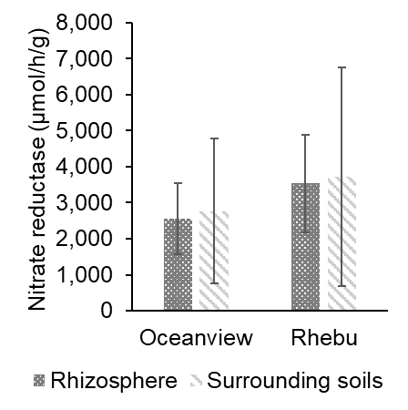
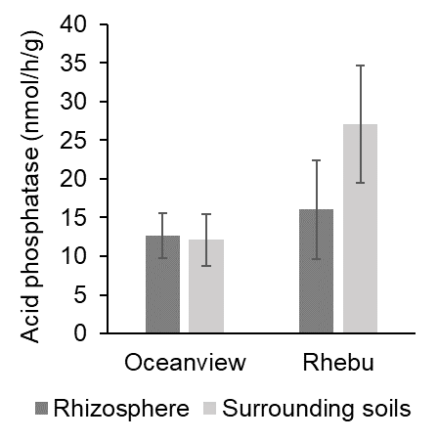
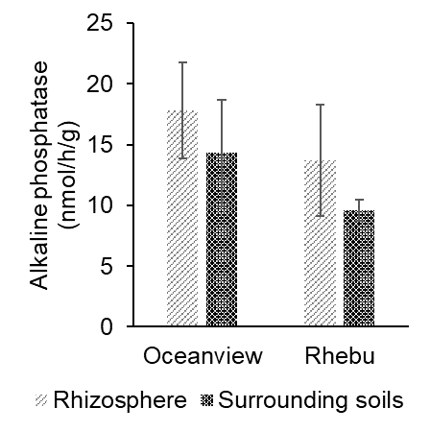
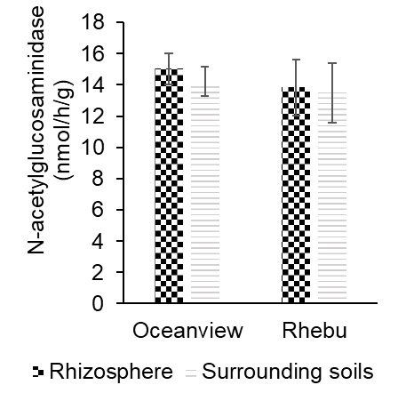
Fig S1: Soil extracellular enzyme activities in E. villosus rhizosphere and surrounding soils collected in Rhebu and Oceanview, Eastern Cape. In each graph, different letters denote significant differences in the enzyme activity of soil samples within study sites (independent samples t-test, p≤0.05, means±SE, n=30).
B
A
D
C
a
a
a
a
a
a
a
a
a
a
a
a
a
a
a
a
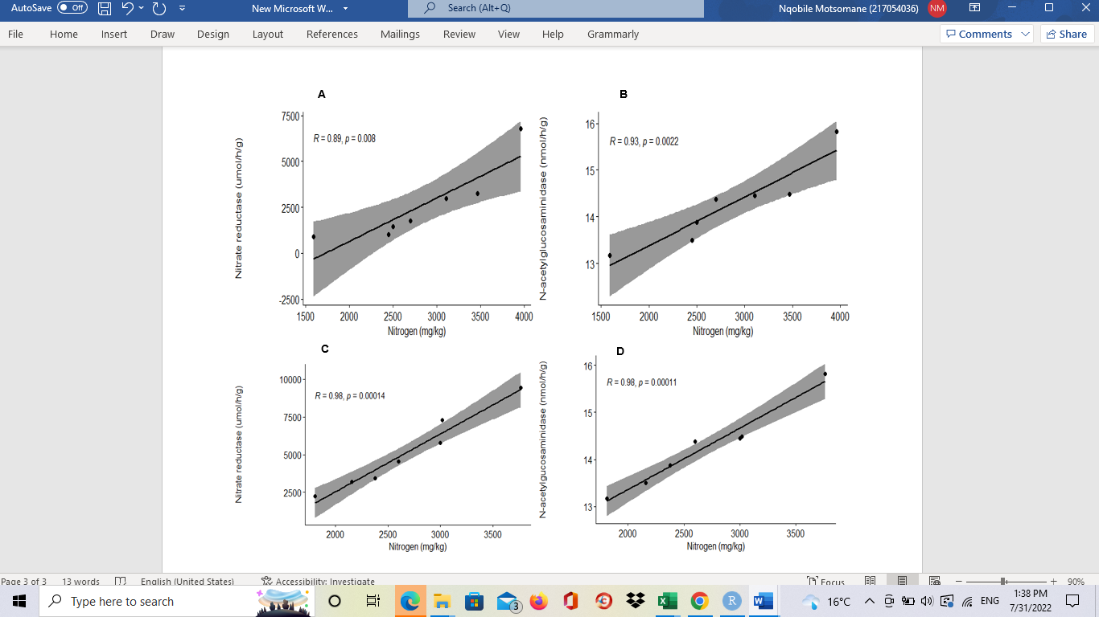
Fig S2: Correlation of N-acetylglucosaminidase activity, nitrate reductase activity, and soil N concentration on E. villosus rhizosphere and surrounding soils, Oceanview (Simple linear correlation, p≤0.05). A: Nitrate reductase activity in rhizosphere soils, B: N-acetylglucosaminidase activity in rhizosphere soils, C: Nitrate reductase activity in surrounding soils, and D: N-acetylglucosaminidase activity in surrounding soils
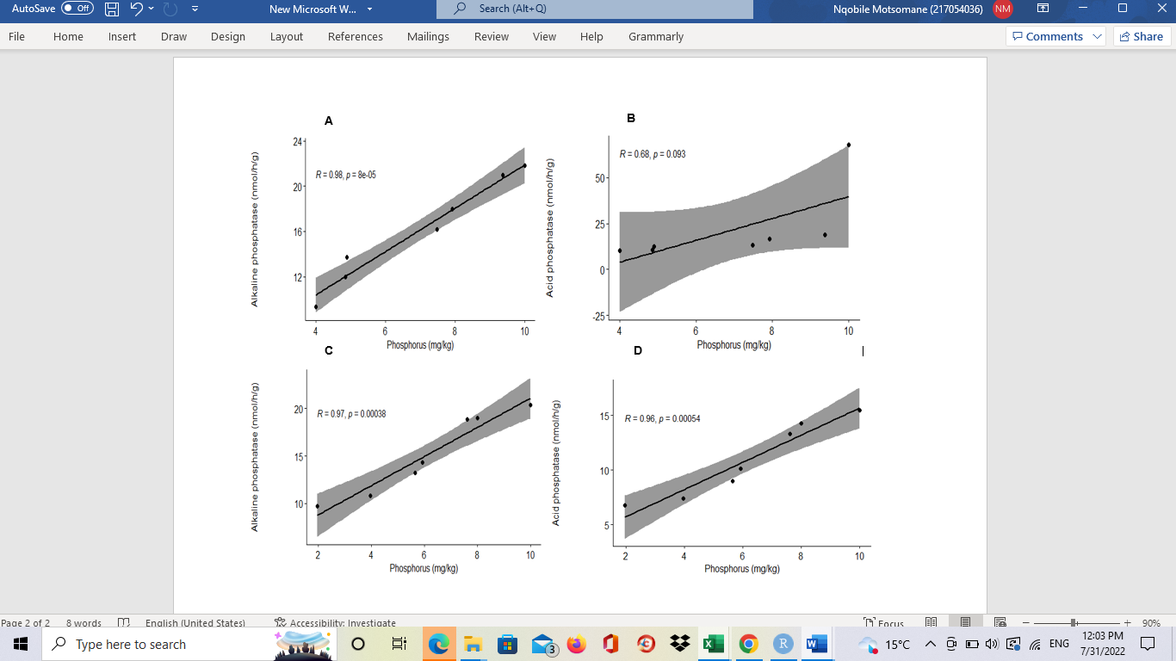 Fig S3: Correlation of alkaline phosphatase activity, acid phosphatase activity, and soil P concentration in E. villosus rhizosphere and surrounding soils, Oceanview (Simple linear correlation, p≤0.05). A: Alkaline phosphatase activity in rhizosphere soils, B: Acid phosphatase activity in rhizosphere soils, C: Alkaline phosphatase activity in surrounding soils, and D: Acid phosphatase activity in surrounding soils.
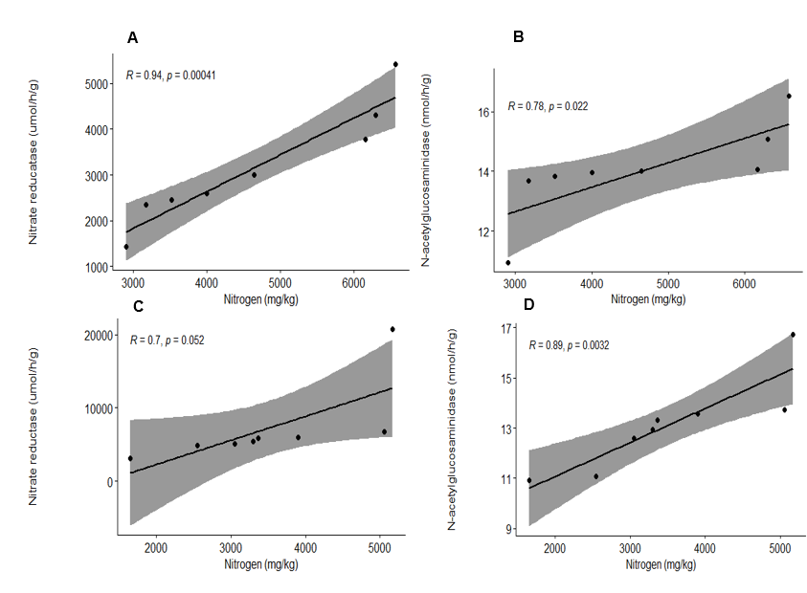 Fig S4: Correlation of N-acetylglucosaminidase activity, nitrate reductase activity, and soil N concentration on E. villosus rhizosphere and surrounding soils, Rhebu (Simple linear correlation, p≤0.05). A: Nitrate reductase activity in rhizosphere soils, B: N-acetylglucosaminidase activity in rhizosphere soils, C; Nitrate reductase activity in surrounding soils, C: N-acetylglucosaminidase activity in surrounding soils
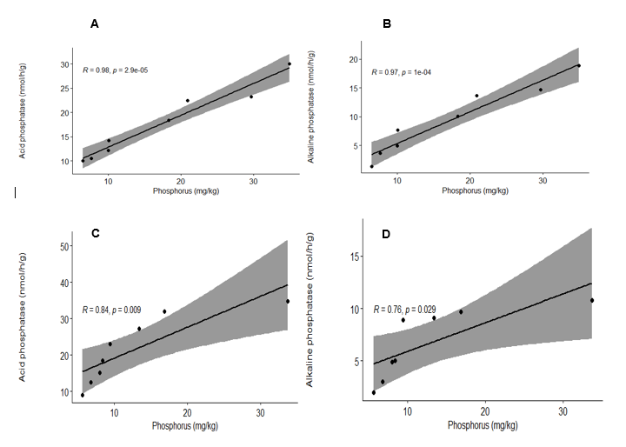
Fig S5: Correlation of alkaline phosphatase activity, acid phosphatase activity, and soil P concentration in E. villosus rhizosphere and surrounding soils, Rhebu (Simple linear correlation, p≤0.05). A: Acid phosphatase activity in rhizosphere soils, B: Alkaline phosphatase activity in rhizosphere soils, C: Acid phosphatase activity in surrounding soils, and D: Alkaline phosphatase activity in surrounding soils.

