Table 1 | Reductive amination of 5-HMF with NH₃ under different reaction conditions.
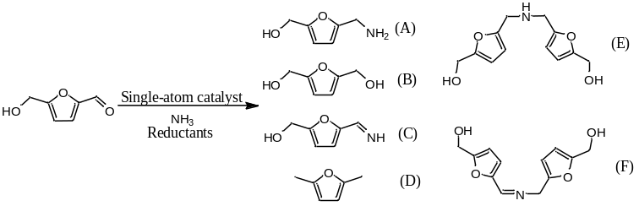
Entry | Catalysts | Reductants | Time | HMF conversion | Products yields ¹ |  |  |  | TOF ⁵  (h⁻¹)
 |  |  |  |  | A | B | C | D, E, F | TOF ⁵  (h⁻¹)
1 | Pd₁/BNC | isopropanol | 6 h | ~100% | 96% | <1% | - | 2%, E 1368
2 | Pd₁/BNC | formic acid ² | 6 h | ~100% | 89% | 8% | - | 3%, E 1265
3 | Pd₁/BNC | NaBH₄ ³ | 6 h | ~100% | 36% | 49% | - | 15%, D 512
4 | Pd₁/BNC | None ⁴ | 6 h | 83% | - | - | 81% | 2%, F -
5 | Pd₁/NC | isopropanol | 6 h | ~100% | 67% | 17% | 7% | 2%, E 893
6 | BNC | isopropanol | 6 h | 35% | 3% | 1% | 29% | 2%, F -
7 | 5% Pd/C | isopropanol | 6 h | ~100% | 71% | 25% | 1% | 3%, D 252
8 | None | isopropanol | 6 h | 7% | - | 1% | 6% | - -
Note 1: Determined by GC using the biphenyl as an internal standard, and the chemical structure of the reaction products were confirmed by GC-MS (The MS spectra of the products A-F could be found in Supplementary Fig. 11)
Note 2: 5 mL formic acid as both reductant and solvent
Note 3: 20 mM (757 mg) NaBH₄ in 5 mL H₂O
Note 4: 5 mL tetrahydrofuran as solvent
Note 5: TOF = mol of product A / mol of single atom sites / 6 h

Table 2 | Scope of full-spectrum amines synthesized via reductive-amination with the catalysis of Pd₁/BNC SAC.
