Supplementary Information for

Modulation of Electronic Structure of Single-Atom Catalysts for Sustainable Production of Full-Spectrum Amines from Renewable Biomass

Wu-Jun Liu¹, Xiao Zhou¹, Yuan Min¹, Jia-Wei Huang¹, Jie-Jie Chen¹, Yuen Wu^{2,*}, and Han-Qing Yu^{1,*}
¹ CAS Key Laboratory of Urban Pollutant Conversion, Department of Environmental Science and Engineering, University of Science and Technology of China, Hefei, 230026, China
² Department of Applied Chemistry, University of Science and Technology of China, Hefei, 230026, China

Supplementary Text 1. Chemicals and materials
Isopropanol, ammonium hydroxide (NH₃H₂O, 25% v/v), HCOOH (95%, v/v), methanol, NaBH₄, boric acid, urea and 5% Pd/C were of analytical degree and purchased from Sinopharm Chemical Reagent Co., China. 2,2′-bipyridinepalladium dichloride was obtained from Sigma‒Aldrich Co., USA. Analytical 5-hydromethylfurfural (5-HMF) and other biomass-derived aldehydes were all purchased from Aladdin Chemical Reagent Co., China, and used as received without any further purifications.

Supplementary Text 2. Characterization of the catalysts
X-ray diffraction (XRD) analysis was performed with an MXPAHF X-ray diffractometer (Rigaku Co., Japan) equipped with a nickel-filtered Cu Kα radiation source (30 kV/160 mA, λ= 0.154 nm). The samples were scanned from ^{10°} to ^{80°} at a scan rate (2θ) of 0.02°/s. The diffraction peaks were attributed to the corresponding crystalline phases in reference to the powder diffraction files from the Joint Committee on Power Diffraction Standards (JCPDS). The HAADF-STEM images were obtained on a JEOL JEM-ARM200F equipped with a CEOS probe corrector, with a guaranteed resolution of 0.08 nm. Before microscopy examination, the samples were suspended in ethanol with ultrasonic dispersion for 5–10 min, and then a drop of the resulting solution was dropped onto a holey carbon film supported by a TEM copper grid. The elemental mapping in selected areas of the TEM image was analyzed with energy dispersive X-ray spectroscopy (EDS) equipped with a Thermo-Fisher EDS detector at 15 kV. X-ray photoelectron spectroscopy (XPS) was conducted via an X-ray photoelectron spectrometer (ESCALAB250, Thermo-VG Scientific Inc., UK) using monochromatized Al Kα radiation (1486.92 eV). The release of Pd during cycle use was analyzed with inductively coupled plasma‒mass spectrometry (ICP‒MS) after digestion with HNO₃.

Supplementary Text 3. DFT calculations
DFT calculations were carried out using the CASTEP code.¹ All-electron calculations were employed using the generalized gradient approximation (GGA) and the Perdew, Bueke, and Ernzerhof (PBE) functional.² During the geometry optimization, the minimum energies for all structures were obtained until the energy became less than 1 × 10^{–5} eV/atom. The atomic position was fully relaxed until the maximum force and the maximum displacement for each atom were less than 0.03 eV/Å and within 1 × 10^{–3} Å, respectively. Noncovalent forces, such as hydrogen bonding and van der Waals (vdW) interactions, were described using the empirical correction in the Grimme scheme.³ During the electronic minimization, the ultrasoft pseudopotential for each element was used, which is fairly efficient compared to the norm-conserving pseudopotentials.⁴ The plane-wave cutoff energy was 450 eV, and variable occupancy calculations were conducted using the density mixing method. Electron smearing of 0.1 eV was used according to the Gaussian scheme. The self-consistent field (SCF) tolerance was set to 5 × 10⁻⁶ eV/atom for geometrical and electronic optimization.
To model the Pd SAs/BCN catalyst, we first built a periodic 6 × 6 supercell containing 36 boron and 36 nitrogen atoms with a vacuum of 18 Å in the z-direction. The substitutional carbon defects were in a triangular shape by replacing BN with 22 carbon atoms. According to previous synthesis and theoretical studies of carbon-doped BN sheets,^{5,6} newly formed C-N and C-B bonds at the boundary linked the BN region and C region. Then, one B atom was removed to create a B monovacancy to provide an anchoring site for a single Pd atom. The distance of the B-vacancy to the boundary gave rise to various chemical environments of the B-vacancy and the capured Pd atom. The k-point sampling of the Brillioun zone was performed using a 2 × 2 × 1 k-point grid for electronic structure computations. Mulliken charge analysis was performed to compute the charge transfer.
The zero point energy and entropy corrections are much smaller than the total energy with less contribution to the trends of free energy change. The adsorption energy of HMF on the surface (* + HMF → HMF*) was defined by E_{ads} = E_{HMF*} – (E* + E_{HMF}), and the adsorption energy of protons (* + H⁺ + e⁻ → H*) was calculated by E_{ads} = E_{H*} – (E* + E_{H+} + E_{e-}), where E_{HMF*} and E_{H*} are the total energy of the surface with HMF and H, respectively; E* is the total energy of the surface, and E_{HMF} is the total energy of the isolated HMF.
5-HMF has a large number of degrees of freedom and provides two possible sites (C atom or O atom) for hydrogenation, leading to various configurations and conformations of 5-HMF and its intermediates upon adsorption on the catalytic site. Based on the static calculations at 0 K, the geometry optimization of the intermediates will give the local lowest energy point to find the minimum energy pathway of a single-step reaction. In a multistep reaction pathway, the adsorption and desorption dynamics will enable the intermediates to cross out the local minima conformation and affect any further reductive conversion. Therefore, the multistep hydrogenation of 5-HMF will be analyzed as a combination of several reactions, and the intermediates generated from one step will be reoriented to give a proper conformation for the next step.

Supplementary Text 4. Separation of lignocellulosic biomass
In a typical experiment, 3 g of fir sawdust biomass and 12 g of a solvent containing Gammar-valerolactone (GVL)/water (70/30, v/v) and 0.1 M sulfuric acid were added to an autoclave reactor and heated at 150 °C for 6 h. After the reaction, the liquid was separated from the solid at ~80 °C using vacuum filtration. The remaining cellulose/hemicellulose was washed with an additional 12 g fresh GVL/water solution. The lignin was obtained by volatilizing the solvent out.

Supplementary Text 5. Lignin depolymerization
The as-separated lignin was depolymerized via an electrochemical oxidation method. In a typical experiment, 2 g of lignin was dissolved in 100 mL of KOH solution (1 M), which was used as the anodic electrolyte, while 100 mL of KOH without lignin was used as the cathodic electrolyte. An anion exchange membrane was used to separate the anode and cathode. Metallic NiFe foam was applied as both anode and cathode. Hg/HgO was used as a reference electrode. The electrochemical oxidative lignin depolymerization was conducted in a chronoamperometric model at 1.6 V vs RHE for 12 h. Both anode and cathode electrolytes were heated at 60 °C in the reaction.

Supplementary Text 6. Cellulose/hemicellulose depolymerization
With the catalysis of HCl/AlCl₃, the cellulose and hemicellulose were hydrolyzed and dehydrated to form glucose and xylose, respectively. In a typical experiment, 2 g of the as-separated cellulose/hemicellulose was mixed with 100 mL of HCl (1 M)/AlCl₃ (1 M) solution in an autoclave reactor and heated at 160 °C for 12 h. In this reaction, cellulose and hemicellulose were hydrolyzed into glucose and xylose with the catalysis of HCl, and then further dehydrated to form 5-HMF and furfural, respectively, with the catalysis of Lewis acid (AlCl₃).

Supplementary Text 7. LCA analysis
The LCA encompasses raw algae biomass acquisition, pretreatment, transportation, manufacturing, end-use and disposal. The LCA work was carried out in regard to the ISO 14040 standards series.¹ The procedures of inventory data collection depend on the unit processes, and thorough knowledge is required to avoid gaps or double counting. LCA was performed with the methodologies available in GaBi (CML2016), and an explanation about how the LCA was conducted is provided in Table S2. To simplify the LCA, only the global warming potentials (GWPs, kg CO₂ per kg products) were evaluated.
Supplementary Table 1 | Comparison of the Pd₁/BNC SAC with other state-of-the-art catalysts reported previously for the reductive-amination reactions
Reaction | Catalyst | Products yield | TOF (h⁻¹) | Cycle | Ref.
Reductive amination of HMF with NH₃ and H₂ | Pd/Fe-BTC | 95% | 304 | 1 | ⁷
Reductive amination of HMF with NH₃ and H₂ | Rh/Al₂O₃ | 86.3% | 80.6 | 1 | ⁸
CO-assisted direct reductive amination of HMF with aniline | Au/TiO₂-R | 99% | 79.2 | 1 | ⁹
Reductive amination of HMF with NH₃ and H₂ | Raney Ni | 94% | 1.2 | 5 | ¹⁰
Reductive amination of HMF with NH₃ and H₂ | Ni/SBA-5 | 89.8% | 23.2 | 5 | ¹¹
Reductive amination of HMF with NH₃ | Single atom Pd₁/BNC | 97% | 1368 | 7 | This work

Supplementary references

1. Clark, S. J. et al. First principles methods using CASTEP. Z. Kristallogr. 220, 567-570 (2005).
2. Perdew, J. P., Burke, K. & Ernzerhof, M. Generalized gradient approximation made simple. Phys. Rev. Lett. 77, 3865-3868 (1996).
3. Tkatchenko, A. & Scheffler, M. Accurate molecular Van der Waals interactions from ground-state electron density and free-atom reference data. Phys. Rev. Lett. 102, 073005 (2009).
4. Vanderbilt, D. Soft self-consistent pseudopotentials in a generalized eigenvalue formalism. Phys. Rev. B 41, 7892-7895 (1990).
5. Huang, C. J. et al. Carbon-doped BN nanosheets for metal-free photoredox catalysis. Nat. Commun. 6, 7698 (2015).
6. Berseneva, N., Gulans, A., Krasheninnikov, A. V. & Nieminen, R. M. Electronic structure of boron nitride sheets doped with carbon from first-principles calculations. Phys. Rev. B 87, 035404 (2013).
7. Karve, V. V.; Sun, D. T.; Trukhina, O.; Yang, S.; Oveisi, E.; Luterbacher, J.; Queen, W. L., Efficient reductive amination of HMF with well dispersed Pd nanoparticles immobilized in a porous MOF/polymer composite. Green Chem. 22, 368-378 (2020).
8. Chatterjee, M.; Ishizaka, T.; Kawanami, H., Reductive amination of furfural to furfurylamine using aqueous ammonia solution and molecular hydrogen: an environmentally friendly approach. Green Chem. 18, 487-496 (2016).
9. Zhu, M.-M.; Tao, L.; Zhang, Q.; Dong, J.; Liu, Y.-M.; He, H.-Y.; Cao, Y., Versatile CO-assisted direct reductive amination of 5-hydroxymethylfurfural catalyzed by a supported gold catalyst. Green Chem. 19, 3880-3887 (2017).
10. Zhou, K.; Liu, H.; Shu, H.; Xiao, S.; Guo, D.; Liu, Y.; Wei, Z.; Li, X., A Comprehensive Study on the Reductive Amination of 5-Hydroxymethylfurfural into 2,5-Bisaminomethylfuran over Raney Ni Through DFT Calculations. ChemCatChem 11, 2649-2656 (2019).
11. Chen, W. et al. Preparation of 5‐(Aminomethyl)‐2‐furanmethanol by direct reductive amination of 5‐Hydroxymethylfurfural with aqueous ammonia over the Ni/SBA‐15 catalyst. J. Chem. Technol. Biotechnol. 93, 3028-3034 (2018).

Supplementary Table 2 | Goal and scope definition for the LCA model
Goals and scope | Definitions
Reason for conducting the LCA | To assess the sustainability of production of amines from lignocellulosic biomass and inform the research community about the state-of-the-art research outcome
Audiences | Environmental researchers, chemical engineering researchers, policy makers, industrial stakeholders, research and public community, sustainability evaluation researchers
Applications | To support interdisciplinary research development on sustainable treatments and resource recovery of the lignocellulosic biomass
Scopes
Product system | Aromatic amines, furonic amines
Function | Lignocellulosic biomass
Functional unit | 1 ton of fir wood dust biomass (dried weight)
System boundary | See Figure 5
Allocation | 1000 kg of fir wood biomass could be finally converted into 538 kg aromatic and furonic amines, as well as 96 kg of aromatic monomers (guaiacols and other phenols) and 207 kg of carbohydrate pulps (monosaccharides and oligosaccharides) In principle, allocation should be avoided via system expansion and subdivision, which is not possible in this study due to resources constraints. As such, a simplified LCA model is developed where input and output data are allocated based on exergy analysis performed using Aspen Plus
Assumptions | (I) The life span of the product system is 20 years;  (II) The product system is primarily made of steel, which is 100% recycled at the end of life;  (III) The product system is based in China
Requirements on data and quality | Output data acquired from the process model simulated in Aspen Plus, relevant GaBi Professional and Ecoinvent Datasets (if available) and literature.

Supplementary Figure 1. XRD pattern of Pd₁/BNC.

Supplementary Figure 2. Raman spectrum of Pd₁/BNC.

Supplementary Figure 3. N₂ adsorption and desorption isotherm for Pd₁/BNC sample.

Supplementary Figure 4. Representative TEM and HRTEM images of Pd₁/BNC.

Supplementary Figure 5. Four representative HAADF STEM images of Pd₁/BNC at different areas.

Supplementary Figure 6. (a) N-K edge, (b) C-K edge, (c) B-K edge XANES spectra and (d) XPS spectrum of Pd₁/BNC.

Supplementary Figure 7. High-resolution XPS of, N 1s (a), C 1s (b), B 1s (c) and Pd 3d (d) for Pd₁/BNC sample.
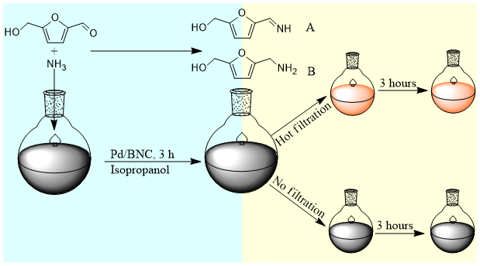

Supplementary Figure 8. Schematic illustration of the hot filtration process

Supplementary Figure 9. Release of Pd during the cycle uses of the Pd₁/BNC catalyst.

Supplementary Figure 10. Four representative HR-TEM image of the Pd₁/BNC catalyst after 7 times reuse.

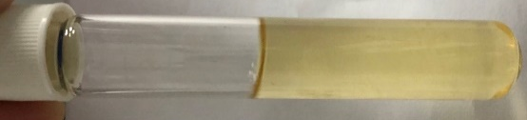

Supplementary Figure 11. Products image of the upscaling reaction of the reductive amination of HMF

Supplementary Figure 12. GC chromatogram of the upscaling reaction of the reductive amination of HMF
Compounds | Formula | Molecular weight | Main ion stream
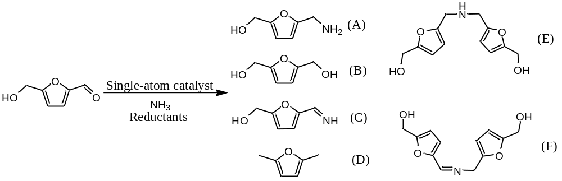 | C₆H₉O₂N | 127 | 128 (M+H)⁺  97 (M+H-CH₂OH)⁺  79 (M+H-CH₂OH-H₂O)⁺
 | C₆H₈O₃ | 127 | 128 (M+H)⁺  97 (M+H-CH₂OH)⁺  79 (M+H-CH₂OH-H₂O)⁺
 | C₆H₇O₂N | 125 | 126 (M+H)⁺  95 (M+H-CH₂OH)⁺  77 (M+H-CH₂OH-H₂O)⁺
 | C₆H₈O | 96 | 97 (M+H)⁺
 | C₁₂H₁₅O₄N | 237 | 238 (M+H)⁺  207 (M+H-CH₂OH)⁺  176 (M+H-CH₂OH- CH₂OH)⁺
 | C₁₂H₁₃O₄N | 235 | 236 (M+H)⁺  205 (M+H-CH₂OH)⁺  174 (M+H-CH₂OH- CH₂OH)⁺

Supplementary Figure 13. MS spectrum of the products of the reductive amination of HMF.
Entry | Potential (V) vs RHE | Temperature  (ºC) | Products distribution (mg/g-lignin) / (mmol/g-lignin) |  |  |  |  |  |  | Total aromatics yields (mg/g- lignin) | Ratio of molar yields (%) ª
1 | 1.4 | 60 | 61 / 0.85 | 64 / 0.52 | 33 / 0.19 | 44 / 0.29 | 108 / 0.71 | 21 / 0.12 | 6 / 0.03 | 277 | 43.1
2 | 1.5 | 60 | 63/ 0.89 | 69 /0.56 | 28 / 0.17 | 72 / 0.48 | 181 / 1.19 | 43 / 0.25 | 24 / 0.13 | 415 | 64.3
3 | 1.6 | 60 | 96 /1.60 | 74 / 0.59 | 21 / 0.12 | 89 / 0.59 | 211 / 1.39 | 66 / 0.40 | 36 / 0.20 | 497 | 76.1
4 | 1.5 | 45 | 43/ 0.71 | 55/0.44 | 22 / 0.13 | 43 / 0.28 | 87 / 0.57 | 21 / 0.12 | 12 / 0.07 | 238 | 37.3
5 | 1.5 | 75 | 104 / 1.73 | 109 /0.83 | 43 / 0.26 | 82 / 0.55 | 195 / 1.28 | 64 / 0.39 | 34 / 0.19 | 527 | 81.0
ª The ratio of molar yields (RMY) = Total molar yields of the aromatics (mmol / g-lignin) over electrochemical oxidation / molar yield of aromatics determined via nitrobenzene oxidation method; the theoretical aromatics amounts of the lignin determined by the nitrobenzene oxidation method is 4.32 mmol/g-lignin.
Supplementary Figure 14. Electrochemical oxidative depolymerization of lignin.

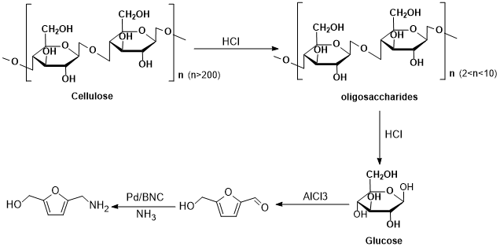

Supplementary Figure 15. Schematic illustration of adopting cellulose as a feedstock for the production of biomass derived amines via reductive amination.
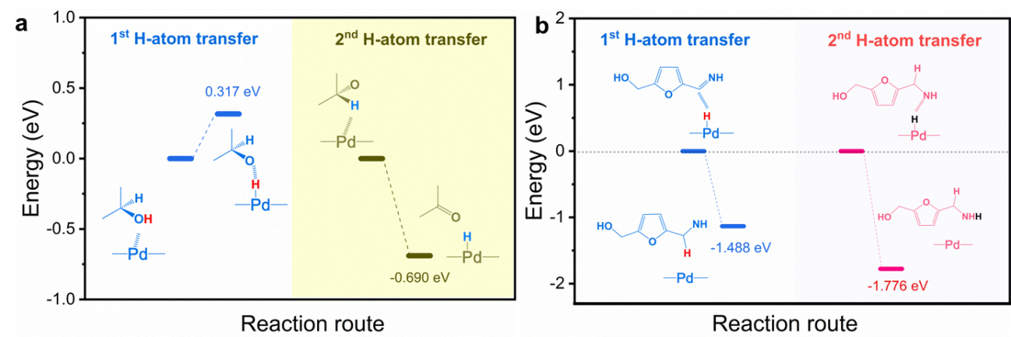

Supplementary Figure 16. Energy diagrams of (a) the deprotonation of isopropanol on the Pd single atom catalyst, (b) the formation of the target product through two steps of H-atom transfer after the amination of HMF.
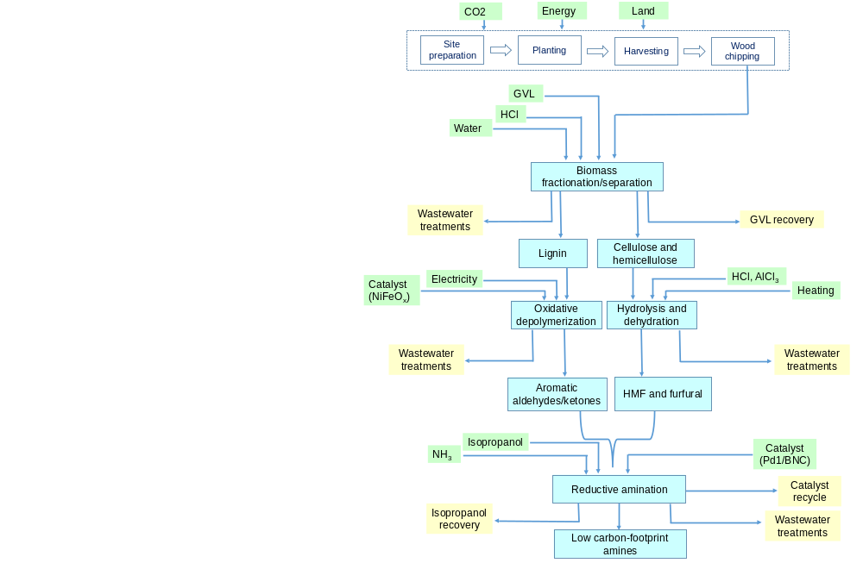

Supplementary Figure 17. System boundary for the LCA analysis
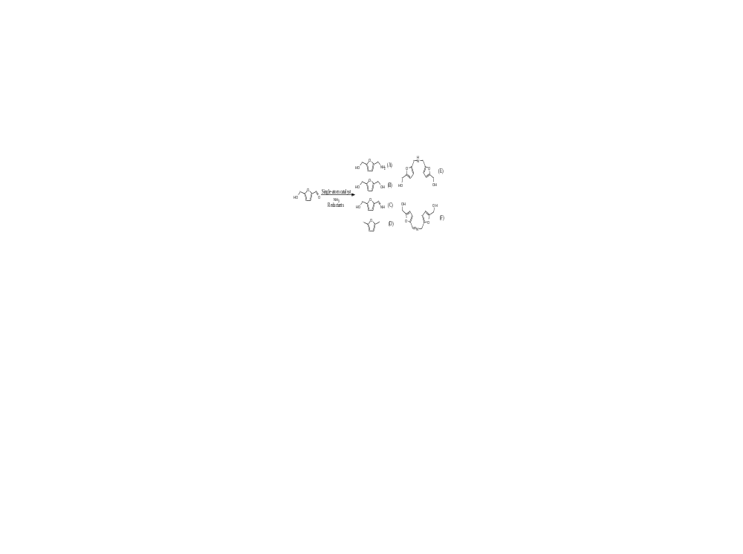

Supplementary Figure S18. ¹³C NMR of the furan-2-ylmethanamine (S1) (600 MHz, DMSO-d6) δ 149.65, 143.10, 113.38, 110.23, 43.10

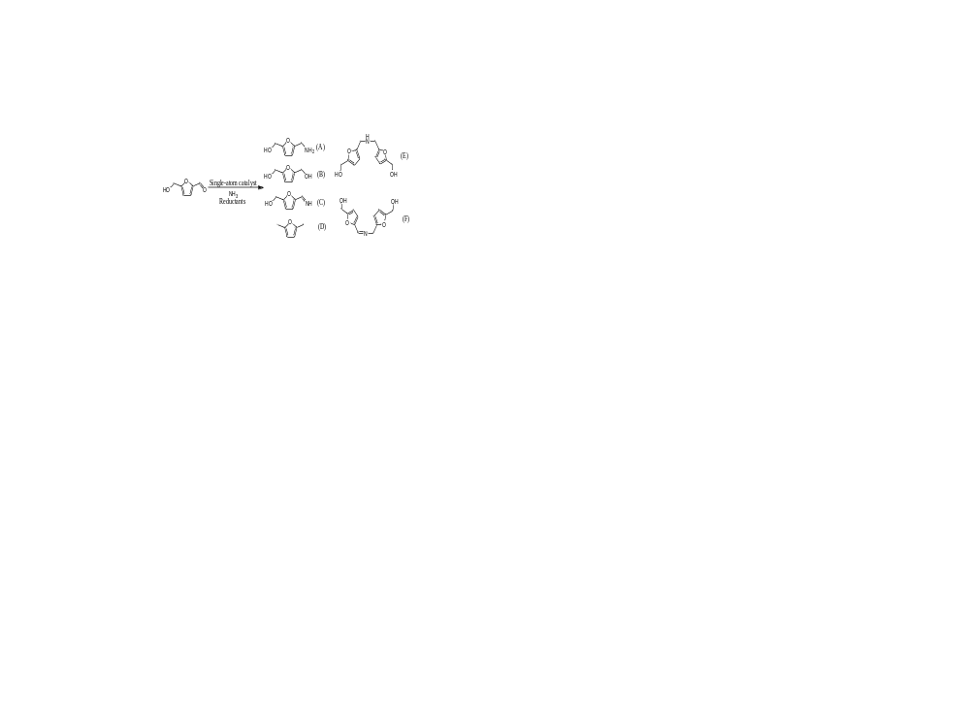

Supplementary Figure 19.¹³C NMR of the (5-methylfuran-2-yl)methanamine (S2) (600 MHz, DMSO-d6) δ 149.12, 145.24, 107.58, 106.28, 44.20, 14.20



Supplementary Figure 20. ¹³C NMR of the 5-(aminomethyl)furfural (S3) (600 MHz, DMSO-d6) δ 177.76, 160.16, 152.11, 125.61, 110.26, 42.23



Supplementary Figure 21. ¹³C NMR of the furan-2,5-diyldimethanamine (S4) (600 MHz, DMSO-d6) δ 146.65, 108.35, 42.65

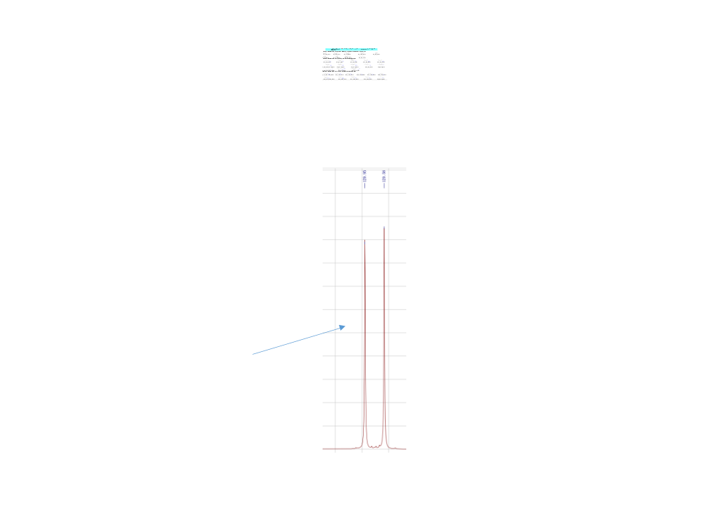

Supplementary Figure 22. ¹³C NMR of the 4-(aminomethyl)phenol (S5) (600 MHz, DMSO-d6) δ 154.32, 129.95, 129.85, 115.35, 43.38

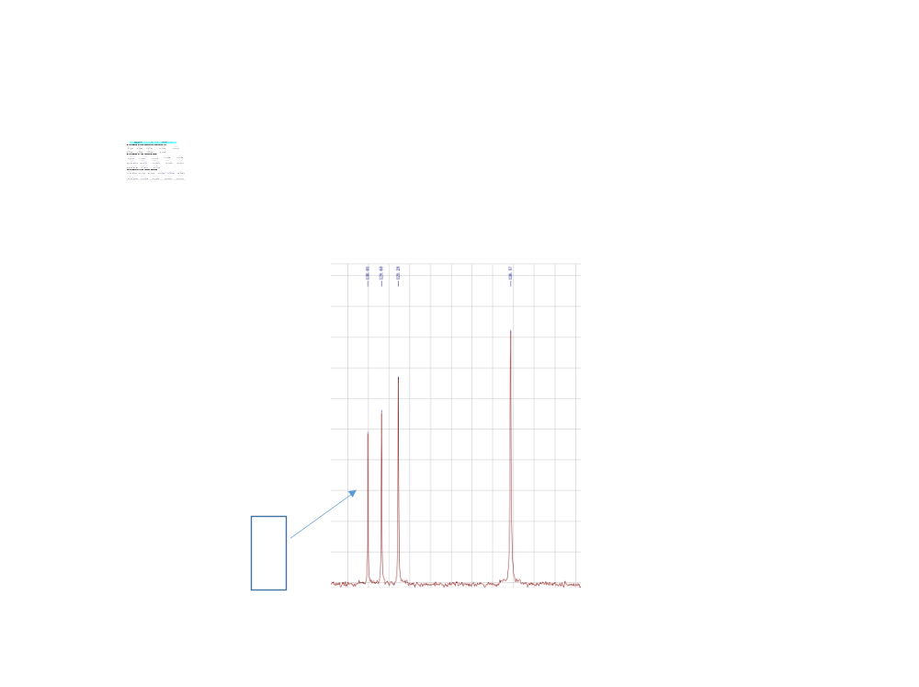

Supplementary Figure 23. ¹³C NMR of the phenylmethanamine (S6) (600 MHz, DMSO-d6) δ 144.71, 130.01, 129.68, 129.28, 126.57, 45.13.



Supplementary Figure 24. ¹³C NMR of the 4-(aminomethyl)-2-methoxyphenol (S7) (600 MHz, DMSO-d6) δ 147.04, 144.03, 135.94, 120.24, 117.31, 110.25, 56.56, 46.35.

Supplementary Figure 25. ¹³C NMR of the 4-phenylbut-2-en-1-amine (S8) (600 MHz, DMSO-d6) δ 142.73, 129.42, 128.73, 125.83, 124.88, 117.31, 56.48, 46.89.

Supplementary Figure 26. ¹³C NMR of the heptan-1-amine (S9) (600 MHz, DMSO-d6) δ 42.54, 35.21, 32.92, 29.26, 25.61, 22.52, 14.09.

Supplementary Figure 27. ¹³C NMR of the (5-((phenylamino)methyl)furan-2-yl)methanol (S10, S23) (600 MHz, DMSO-d6) δ 152.36, 144.03, 129.72, 129.38, 124.91, 120.21, 117.34, 110.25, 56.56.



Supplementary Figure 28. ¹³C NMR of the (5-((p-tolylamino)methyl)furan-2-yl)methanol (S11, S24) (600 MHz, DMSO-d6) δ 151.74, 149.10, 148.61, 129.78, 129.35, 126.49, 120.21, 114.48, 113.31, 109.98, 56.46, 21.56.

Supplementary Figure 29. ¹³C NMR of the 4-(((5-(hydroxymethyl)furan-2-yl)methyl)amino)phenol (S12, S26) (600 MHz, DMSO-d6) δ 152.36, 145.36, 144.33, 118.29, 117.36, 107.95, 56.56.



Supplementary Figure 30. ¹³C NMR of the 3-(((5-(hydroxymethyl)furan-2-yl)methyl)amino)phenol (S13, S27) (600 MHz, DMSO-d6) δ 158.78, 150.94, 149.00, 147.96, 129.47, 109.30, 108.06, 57.76.



Supplementary Figure 31. ¹³C NMR of the 2-(((5-(hydroxymethyl)furan-2-yl)methyl)amino)phenol (S14, S28) (600 MHz, DMSO-d6) δ 152.11, 140.52, 139.01, 122.65, 117.27, 115.67, 113.40, 110.26, 57.61.

Supplementary Figure 32. ¹³C NMR of the (5-(((4-chlorophenyl)amino)methyl)furan-2-yl)methanol (S15, S32) (600 MHz, DMSO-d6) δ 152.4, 149. 2, 145.2, 129.7, 124.9, 120.2, 117.3, 107.0, 56.6.

Supplementary Figure 33. ¹³C NMR of the 4-(((5-(hydroxymethyl)furan-2-yl)methyl)amino)benzenesulfonic acid (S16, S33) (600 MHz, DMSO-d6) δ 154.4, 146. 8, 144.2, 127.4, 124.9, 115.5, 113.3, 107.4, 57.0.

Supplementary Figure 34. ¹³C NMR of the 4-(((5-(hydroxymethyl)furan-2-yl)methyl)amino)benzoic acid (S17, S31) (600 MHz, DMSO-d6) δ 168.9, 154.7, 152.3, 131.9, 120.8, 110.2, 107.3, 56.5.

Supplementary Figure 35. ¹³C NMR of the 1-(4-(((5-(hydroxymethyl)furan-2-yl)methyl)amino)phenyl)ethanone (S30) (600 MHz, DMSO-d6) δ 193.7, 153.6, 148.7, 130.0, 129.7, 129.3, 111.3, 107.9, 56.1.

Supplementary Figure 36. ¹³C NMR of the 4-(((5-(hydroxymethyl)furan-2-yl)methyl)amino)benzaldehyde (S29) (600 MHz, DMSO-d6) δ 192.0, 152.9, 152.3, 148.6, 130.5, 125.9, 112.6, 107.8, 56.3.


Supplementary Figure 37. ¹³C NMR of the (5-((butylamino)methyl)furan-2-yl)methanol (S18) (600 MHz, DMSO-d6) δ 154.2, 147.7, 107.3, 56.2, 50.5, 47.4, 20.3, 14.2.


Supplementary Figure 38. ¹³C NMR of the 2-(((5-(hydroxymethyl)furan-2-yl)methyl)amino)ethanol (S19) (600 MHz, DMSO-d6) δ 152.1, 147.8, 107.8, 60.8, 57.1, 50.7.



Supplementary Figure 39. ¹³C NMR of the 2,2'-(((5-(hydroxymethyl)furan-2-yl)methyl)azanediyl)diethanol (S20) (600 MHz, DMSO-d6) δ 153.1, 149.6, 106.9, 58.4, 56.9.

Supplementary Figure 40. ¹³C NMR of the (5-((diphenylamino)methyl)furan-2-yl)methanol (S21) (600 MHz, DMSO-d6) δ 152.3, 148.7, 145.5, 143.0, 129.8, 122.9, 118.9, 110.0, 60.9, 56.5.

Supplementary Figure 41. ¹³C NMR of the (5-((2-methyl-1H-imidazol-1-yl)methyl)furan-2-yl)methanol (S22) (600 MHz, DMSO-d6) δ 152.3, 150.3, 145.8, 125.8, 120.4, 110.2, 56.5, 12.6.

1. Standardization, I. O. f., Environmental Management: Life Cycle Assessment; Principles and Framework. ISO: 2006; Vol. 14044.

