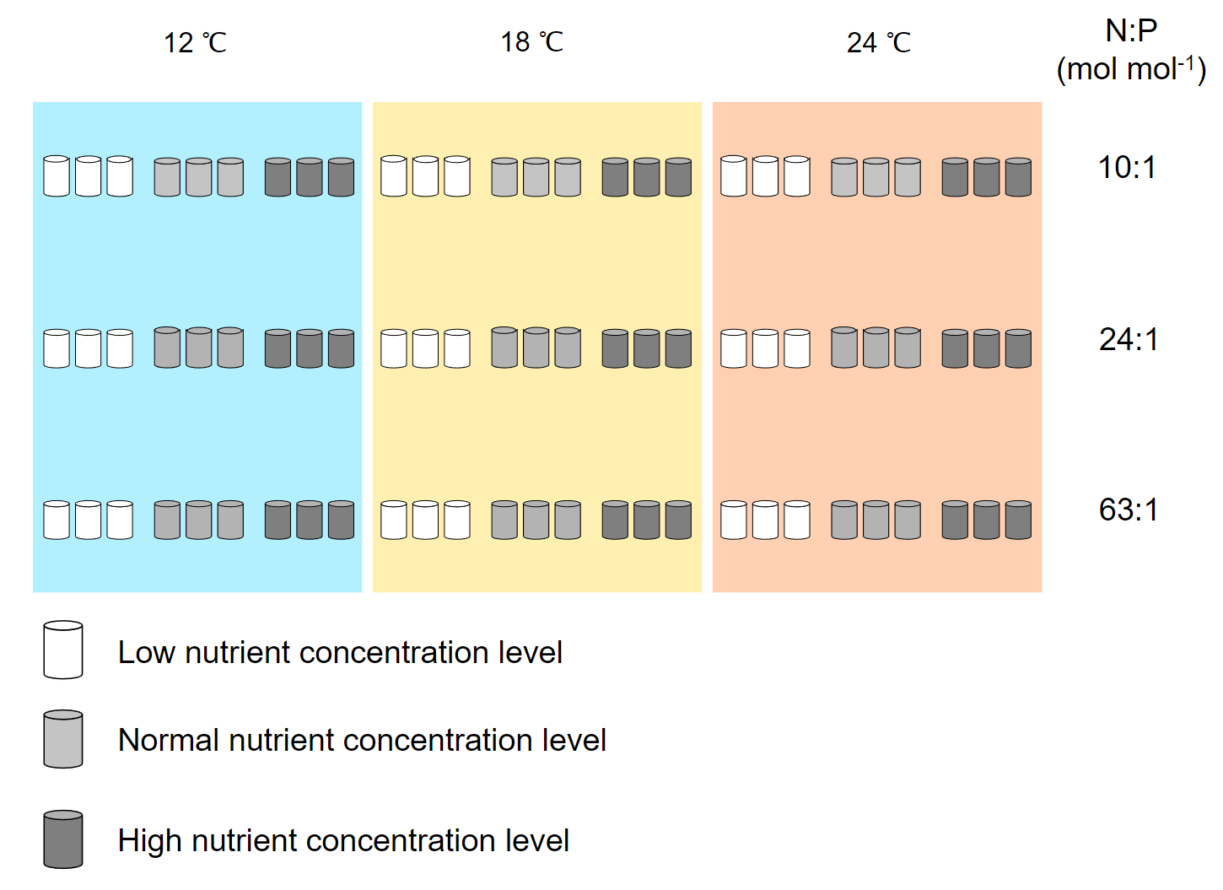
Supplementary Fig. 1 Schematic diagram of monoculture conditions for Phaeodactylum tricornutum and Prorocentrum minimum.

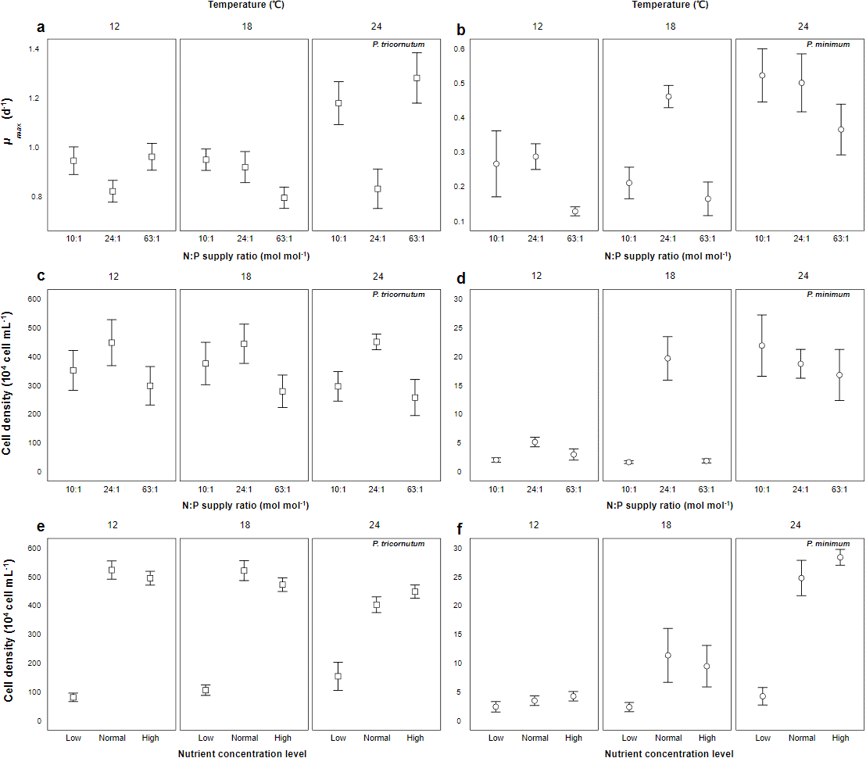
Supplementary Fig. 2 The observed maximal growth rate (μ_{max}, d⁻¹, mean ± SE) and cell density at steady state (cell density, 10⁴ cells ml⁻¹, mean ± SE) under different temperatures (12, 18 and 24 ℃) and N:P supply ratios (molar ratios 10:1, 24:1 and 63:1), and cell density of steady state during semi-continuous cultures (cell density, 10⁴ cells ml⁻¹, mean ± SE), under different temperatures and nutrient concentrations (low, normal and high) in monocultures of Phaeodactylum tricornutum and Prorocentrum minimum.

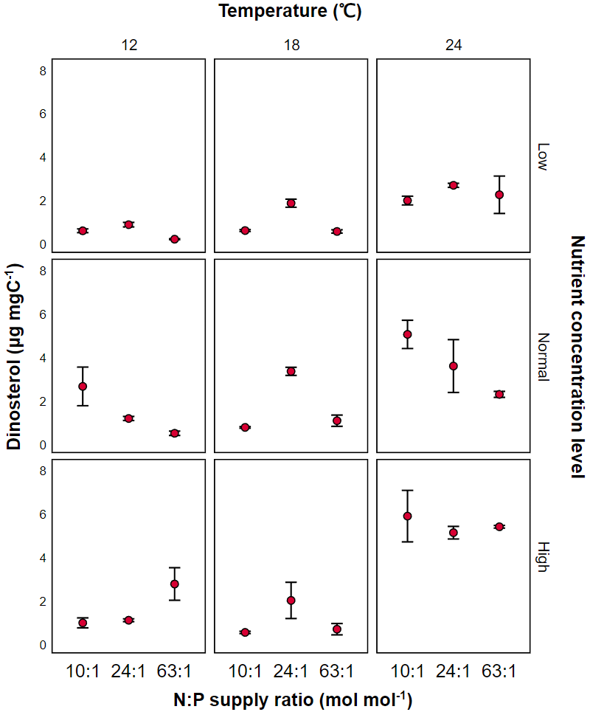
Supplementary Fig. 3 The effects of temperature, N and P concentrations and their ratios on C-normalized contents of dinosterol (mean ± SE) in the dinoflagellate Prorocentrum minimum.

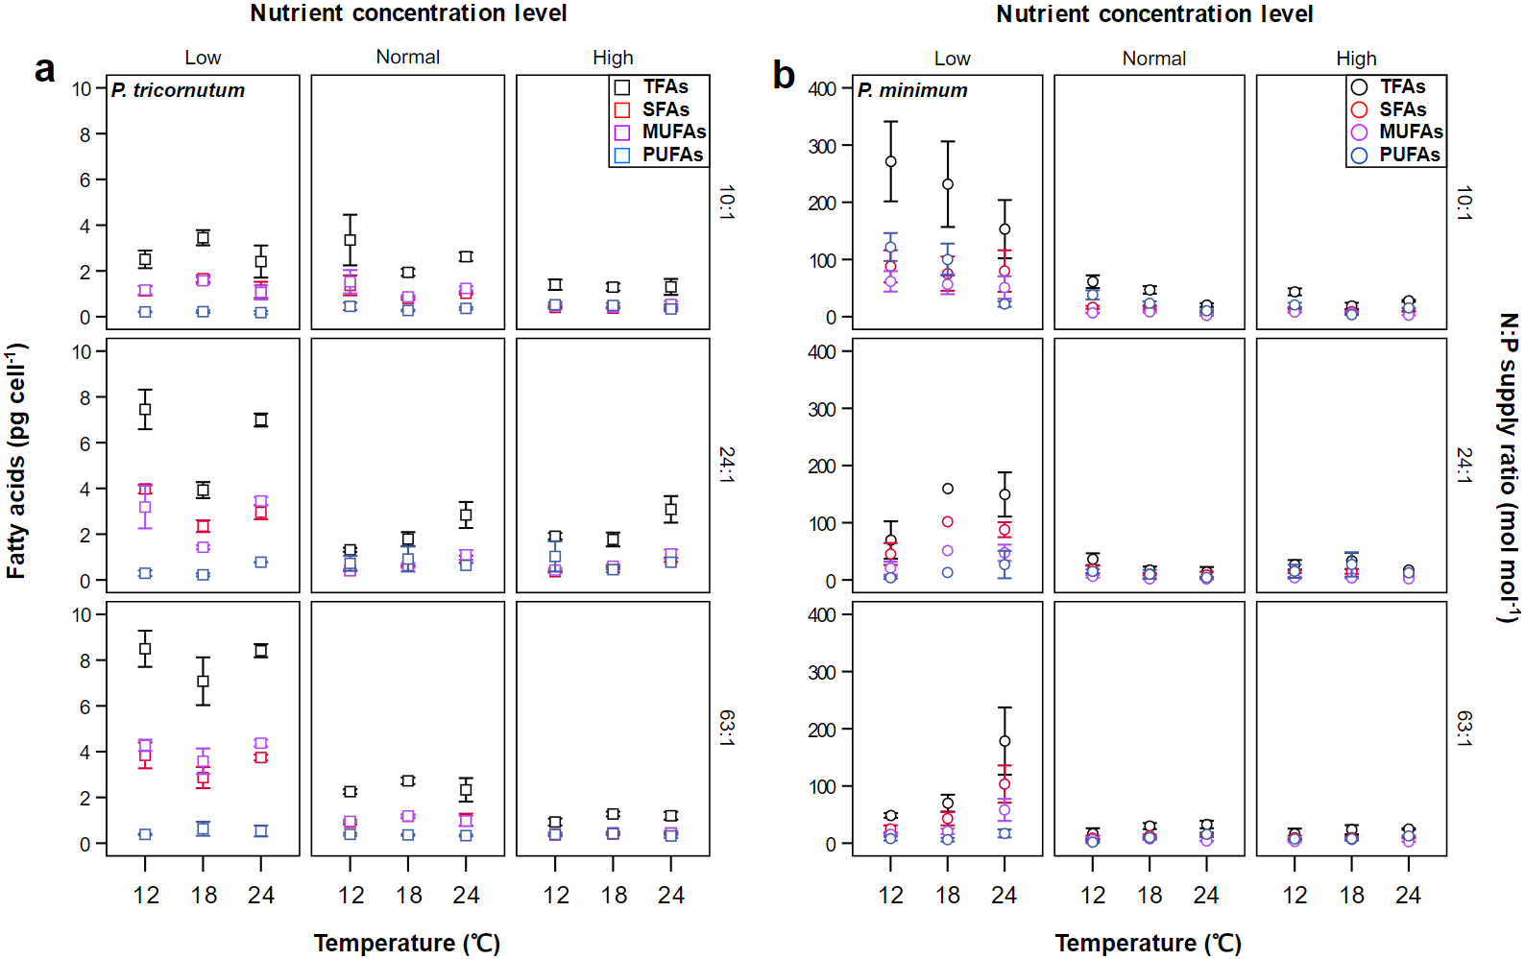
Supplementary Fig. 4 The effects of temperature, N and P concentrations and their ratios on per-cell contents of TFAs, SFAs, MUFAs and PUFAs (mean ± SE) in the diatom Phaeodactylum tricornutum and the dinoflagellate Prorocentrum minimum.

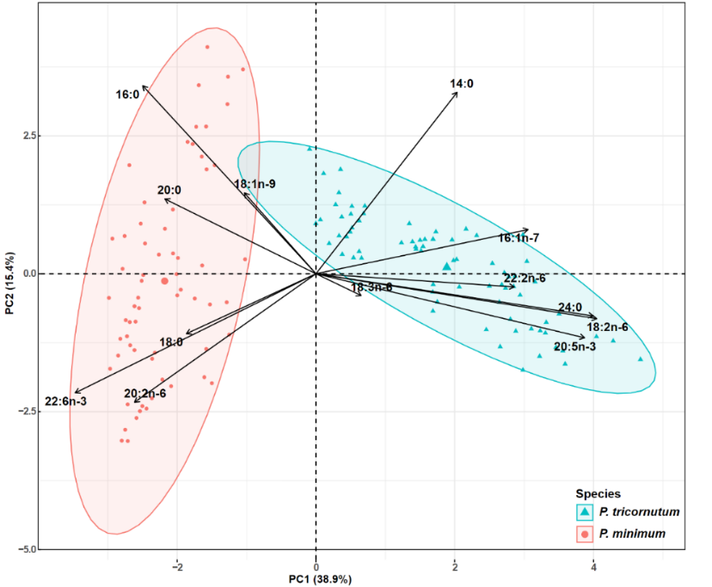
Supplementary Fig. 5 PCA biplot of fatty acid composition (as % of total fatty acids) under the entire ranges of temperature, N and P concentrations and their ratios in Phaeodactylum tricornutum and Prorocentrum minimum.

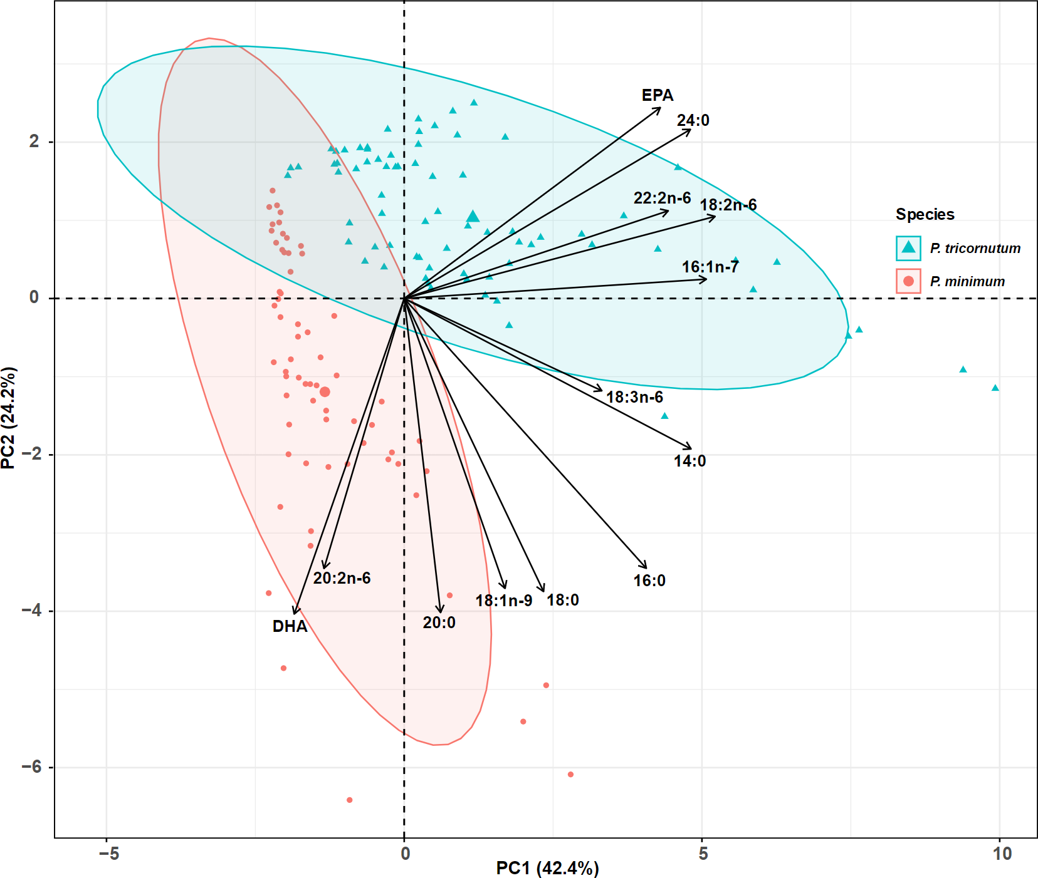
Supplementary Fig. 6 PCA biplot of carbon-normalized contents of major fatty acids under different temperatures, N and P concentration and their ratios in the diatom Phaeodactylum tricornutum and the dinoflagellate Prorocentrum minimum.

Supplementary Table 1. N and P concentrations and their ratios in monocultures of Phaeodactylum tricornutum and Prorocentrum minimum.

N:P supply ratio |  |  | 10:1 | 24:1 | 63:1
Nutrient concentration level  (μmol L⁻¹) | Low | N | 35.2 | 88 | 88
Nutrient concentration level  (μmol L⁻¹) | Low | P | 3.6 | 3.6 | 1.4
Nutrient concentration level  (μmol L⁻¹) | Normal | N | 352 | 880 | 880
Nutrient concentration level  (μmol L⁻¹) | Normal | P | 36 | 36 | 14
Nutrient concentration level  (μmol L⁻¹) | High | N | 1760 | 4400 | 4400
Nutrient concentration level  (μmol L⁻¹) | High | P | 180 | 180 | 70

Supplementary Table 2. Results of Akaike information criterion corrected (AICc) in GLMMs testing for the effects of temperature, N:P concentrations and their ratios on per-cell POC contents, and per-cell and carbon-normalized contents of sterols and FAs. The selected models are in bold. POC: particulate organic carbon; TFAs: total fatty acids; SFAs: saturated fatty acids; MUFAs: monounsaturated fatty acids; PUFAs: polyunsaturated fatty acids; EPA: eicosapentaenoic acid (20:5n-3); DHA: docosahexaenoic acid (22:6n-3). The effect builder of ‘main’ refers to models containing first order effects of the three factors, with that of ‘main, two way’ for models containing first order effects and second order interactions and that of ‘main, two way and three way’ for models containing first order effects, second and third order interactions. Brassicasterol: brassicasterol/epi-brassicasterol; Campesterol: campesterol/5-ergostenol.
Specie | Variable | Effect builder | AICc
P. tricornutum | POC/cell | Main | 67.444
 |  | Main, two way | 112.499
 |  | Main, two way and three way | 137.798
 | Brassicasterol/cell | Main | -362.477
 |  | Main, two way | -285.341
 |  | Main, two way and three way | -255.506
 | Brassicasterol/POC | Main | 74.279
 |  | Main, two way | 116.509
 |  | Main, two way and three way | 144.909
 | SFA/cell | Main | 41.436
 |  | Main, two way | 101.765
 |  | Main, two way and three way | 130.513
 | MUFA/cell | Main | 45.483
 |  | Main, two way | 103.403
 |  | Main, two way and three way | 131.795
 | PUFA/cell | Main | 46.458
 |  | Main, two way | 99.756
 |  | Main, two way and three way | 129.064
 | TFA/cell | Main | 35.641
 |  | Main, two way | 90.531
 |  | Main, two way and three way | 120.051
 | ω-3PUFA/POC | Main | 93.642
 |  | Main, two way | 154.655
 |  | Main, two way and three way | 182.063
 | SFA/POC | Main | 70.239
 |  | Main, two way | 125.964
 |  | Main, two way and three way | 153.746
 | MUFA/POC | Main | 68.065
 |  | Main, two way | 126.962
 |  | Main, two way and three way | 155.17
 | PUFA/POC | Main | 92.749
 |  | Main, two way | 153.992
 |  | Main, two way and three way | 181.467
 | TFA/POC | Main | 60.072
 |  | Main, two way | 120.754
 |  | Main, two way and three way | 146.862
 | EPA/cell | Main | 54.761
 |  | Main, two way | 105.304
 |  | Main, two way and three way | 134.172
 | EPA/POC | Main | 206.513
 |  | Main, two way | 262.528
 |  | Main, two way and three way | 288.211
 | DHA/cell | Main | 34.673
 |  | Main, two way | 97.502
 |  | Main, two way and three way | 126.588
 | DHA/POC | Main | 85.850
 |  | Main, two way | 143.170
 |  | Main, two way and three way | 170.108
P. minimum | POC/cell | Main | 65.816
 |  | Main, two way | 126.311
 |  | Main, two way and three way | 153.818
 | Cholesterol/cell | Main | 45.839
 |  | Main, two way | 103.675
 |  | Main, two way and three way | 132.769
 | Brassicasterol/cell | Main | 85.85
 |  | Main, two way | 142.398
 |  | Main, two way and three way | 170.711
 | Campesterol/cell | Main | 97.647
 |  | Main, two way | 152.147
 |  | Main, two way and three way | 180.926
 | Dinosterol/cell | Main | 34.625
 |  | Main, two way | 93.044
 |  | Main, two way and three way | 122.279
 | Total sterol/cell | Main | 51.837
 |  | Main, two way | 110.185
 |  | Main, two way and three way | 139.008
 | Cholesterol/POC | Main | 59.028
 |  | Main, two way | 114.354
 |  | Main, two way and three way | 137.762
 | Brassicasterol/POC | Main | 60.346
 |  | Main, two way | 113.272
 |  | Main, two way and three way | 134.416
 | Campesterol/POC | Main | 68.799
 |  | Main, two way | 111.245
 |  | Main, two way and three way | 135.731
 | Dinosterol/POC | Main | 92.958
 |  | Main, two way | 152.764
 |  | Main, two way and three way | 178.107
 | Total sterol/POC | Main | 56.703
 |  | Main, two way | 113.588
 |  | Main, two way and three way | 136.126
 | SFA/cell | Main | 89.178
 |  | Main, two way | 146.286
 |  | Main, two way and three way | 174.591
 | MUFA/cell | Main | 117.686
 |  | Main, two way | 173.746
 |  | Main, two way and three way | 201.581
 | PUFA/cell | Main | 112.085
 |  | Main, two way | 163.597
 |  | Main, two way and three way | 190.937
 | TFA/cell | Main | 91.235
 |  | Main, two way | 144.317
 |  | Main, two way and three way | 172.655
 | ω-3 PUFA/POC | Main | 327.313
 |  | Main, two way | 367.667
 |  | Main, two way and three way | 390.101
 | SFA/POC | Main | 59.938
 |  | Main, two way | 116.917
 |  | Main, two way and three way | 143.434
 | MUFA/POC | Main | 42.6
 |  | Main, two way | 95.546
 |  | Main, two way and three way | 121.258
 | PUFA/POC | Main | 95.881
 |  | Main, two way | 147.656
 |  | Main, two way and three way | 172.1
 | TFA/POC | Main | 43.406
 |  | Main, two way | 93.942
 |  | Main, two way and three way | 120.336
 | DHA/cell | Main | 89.546
 |  | Main, two way | 143.182
 |  | Main, two way and three way | 170.734
 | DHA/POC | Main | 85.445
 |  | Main, two way | 136.932
 |  | Main, two way and three way | 160.562

Supplementary Table 3. Carbon-normalized contents (µg mg C⁻¹; mean ± SE) and mean proportions of fatty acids and sterols under different temperatures (12, 18 and 24 ℃), N:P supply ratios (molar ratios 10:1, 24:1 and 63:1) and nutrient concentrations (low, normal and high levels) in monocultures of Phaeodactylum tricornutum and Prorocentrum minimum.
P. tricornutum | 12 ℃
 | Low nutrient level |  |  |  |  |  | Normal nutrient level |  |  |  |  |  | High nutrient level
 | N:P = 10:1 |  | N:P = 24:1 |  | N:P = 63:1 |  | N:P = 10:1 |  | N:P = 24:1 |  | N:P = 63:1 |  | N:P = 10:1 |  | N:P = 24:1 |  | N:P = 63:1
 | Content | % | Content | % | Content | % | Content | % | Content | % | Content | % | Content | % | Content | % | Content | %
14:0 | 7.87±2.62 | 4% | 15.2±2.75 | 7% | 11.38±2.21 | 5% | 26.64±9.28 | 7% | 5.21±0.89 | 6% | 16.53±1.4 | 6% | 3.6±0.74 | 7% | 4.63±0.22 | 4% | 4.26±1.33 | 6%
16:0 | 73.9±10.16 | 38% | 88.61±11.97 | 42% | 77.37±7.71 | 37% | 125.81±42.3 | 31% | 17.84±0.92 | 20% | 75.36±8.59 | 30% | 10.12±0.16 | 18% | 13.41±0.78 | 12% | 21.21±3.52 | 28%
16:1 | 83.85±11.76 | 44% | 82.45±38.09 | 39% | 100.03±6.79 | 48% | 173.68±61.16 | 43% | 23.97±0.38 | 27% | 101.05±14.26 | 40% | 15.96±0.84 | 29% | 19.4±1.51 | 18% | 28.96±4.48 | 38%
18:0 | 2.93±0.23 | 2% | 3.18±0.4 | 2% | 3.22±0.03 | 2% | 4.39±1.38 | 1% | 2.08±1.15 | 2% | 4.55±0.41 | 2% | 0.8±0.03 | 1% | 0.68±0.03 | 1% | 1.92±0.73 | 3%
18:1n-9c | 4.38±0.43 | 2% | 9.55±3.84 | 5% | 6.28±0.5 | 3% | 8.98±3.12 | 2% | 3.45±0.5 | 4% | 6.72±0.92 | 3% | 2.66±0.24 | 5% | 4.87±1.53 | 4% | 2.71±0.17 | 4%
18:2n-6c | 4.03±0.37 | 2% | 2.35±1.1 | 1% | 2.73±0.18 | 1% | 12.61±4.67 | 3% | 5.05±0.46 | 6% | 8.68±1.66 | 3% | 3.59±0.47 | 7% | 4.4±0.52 | 4% | 6.05±0.63 | 8%
20:2n-6 | 2.88±0.54 | 2% | 0±0 | 0% | 2.52±0.58 | 1% | 4.94±2.05 | 1% | 0.03±0.03 | 0% | 2.91±0.84 | 1% | 0.31±0.02 | 1% | 0.07±0.02 | 0% | 0±0 | 0%
24:0 | 1.58±0.16 | 1% | 0.75±0.02 | 0% | 1.01±0.16 | 0% | 3.32±0.81 | 1% | 2.32±0.4 | 3% | 3.18±0.5 | 1% | 1.21±0.05 | 2% | 1.47±0.08 | 1% | 1.93±0.24 | 3%
20:5n-3 | 8.54±1.69 | 4% | 4.71±2.9 | 2% | 4.43±0.81 | 2% | 29.66±11.47 | 7% | 24.85±5.86 | 28% | 30.24±9.68 | 12% | 15.02±1.93 | 27% | 26.65±10.11 | 24% | 21.35±2.97 | 28%
22:6n-3 | 0.91±0.51 | 0% | 0.39±0.21 | 0% | 0±0 | 0% | 5.64±1.59 | 1% | 2.33±0.27 | 3% | 1.95±0.68 | 1% | 1.38±0.24 | 3% | 1.81±0.41 | 2% | 1.58±0.17 | 2%
ω-3 PUFA | 10.25±2.08 | 5% | 5.79±3.57 | 2% | 5.33±0.99 | 3% | 36.37±13.2 | 9% | 27.66±6.21 | 30% | 33.33±10.63 | 13% | 16.48±2.23 | 30% | 28.8±10.63 | 35% | 23.23±3.23 | 26%
ΣSFA | 86.78±13.28 | 45% | 108.19±15.18 | 52% | 94.46±10.09 | 45% | 164.11±55.17 | 41% | 27.88±1.65 | 31% | 101.51±10.32 | 40% | 15.84±0.89 | 29% | 20.46±1.07 | 19% | 29.31±4.94 | 38%
ΣMUFA | 88.82±11.67 | 46% | 92.3±42.04 | 44% | 106.3±7.26 | 51% | 183.31±64.54 | 46% | 27.67±0.76 | 31% | 107.94±15 | 42% | 18.61±1.03 | 34% | 24.48±3.02 | 22% | 31.67±4.34 | 41%
ΣPUFA | 16.35±2.8 | 9% | 8.64±4.92 | 4% | 9.69±1.57 | 5% | 54.27±20.23 | 14% | 49.26±22.57 | 55% | 45.95±13.47 | 18% | 20.31±2.64 | 37% | 56.14±33.8 | 51% | 28.98±3.13 | 38%
ΣTFA | 191.95±25.49 | 100% | 209.13±62.13 | 100% | 210.46±15.9 | 100% | 401.69±139.92 | 100% | 89.07±6.44 | 100% | 255.39±35.72 | 100% | 54.76±4.54 | 100% | 110.18±16.2 | 100% | 76.35±18.99 | 100%
Brassicasterol | 3.23±0.55 |  | 2.02±0.68 |  | 0.96±0.12 |  | 5.6±0.7 |  | 2.77±0.18 |  | 5.26±0.94 |  | 2.06±0.15 |  | 2.77±0.16 |  | 5.29±0.13

Supplementary Table 3 continued
P. tricornutum | 18℃
 | Low nutrient level |  |  |  |  |  | Normal nutrient level |  |  |  |  |  | High nutrient level
 | N:P = 10:1 |  | N:P = 24:1 |  | N:P = 63:1 |  | N:P = 10:1 |  | N:P = 24:1 |  | N:P = 63:1 |  | N:P = 10:1 |  | N:P = 24:1 |  | N:P = 63:1
 | Content | % | Content | % | Content | % | Content | % | Content | % | Content | % | Content | % | Content | % | Content | %
14:0 | 13.2±3.16 | 5% | 13.23±1 | 8% | 13.52±0.43 | 5% | 15.06±0.79 | 7% | 12.23±1.83 | 9% | 29.78±4.38 | 7% | 2.46±0.16 | 5% | 7.26±0.57 | 8% | 4.52±1.46 | 5%
16:0 | 115.97±3.35 | 41% | 85.98±5.21 | 49% | 81.98±0.44 | 32% | 66.59±3.86 | 31% | 26.85±1.79 | 21% | 135.02±14.83 | 32% | 10.59±0.24 | 20% | 17.44±2.13 | 19% | 17.55±3.33 | 21%
16:1n-7 | 121.15±5.67 | 43% | 57.93±0.58 | 33% | 119.85±8.01 | 47% | 90.78±3.89 | 42% | 34.93±6.31 | 27% | 167.74±14.75 | 40% | 14.44±0.07 | 28% | 22.78±2.1 | 25% | 26.18±3.68 | 32%
18:0 | 4.08±0.52 | 1% | 3.79±0.13 | 2% | 3.53±0.35 | 1% | 3.46±0.85 | 2% | 2.59±1.45 | 2% | 7.5±1.02 | 2% | 1.16±0.47 | 2% | 0.83±0.21 | 1% | 1.84±0.44 | 2%
18:1n-9 | 7.71±0.31 | 3% | 5.96±0.14 | 3% | 7.55±0.35 | 3% | 5.94±0.34 | 3% | 10.39±2.08 | 8% | 13.95±1.18 | 3% | 2.97±0.28 | 6% | 8.3±1.41 | 9% | 3.14±0.87 | 4%
18:2n-6 | 4.68±0.37 | 2% | 2.29±0.04 | 1% | 4.06±1.25 | 2% | 7.16±0.33 | 3% | 5.04±0.12 | 4% | 12.36±0.61 | 3% | 2.61±0.16 | 5% | 4.06±0.61 | 4% | 5.79±1.32 | 7%
20:2n-6 | 3.41±0.58 | 1% | 0±0 | 0% | 6.87±4.22 | 3% | 2.45±0.38 | 1% | 0.11±0.03 | 0% | 5.65±0.06 | 1% | 0.41±0.06 | 1% | 0.1±0.02 | 0% | 0±0 | 0%
24:0 | 1.65±0.06 | 1% | 1.36±0.06 | 1% | 1.06±0.07 | 0% | 2.19±0.22 | 1% | 2.01±0.22 | 2% | 4.87±0.38 | 1% | 1.07±0.06 | 2% | 1.44±0.09 | 2% | 2.03±0.41 | 2%
20:5n-3 | 8.78±1.71 | 3% | 3.52±0.18 | 2% | 11.69±6.7 | 5% | 17.1±1.29 | 8% | 31.51±12.63 | 24% | 30.14±1.38 | 7% | 15.42±2.38 | 29% | 26.35±8.25 | 29% | 19.28±4.73 | 23%
22:6n-3 | 0.61±0.61 | 0% | 0.25±0.03 | 0% | 0.39±0.39 | 0% | 2.56±0.76 | 1% | 1.67±0.59 | 1% | 2.88±0.18 | 1% | 0.95±0.07 | 2% | 1.18±0.31 | 1% | 1.9±0.43 | 2%
ω-3 PUFA | 6.44±1.93 | 2% | 4.17±0.26 | 2% | 13.17±7.58 | 5% | 20.56±1.37 | 9% | 34.01±13.41 | 25% | 34.77±1.72 | 8% | 16.47±2.42 | 31% | 28.24±8.66 | 30% | 21.5±5.33 | 26%
ΣSFA | 136.6±5.55 | 48% | 105.28±4.42 | 60% | 101.57±1.07 | 40% | 89.52±5.51 | 41% | 44.27±2.33 | 34% | 180.51±20.67 | 43% | 15.29±0.91 | 29% | 27.3±3.7 | 30% | 25.94±4.43 | 31%
ΣMUFA | 128.87±5.46 | 46% | 64.1±0.38 | 36% | 127.39±8.34 | 50% | 97.21±4.2 | 45% | 45.62±8.4 | 35% | 182.57±16.1 | 44% | 17.41±0.3 | 33% | 31.3±3.64 | 34% | 29.32±4.48 | 36%
ΣPUFA | 17.47±2.69 | 6% | 10.34±3.66 | 6% | 24.14±13.66 | 10% | 30.55±2.08 | 14% | 67.11±40.86 | 52% | 54.89±1.86 | 13% | 19.68±2.94 | 38% | 50.02±31.71 | 55% | 27.27±6.75 | 33%
ΣTFA | 282.94±9.75 | 100% | 176.22±3.88 | 100% | 253.1±22.96 | 100% | 217.27±9.72 | 100% | 130±24.59 | 100% | 417.98±36.66 | 100% | 52.37±2.96 | 100% | 91.73±15.14 | 100% | 82.53±14.13 | 100%
Brassicasterol | 3.37±0.76 |  | 1.25±0.58 |  | 1.03±0.34 |  | 5.48±0.12 |  | 3.03±0.3 |  | 6.34±0.24 |  | 2.54±0.36 |  | 2.94±0.16 |  | 5.02±1.19

Supplementary Table 3 continued
P. tricornutum | 24℃
 | Low nutrient level |  |  |  |  |  | Normal nutrient level |  |  |  |  |  | High nutrient level
 | N:P = 10:1 |  | N:P = 24:1 |  | N:P = 63:1 |  | N:P = 10:1 |  | N:P = 24:1 |  | N:P = 63:1 |  | N:P = 10:1 |  | N:P = 24:1 |  | N:P = 63:1
 | Content | % | Content | % | Content | % | Content | % | Content | % | Content | % | Content | % | Content | % | Content | %
14:0 | 9.69±4.52 | 4% | 29.15±2.35 | 7% | 5.8±1.29 | 4% | 32.22±6.94 | 7% | 5.45±1.98 | 8% | 16.39±4.79 | 8% | 1.45±0.23 | 5% | 4.58±0.89 | 7% | 5.81±1.3 | 6%
16:0 | 89.25±26.39 | 41% | 150.2±10.78 | 34% | 55.59±5.44 | 38% | 137.64±35.26 | 29% | 14.53±3.24 | 21% | 68.67±16.97 | 33% | 6.39±0.67 | 24% | 12.81±1.88 | 19% | 27.06±2.19 | 27%
16:1n-7 | 85.32±24.7 | 40% | 204.29±8.86 | 46% | 70.17±7.39 | 48% | 199.68±52.08 | 42% | 20.72±5.35 | 30% | 78.32±17.26 | 37% | 8.82±1.26 | 33% | 17.92±3.38 | 27% | 29.64±6 | 29%
18:0 | 4.59±1.15 | 2% | 6.09±0.97 | 1% | 3.12±0.39 | 2% | 5.82±1.52 | 1% | 0.56±0.08 | 1% | 3.76±0.84 | 2% | 0.63±0.19 | 2% | 0.5±0.06 | 1% | 2.56±0.66 | 3%
18:1n-9 | 9.7±2.64 | 4% | 15.92±6.85 | 4% | 5.72±0.28 | 4% | 24.22±7.41 | 5% | 5.42±1.5 | 8% | 9.58±1.69 | 5% | 2.07±0.35 | 8% | 6.36±1.8 | 10% | 6.56±1.85 | 7%
18:2n-6 | 3.99±1.11 | 2% | 6.12±1.68 | 1% | 1.53±0.09 | 1% | 11.87±3.27 | 2% | 2.41±0.64 | 4% | 6.52±1.16 | 3% | 0.88±0.13 | 3% | 2.75±0.64 | 4% | 4.12±0.8 | 4%
20:2n-6 | 1.66±0.59 | 1% | 0.31±0.12 | 0% | 1.64±0.25 | 1% | 1.97±0.64 | 0% | 0.09±0.03 | 0% | 1.39±0.19 | 1% | 0.05±0.05 | 0% | 0.09±0.02 | 0% | 0.29±0.29 | 0%
24:0 | 1.24±0.32 | 1% | 1.9±1.2 | 0% | 0±0 | 0% | 3.62±1.02 | 1% | 0.86±0.08 | 1% | 2.39±0.32 | 1% | 0.41±0.05 | 2% | 0.82±0.1 | 1% | 1.89±0.29 | 2%
20:5n-3 | 8.49±2.94 | 4% | 24.62±11.08 | 6% | 3.16±0.42 | 2% | 42.62±14.46 | 9% | 15.51±4.83 | 23% | 17.03±1.18 | 8% | 5.45±0.94 | 20% | 17.96±5.98 | 27% | 21.28±8.45 | 21%
22:6n-3 | 0.42±0.42 | 0% | 1.4±0.86 | 0% | 0±0 | 0% | 5.97±2.05 | 1% | 0.81±0.21 | 1% | 1.45±0.09 | 1% | 0.36±0.07 | 1% | 0.78±0.22 | 1% | 0.94±0.5 | 1%
ω-3 PUFA | 10.16±3.69 | 5% | 29.14±12.11 | 6% | 3.77±0.52 | 3% | 51.58±17.36 | 10% | 16.99±5.28 | 25% | 20.12±1.57 | 10% | 5.95±1.07 | 22% | 19.42±6.39 | 28% | 22.9±8.98 | 21%
ΣSFA | 105.48±32.24 | 49% | 188.45±8.07 | 42% | 65.02±6.51 | 44% | 183.55±45.83 | 39% | 21.67±5.23 | 32% | 92.68±23.15 | 44% | 8.93±0.69 | 34% | 18.94±2.74 | 28% | 37.31±2.68 | 37%
ΣMUFA | 95.02±27.23 | 44% | 220.84±2.27 | 49% | 75.89±7.65 | 51% | 224.31±59.42 | 47% | 26.31±6.83 | 39% | 88.05±18.94 | 42% | 10.89±1.59 | 41% | 24.45±5.18 | 37% | 36.2±7.85 | 36%
ΣPUFA | 15.3±5.16 | 7% | 49.71±2.51 | 11% | 6.7±1.1 | 5% | 68.3±22.15 | 14% | 33.49±19.45 | 49% | 29.87±3.16 | 14% | 6.79±1.15 | 26% | 38.51±22.61 | 58% | 27±9.05 | 27%
ΣTFA | 215.8±62.18 | 100% | 447.19±8.51 | 100% | 147.61±13.29 | 100% | 476.17±127.35 | 100% | 68.24±18.27 | 100% | 210.6±45.25 | 100% | 26.62±3.43 | 100% | 66.62±15.25 | 100% | 100.51±16.75 | 100%
Brassicasterol | 4.04±0.46 |  | 4.1±1.89 |  | 1.04±0.21 |  | 9.51±1.83 |  | 1.67±0.13 |  | 4.84±0.31 |  | 1.46±0.23 |  | 1.55±0.06 |  | 4.89±0.51

Supplementary Table 3 continued

P. minimum | 12℃
 | Low nutrient level |  |  |  |  |  | Normal nutrient level |  |  |  |  |  | High nutrient level
 | N:P = 10:1 |  | N:P = 24:1 |  | N:P = 63:1 |  | N:P = 10:1 |  | N:P = 24:1 |  | N:P = 63:1 |  | N:P = 10:1 |  | N:P = 24:1 |  | N:P = 63:1
 | Content | % | Content | % | Content | % | Content | % | Content | % | Content | % | Content | % | Content | % | Content | %
14:0 | 3±1.92 | 2% | 22.06±4.4 | 12% | 1.06±1.06 | 4% | 0 | 0% | 5.71±0.66 | 5% | 0 | 0% | 0 | 0% | 5.18±1.19 | 5% | 5.15±2.73 | 5%
16:0 | 46.57±0.06 | 27% | 90.22±18.3 | 51% | 11.4±2.25 | 43% | 59.73±12.17 | 23% | 42.7±3.16 | 38% | 15.11±2.63 | 46% | 36.65±7.41 | 28% | 42.61±0.42 | 43% | 54.56±1.79 | 52%
16:1n-7 | 14.18±1.29 | 8% | 22.75±6.79 | 13% | 3.29±0.95 | 12% | 21.54±2.97 | 8% | 14.44±1.12 | 13% | 10.2±1.91 | 31% | 20.47±3.43 | 16% | 10.5±2.19 | 11% | 19.07±1.21 | 18%
18:0 | 4.95±0.76 | 3% | 3.27±0.31 | 2% | 1.18±0.05 | 4% | 8.01±2.07 | 3% | 3.8±1.49 | 3% | 3.22±0.35 | 10% | 6.72±0.42 | 5% | 3.67±0.9 | 4% | 5.88±0.75 | 6%
18:1n-9 | 24.53±2.11 | 14% | 27.59±11.13 | 16% | 5.21±0.19 | 20% | 5.92±1.35 | 2% | 4.05±0.24 | 4% | 1.72±1.72 | 5% | 3.11±1.58 | 2% | 2.02±1.36 | 2% | 2.03±2.03 | 2%
18:2n-6 | 4.21±0.45 | 2% | 1.17±0.38 | 1% | 0 | 0% | 0 | 0% | 0.87±0.18 | 1% | 0 | 0% | 0 | 0% | 0 | 0% | 0 | 0%
20:2n-6 | 25.48±1.73 | 15% | 0 | 0% | 1.77±0.57 | 7% | 58.2±14.81 | 23% | 0 | 0% | 0 | 0% | 23.06±8.05 | 18% | 0 | 0% | 8.94±7.3 | 8%
20:5n-3 | 0 | 0% | 0 | 0% | 0 | 0% | 0 | 0% | 1.67±0.38 | 1% | 0 | 0% | 0 | 0% | 1.09±0.55 | 1% | 0.96±0.96 | 1%
22:6n-3 | 48.26±5.72 | 28% | 7.19±2.29 | 4% | 2.59±1.37 | 10% | 101.64±26.01 | 40% | 35.34±7.36 | 32% | 2.87±2.87 | 9% | 39.29±9.88 | 30% | 29.02±12.76 | 30% | 46.99±21.62 | 45%
ω-3 PUFA | 53.72±6.13 | 31% | 7.77±2.57 | 4% | 2.91±1.51 | 11% | 105.21±26.7 | 41% | 20.67±10.78 | 31% | 3.33±0 | 9% | 40.52±10.51 | 31% | 30.11±13.31 | 29% | 48.48±22.05 | 32%
∑SFAsª | 54.52±1.28 | 31% | 118.16±22.76 | 67% | 13.64±3.26 | 51% | 67.74±14.15 | 27% | 54.6±3.96 | 49% | 18.33±2.98 | 55% | 43.37±7.21 | 34% | 54.15±0.7 | 55% | 66.97±0.31 | 64%
∑MUFAs^{b} | 38.71±2.43 | 22% | 50.69±18.03 | 29% | 8.5±0.76 | 32% | 27.47±4.24 | 11% | 18.76±1.57 | 17% | 11.93±3.64 | 36% | 23.58±5.01 | 18% | 13.83±2.2 | 14% | 21.1±0.82 | 20%
∑PUFAs^{c} | 80.58±7.72 | 46% | 8.82±2.96 | 5% | 4.36±1.95 | 16% | 159.83±40.71 | 63% | 55.25±23.84 | 50% | 2.87±2.87 | 9% | 62.35±17.93 | 48% | 51.83±35.03 | 53% | 56.89±13.64 | 54%
∑TFAs | 173.81±7.86 | 100% | 177.66±43.23 | 100% | 26.5±2.08 | 100% | 255.04±59.02 | 100% | 111.52±10.81 | 100% | 33.13±9.49 | 100% | 129.3±29.76 | 100% | 98.09±12.5 | 100% | 105.18±25.63 | 100%
Cholesterol | 0.77±0.12 | 31% | 1.16±0.11 | 35% | 0.22±0.03 | 33% | 2.37±0.66 | 34% | 1.32±0.17 | 40% | 0.42±0.09 | 33% | 1±0.16 | 36% | 1.32±0.05 | 39% | 2.72±0.55 | 33%
Brassicasterol | 0.84±0.15 | 34% | 0.89±0.11 | 26% | 0.19±0.02 | 28% | 1.24±0.36 | 18% | 0.61±0.02 | 19% | 0.22±0.05 | 17% | 0.5±0.12 | 18% | 0.58±0.04 | 17% | 1.35±0.35 | 16%
Campesterol | 0.34±0.09 | 14% | 0.48±0.13 | 14% | 0.1±0.01 | 15% | 0.79±0.38 | 11% | 0.23±0 | 7% | 0.19±0.04 | 15% | 0.36±0.05 | 13% | 0.46±0.11 | 13% | 1.46±0.37 | 18%
Dinosterol | 0.55±0.09 | 22% | 0.83±0.1 | 25% | 0.16±0.02 | 24% | 2.6±0.89 | 37% | 1.12±0.09 | 34% | 0.44±0.1 | 35% | 0.93±0.23 | 33% | 1.05±0.07 | 31% | 2.72±0.75 | 33%

Supplementary Table3 continued

P. minimum | 18 ℃
 | Low nutrient level |  |  |  |  |  | Normal nutrient level |  |  |  |  |  | High nutrient level
 | N:P = 10:1 |  | N:P = 24:1 |  | N:P = 63:1 |  | N:P = 10:1 |  | N:P = 24:1 |  | N:P = 63:1 |  | N:P = 10:1 |  | N:P = 24:1 |  | N:P = 63:1
 | Content | % | Content | % | Content | % | Content | % | Content | % | Content | % | Content | % | Content | % | Content | %
14:0 | 1.9±1.08 | 1% | 46.7±0 | 12% | 3.36±1.7 | 6% | 0 | 0% | 10.58±0 | 6% | 1.74±0.92 | 3% | 0 | 0% | 8.81±0.59 | 4% | 2±1.17 | 5%
16:0 | 47.79±5.54 | 27% | 185.73±0 | 49% | 27.04±3.31 | 48% | 23.89±4.82 | 26% | 77.23±0 | 42% | 19.01±2.6 | 36% | 19.44±3.22 | 42% | 76.01±4.1 | 39% | 22.12±5.55 | 52%
16:1n-7 | 14.5±0.83 | 8% | 32.55±0 | 9% | 7.31±1.63 | 13% | 14.47±3.45 | 16% | 11.78±0 | 6% | 9.59±2.59 | 18% | 15.44±3.95 | 33% | 12.15±0.85 | 6% | 15.88±4.06 | 18%
18:0 | 5.86±0.41 | 3% | 6.25±0 | 2% | 2.89±0.19 | 5% | 5.6±1.21 | 6% | 2.94±0 | 2% | 2.16±0.08 | 4% | 2.37±2.37 | 5% | 2.68±0.08 | 1% | 2.26±0.3 | 6%
18:1n-9 | 29.37±2.02 | 17% | 88.9±0 | 23% | 9.44±1.22 | 17% | 2.6±0.34 | 3% | 6.81±0 | 4% | 3.78±0.39 | 7% | 0 | 0% | 7.72±0.47 | 4% | 1.81±0.26 | 2%
18:2n-6 | 3.84±0.52 | 2% | 2.82±0 | 1% | 0 | 0% | 0 | 0% | 0.57±0 | 0% | 0 | 0% | 0 | 0% | 0.63±0.04 | 0% | 0 | 0%
20:2n-6 | 25.08±1.18 | 14% | 0 | 0% | 0.85±0.85 | 2% | 15.67±2.77 | 17% | 0 | 0% | 2.83±2.83 | 5% | 1.89±1.89 | 4% | 30.2±30.2 | 15% | 6.38±3.99 | 8%
20:5n-3 | 0 | 0% | 0 | 0% | 0 | 0% | 0 | 0% | 1.13±0 | 1% | 0 | 0% | 0 | 0% | 1.15±0.29 | 1% | 0 | 1%
22:6n-3 | 47.64±1.84 | 27% | 11.14±0 | 3% | 5.05±3.66 | 9% | 29.95±3.85 | 32% | 64.99±0 | 35% | 14.24±1.07 | 27% | 7.08±0.8 | 15% | 43.88±0 | 22% | 15.22±3.8 | 30%
ω-3 PUFA | 52.2±2.23 | 30% | 12.67±0 | 3% | 8.32±4.71 | 12% | 31.04±4 | 34% | 67.39±158.4 | 29% | 5.72±5.72 | 43% | 7.08±0.8 | 15% | 22.98±0 | 30% | 15.94±4.01 | 26%
∑SFAsª | 55.55±6.81 | 31% | 243.13±0 | 64% | 33.29±5.08 | 60% | 29.48±5.88 | 32% | 94.51±0 | 52% | 22.9±3.53 | 43% | 21.81±0.85 | 47% | 90.68±4.74 | 46% | 26.38±6.59 | 40%
∑MUFAs^{b} | 43.87±2.82 | 25% |  |  | 16.74±2.09 | 30% | 17.07±3.79 | 19% | 20.75±0 | 11% | 13.37±2.98 | 25% | 15.44±3.96 | 33% | 21.53±1.37 | 11% | 17.69±4.28 | 27%
∑PUFAs^{c} | 78.56±4 | 44% | 30.98±0 | 8% | 8.85±3.32 | 16% | 45.61±6.62 | 49% | 135.92±0 | 74% | 17.08±2.47 | 32% | 8.98±1.09 | 19% | 144.84±98.03 | 74% | 21.6±5.57 | 33%
∑TFAs | 177.98±11.68 | 100% | 381.07±0 | 100% | 55.93±4.79 | 100% | 92.16±16.25 | 100% | 183.22±0 | 100% | 53.35±7.57 | 100% | 46.22±3.72 | 100% | 196.32±43.42 | 100% | 65.67±15.79 | 100%
Cholesterol | 0.75±0.06 | 29% | 2.05±0.29 | 35% | 0.54±0.09 | 27% | 0.77±0.03 | 35% | 2.13±0.19 | 32% | 0.77±0.27 | 29% | 0.57±0.1 | 36% | 2.08±0.02 | 37% | 0.69±0.18 | 33%
Brassicasterol | 0.87±0.06 | 33% | 1.55±0.27 | 27% | 0.61±0.11 | 31% | 0.38±0.03 | 17% | 0.93±0.01 | 14% | 0.48±0.1 | 18% | 0.28±0.01 | 18% | 1.32±0.48 | 23% | 0.39±0.11 | 19%
Campesterol | 0.44±0.03 | 17% | 0.37±0.04 | 6% | 0.3±0.05 | 15% | 0.37±0.02 | 17% | 0.29±0.05 | 4% | 0.4±0.13 | 15% | 0.24±0.01 | 15% | 0.28±0.01 | 5% | 0.34±0.09 | 17%
Dinosterol | 0.56±0.04 | 21% | 1.81±0.18 | 31% | 0.52±0.08 | 26% | 0.71±0.04 | 32% | 3.29±0.19 | 50% | 1.02±0.26 | 38% | 0.49±0.05 | 31% | 1.96±0.83 | 35% | 0.64±0.26 | 31%

Supplementary Table 3 continued
P. minimum | 24 ℃
 | Low nutrient level |  |  |  |  |  | Normal nutrient level |  |  |  |  |  | High nutrient level
 | N:P = 10:1 |  | N:P = 24:1 |  | N:P = 63:1 |  | N:P = 10:1 |  | N:P = 24:1 |  | N:P = 63:1 |  | N:P = 10:1 |  | N:P = 24:1 |  | N:P = 63:1
 | Content | % | Content | % | Content | % | Content | % | Content | % | Content | % | Content | % | Content | % | Content | %
14:0 | 7.77±3.48 | 4% | 34.84±7.31 | 8% | 14.74±5.88 | 6% | 13.41±7.42 | 4% | 5.64±4.65 | 3% | 3.71±0.9 | 4% | 6.39±1.3 | 3% | 5±0 | 4% | 4.82±1.06 | 4%
16:0 | 73.29±9.25 | 42% | 210.53±29.57 | 50% | 107.95±17.94 | 45% | 105.86±28.33 | 33% | 50.19±36.64 | 30% | 31.34±1.7 | 35% | 55.6±1.41 | 29% | 53.9±0 | 44% | 41.62±2.33 | 32%
16:1n-7 | 14.23±1.98 | 8% | 28.91±0.11 | 7% | 21.57±4.38 | 9% | 17.58±5.32 | 5% | 4.94±3.61 | 3% | 5.28±0.4 | 6% | 8.67±0.27 | 4% | 6.41±0 | 5% | 6.78±0.53 | 5%
18:0 | 4.19±0.06 | 2% | 7.95±1.36 | 2% | 5.86±0.48 | 2% | 4.24±1.07 | 1% | 2.87±1.35 | 2% | 1.24±0.11 | 1% | 2.85±0.34 | 1% | 3.08±0 | 2% | 2.11±0.09 | 2%
18:1n-9 | 42.61±1.56 | 25% | 102.82±1 | 24% | 56.45±5.81 | 24% | 14.22±0.69 | 4% | 7.34±3.82 | 4% | 5.33±0.1 | 6% | 9.8±0.59 | 5% | 7.12±0 | 6% | 6.39±0.35 | 5%
18:2n-6 | 2.24±0.43 | 1% | 2.93±0.87 | 1% | 2.88±0.26 | 1% | 1±0.17 | 0% | 0.26±0.13 | 0% | 0.22±0.11 | 0% | 0 | 0% | 0.49±0 | 0% | 0.29±0.15 | 0%
20:2n-6 | 13.26±5.97 | 8% | 0 | 0% | 14.19±2.65 | 6% | 86.25±21 | 27% | 0 | 0% | 22±1.92 | 24% | 60.51±4.54 | 31% | 0 | 0% | 38.09±1.71 | 29%
20:5n-3 | 0 | 0% | 0.07±0.07 | 0% | 0 | 0% | 0 | 0% | 0.31±0.17 | 0% | 0 | 0% | 0.48±0.03 | 0% | 0.5±0 | 0% | 0.14±0.14 | 0%
22:6n-3 | 13.32±7.59 | 8% | 27.66±19.33 | 7% | 13.54±4.06 | 6% | 73.18±13.7 | 23% | 37.1±0 | 22% | 20.06±1.88 | 22% | 46.73±6.58 | 24% | 42.53±0 | 35% | 28.25±0.8 | 22%
ω-3 PUFA | 15.97±8.43 | 9% | 30.3±20.88 | 7% | 15.94±4.85 | 7% | 76.19±14.03 | 24% | 19.22±19.08 | 12% | 15.25±7.28 | 16% | 46.96±6.35 | 24% | 44.07±0 | 36% | 29.27±0.72 | 22%
∑SFAsª | 86.6±12.77 | 50% | 217.91±0 | 52% | 129.92±24.38 | 54% | 127.09±37.67 | 39% | 60.87±0 | 37% | 37.24±2.33 | 41% | 66.97±0.67 | 35% | 64.5±0 | 52% | 50.22±3.2 | 38%
∑MUFAs^{b} | 56.85±3.54 | 33% |  |  | 78.03±9.66 | 33% | 32.09±4.34 | 10% | 21.43±0 | 13% | 10.61±0.47 | 12% | 18.47±0.87 | 10% | 14.08±0 | 11% | 13.17±0.87 | 10%
∑PUFAs^{c} | 30.29±15.46 | 17% | 60.73±49.25 | 14% | 31.38±7.52 | 13% | 162.6±34.36 | 51% | 38.95±0 | 23% | 42.62±3.66 | 47% | 107.72±11.15 | 56% | 89.34±0 | 72% | 67.37±1.91 | 52%
∑TFAs^{d} | 173.73±0.84 | 100% | 422.2±16.17 | 100% | 239.33±29.58 | 100% | 321.77±76.36 | 100% | 165.8±0 | 100% | 90.48±4.79 | 100% | 193.15±12.69 | 100% | 123.25±0 | 100% | 130.76±5.25 | 100%
Cholesterol | 1.29±0.15 | 27% | 1.51±0.19 | 26% | 2.2±0.21 | 32% | 3.5±1.16 | 30% | 1.35±0.45 | 24% | 1.14±0.09 | 22% | 3.31±0.45 | 28% | 1.83±0.02 | 23% | 2.4±0.1 | 25%
Brassicasterol | 0.96±0.09 | 20% | 1.1±0.13 | 19% | 1.63±0.14 | 24% | 1.74±0.5 | 15% | 0.51±0.17 | 9% | 0.97±0.06 | 19% | 1.37±0.13 | 12% | 0.79±0.03 | 10% | 1.03±0.06 | 11%
Campesterol | 0.54±0.07 | 11% | 0.5±0.03 | 9% | 0.88±0.06 | 13% | 1.29±0.44 | 11% | 0.23±0.07 | 4% | 0.74±0.04 | 15% | 1.3±0.18 | 11% | 0.32±0.01 | 4% | 0.93±0.05 | 10%
Dinosterol | 1.93±0.2 | 41% | 2.64±0.1 | 46% | 2.2±0.86 | 32% | 4.99±0.65 | 43% | 3.54±1.21 | 63% | 2.23±0.14 | 44% | 5.84±1.18 | 49% | 5.08±0.29 | 63% | 5.35±0.06 | 55%

SFAs: Saturated fatty acids; MUFAs: monounsaturated fatty acids; PUFAs: polyunsaturated fatty acids; TFAs: total fatty acids. ªcontains also 20:0、22:0 and 24:0, but their percentage of TFAs were less than 0.5% under any condition. ^{b}contains also 14:1, 20:1n-9, 22:1n-9 and 24:1n-9, but their percentage were less than 0.5% under any condition. ^{c}contains also 18:3n-6, 18:3n-3, 20:2n-6, 20:3n-6 and 20:3n-3, but their percentage were less than 0.5% under any condition. ^{d}Unidentified fatty acids are not included. Brassicasterol: brassicasterol/epi-brassicasterol; Campesterol: campesterol/5-ergostenol.
Supplementary Table 4. Summary of the selected GLMM results showing the effects of temperature, N and P concentrations and their ratios on the observed maximal growth rate (μ_{max}, d⁻¹), cell density of steady state (cell density, 10⁴ cells ml⁻¹), per-cell and carbon-normalized contents of sterols and fatty acids in Phaeodactylum tricornutum and Prorocentrum minimum. Significant results (p < 0.05) are shown in bold. T: temperature; Nut. conc.: nutrient concentration; N:P: N:P ratios; Brassicasterol: brassicasterol/epi-brassicasterol; Campesterol: campesterol/5-ergostenol.
Species | Variable | Factor | Coefficient | SE | t | p | n
P. tricornutum | μ_{max} | Intercept | −0.139 | 0.048 | −2.880 | 0.005 | 81
 |  | T | 0.006 | 0.002 | 2.371 | 0.02
 |  | Nut. conc. | ＜0.001 | ＜0.001 | 0.276 | 0.784
 |  | N:P | ＜0.001 | 0.001 | 0.292 | 0.771
 | Cell density | Intercept | 0.9 | 0.07 | 12.83 | ＜0.001 | 81
 |  | T | −0.001 | 0.003 | −0.144 | 0.886
 |  | Nut. conc. | ＜0.001 | ＜0.001 | 5.786 | ＜0.001
 |  | N:P | −0.003 | 0.001 | −4.012 | ＜0.001
 | Brassicasterol/cell | Intercept | 0.02 | 0.008 | 2.53 | 0.013 | 80
 |  | T | 0.002 | ＜0.001 | 4.037 | ＜0.001
 |  | Nut. conc. | ＜0.001 | ＜0.001 | 3.512 | 0.001
 |  | N:P | ＜0.001 | ＜0.001 | −0.334 | 0.74
 | TFA/cell | Intercept | 0.37 | 0.11 | 3.37 | 0.001 | 73
 |  | T | 0.003 | 0.006 | 0.503 | 0.617
 |  | Nut. conc. | ＜0.001 | ＜0.001 | −6.736 | ＜0.001
 |  | N:P | 0.004 | 0.001 | 3.146 | 0.002
 | SFA/cell | Intercept | −0.068 | 0.114 | −0.591 | 0.556 | 73
 |  | T | 0.005 | 0.006 | 0.824 | 0.413
 |  | Nut. conc. | ＜0.001 | ＜0.001 | −8.812 | ＜0.001
 |  | N:P | 0.005 | 0.001 | 4.04 | ＜0.001
 | MUFA/cell | Intercept | −0.066 | 0.118 | −0.559 | 0.578 | 73
 |  | T | 0.006 | 0.006 | 0.941 | 0.35
 |  | Nut. conc. | ＜0.001 | ＜0.001 | −8.017 | ＜0.001
 |  | N:P | 0.005 | 0.001 | 3.826 | ＜0.001
 | PUFA/cell | Intercept | −0.410 | 0.119 | −3.442 | 0.001 | 71
 |  | T | −0.005 | 0.006 | −0.750 | 0.456
 |  | Nut. conc. | ＜0.001 | ＜0.001 | 1.439 | 0.155
 |  | N:P | 0.001 | 0.001 | 0.52 | 0.605
 | ω-3 PUFA/POC | Intercept | 1.225 | 0.164 | 7.446 | ＜0.001 | 74
 |  | T | -0.006 | 0.008 | -0.73 | 0.468
 |  | Nut. conc. | ＜0.001 | ＜0.001 | 2.754 | 0.007
 |  | N:P | -0.001 | 0.002 | -0.6 | 0.551
 | EPA/cell | Intercept | −0.745 | 0.125 | −5.981 | ＜0.001 | 71
 |  | T | 0.001 | 0.006 | 0.179 | 0.858
 |  | Nut. conc. | ＜0.001 | ＜0.001 | 4.245 | ＜0.001
 |  | N:P | −0.001 | 0.001 | −0.586 | 0.560
 | DHA/cell | Intercept | −1.549 | 0.119 | −12.997 | ＜0.001 | 74
 |  | T | −0.005 | 0.006 | −0.846 | 0.401
 |  | Nut. conc. | ＜0.001 | ＜0.001 | 1.854 | 0.069
 |  | N:P | −0.003 | 0.001 | −1.900 | 0.063
P. minimum | μ_{max} | Intercept | −0.039 | 0.135 | −0.287 | 0.775 | 63
 |  | T | 0.024 | 0.006 | 3.848 | ＜0.001
 |  | Nut. conc. | ＜0.001 | ＜0.001 | 0.642 | 0.523
 |  | N:P | −0.003 | 0.001 | −4.012 | ＜0.001
 | Cell density | Intercept | −13.956 | 4.01 | −3.481 | 0.001 | 81
 |  | T | 1.315 | 0.199 | 6.603 | ＜0.001
 |  | Nut. conc. | 0.002 | 0.001 | 4.166 | ＜0.001
 |  | N:P | −0.099 | 0.045 | −2.234 | 0.028
 | Brassicasterol/cell | Intercept | −0.511 | 0.148 | −3.448 | ＜0.001 | 79
 |  | T | ＜0.001 | 0.007 | 0.052 | 0.959
 |  | Nut. conc. | ＜0.001 | ＜0.001 | −4.991 | ＜0.001
 |  | N:P | 0.002 | 0.002 | 1.009 | 0.316
 | Dinosterol/cell | Intercept | −0.807 | 0.105 | −7.662 | ＜0.001 | 77
 |  | T | 0.029 | 0.005 | 5.6 | ＜0.001
 |  | Nut. conc. | ＜0.001 | ＜0.001 | −1.362 | 0.177
 |  | N:P | ＜0.001 | 0.001 | −0.061 | 0.952
 | Cholesterol/cell | Intercept | 0.344 | 0.113 | −3.032 | 0.003 | 79
 |  | T | 0.003 | 0.006 | 0.502 | 0.617
 |  | Nut. conc. | ＜0.001 | ＜0.001 | −3.464 | 0.001
 |  | N:P | ＜0.001 | 0.001 | −0.220 | 0.827
 | Campesterol/cell | Intercept | −0.870 | 0.161 | −5.390 | ＜0.001 | 78
 |  | T | 0.002 | 0.008 | 0.201 | 0.841
 |  | Nut. conc. | ＜0.001 | ＜0.001 | −3.848 | ＜0.001
 |  | N:P | 0.004 | 0.002 | 2.081 | 0.041
 | Total sterol/cell | Intercept | −0.030 | 0.118 | −0.258 | 0.797 | 79
 |  | T | 0.013 | 0.006 | 2.279 | 0.025
 |  | Nut. conc. | ＜0.001 | ＜0.001 | −3.727 | ＜0.001
 |  | N:P | ＜0.001 | 0.001 | 0.245 | 0.807
 | Cholesterol/POC | Intercept | −0.292 | 0.123 | −2.374 | 0.02 | 79
 |  | T | 0.023 | 0.006 | 3.818 | ＜0.001
 |  | Nut. conc. | ＜0.001 | ＜0.001 | 3.266 | 0.002
 |  | N:P | −0.004 | 0.001 | −3.286 | 0.002
 | Campesterol/POC | Intercept | −0.774 | 0.132 | −5.856 | ＜0.001 | 77
 |  | T | 0.02 | 0.007 | 3.054 | 0.003
 |  | Nut. conc. | ＜0.001 | ＜0.001 | 1.423 | 0.159
 |  | N:P | −0.001 | 0.001 | −0.423 | 0.674
 | Total sterol/POC | Intercept | 0.025 | 0.121 | 0.204 | 0.839 | 79
 |  | T | 0.034 | 0.006 | 5.633 | ＜0.001
 |  | Nut. conc. | ＜0.001 | ＜0.001 | 2.946 | 0.004
 |  | N:P | −0.004 | 0.001 | −2.952 | 0.004
 | TFA/cell | Intercept | 1.878 | 0.177 | 10.585 | ＜0.001 | 64
 |  | T | ＜0.001 | 0.009 | −0.046 | 0.963
 |  | Nut. conc. | ＜0.001 | ＜0.001 | −4.149 | ＜0.001
 |  | N:P | −0.002 | 0.002 | −1.118 | 0.268
 | SFA/cell | Intercept | 1.478 | 0.174 | 8.479 | ＜0.001 | 64
 |  | T | −0.001 | 0.009 | −0.103 | 0.918
 |  | Nut. conc. | ＜0.001 | ＜0.001 | −4.352 | ＜0.001
 |  | N:P | ＜0.001 | 0.002 | −0.175 | 0.862
 | MUFA/cell | Intercept | 1.306 | 0.221 | 5.906 | ＜0.001 | 64
 |  | T | −0.011 | 0.012 | −0.909 | 0.367
 |  | Nut. conc. | ＜0.001 | ＜0.001 | −4.748 | ＜0.001
 |  | N:P | ＜0.001 | 0.003 | 0.308 | 0.759
 | PUFA/cell | Intercept | 1.368 | 0.218 | 6.289 | ＜0.001 | 64
 |  | T | ＜0.001 | 0.012 | −0.035 | 0.972
 |  | Nut. conc. | ＜0.001 | ＜0.001 | −0.816 | 0.418
 |  | N:P | −0.006 | 0.003 | −2.339 | 0.023
 | ω-3 PUFA/POC | Intercept | 6.004 | 1.209 | 4.968 | ＜0.001 | 63
 |  | T | 0.017 | 0.064 | 0.261 | 0.795
 |  | Nut. conc. | ＜0.001 | ＜0.001 | 1.535 | 0.13
 |  | N:P | -0.06 | 0.014 | -4.338 | ＜0.001
 | DHA/cell | Intercept | 1.119 | 0.189 | 5.918 | ＜0.001 | 62
 |  | T | −0.006 | 0.01 | −0.598 | 0.552
 |  | Nut. conc. | ＜0.001 | ＜0.001 | −1.016 | 0.314
 |  | N:P | −0.003 | 0.002 | −1.401 | 0.167

Supplementary Table 5. PCA loadings of major fatty acid proportions in monocultures of Phaeodactylum tricornutum and Prorocentrum minimum.
Primary variables (FA proportion) | Loading
Primary variables (FA proportion) | PC1 | PC2
14:0 | 0.449 | 0.726
16:0 | -0.551 | 0.752
16:1n-7 | 0.674 | 0.177
18:0 | -0.412 | -0.24
18:1n-9 | -0.228 | 0.324
18:2n-6 | 0.893 | -0.18
20:0 | -0.481 | 0.299
18:3n-6 | 0.144 | -0.087
20:2n-6 | -0.577 | -0.514
22:2n-6 | 0.63 | -0.053
24:0 | 0.882 | -0.169
20:5n-3 | 0.854 | -0.256
22:6n-3 | -0.765 | -0.476
Supplementary Table 6. PCA loadings of carbon-normalized contents of major fatty acids in monocultures of Phaeodactylum tricornutum and Prorocentrum minimum.
Primary variables (FA/POC) | Loading
Primary variables (FA/POC) | PC1 | PC2
14:0 | 0.846 | 0.338
16:0 | 0.714 | 0.606
16:1n-7 | 0.891 | -0.043
18:0 | 0.411 | 0.658
18:1n-9 | 0.297 | 0.651
18:2n-6 | 0.916 | -0.184
20:0 | 0.107 | 0.705
18:3n-6 | 0.583 | 0.207
20:2n-6 | -0.236 | 0.606
22:2n-6 | 0.779 | -0.197
24:0 | 0.844 | -0.38
20:5n-3 | 0.755 | -0.429
22:6n-3 | -0.324 | 0.709

Supplementary Table 7. The mean percent changes in per-cell content of major sterols and fatty acid groups in Phaeodactylum tricornutum and Prorocentrum minimum, and per-cell and carbon-normalized contents of cholesterol, campesterol and total sterols in the dinoflagellate P. minimum in response to warming, high nutrient concentrations (at balanced N:P ratios) and N- and P-deficiency (at the normal nutrient concentration). Significant changes are shown in color according to GLMMs. TFAs: total fatty acids; SFAs: saturated fatty acids; MUFAs: monounsaturated fatty acids; PUFAs: polyunsaturated fatty acids; EPA: eicosapentaenoic acid (20:5n-3); DHA: docosahexaenoic acid (22:6n-3); Brassicasterol: brassicasterol/epi-brassicasterol; Campesterol: campesterol/5-ergostenol.
Species | Lipids | Effect
Species | Lipids | Warming | High nutrient | −N | −P
P. tricornutum | Brassicasterol/cell | 24% | 25% | 7% | 10%
 | SFA/cell | −4% | −66% | −31% | 16%
 | MUFA/cell | 2% | −63% | −23% | 36%
 | PUFA/cell | −8% | 19% | −48% | −36%
 | TFA/cell | 0% | −55% | −31% | 13%
 | EPA/cell | 11% | 69% | −49% | −44%
 | DHA/cell | -12% | 150% | −11% | −44%
P. minimum | Cholesterol/cell | 8% | −40% | 53% | 21%
 | Brassicasterol/cell | 0% | −57% | 97% | 47%
 | Campesterol/cell | 10% | −46% | 182% | 151%
 | Dinosterol/cell | 75% | −21% | 27% | 12%
 | Total sterol/cell | 26% | −42% | 69% | 32%
 | Cholesterol/POC | 47% | 34% | −2% | −24%
 | Campesterol/POC | 46% | 29% | 77% | 72%
 | Total sterol/POC | 80% | 35% | 2% | −17%
 | SFA/cell | 15% | −59% | 15% | −24%
 | MUFA/cell | 10% | −63% | 71% | −10%
 | PUFA/cell | −33% | −47% | 220% | −29%
 | TFA/cell | −5% | −59% | 93% | −15%
 | DHA/cell | −17% | −38% | 149% | 6%

Increase |  | Decrease

Supplementary Table 8. PCA loadings of carbon-normalized contents of major fatty acids and sterols in monocultures of Phaeodactylum tricornutum and Prorocentrum minimum.
Primary variables (Lipid/POC) | Loading
Primary variables (Lipid/POC) | PC1 | PC2
14:0 | 0.778 | 0.444
16:0 | 0.613 | 0.684
16:1n-7 | 0.885 | 0.081
18:0 | 0.322 | 0.674
18:1n-9 | 0.199 | 0.646
18:2n-6 | 0.938 | -0.04
20:0 | -0.002 | 0.749
18:3n-6 | 0.553 | 0.269
20:2n-6 | -0.313 | 0.613
22:2n-6 | 0.78 | -0.053
24:0 | 0.894 | -0.231
20:5n-3 | 0.816 | -0.284
22:6n-3 | -0.406 | 0.673
Brassicasterol/epi-brassicasterol | 0.829 | -0.058
Dinosterol | -0.432 | 0.693

