Supporting Information
Restoration of dysregulated intestinal barrier and inflammatory regulation through synergistically ameliorating hypoxia and scavenging reactive oxygen species using ceria nanozymes in ulcerative colitis
Ying Zhang^{1,2#}, Kai Dong^{2#}, Hengyu Lei², Qinyuan Zhou², Jie Yu², Xue Leng², Ruirui Ma², Danyang Wang², Jianfeng Xing^{2*}, Yalin Dong^{1*}.

¹Department of Pharmacy, The First Affiliated Hospital of Xi’an Jiaotong University, Xi’an, Shaanxi, China.
²Department of Pharmaceutics, School of Pharmacy, Xi’an Jiaotong University, Xi’an, Shaanxi, China.

#Ying Zhang and Kai Dong contributed equally to this work.

*Corresponding author: Jianfeng Xing, Ph.D.
Department of Pharmacy, Xi’an Jiaotong University, Xi’an 710061, China.
Phone: +86-29-82655139
Email: xajdxjf@mail.xjtu.edu.cn

*Corresponding author: Yalin Dong, Ph.D.
Department of Pharmacy, The First Affiliated Hospital of Xi’an Jiaotong University, Xi’an 710061, China.
Phone: +86-29-85323241
Email: dongyalin@mail.xjtu.edu.cn

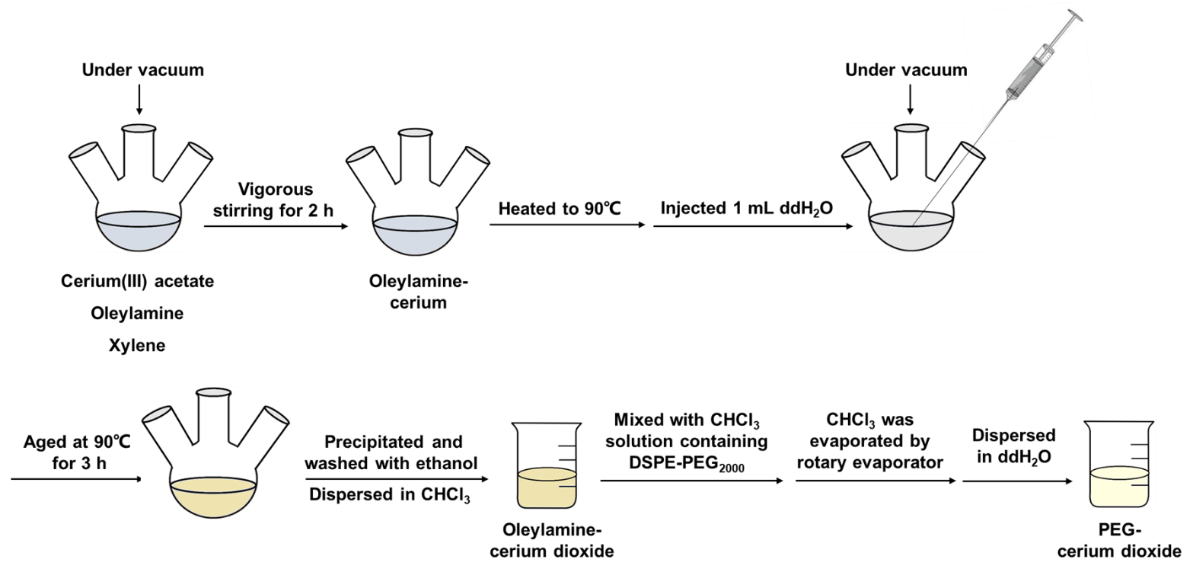

Fig. S1 Scheme of CNPs preparation via a modified reverse micelle method

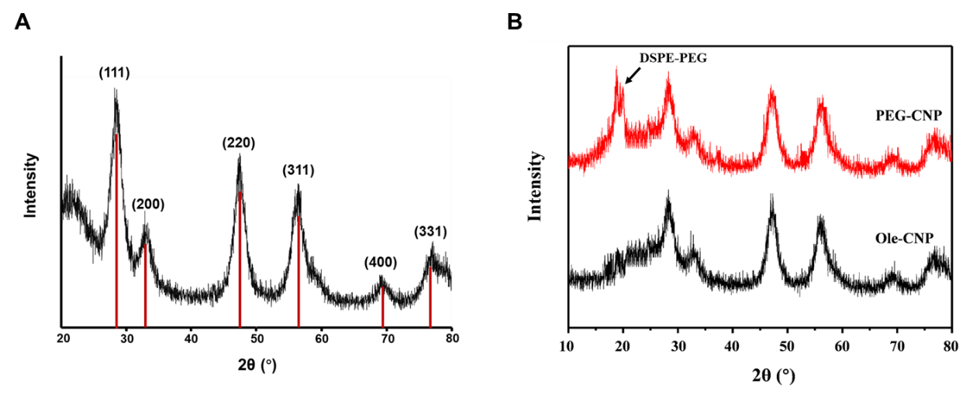
Fig. S2 The XRD pattern shows the structure of CNPs and PEG-CNPs.

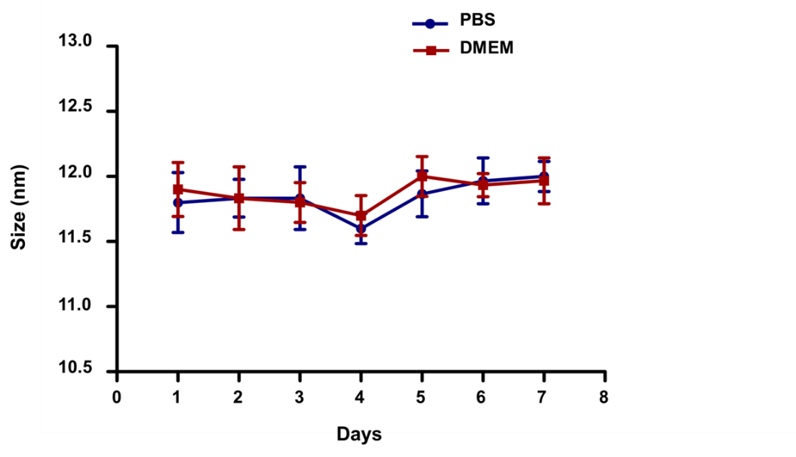
Fig. S3 The colloidal stability of PEG-CNPs in PBS or DMEM containing 10% FBS (fetal bovine serum) for 7 days. Data represent means ± s.d. n = 3.

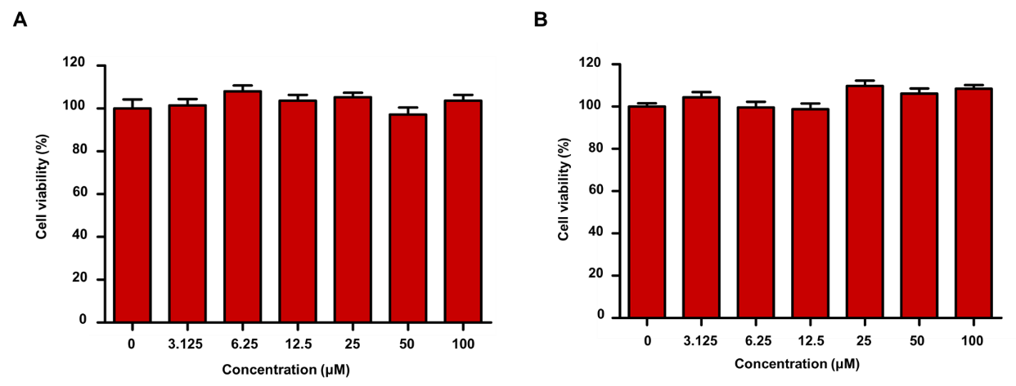

Fig. S4 Cytotoxicity of CNPs in (A) RAW 264.7 cells and (B) HT-29 cells. Cell viability was evaluated at 24 h of exposure to CNPs. Data represent means ± s.d. n = 6.

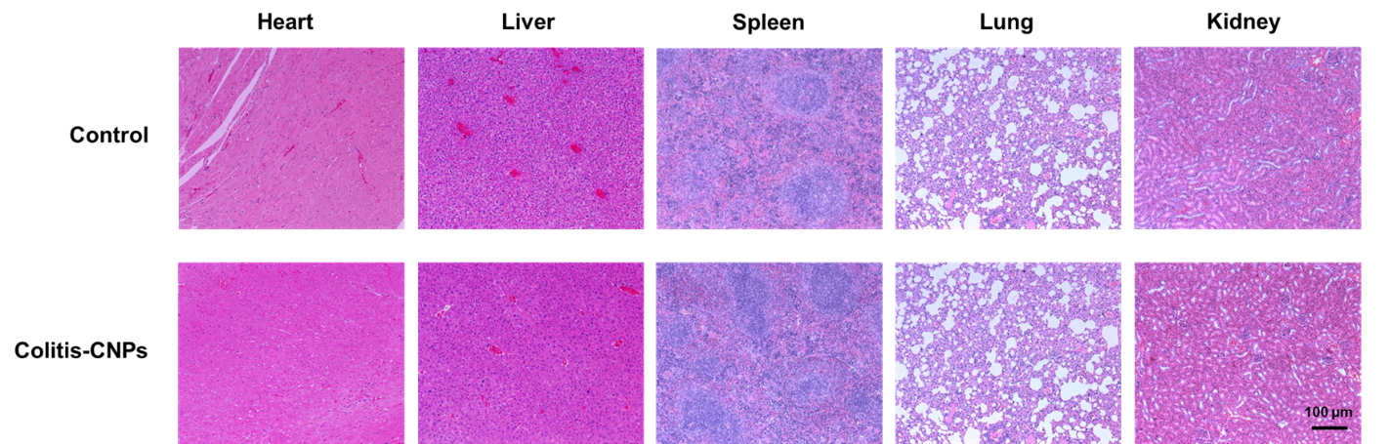
Fig. S5 Representative H&E staining of major organs from mice after 1.5 mg/kg CNPs treatment.

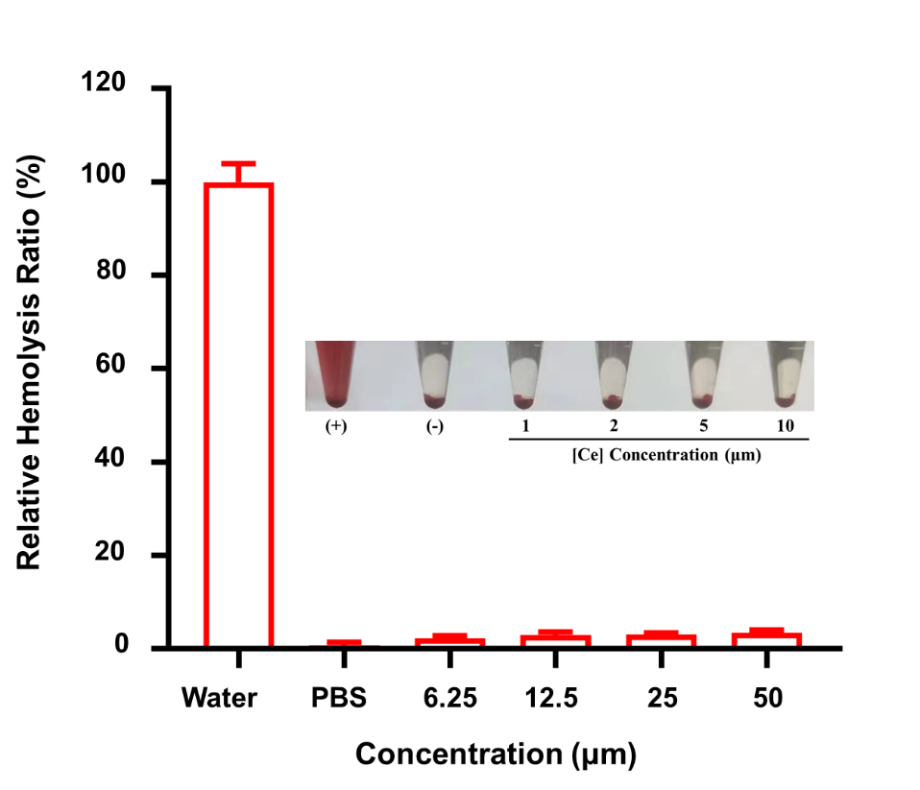
Fig. S6 Photographs of red blood cells and the hemolytic activity of CNPs. Data represent means ± s.d. n = 3.

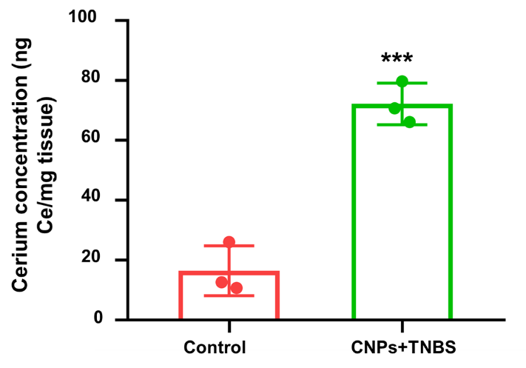
Fig. S7 Biodistribution of Ce element after intravenous injection of CNPs (1.5 mg/kg) in colon tissues. Data represent means ± s.d. n = 3. ***P < 0.001 vs. control group.

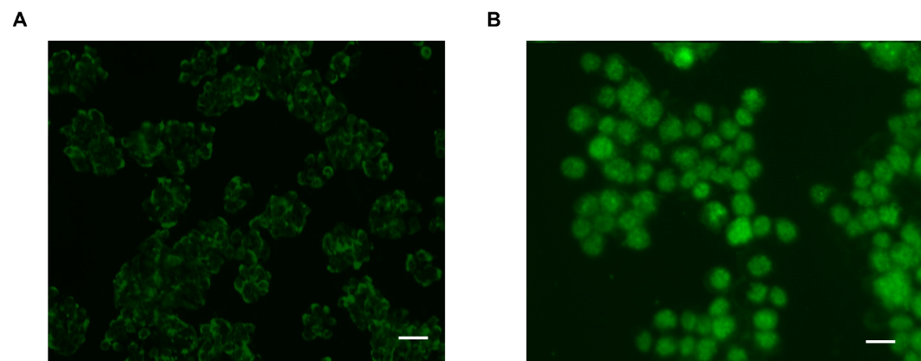
Fig. S8 Representative fluorescence images of cells after incubation with FITC-CNPs for 24 h. (A) HT-29 cells. (B) RAW 264.7 cells. Scale bars: 50 μm.

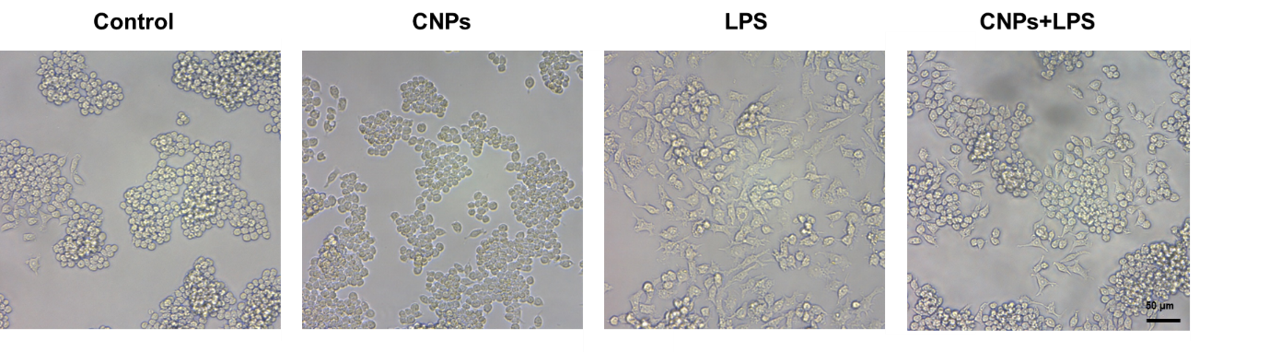
Fig. S9 Morphology of RAW 264.7 cells after treated with LPS (-/+) (100 ng/ml) and CNPs.

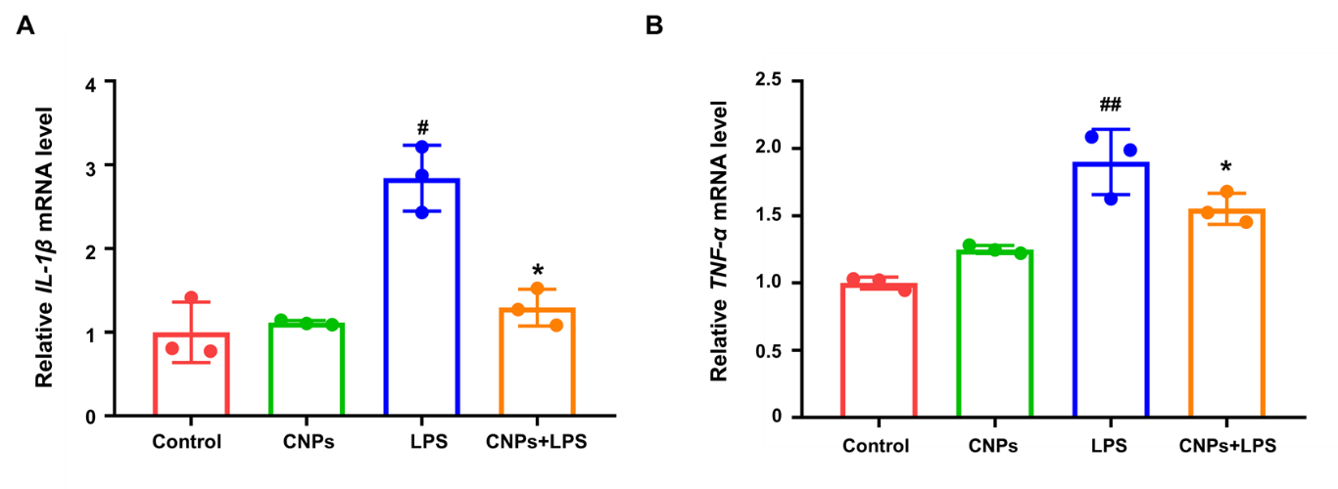
Fig. S10 qRT-PCR analysis of (A) IL-1β and (B) TNF-α mRNA levels in RAW 264.7 cells with different treatments. Data represent means ± s.d. n = 3. #P < 0.05, ##P < 0.01 vs. control group; *P < 0.05 vs. LPS group.

Table S1 Sequences of the primers used for qRT-PCR.

Serial number | Primer name | Forward sequences | Reverse sequences
1 | Human HO-1 | 5-CTCTCTTCTCTTGGGCCTCTAA-3 | 5-TGTCAGGTATCTCCCTCCATTC-3
2 | Human Nqo1 | 5-GAGAAGAGCCCTGATTGTACTG-3 | 5-ACCTCCCATCCTCTCTTCTT-3
3 | Human Gpx1 | 5-TGCGAAGTGAATGGTGAGAA-3 | 5-CACCGGAGACCAAATGATGTA-3
4 | Human NOX2 | 5-GGCCATGGAGTGGACTTAAA-3 | 5-GATACACCTCTCCACCAATGAC-3
5 | Human Cyp2e1 | 5-CACAGCCAAGAACCCATGTA-3 | 5-CACAGCCAAGAACCCATGTA-3
6 | Human Nrf2 | 5-CTCCGTGGAGTCTTCCATTTAC-3 | 5-GCACTATCTAGCTCCTCCATTTC-3
7 | Human Keap1 | 5-CTCTGAGCCCTGAACAGTTATT-3 | 5-CTGTGTGCCTACTCCATTCTT-3
8 | Human DJ-1 | 5-GCAGTGTAGCCGTGATGTAA-3 | 5-CACCATAGGCGACTCAGATAAA-3
9 | Mouse IL-1β | 5-CTCCACCTCAATGGACAGAATATC-3 | 5-GGGTGTGCCGTCTTTCATTA-3
10 | Mouse TNF-α | 5-CGATGGGTTGTACCTTGTCTAC-3 | 5-GAGGTTGACTTTCTCCTGGTATG-3
11 | Mouse HIF-1α | 5-CCACCTATGACCTGCTTGGT-3 | 5-TATCCAGGCTGTGTCGACTG-3
12 | Human GAPDH | 5-GGTGTGAACCATGAGAAGTATGA-3 | 5-GAGTCCTTCCACGATACCAAAG-3
13 | Mouse GAPDH | 5-TCAACAGCAACTCCCACTCTTCCA-3 | 5-ACCCTGTTGCTGTAGCCGTATTCA-3
14 | Human SiNrf2 | 5-CCUGAAAGCACAGCAGAAUTT-3 | 5-AUUCUGCUGUGCUUUCAGGTT-3

Table S2 The evaluation criteria of disease activity index (DAI) of mice.

Weight loss | Stool consistency | Fecal occult blood | Score
none | well-formed pellets | normal | 0
1%-5% | loose stools | Occult blood + | 1
5%-10% | diarrhea | Occult blood + + | 2
10%-15% | diarrhea | Occult blood + + + | 3
> 15% | diarrhea | visible gross bleeding | 4

