Graphene quantum dots harvest anti-trypanosomatid efficacy by disrupting antioxidant networks centered on trypanothione reductase

Di Zhang^{1,3†}, Rui Ju^{1†}, Limei Li^{2†}, Lilian Yang¹, Qianwen Jia¹, Rong Lei⁴, Na Wang⁵, Xiaofei Han^{1*}, Xinyi Wang^{1*}

¹ Key Laboratory of Glycolipid Metabolism of Liaoning Province, School of Life and Health, Dalian University, Dalian, Liaoning, 116622, China;
² College of Sciences, Shenyang Agricultural University, Shenyang, Liaoning, 110866, China;
³ State Key Laboratory of Advanced Technology for Materials Synthesis and Processing, Wuhan University of Technology, Wuhan, Hubei, 430070, China；
⁴ Institute of Plant Quarantine, Chinese Academy of Inspection and Quarantine, Beijing, 100176, China；
⁵ Pharmaceutical College, Hebei Medical University, Shijiazhuang, Hebei, 050017, China.

¹ These authors contributed equally to this work.
* Correspondence: Xinyi Wang, wangxinyi@dlu.edu.cn; Xiaofei Han, hanxiaofei@dlu.edu.cn

Additional file 1:

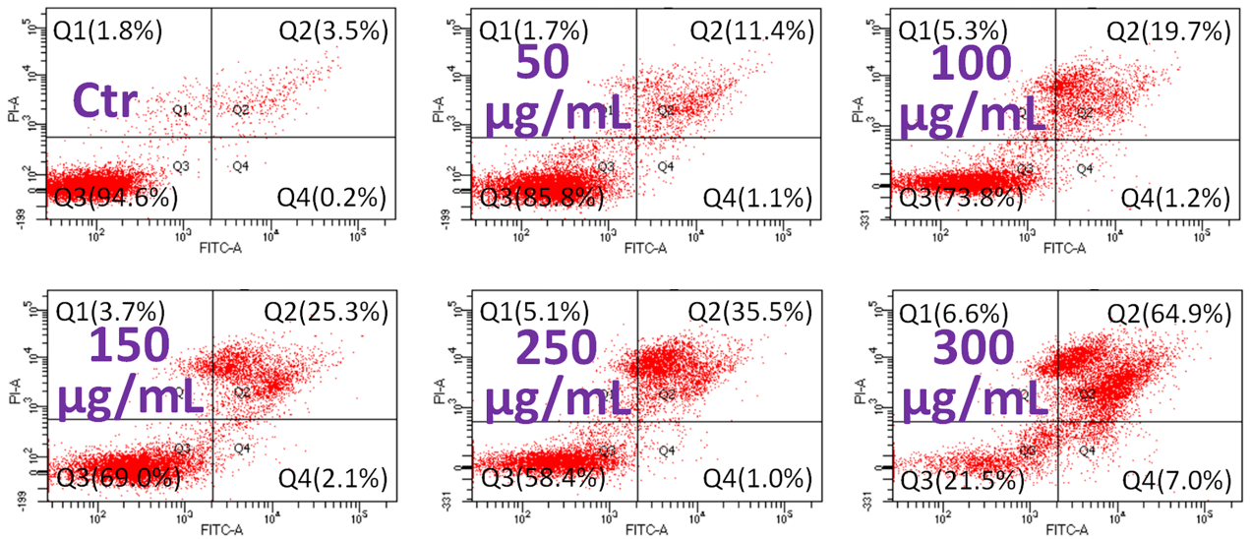
Figure S1. Flow cytometry analysis of apoptosis/necrosis of T. brucei after exposure to 50, 100, 150, 250, 300 μg/mL GQDs for 24 h, using Annexin V-FITC/PI apoptosis assay kit. T. brucei cells without treatment were used as controls.

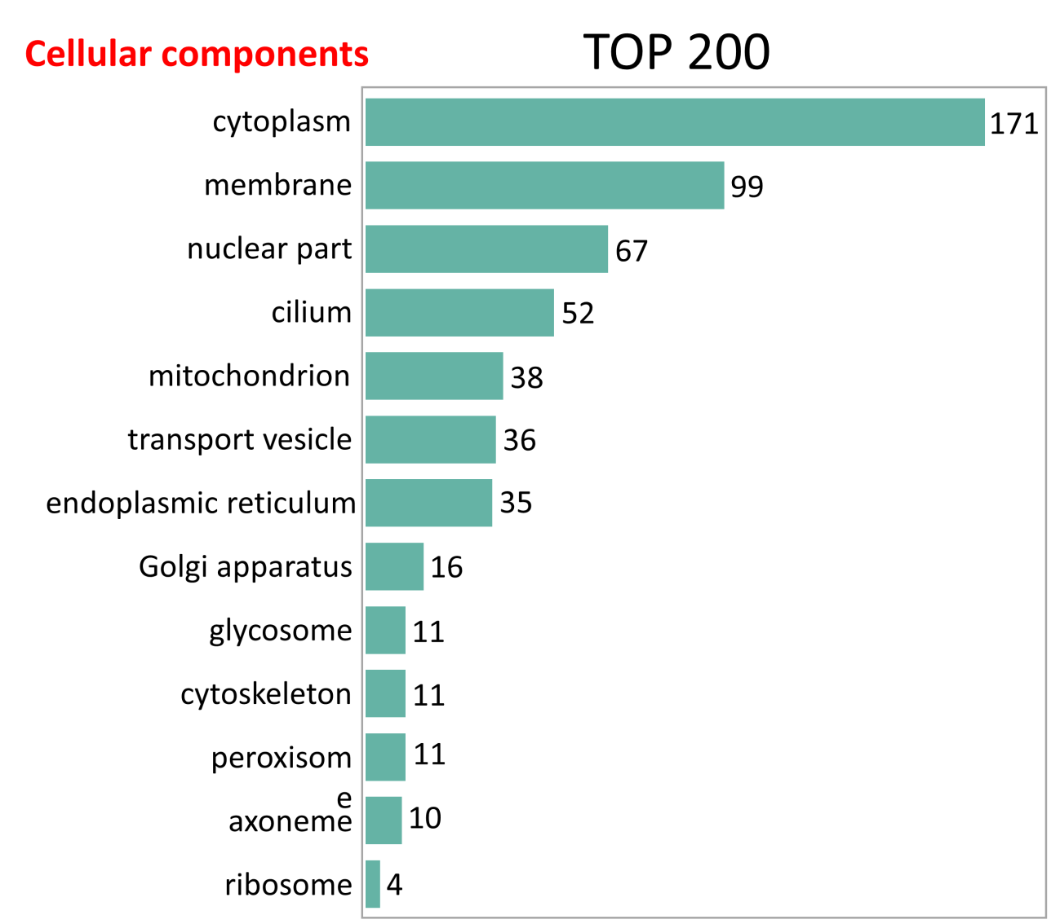
Figure S2. The cellular distributions of the top 200 identified proteins.

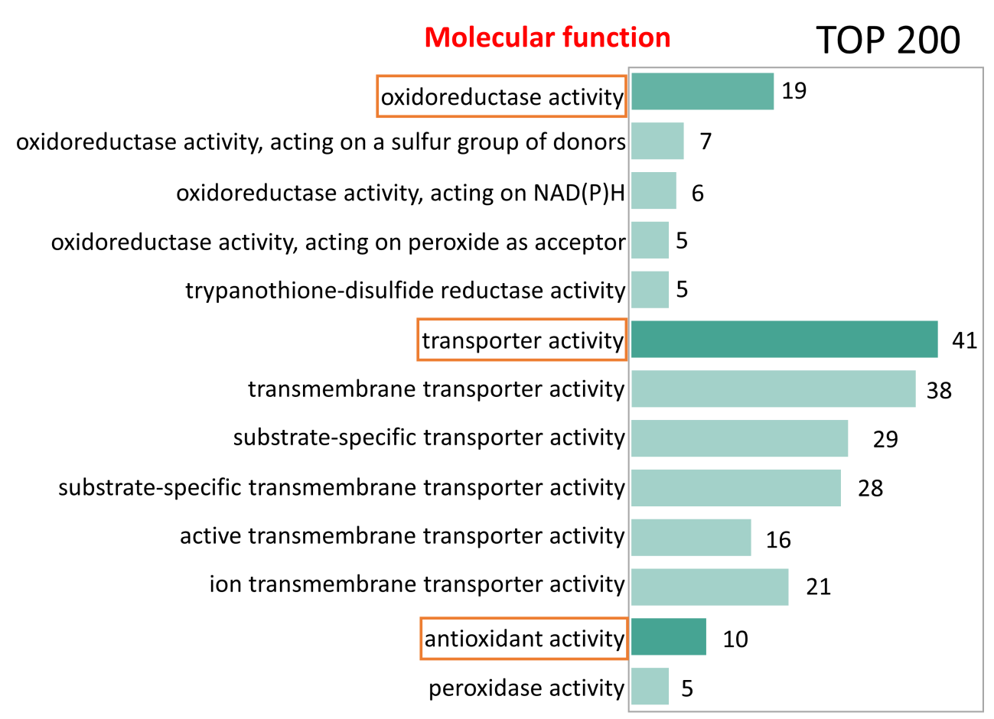
Figure S3. The molecular function patterns of top 200 identified proteins. Red boxes indicate the major molecular functions of the top 200 proteins.

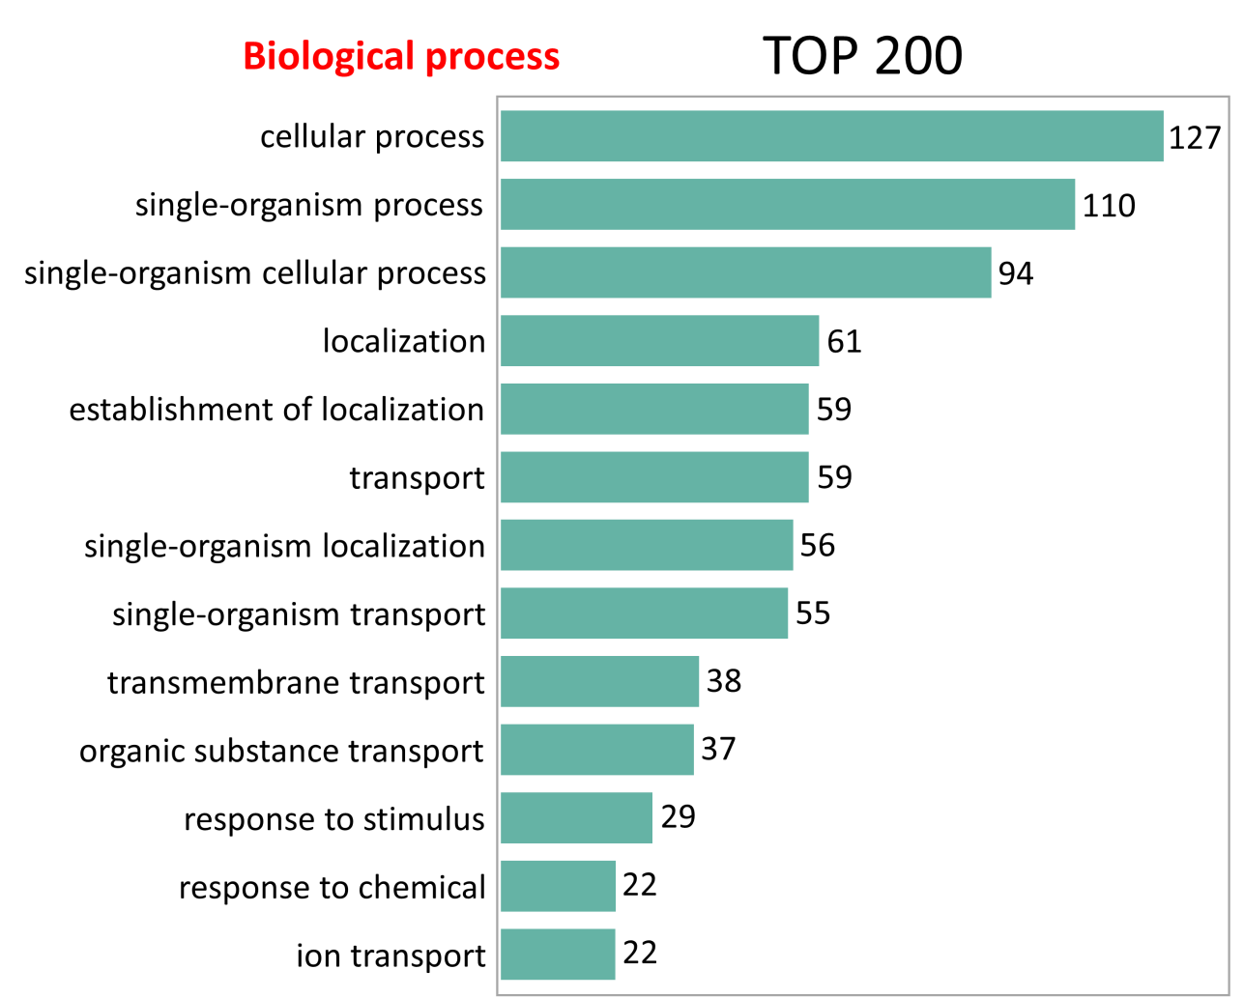
Figure S4. The biological process of top 200 identified proteins.

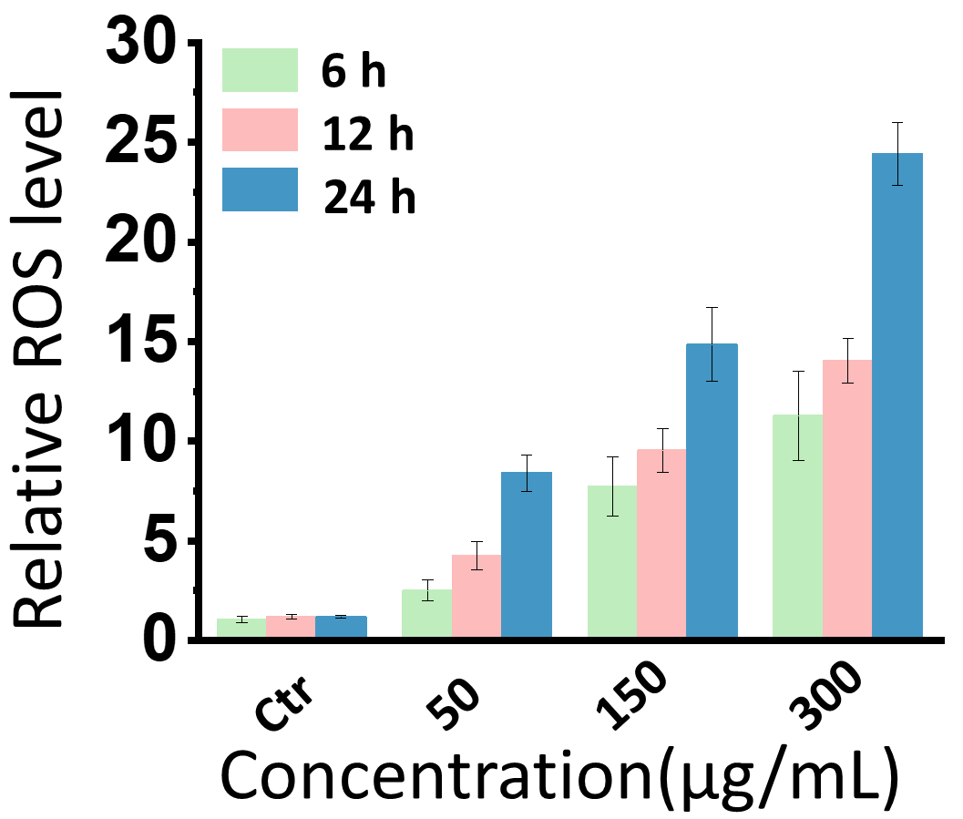

Figure S5.Quantitative analysis of cellular ROS levels of T. brucei after incubating with 50, 150, 300 μg/mL GQDs for 6 h, 12 h, 24 h by DCFHDA.

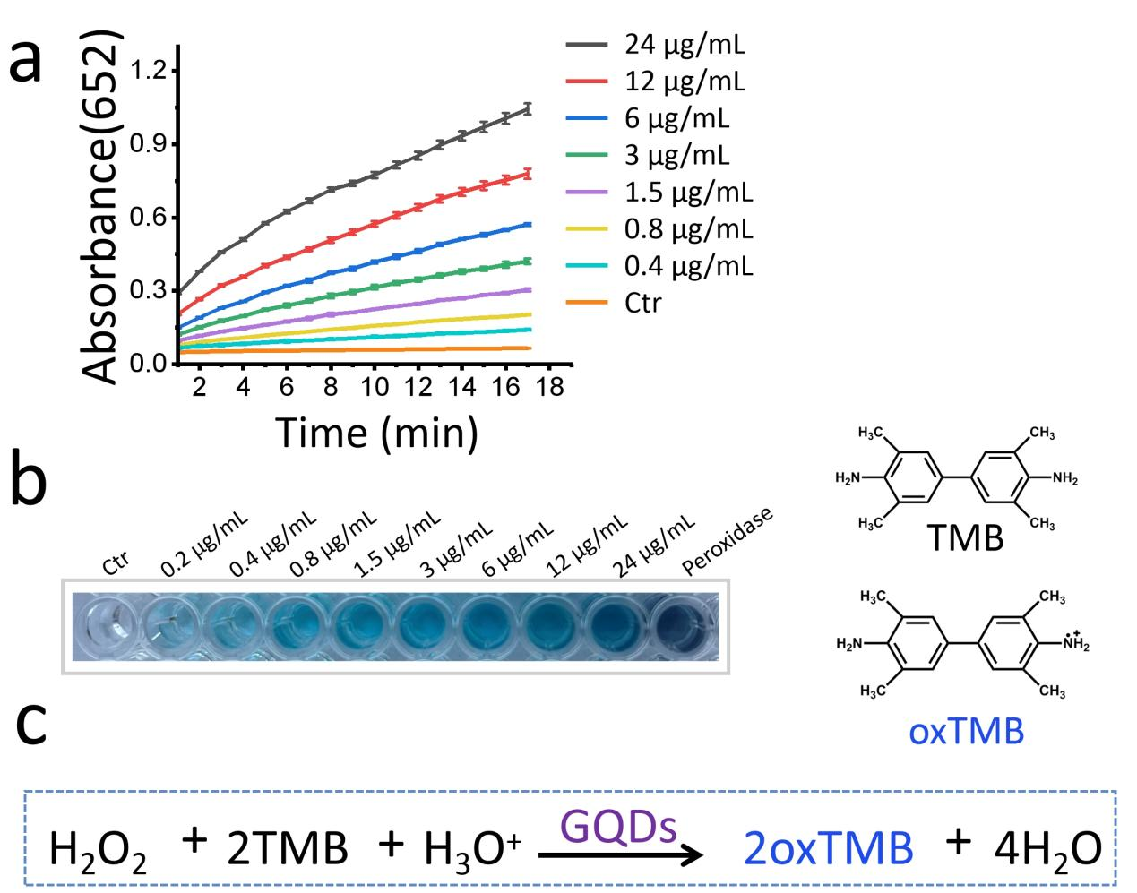

Figure S6. The peroxidase-like activity and kinetic analysis of the GQDs. (a) Kinetics of oxidation of TMB monitored at 652 nm in the presence of the 0, 0.4, 0.8, 1.5, 3, 6, 12, 24 μg/mL GQDs. (b) Photographs of TMB peroxidation catalyzed by 0.2, 0.4, 0.8, 1.5, 3, 6, 12, 24 μg/mL GQDs. (c) Proposed reaction mechanism of TMB and H₂O₂ in the presence of GQDs.

Table S1 Twenty redox proteins with high affinity for GQDs.
Index | Gene ID | Name | Uniprot ID
1 | Tb927.10.10390 | TR | Q389T8
2 | Tb927.7.1130 | GPX-II | Q869A6
3 | Tb927.8.1990 | MPX | D6XKT6
4 | Tb927.9.5770 | CPX | Q38EX8
5 | Tbg972.3.4110 | TXN | O77404
6 | Tb927.5.3350 | Fe-SODa | Q2KN28
7 | Tb927.11.15020 | SODb2 | Q2KN30
8 | Tb927.4.3690 | Fe-SODb | Q585I1
9 | Tb927.6.4030 | SODb | Q586A1
10 | Tb927.10.430 | APx-Ccp | Q38CJ5
11 | Tb927.2.4370 | TS | Q86MC2
12 | Tb927.9.6060 | ERV1 | Q38EW2
13 | Tb927.8.6000 | FAD | Q57YK1
14 | Tb927.7.7410 | ENR2 | Q57TX8
15 | Tb927.6.3000 | SL4D | Q583N4
16 | Tb927.8.2210 | PTR1 | Q581W1
17 | Tb927.10.7570 | PDH-E2 | Q38AK7
18 | Tb927.8.550 | MrsA | Q57YH5
19 | Tb927.9.5860 | TRYP1 | Q38EX8
20 | Tb11.v5.0580 | Δ6FAD | Q38AQ3

Additional file 2:
All the supplementary datasets can be download at the website ((https://pan.baidu.com/s/1ofCIfXrWj7jOkeKDfkzP4w) with the password: wxyi.
Supplemental Dataset S1. PDB files of GQDs.
Supplemental Dataset S2. 5190 docking PDB files of GQDs-protein complexes.
Supplemental Dataset S3. GO annotations of Top 200 proteins with high affinity towards GQDs.

