Supplemental Figures
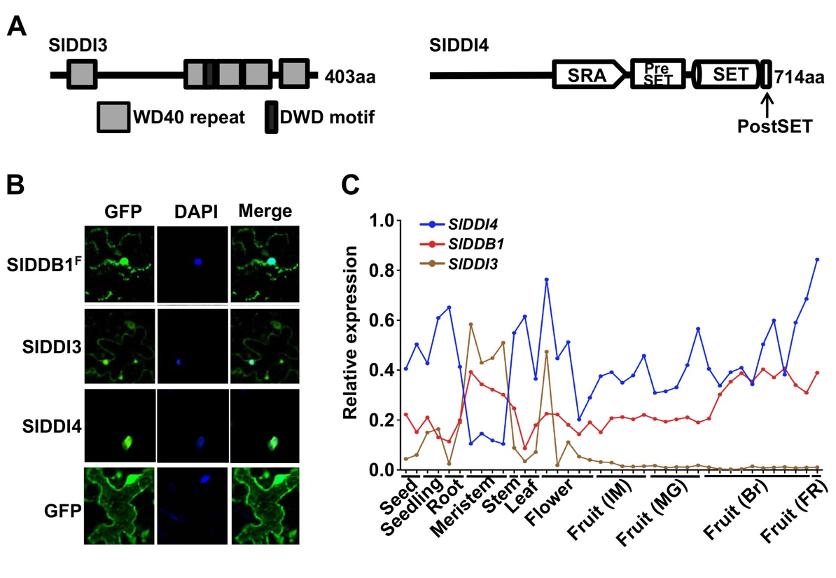
Fig. S1 Structure, or subcellular localization and expression pattern of SlDDI3 and SlDDI4, or SlDDB1
(A) Schematic diagram of SlDDI3 and SlDDI4 proteins. (B) Subcellular localization of SlDDI3-GFP and SlDDI4-GFP. The indicated proteins were transiently expressed via Agrobacterium in Nicotiana benthamiana leaves. After 48 hours, the epidermal cells of the infiltrated leaf tissues were subjected to confocal microscopy. Signals from GFP, 4’-6-diamidino-2-phenylindole (DAPI) and the merger of two signals are shown. (C) Normalized expression profiles for SlDDB1, SlDDI3 and SlDDI4 in various tomato tissues. The expression information was retrieved from the TomExpress RNA-Seq platform and is also available in Supporting Information Spreadsheet S2.

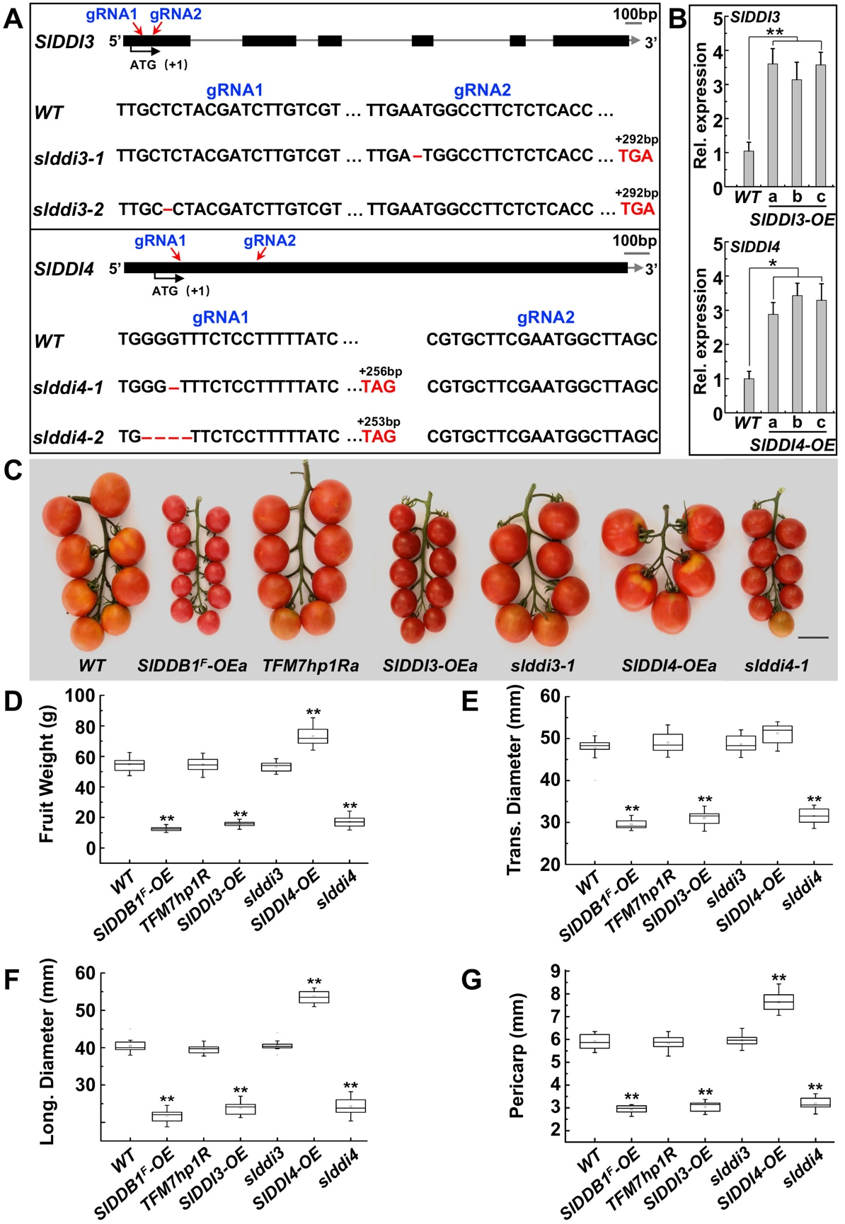

Fig. S2 Phenotypic variation in fruit size in SlDDI3 or SlDDI4 suppression or overexpression transgenic tomato plants
(A) Gene structure of slddi3 (top panel) or slddi4 (bottom panel). Exons and introns are indicated by black bars and grey lines respectively. Guide RNA (gRNA) targets are indicated with red arrowheads. gRNA target regions are shown in black font. The red dash represents one delete base and the stop codon is indicated in red font. (B) Transcript levels of SlDDI3 (upper panel) or SlDDI4 (lower panel) in wild type (WT) and three independent transgenic lines (a, b, c) were determined by real-time quantitative PCR. Total RNA was extracted from the 7 DPA fruits, values are means ±SE of 9 biological replicates (*P<0.05, **P<0.01). (C) Representative bunched red ripe fruits from various genotypic (homozygous generation, line a or line 1) plants. Bar = 5 cm. (D) Quantification of the fruit weight for different genotypes. (E) and (F) Quantification of transverse or longitudinal diameter of different genotypic fruits. (G) Quantification of the fruit pericarp thickness of different genotypes. Mean values from 90 red ripe fruits pooled of wild type (WT) and transgenic (three independent lines) or CRISPR-based mutant (two independent lines) plants and standard errors are shown (*P<0.05, **P<0.01).

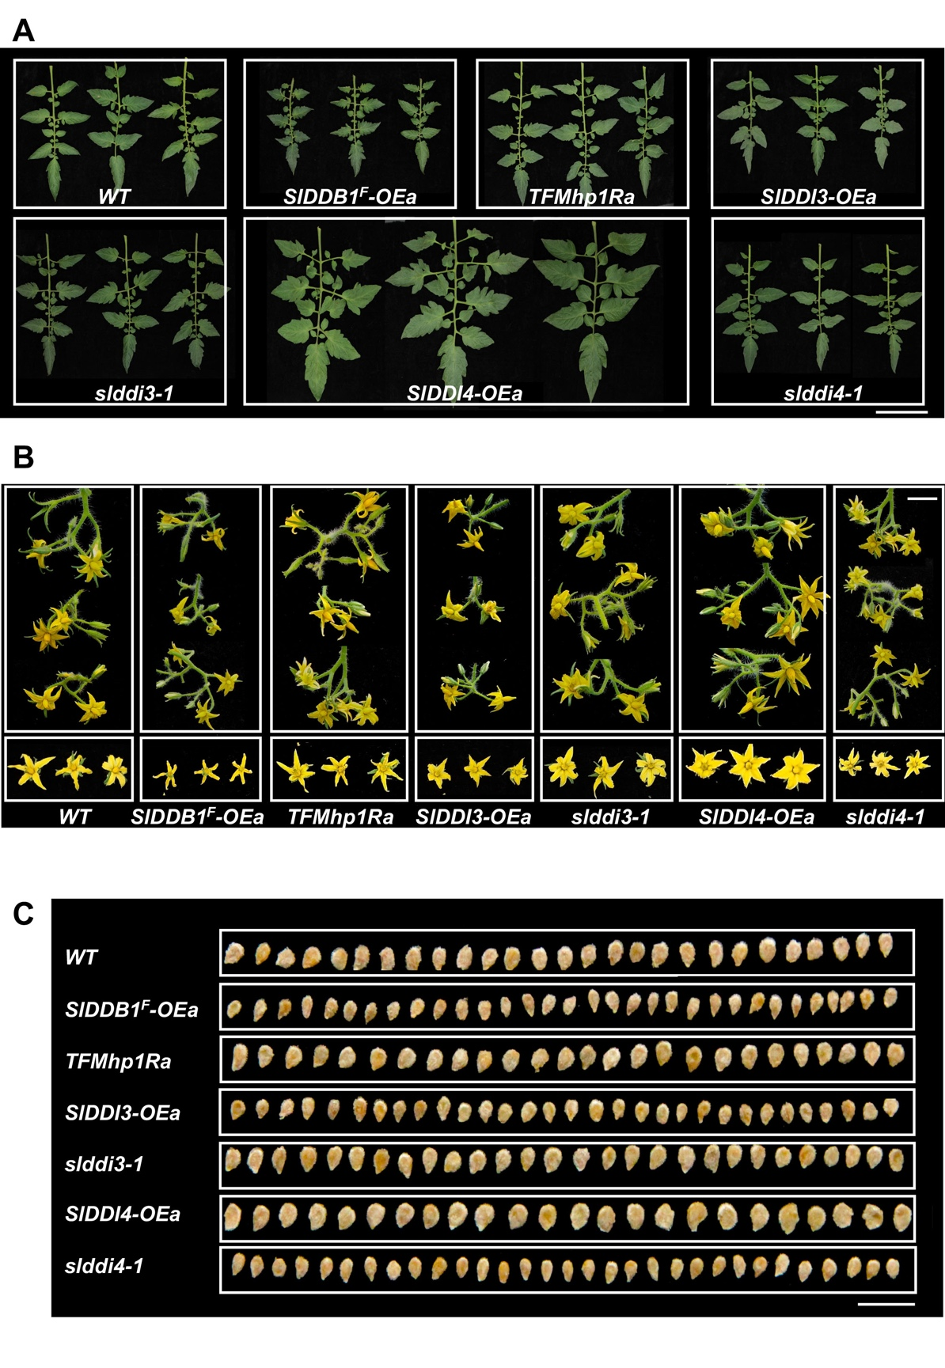

Fig. S3 Effects of SlDDI3 and SlDDI4 on plant development
(A)-(C) Comparison of leaves, flowers and seeds from wild type (WT) and transgenic (homozygous generation; line a) or CRISPR-based mutant (line 1) tomato plants. Bar: 10cm (A), 2cm (B), 1cm (C).

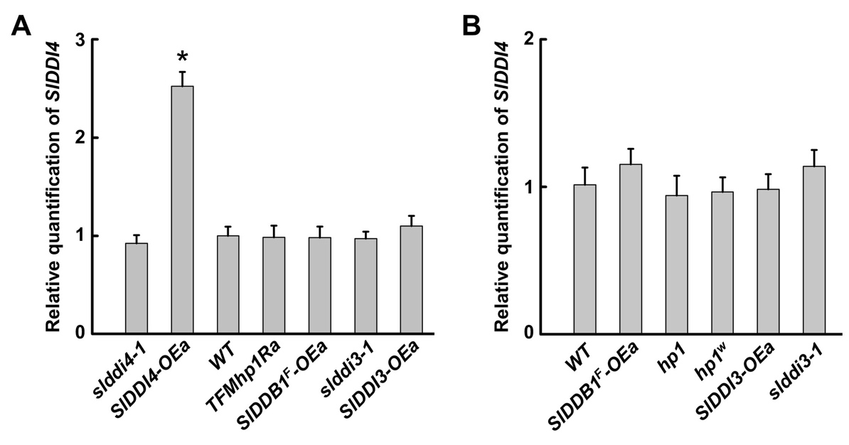

Fig. S4 Expression of SlDDI4 in different genotypic tomato plants
(A) Expression levels of SlDDI4 in wild type (WT) and transgenic tomato fruits (homozygous generation, line a) or CRISPR-based mutants (line 1). Total RNA was extracted from the 7 DPA fruits and the mRNA level of SlDDI4 gene was determined by quantitative RT-PCR. Values are means ±SE of 9 biological replicates (*P<0.05, **P<0.01) (B) Real-time quantitative RT-PCR analyses of SlDDI4 expressions in protoplasts from WT，hp or CRISPR-based mutants (line 1) and over-expression transgenic tomato plants (homozygous generation, line a). Error bars indicate standard deviation (n=9).

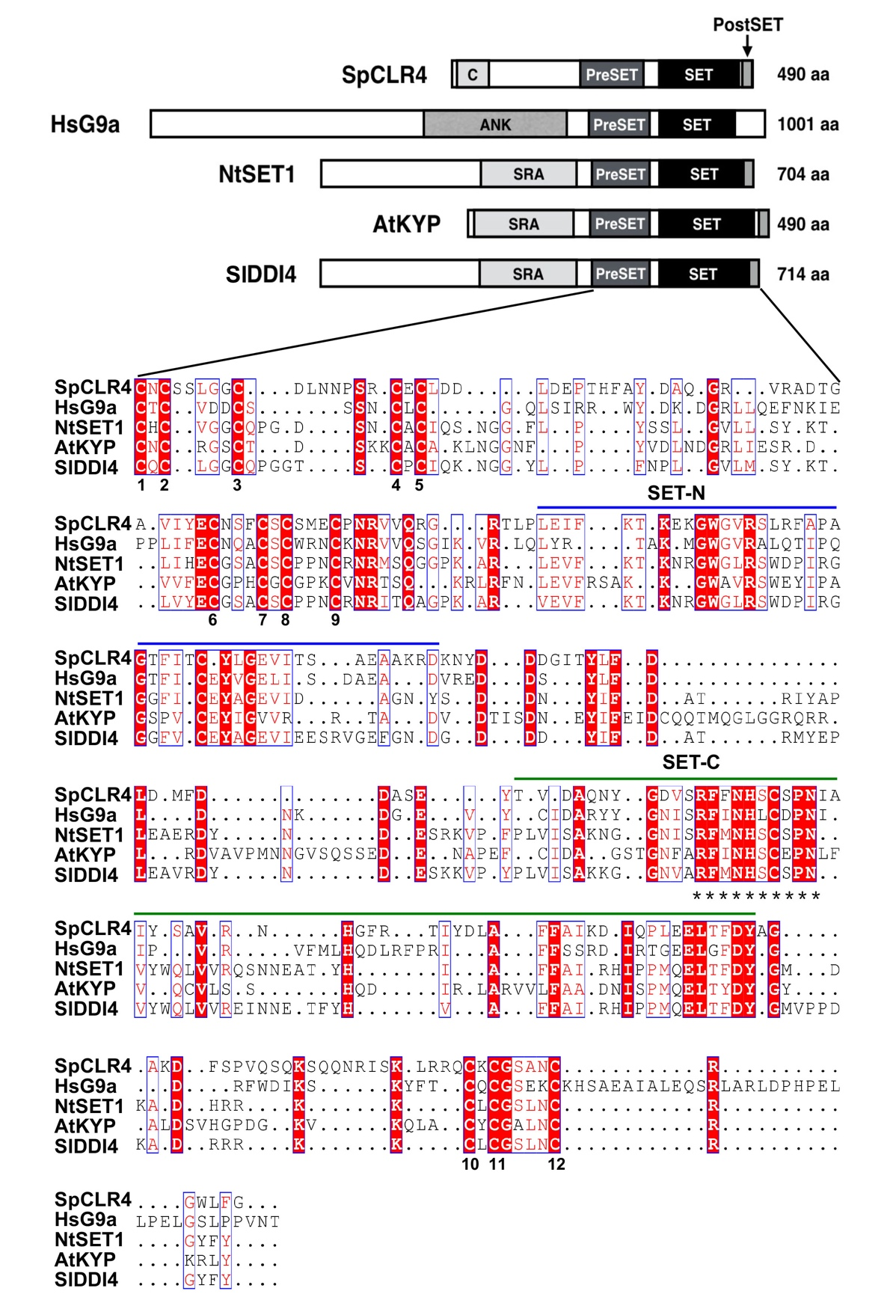

Figure S5. Diagram of the domain organization of SpCLR4, HsG9a, NtSET1, AtKYP and SlDDI4 proteins.
The chromo (C) domain, the ankyrin-repeat domain (ANK), RING finger-associated domain (SRA), pre-SET, SET and post-SET domains are conserved in all five proteins. Asterisks indicate the conserved catalytic core motif. RFXNHS/LCXPN, 12 highly conserved cysteine residues are numbered. Other highlighted conserved amino acid residues are primarily located within the N-terminal (SET-N) and C-terminal (SET-C) regions of the SET domain. Protein sequence accession: CAA22283 for Schizosaccharomyces pombe CLR4 (SpCLR4), NP_001350618 for Homo sapiens G9a (HsG9a), CAC67503 for Nicotianata bacum SET (NtSET), Q8GZB6 for the Arabidopsis thaliana KYP (AtKYP), and XP_004249103 for Solanum lycopersicum DDI4 (SlDDI4).

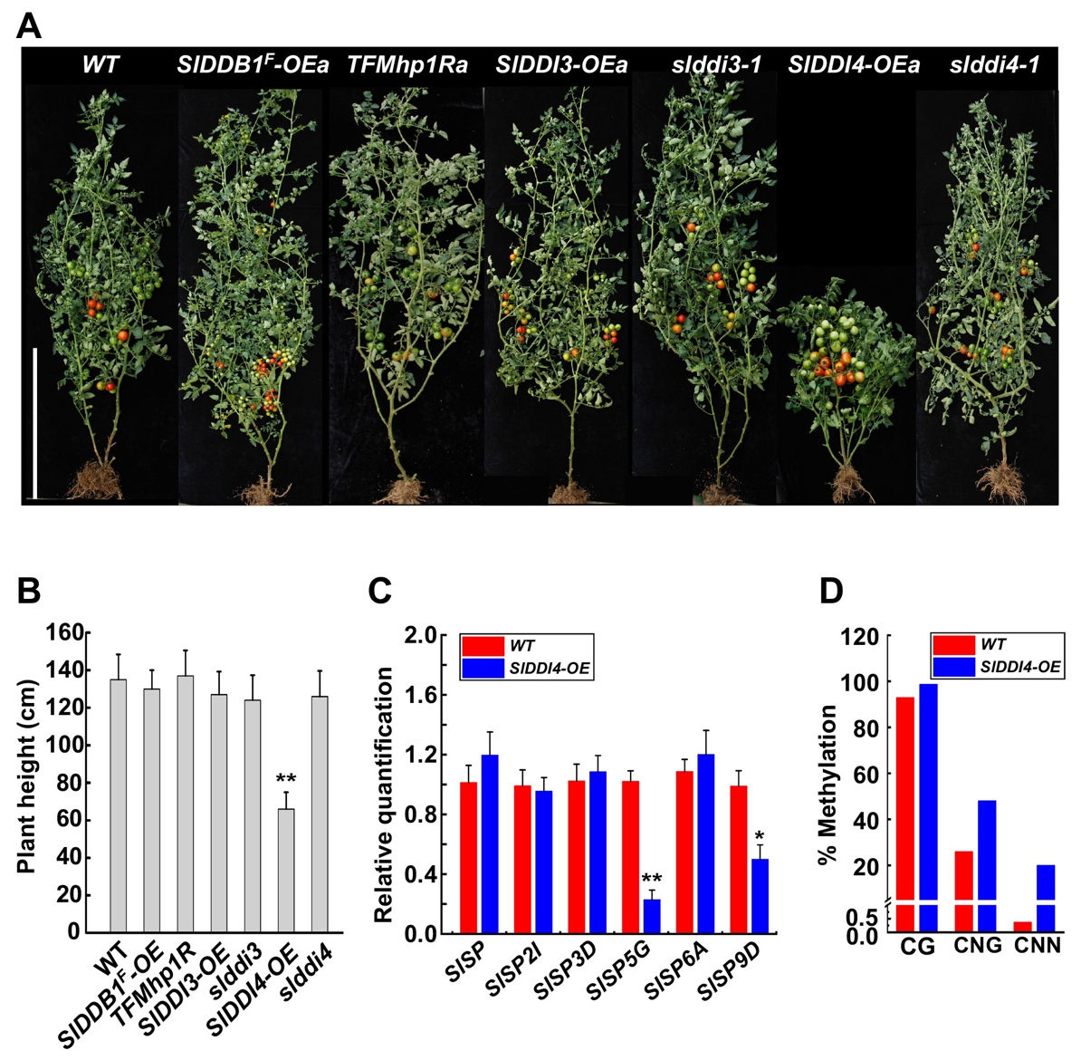

Fig. S6 Over-expression of SlDDI4 results in switch of plant architecture from indeterminate to determinate by modulating expression of SELF-SPRUNING family genes
(A) Comparison of whole plant architecture between different genotypes. Bar = 50cm. (B) Plant height of different genotypes. Mean values from 20 plants of wild type (WT) and transgenic (three independent lines) or CRISPR-based mutant tomato plants and standard errors are shown (*P<0.05, **P<0.01). (C) Relative expression of self-pruning family genes in WT and DDI4-OE transgenic shoot apices. Values are means ±SD of three biological replicates. (*P<0.05, **P<0.01). (D) Percentages of cytosine methylation at region (SL4.0ch05:63272185-63272669, contains 7 CG, 5 CNG and 54 CNN sites) of the SlSP5G gene in shoot apex of WT or DDI4-OEa transgenic plant.

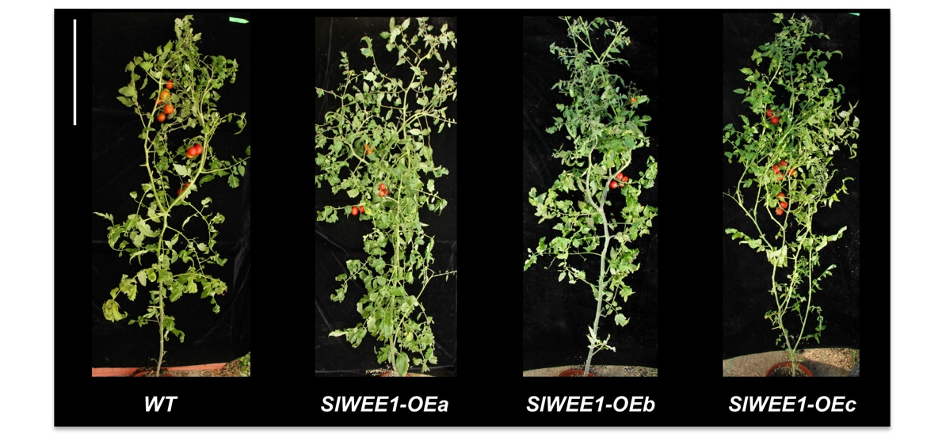

Fig. S7 Plant architecture of the SlWEE1 transgenic lines
Whole plant architecture of WT and SlWEE1-OE transgenic lines (a, b, c). Bar = 50cm.

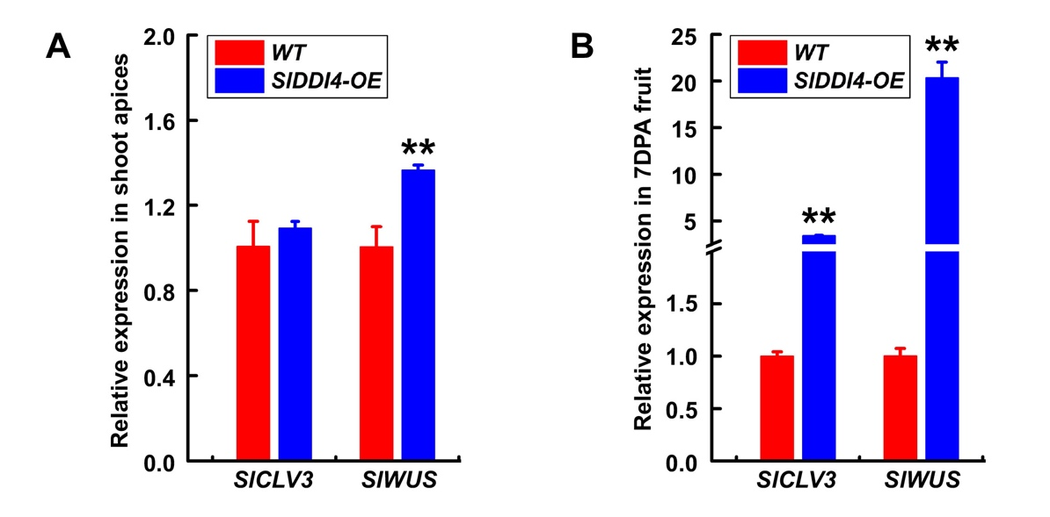
Fig. S8 SlDDI4 positively affects the expression of SlCLV3 and SlWUS
Relative expression of SlCLV3 and SlWUS genes in wild type and SlDDI4-OE transgenic plant. Total RNA was extracted from the shoot apices (A) and the 7 DPA fruits (B), and the mRNA level was determined by quantitative RT-PCR, normalized to SlActin. Values are means ±SE of 9 biological replicates (*P<0.05, **P<0.01)

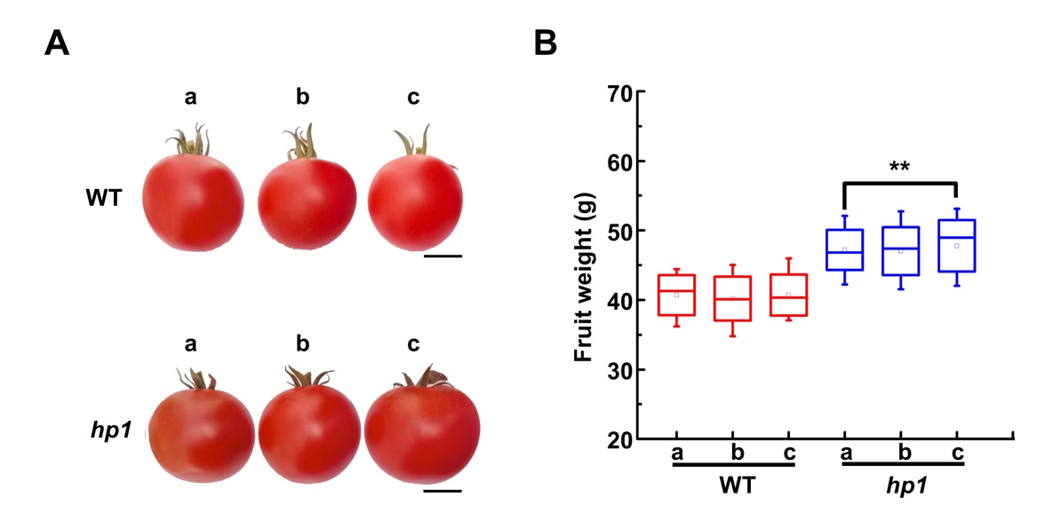
Fig. S9 Comparison of fruit size between wild type (WT) and SlDDB1-defective hp1 mutant
(A) Red ripe fruits of WT and hp1 mutant plants grown in greenhouse (line a, b, c). Bar = 2cm. (B) Fruit weight of greenhouse-grown WT or hp1 plants (individual plants, a, b and c). Error bars represent standard error; asterisks above bars indicate statistically significant differences. (n= 60, *P<0.05, **P<0.01).

