Table I. 87 SARS-COV2 interacting proteins share identities with BRD4-interacting proteins in B cells.

SARS-COV2 PROTEIN | KROGAN et  al | Number of interactants in BRD4-pep samples | BRD4 interacting proteins
NSP1 | 6 | 1 | 0
NSP2 | 7 | 2 | 0
NSP4 | 7 | 3 | 0
NSP5 | 1 | 0 | 0
NSP5 C145A | 2 | 0 | 0
NSP6 | 4 | 0 | 0
NSP7 | 32 | 14 | 0
NSP8 | 24 | 2 | 0
NSP9 | 16 | 5 | 0
NSP10 | 5 | 3 | 0
NSP11 | 1 | 1 | 0
NSP12 | 20 | 6 | 0
NSP13 | 39 | 5 | 0
NSP14 | 3 | 1 | 0
NSP15 | 3 | 2 | 0
SPIKE | 2 | 1 | 0
ORF3A | 8 | 2 | 0
ORF3B | 1 | 1 | 0
ORF6 | 3 | 1 | 1
ORF7A | 2 | 0 | 0
ORF8 | 47 | 10 | 1
ORF9B | 11 | 2 | 0
ORF9C | 26 | 1 | 0
ORF10 | 9 | 3 | 1
E | 6 | 4 | 3
N | 15 | 9 | 2
M | 30 | 5 | 0

Table II. SARS-COV2 virus interacting proteins which are differentially recruited into a BRD4 network during BET inhibition of B cells.

DMSO | JQ1 | AZD5153 | I-BET151
 | NUP98 | NUP98
 |  | ERP44
 | ELOB | ELOB
ZC3H18 | ZC3H18 | ZC3H18 | ZC3H18
DDX21 | DDX21
BRD2 |  | BRD2
 |  | UPF1

Table III. Correlations of Histones and bromodomain proteins identified in each sample suggests a role for BRD2 in recruitment of H2 histones.
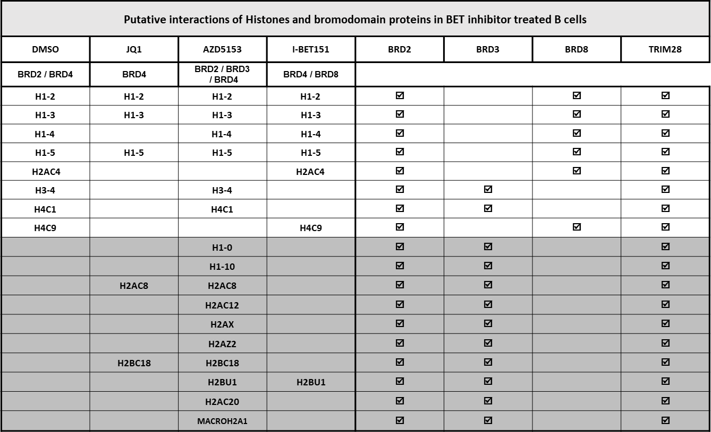

Table IV. TRIM28 is a bromodomain protein with diverse functions.

The druggable sub-network of TRIM28 interacting proteins
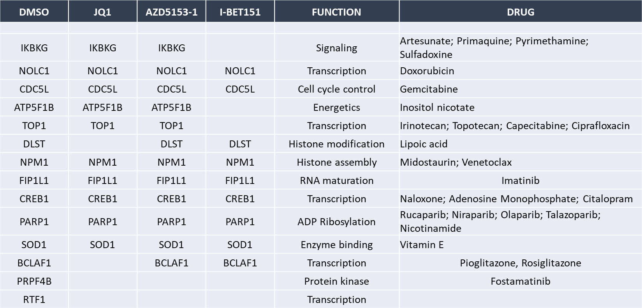

Table V. CD antigens identified in BET inhibitor treated B cells.

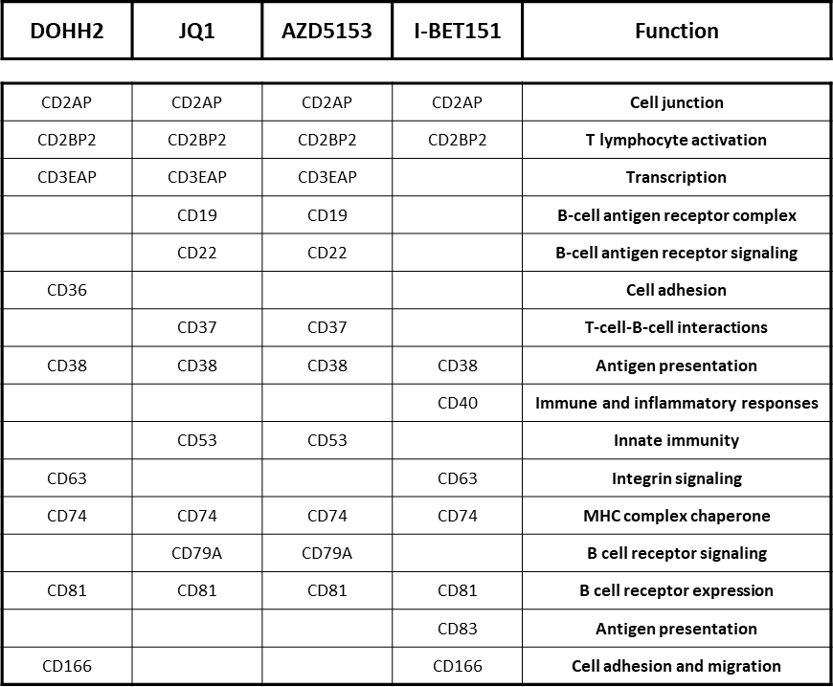

Table VI. SARS-COV2 proteins may recruit many proteins in B cells whose interaction with BRD4 is lost upon BET inhibition.

SARS-COV2  protein | Interaction with BRD4 lost upon BET inhibition
M | AASS
NSP4 | IDE
NSP7 | COMT
NSP7 | FAM162A
NSP7 | RAB18
ORF3A | HMOX1
ORF9C | NDUFB9

Table VII. Common interactants of BRD4 and SARS-COV2 viral proteins, and FDA approved drugs using those as Targets.
