Supplementary Materials

Supplementary Table S1. Characteristics of clinical trials included in the meta-analysis.
Study name | Year | Study type | Population | Sample size | Intervetion | Control
KEYNOTE 024 | 2016 | Phase Ⅲ RCT | PD-L1≥50% advanced NSCLC | 305 | Pembrolizumab | Chemotherapy
KEYNOTE 042 | 2019 | Phase Ⅲ RCT | PD-L1≥1% advanced NSCLC | 599 | Pembrolizumab | Chemotherapy
IMpower 110 | 2020 | Phase Ⅲ RCT | PD-L1≥1% advanced NSCLC | 205 | Atezolizumab | Chemotherapy

Supplementary Table S2. Summary of subsequent therapy.
Type of therapy | Atezolizumab |  | Pembrolizumab
Type of therapy | Therapy* | Proportion | Therapy* | Proportion
Anticancer therapy # | - | 24.3% | - | 38%
Chemotherapy |  |  |  | 37%
 | Carboplatin | 12.1%
 | Docetaxel | 4.7%
 | Gemcitabine | 7.5%
 | Pemetrexed | 7.5%
 | Cisplatin | 3.7%
 | Paclitaxel | 6.5%
Immunotherapy
 | Nivolumab | 1.9% | Nivolumab | 2.4%
Best supportive care | - | 75.7% | - | 62%
# Participants may have received more than one subsequent anticancer therapy.

Supplementary Table S3. Adverse events of grade 3-5 with a frequency of greater than 3% in clinical trial.
Adverse Event | Incidence (%) |  | Cost per event ($)
Adverse Event | Atezolizumab | Pembrolizumab | Cost per event ($)
Diarrhoea | 0% | 5.2% | 916.77
Severe skin reaction | 0% | 3.9% | 11.39

Supplementary Figure S1. Parametric survival analysis.
Abbreviation: OS= Overall survival; PFS= Progression-free survival; KM= Kaplan-Meier curve.

A Parametric survival analysis for PFS of atezolizumab and pembrolizumab.
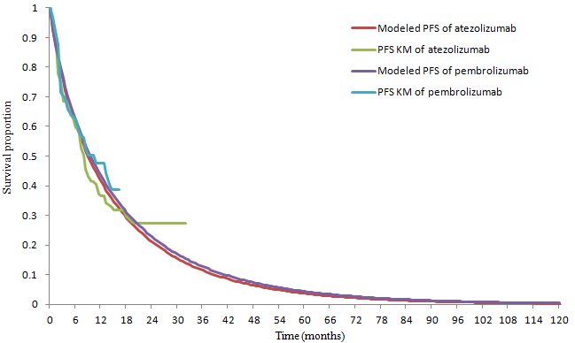

B Parametric survival analysis for OS of atezolizumab and pembrolizumab.
