Support Information
Reaction route, mechanism, and procedure of the photoredox of U(VI) and Sb(III) using a Fe₃O₄/TiO₂/g-C₃N₄ heterojunction nano-photocatalyst under visible sunlight

Chun Wang ª, Han Jiao ª, Yinbo Yang ª, Lihong Wei ^{b}, Ping Na ^{a,} *

ª School of Chemical Engineering and Technology, Tianjin University, Tianjin 300072, PR China
^{b} School of Energy and Environment, Shenyang Aerospace University, Shenyang 110122, PR China
⁎ Corresponding authors.
E-mail addresses: naping@tju.edu.cn
Text S1.
Synthesis methods of three facet nanometer TiO₂.
{001} facet TiO₂ ^{[1]}: In a typical experimental procedure, 5 mL of Tetrabutyl titanate (Ti(OBu)₄, 98%, Kermel, AR) and 0.8 mL of hydrofluoric acid solution (HF, 47%, Kermel, AR) were mixed in a dried Teflon autoclave with a capacity of 20 mL, and then kept at 200 °C for 24 h. After being cooled to room temperature, the white powder was separated by high-speed centrifugation and washed with ethanol and distilled water for several times, and then dried by vacuum freeze-drying (-60°C) for about 24 h. The final powder was calcined at 550 °C in air for 2 h to remove fluoride ions.
{100} facet TiO₂ ^{[2]}: 0.48g of titanium sulfate (Ti(SO₄)₂, ≥ 96.0%, Meryer, AR), 0.48 g of urea (CO(NH₂)₂, ≥99.0%, Kermel, AR) and 0.8 g of ethylenediaminetetraacetic acid disodium salt (EDTA-2Na, Kermel, AR) were added to 40 mL deionized water. Stir until a large amount of white precipitate appears. After stirring, the mixed suspension with a massive white precipitate was transferred to a 70 mL Teflon-lined autoclave and kept at 180°C for 15 h before cooling down to room temperature. The white precipitate was collected, washed and rinsed with deionized water and ethanol, and then dried by vacuum freeze-drying (-60°C) for about 24 h. The final powder was calcined at 550°C in air for 2 h to remove residual organics.
{101} facet TiO₂ ^{[3]}: 0.6 mL of titanium trichloride (TiCl₃, Kermel, AR) was added into a 100 mL Teflon-lined autoclave containing 40 mL of Formic acid (HCOOH, Kermel, AR) under vigorous stirring at ambient temperature. Stir for more than 1 hour and stop after the solution turns milky white. The autoclave was then sealed and heated to 150°C for 12 h. After cooling to room temperature, the white precipitate was collected via centrifugation, and rinsed with deionized water and absolute ethanol several times. Finally, the prepared sample was dried by vacuum freeze-drying (-60°C) for about 24 h. The final powder was calcined at 550°C in air for 2 h to remove residual organics.
Text S2.
Photocatalytic performance of three facet nanometer TiO₂.
30 mg of {001}, {100}, and {101} TiO₂ was suspended respectively in the solution with 20 ppm U(Ⅵ) and 20 ppm Sb(Ⅲ)。The concentration of U(Ⅵ) and Sb(Ⅲ) were measured after 5 hours of illumination. After comparing the removal rates of U(Ⅵ) and Sb(Ⅲ) in Fig. S1, {001} was selected as the best reaction face of TiO₂.
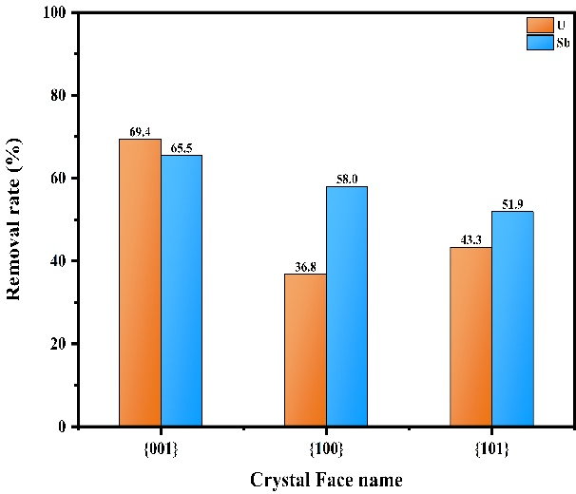
Fig. S1. Removal rates of U(Ⅵ) and Sb(Ⅲ) in the solution with {001}, {100}, and {101} TiO₂.
Text S3.
Synthesis of g-C₃N₄.
6 g of urea was calcined under 550 °C in a muffle furnace for 2 h at a heating rate of 8 °C/min. After the reaction, the alumina crucible was cooled to room temperature, and the g-C₃N₄ with the yellow color were obtained ^{[4]}.
Text S4.
Synthesis and photocatalytic performance of TiO₂/g-C₃N₄ with different optimum amount of urea.
0, 3, 5, 6, 7 and 9 g of urea was mixed respectively with the as-prepared 0.25 g of {001}TiO₂, then the mixture was calcined under 550 °C in a muffle furnace for 2 h at a heating rate of 8 °C/min ^{[5]}. After the reaction, the alumina crucible was cooled to room temperature, and the TiO₂/g-C₃N₄ with the color from white to yellow were obtained.
30 mg of TiO₂/g-C₃N₄ with different amount of urea or g-C₃N₄ were suspended respectively in the solution with 20 ppm U(Ⅵ) and 20 ppm Sb(Ⅲ)。The concentration of U(Ⅵ) and Sb(Ⅲ) were measured after 5 hours of illumination. After comparing the removal rates of U(Ⅵ) and Sb(Ⅲ) in Fig. S2, 6 g was selected as the best optimum amount of urea.
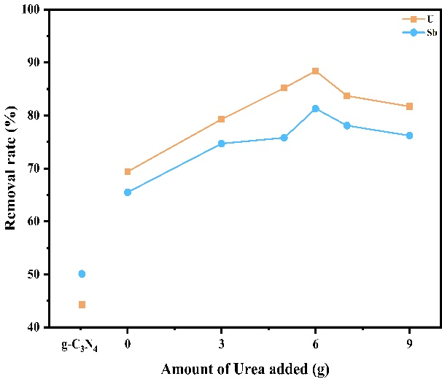
Fig. S2. Removal rates of U(Ⅵ) and Sb(Ⅲ) in the solution with g-C₃N₄ or TiO₂/g-C₃N₄ made by different amount of urea.
Text S5.
Synthesis and photocatalytic performance of TiO₂ /Fe₃O₄ with different optimum amount of Fe₃O₄.
By stirring the composite in 6 M HCl for 12 h and measuring the dissolved iron ion concentration, the Fe₃O₄ loading was calculated to be 0、25、40、50、60、75 mg. 30 mg of TiO₂/Fe₃O₄ with different amount of Fe₃O₄ or Fe₃O₄ were suspended respectively in the solution with 20 ppm U(Ⅵ) and 20 ppm Sb(Ⅲ)。The concentration of U(Ⅵ) and Sb(Ⅲ) were measured after 5 hours of illumination. After comparing the removal rates of U(Ⅵ) and Sb(Ⅲ) in Fig. S3, 50 mg was selected as the best optimum amount of Fe₃O₄.

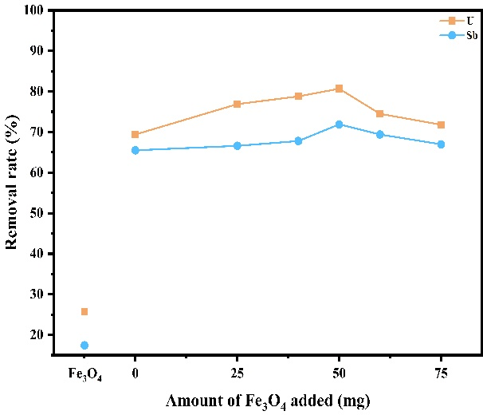
Fig. S3. Removal rates of U(Ⅵ) and Sb(Ⅲ) in the solution with Fe₃O₄ or TiO₂/Fe₃O₄ made by different amount of Fe₃O₄.
Text S6.
Synthesis and photocatalytic performance of best scale between FT and TC.
During the exploration, it was found that if Fe₃O₄ was added too much (m (FT): m (TC)>3), FTC would be dissolved due to the electronic interaction between the two contact semiconductors. Since TiO₂/g-C₃N₄ heterojunction was the main reaction site, the ratio of TC should be as high as possible, but m (FT): m (TC)<1 would lead to difficulties to recycle due to poor magnetism.
So mixed FT and TC into the solution in the proportion of 1, 1.5, 2, 2.5 and 3 containing Absolute Alcohol and Glycerin (3:1). After sonicated for 30 min, the as-prepared mixture was transferred into a Teflon-lined stainless steel autoclave, and then heated at 200 °C in an oven for 24 h. The final black product was thoroughly washed by ethanol via magnetic separation and dried in vacuum at 50°C for 4 h. The abbreviation of Fe₃O₄/TiO₂/g-C₃N₄ is FTC.
30 mg of Fe₃O₄ /TiO₂/ g-C₃N₄ with different scale between FT and TC were suspended respectively in the solution with 20 ppm U(Ⅵ) and 20 ppm Sb(Ⅲ)。The concentration of U(Ⅵ) and Sb(Ⅲ) were measured after 5 hours of illumination. After comparing the removal rates of U(Ⅵ) and Sb(Ⅲ) in Fig. S4, 1 was selected as the best scale between FT and TC.
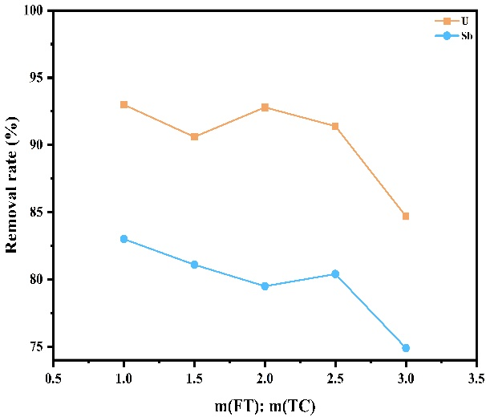
Fig. S4. Removal rates of U(Ⅵ) and Sb(Ⅲ) in the solution over FTC with different scale between FT and TC.
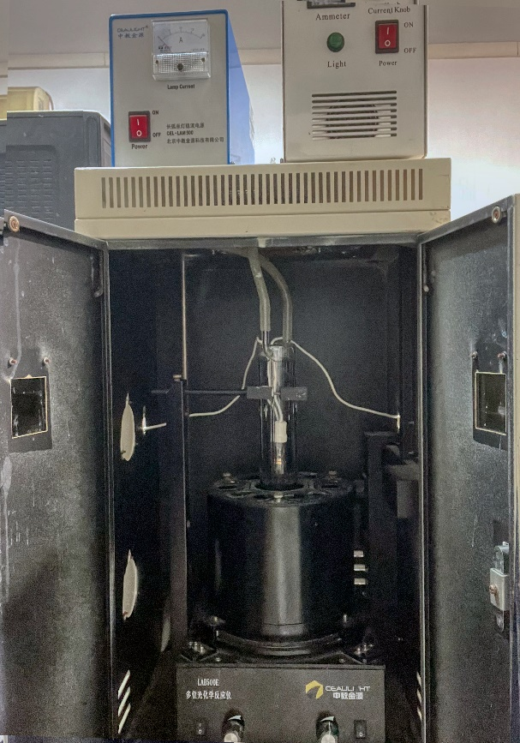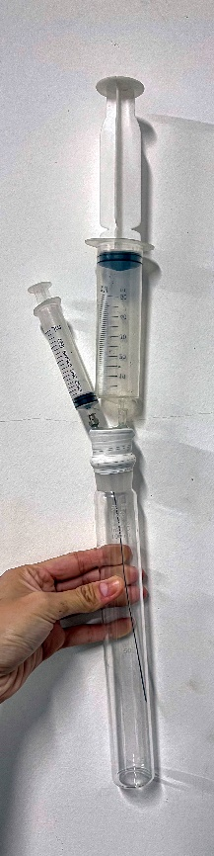
Fig. S5. The pictures of photoreactor and colorimetric tube.
Text S7.
Methods Co-existing ions experiment.
Since the original solution contains NO- 3, 10 mM NaNO₃, KNO₃ and Mg(NO₃)₂ solution were used to explore the removal rate of Na⁺, K⁺ and Mg²⁺ on U(Ⅵ) and Sb(Ⅲ). After that, used 10 mM Na₂CO₃, Na₂SO₄ and NaCl to explore the influence of SO₂₋ ₄, CO_{2- 3,} and Cl⁻.Took exploring the influence of Na⁺ as an example. The specific method is to replace the Milli-Q water in 2.5 with 10 mM NaNO₃, and the other steps are identical. The concentration of U(Ⅵ) and Sb(Ⅲ) were measured after 5 hours of illumination. The removal rate of U(Ⅵ) and Sb(Ⅲ) was the basis to judge the influence of Co-existing ions.
Text S8.
Material Characterizations.
The morphology of materials was characterized by scanning electron microscopy (SEM) (TESCAN MIRA LMS, Czech), transmission electron microscopy (TEM) (FEI Tecnai F30, America) and high resolution TEM(HRTEM) (JEM-2011, Japan). Powder X-ray diffraction (XRD) patterns were recorded using a Bruker D2 PHASER X-ray diffractometer operating with Cu Kα radiation at a speed of 2°/min. Fourier transform infrared (FT-IR) spectroscopy was carried out on a Thermo Scientific Nicolet iS20 FTIR spectroscopy. Raman spectroscopy was carried out using a HORIBA Scientific LabRAM HR Evolution Raman system. A 785 nm laser was utilized as the source of light for excitation. The optical properties were detected using UV–Vis diffuse reflection spectra (Hitachi U4150). The photocurrent and electrochemical impedance spectroscopy (EIS) responses were measured by an electrochemical analyzer (CHI 760E electrochemical workstation) at 0.24 V bias voltage under illumination of a 300 W Xe lamp. Three electrodes, of which fluorine-tin oxide (FTO) glass, Ag/AgCl and Pt electrodes were used as working electrode, the counter and reference electrodes, respectively. A 0.5 M Na₂SO₄ aqueous solution was used as the electrolyte. A 300 W Xe lamp was used as the source of simulated sunlight irradiation for Photocurrent measurements, the Mott–Schottky plots were obtained at a fixed frequency of 100 kHz，and the other conditions were similar to those of EIS. The working electrodes were prepared by dip-coating. The details are shown below: 20 mg of photocatalyst was suspended in 2 mL of deionization water to produce a slurry that was then dip-coated onto a 1 cm × 1 cm fluorine-tin oxide (FTO) glass electrode. After dried under ambient conditions, the films were vacuum sintered at 50 °C for 4 h. The magnetic property of the materials composite was analyzed by using a vibrating sample magnetometer (VSM, Lakeshore 7404). The surface electronic state was recorded via the XPS spectrum(Thermo ESCALAB 250XI). And the Photoluminescence spectra have been recorded using Edinburgh FLS1000 with the wavelength at 325 nm. The values of zeta potentials were performed using Malvern Zetasizer Nano ZS ZEN3600. Room-temperature ESR spectra were obtained at Xe lamp using German Bruker EMXplus-6/1. The synchrotron radiation used Shanghai Synchrotron Radiation Facility to record U L_{III}-edge EXAFS spectra and Sb K-edge EXAFS spectra.
Text S9.
Computational details.
We have employed the Vienna Ab Initio Package (VASP) ^{[6, 7]} to perform all the density functional theory (DFT) calculations within the generalized gradient approximation (GGA) using the PBE ^{[8]} formulation. We have chosen the projected augmented wave (PAW) potentials ^{[9, 10]} to describe the ionic cores and take valence electrons into account using a plane wave basis set with a kinetic energy cutoff of 450 eV. Partial occupancies of the Kohn−Sham orbitals were allowed using the Gaussian smearing method and a width of 0.05 eV. The on-site corrections (DFT+U) has been applied to the 3d electron of Ti atoms (U_{eff}=4.5 eV) by the approach from Dudarev et al ^{[11]}. The electronic energy was considered self-consistent when the energy change was smaller than 10⁻⁵ eV. A geometry optimization was considered convergent when the force change was smaller than 0.02 eV/Å. Grimme’s DFT-D3 methodology ^{[12]} was used to describe the dispersion interactions.
The equilibrium lattice constants of anatase TiO₂ unit cell were optimized, when using a 10×10×4 Monkhorst-Pack k-point grid for Brillouin zone sampling, to be a=b=3.858 Å and c=9.652 Å. The equilibrium lattice constant of spinel-type Fe₃O₄ unit cell was optimized, when using a 4×4×4 Monkhorst-Pack k-point grid for Brillouin zone sampling, to be a=8.502 Å. The equilibrium lattice constant of g-C₃N₄ monolayer unit cell was optimized, when using a 7×7×7 Monkhorst-Pack k-point grid for Brillouin zone sampling, to be a=7.136 Å. We then use them to construct two heterojunction surface models. Model 1 is TiO₂(001)/Fe₃O₄(311) heterojunction. The TiO₂(001) part has a p(7×7) periodicity in the X and Y directions and half stoichiometric layer in the Z direction; the Fe₃O₄(311) part has a p(7×7) periodicity in the X and Y directions and half stoichiometric layer in the Z direction; the slab was separated in the Z direction by a vacuum layer in the depth of 15 Å in order to separate the surface slab from its periodic duplicates. Model 1 comprises of 98 Ti, 108 Fe, and 340 O atoms. During structural optimizations, the Γ point in the Brillouin zone was used for k-point sampling, and the bottom 1/4 stoichiometric layer of the TiO₂(001) part was fixed while the rest were allowed to fully relax. Model 2 is TiO₂(001)/g-C₃N₄ heterojunction. The TiO₂(001) part has a p(4×3) periodicity in the X and Y directions and one stoichiometric layer in the Z direction; the g-C₃N₄ part has a p(2×1) periodicity in the X and Y directions and half stoichiometric layer in the Z direction; the slab was separated in the Z direction by a vacuum layer in the depth of 15 Å in order to separate the surface slab from its periodic duplicates. Model 2 comprises of 48 Ti, 96 O, 24 N, and 32 N atoms. During structural optimizations, the Γ point in the Brillouin zone was used for k-point sampling, and the bottom half stoichiometric layer of the TiO₂(001) part was fixed while the rest were allowed to fully relax.
The adsorption energy (E_{ads}) of adsorbate A was defined as
E_{ads} = E_{A/surf} – E_{surf} – E_{A(g)}
where E_{A/surf}, E_{surf} and E_{A(g)} are the energy of adsorbate A adsorbed on the model, the energy of clean model, and the energy of isolated A molecule in a cubic periodic box with a side length of 20 Å and a 1×1×1 Monkhorst-Pack k-point grid for Brillouin zone sampling, respectively.
Text S10.
The EXAFS signals fitting and wavelet transform (WT) analysis.
Uranium L_{III}-edge and Antimony K-edge EXAFS spectra were conducted at Shanghai Synchrotron Radiation Facility (BL14W, Shanghai, China) by silicon (111) double crystal monochromator with a multi-element Ge solid-state detector in transmission mode. The obtained XAFS data was processed in Athena (version 0.9.26) for background, pre-edge line and post-edge line calibrations. Then Fourier transformed fitting was carried out in Artemis (version 0.9.26) ^{[13, 14]}. The k³-weighted χ(k) function, k-range of ~3.0-~10.0 Å⁻¹ and R range of ~1.0-~2.5 Å were used for the fitting. The models of Sb foil, Sb(OH)₃, Sb(OH)_{5,} UO_{2,} UO_{3,} UO₂(NO₃)_{2,} and sample were used to calculate the simulated scattering paths. The four parameters, coordination number, bond length, Debye-Waller factor and E₀ shift (CN, R, σ², ΔE₀) were fitted and partially fixed. The k³χ(k) functions of the k-space data were the original spatial vibration of the central element of the samples, and the signals of those were clear, indicating that the quality of the data measured by Sb and U in the sample was accurate.
Table S1
Magnetic parameters of Fe₃O₄, FT, FTC before and after cycles.
 | H_{c}(Oe) ª | H_{m}(Oe)^{b} | B_{r}(emu/g)^{c} | B_{s}(emu/g)^{d}
Fe₃O₄ | 79.91 | 17876.40 | 10.15 | 87.82
FT | 96.85 | 18868.67 | 3.42 | 27.82
FTC | 116.75 | 17891.60 | 2.29 | 16.02
After 4 cycles | 113.79 | 18385.59 | 2.20 | 15.59
After 7 cycles | 110.79 | 18396.58 | 1.76 | 13.12
ª The coercive force.
^{b} The saturation magnetization.
^{c} The remanence.
^{d} The saturation magnetic induction.
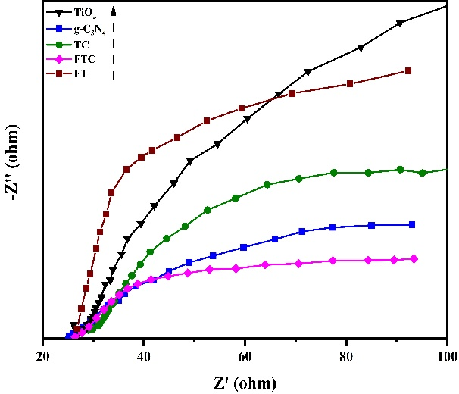
Fig. S6. EIS of TiO₂, g-C₃N₄, FT, TC, and FTC.

Table S2
Adsorption energies (Eads) of U(Ⅵ) or Sb(Ⅲ) adsorbed on the one side of {001}TiO₂, g-C₃N₄, in the middle of TiO₂/g-C₃N₄, and Fe₃O₄/TiO₂ heterojunction.
Model | Adsorbate | Eads (eV)
{001}TiO₂ | UO2+ 2 | -2.36
{001}TiO₂ | Sb(OH)₃ | -4.37
g-C₃N₄ | UO2+ 2 | -0.93
g-C₃N₄ | Sb(OH)₃ | 6.81
{001}TiO₂/g-C₃N₄ | UO2+ 2 | -2.51
{001}TiO₂/g-C₃N₄ | Sb(OH)₃ | -7.72
{001}TiO₂/Fe₃O₄ | UO2+ 2 | 27.56
{001}TiO₂/Fe₃O₄ | Sb(OH)₃ | 24.44
{001}TiO₂/g-C₃N₄ | UO 2 | -5.65
{001}TiO₂/g-C₃N₄ | Sb(OH)₅ | -9.68
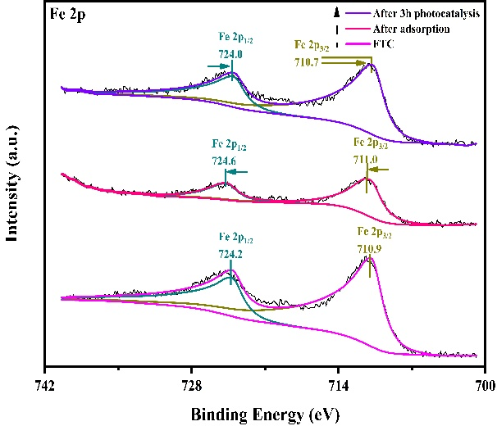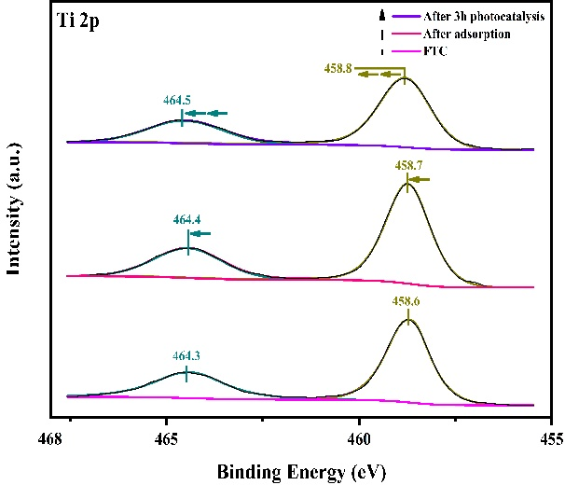
(a)
(b)

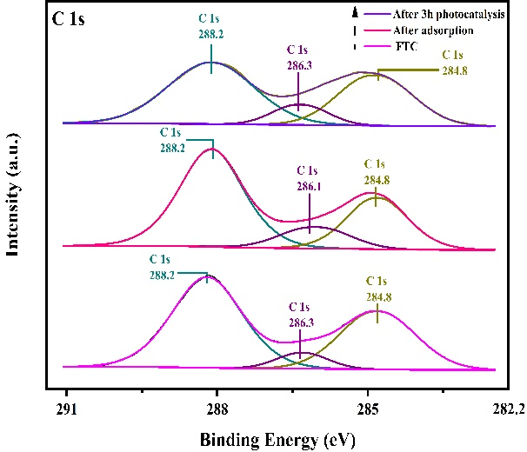
(c)
Fig. S7. XPS spectra of high-resolution Fe 2p (a), high-resolution Ti 2p (b) and high-resolution C 1s (c) of FTC after adsorption and 3h photocatalysis.

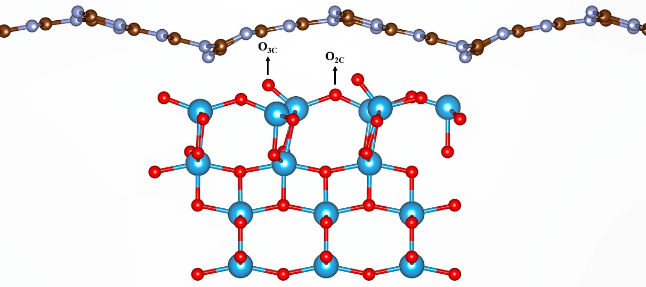
Fig. S8. O_{2c} and O_{3c} sites of {001}TiO₂/g-C₃N₄.
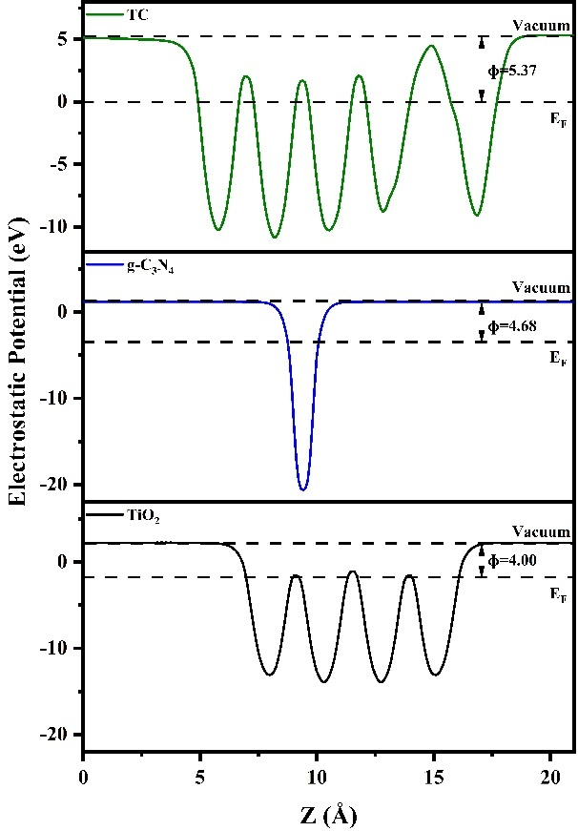
Fig. S9. The electrostatic potentials of TiO₂, g-C₃N₄, and TiO₂/g-C₃N₄.

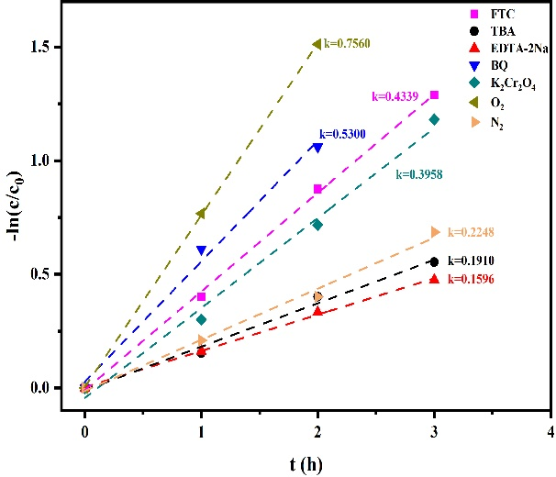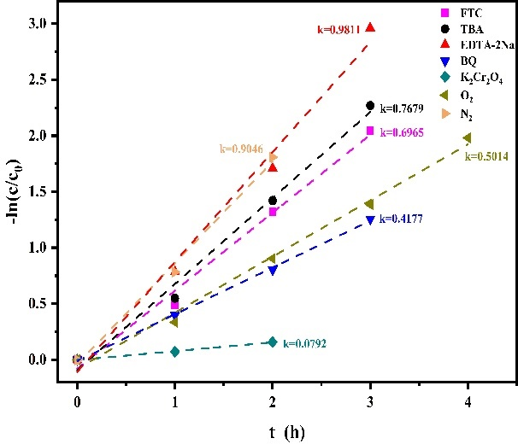
(a)
(b)
Fig. S10. First-order kinetic models of Sb(III) (a) and U(VI) (b) in the solution over FTC with different scavengers.

References
- Han X, Kuang Q, Jin M, Xie Z, Zheng L (2009) Synthesis of Titania Nanosheets with a High Percentage of Exposed (001) Facets and Related Photocatalytic Properties. J Am Chem Soc 131:3152-3153. https://doi.org/10.1021/ja8092373.
- Yang Y, Wang G, Deng Q, Kang S, Ng DHL, Zhao H (2014) A facile synthesis of single crystal TiO₂ nanorods with reactive {100} facets and their enhanced photocatalytic activity. CrystEngComm 16:3091-3096. https://doi.org/10.1039/c3ce42505c.
- Zhou Y, Wang X, Wang H, Song Y, Fang L, Ye N, Wang L (2014) Enhanced dye-sensitized solar cells performance using anatase TiO₂ mesocrystals with the Wulff construction of nearly 100% exposed {101} facets as effective light scattering layer. Dalton Trans 43:4711-4719. https://doi.org/10.1039/c3dt53010h.
- Zou J, Wang L, Luo J, Nie Y, Xing Q, Luo X, Suib SL (2016) Synthesis and efficient visible light photocatalytic H₂ evolution of a metal-free g-C₃N₄/graphene quantum dots hybrid photocatalyst. Appl Catal B 193:103-109. https://doi.org/10.1016/j.apcatb.2016.04.017.
- Chen X, Wei J, Hou R, Liang Y, Xie Z, Zhu Y, Wang H (2016) Growth of g-C₃N₄ on mesoporous TiO₂ spheres with high photocatalytic activity under visible light irradiation. Appl Catal B 188:342-350. https://doi.org/10.1016/j.apcatb.2016.02.012.
- Kresse G, Furthmüller J (1996) Efficiency of ab-initio total energy calculations for metals and semiconductors using a plane-wave basis set. Comput Mater Sci 6:15-50. https://doi.org/10.1016/0927-0256(96)00008-0.
- Kresse G, Furthmüller J (1996) Efficient iterative schemes for ab initio total-energy calculations using a plane-wave basis set. Phys Rev B 54:11169-11186. https://doi.org/10.1103/PhysRevB.54.11169.
- Perdew JP, Burke K, Ernzerhof M (1996) Generalized Gradient Approximation Made Simple. Phys Rev Lett 77:3865-3868. https://doi.org/10.1103/PhysRevLett.77.3865.
- Kresse G, Joubert D (1999) From ultrasoft pseudopotentials to the projector augmented-wave method. Phys Rev B 59:1758-1775. https://doi.org/10.1103/PhysRevB.59.1758.
- BlöchlP E (1994) Projector augmented-wave method. Phys Rev B 50:17953−17979. https://doi.org/10.1103/physrevb.50.17953.
- Dudarev SL, Botton GA, Savrasov SY, Humphreys CJ, Sutton AP (1998) Electron-energy-loss spectra and the structural stability of nickel oxide: An LSDA+U study. Phys Rev B 57:1505. https://doi.org/10.1103/PhysRevB.57.1505.
- Grimme S, Antony J, Ehrlich S, Krieg H (2010) A consistent and accurate ab initio parametrization of density functional dispersion correction (DFT-D) for the 94 elements H-Pu. J Chem Phys 132:154104. https://doi.org/10.1063/1.3382344.
- Funke H, Chukalina M, Scheinost AC (2007) A new FEFF-based wavelet for EXAFS data analysis. J Synchrotron Radiat 14:426-432. https://doi.org/10.1107/S0909049507031901.
- Ravel B, Newville M (2005) ATHENA, ARTEMIS, HEPHAESTUS: data analysis for X-ray absorption spectroscopy using IFEFFIT. J Synchrotron Radiat 12:537-541. https://doi.org/10.1107/S0909049505012719.

