Supplemental Information

The association between gut microbiota and postoperative delirium in patients

Yiying Zhang MD, PhD, Kathryn Baldyga BS, Yuanlin Dong MD MS,
Wenyu Song, PhD, Mirella Villanueva, M.S., Hao Deng, MPH , Ariel Mueller MA,
Timothy T Houle PhD, Edward R Marcantonio MD MS, Zhongcong Xie MD, PhD

Supplemntal Figure 1.
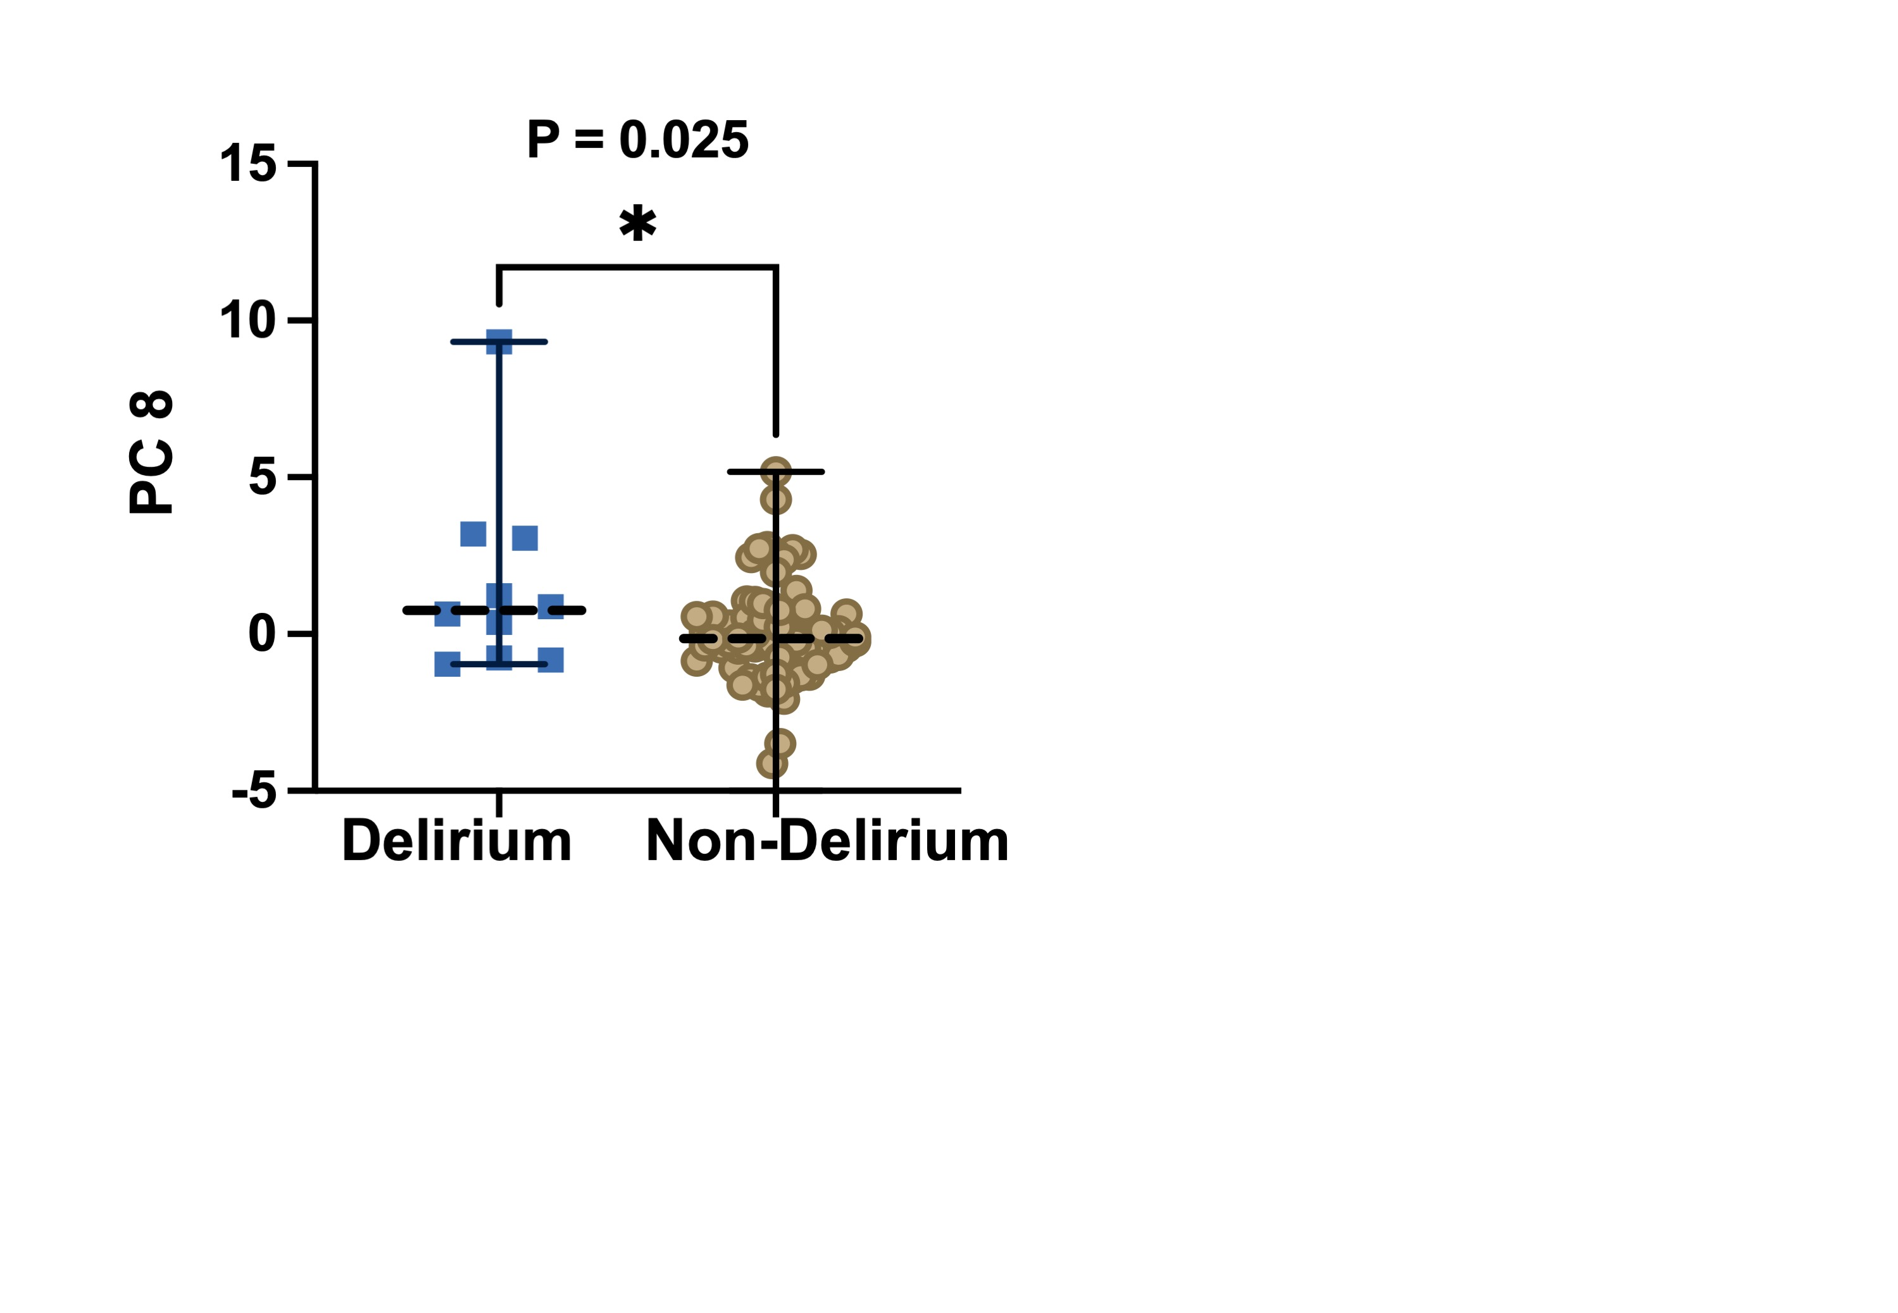

Supplemental Figure 1: Different postoperative gut bacteria profiles between participants with and without postoperative delirium.
The participants with postoperative delirium (left column) had different index of principal component 8 than the participants without delirium (right column). The box indicates median (50th percentile), the ﬁrst quartile (25th percentile), and the third quartile (75th percentile) of the abundances of bacteria.

Supplemental Table 1. Demographic characteristics of the participants
 | Included participants (N = 86) | Excluded participants (N = 134) | P-value
Age, median  (25%-75% percentile of quartile) | 72.0 (69.0 – 76.0) | 72.0 (68.0 – 76.0) | 0.852
Female, n (%) | 46 (53) | 73 (54) | 0.237
Non-white or Hispanic, n (%) | 4 (5) | 10 (7) | 0.582
Surgery type, n (%)
Knee replacement | 53 (62) | 96 (72) | 0.251
Hip replacement | 26 (30) | 32 (24) | 0.251
Spinal stenosis | 7 (7) | 6 (4) | 0.251
Anesthesia type, n (%)
General | 46 (53) | 52 (39) | 0.038
Spinal | 40 (47) | 82 (61) | 0.038
MMSE, median
(25% -75% percentile of quartile)
Pre-surgery score | 29.0 (28.8 – 30.0) | 29.0 (28.0 – 30.0) | 0.931
MMSE, mini-mental status examination.

