ELECTRONIC SUPPLEMENTARY MATERIAL

Article title: Estimating river discharge from rainfall satellite data through simple statistical models

Journal name: Theoretical and Applied Climatology (Springer)
Author names: Paula Birocchi, Danilo Augusto Silva, Dalton Kei Sasaki, Marcelo Dottori.
Affiliations: Oceanographic Institute, University of São Paulo, São Paulo, Brazil
E-mail address of the corresponding author: paula.birocchi@usp.br

The shapefile for the Ribeira de Iguape was obtained from http://riverbasins.wateractionhub.org/.

The MERGE dataset is freely available at http://ftp.cptec.inpe.br/modelos/tempo/MERGE/.

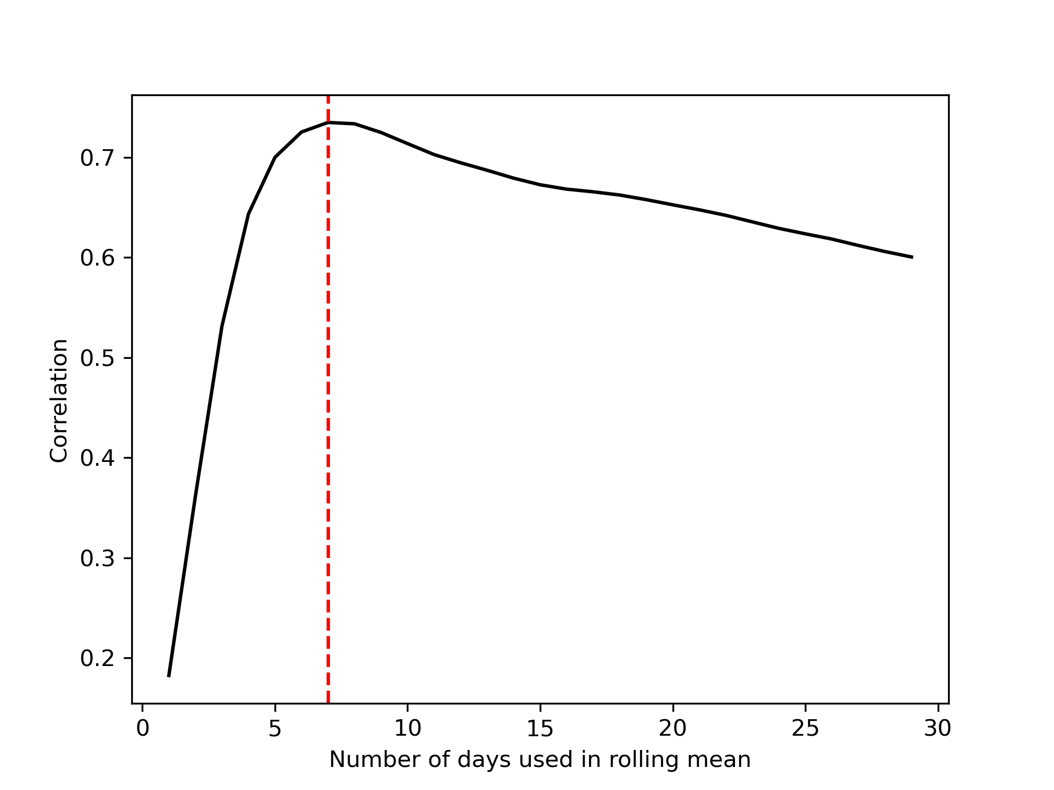
Fig. S1 Number of days used to calculate the R (x-axis) and Pearson’s correlation between R and discharge (y-axis). The maximum correlation occurred with a 7-day R (R⁷) (red dashed line) with a value of 0.735 and p value <0.01.

We present a comparison between the 7-day accumulated rainfall (R⁷) and the VGC discharge data (Q_{VGC}), which was split into the training and validation datasets for the linear, quadratic, and exponential models in Fig. S2 (a), (c), and (e), respectively. The linear regression presents a coefficient of 0.05, while the offset of the model represents an approximate minimum value of 215.06 m³.s⁻¹ in the river discharge time series, as shown in Fig. S2 (a). Applying the quadratic model, we found coefficient and offset values of 0.001 and 15.51 s.m⁻³, respectively (Fig. S2(c)). The exponential model had an offset of 5.53 m³.s⁻¹ and a coefficient of 0.001 s.m⁻³ (Fig. S2 (e)). In the test subset validation for the linear, quadratic, and exponential models (Fig. S2 (b), (d), and (f), respectively), we found skill values between 0.81 and 0.83, CD values between 0.51 and 0.53, and RMSE between 122.66 m³.s⁻¹ and 125.26 m³.s⁻¹.
For the time series validation of the linear, quadratic, and exponential models (Fig. S3 ((a), (b), and (c), respectively), we found skills between 0.83 and 0.84, CD between 0.54 and 0.57, and RMSE between 136.38 m³.s⁻¹ and 141.61 m³.s⁻¹.

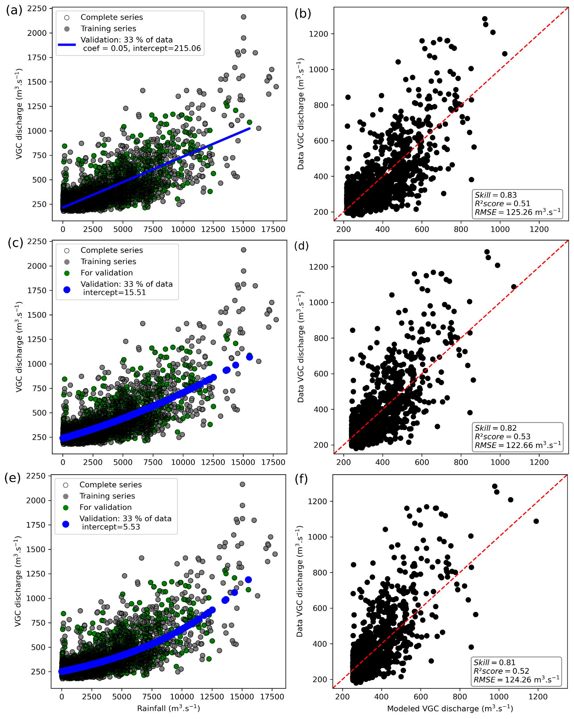
Fig. S2 Precipitation and VGC discharge data used to build the (a) linear, (c) quadratic and (e) exponential regression models. Contoured circles indicate the complete series, gray circles indicate the data used to train the model (67%), and green circles indicate the data used to test (or validate) the model (33%). The blue line represents the fitted model in the data, which was the smallest RMSE found. Comparison of the discharge results from the (b) linear, (d) quadratic and (f) exponential regression models and data estimated using the GEOBRÁS (1966) method (in m³.s⁻¹).

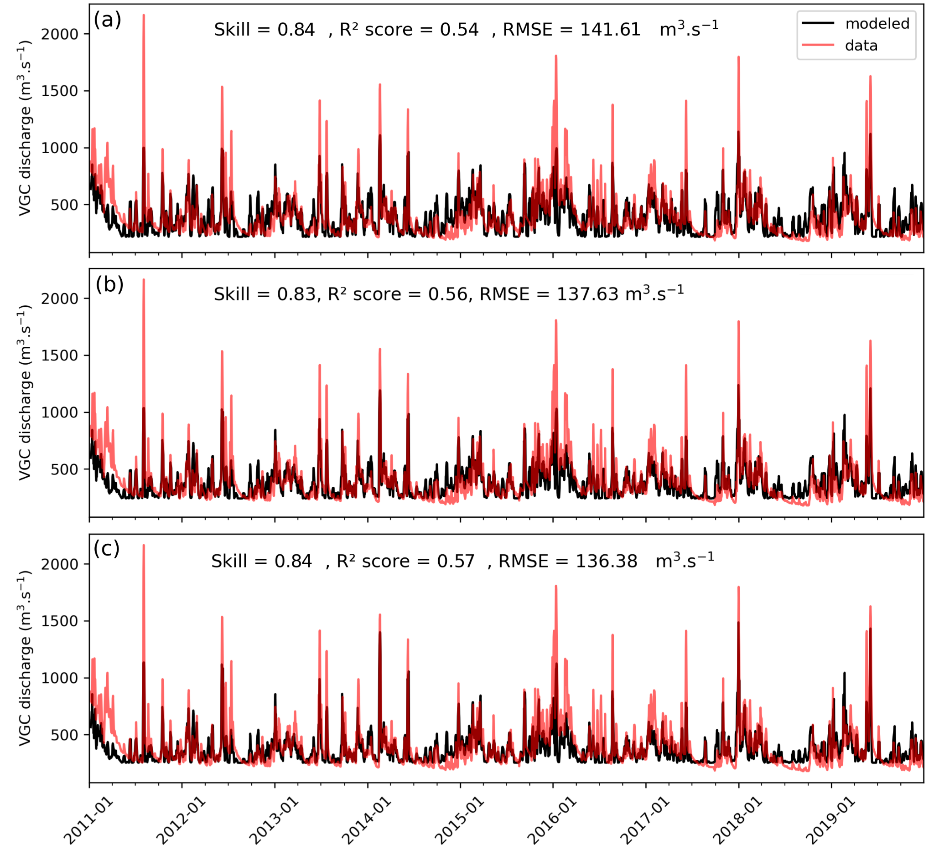
Fig. S3 VGC discharge time series for the linear (a), quadratic (b) and exponential (c) regression model results (in black) and estimated by the method proposed by GEOBRÁS (1966) (in red).

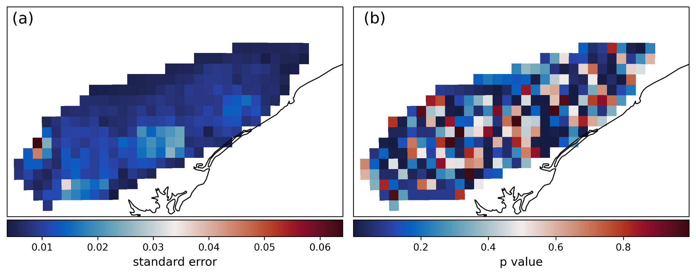
Fig. S4 (a) Standard errors and (b) p values for the multiple regression using R⁷.

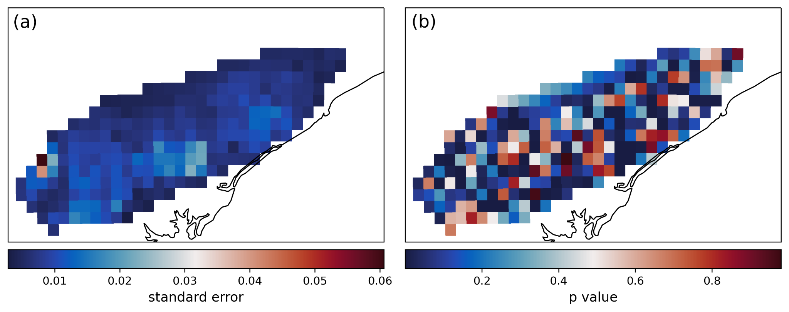
Fig. S5 (a) Standard error and (b) p value for the multiple regression using R^{VT}.

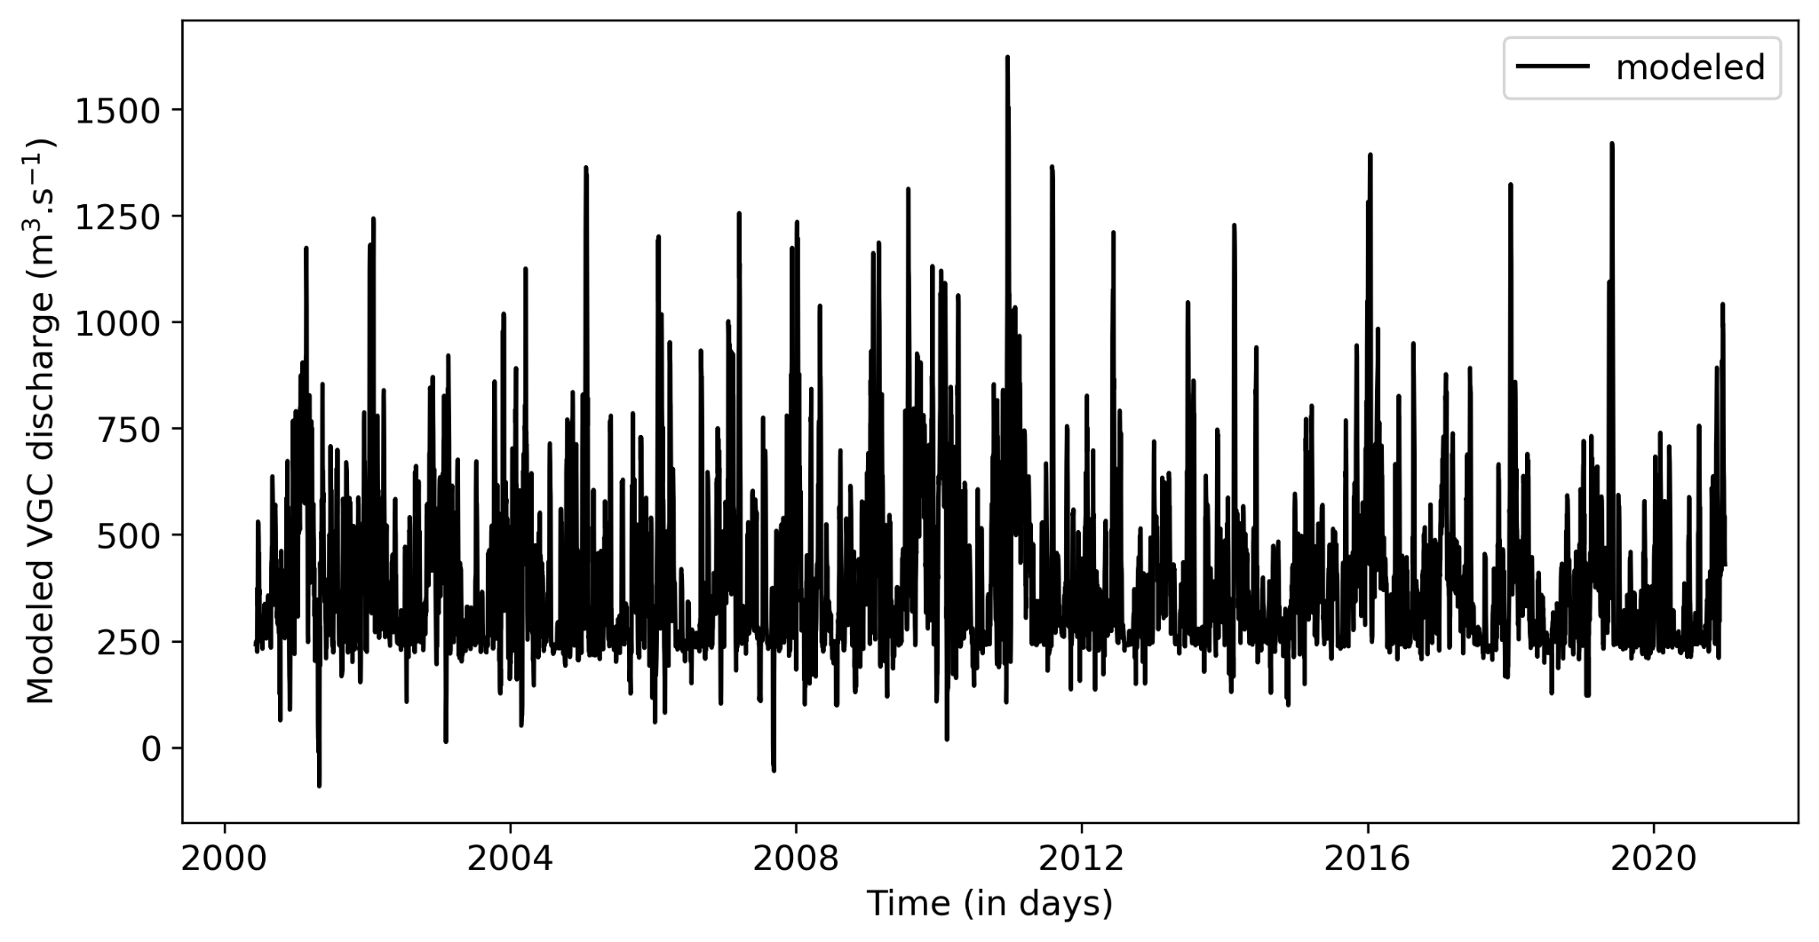
Fig. S6 Complete time series for VGC discharge using the multiple regression model with R^{VT} fed by MERGE precipitation data from June 2000 to December 2020.

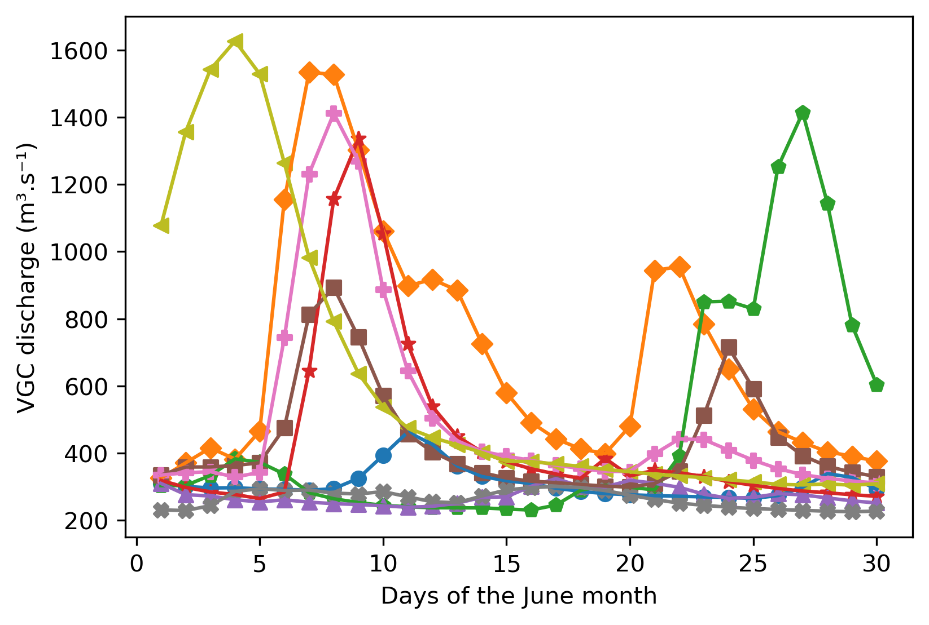
Fig. S7 Estimated daily mean discharge for the Valo Grande Channel for June from 2011 to 2019 (from the top to the bottom).
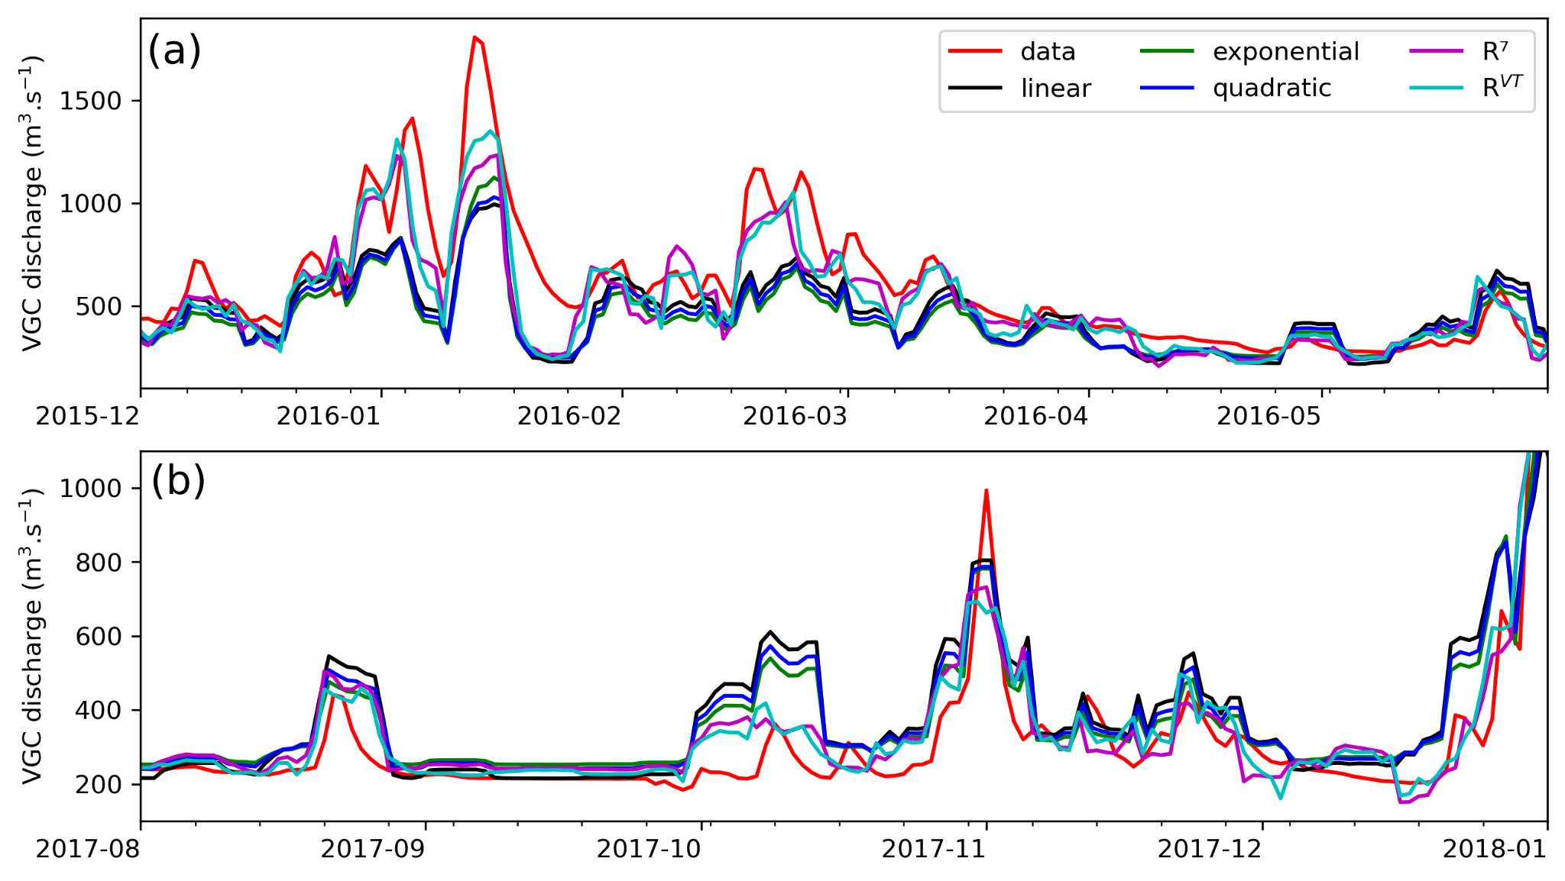
Fig. S8 Magnified view of a peak (a) and small values (b) for the VGC discharge estimated by the method proposed by GEOBRÁS (1966) (in red) and modeled by the linear regression model (in black), quadratic function (in blue), exponential function (in green), multiple linear regression using R⁷ (in magenta) and multiple linear regression with R^{VT} (in light blue).

