Supplementary materials
for
Correlation between microbial diversity and geochemistry of representative elements in the surface environment of the antimony mining area in Xikuangshan, China
Can Wang^{1#}, Ruiyong Zhang ^{1, 2, 3#}, Jinlan Xia¹, Hongchang Liu¹*, Yue Liu¹, Yuhang Zhou¹, Zhenyuan Nie¹, Wensheng Shu⁴
¹ Key Lab of Biometallurgy of Ministry of Education of China, School of Minerals Processing and Bioengineering, Central South University, Changsha 410083, China,
² Key Laboratory of Marine Environmental Corrosion and Biofouling, Institute of Oceanology, Chinese Academy of Sciences, Qingdao 266071, China,
³ Open Studio for Marine Corrosion and Protection, Pilot National Laboratory for Marine Science and Technology (Qingdao), No. 1 Wenhai Road, Qingdao 266237, China,
⁴ School of Life Science, South China Normal University, Guangzhou 510631, China
* Correspondence: Hong-chang Liu, hchliu2050@csu.edu.cn
#These authors contributed equally to this work.

Table S1 pH and ORP values of all samples (i, ii, iii represent data from repeated trials)
Sample | pH |  |  |  |  | ORP
Soil | i | ii | iii | Average | Stdev | i | ii | iii | Average | Stdev
S.1.1 | 8.95 | 8.90 | 9.09 | 8.98 | 0.08 | 170 | 173 | 185 | 176 | 6.48
S.1.2 | 8.35 | 8.46 | 8.39 | 8.40 | 0.05 | 220 | 220 | 229 | 223 | 4.24
S.1.3 | 8.62 | 8.44 | 8.53 | 8.53 | 0.07 | 228 | 235 | 254 | 239 | 10.98
S.2.1 | 7.60 | 7.55 | 7.71 | 7.62 | 0.07 | 290 | 296 | 329 | 305 | 17.15
S.2.2 | 8.09 | 8.21 | 8.03 | 8.11 | 0.07 | 240 | 246 | 249 | 245 | 3.74
S.2.3 | 7.43 | 7.45 | 7.59 | 7.49 | 0.07 | 313 | 306 | 311 | 310 | 2.94
S.2.4 | 8.26 | 8.16 | 8.24 | 8.22 | 0.04 | 247 | 238 | 235 | 240 | 5.10
S.3.1 | 8.12 | 8.16 | 8.26 | 8.18 | 0.06 | 238 | 234 | 236 | 236 | 1.63
S.3.2 | 7.68 | 7.82 | 8.14 | 7.88 | 0.19 | 245 | 245 | 266 | 252 | 9.90
S.3.3 | 7.78 | 7.95 | 8.27 | 8.00 | 0.20 | 236 | 239 | 230 | 235 | 3.74
S.3.4 | 6.26 | 6.02 | 5.69 | 5.99 | 0.23 | 399 | 393 | 417 | 403 | 10.20
Average | 7.92 | 7.92 | 7.99 | 7.95 | 0.03 | 257 | 257 | 266 | 260 | 4.44
Sediment | i | ii | iii | Average | Stdev | i | ii | iii | Average | Stdev
Sed.1.1 | 8.36 | 8.26 | 8.34 | 8.32 | 0.04 | 133 | 140 | 141 | 138 | 3.56
Sed.1.2 | 8.29 | 8.17 | 8.35 | 8.27 | 0.07 | -6 | -7 | -2 | -5 | 2.16
Sed.1.3 | 10.00 | 10.26 | 10.40 | 10.22 | 0.17 | -3 | -3 | 6 | 0 | 4.24
Sed.2.1 | 8.34 | 8.47 | 8.36 | 8.39 | 0.06 | 186 | 196 | 191 | 191 | 4.08
Sed.2.2 | 9.09 | 8.69 | 9.22 | 9.00 | 0.23 | 99 | 86 | 109 | 98 | 9.42
Sed.2.3 | 8.23 | 8.54 | 8.16 | 8.31 | 0.17 | 136 | 127 | 85 | 116 | 22.23
Average | 8.72 | 8.73 | 8.81 | 8.75 | 0.04 | 91 | 90 | 88 | 90 | 1.03
Water | i | ii | iii | Average | Stdev | i | ii | iii | Average | Stdev
W.1.1 | 7.59 | 7.60 | 7.64 | 7.61 | 0.02 | 208 | 220 | 181 | 203 | 16.31
W.1.2 | 7.78 | 7.68 | 8.06 | 7.84 | 0.16 | 153 | 165 | 141 | 153 | 9.80
W.1.3 | 7.99 | 7.65 | 7.88 | 7.84 | 0.14 | 166 | 156 | 173 | 165 | 6.98
W.2.1 | 9.33 | 9.26 | 9.37 | 9.32 | 0.05 | 95 | 88 | 93 | 92 | 2.94
W.2.2 | 8.00 | 8.05 | 8.22 | 8.09 | 0.09 | 136 | 118 | 133 | 129 | 7.87
W.2.3 | 8.16 | 7.99 | 8.18 | 8.11 | 0.09 | 138 | 146 | 145 | 143 | 3.56
Average | 8.14 | 8.04 | 8.23 | 8.14 | 0.08 | 149 | 149 | 144 | 143 | 2.25

Table S2 Content of different occurrence forms of C/S in solid and sediment samples and C/N in water samples
Form | TC(mg/L) |  |  |  |  | TS(mg/L)
Sample | i | ii | iii | Average | Stdev | i | ii | iii | Average | Stdev
S.1.1 | 1.47 | 1.50 | 1.56 | 1.51 | 0.04 | 1.52 | 1.54 | 1.47 | 1.51 | 0.03
S.1.2 | 3.99 | 3.99 | 3.93 | 3.97 | 0.03 | 3.98 | 3.94 | 3.99 | 3.97 | 0.02
S.1.3 | 3.32 | 3.28 | 3.39 | 3.33 | 0.05 | 3.36 | 3.36 | 3.27 | 3.33 | 0.04
S.2.1 | 2.19 | 2.16 | 2.19 | 2.18 | 0.01 | 2.16 | 2.19 | 2.19 | 2.18 | 0.01
S.2.2 | 0.50 | 0.50 | 0.53 | 0.51 | 0.01 | 0.52 | 0.53 | 0.48 | 0.51 | 0.02
S.2.3 | 3.06 | 3.05 | 3.07 | 3.06 | 0.01 | 3.08 | 3.07 | 3.03 | 3.06 | 0.02
S.2.4 | 3.77 | 3.74 | 3.83 | 3.78 | 0.04 | 3.76 | 3.78 | 3.80 | 3.78 | 0.02
S.3.1 | 4.60 | 4.63 | 4.66 | 4.63 | 0.02 | 4.66 | 4.68 | 4.55 | 4.63 | 0.06
S.3.2 | 1.18 | 1.19 | 1.11 | 1.16 | 0.04 | 1.18 | 1.19 | 1.11 | 1.16 | 0.04
S.3.3 | 1.46 | 1.45 | 1.56 | 1.49 | 0.05 | 1.46 | 1.18 | 1.83 | 1.49 | 0.27
S.3.4 | 0.51 | 0.53 | 0.46 | 0.50 | 0.03 | 0.49 | 0.52 | 0.49 | 0.50 | 0.01
Average | 2.37 | 2.37 | 2.38 | 2.37 | 0.00 | 2.38 | 2.36 | 2.37 | 2.37 | 0.01
Form | IC(mg/L) |  |  |  |  | IS(mg/L)
S.1.1 | 0.96 | 0.96 | 1.02 | 0.98 | 0.03 | 1.39 | 1.38 | 1.46 | 1.41 | 0.04
S.1.2 | 2.63 | 2.64 | 2.59 | 2.62 | 0.02 | 3.98 | 3.94 | 3.75 | 3.89 | 0.10
S.1.3 | 0.54 | 0.58 | 0.47 | 0.53 | 0.05 | 3.36 | 3.29 | 3.13 | 3.26 | 0.10
S.2.1 | 0.18 | 0.18 | 0.21 | 0.19 | 0.01 | 2.15 | 2.19 | 1.99 | 2.11 | 0.09
S.2.2 | 0.04 | 0.05 | 0.06 | 0.05 | 0.01 | 0.44 | 0.49 | 0.45 | 0.46 | 0.02
S.2.3 | 0.98 | 0.98 | 1.01 | 0.99 | 0.01 | 2.99 | 2.95 | 2.97 | 2.97 | 0.02
S.2.4 | 0.20 | 0.20 | 0.23 | 0.21 | 0.01 | 3.72 | 3.79 | 3.56 | 3.69 | 0.10
S.3.1 | 0.66 | 0.67 | 0.68 | 0.67 | 0.01 | 4.48 | 4.66 | 4.33 | 4.49 | 0.13
S.3.2 | 0.78 | 0.77 | 0.82 | 0.79 | 0.02 | 0.68 | 0.70 | 0.69 | 0.69 | 0.01
S.3.3 | 0.46 | 0.46 | 0.49 | 0.47 | 0.01 | 1.36 | 1.38 | 1.22 | 1.32 | 0.07
S.3.4 | 0.19 | 0.19 | 0.16 | 0.18 | 0.01 | 0.44 | 0.43 | 0.45 | 0.44 | 0.01
Average | 0.69 | 0.70 | 0.71 | 0.70 | 0.01 | 2.27 | 2.29 | 2.19 | 2.25 | 0.05
Form | OC(mg/L) |  |  |  |  | OS(mg/L)
S.1.1 | 0.53 | 0.52 | 0.54 | 0.53 | 0.01 | 0.08 | 0.08 | 0.14 | 0.10 | 0.03
S.1.2 | 1.33 | 1.33 | 1.39 | 1.35 | 0.03 | 0.08 | 0.08 | 0.08 | 0.08 | 0.00
S.1.3 | 2.83 | 2.83 | 2.74 | 2.80 | 0.04 | 0.07 | 0.06 | 0.08 | 0.07 | 0.01
S.2.1 | 1.96 | 1.96 | 2.05 | 1.99 | 0.04 | 0.07 | 0.07 | 0.07 | 0.07 | 0.00
S.2.2 | 0.44 | 0.43 | 0.51 | 0.46 | 0.04 | 0.04 | 0.04 | 0.07 | 0.05 | 0.01
S.2.3 | 2.09 | 2.08 | 2.04 | 2.07 | 0.02 | 0.08 | 0.08 | 0.11 | 0.09 | 0.01
S.2.4 | 3.55 | 3.64 | 3.52 | 3.57 | 0.05 | 0.09 | 0.09 | 0.09 | 0.09 | 0.00
S.3.1 | 3.89 | 4.04 | 3.95 | 3.96 | 0.06 | 0.14 | 0.13 | 0.15 | 0.14 | 0.01
S.3.2 | 0.33 | 0.36 | 0.42 | 0.37 | 0.04 | 0.42 | 0.45 | 0.54 | 0.47 | 0.05
S.3.3 | 1.00 | 1.02 | 1.04 | 1.02 | 0.02 | 0.16 | 0.17 | 0.18 | 0.17 | 0.01
S.3.4 | 0.30 | 0.36 | 0.30 | 0.32 | 0.03 | 0.06 | 0.05 | 0.07 | 0.06 | 0.01
Average | 1.66 | 1.69 | 1.69 | 1.68 | 0.03 | 0.12 | 0.12 | 0.15 | 0.13 | 0.01
Form | TC(mg/L) |  |  |  |  | TS(mg/L)
Sed.1.1 | 5.01 | 5.01 | 4.86 | 4.96 | 0.07 | 1.77 | 4.99 | 4.91 | 4.96 | 0.06
Sed.1.2 | 5.21 | 5.34 | 5.23 | 5.26 | 0.06 | 5.23 | 5.26 | 5.29 | 5.26 | 0.05
Sed.1.3 | 4.36 | 4.38 | 4.34 | 4.36 | 0.02 | 4.29 | 4.35 | 4.44 | 4.36 | 0.02
Sed.2.1 | 2.99 | 2.89 | 2.88 | 2.92 | 0.05 | 2.82 | 3.01 | 2.93 | 2.92 | 0.01
Sed.2.2 | 1.09 | 1.08 | 0.89 | 1.02 | 0.09 | 0.99 | 1.04 | 1.03 | 1.02 | 0.01
Sed.2.3 | 2.01 | 2.10 | 2.10 | 2.07 | 0.04 | 2.11 | 2.10 | 2.00 | 2.07 | 0.01
Average | 3.45 | 3.47 | 3.38 | 3.43 | 0.04 | 1.82 | 3.46 | 3.43 | 3.43 | 0.02
Form | IC(mg/L) |  |  |  |  | IS(mg/L)
Sed.1.1 | 1.98 | 1.88 | 2.11 | 1.99 | 0.09 | 4.76 | 4.76 | 4.73 | 4.75 | 0.01
Sed.1.2 | 2.06 | 2.06 | 2.12 | 2.08 | 0.03 | 5.05 | 5.07 | 5.12 | 5.08 | 0.03
Sed.1.3 | 1.55 | 1.53 | 1.42 | 1.50 | 0.06 | 4.22 | 4.28 | 4.37 | 4.29 | 0.06
Sed.2.1 | 2.11 | 2.14 | 2.20 | 2.15 | 0.04 | 2.68 | 2.87 | 2.82 | 2.79 | 0.08
Sed.2.2 | 0.88 | 0.86 | 0.69 | 0.81 | 0.09 | 0.64 | 0.68 | 0.66 | 0.66 | 0.02
Sed.2.3 | 1.66 | 1.66 | 1.60 | 1.64 | 0.03 | 2.04 | 2.03 | 1.93 | 2.00 | 0.05
Average | 1.71 | 1.69 | 1.71 | 1.70 | 0.01 | 3.23 | 3.28 | 3.27 | 3.26 | 0.02
Form | OC(mg/L) |  |  |  |  | OS(mg/L)
Sed.1.1 | 2.99 | 2.99 | 2.93 | 2.97 | 0.03 | 0.22 | 0.23 | 0.18 | 0.21 | 0.02
Sed.1.2 | 3.18 | 3.19 | 3.17 | 3.18 | 0.01 | 0.18 | 0.19 | 0.17 | 0.18 | 0.01
Sed.1.3 | 2.88 | 2.76 | 2.94 | 2.86 | 0.07 | 0.07 | 0.07 | 0.07 | 0.07 | 0.00
Sed.2.1 | 0.77 | 0.79 | 0.75 | 0.77 | 0.02 | 0.14 | 0.14 | 0.11 | 0.13 | 0.01
Sed.2.2 | 0.21 | 0.21 | 0.21 | 0.21 | 0.00 | 0.35 | 0.36 | 0.37 | 0.36 | 0.01
Sed.2.3 | 0.36 | 0.38 | 0.55 | 0.43 | 0.09 | 0.07 | 0.07 | 0.07 | 0.07 | 0.00
Average | 1.73 | 1.72 | 1.77 | 1.74 | 0.02 | 0.17 | 0.18 | 0.16 | 0.17 | 0.01
Form | TC(mg/L) |  |  |  |  | TN(mg/L)
W.1.1 | 90.21 | 89.62 | 98.54 | 92.79 | 4.07 | 1.79 | 1.90 | 1.74 | 1.81 | 0.07
W.1.2 | 60.52 | 59.66 | 61.56 | 60.58 | 0.78 | 1.36 | 1.29 | 1.31 | 1.32 | 0.03
W.1.3 | 65.33 | 65.36 | 65.33 | 65.34 | 0.01 | 0.89 | 0.88 | 0.93 | 0.90 | 0.02
W.2.1 | 50.66 | 50.87 | 50.48 | 50.67 | 0.16 | 5.22 | 5.21 | 5.41 | 5.28 | 0.09
W.2.2 | 57.21 | 57.02 | 57.37 | 57.20 | 0.14 | 0.44 | 0.46 | 0.51 | 0.47 | 0.03
W.2.3 | 26.59 | 26.29 | 26.61 | 26.33 | 0.20 | 1.20 | 1.18 | 1.22 | 1.20 | 0.02
Average | 58.42 | 58.14 | 59.98 | 58.82 | 0.81 | 1.82 | 1.82 | 1.85 | 1.83 | 0.02
Form | OC(mg/L) |  |  |  |  | IC(mg/L)
W.1.1 | 82.26 | 81.69 | 82.86 | 82.27 | 0.48 | 10.48 | 10.55 | 10.53 | 10.52 | 0.03
W.1.2 | 50.55 | 51.09 | 50.10 | 50.58 | 0.40 | 10.01 | 9.89 | 10.10 | 10.00 | 0.09
W.1.3 | 54.36 | 54.33 | 54.57 | 54.42 | 0.11 | 10.89 | 10.83 | 11.04 | 10.92 | 0.09
W.2.1 | 40.09 | 39.98 | 39.96 | 40.01 | 0.06 | 10.56 | 10.54 | 10.88 | 10.66 | 0.16
W.2.2 | 50.50 | 50.56 | 50.74 | 50.60 | 0.10 | 6.68 | 6.65 | 6.47 | 6.60 | 0.09
W.2.3 | 21.56 | 21.55 | 21.42 | 21.51 | 0.06 | 4.86 | 4.89 | 4.81 | 4.82 | 0.16
Average | 49.89 | 49.87 | 49.95 | 49.90 | 0.03 | 8.91 | 8.89 | 8.97 | 8.92 | 0.01
Form | TS(mg/L)
W.1.1 | 24.74 | 25.23 | 23.92 | 24.63 | 0.54
W.1.2 | 191.71 | 191.46 | 189.26 | 190.81 | 1.10
W.1.3 | 131.37 | 131.37 | 130.71 | 131.15 | 0.31
W.2.1 | 50.23 | 49.98 | 49.37 | 49.86 | 0.36
W.2.2 | 18.88 | 19.38 | 17.51 | 18.59 | 0.79
W.2.3 | 24.49 | 24.58 | 22.84 | 23.97 | 0.80
Average | 73.57 | 73.67 | 72.27 | 73.17 | 0.03

Table S3 Content of primary element expect C/S/N
Element |  | Sb (mg/L) |  |  |  |  | Mn (mg/L)
Sample | i |  | ii | iii | Average | Stdev |  | i | ii | iii | Average | Stdev
S.1.1 | 13.99 |  | 13.46 | 11.82 | 13.09 | 0.92 |  | 15.06 | 15.09 | 15.01 | 15.05 | 0.03
S.1.2 | 11.87 |  | 12.18 | 10.99 | 11.68 | 0.5 |  | 11.05 | 11.06 | 10.92 | 11.01 | 0.06
S.1.3 | 6.53 |  | 7.13 | 5.84 | 6.5 | 0.53 |  | 21.28 | 21.26 | 21.09 | 21.21 | 0.08
S.2.1 | 6.01 |  | 5.37 | 4.64 | 5.34 | 0.56 |  | 12.6 | 12.55 | 12.38 | 12.51 | 0.09
S.2.2 | 6.55 |  | 7.06 | 4.84 | 6.15 | 0.95 |  | 9.55 | 9.6 | 9.41 | 9.52 | 0.08
S.2.3 | 4.95 |  | 4.94 | 3.4 | 4.43 | 0.73 |  | 15.85 | 15.84 | 15.73 | 15.81 | 0.05
S.2.4 | 15.03 |  | 15.83 | 14.12 | 14.99 | 0.7 |  | 13.68 | 13.75 | 13.55 | 13.66 | 0.08
S.3.1 | 20.23 |  | 20.22 | 18.23 | 19.56 | 0.94 |  | 9.47 | 9.52 | 9.35 | 9.45 | 0.07
S.3.2 | 22.79 |  | 22.26 | 20.77 | 21.94 | 0.86 |  | 7.88 | 7.89 | 7.6 | 7.79 | 0.13
S.3.3 | 8.61 |  | 9.2 | 7.58 | 8.46 | 0.67 |  | 8.3 | 8.36 | 8.18 | 8.28 | 0.07
S.3.4 | 7.27 |  | 7.23 | 4.54 | 6.35 | 1.28 |  | 1.9 | 1.93 | 1.84 | 1.89 | 0.03
Sed.1.1 | 17.61 |  | 18.18 | 16.44 | 17.41 | 0.73 |  | 2.47 | 2.45 | 2.21 | 2.38 | 0.12
Sed.1.2 | 82.65 |  | 82.33 | 81.92 | 82.3 | 0.3 |  | 10.25 | 10.31 | 7.58 | 9.38 | 1.27
Sed.1.3 | 88.55 |  | 88.16 | 86.72 | 87.81 | 0.79 |  | 14.99 | 14.76 | 14.11 | 14.62 | 0.37
Sed.2.1 | 137.95 |  | 137.31 | 135.63 | 136.96 | 0.98 |  | 14.52 | 14.51 | 13.03 | 14.02 | 0.7
Sed.2.2 | 39.08 |  | 39.22 | 36.99 | 38.43 | 1.02 |  | 8.74 | 9.4 | 7.45 | 8.53 | 0.81
Sed.2.3 | 24.04 |  | 24.02 | 22.77 | 23.61 | 0.59 |  | 2.91 | 3.44 | 2.35 | 2.9 | 0.45
W.1.1 | 0.52 |  | 0.56 | 0.42 | 0.5 | 0.06 |  | 10.94 | 10.96 | 10.8 | 10.9 | 0.07
W.1.2 | 0.23 |  | 0.18 | 0.03 | 0.15 | 0.08 |  | 8.98 | 8.95 | 8.89 | 8.94 | 0.04
W.1.3 | 0.26 |  | 0.33 | 0.11 | 0.23 | 0.09 |  | 8.2 | 8.23 | 8.11 | 8.18 | 0.05
W.2.1 | 0.29 |  | 0.33 | 0.13 | 0.25 | 0.09 |  | 24.24 | 24.16 | 24.06 | 24.15 | 0.07
W.2.2 | 0.22 |  | 0.24 | -0.01 | 0.15 | 0.11 |  | 24.19 | 24.2 | 24.06 | 24.15 | 0.07
W.2.3 | 0.44 |  | 0.43 | 0.39 | 0.42 | 0.02 |  | 10.92 | 10.91 | 10.87 | 10.9 | 0.02
Element |  | Mn (mg/L) |  |  |  |  | Fe (mg/L)
Sample | i |  | ii | iii | Average | Stdev |  | i | ii | iii | Average | Stdev
44.94 | 44.87 |  | 44.8 | 44.87 | 0.06 | 565.63 |  | 563.78 | 543.8 | 557.74 | 9.88 | 44.94
11 | 11.02 |  | 10.74 | 10.92 | 0.13 | 355.16 |  | 360.59 | 337.73 | 351.16 | 9.75 | 11
15.53 | 15.54 |  | 15.28 | 15.45 | 0.12 | 211.6 |  | 215.76 | 206.72 | 211.36 | 3.7 | 15.53
8.92 | 9 |  | 8.82 | 8.91 | 0.07 | 223.13 |  | 220.31 | 211.82 | 218.42 | 4.81 | 8.92
6.76 | 6.76 |  | 6.61 | 6.71 | 0.07 | 356.27 |  | 361.08 | 339.13 | 352.16 | 9.42 | 6.76
20.22 | 20.3 |  | 20.11 | 20.21 | 0.08 | 255.4 |  | 252.14 | 241.65 | 249.73 | 5.86 | 20.22
12.69 | 12.7 |  | 12.48 | 12.62 | 0.1 | 275.71 |  | 272.37 | 265.43 | 271.17 | 4.28 | 12.69
28.57 | 28.51 |  | 28.36 | 28.48 | 0.09 | 121.16 |  | 120.85 | 115.23 | 119.08 | 2.73 | 28.57
35.2 | 35.27 |  | 35.08 | 35.18 | 0.08 | 250.2 |  | 248.65 | 224.69 | 241.18 | 11.68 | 35.2
18.92 | 18.86 |  | 18.74 | 18.84 | 0.07 | 410.72 |  | 402.42 | 393.13 | 402.09 | 7.19 | 18.92
6.14 | 6.15 |  | 6.05 | 6.11 | 0.04 | 68.83 |  | 67.61 | 62.11 | 66.18 | 2.92 | 6.14
10.49 | 10.49 |  | 10.46 | 10.48 | 0.01 | 106.77 |  | 106.85 | 104.77 | 106.13 | 0.96 | 10.49
56.32 | 56.33 |  | 53.76 | 55.47 | 1.21 | 323.47 |  | 323.67 | 323.24 | 323.46 | 0.18 | 56.32
78.52 | 78 |  | 76.31 | 77.61 | 0.94 | 265.67 |  | 265.37 | 264.09 | 265.04 | 0.69 | 78.52
69.6 | 70.23 |  | 68.84 | 69.56 | 0.57 | 477.94 |  | 477.9 | 477.02 | 477.62 | 0.43 | 69.6
28.46 | 28.2 |  | 25.99 | 27.55 | 1.11 | 167.07 |  | 167.52 | 166.45 | 167.01 | 0.44 | 28.46
32.31 | 32.06 |  | 30.97 | 31.78 | 0.58 | 108.67 |  | 109.56 | 107.57 | 108.6 | 0.81 | 32.31
3.99 | 3.95 |  | 3.8 | 3.91 | 0.08 | 0.21 |  | 0.24 | 0.03 | 0.16 | 0.09 | 3.99
5.29 | 5.2 |  | 5.1 | 5.2 | 0.08 | 0.22 |  | 0.15 | 0.05 | 0.14 | 0.07 | 5.29
4.58 | 4.57 |  | 4.45 | 4.53 | 0.06 | 0.23 |  | 0.18 | 0.01 | 0.14 | 0.1 | 4.58
2.96 | 2.97 |  | 2.71 | 2.88 | 0.12 | 0.24 |  | 0.25 | 0.05 | 0.18 | 0.09 | 2.96
2.98 | 2.91 |  | 2.75 | 2.88 | 0.1 | 0.25 |  | 0.23 | 0.06 | 0.18 | 0.09 | 2.98
3.96 | 3.95 |  | 3.81 | 3.91 | 0.07 | 0.22 |  | 0.19 | 0.08 | 0.16 | 0.06 | 3.96

Element |  | Sb (mg/L) |  |  |  |  | Mn (mg/L)
Sample | i |  | ii | iii | Average | Stdev |  | i | ii | iii | Average | Stdev
S.1.1 | 13.99 |  | 13.46 | 11.82 | 13.09 | 0.92 |  | 15.06 | 15.09 | 15.01 | 15.05 | 0.03
S.1.2 | 11.87 |  | 12.18 | 10.99 | 11.68 | 0.5 |  | 11.05 | 11.06 | 10.92 | 11.01 | 0.06
S.1.3 | 6.53 |  | 7.13 | 5.84 | 6.5 | 0.53 |  | 21.28 | 21.26 | 21.09 | 21.21 | 0.08
S.2.1 | 6.01 |  | 5.37 | 4.64 | 5.34 | 0.56 |  | 12.6 | 12.55 | 12.38 | 12.51 | 0.09
S.2.2 | 6.55 |  | 7.06 | 4.84 | 6.15 | 0.95 |  | 9.55 | 9.6 | 9.41 | 9.52 | 0.08
S.2.3 | 4.95 |  | 4.94 | 3.4 | 4.43 | 0.73 |  | 15.85 | 15.84 | 15.73 | 15.81 | 0.05
S.2.4 | 15.03 |  | 15.83 | 14.12 | 14.99 | 0.7 |  | 13.68 | 13.75 | 13.55 | 13.66 | 0.08
S.3.1 | 20.23 |  | 20.22 | 18.23 | 19.56 | 0.94 |  | 9.47 | 9.52 | 9.35 | 9.45 | 0.07
S.3.2 | 22.79 |  | 22.26 | 20.77 | 21.94 | 0.86 |  | 7.88 | 7.89 | 7.6 | 7.79 | 0.13
S.3.3 | 8.61 |  | 9.2 | 7.58 | 8.46 | 0.67 |  | 8.3 | 8.36 | 8.18 | 8.28 | 0.07
S.3.4 | 7.27 |  | 7.23 | 4.54 | 6.35 | 1.28 |  | 1.9 | 1.93 | 1.84 | 1.89 | 0.03
Sed.1.1 | 17.61 |  | 18.18 | 16.44 | 17.41 | 0.73 |  | 2.47 | 2.45 | 2.21 | 2.38 | 0.12
Sed.1.2 | 82.65 |  | 82.33 | 81.92 | 82.3 | 0.3 |  | 10.25 | 10.31 | 7.58 | 9.38 | 1.27
Sed.1.3 | 88.55 |  | 88.16 | 86.72 | 87.81 | 0.79 |  | 14.99 | 14.76 | 14.11 | 14.62 | 0.37
Sed.2.1 | 137.95 |  | 137.31 | 135.63 | 136.96 | 0.98 |  | 14.52 | 14.51 | 13.03 | 14.02 | 0.7
Sed.2.2 | 39.08 |  | 39.22 | 36.99 | 38.43 | 1.02 |  | 8.74 | 9.4 | 7.45 | 8.53 | 0.81
Sed.2.3 | 24.04 |  | 24.02 | 22.77 | 23.61 | 0.59 |  | 2.91 | 3.44 | 2.35 | 2.9 | 0.45
W.1.1 | 0.52 |  | 0.56 | 0.42 | 0.5 | 0.06 |  | 10.94 | 10.96 | 10.8 | 10.9 | 0.07
W.1.2 | 0.23 |  | 0.18 | 0.03 | 0.15 | 0.08 |  | 8.98 | 8.95 | 8.89 | 8.94 | 0.04
W.1.3 | 0.26 |  | 0.33 | 0.11 | 0.23 | 0.09 |  | 8.2 | 8.23 | 8.11 | 8.18 | 0.05
W.2.1 | 0.29 |  | 0.33 | 0.13 | 0.25 | 0.09 |  | 24.24 | 24.16 | 24.06 | 24.15 | 0.07
W.2.2 | 0.22 |  | 0.24 | -0.01 | 0.15 | 0.11 |  | 24.19 | 24.2 | 24.06 | 24.15 | 0.07
W.2.3 | 0.44 |  | 0.43 | 0.39 | 0.42 | 0.02 |  | 10.92 | 10.91 | 10.87 | 10.9 | 0.02

Element |  | Ba (mg/L) |  |  |  |  | As (mg/L)
S.1.1 | 6.19 |  | 6.27 | 6.08 | 6.18 | 0.08 |  | 36.28 | 36.24 | 36.2 | 36.24 | 0.03
S.1.2 | 3 |  | 3.03 | 2.76 | 2.93 | 0.12 |  | 1.5 | 1.55 | 1.45 | 1.5 | 0.04
S.1.3 | 3.38 |  | 3.33 | 3.2 | 3.3 | 0.07 |  | 0.49 | 0.49 | 0.31 | 0.43 | 0.08
S.2.1 | 4.25 |  | 4.2 | 4 | 4.15 | 0.11 |  | 0.14 | 0.09 | 0.02 | 0.08 | 0.05
S.2.2 | 3.44 |  | 3.44 | 3.26 | 3.38 | 0.09 |  | 0.08 | 0.11 | 0.05 | 0.08 | 0.03
S.2.3 | 4.1 |  | 4.08 | 3.92 | 4.03 | 0.08 |  | 0.42 | 0.4 | 0.2 | 0.34 | 0.1
S.2.4 | 3.26 |  | 3.23 | 3.14 | 3.21 | 0.05 |  | 0.96 | 0.93 | 0.7 | 0.86 | 0.12
S.3.1 | 2.75 |  | 2.74 | 2.52 | 2.67 | 0.11 |  | 1.86 | 1.82 | 1.6 | 1.76 | 0.11
S.3.2 | 3.17 |  | 3.17 | 2.9 | 3.08 | 0.13 |  | 3.31 | 3.28 | 3.04 | 3.21 | 0.12
S.3.3 | 3.5 |  | 3.49 | 3.39 | 3.46 | 0.05 |  | 0.64 | 0.67 | 0.61 | 0.64 | 0.02
S.3.4 | 1.08 |  | 1.06 | 0.95 | 1.03 | 0.06 |  | 0.39 | 0.37 | 0.33 | 0.36 | 0.03
Sed.1.1 | 4.87 |  | 4.93 | 4.72 | 4.84 | 0.09 |  | 4.21 | 4.22 | 4.05 | 4.16 | 0.08
Sed.1.2 | 10.05 |  | 10.48 | 9.44 | 9.99 | 0.43 |  | 4.7 | 4.08 | 2.53 | 3.77 | 0.91
Sed.1.3 | 5.64 |  | 5.15 | 3.22 | 4.67 | 1.05 |  | 23.06 | 23.68 | 22.23 | 22.99 | 0.59
Sed.2.1 | 5.12 |  | 4.25 | 3.12 | 4.16 | 0.82 |  | 33.23 | 33.16 | 30.78 | 32.39 | 1.14
Sed.2.2 | 4.47 |  | 4.47 | 1.53 | 3.49 | 1.38 |  | 3.42 | 4.16 | 2.02 | 3.2 | 0.89
Sed.2.3 | 6.4 |  | 6.59 | 4.59 | 5.86 | 0.9 |  | 5.85 | 5.27 | 4.46 | 5.19 | 0.57
W.1.1 | 0.35 |  | 0.35 | 0.09 | 0.26 | 0.12 |  | 14.34 | 14.33 | 14.18 | 14.28 | 0.07
W.1.2 | 0.28 |  | 0.34 | 0.18 | 0.27 | 0.07 |  | 1.29 | 1.28 | 1.04 | 1.2 | 0.12
W.1.3 | 0.35 |  | 0.28 | 0.21 | 0.28 | 0.06 |  | 1.03 | 1.03 | 0.98 | 1.01 | 0.02
W.2.1 | 0.26 |  | 0.32 | 0.17 | 0.25 | 0.06 |  | 28.89 | 28.87 | 28.73 | 28.83 | 0.07
W.2.2 | 0.32 |  | 0.28 | 0.15 | 0.25 | 0.07 |  | 28.84 | 28.91 | 28.74 | 28.83 | 0.07
W.2.3 | 0.32 |  | 0.35 | 0.11 | 0.26 | 0.1 |  | 14.31 | 14.33 | 14.2 | 14.28 | 0.06

Element |  | Al (mg/L)
S.1.1 | 304.11 |  | 304.57 | 284.6 | 297.76 | 9.3
S.1.2 | 238.64 |  | 235.98 | 223.94 | 232.85 | 6.39
S.1.3 | 197.08 |  | 193.83 | 185.15 | 192.02 | 5.03
S.2.1 | 201.72 |  | 206.23 | 185.51 | 197.82 | 8.89
S.2.2 | 191.37 |  | 194.32 | 171.38 | 185.69 | 10.19
S.2.3 | 252.22 |  | 243.88 | 234.13 | 243.41 | 7.39
S.2.4 | 214.23 |  | 214.03 | 200.39 | 209.55 | 6.48
S.3.1 | 169.71 |  | 168.67 | 158.9 | 165.76 | 4.87
S.3.2 | 174.61 |  | 174.32 | 157.49 | 168.81 | 8
S.3.3 | 256.51 |  | 252.5 | 246.78 | 251.93 | 3.99
S.3.4 | 49.92 |  | 49.94 | 47.1 | 48.99 | 1.33
Sed.1.1 | 152.22 |  | 152.53 | 151.1 | 151.95 | 0.62
Sed.1.2 | 156.33 |  | 156.63 | 154.14 | 155.7 | 1.11
Sed.1.3 | 179.33 |  | 179.72 | 178.04 | 179.03 | 0.72
Sed.2.1 | 193.59 |  | 193.01 | 191.9 | 192.83 | 0.7
Sed.2.2 | 183.03 |  | 183.21 | 181.19 | 182.48 | 0.91
Sed.2.3 | 102.77 |  | 103.42 | 101.31 | 102.5 | 0.88

Table S4 Different speciation content of metal elements processing by BCR
Speciation | Sample | Sb | Mn | Mg | Fe | Ba | As | Al
Weak acid dissolved | S.1.1 | 0.35 | 9.76 | 30.48 | 0.48 | 1.63 | 0.00 | 2.03
Weak acid dissolved | S.1.2 | 1.05 | 6.52 | 6.07 | 0.30 | 0.50 | 0.03 | 1.56
 | S.1.3 | 0.37 | 11.24 | 5.51 | 0.41 | 0.54 | 0.02 | 1.15
 | S.2.1 | 0.39 | 5.07 | 3.80 | 0.21 | 0.88 | 0.01 | 1.73
 | S.2.2 | 0.11 | 4.49 | 2.48 | 0.51 | 0.71 | 0.00 | 0.99
 | S.2.3 | 0.43 | 9.96 | 8.54 | 0.42 | 0.64 | 0.02 | 1.55
 | S.2.4 | 1.31 | 8.27 | 5.38 | 0.30 | 0.82 | 0.05 | 2.07
 | S.3.1 | 1.81 | 7.82 | 24.13 | 0.89 | 1.08 | 0.08 | 2.84
 | S.3.2 | 4.85 | 2.41 | 27.92 | 20.72 | 0.30 | 0.14 | 4.21
 | S.3.3 | 3.14 | 2.94 | 8.86 | 2.64 | 0.44 | 0.04 | 6.36
 | S.3.4 | 0.05 | 0.48 | 0.72 | 0.64 | 0.47 | 0.00 | 11.99
 | Sed.1.1 | 1.31 | 1.99 | 5.87 | 22.69 | 2.39 | 0.49 | 20.13
 | Sed.1.2 | 11.79 | 6.26 | 39.74 | 3.51 | 2.18 | 0.84 | 3.79
 | Sed.1.3 | 32.61 | 8.42 | 32.46 | 0.29 | 0.54 | 10.56 | 1.35
 | Sed.2.1 | 35.03 | 8.50 | 27.30 | 0.17 | 0.48 | 10.94 | 0.91
 | Sed.2.2 | 1.33 | 5.95 | 15.10 | 4.40 | 0.92 | 0.08 | 9.25
 | Sed.2.3 | 4.33 | 1.95 | 25.58 | 17.56 | 0.99 | 0.45 | 5.25
Oxidizable | S.1.1 | 0.28 | 0.54 | 1.44 | 21.56 | 0.23 | 0.06 | 38.61
 | S.1.2 | 0.45 | 0.62 | 3.07 | 27.68 | 0.22 | 0.20 | 40.81
 | S.1.3 | 0.32 | 0.82 | 5.06 | 33.67 | 0.22 | 0.08 | 40.79
 | S.2.1 | 0.17 | 0.20 | 1.67 | 8.71 | 0.07 | 0.04 | 11.91
 | S.2.2 | 0.21 | 0.09 | 0.76 | 4.85 | 0.05 | 0.03 | 7.34
 | S.2.3 | 0.40 | 0.52 | 8.21 | 32.52 | 0.38 | 0.11 | 54.70
 | S.2.4 | 0.19 | 0.35 | 2.93 | 16.72 | 0.18 | 0.05 | 30.27
 | S.3.1 | 0.72 | 0.20 | 1.12 | 18.91 | 0.06 | 0.16 | 13.82
 | S.3.2 | 2.97 | 0.16 | 1.56 | 63.48 | 0.10 | 2.46 | 16.69
 | S.3.3 | 0.87 | 0.47 | 2.85 | 46.18 | 0.33 | 0.54 | 45.09
 | S.3.4 | 0.10 | 0.13 | 0.92 | 13.19 | 0.08 | 0.02 | 16.31
 | Sed.1.1 | 0.25 | 0.04 | 1.30 | 1.18 | 0.03 | 0.11 | 3.02
 | Sed.1.2 | 0.49 | 0.09 | 1.45 | 1.87 | 0.06 | 0.14 | 3.67
 | Sed.1.3 | 1.06 | 0.77 | 4.08 | 6.07 | 0.26 | 1.02 | 16.03
 | Sed.2.1 | 0.48 | 0.15 | 1.31 | 2.17 | 0.06 | 0.23 | 5.38
 | Sed.2.2 | 0.36 | 0.11 | 2.19 | 2.93 | 0.07 | 0.05 | 7.19
 | Sed.2.3 | 0.27 | 0.06 | 1.71 | 1.34 | 0.04 | 0.08 | 3.51
Reducible | S.1.1 | 7.09 | 3.70 | 12.32 | 71.40 | 2.94 | 35.29 | 52.38
 | S.1.2 | 1.36 | 3.20 | 0.86 | 16.77 | 0.70 | 0.24 | 8.57
 | S.1.3 | 0.89 | 8.33 | 1.49 | 23.55 | 0.87 | 0.14 | 7.95
 | S.2.1 | 0.87 | 6.81 | 1.10 | 18.12 | 1.69 | 0.04 | 12.43
 | S.2.2 | 1.38 | 4.24 | 1.51 | 31.41 | 1.14 | 0.02 | 5.81
 | S.2.3 | 1.89 | 4.74 | 1.24 | 25.46 | 1.44 | 0.22 | 9.43
 | S.2.4 | 0.66 | 3.78 | 1.75 | 17.94 | 0.98 | 0.06 | 8.28
 | S.3.1 | 6.12 | 1.22 | 1.03 | 43.62 | 0.43 | 0.35 | 5.60
 | S.3.2 | 1.95 | 4.77 | 1.21 | 25.50 | 1.42 | 0.22 | 9.20
 | S.3.3 | 0.65 | 3.79 | 1.76 | 17.94 | 0.97 | 0.06 | 8.15
 | S.3.4 | 5.96 | 1.21 | 1.03 | 43.34 | 0.43 | 0.34 | 5.51
 | Sed.1.1 | 2.38 | 0.07 | 0.23 | 25.00 | 1.43 | 1.20 | 2.93
 | Sed.1.2 | 13.66 | 1.87 | 12.61 | 59.18 | 6.07 | 2.21 | 23.07
 | Sed.1.3 | 21.61 | 4.39 | 39.06 | 47.79 | 2.58 | 4.83 | 6.70
 | Sed.2.1 | 19.11 | 4.01 | 39.61 | 42.21 | 2.24 | 4.31 | 5.25
 | Sed.2.2 | 3.20 | 1.76 | 5.42 | 40.40 | 1.12 | 0.17 | 21.52
 | Sed.2.3 | 11.66 | 0.49 | 2.50 | 53.27 | 3.99 | 3.95 | 4.83
Residual | S.1.1 | 5.37 | 1.05 | 0.63 | 464.30 | 1.38 | 0.89 | 204.75
 | S.1.2 | 8.81 | 0.67 | 0.92 | 306.42 | 1.51 | 1.03 | 181.91
 | S.1.3 | 4.92 | 0.82 | 3.39 | 153.74 | 1.67 | 0.20 | 142.14
 | S.2.1 | 3.92 | 0.43 | 2.35 | 191.38 | 1.51 | 0.00 | 171.75
 | S.2.2 | 4.46 | 0.70 | 1.97 | 315.39 | 1.48 | 0.04 | 171.55
 | S.2.3 | 1.72 | 0.58 | 2.22 | 191.33 | 1.57 | 0.00 | 177.73
 | S.2.4 | 12.83 | 1.27 | 2.55 | 236.21 | 1.23 | 0.69 | 168.93
 | S.3.1 | 10.91 | 0.21 | 2.21 | 55.67 | 1.09 | 1.17 | 143.51
 | S.3.2 | 12.17 | 0.46 | 4.49 | 131.48 | 1.27 | 0.40 | 138.72
 | S.3.3 | 3.81 | 1.09 | 5.38 | 335.34 | 1.72 | 0.00 | 192.33
 | S.3.4 | 0.25 | 0.07 | 3.44 | 9.01 | 0.06 | 0.00 | 15.17
 | Sed.1.1 | 13.47 | 0.27 | 3.08 | 57.27 | 0.99 | 2.37 | 125.86
 | Sed.1.2 | 56.37 | 1.16 | 1.68 | 258.91 | 1.68 | 0.58 | 125.17
 | Sed.1.3 | 32.52 | 1.05 | 2.01 | 210.90 | 1.29 | 6.59 | 154.95
 | Sed.2.1 | 82.34 | 1.37 | 1.34 | 433.08 | 1.38 | 16.91 | 181.28
 | Sed.2.2 | 33.54 | 0.72 | 4.85 | 119.28 | 1.38 | 2.90 | 144.51
 | Sed.2.3 | 7.36 | 0.40 | 1.99 | 36.43 | 0.84 | 0.71 | 88.90

Table S5 Results of K-S test about primary elements
S | element | pH | LnORP | TC | IC | LnOC | S | Sb | Mn | Mg | Fe | Ba | LnAs | Al
 | p | 0.058 | 0.205 | 0.420 | 0.148 | 0.760 | 0.420 | 0.117 | 0.952 | 0.153 | 0.819 | 0.160 | 0.428 | 0.290
Sed | element | pH | ORP | TC | LnIC | OC | S | Sb | Mn | Mg | Fe | LnBa | LnAs | Al
 | p | 0.054 | 0.444 | 0.564 | 0.172 | 0.266 | 0.564 | 0.458 | 0.325 | 0.694 | 0.412 | 0.408 | 0.061 | 0.295
W | element | pH | ORP | TC | IC | OC | S | LnN | As | Sb | Mg | LnMn | Ba | Fe
 | p | 0.050 | 0.986 | 0.792 | 0.050 | 0.676 | 0.062 | 0.800 | 0.172 | 0.230 | 0.485 | 0.065 | 0.421 | 0.167

Table S6 Results of K-S test about different speciation of metal elements in soil and sediment samples
Sample |  | Soil |  |  |  |  |  |  | Sediment
w | element | LnSb | Mn | LnMg | Fe | Ba | LnAs | LnAl | Sb | Mn | Mg | Fe | Ba | lnAs | Al
 | p | 0.831 | 0.820 | 0.493 | 0.000 | 0.097 | 0.071 | 0.260 | 0.061 | 0.143 | 0.898 | 0.083 | 0.119 | 0.333 | 0.114
o | element | LnSb | Mn | LnMg | Fe | Ba | LnAs | Al | lnSb | lnMn | lnMg | Fe | lnBa | lnAs | lnAl
 | p | 0.601 | 0.343 | 0.757 | 0.446 | 0.183 | 0.325 | 0.259 | 0.424 | 0.356 | 0.109 | 0.052 | 0.194 | 0.487 | 0.284
r | element | LnSb | Mn | Mg | LnFe | Ba | As | Al | Sb | Mn | Mg | Fe | Ba | As | Al
 | p | 0.081 | 0.376 | 0.000 | 0.144 | 0.063 | 0.000 | 0.000 | 0.478 | 0.396 | 0.058 | 0.853 | 0.396 | 0.522 | 0.030
re | element | Sb | Mn | Mg | Fe | Ba | As | Al | Sb | Mne | Mg | Fe | Bae | lnAs | lnAl
 | p | 0.320 | 0.951 | 0.688 | 0.966 | 0.001 | 0.019 | 0.001 | 0.622 | 0.660 | 0.129 | 0.550 | 0.735 | 0.736 | 0.245
(w: weak acid soluble state ; o: oxidizable state ; r: reducible state; re: residual state)

Table S7 Alpha diversity index statistics analysis of microorganisms in total soil, water and sedimentary samples.
 | Bacteria |  | Fungi |  | Archaea
Diversity index | Chao1 | Simpson | Chao1 | Simpson | Chao1 | Simpson
Soil Sample | 2029.7 | 0.0485 | 879.4 | 0.2033 | 455.6 | 0.1314
Water sample | 2671.5 | 0.0196 | 870.6 | 0.1 | 286.9 | 0.1681
Sed. sample | 3338.3 | 0.0072 | 1140.1 | 0.0448 | 272.3 | 0.4483
Total | 2823.0 | 0.0212 | 1001.8 | 0.0955 | 323.9 | 0.2926

Table S8 XKS microbial community of total Bacteria, Fungus and Archaea in the phylum ‘Other’ includes phyla with <1% average relative abundance.
Microbe | Phylum | Proportion (%)
Bacteria | Proteobacteria | 55
Bacteria | Bacteroidetes | 11
Bacteria | Acidobacteria | 11
Bacteria | Chloroflexi | 7
Bacteria | Firmicutes | 4
Bacteria | Gemmatimonadetes | 2
Bacteria | Planctomycetes | 2
Bacteria | Verrucomicrobia | 2
Bacteria | Patescibacteria | 2
Bacteria | Actinobacteria | 1
Bacteria | Others | 3
Fungi | Ascomycota | 53
Fungi | Basidiomycota | 12
Fungi | Rozellomycota | 4
Fungi | unidentified | 3
Fungi | Mortierellomycota | 3
Fungi | Chytridiomycota | 2
Fungi | Glomeromycota | 2
Fungi | Others | 21
Archaea | Thaumarchaeota | 74
Archaea | Nanoarchaeaeota | 18
Archaea | Euryarchaeota | 6
Archaea | Crenarchaeota | 2
Archaea | Diapherotrites | 0.3
Archaea | Others | 0.1

Table S9 The specific values of mantel test to analyze the correlation of microbial communities and environmental factors

Soil | F | pH | ORP | TC | IC | OC | S | Sb | Mn | Mg | Fe | Ba | As | Al
Bacteria | r | 0.41 | 0.43 | 0.25 | 0.01 | -0.09 | 0.25 | 0.05 | 0.28 | 0.23 | 0.18 | 0.28 | 0.11 | 0.49
 | p | 0.07 | 0.08 | 0.02 | 0.41 | 0.61 | 0.02 | 0.36 | 0.14 | 0.16 | 0.23 | 0.16 | 0.31 | 0.04
Fungus | r | 0.39 | 0.39 | 0.15 | 0.07 | 0.01 | 0.15 | 0.03 | 0.33 | -0.05 | -0.05 | 0.14 | -0.05 | 0.25
 | p | 0.03 | 0.02 | 0.11 | 0.29 | 0.46 | 0.13 | 0.40 | 0.04 | 0.62 | 0.58 | 0.22 | 0.59 | 0.11
Archaea | r | 0.29 | 0.22 | 0.00 | -0.13 | -0.10 | 0.00 | 0.10 | 0.34 | 0.16 | 0.01 | 0.09 | -0.09 | 0.33
 | p | 0.12 | 0.17 | 0.45 | 0.81 | 0.65 | 0.48 | 0.27 | 0.04 | 0.20 | 0.43 | 0.32 | 0.59 | 0.07
Sediment | F | pH | ORP | TC | IC | OC | S | Sb | Mn | Mg | Fe | Ba | As | Al
Bacteria | r | -0.22 | 0.11 | 0.04 | 0.06 | -0.36 | 0.04 | 0.09 | 0.42 | 0.35 | -0.06 | -0.27 | -0.58 | 0.17
 | p | 0.69 | 0.35 | 0.42 | 0.40 | 0.86 | 0.42 | 0.35 | 0.03 | 0.07 | 0.55 | 0.74 | 1.00 | 0.26
Fungus | r | 0.21 | 0.52 | 0.01 | 0.03 | -0.25 | 0.01 | -0.10 | 0.09 | 0.09 | 0.02 | 0.57 | -0.37 | -0.34
 | p | 0.22 | 0.04 | 0.41 | 0.40 | 0.75 | 0.41 | 0.55 | 0.31 | 0.35 | 0.37 | 0.13 | 0.92 | 0.86
Archaea | r | -0.20 | 0.37 | 0.26 | 0.34 | -0.50 | 0.26 | -0.29 | -0.25 | -0.19 | -0.13 | 0.67 | -0.43 | -0.08
 | p | 0.66 | 0.07 | 0.18 | 0.07 | 0.99 | 0.18 | 0.89 | 0.82 | 0.76 | 0.61 | 0.09 | 0.97 | 0.46
Water | F | pH | ORP | TC | IC | OC | S | N | As | Sb | Mg | Mn | Ba | Fe
Bacteria | r | 0.13 | 0.28 | 0.10 | -0.13 | 0.17 | 0.05 | 0.26 | -0.03 | 0.54 | 0.07 | -0.03 | -0.14 | -0.03
 | p | 0.38 | 0.20 | 0.42 | 0.66 | 0.32 | 0.51 | 0.23 | 0.54 | 0.03 | 0.39 | 0.54 | 0.70 | 0.54
Fungus | r | -0.03 | 0.17 | 0.16 | 0.13 | 0.14 | 0.08 | -0.19 | 0.18 | -0.13 | -0.08 | 0.18 | 0.37 | 0.18
 | p | 0.52 | 0.27 | 0.28 | 0.36 | 0.31 | 0.43 | 0.66 | 0.24 | 0.66 | 0.59 | 0.24 | 0.11 | 0.24
Archaea | r | 0.48 | 0.22 | -0.51 | -0.11 | -0.49 | 0.08 | 0.71 | 0.45 | -0.20 | 0.43 | 0.45 | 0.10 | 0.45
 | p | 0.16 | 0.28 | 0.89 | 0.56 | 0.88 | 0.38 | 0.03 | 0.04 | 0.84 | 0.08 | 0.04 | 0.32 | 0.04

Fig. S1 The BCR continuous extraction method process

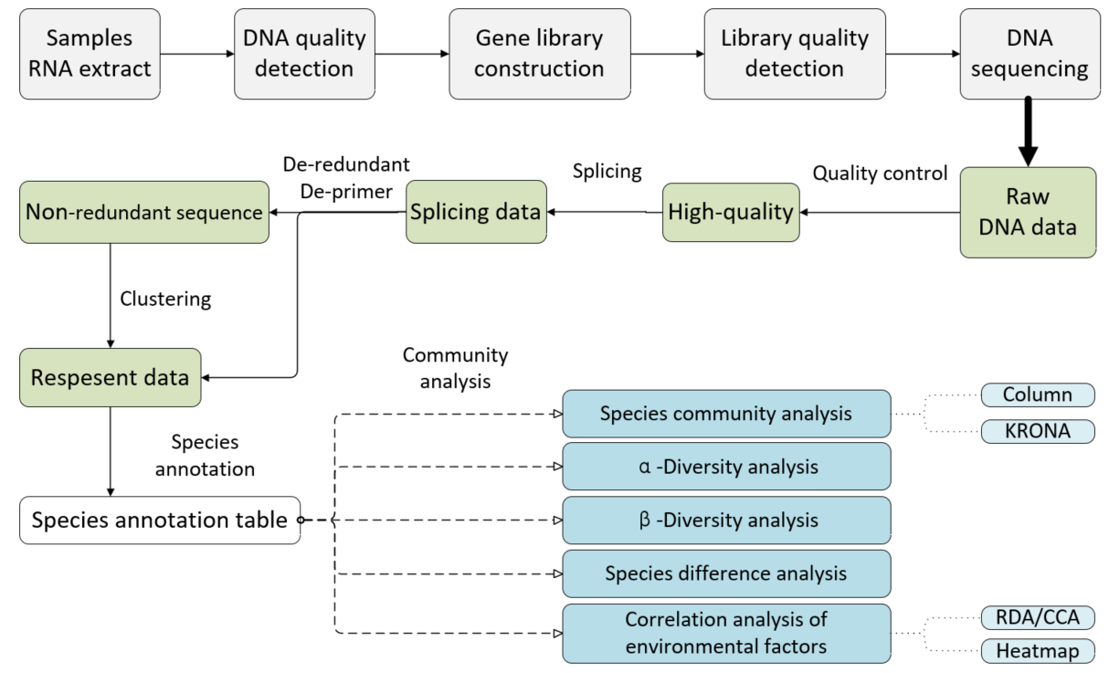
Fig. S2 The process for microbe community analysis

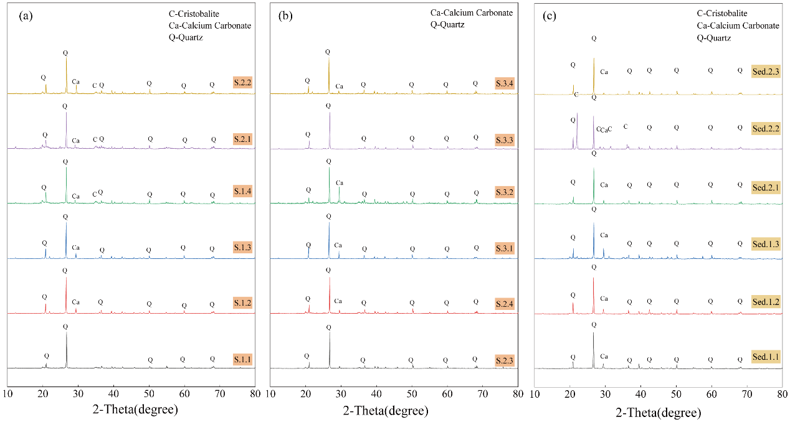
Fig. S3 XRD patterns of soil (a-b) and sediment (c) samples
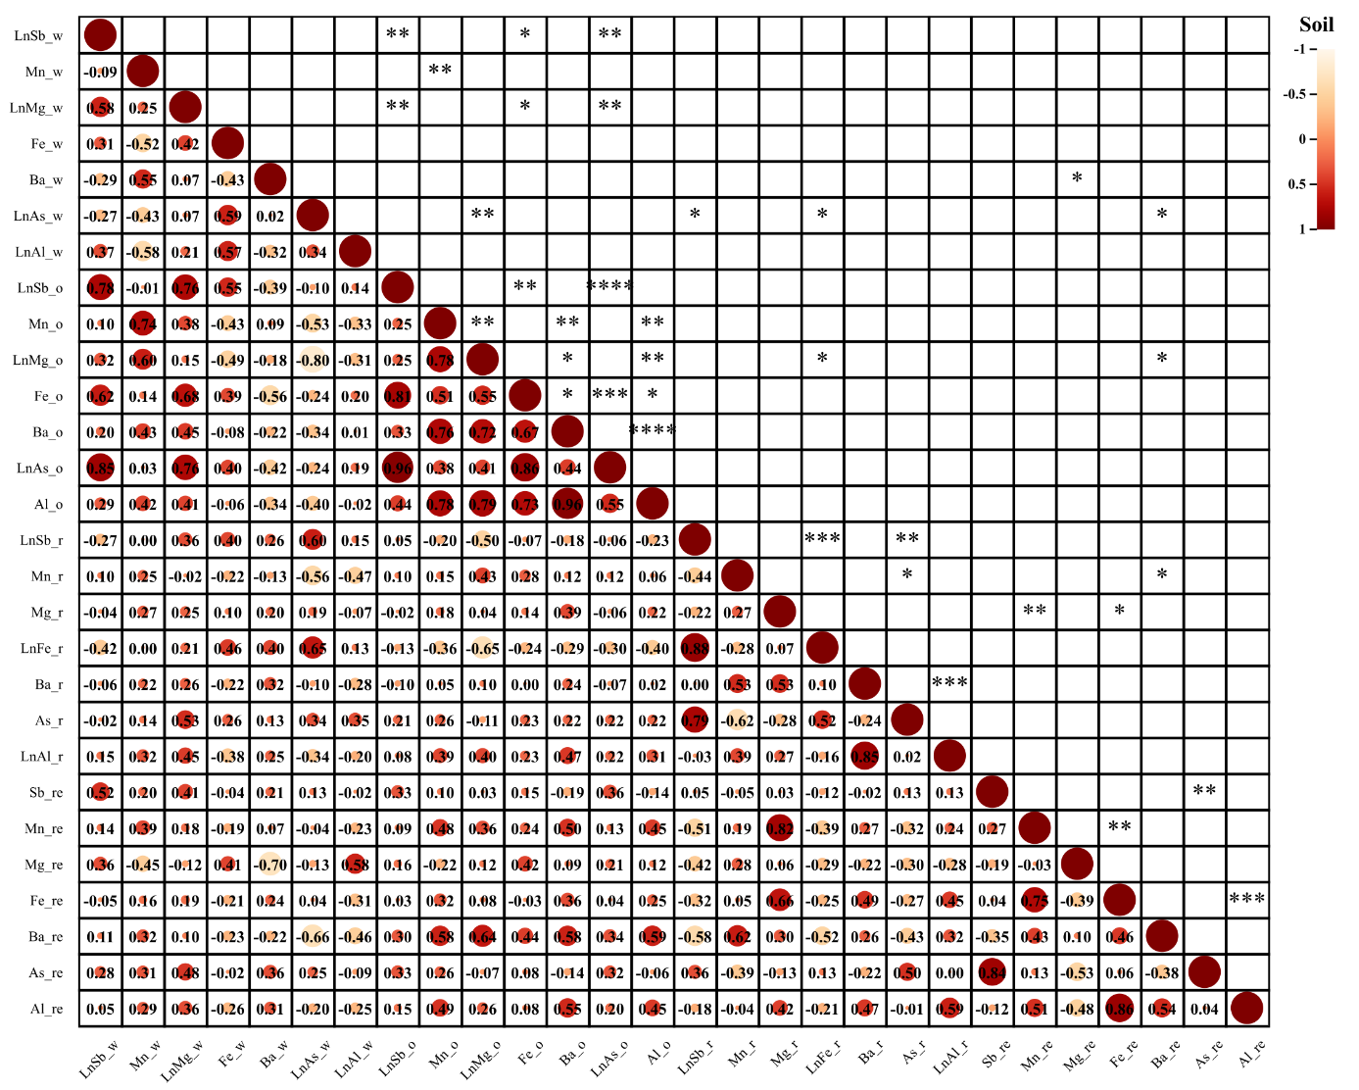
Fig. S4 The correlation analysis (Low) and significance test (Top) of metal speciation for soil samples. (* p<0.01, ** p<0.05, *** p<0.001, **** p<0.0001) (w: weak acid soluble state; o: oxidizable state ; r: reducible state; re: residual state)
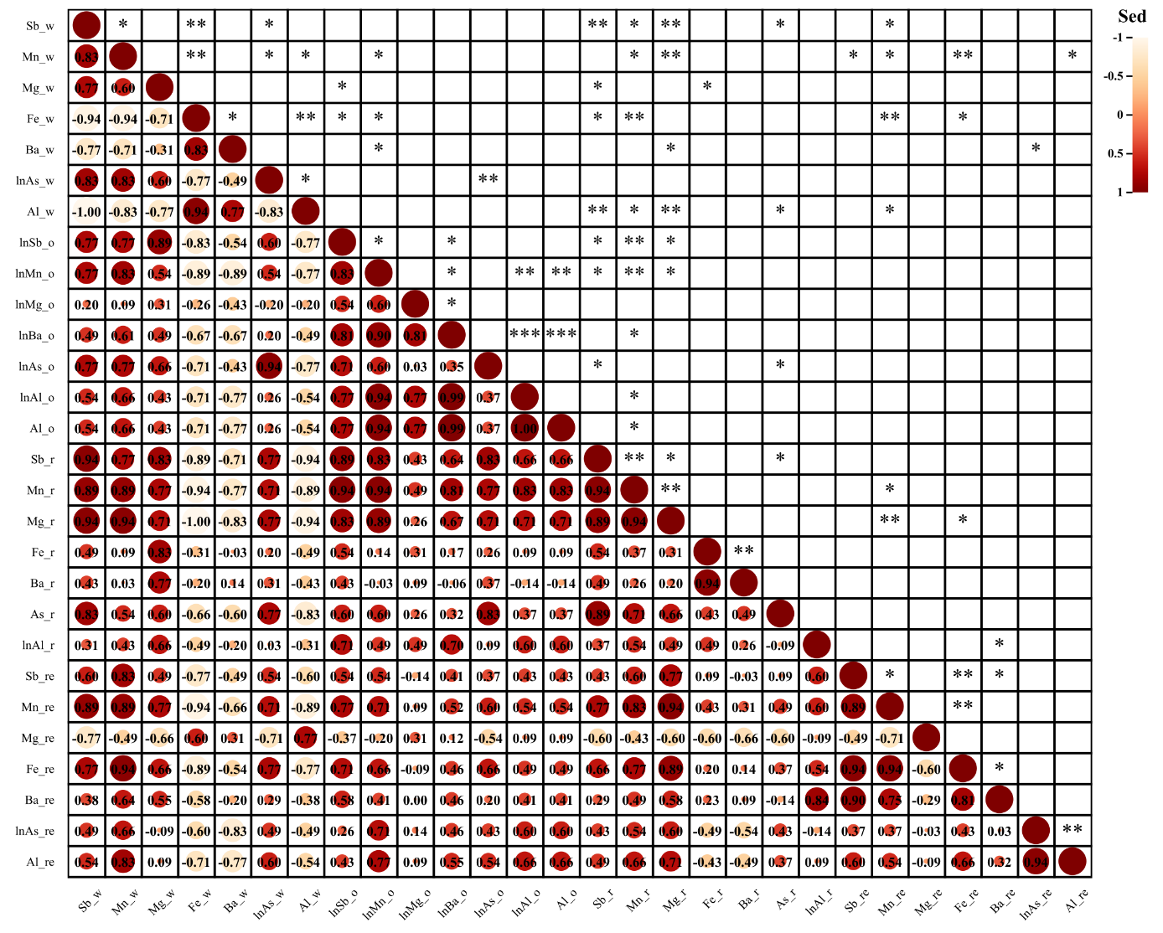
Fig. S5 The correlation analysis (Low) and significance test (Top) of metal speciation for sediment samples. (* p<0.01, ** p<0.05, *** p<0.001, **** p<0.0001) (w: weak acid soluble state ; o: oxidizable state ; r: reducible state; re: residual state)
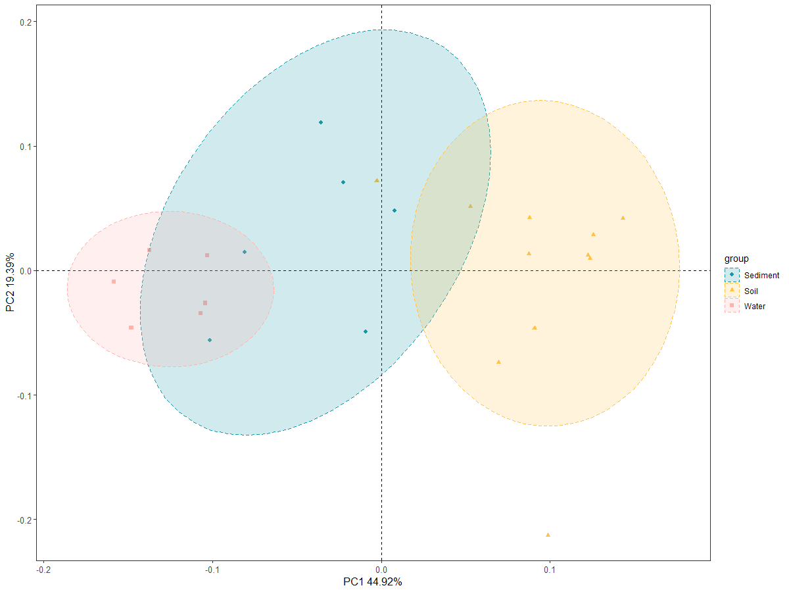(a)
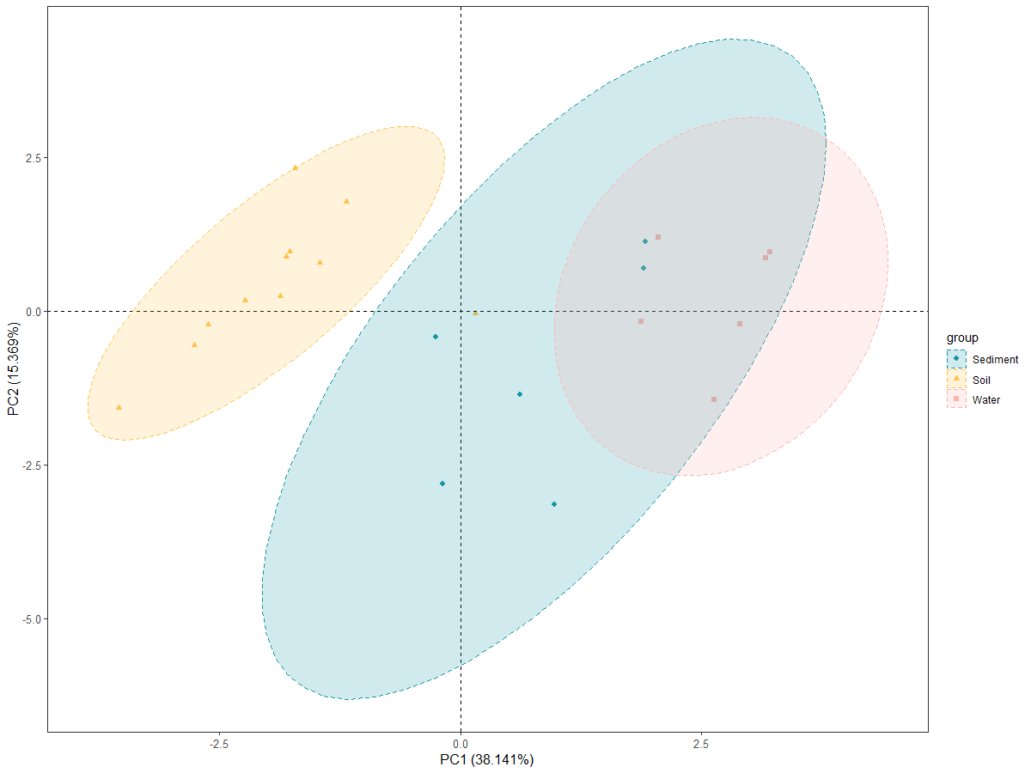(b)
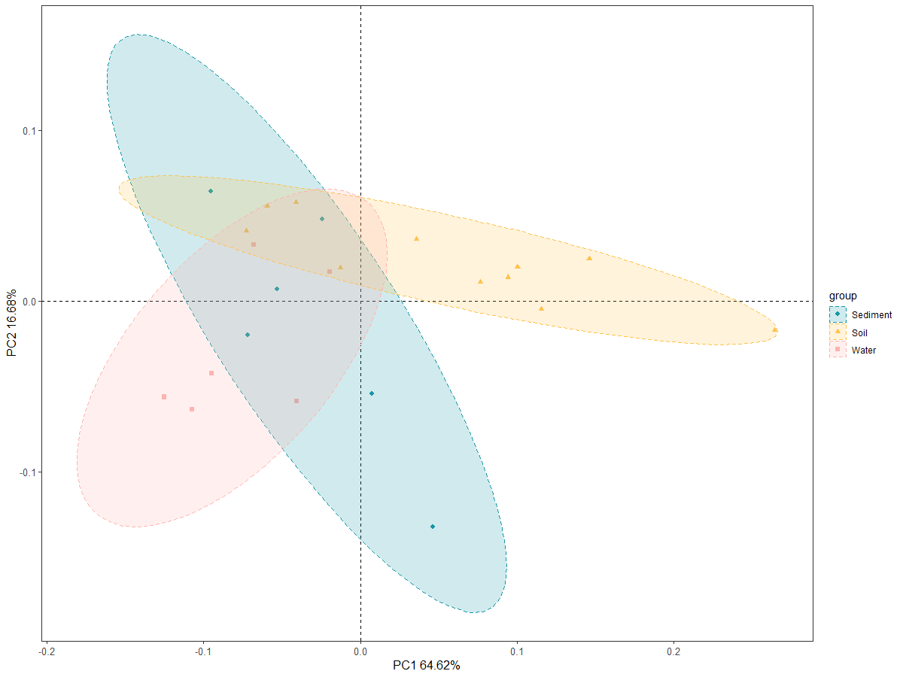(c)
Fig. S6 Microbial community structure PCoA analysis of bacteria(a), fungi(b) and archaea(c). PCoA can use the dimension reduction analysis method to convert the matrix through the community composition of the sample, so as to find out the characteristics affecting the microbial community. Different colored points in Fig. S5 represent different samples in different sites. PCoA1 and PCoA2 in each figure are the two main factors affecting community distribution. The distance between points represents the similarity of species among samples. The closer the distance, the more similar the composition is.

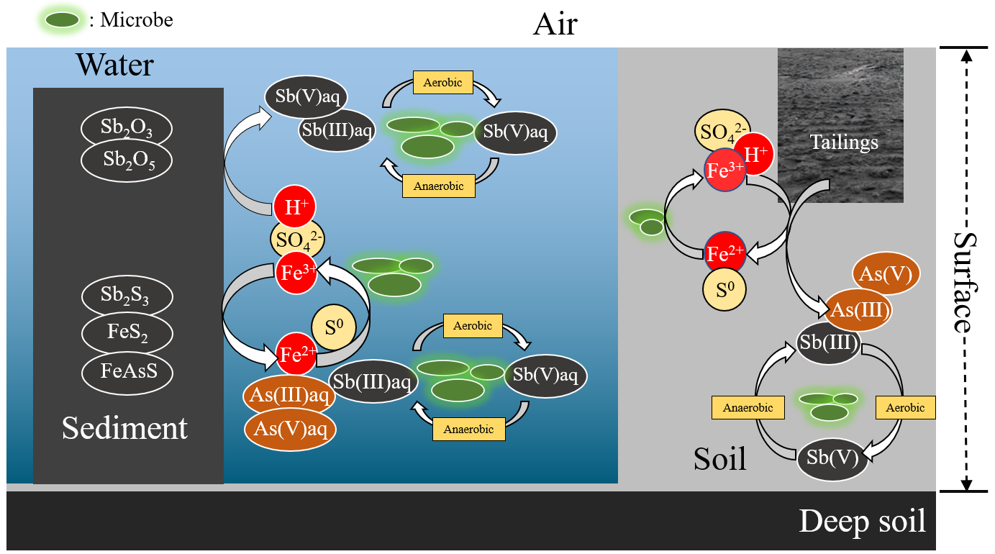
Fig. S7 Microbial diversity and geochemical cycle with C/S/Fe/As/Sb occurrence forms

