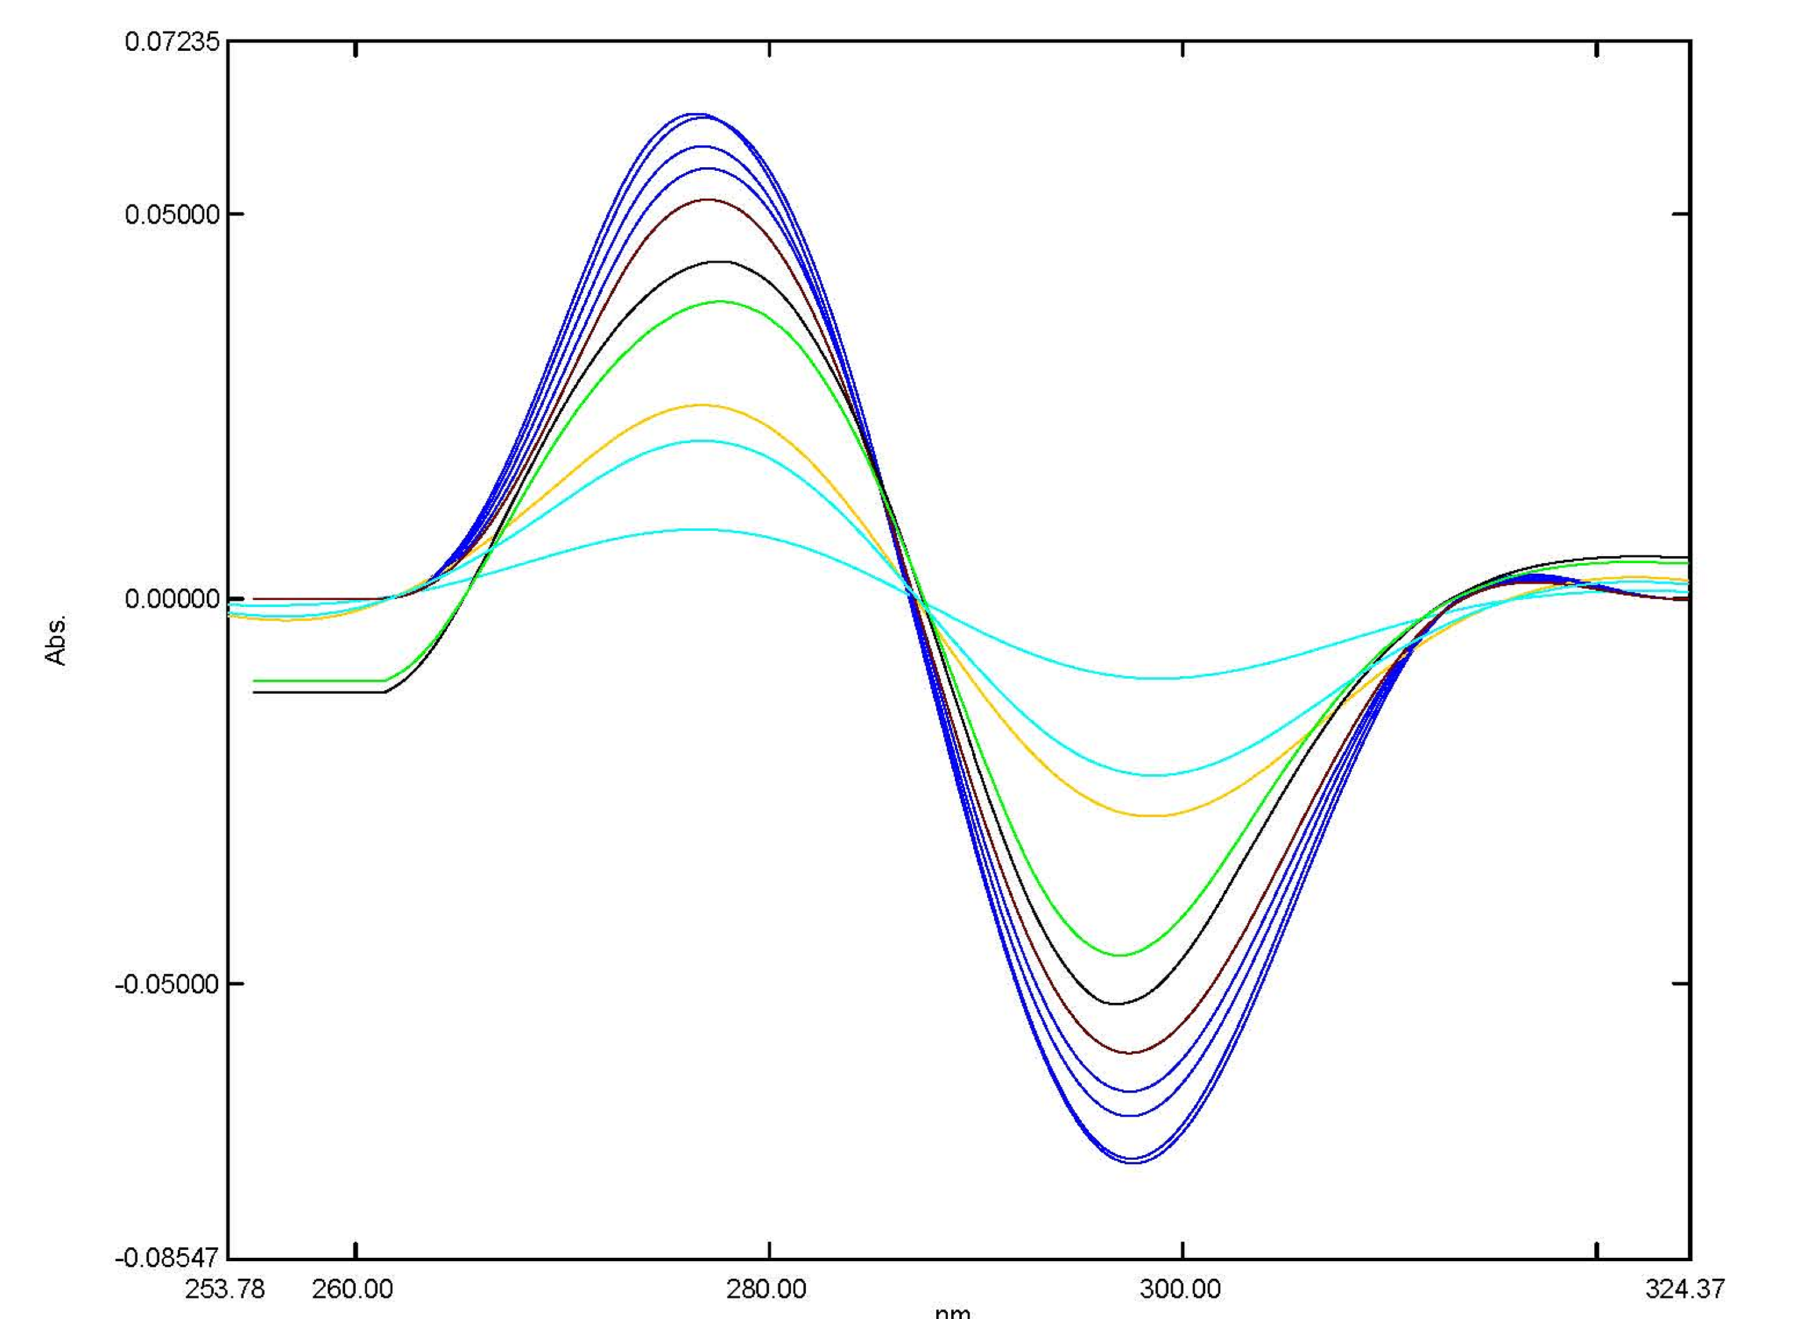 | 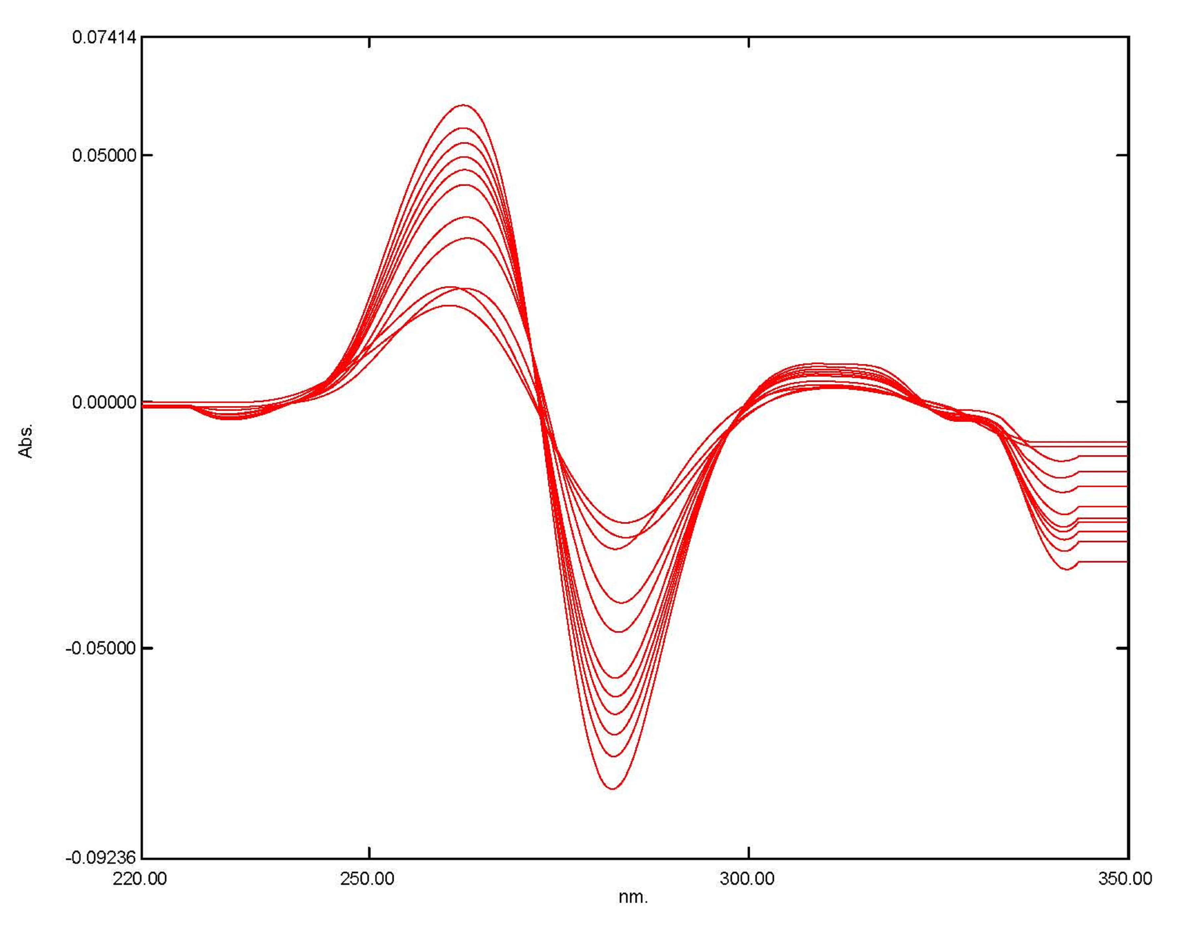 | 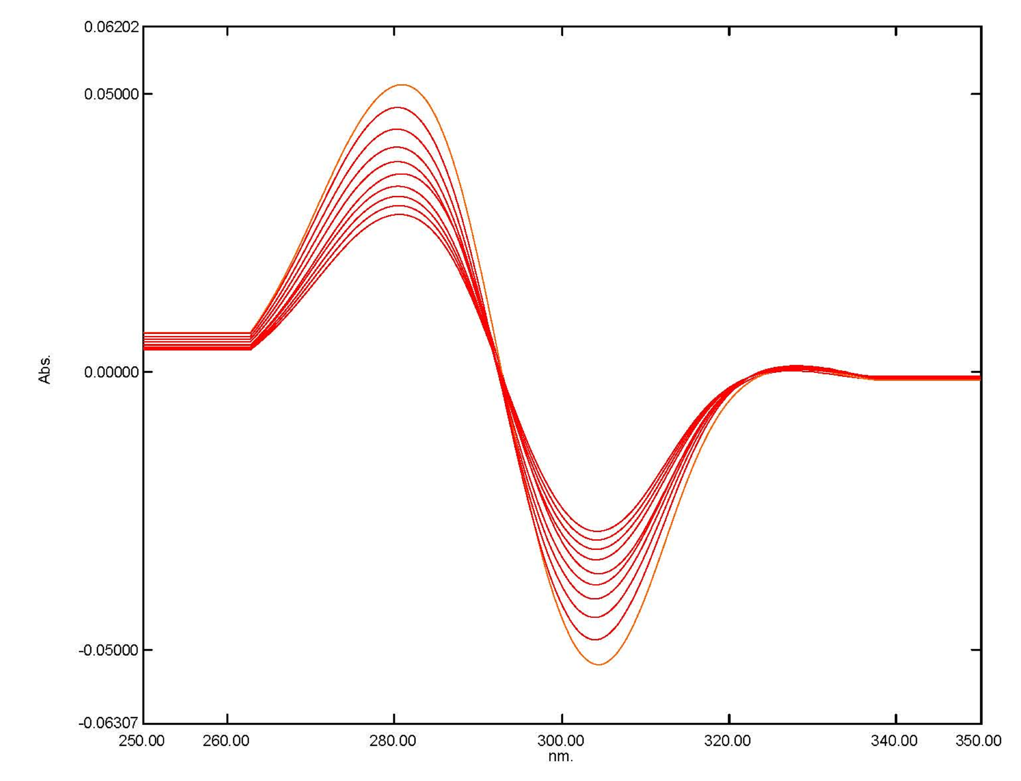 | First (l) derivative spectra
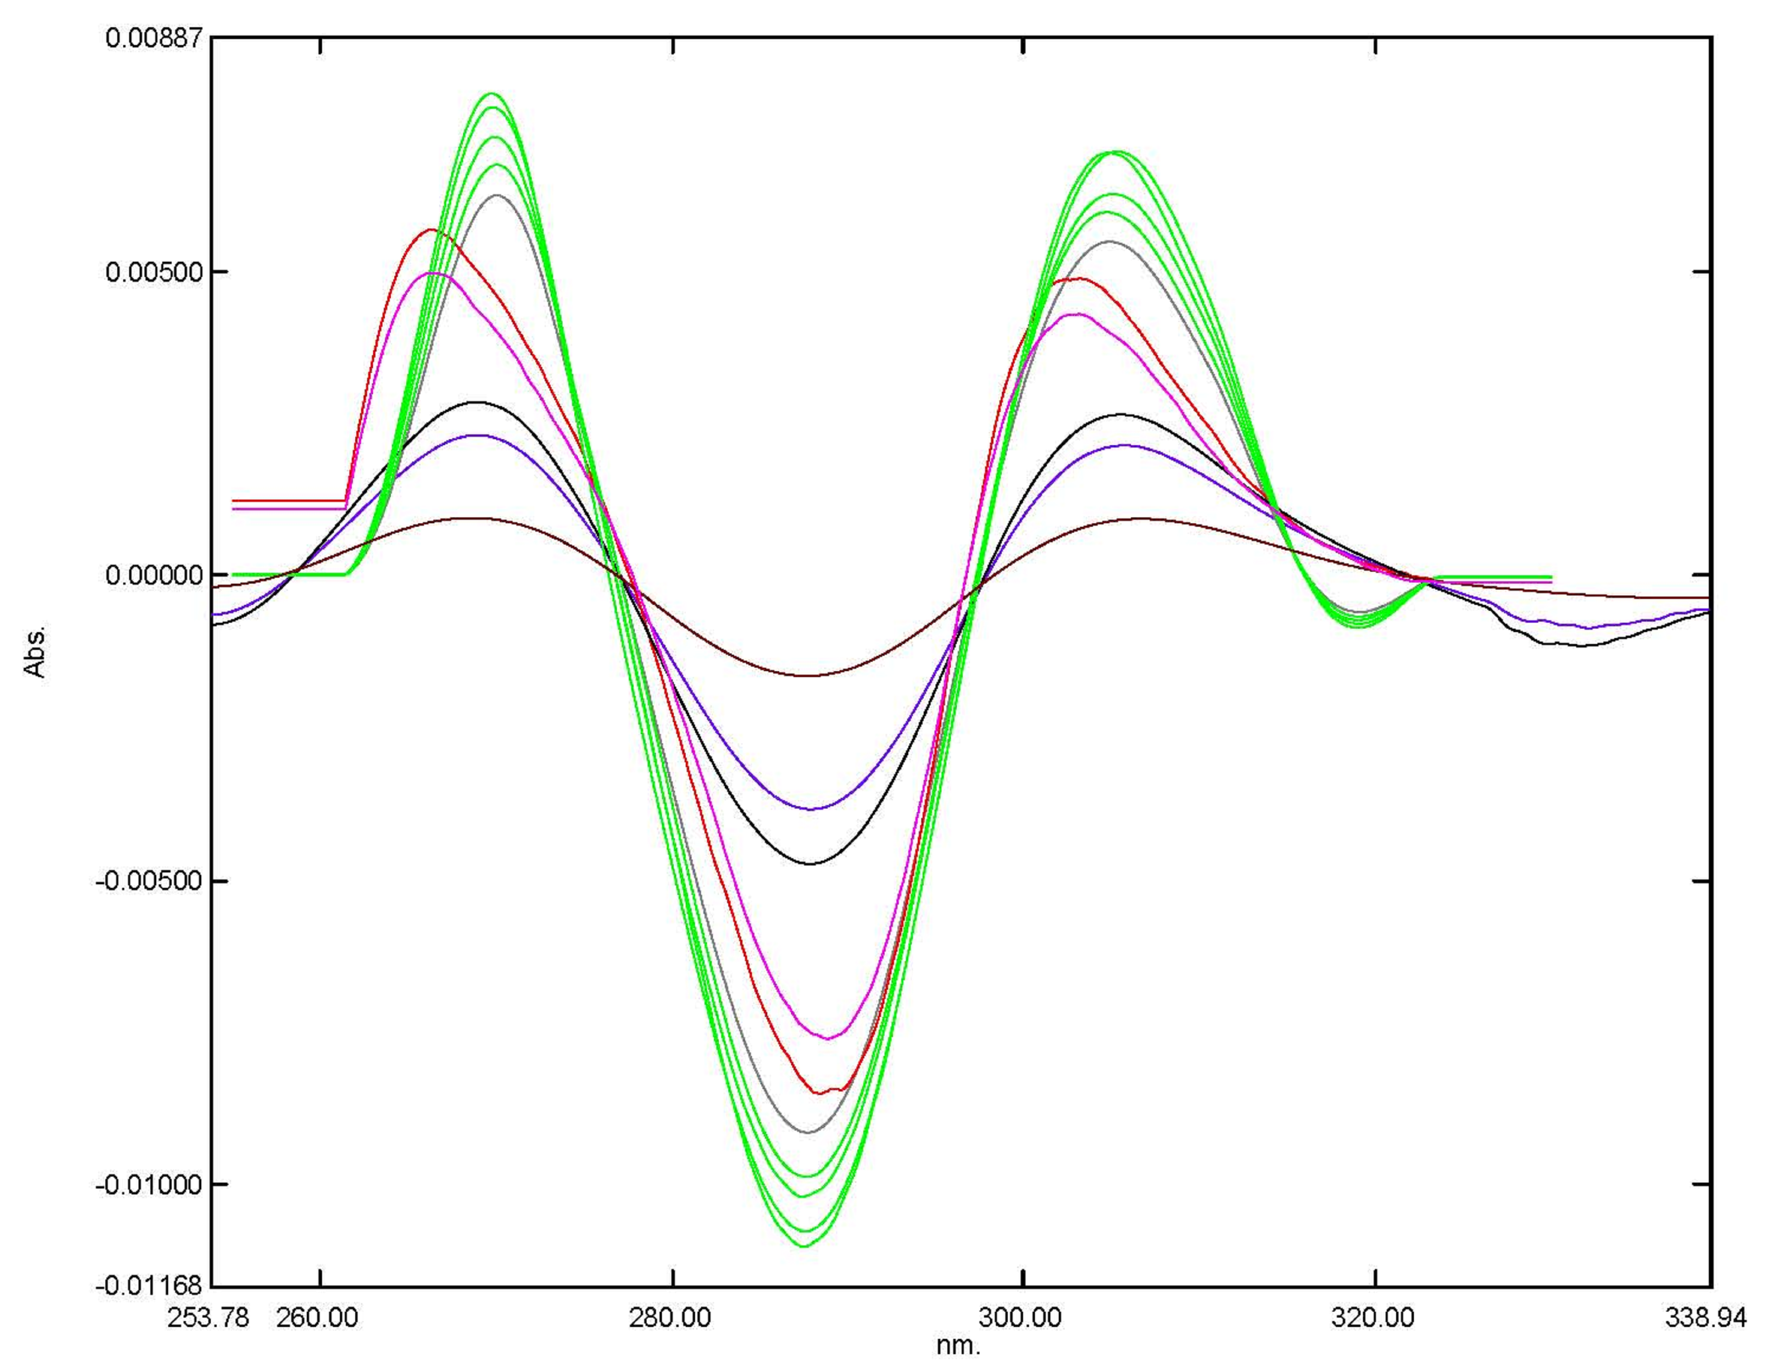 | 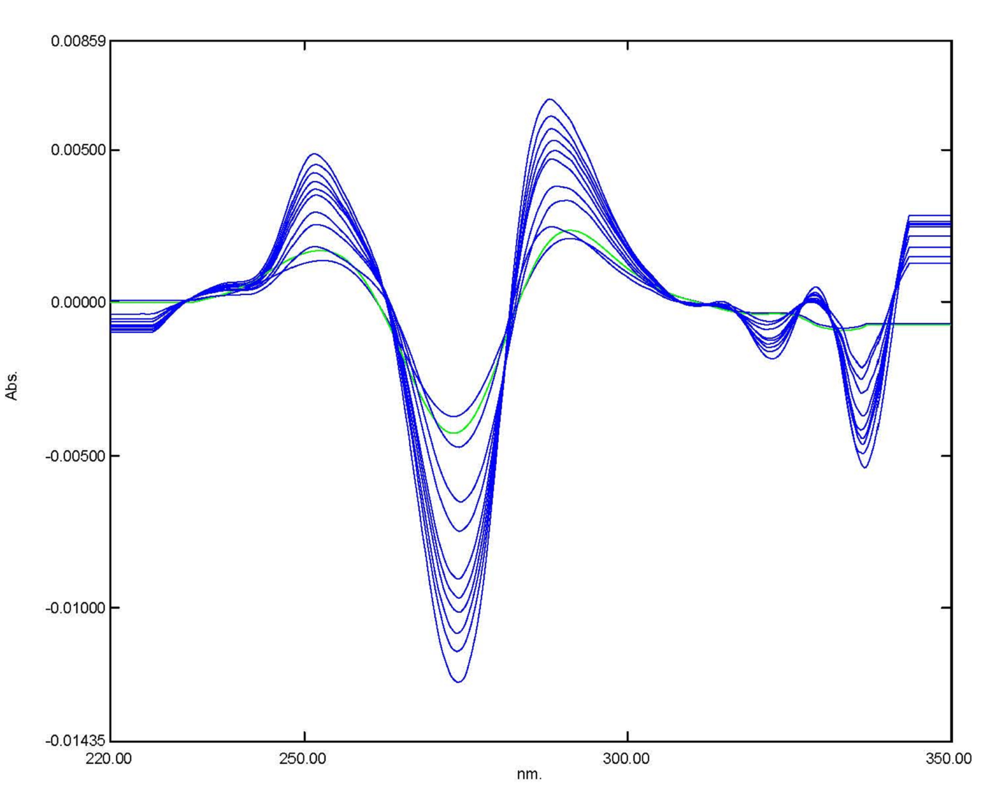 | 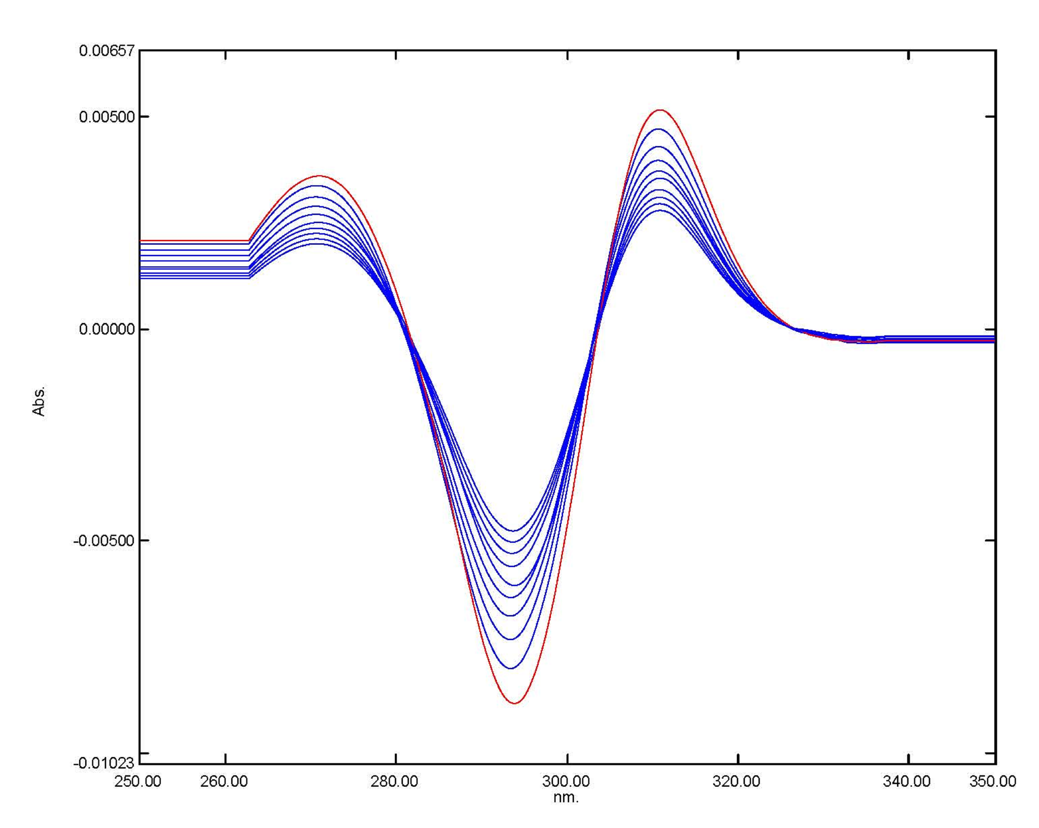 | second (2)  derivative spectra
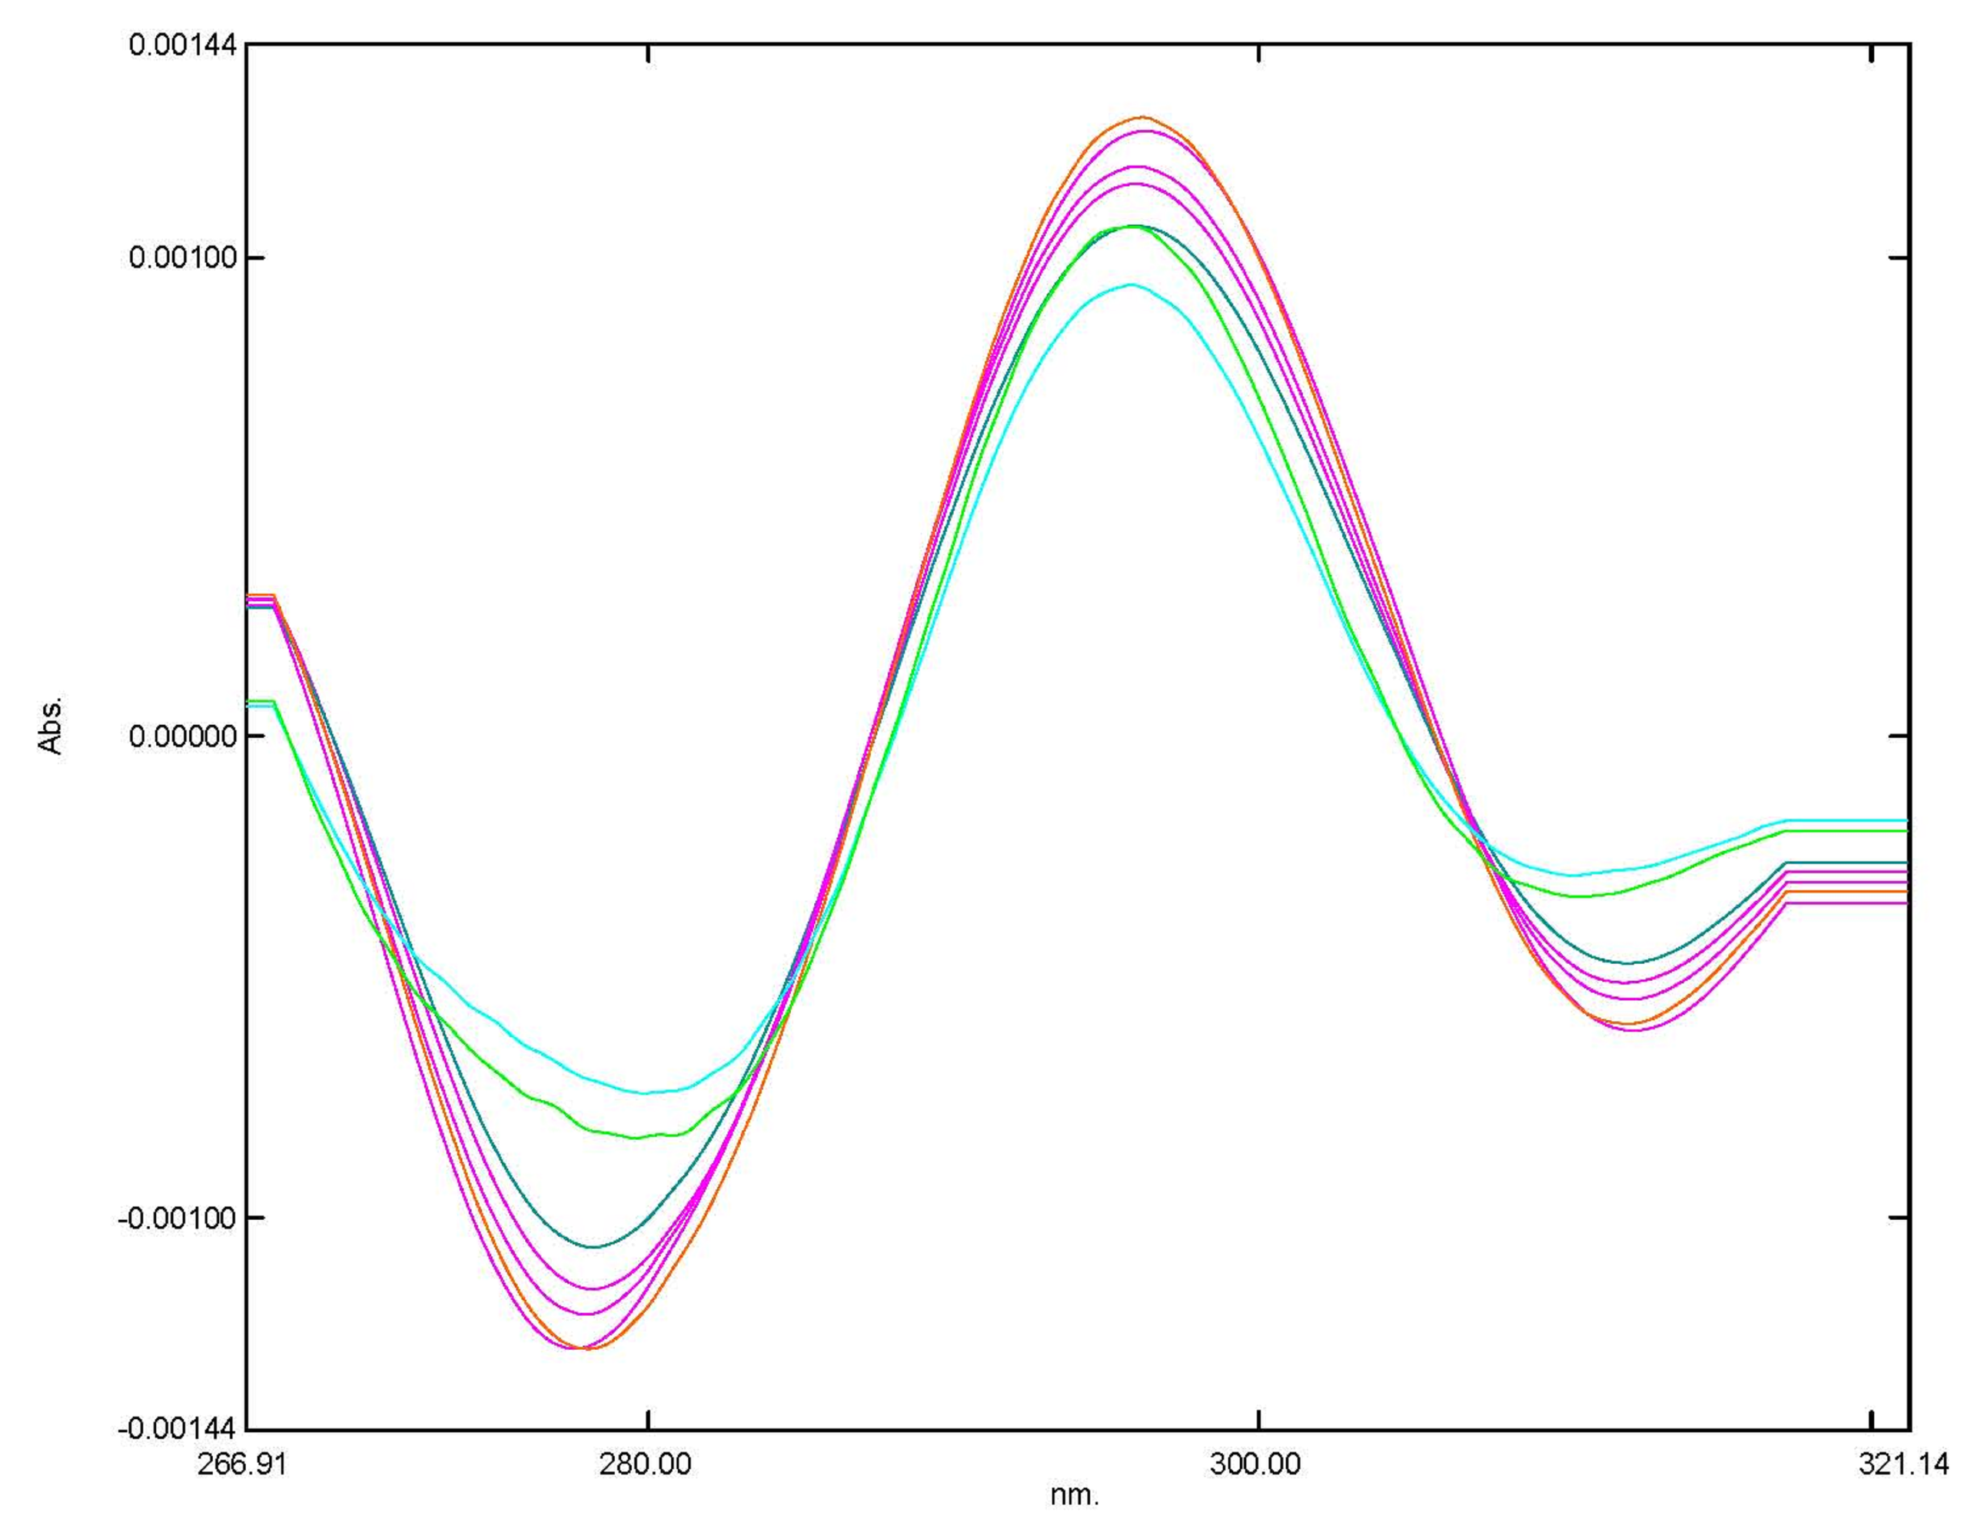 | 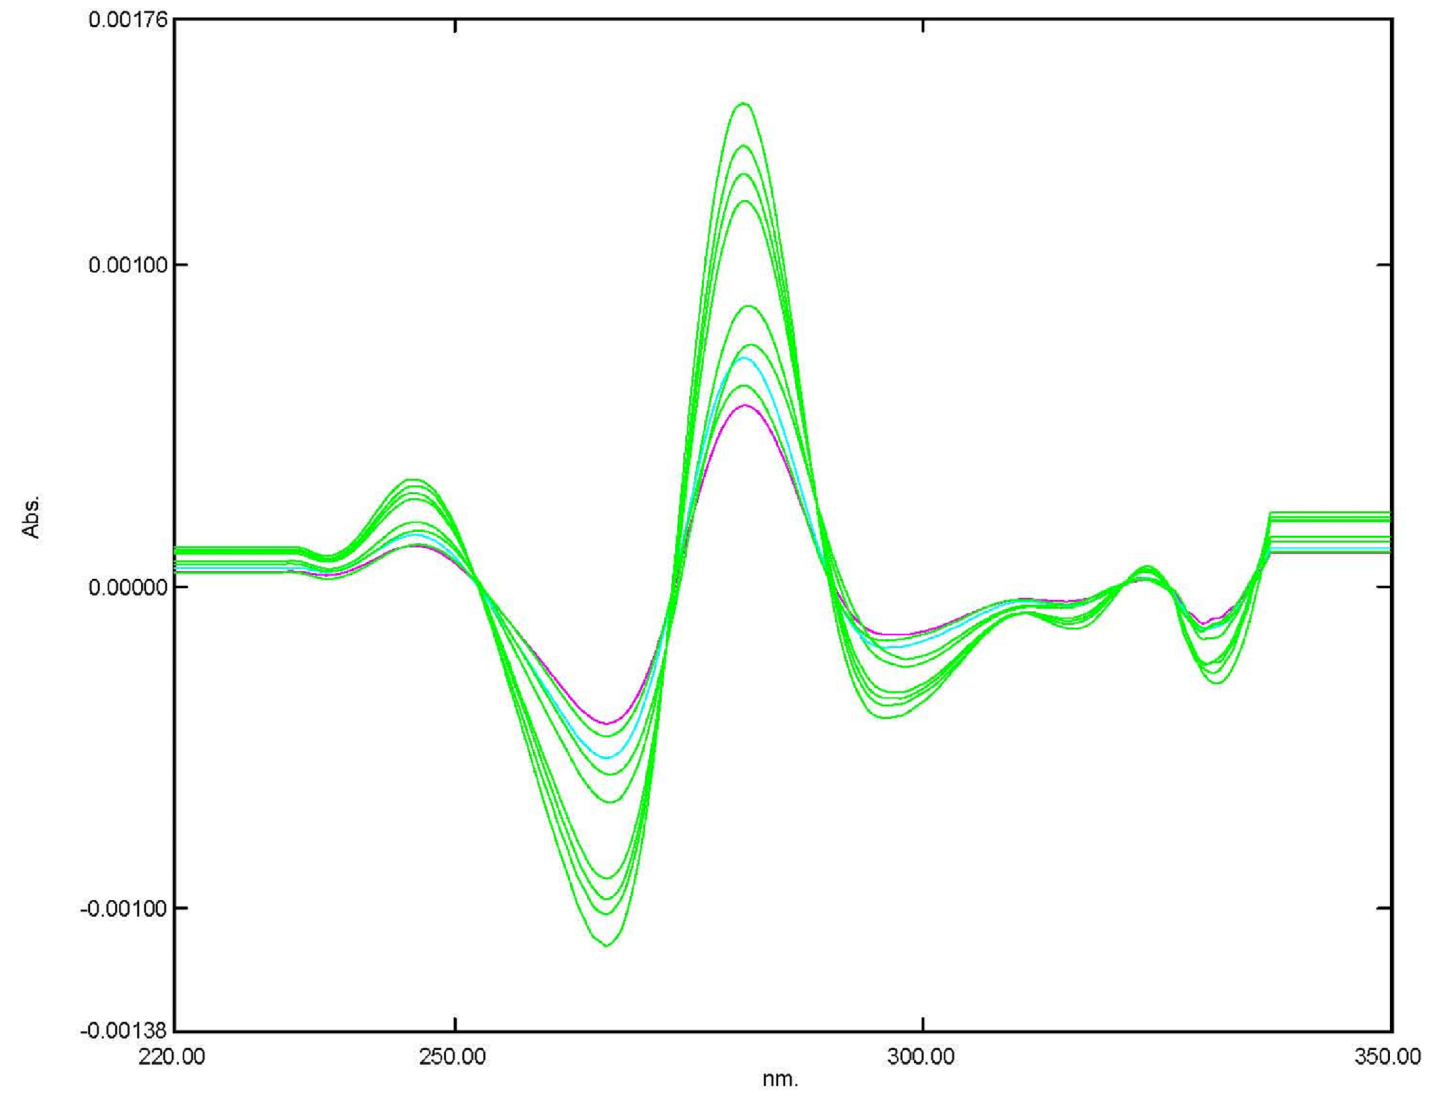 | 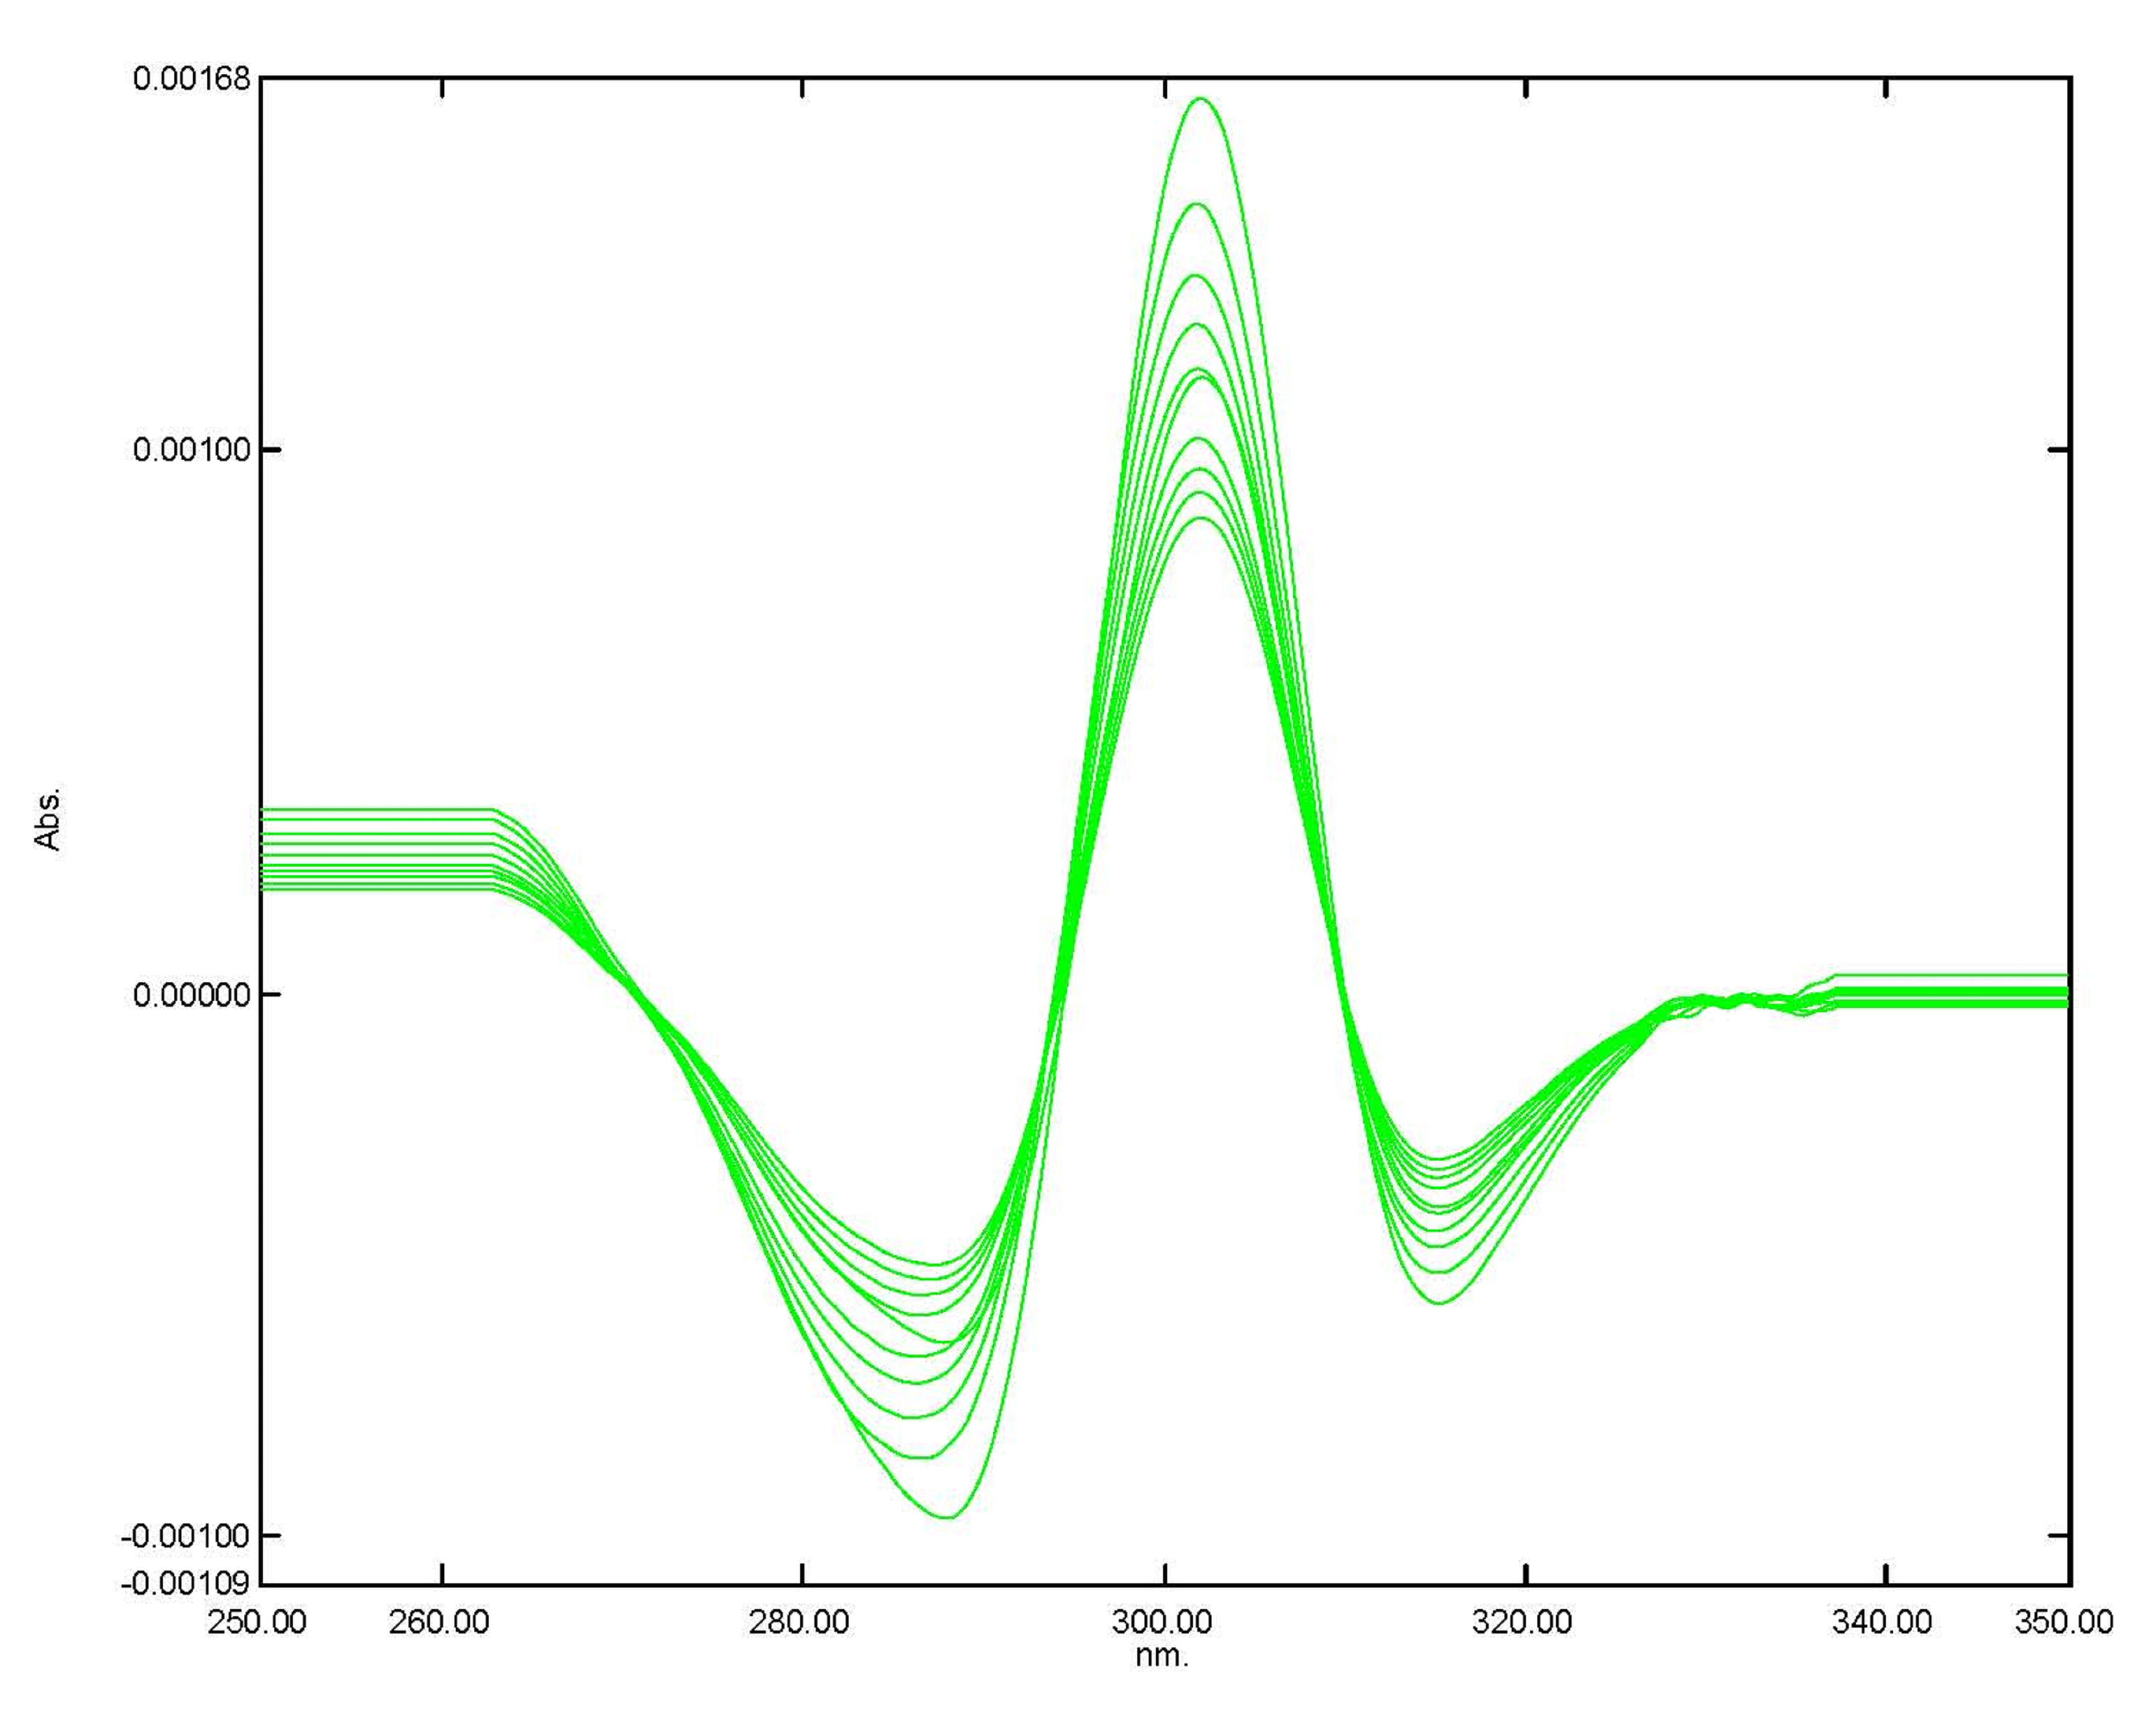 | third (3) derivative spectra
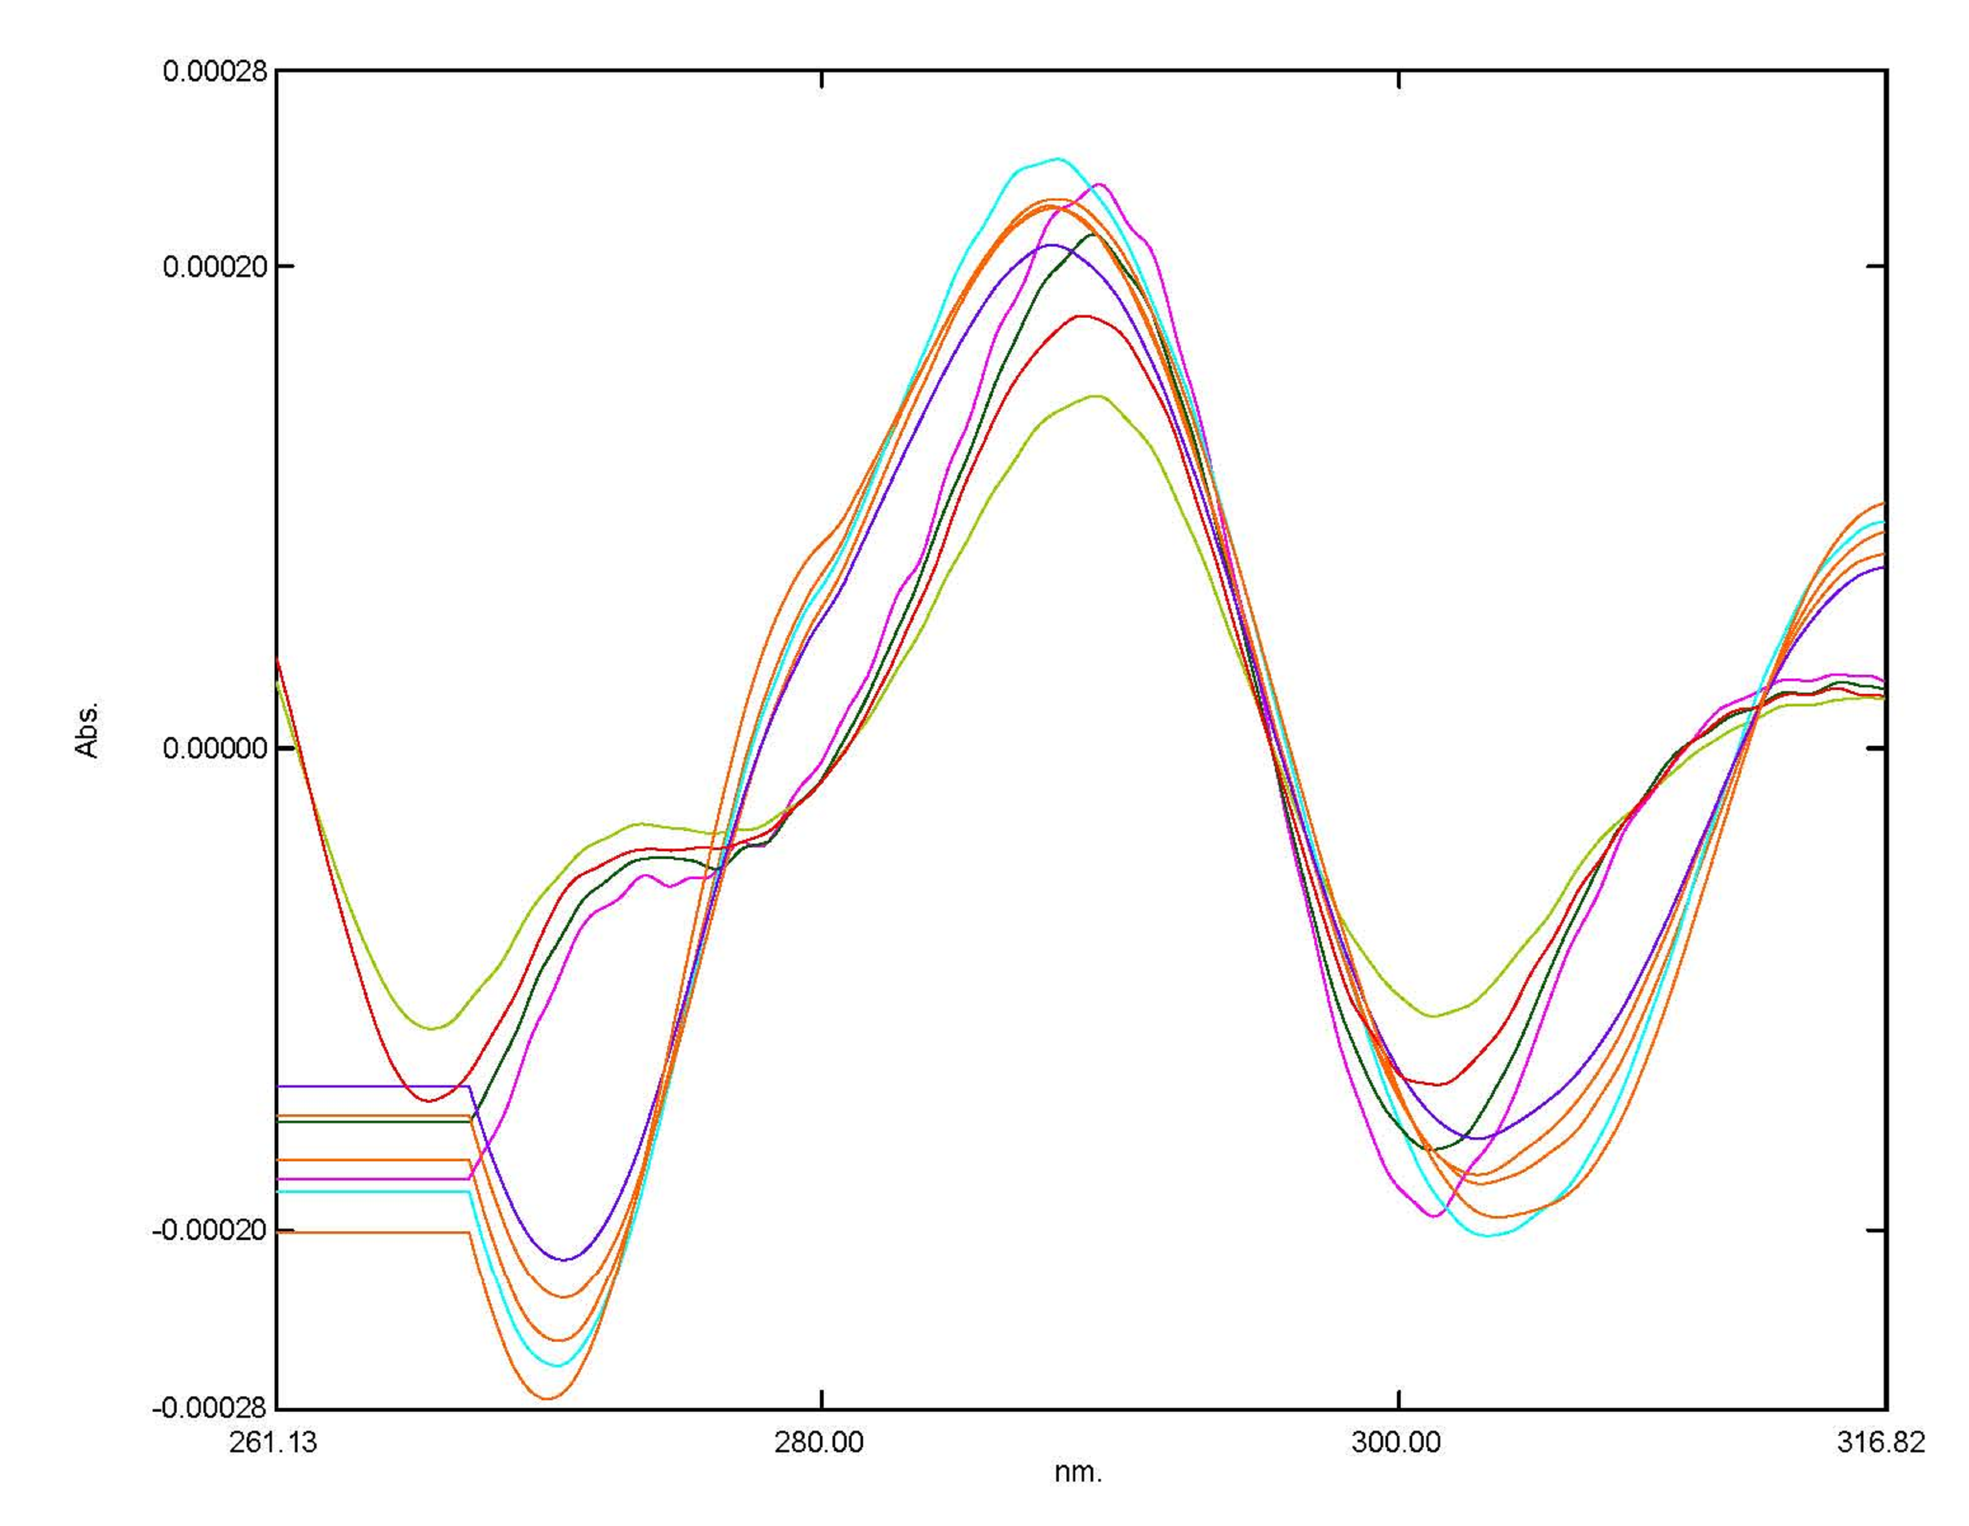 | 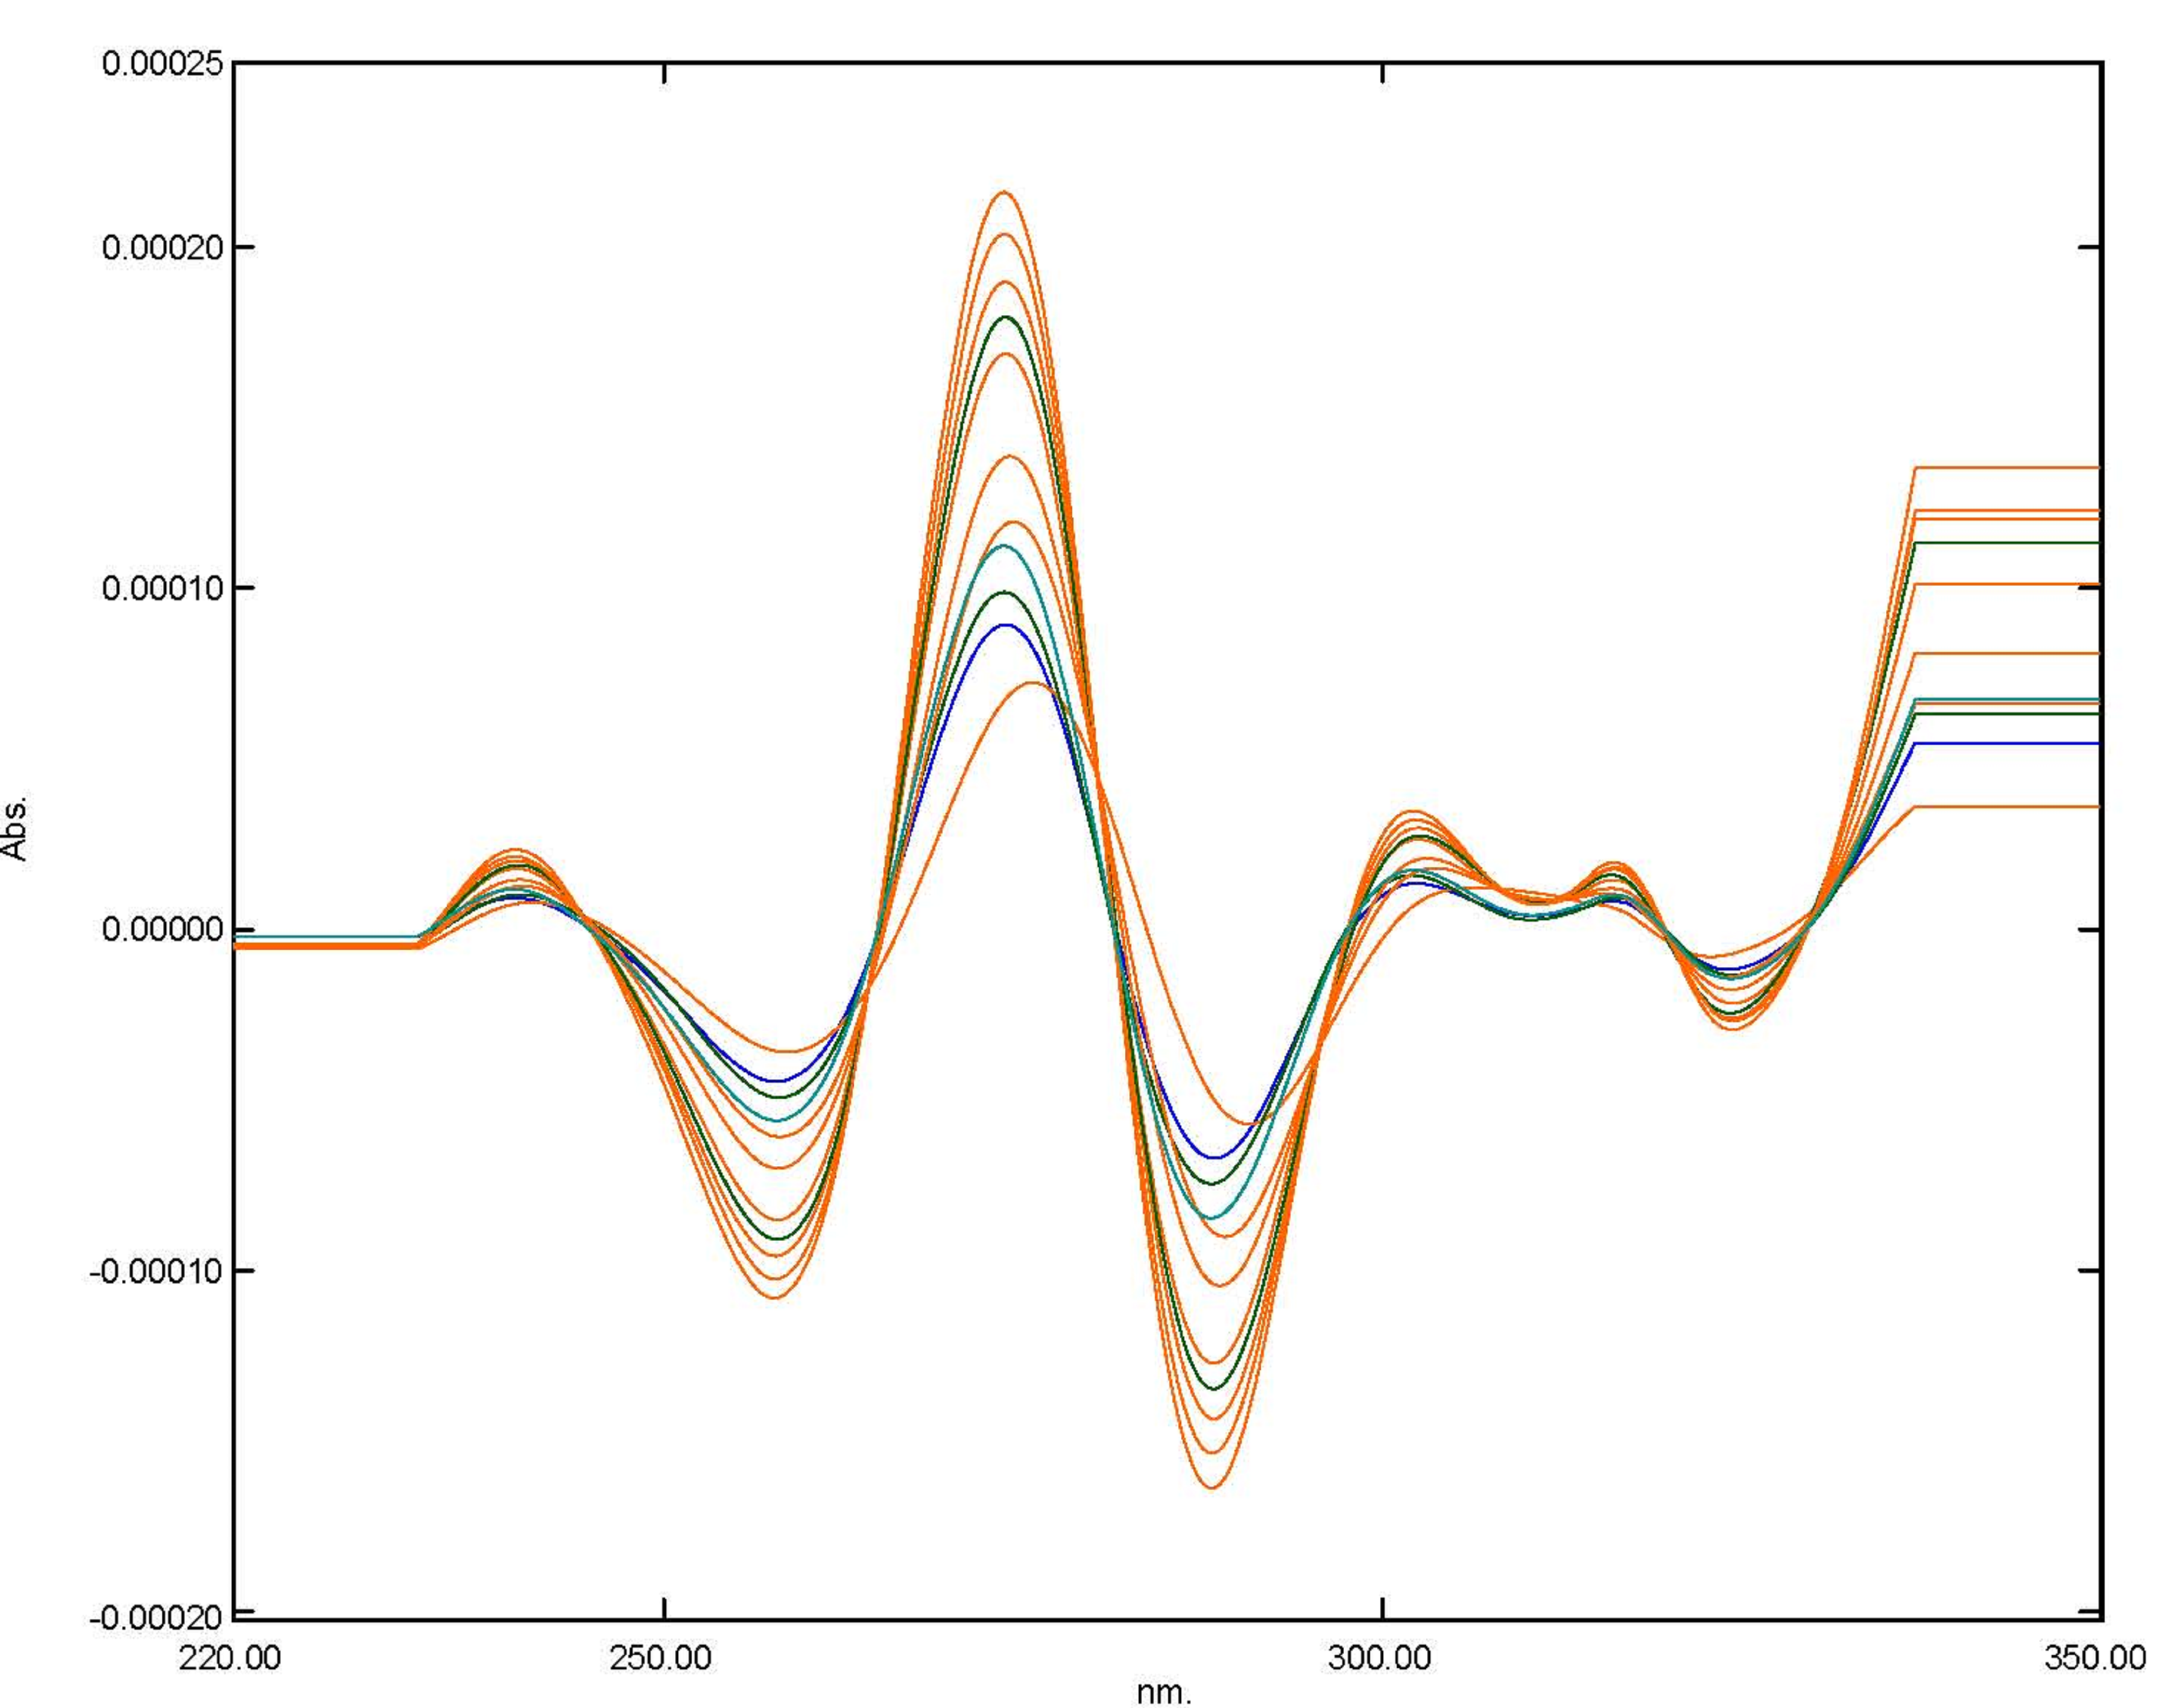 | 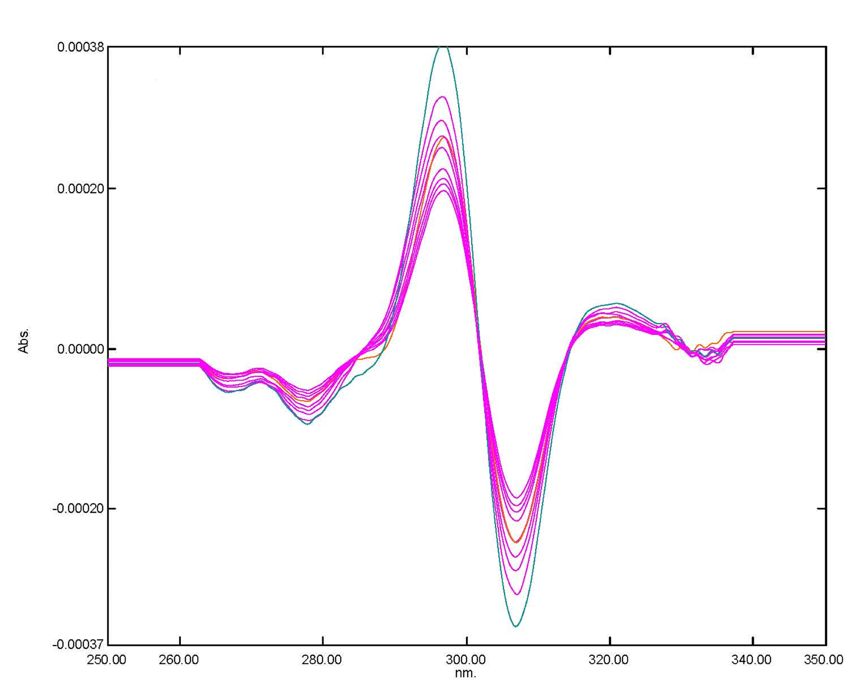 | fourth (4) derivative spectra
Fig.2 First (l) second (2), third (3) and fourth (4) derivative spectra of levofloxacin in 0.1 ml HCI  Spectra l, 2, 3, 4, 5, 6,7,8,9,10 — concentrations: 2µg ml TO 20.0 µg ml | Fig.3 First (l) second (2), third (3) and fourth (4) derivative spectra of norfloxacin in 0.1 ml HCI  Spectra l, 2, 3, 4, 5, 6,7,8,9,10 — concentrations: 2µg ml TO 20.0 µg ml | Fig.4 First (l) second (2), third (3) and fourth (4) derivative spectra of moxifloxacin 0.1 ml HCI  Spectra l, 2, 3, 4, 5, 6,7,8,9,10 — concentrations: 2µg ml TO 20.0 µg ml

