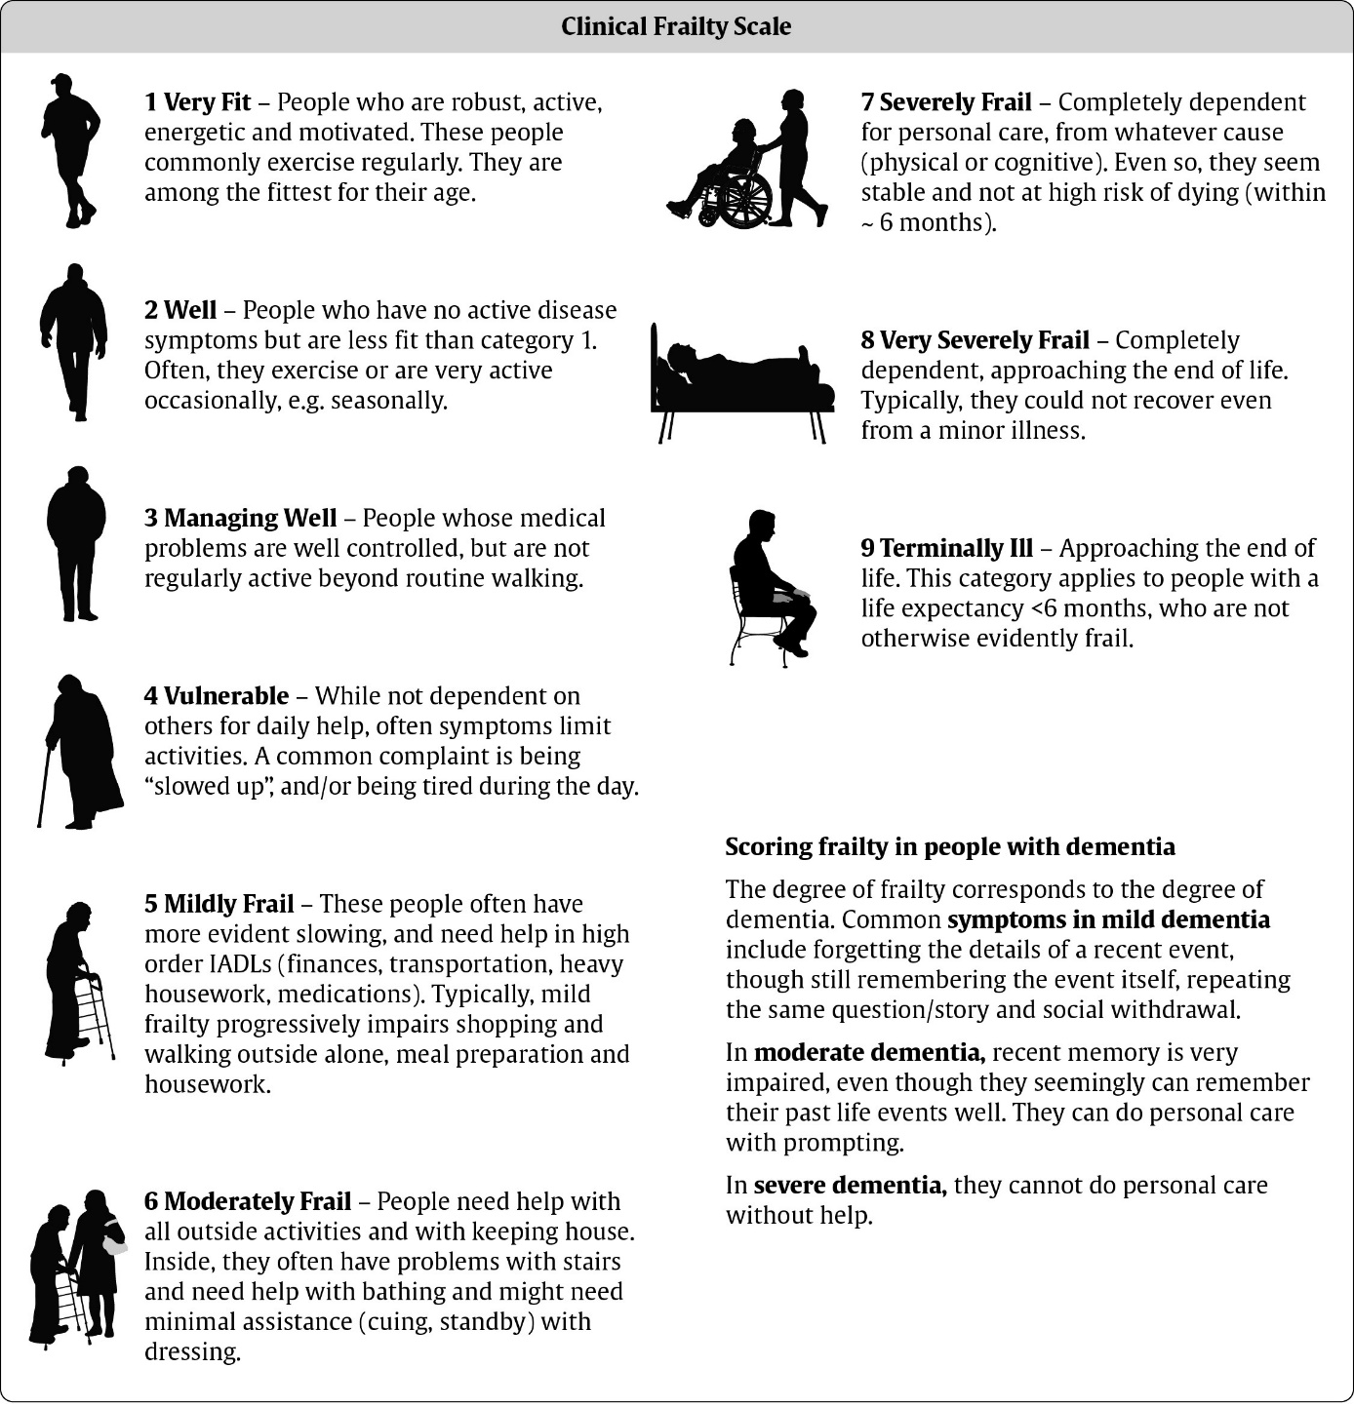

Permission to use this scale was granted from Dalhouse University

