Quantifying and Mapping the Realized Value of Ecosystem Services in Megacities

Supplementary Information

SI 1 Data Sources
SI Table 1 Data Sources
Data | Data Type | Description | Source | Access Time
Real property POIs | point | Age, unit type, floor, building type, unit orientation, unit installation, etc. | Lianjia.com | July 2018
Tiananmen Square | polygon | AOI Boundary | Google Maps | July 2018
Zhongguancun | point | Central coordinates | Baidu Maps | July 2018
Greenspace | polygon | Parks, residential greenspace, etc. | Google Maps | July 2018
River and lake system | polygon | Rivers, lakes, aqueducts, reservoirs, etc. | Google Maps | July 2018
Farmland | polygon | Farmland | Google Maps | July 2018

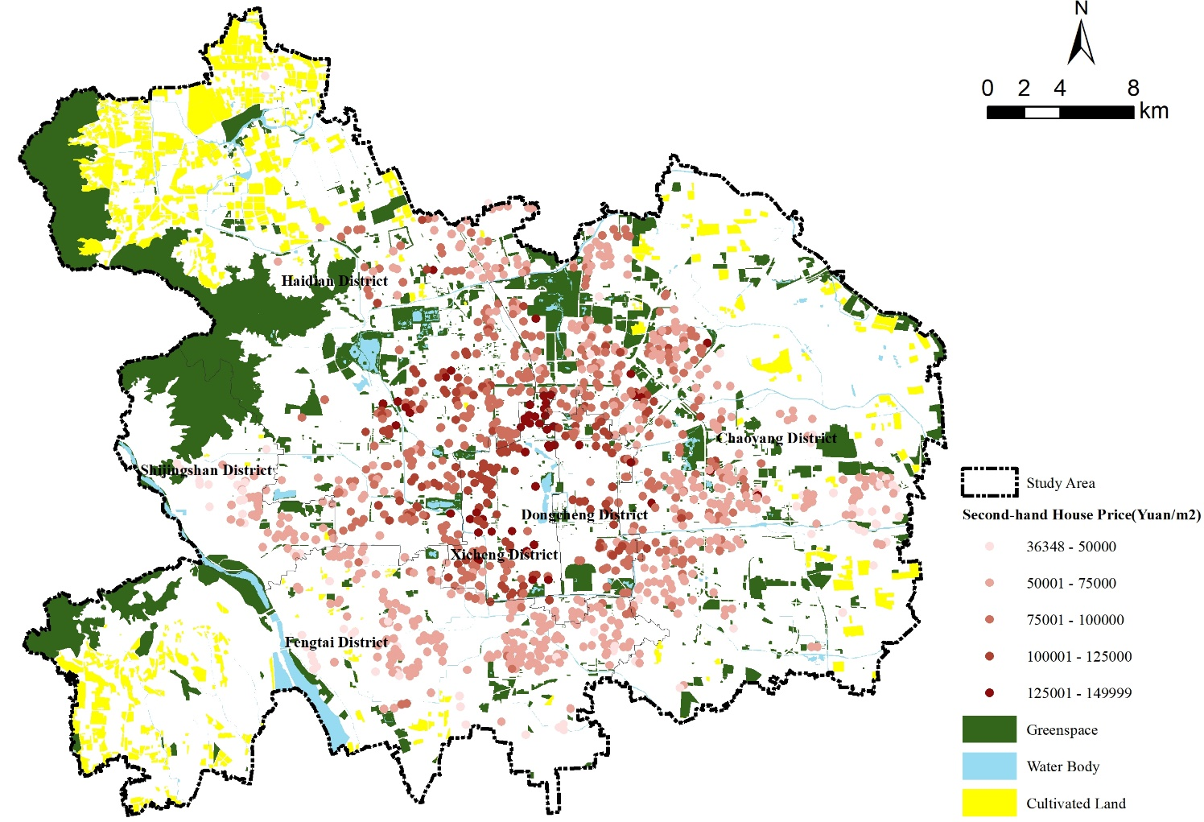
SI Figure 1 Study Area and Data

SI 2 Overview of Second-hand Houses Market in Beijing City Proper
According to the Beijing Real Estate Statistical Yearbook 2019, in 2018, Beijing's second-hand property transaction area was 12.878 million m² and the transaction amount was 370.40 billion yuan, of which 7.762 million ㎡ was transacted within the study area (SI Table 5). With a 59.6% transaction area share, the property transaction amount within the study area is about 220.66 billion yuan.

SI Table 2 Overview of Second-hand Property Transactions by District (Source: Beijing Real Estate Statistical Yearbook 2019)
 | Number of units sold | Sold area (million square meters) |  | Number of units sold | Sold area (million square meters)
Dongcheng District | 5898 | 44.8 | Mentougou District | 1625 | 12.7
Xicheng District | 11073 | 75.1 | Daxing District | 9895 | 90.9
Chaoyang District | 35827 | 323.3 | Huairou District | 129 | 10.9
Haidian District | 19142 | 157.6 | Miyun District | 2742 | 26.1
Fengtai District | 16358 | 129.4 | Changping District | 13502 | 137.1
Shijingshan District | 4993 | 37.0 | Yanqing District | 1358 | 12.1
Tongzhou District | 7994 | 71.1 | Pinggu District | 1307 | 12.1
Fangshan District | 7858 | 67.3 | Development Zone | 1404 | 14.6
Shunyi District | 5924 | 66.1 | Total | 148029 | 1287.8

SI 3 Calculation of the Provision Value of ES
We used the method and parameters in literature ¹⁰⁶ and ⁷¹ for the calculation of provision value of ES. The literature give two widely referenced per area unit valuation tables of ES provision (SI Tables 3 & 4), which we adopted with necessary transformation to adapt to the actual ecosystem type composition in urban greenspaces. The formula is:
$$VES={CPI}_{2007-2018}×\sum_{i}^{n}{\sum_{j}^{m}{{Area}_{i}×{UV}_{ij}}}$$
Where ${Area}_{i}$ denotes the area size of the i-th type of ecosystem; ${UV}_{ij}$ denotes the per area unit value of the j-th type of ES in the i-th type of ecosystem; ${CPI}_{2007-2018}$ notes the Consumer Price Index from 2007 to 2018, as an inflation adjustment term.

SI Table 3 Per Area Unit Monetary Value of ES Provision in China (Yuan/ ha* a , 2007)¹⁰⁶
ES Class | ES Type | Forests | Grasslands | Farmlands | Wetlands | Rivers and Lakes | Deserts
Provisioning | Food production | 148.20 | 193.11 | 449.10 | 161.68 | 238.02 | 8.98
 | Raw materials production | 1338.32 | 161.68 | 175.15 | 107.78 | 157.19 | 17.96
Regulating | Gas regulation | 1940.11 | 673.65 | 323.35 | 1082.33 | 229.04 | 26.95
 | Climate regulation | 1827.84 | 700.60 | 435.63 | 6085.31 | 925.15 | 58.38
 | Water regulation | 1836.82 | 682.63 | 345.81 | 6035.9 | 8429.61 | 31.44
 | Waste treatment | 772.45 | 592.81 | 624.25 | 6467.04 | 6669.14 | 116.77
Supporting | Soil formation | 1805.38 | 1005.98 | 660.18 | 893.71 | 184.13 | 76.35
 | Biodiversity maintenance | 2025.44 | 839.82 | 458.08 | 1657.18 | 1540.41 | 179.64
Cultural | Aesthetic | 934.13 | 390.72 | 76.35 | 2106.28 | 1994.00 | 107.78
Total |  | 12628.69 | 5241.00 | 3547.90 | 24597.21 | 20366.69 | 624.25

SI Table 4 Per Area Unit Monetary Value of ES Provision in China (2014)⁷¹
ES Class | ES Type | Drylands | Water systems | Mixed forests | Grasslands
Provisioning | Food production | 0.85 | 0.8 | 0.31 | 0.22
 | Raw materials production | 0.4 | 0.23 | 0.71 | 0.33
 | Water resource provisioning | 0.02 | 8.29 | 0.37 | 0.18
Regulating | Gas regulation | 0.67 | 0.77 | 2.35 | 1.14
 | Climate regulation | 0.36 | 2.29 | 7.03 | 3.02
 | Waste treatment | 0.1 | 5.55 | 1.99 | 1
 | Water regulation | 0.27 | 102.24 | 3.51 | 2.21
Supporting | Soil formation | 1.03 | 0.93 | 2.86 | 1.39
 | Nutrient cycling | 0.12 | 0.07 | 0.22 | 0.11
 | Biodiversity maintenance | 0.13 | 2.55 | 2.6 | 1.27
Cultural | Aesthetic | 0.06 | 1.89 | 1.14 | 0.56

