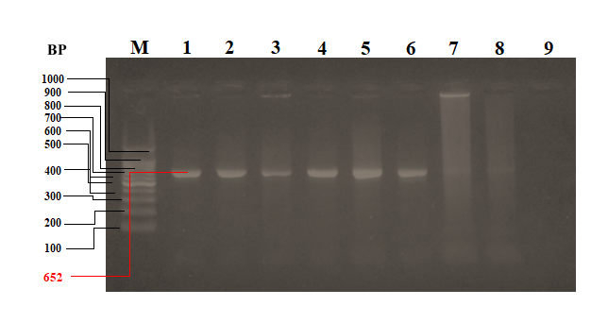

Supplementary figure 01: Agarose gel electrophoresis of colony PCR products of E.coli-BL21-pJET1.2-CadA/CadR cells (Modified and cropped image) Well Numbers: M- 100bp DNA ladder, 2- positive control DNA construct, 3-9 - isolated colonies of E.coli-BL21-pJET1.2-CadA/CadR cells.

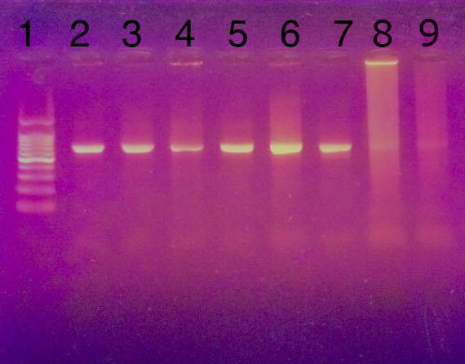

Supplementary figure 02: An uncropped image of agarose gel electrophoresis of colony PCR products of E. coli-BL21-pJET1.2-CadA/CadR cells Well Numbers: 1- 100bp DNA ladder, 2- positive control DNA construct, 3-9 - isolated colonies of E.coli-BL21-pJET1.2-CadA/CadR cells.

