Supplementary

Some background information regarding peak models and fitting of the HAXPES data
We approached several databases, literature, and professional web pages to find plausible models for the photoemission spectra. We aimed at creating a simple but reasonable model due to the complex nature of XPS. We sought to understand the surface chemistry and oxidation state qualitatively. We often used a Shirley background recommended for fitting transition metal oxides. However, a linear background was used due to core level overlap with the intended element. We did not include satellites as these were highly subjective.
For fitting the Ni 2p core level peaks, we used the following information from the Materials Science Learning Centre of ThermoFisher Scientific:
Chemical state Binding energy Ni 2p3/2
Ni metal 852.6 eV
NiO 853.7 eV
Ni(OH)₂ 855.6 eV
The Ni 2p peak has significantly split spin-orbit components (Δmetal = 17.3 eV). As a result, the Ni metal spectrum has a complex shape.
For fitting the Fe 2p core level peaks, we used the following information:
Chemical state Binding energy Fe 2p3/2
Fe metal 706.7 eV
FeO 709.6 eV
Fe₂O₃ 710.8 eV
The Fe 2p region has significantly split spin-orbit components (Δmetal=13.1eV). Fe 2p peaks have an asymmetric shape for metal. A well-resolved Fe 2p3/2 spectrum for metal shows multiplet splitting. The second component (shifted by 0.9eV from the central peak) can be neglected when fitting typical mixed oxide/metal spectra.

Figure S 1: The specimens used for HAXPES analysis. The specimens were polarized from OCP until the anodic potential, as indicated by the marker in the polarization curves, and kept for 20 seconds under potentiostatic control. Specimen no. 1 and no. 6 are non-polarized conditions forming native surface oxide/oxyhydroxide.

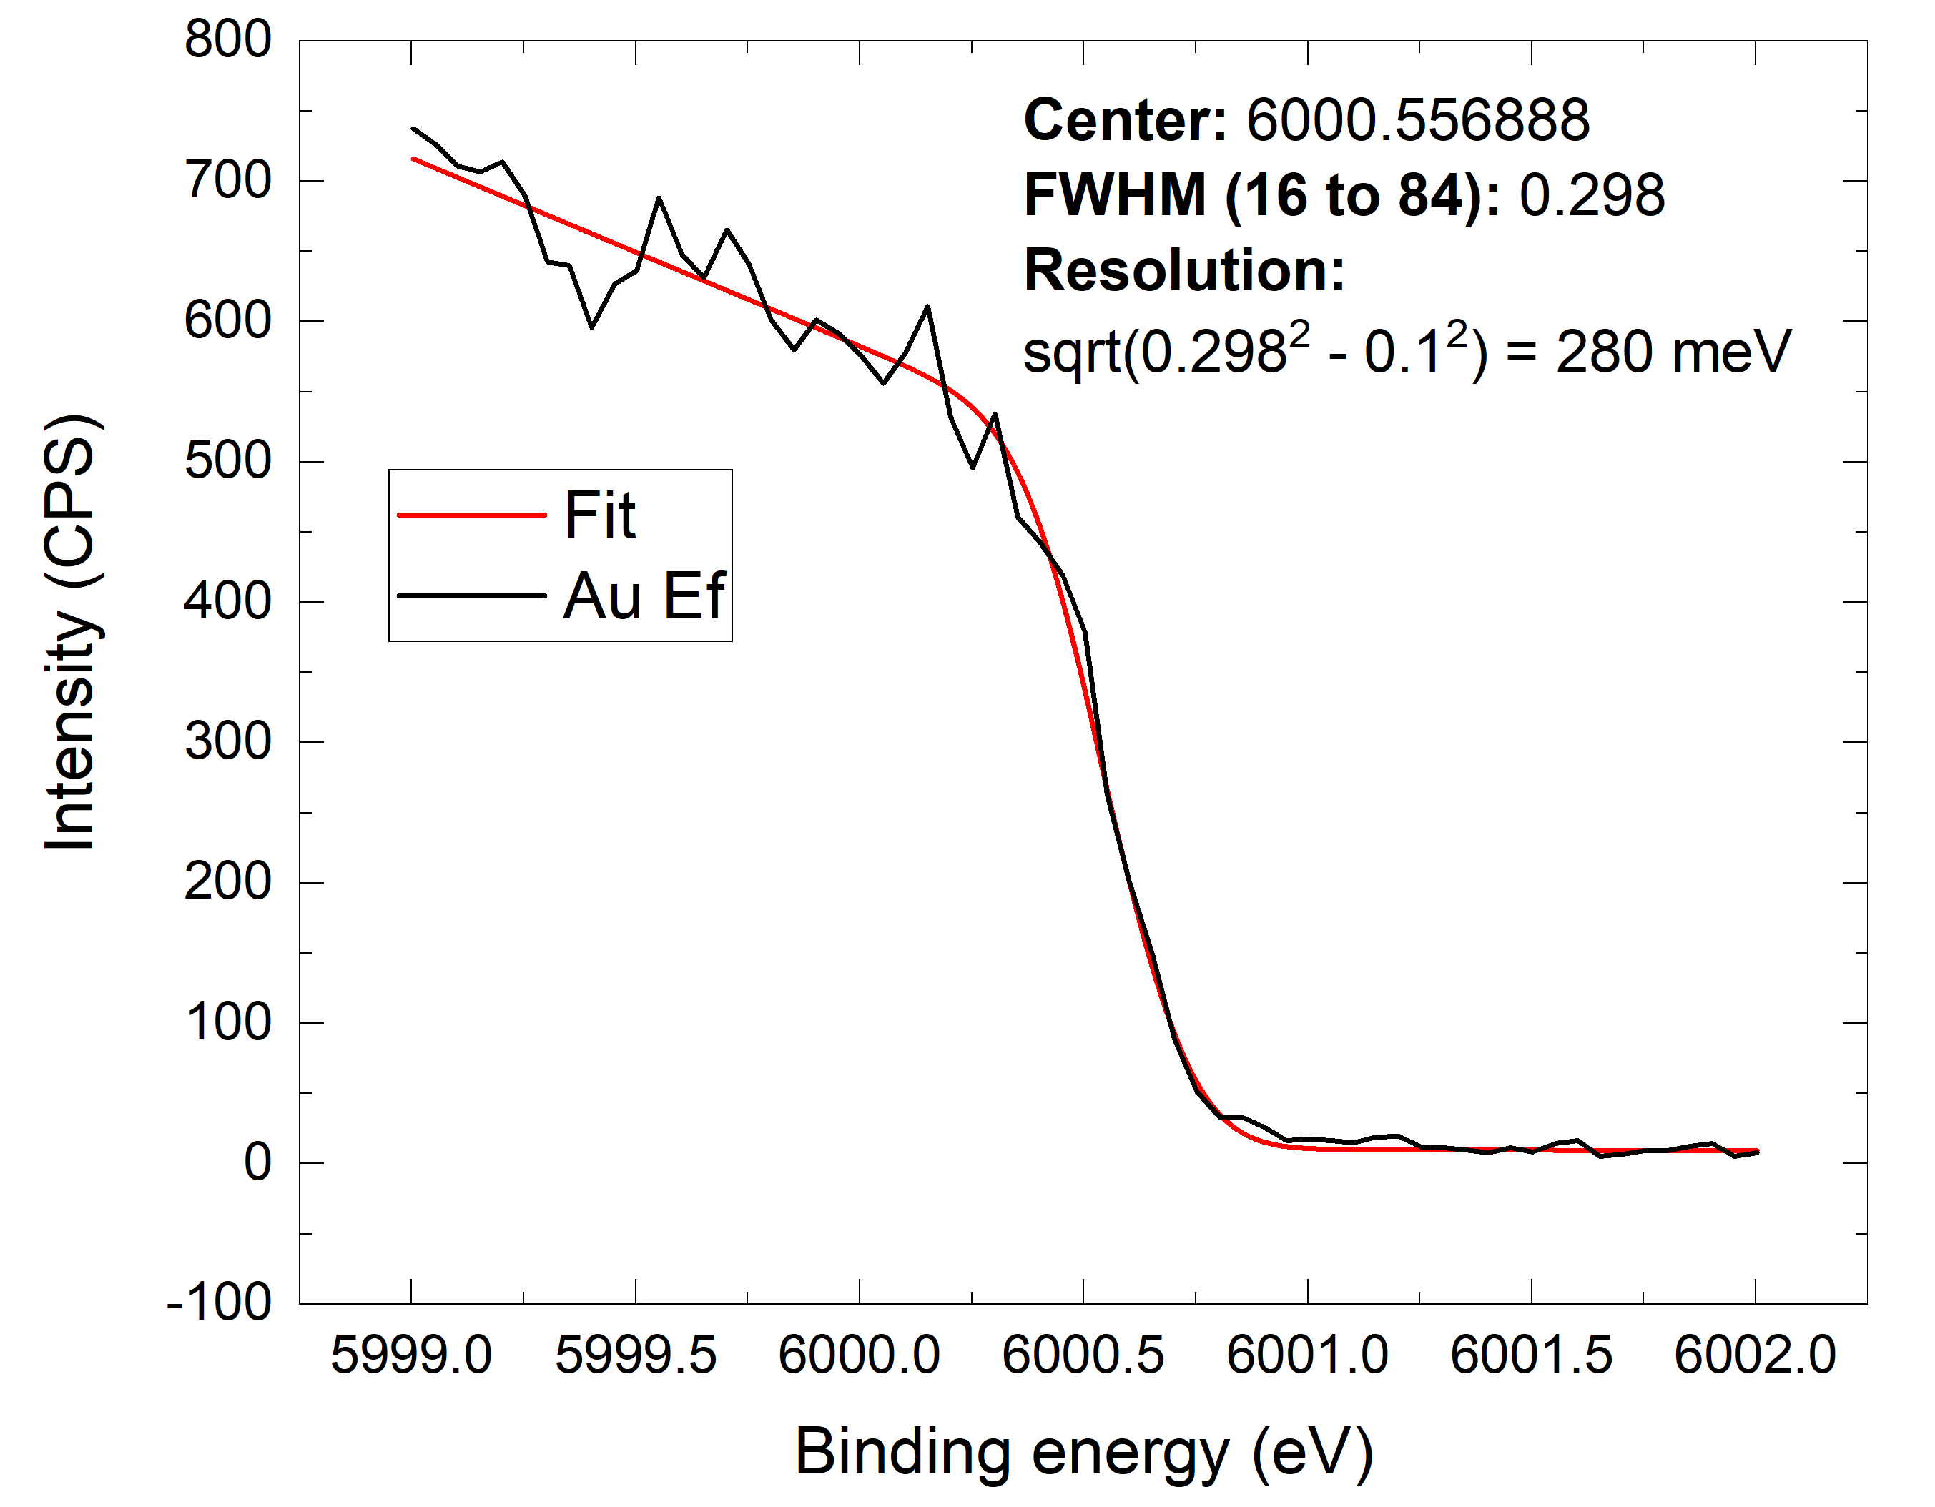
Figure S 2: Considering thermal broadening at room temperature of 100 meV, the instrument’s resolution was about 280 meV, which defines the HAXPES resolution.

High-resolution HAXPES measured data and fitting results for Fe 2p

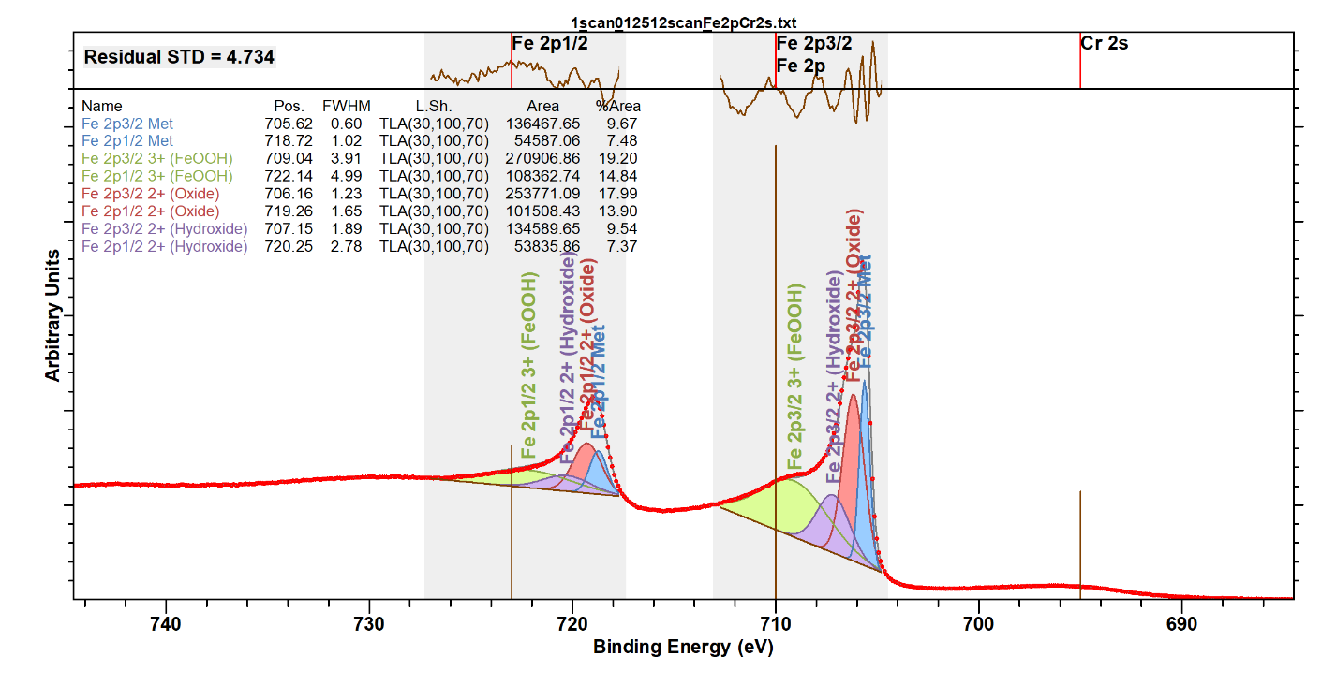

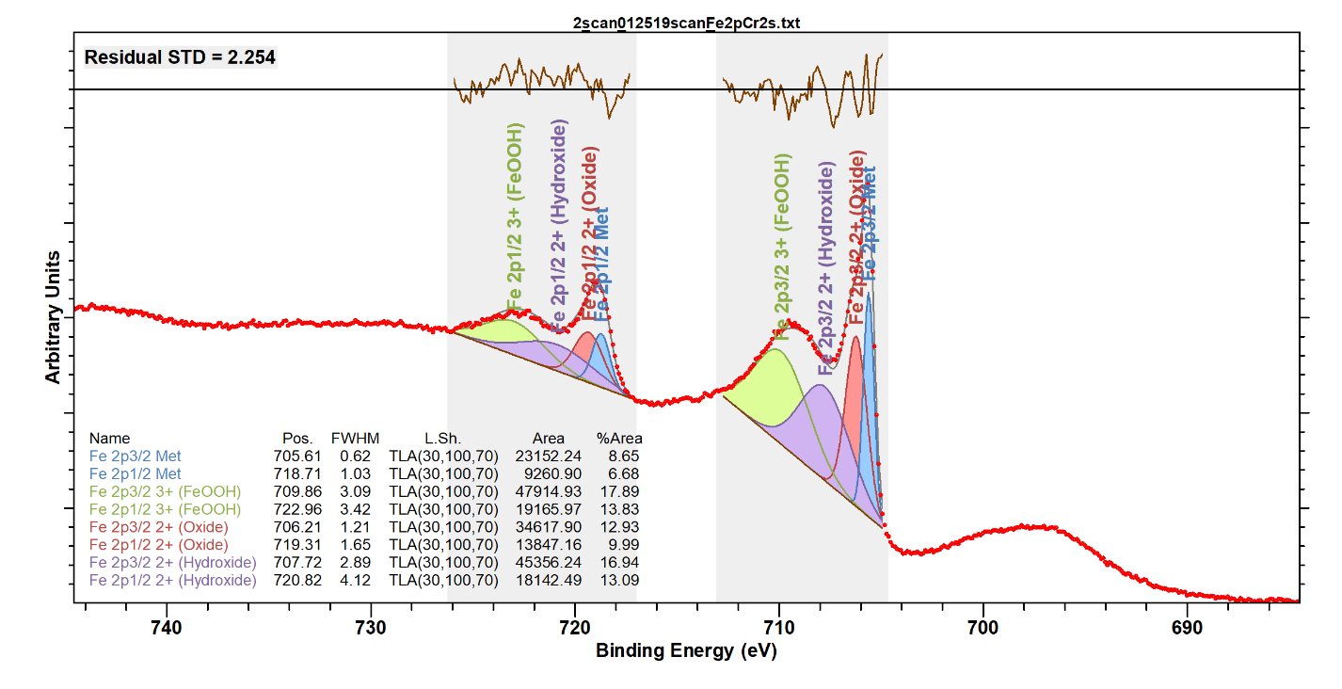
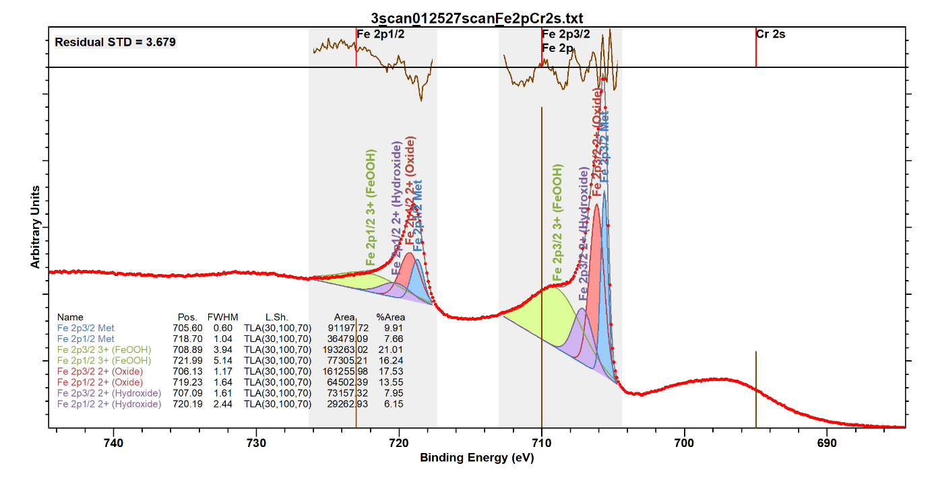

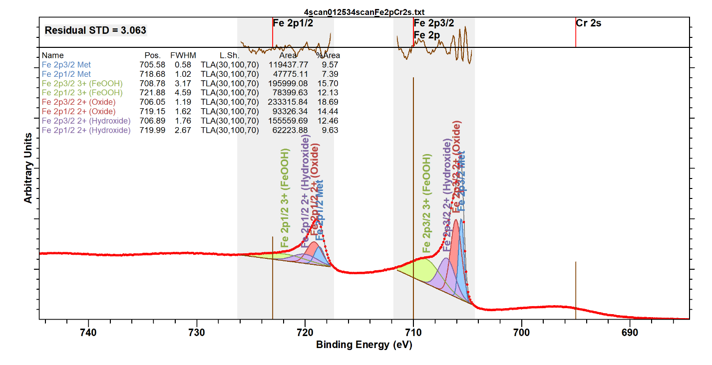
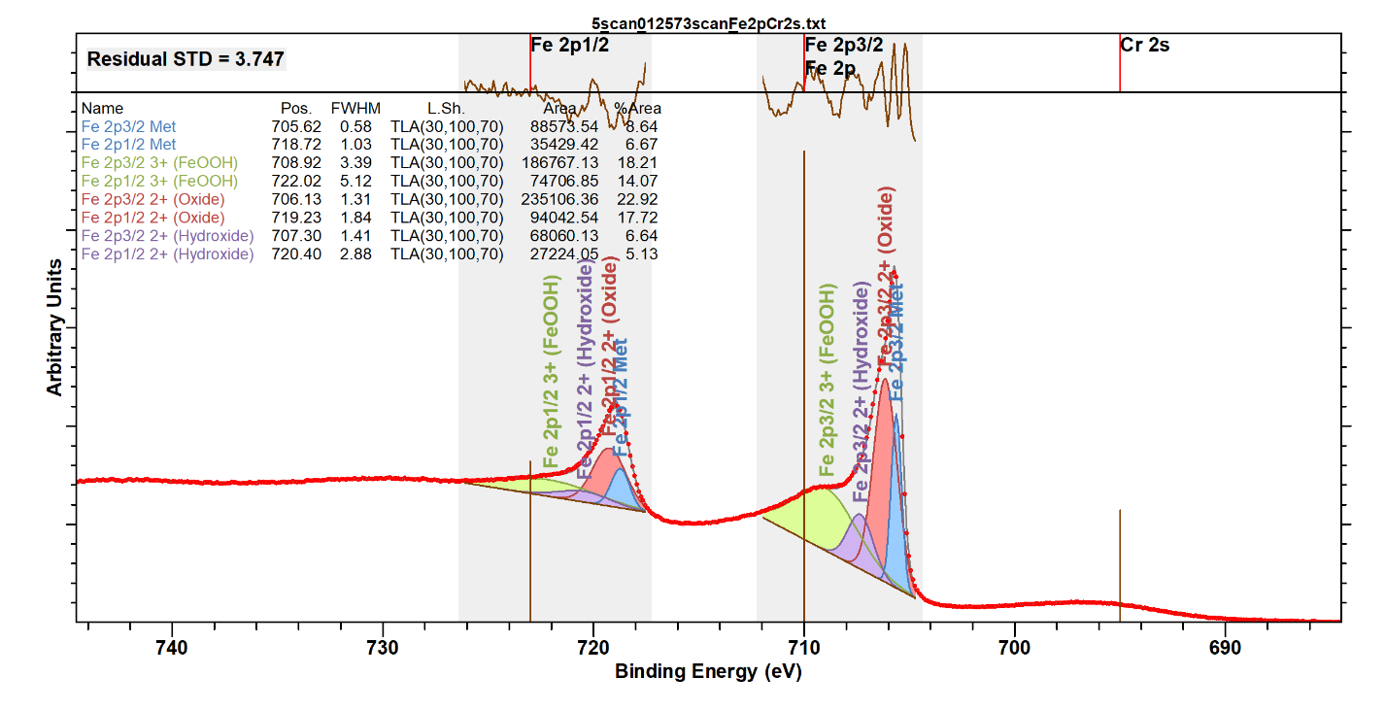

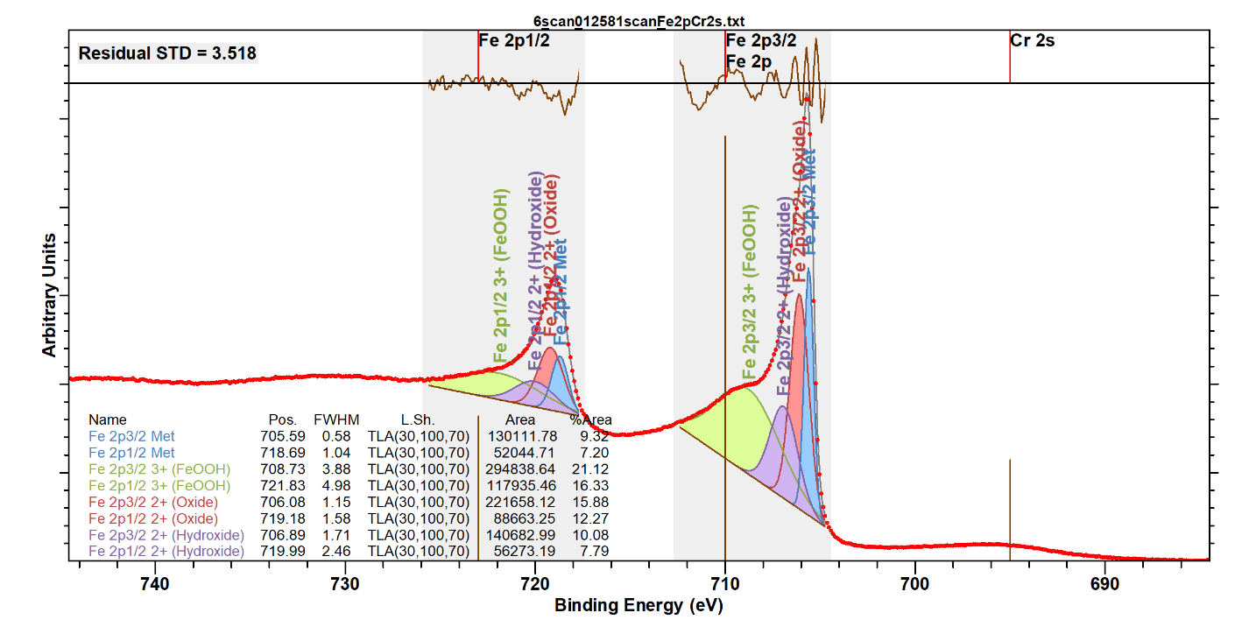
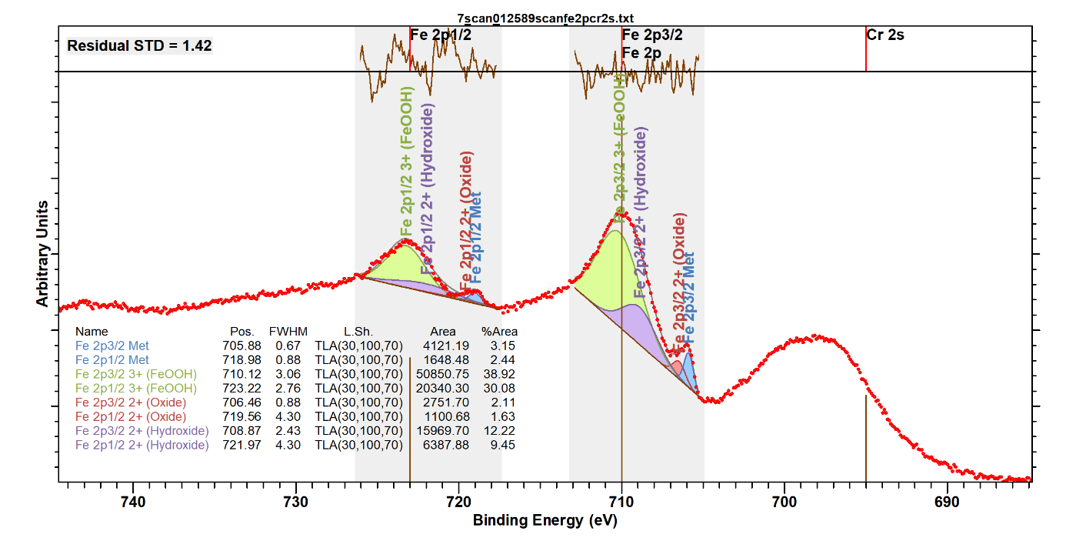

High-resolution HAXPES measured data and fitting results for Cr 2p

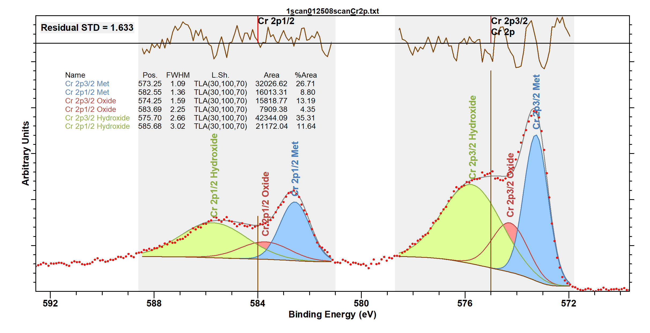

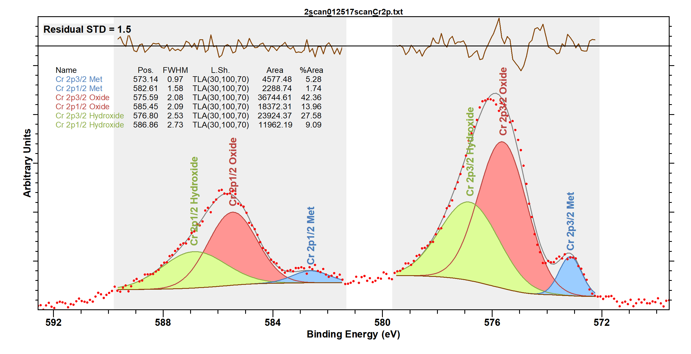

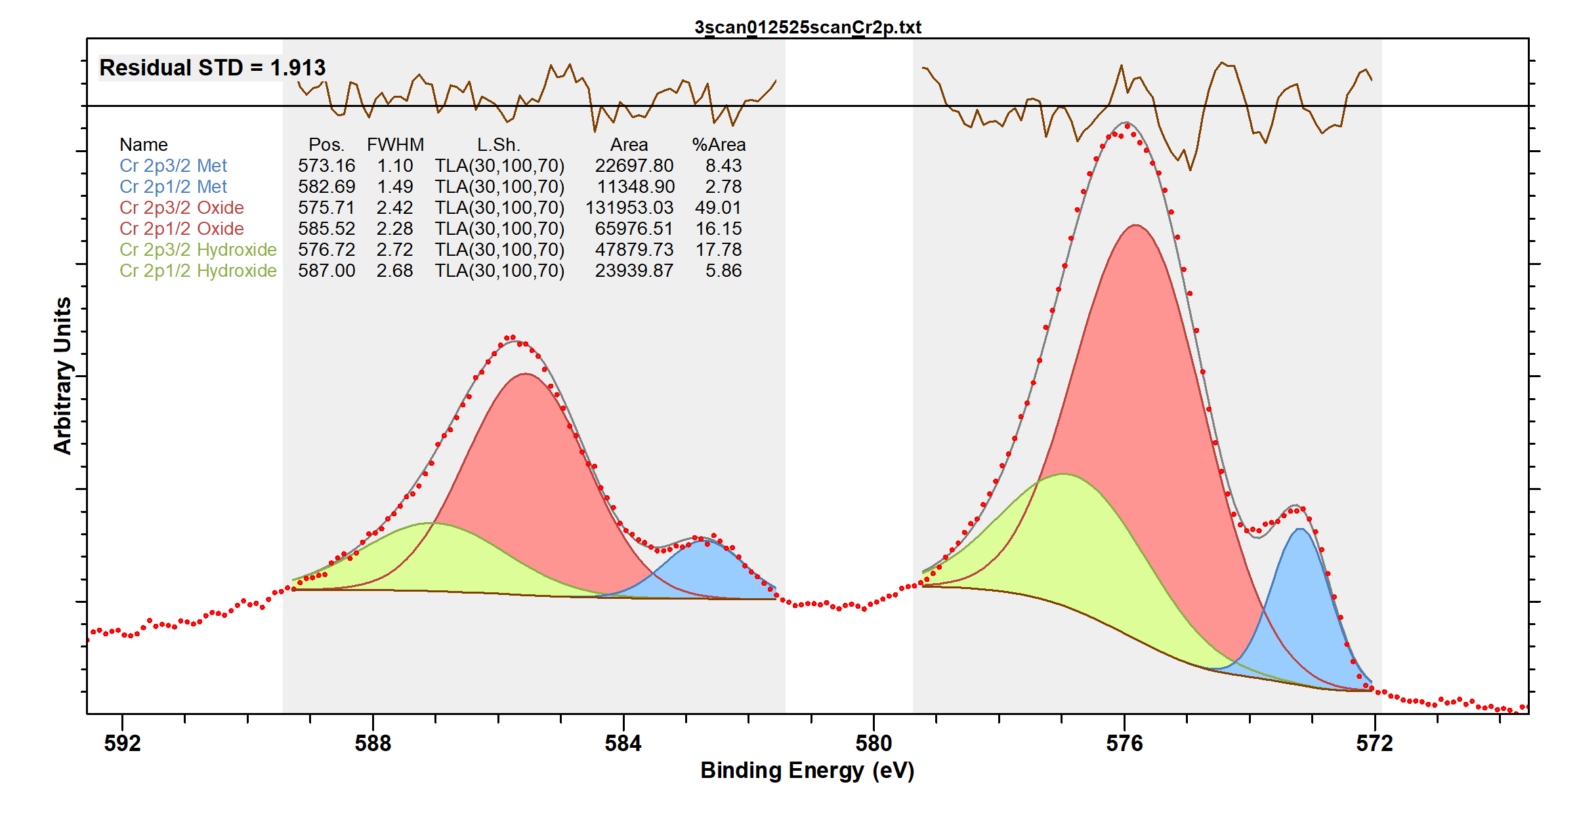

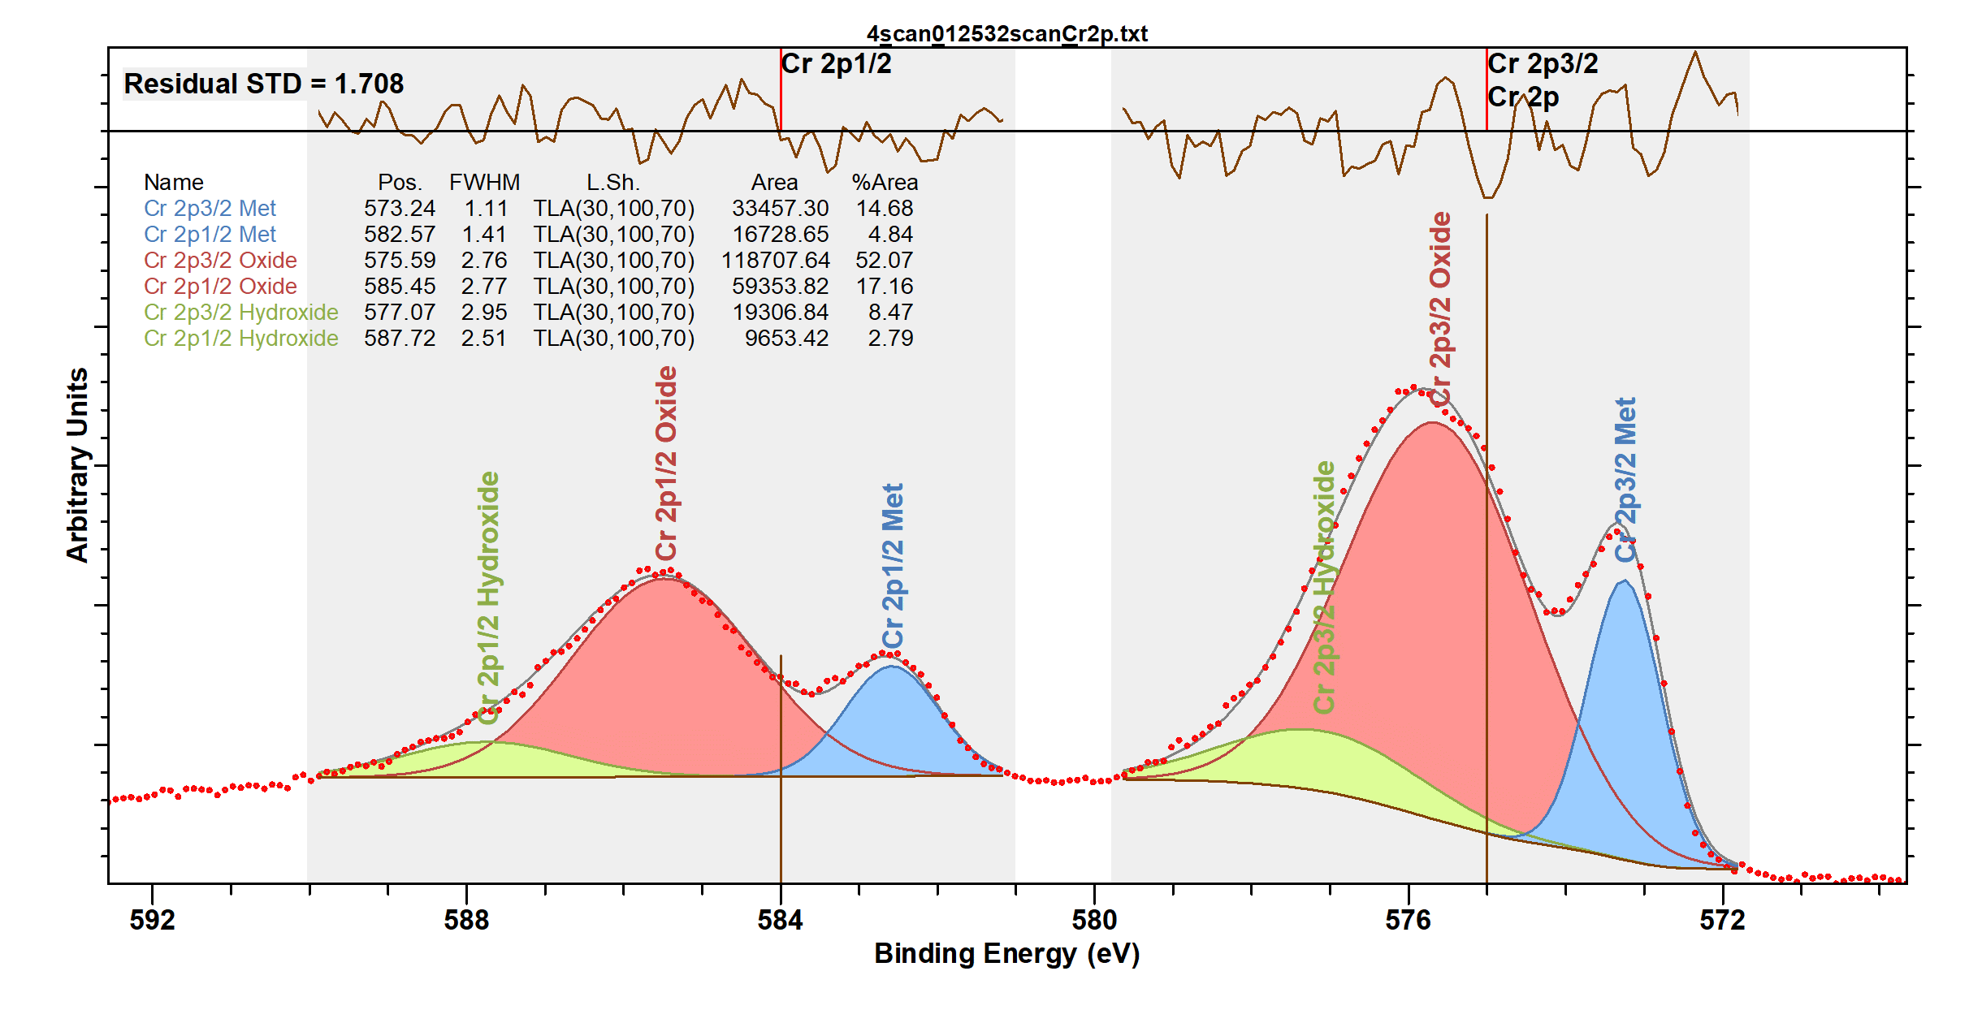

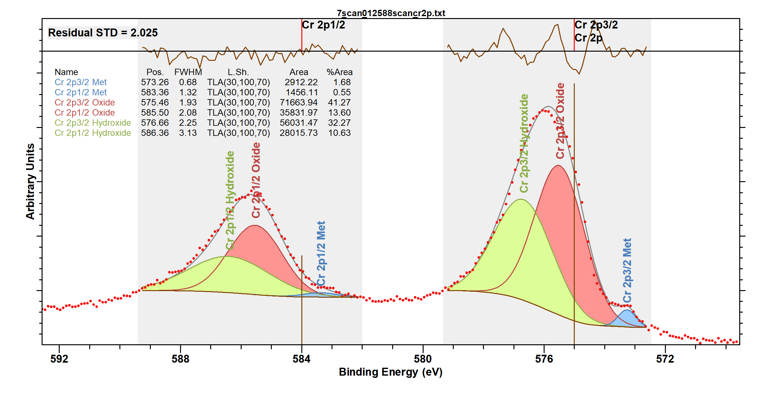

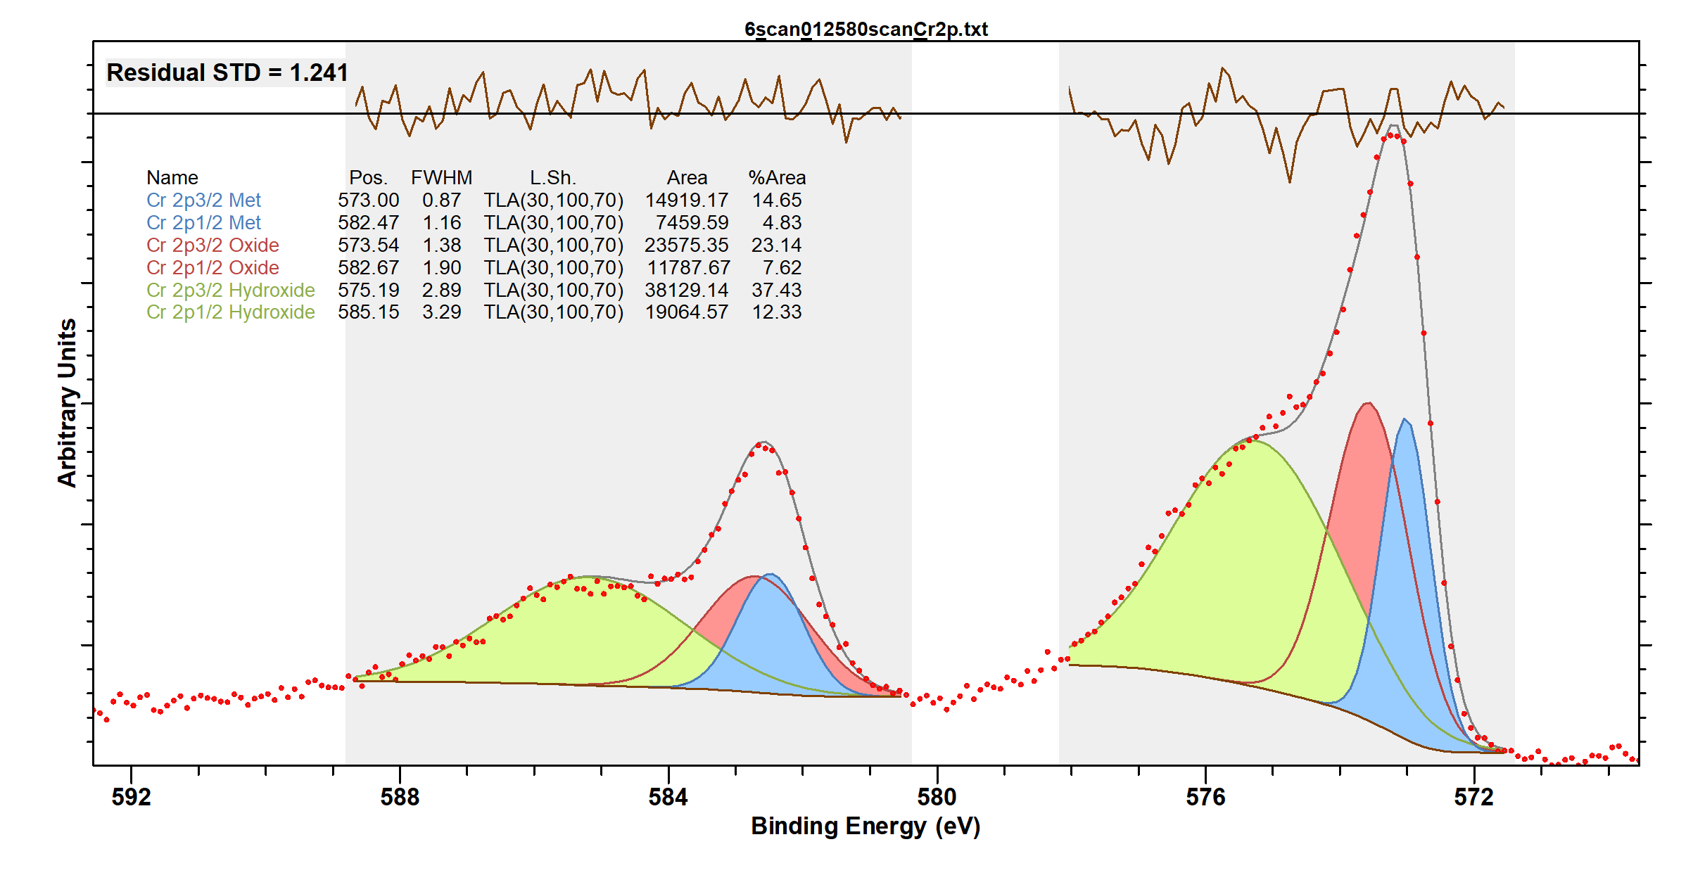

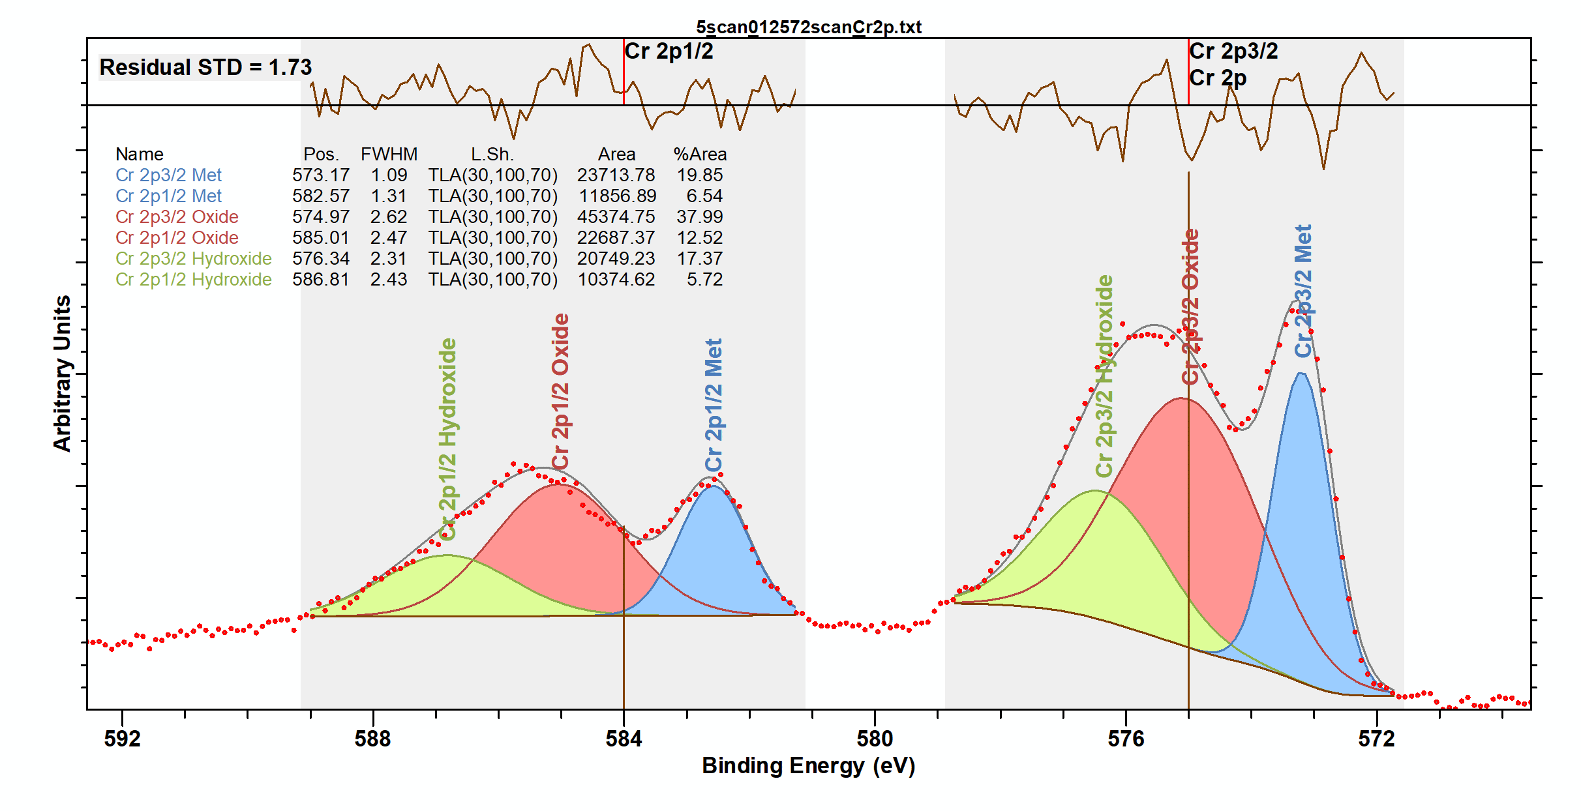

High-resolution HAXPES measured data and fitting results for Ni 2p

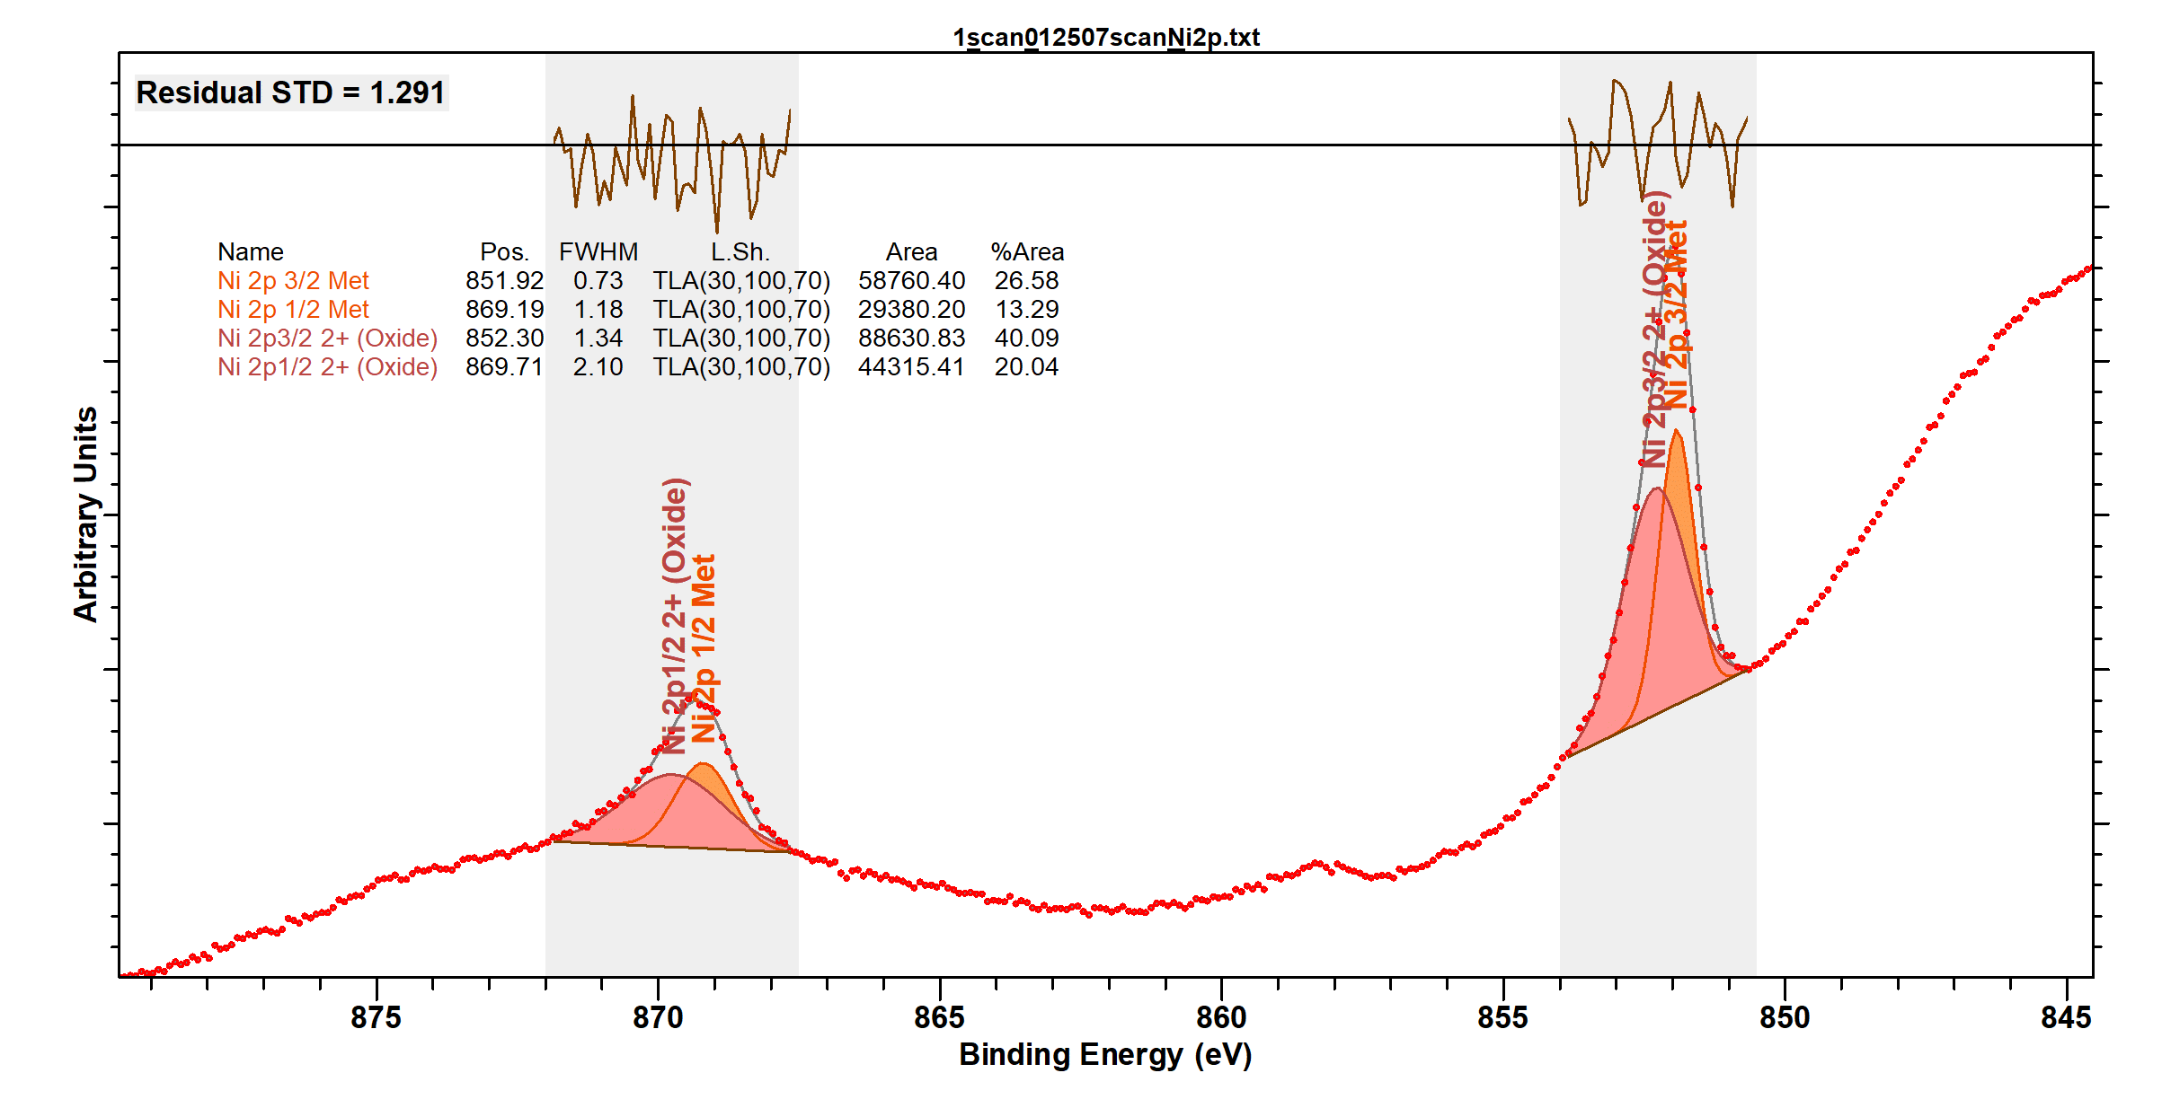

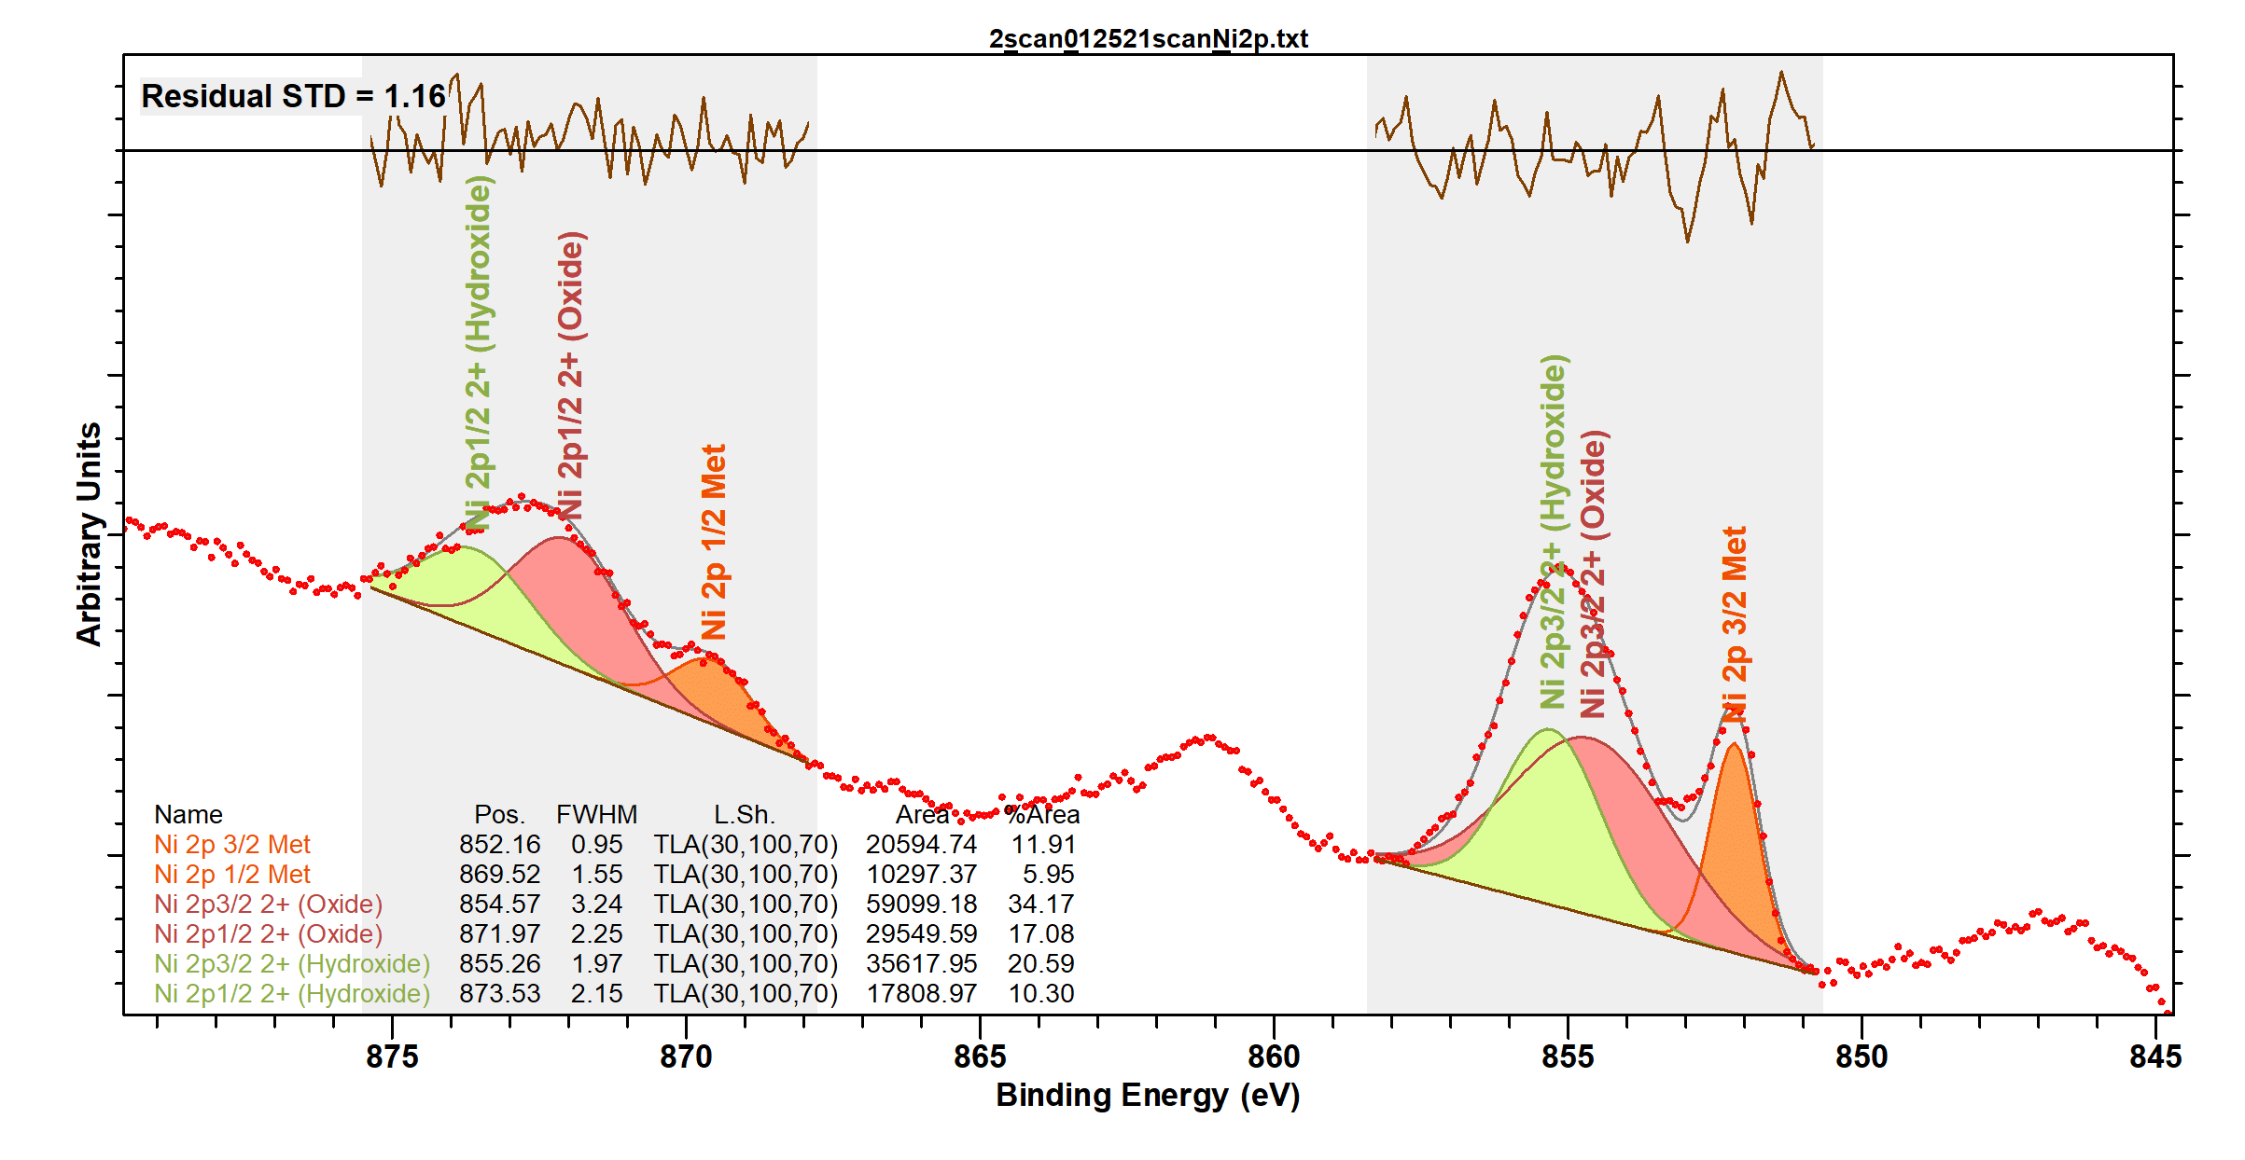

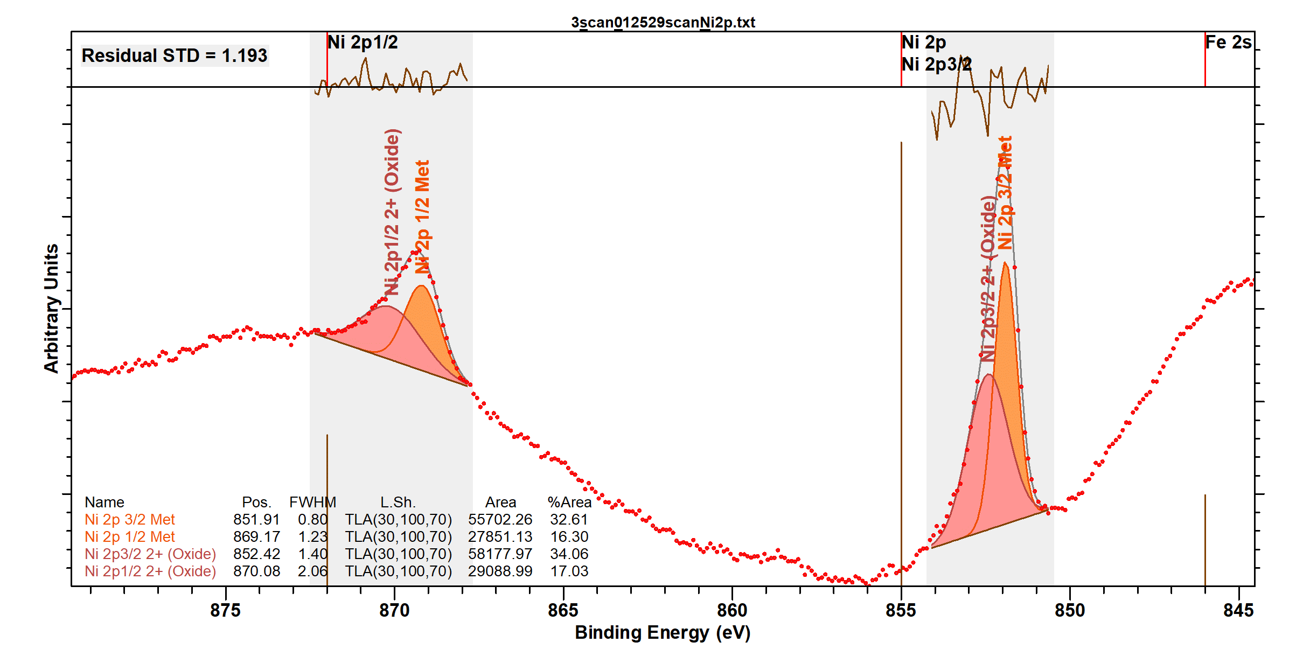

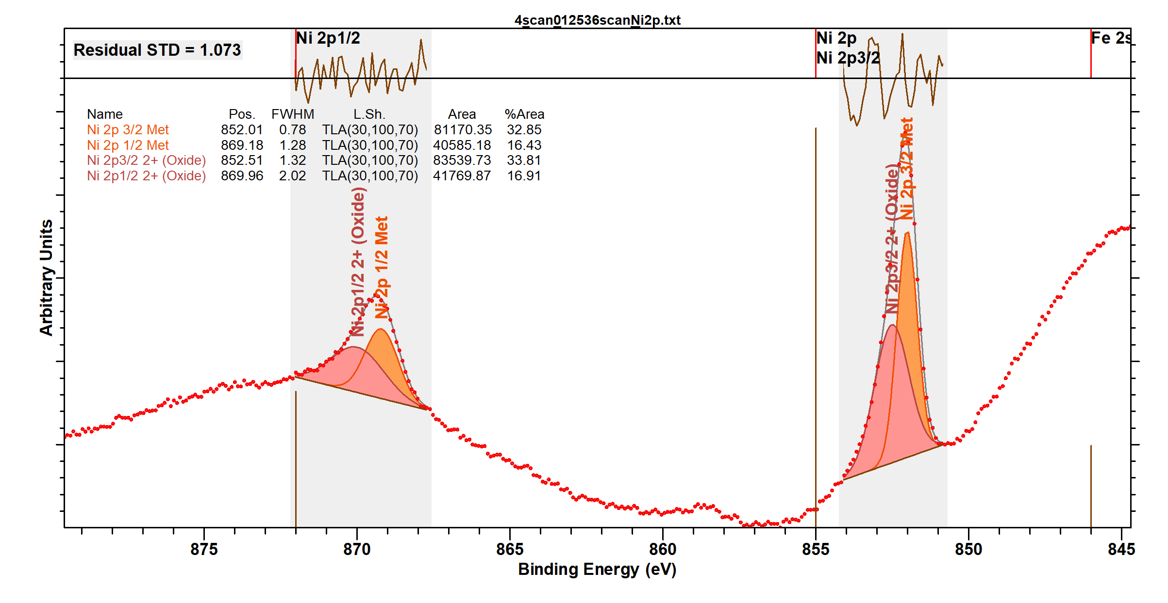

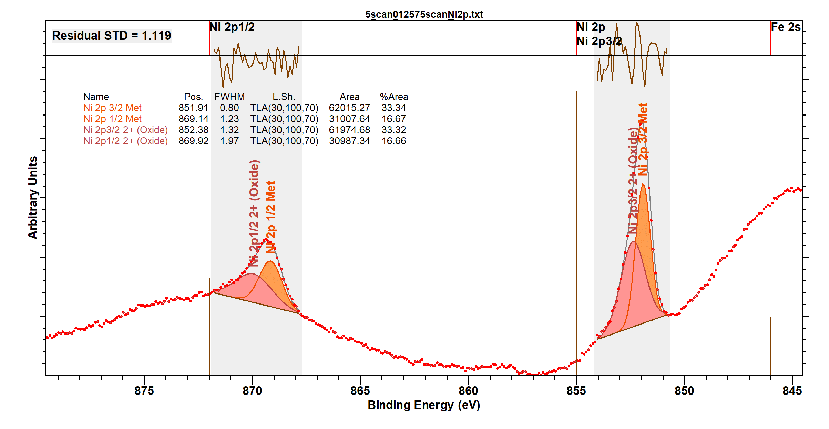

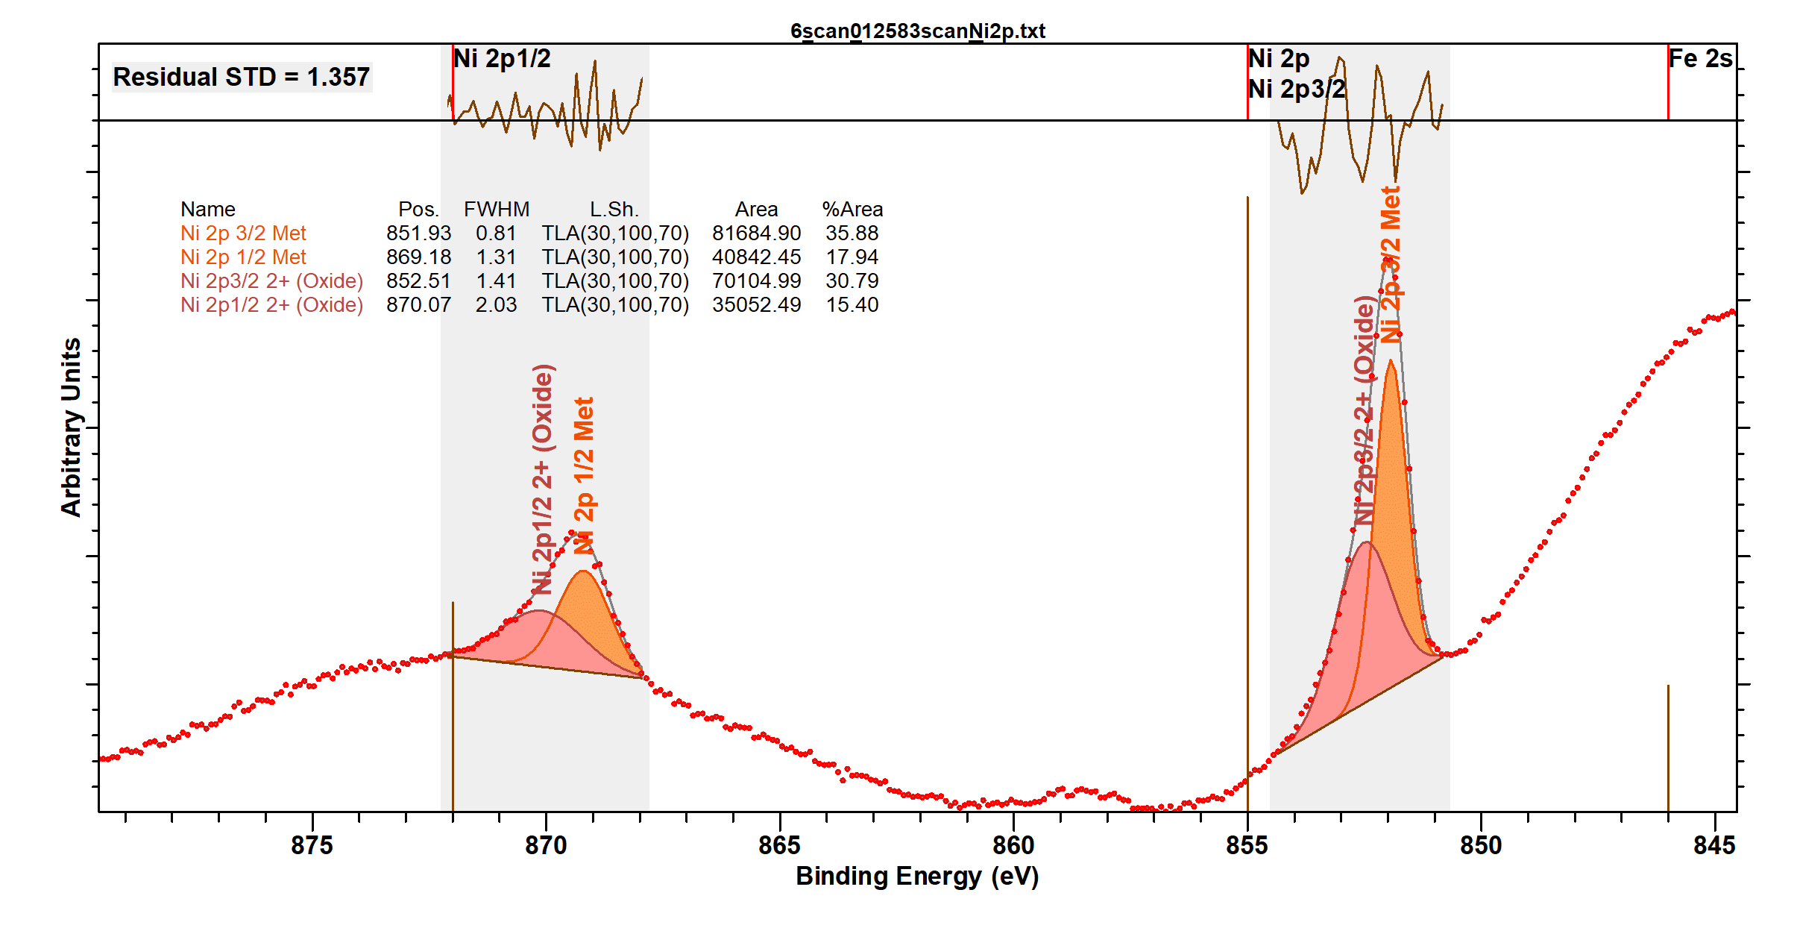

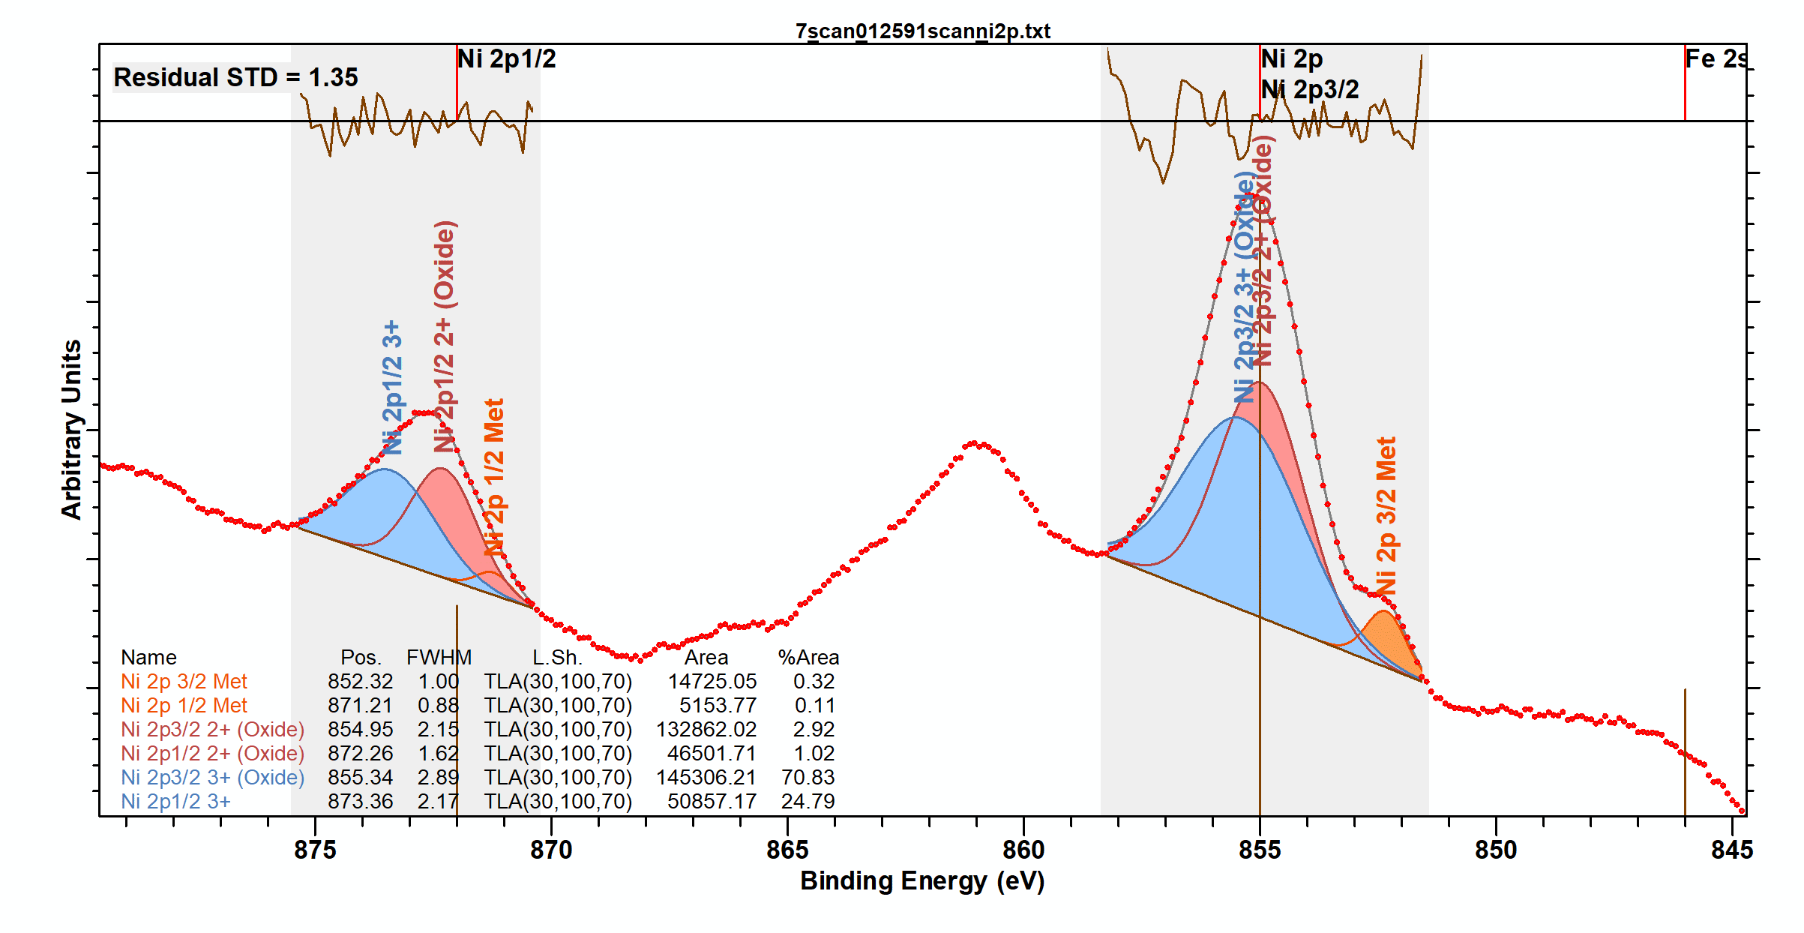

High-resolution HAXPES measured data and fitting results for Al 1s

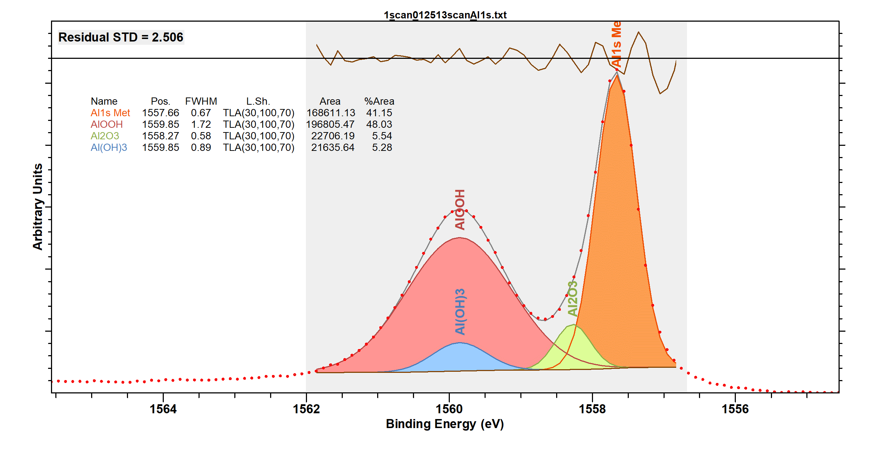

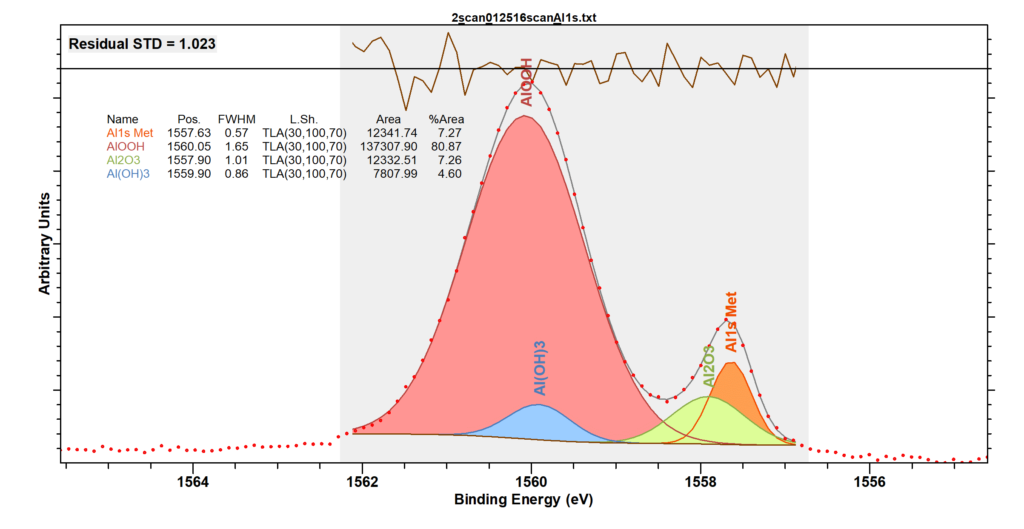
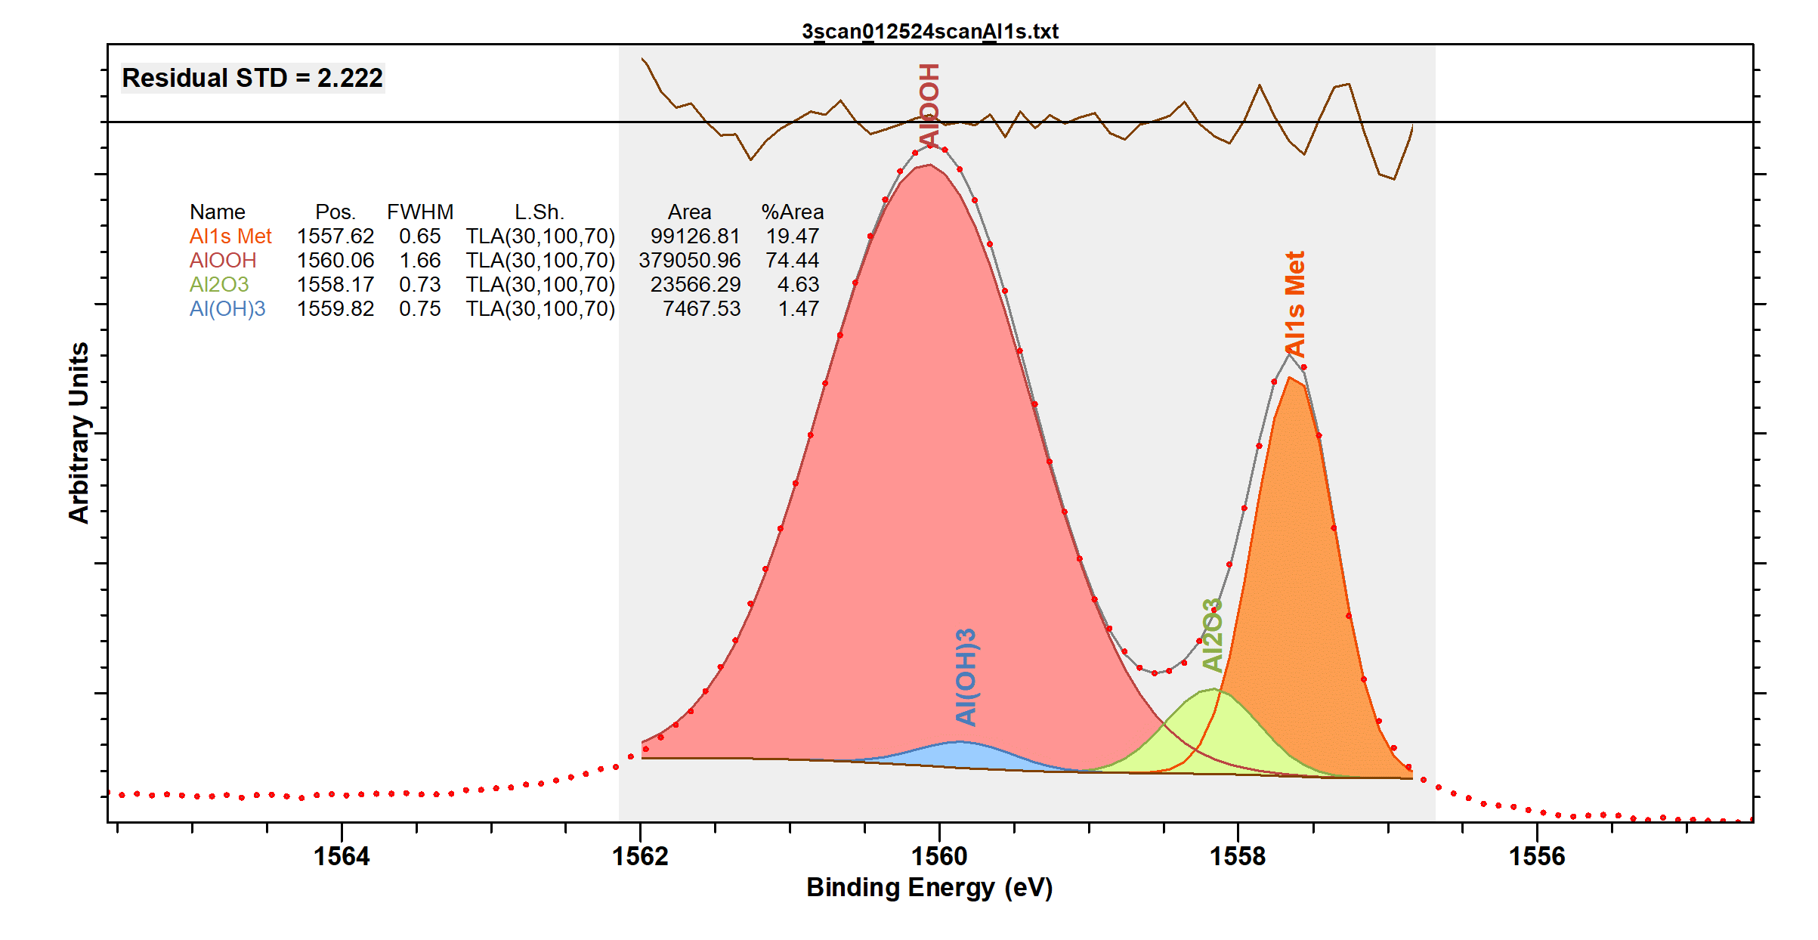

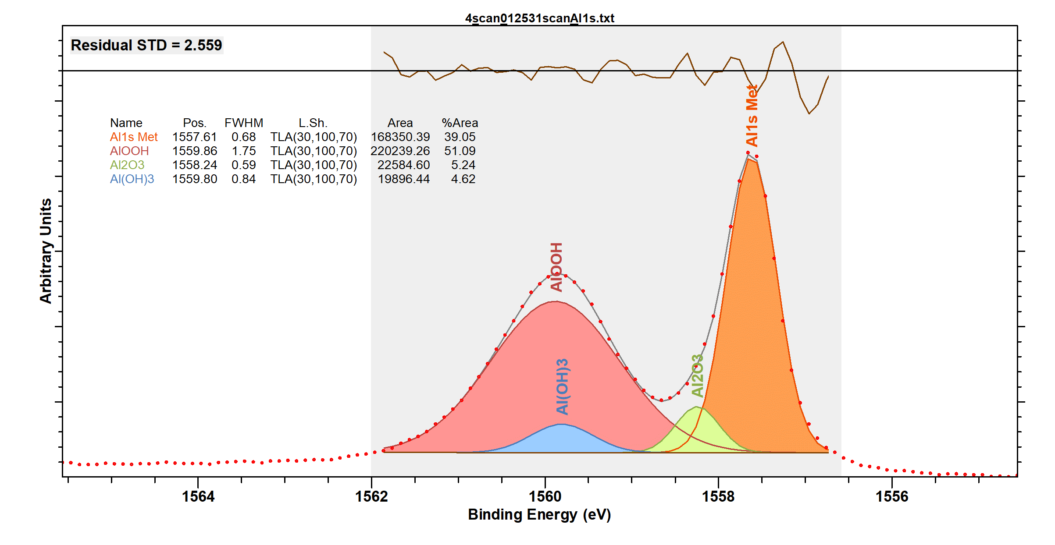

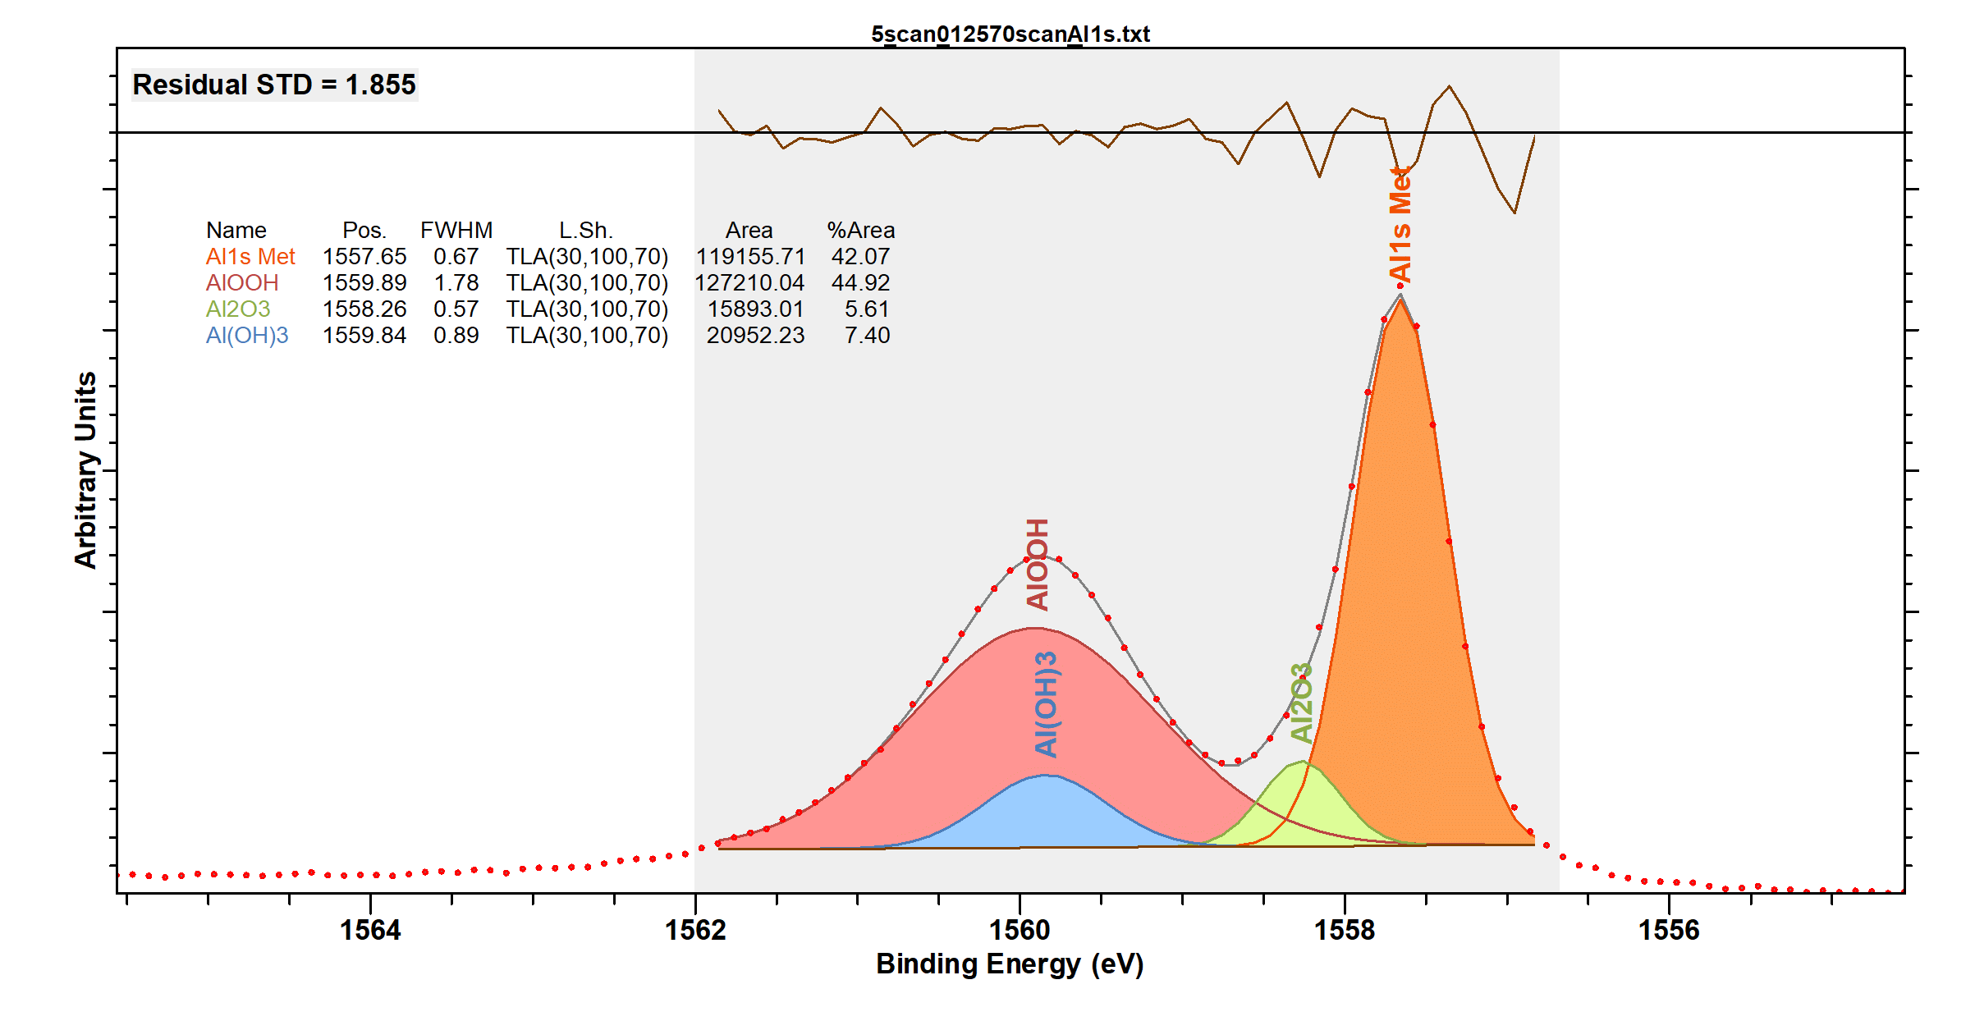

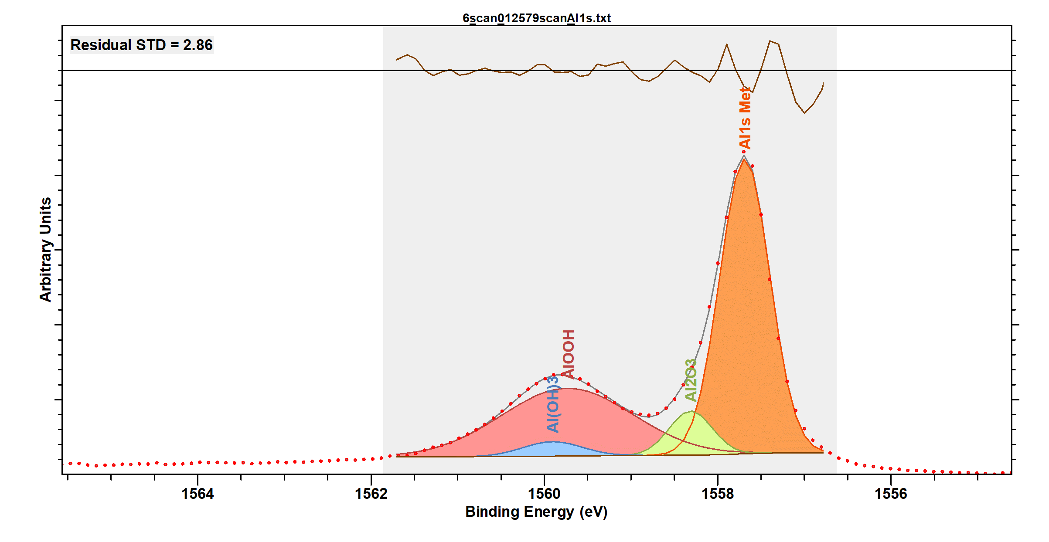

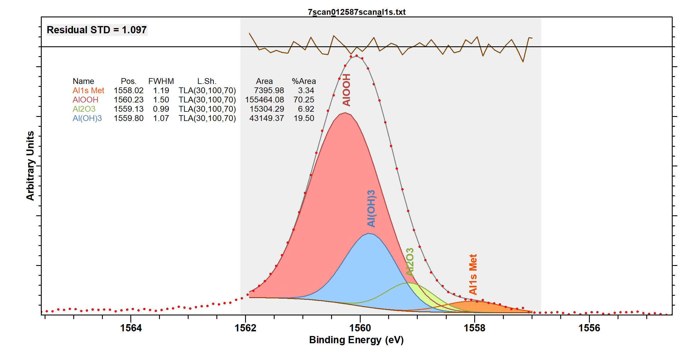

High-resolution HAXPES measured data and fitting results for Mo 3p

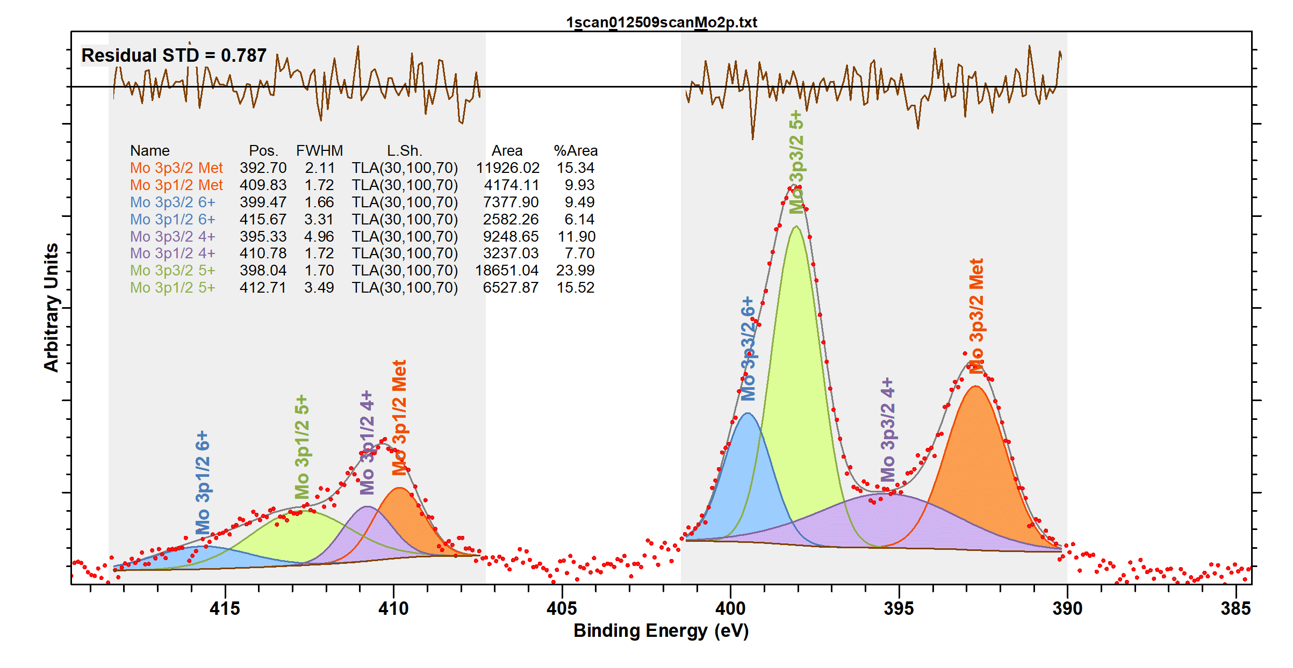

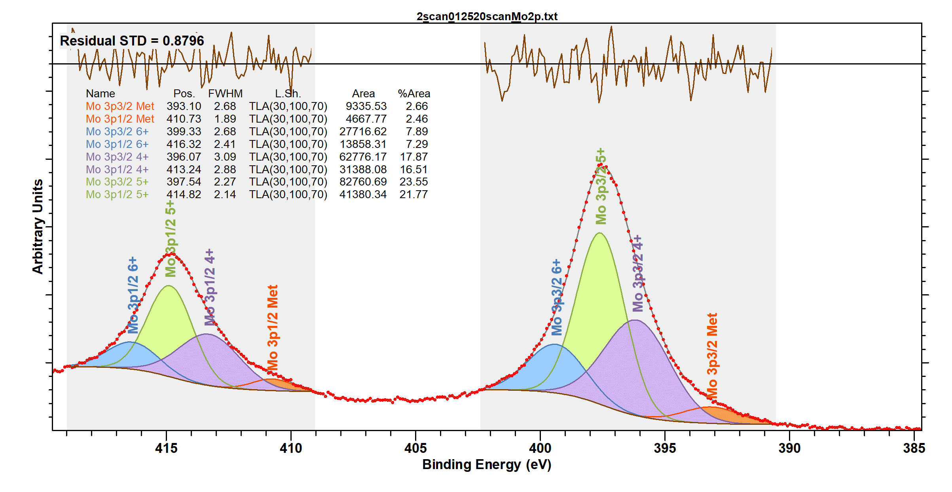
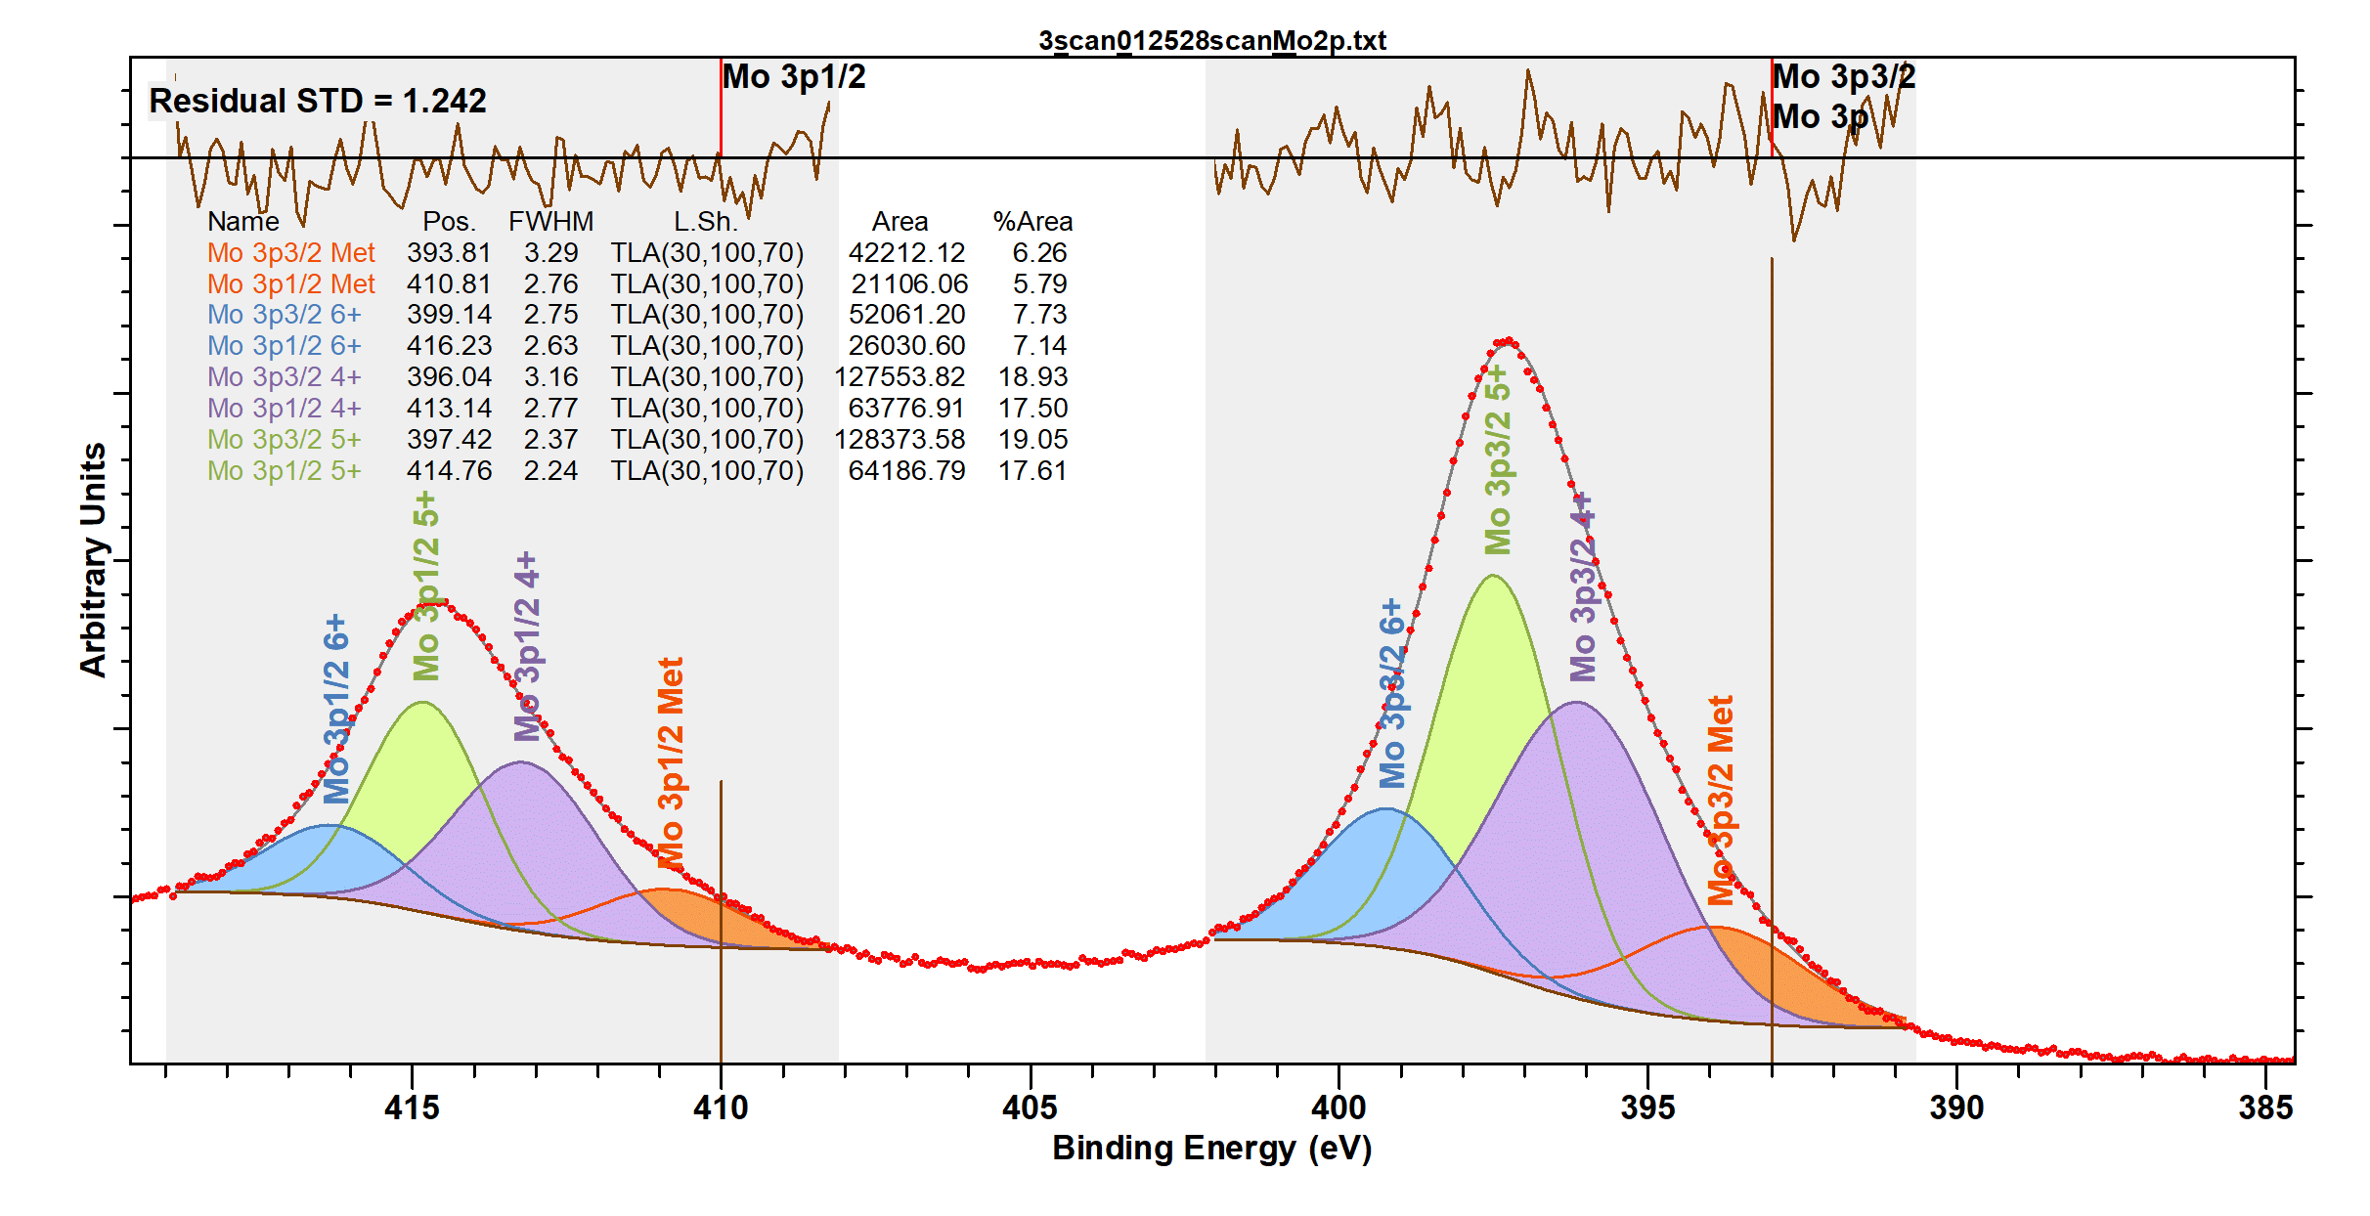

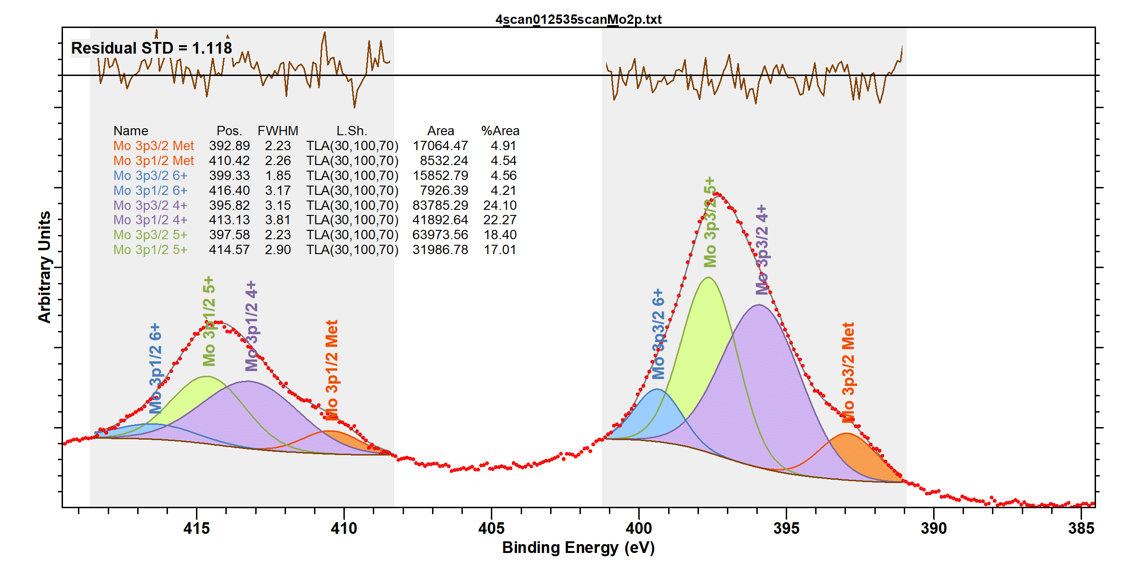

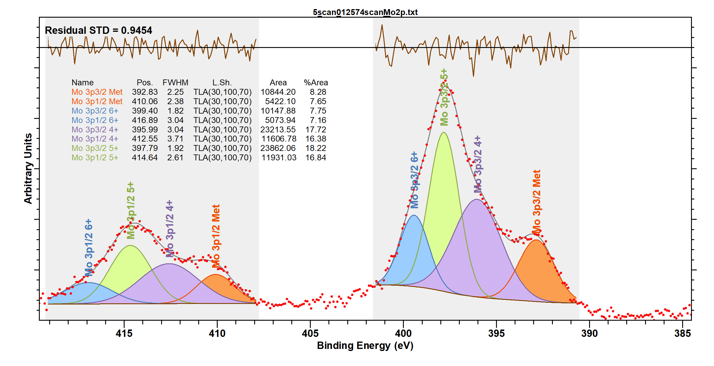

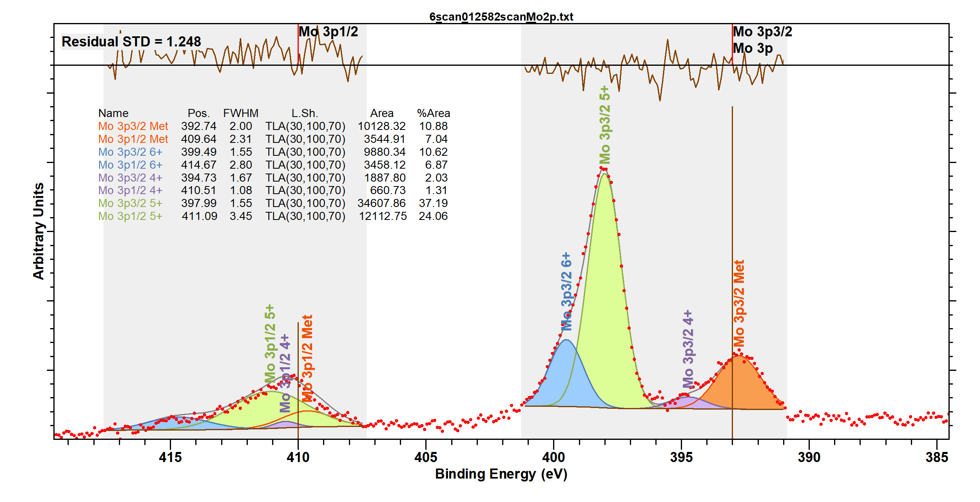

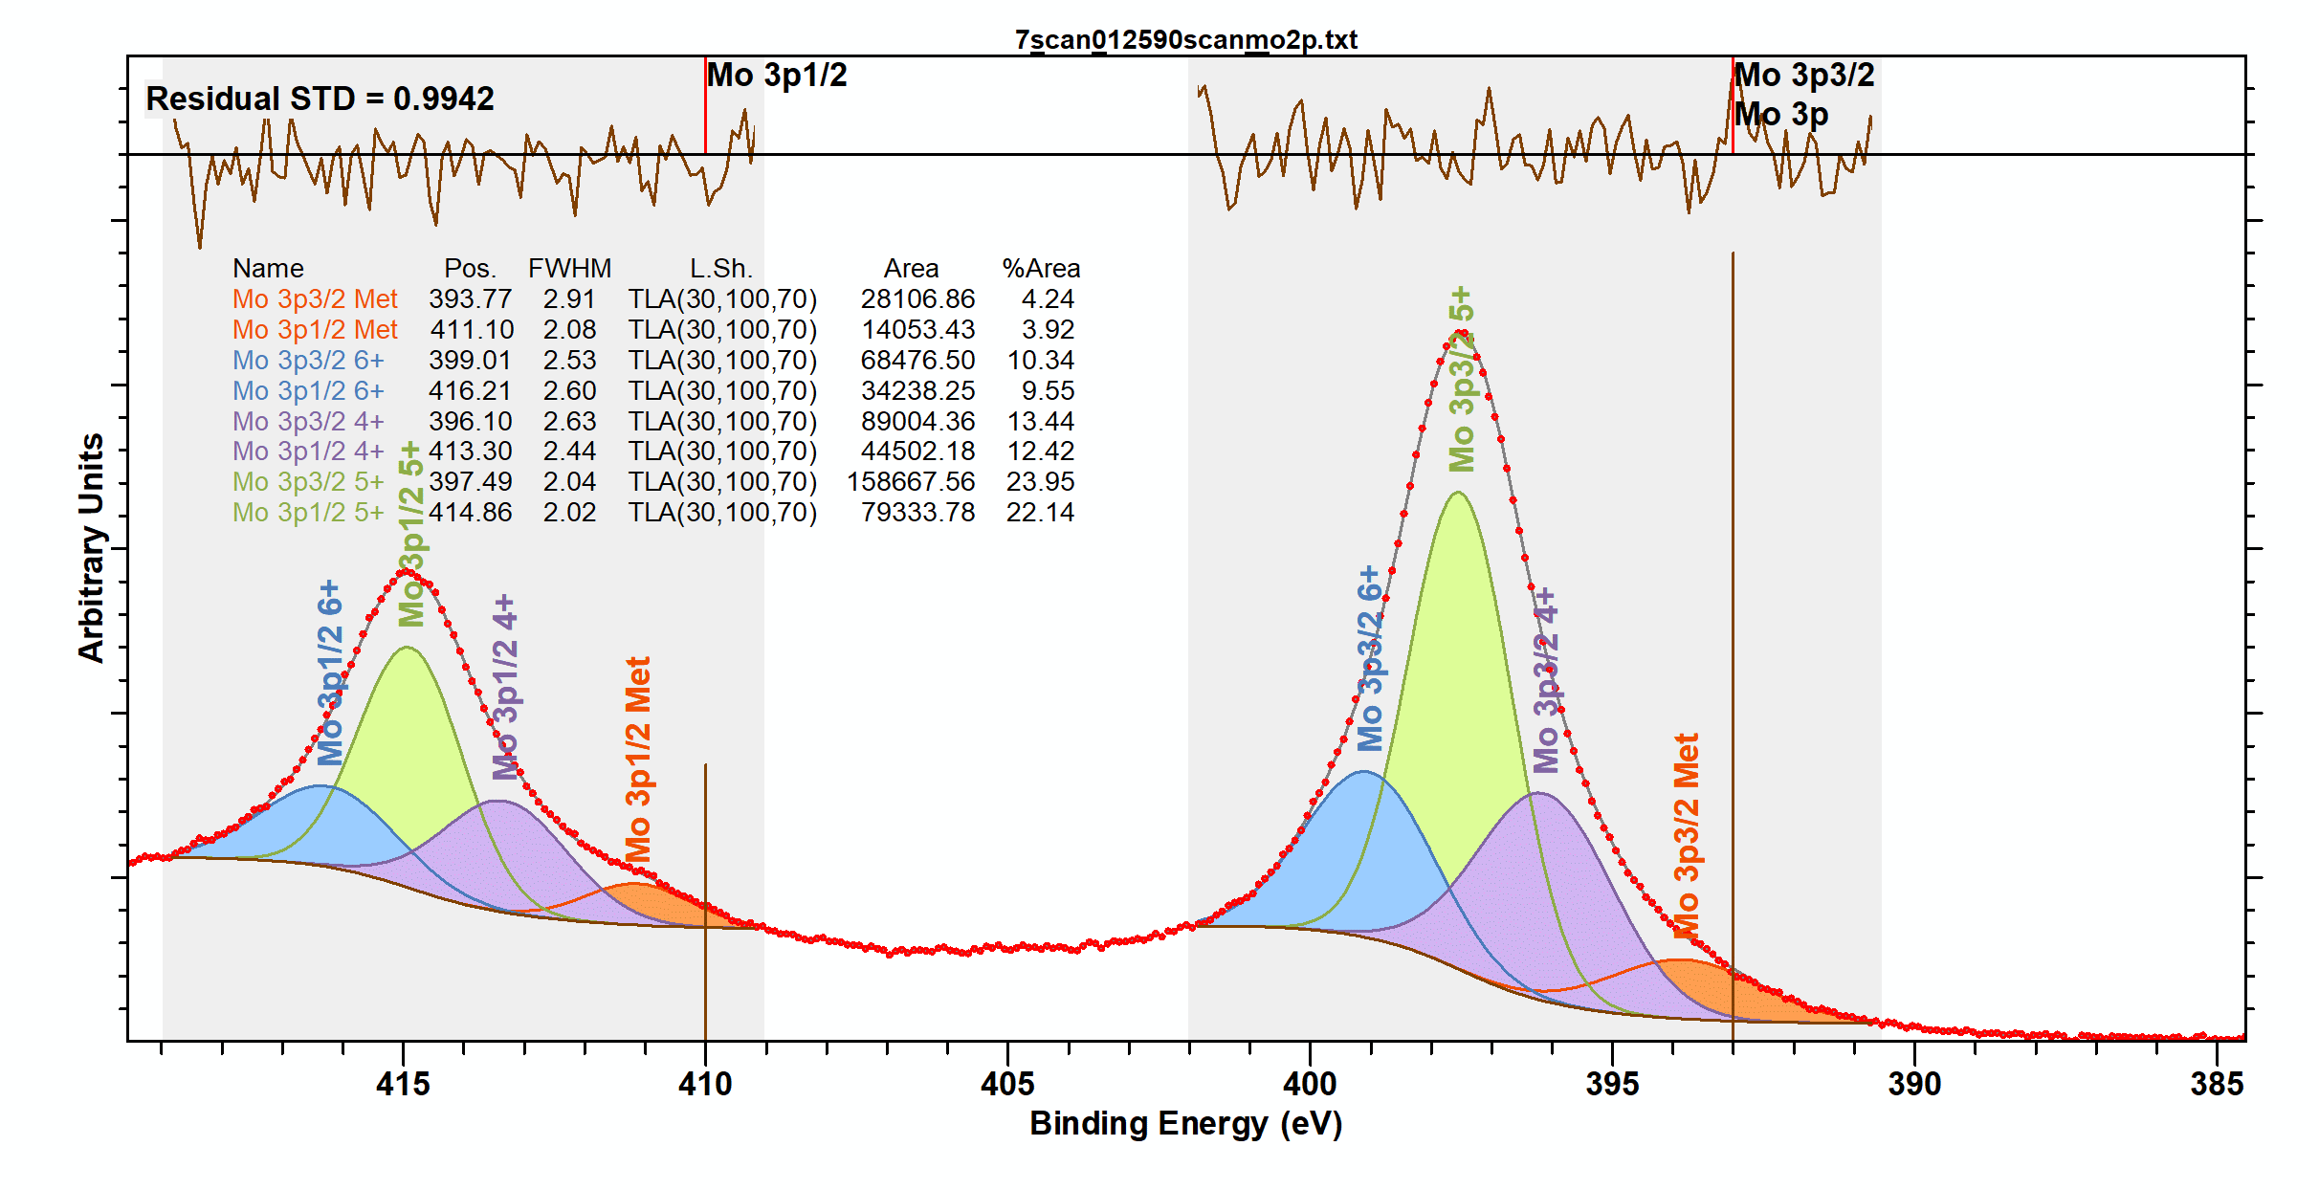

Table S 1: HAXPES fitting results showing the composition of the surface film of Hy55 steel as a function of electrochemical polarization in sulfuric acid. Refer to Figure S 1 for the details of sample no. Note that samples no. 1 and no. 6 had a native surface film (native surface oxyhydroxide).
Sample No. | Name | Position | FWHM | Line Shape | Area | % Conc.
1 | Fe 2p3/2 Met | 705.6205 | 0.598453 | TLA(30,100,70) | 136467.65 | 9.674
1 | Fe 2p1/2 Met | 718.7205 | 1.02022 | TLA(30,100,70) | 54587.06 | 7.476
1 | Fe 2p3/2 3+ (FeOOH) | 709.0412 | 3.9119 | TLA(30,100,70) | 270906.86 | 19.2
1 | Fe 2p1/2 3+ (FeOOH) | 722.1412 | 4.98862 | TLA(30,100,70) | 108362.74 | 14.84
1 | Fe 2p3/2 2+ (Oxide) | 706.1584 | 1.23373 | TLA(30,100,70) | 253771.09 | 17.99
1 | Fe 2p1/2 2+ (Oxide) | 719.2584 | 1.64552 | TLA(30,100,70) | 101508.43 | 13.9
1 | Fe 2p3/2 2+ (Hydroxide) | 707.1456 | 1.88888 | TLA(30,100,70) | 134589.65 | 9.54
1 | Fe 2p1/2 2+ (Hydroxide) | 720.2456 | 2.7823 | TLA(30,100,70) | 53835.86 | 7.373
2 | Fe 2p3/2 Met | 705.6085 | 0.61702 | TLA(30,100,70) | 23152.24 | 8.646
2 | Fe 2p1/2 Met | 718.7085 | 1.03372 | TLA(30,100,70) | 9260.9 | 6.682
2 | Fe 2p3/2 3+ (FeOOH) | 709.8588 | 3.09243 | TLA(30,100,70) | 47914.93 | 17.89
2 | Fe 2p1/2 3+ (FeOOH) | 722.9588 | 3.41561 | TLA(30,100,70) | 19165.97 | 13.83
2 | Fe 2p3/2 2+ (Oxide) | 706.2092 | 1.21414 | TLA(30,100,70) | 34617.9 | 12.93
2 | Fe 2p1/2 2+ (Oxide) | 719.3092 | 1.64952 | TLA(30,100,70) | 13847.16 | 9.991
2 | Fe 2p3/2 2+ (Hydroxide) | 707.7191 | 2.89441 | TLA(30,100,70) | 45356.24 | 16.94
2 | Fe 2p1/2 2+ (Hydroxide) | 720.8191 | 4.11972 | TLA(30,100,70) | 18142.49 | 13.09
3 | Fe 2p3/2 Met | 705.5982 | 0.599014 | TLA(30,100,70) | 91197.72 | 9.914
3 | Fe 2p1/2 Met | 718.6982 | 1.04041 | TLA(30,100,70) | 36479.09 | 7.662
3 | Fe 2p3/2 3+ (FeOOH) | 708.8878 | 3.93955 | TLA(30,100,70) | 193263.02 | 21.01
3 | Fe 2p1/2 3+ (FeOOH) | 721.9878 | 5.14189 | TLA(30,100,70) | 77305.21 | 16.24
3 | Fe 2p3/2 2+ (Oxide) | 706.1288 | 1.17398 | TLA(30,100,70) | 161255.98 | 17.53
3 | Fe 2p1/2 2+ (Oxide) | 719.2288 | 1.64268 | TLA(30,100,70) | 64502.39 | 13.55
3 | Fe 2p3/2 2+ (Hydroxide) | 707.0894 | 1.61378 | TLA(30,100,70) | 73157.32 | 7.953
3 | Fe 2p1/2 2+ (Hydroxide) | 720.1894 | 2.43512 | TLA(30,100,70) | 29262.93 | 6.146
4 | Fe 2p3/2 Met | 705.5768 | 0.577201 | TLA(30,100,70) | 119437.77 | 9.565
4 | Fe 2p1/2 Met | 718.6768 | 1.01901 | TLA(30,100,70) | 47775.11 | 7.393
4 | Fe 2p3/2 3+ (FeOOH) | 708.7846 | 3.1653 | TLA(30,100,70) | 195999.08 | 15.7
4 | Fe 2p1/2 3+ (FeOOH) | 721.8846 | 4.58674 | TLA(30,100,70) | 78399.63 | 12.13
4 | Fe 2p3/2 2+ (Oxide) | 706.0461 | 1.18568 | TLA(30,100,70) | 233315.84 | 18.69
4 | Fe 2p1/2 2+ (Oxide) | 719.1461 | 1.62047 | TLA(30,100,70) | 93326.34 | 14.44
4 | Fe 2p3/2 2+ (Hydroxide) | 706.8915 | 1.76422 | TLA(30,100,70) | 155559.69 | 12.46
4 | Fe 2p1/2 2+ (Hydroxide) | 719.9915 | 2.66952 | TLA(30,100,70) | 62223.88 | 9.628
5 | Fe 2p3/2 Met | 705.617 | 0.578503 | TLA(30,100,70) | 88573.54 | 8.636
5 | Fe 2p1/2 Met | 718.717 | 1.02775 | TLA(30,100,70) | 35429.42 | 6.675
5 | Fe 2p3/2 3+ (FeOOH) | 708.9166 | 3.39298 | TLA(30,100,70) | 186767.13 | 18.21
5 | Fe 2p1/2 3+ (FeOOH) | 722.0166 | 5.12313 | TLA(30,100,70) | 74706.85 | 14.07
5 | Fe 2p3/2 2+ (Oxide) | 706.13 | 1.3132 | TLA(30,100,70) | 235106.36 | 22.92
5 | Fe 2p1/2 2+ (Oxide) | 719.23 | 1.84102 | TLA(30,100,70) | 94042.54 | 17.72
5 | Fe 2p3/2 2+ (Hydroxide) | 707.3025 | 1.41492 | TLA(30,100,70) | 68060.13 | 6.636
5 | Fe 2p1/2 2+ (Hydroxide) | 720.4025 | 2.87546 | TLA(30,100,70) | 27224.05 | 5.129
6 | Fe 2p3/2 Met | 705.5913 | 0.583498 | TLA(30,100,70) | 130111.78 | 9.322
6 | Fe 2p1/2 Met | 718.6913 | 1.04317 | TLA(30,100,70) | 52044.71 | 7.205
6 | Fe 2p3/2 3+ (FeOOH) | 708.7265 | 3.88454 | TLA(30,100,70) | 294838.64 | 21.12
6 | Fe 2p1/2 3+ (FeOOH) | 721.8265 | 4.97924 | TLA(30,100,70) | 117935.46 | 16.33
6 | Fe 2p3/2 2+ (Oxide) | 706.0777 | 1.14998 | TLA(30,100,70) | 221658.12 | 15.88
6 | Fe 2p1/2 2+ (Oxide) | 719.1777 | 1.5776 | TLA(30,100,70) | 88663.25 | 12.27
6 | Fe 2p3/2 2+ (Hydroxide) | 706.8937 | 1.70802 | TLA(30,100,70) | 140682.99 | 10.08
6 | Fe 2p1/2 2+ (Hydroxide) | 719.9937 | 2.46366 | TLA(30,100,70) | 56273.19 | 7.79
7 | Fe 2p3/2 Met | 705.876 | 0.671973 | TLA(30,100,70) | 4121.19 | 3.154
7 | Fe 2p1/2 Met | 718.976 | 0.878472 | TLA(30,100,70) | 1648.48 | 2.438
7 | Fe 2p3/2 3+ (FeOOH) | 710.1172 | 3.06058 | TLA(30,100,70) | 50850.75 | 38.92
7 | Fe 2p1/2 3+ (FeOOH) | 723.2172 | 2.76118 | TLA(30,100,70) | 20340.3 | 30.08
7 | Fe 2p3/2 2+ (Oxide) | 706.463 | 0.884719 | TLA(30,100,70) | 2751.7 | 2.106
7 | Fe 2p1/2 2+ (Oxide) | 719.563 | 4.29837 | TLA(30,100,70) | 1100.68 | 1.628
7 | Fe 2p3/2 2+ (Hydroxide) | 708.8694 | 2.4319 | TLA(30,100,70) | 15969.7 | 12.22
7 | Fe 2p1/2 2+ (Hydroxide) | 721.9694 | 4.29637 | TLA(30,100,70) | 6387.88 | 9.447
1 | Cr 2p3/2 Met | 573.246 | 1.09069 | TLA(30,100,70) | 32026.62 | 26.71
1 | Cr 2p1/2 Met | 582.5523 | 1.35636 | TLA(30,100,70) | 16013.31 | 8.8
1 | Cr 2p3/2 Oxide | 574.2461 | 1.59433 | TLA(30,100,70) | 15818.76 | 13.19
1 | Cr 2p1/2 Oxide | 583.6946 | 2.25306 | TLA(30,100,70) | 7909.38 | 4.347
1 | Cr 2p3/2 Hydroxide | 575.7006 | 2.66053 | TLA(30,100,70) | 42344.09 | 35.31
1 | Cr 2p1/2 Hydroxide | 585.6796 | 3.01869 | TLA(30,100,70) | 21172.04 | 11.64
2 | Cr 2p3/2 Met | 573.1393 | 0.965972 | TLA(30,100,70) | 4577.48 | 5.277
2 | Cr 2p1/2 Met | 582.6101 | 1.58185 | TLA(30,100,70) | 2288.74 | 1.739
2 | Cr 2p3/2 Oxide | 575.5894 | 2.0771 | TLA(30,100,70) | 36744.61 | 42.36
2 | Cr 2p1/2 Oxide | 585.4529 | 2.08628 | TLA(30,100,70) | 18372.31 | 13.96
2 | Cr 2p3/2 Hydroxide | 576.7955 | 2.52835 | TLA(30,100,70) | 23924.37 | 27.58
2 | Cr 2p1/2 Hydroxide | 586.8603 | 2.72668 | TLA(30,100,70) | 11962.19 | 9.087
3 | Cr 2p3/2 Met | 573.1642 | 1.10171 | TLA(30,100,70) | 22697.8 | 8.43
3 | Cr 2p1/2 Met | 582.6914 | 1.48602 | TLA(30,100,70) | 11348.9 | 2.777
3 | Cr 2p3/2 Oxide | 575.7071 | 2.42416 | TLA(30,100,70) | 131953.03 | 49.01
3 | Cr 2p1/2 Oxide | 585.525 | 2.27512 | TLA(30,100,70) | 65976.51 | 16.15
3 | Cr 2p3/2 Hydroxide | 576.723 | 2.72177 | TLA(30,100,70) | 47879.73 | 17.78
3 | Cr 2p1/2 Hydroxide | 586.9998 | 2.68056 | TLA(30,100,70) | 23939.87 | 5.859
4 | Cr 2p3/2 Met | 573.2355 | 1.10686 | TLA(30,100,70) | 33457.3 | 14.68
4 | Cr 2p1/2 Met | 582.5701 | 1.40935 | TLA(30,100,70) | 16728.65 | 4.836
4 | Cr 2p3/2 Oxide | 575.5869 | 2.76485 | TLA(30,100,70) | 118707.64 | 52.07
4 | Cr 2p1/2 Oxide | 585.4477 | 2.76989 | TLA(30,100,70) | 59353.82 | 17.16
4 | Cr 2p3/2 Hydroxide | 577.0663 | 2.94941 | TLA(30,100,70) | 19306.84 | 8.469
4 | Cr 2p1/2 Hydroxide | 587.7243 | 2.50661 | TLA(30,100,70) | 9653.42 | 2.79
5 | Cr 2p3/2 Met | 573.1739 | 1.09409 | TLA(30,100,70) | 23713.78 | 19.85
5 | Cr 2p1/2 Met | 582.5659 | 1.31107 | TLA(30,100,70) | 11856.89 | 6.542
5 | Cr 2p3/2 Oxide | 574.9724 | 2.62009 | TLA(30,100,70) | 45374.75 | 37.99
5 | Cr 2p1/2 Oxide | 585.0149 | 2.46942 | TLA(30,100,70) | 22687.37 | 12.52
5 | Cr 2p3/2 Hydroxide | 576.3393 | 2.31444 | TLA(30,100,70) | 20749.23 | 17.37
5 | Cr 2p1/2 Hydroxide | 586.8078 | 2.43305 | TLA(30,100,70) | 10374.62 | 5.724
6 | Cr 2p3/2 Met | 573.0006 | 0.866942 | TLA(30,100,70) | 14919.17 | 14.65
6 | Cr 2p1/2 Met | 582.4706 | 1.16242 | TLA(30,100,70) | 7459.59 | 4.825
6 | Cr 2p3/2 Oxide | 573.5395 | 1.38229 | TLA(30,100,70) | 23575.35 | 23.14
6 | Cr 2p1/2 Oxide | 582.6714 | 1.89829 | TLA(30,100,70) | 11787.67 | 7.625
6 | Cr 2p3/2 Hydroxide | 575.1924 | 2.88977 | TLA(30,100,70) | 38129.14 | 37.43
6 | Cr 2p1/2 Hydroxide | 585.1461 | 3.29433 | TLA(30,100,70) | 19064.57 | 12.33
7 | Cr 2p3/2 Met | 573.2557 | 0.677855 | TLA(30,100,70) | 2912.22 | 1.677
7 | Cr 2p1/2 Met | 583.3602 | 1.32368 | TLA(30,100,70) | 1456.11 | 0.5526
7 | Cr 2p3/2 Oxide | 575.4602 | 1.93298 | TLA(30,100,70) | 71663.94 | 41.27
7 | Cr 2p1/2 Oxide | 585.5033 | 2.08281 | TLA(30,100,70) | 35831.97 | 13.6
7 | Cr 2p3/2 Hydroxide | 576.6565 | 2.2469 | TLA(30,100,70) | 56031.46 | 32.27
7 | Cr 2p1/2 Hydroxide | 586.361 | 3.12868 | TLA(30,100,70) | 28015.73 | 10.63
1 | Ni 2p 3/2 Met | 851.9235 | 0.731571 | TLA(30,100,70) | 58760.4 | 26.58
1 | Ni 2p 1/2 Met | 869.185 | 1.17961 | TLA(30,100,70) | 29380.2 | 13.29
1 | Ni 2p3/2 2+ (Oxide) | 852.3046 | 1.33977 | TLA(30,100,70) | 88630.83 | 40.09
1 | Ni 2p1/2 2+ (Oxide) | 869.7126 | 2.09836 | TLA(30,100,70) | 44315.41 | 20.04
2 | Ni 2p 3/2 Met | 852.1566 | 0.951561 | TLA(30,100,70) | 20594.74 | 11.91
2 | Ni 2p 1/2 Met | 869.5235 | 1.5499 | TLA(30,100,70) | 10297.37 | 5.953
2 | Ni 2p3/2 2+ (Oxide) | 854.5695 | 3.23658 | TLA(30,100,70) | 59099.18 | 34.17
2 | Ni 2p1/2 2+ (Oxide) | 871.9667 | 2.24716 | TLA(30,100,70) | 29549.59 | 17.08
2 | Ni 2p3/2 2+ (Hydroxide) | 855.2579 | 1.96914 | TLA(30,100,70) | 35617.95 | 20.59
2 | Ni 2p1/2 2+ (Hydroxide) | 873.5327 | 2.15402 | TLA(30,100,70) | 17808.97 | 10.3
3 | Ni 2p 3/2 Met | 851.9084 | 0.797144 | TLA(30,100,70) | 55702.26 | 32.61
3 | Ni 2p 1/2 Met | 869.167 | 1.22762 | TLA(30,100,70) | 27851.13 | 16.3
3 | Ni 2p3/2 2+ (Oxide) | 852.419 | 1.40372 | TLA(30,100,70) | 58177.97 | 34.06
3 | Ni 2p1/2 2+ (Oxide) | 870.0777 | 2.0625 | TLA(30,100,70) | 29088.99 | 17.03
4 | Ni 2p 3/2 Met | 852.0112 | 0.784018 | TLA(30,100,70) | 81170.35 | 32.85
4 | Ni 2p 1/2 Met | 869.1833 | 1.27684 | TLA(30,100,70) | 40585.18 | 16.43
4 | Ni 2p3/2 2+ (Oxide) | 852.5069 | 1.32343 | TLA(30,100,70) | 83539.73 | 33.81
4 | Ni 2p1/2 2+ (Oxide) | 869.9607 | 2.0203 | TLA(30,100,70) | 41769.87 | 16.91
5 | Ni 2p 3/2 Met | 851.9123 | 0.803198 | TLA(30,100,70) | 62015.27 | 33.34
5 | Ni 2p 1/2 Met | 869.1412 | 1.23408 | TLA(30,100,70) | 31007.64 | 16.67
5 | Ni 2p3/2 2+ (Oxide) | 852.3756 | 1.31683 | TLA(30,100,70) | 61974.68 | 33.32
5 | Ni 2p1/2 2+ (Oxide) | 869.9181 | 1.96787 | TLA(30,100,70) | 30987.34 | 16.66
6 | Ni 2p 3/2 Met | 851.9319 | 0.808554 | TLA(30,100,70) | 81684.9 | 35.88
6 | Ni 2p 1/2 Met | 869.1808 | 1.31071 | TLA(30,100,70) | 40842.45 | 17.94
6 | Ni 2p3/2 2+ (Oxide) | 852.509 | 1.41036 | TLA(30,100,70) | 70104.99 | 30.79
6 | Ni 2p1/2 2+ (Oxide) | 870.0681 | 2.02547 | TLA(30,100,70) | 35052.49 | 15.4
7 | Ni 2p 3/2 Met | 852.3209 | 0.995967 | TLA(30,100,70) | 14725.05 | 0.3236
7 | Ni 2p 1/2 Met | 871.2066 | 0.876069 | TLA(30,100,70) | 5153.77 | 0.1133
7 | Ni 2p3/2 2+ (Oxide) | 854.9489 | 2.15436 | TLA(30,100,70) | 132862.02 | 2.92
7 | Ni 2p1/2 2+ (Oxide) | 872.2606 | 1.61962 | TLA(30,100,70) | 46501.71 | 1.022
7 | Ni 2p3/2 3+ (Oxide) | 855.3386 | 2.89274 | TLA(30,100,70) | 145306.21 | 70.83
7 | Ni 2p1/2 3+ (Oxide) | 873.3619 | 2.1672 | TLA(30,100,70) | 50857.17 | 24.79
1 | Al1s Met | 1557.6595 | 0.672158 | TLA(30,100,70) | 168611.12 | 41.15
1 | AlOOH | 1559.8472 | 1.72281 | TLA(30,100,70) | 196805.46 | 48.03
1 | Al2O3 | 1558.2703 | 0.584807 | TLA(30,100,70) | 22706.19 | 5.541
1 | Al(OH)3 | 1559.8497 | 0.888048 | TLA(30,100,70) | 21635.65 | 5.28
2 | Al1s Met | 1557.6341 | 0.574493 | TLA(30,100,70) | 12341.74 | 7.269
2 | AlOOH | 1560.0538 | 1.64827 | TLA(30,100,70) | 137307.9 | 80.87
2 | Al2O3 | 1557.897 | 1.00771 | TLA(30,100,70) | 12332.51 | 7.263
2 | Al(OH)3 | 1559.8982 | 0.859597 | TLA(30,100,70) | 7807.99 | 4.599
3 | Al1s Met | 1557.6189 | 0.64901 | TLA(30,100,70) | 99126.81 | 19.47
3 | AlOOH | 1560.0648 | 1.66078 | TLA(30,100,70) | 379050.96 | 74.44
3 | Al2O3 | 1558.1686 | 0.728241 | TLA(30,100,70) | 23566.29 | 4.628
3 | Al(OH)3 | 1559.8238 | 0.751407 | TLA(30,100,70) | 7467.53 | 1.466
4 | Al1s Met | 1557.6116 | 0.681357 | TLA(30,100,70) | 168350.39 | 39.05
4 | AlOOH | 1559.8649 | 1.74705 | TLA(30,100,70) | 220239.26 | 51.09
4 | Al2O3 | 1558.2389 | 0.587503 | TLA(30,100,70) | 22584.6 | 5.239
4 | Al(OH)3 | 1559.7991 | 0.843124 | TLA(30,100,70) | 19896.44 | 4.616
5 | Al1s Met | 1557.6525 | 0.672294 | TLA(30,100,70) | 119155.71 | 42.07
5 | AlOOH | 1559.8911 | 1.78198 | TLA(30,100,70) | 127210.04 | 44.92
5 | Al2O3 | 1558.2641 | 0.570661 | TLA(30,100,70) | 15893.01 | 5.612
5 | Al(OH)3 | 1559.8362 | 0.885883 | TLA(30,100,70) | 20952.23 | 7.398
6 | Al1s Met | 1557.6809 | 0.678683 | TLA(30,100,70) | 164136.1 | 55.89
6 | AlOOH | 1559.7191 | 1.78466 | TLA(30,100,70) | 98952.43 | 33.7
6 | Al2O3 | 1558.3061 | 0.585453 | TLA(30,100,70) | 21171.2 | 7.209
6 | Al(OH)3 | 1559.8993 | 0.796191 | TLA(30,100,70) | 9403.25 | 3.202
7 | Al1s Met | 1558.0236 | 1.19224 | TLA(30,100,70) | 7395.98 | 3.342
7 | AlOOH | 1560.2349 | 1.49665 | TLA(30,100,70) | 155464.08 | 70.25
7 | Al2O3 | 1559.125 | 0.986041 | TLA(30,100,70) | 15304.29 | 6.915
7 | Al(OH)3 | 1559.8038 | 1.07109 | TLA(30,100,70) | 43149.37 | 19.5
1 | Mo 3p3/2 Met | 392.6983 | 2.11397 | TLA(30,100,70) | 11926.02 | 15.34
1 | Mo 3p1/2 Met | 409.831 | 1.72299 | TLA(30,100,70) | 4174.11 | 9.925
1 | Mo 3p3/2 6+ | 399.4733 | 1.66111 | TLA(30,100,70) | 7377.9 | 9.49
1 | Mo 3p1/2 6+ | 415.666 | 3.30972 | TLA(30,100,70) | 2582.26 | 6.14
1 | Mo 3p3/2 4+ | 395.329 | 4.95618 | TLA(30,100,70) | 9248.65 | 11.9
1 | Mo 3p1/2 4+ | 410.7838 | 1.72381 | TLA(30,100,70) | 3237.03 | 7.697
1 | Mo 3p3/2 5+ | 398.0364 | 1.70192 | TLA(30,100,70) | 18651.04 | 23.99
1 | Mo 3p1/2 5+ | 412.7055 | 3.48829 | TLA(30,100,70) | 6527.87 | 15.52
2 | Mo 3p3/2 Met | 393.1034 | 2.67907 | TLA(30,100,70) | 9335.53 | 2.657
2 | Mo 3p1/2 Met | 410.7276 | 1.89334 | TLA(30,100,70) | 4667.77 | 2.456
2 | Mo 3p3/2 6+ | 399.3283 | 2.67989 | TLA(30,100,70) | 27716.62 | 7.888
2 | Mo 3p1/2 6+ | 416.3241 | 2.41158 | TLA(30,100,70) | 13858.31 | 7.291
2 | Mo 3p3/2 4+ | 396.0707 | 3.08856 | TLA(30,100,70) | 62776.17 | 17.87
2 | Mo 3p1/2 4+ | 413.2423 | 2.87791 | TLA(30,100,70) | 31388.08 | 16.51
2 | Mo 3p3/2 5+ | 397.545 | 2.27414 | TLA(30,100,70) | 82760.69 | 23.55
2 | Mo 3p1/2 5+ | 414.8192 | 2.13567 | TLA(30,100,70) | 41380.34 | 21.77
3 | Mo 3p3/2 Met | 393.809 | 3.28503 | TLA(30,100,70) | 42212.12 | 6.264
3 | Mo 3p1/2 Met | 410.8072 | 2.7569 | TLA(30,100,70) | 21106.06 | 5.79
3 | Mo 3p3/2 6+ | 399.1387 | 2.74648 | TLA(30,100,70) | 52061.2 | 7.725
3 | Mo 3p1/2 6+ | 416.2251 | 2.62975 | TLA(30,100,70) | 26030.6 | 7.141
3 | Mo 3p3/2 4+ | 396.0419 | 3.15553 | TLA(30,100,70) | 127553.82 | 18.93
3 | Mo 3p1/2 4+ | 413.1375 | 2.76951 | TLA(30,100,70) | 63776.91 | 17.5
3 | Mo 3p3/2 5+ | 397.4212 | 2.36659 | TLA(30,100,70) | 128373.58 | 19.05
3 | Mo 3p1/2 5+ | 414.7631 | 2.23895 | TLA(30,100,70) | 64186.79 | 17.61
4 | Mo 3p3/2 Met | 392.8895 | 2.23241 | TLA(30,100,70) | 17064.47 | 4.908
4 | Mo 3p1/2 Met | 410.4195 | 2.25987 | TLA(30,100,70) | 8532.24 | 4.537
4 | Mo 3p3/2 6+ | 399.3313 | 1.84699 | TLA(30,100,70) | 15852.79 | 4.56
4 | Mo 3p1/2 6+ | 416.3959 | 3.17242 | TLA(30,100,70) | 7926.39 | 4.215
4 | Mo 3p3/2 4+ | 395.823 | 3.14656 | TLA(30,100,70) | 83785.29 | 24.1
4 | Mo 3p1/2 4+ | 413.1261 | 3.80583 | TLA(30,100,70) | 41892.64 | 22.27
4 | Mo 3p3/2 5+ | 397.5819 | 2.23208 | TLA(30,100,70) | 63973.56 | 18.4
4 | Mo 3p1/2 5+ | 414.567 | 2.9018 | TLA(30,100,70) | 31986.78 | 17.01
5 | Mo 3p3/2 Met | 392.8314 | 2.25134 | TLA(30,100,70) | 10844.2 | 8.279
5 | Mo 3p1/2 Met | 410.0571 | 2.38168 | TLA(30,100,70) | 5422.1 | 7.653
5 | Mo 3p3/2 6+ | 399.3999 | 1.81599 | TLA(30,100,70) | 10147.88 | 7.747
5 | Mo 3p1/2 6+ | 416.8914 | 3.03872 | TLA(30,100,70) | 5073.94 | 7.161
5 | Mo 3p3/2 4+ | 395.9931 | 3.04195 | TLA(30,100,70) | 23213.55 | 17.72
5 | Mo 3p1/2 4+ | 412.5534 | 3.71382 | TLA(30,100,70) | 11606.78 | 16.38
5 | Mo 3p3/2 5+ | 397.795 | 1.91868 | TLA(30,100,70) | 23862.06 | 18.22
5 | Mo 3p1/2 5+ | 414.6386 | 2.6147 | TLA(30,100,70) | 11931.03 | 16.84
6 | Mo 3p3/2 Met | 392.7378 | 1.99572 | TLA(30,100,70) | 10128.32 | 10.88
6 | Mo 3p1/2 Met | 409.6376 | 2.31231 | TLA(30,100,70) | 3544.91 | 7.042
6 | Mo 3p3/2 6+ | 399.4926 | 1.55214 | TLA(30,100,70) | 9880.34 | 10.62
6 | Mo 3p1/2 6+ | 414.6653 | 2.80444 | TLA(30,100,70) | 3458.12 | 6.869
6 | Mo 3p3/2 4+ | 394.7257 | 1.67236 | TLA(30,100,70) | 1887.8 | 2.028
6 | Mo 3p1/2 4+ | 410.5071 | 1.07839 | TLA(30,100,70) | 660.73 | 1.313
6 | Mo 3p3/2 5+ | 397.9855 | 1.55137 | TLA(30,100,70) | 34607.86 | 37.19
6 | Mo 3p1/2 5+ | 411.0888 | 3.44722 | TLA(30,100,70) | 12112.75 | 24.06
7 | Mo 3p3/2 Met | 393.7689 | 2.90896 | TLA(30,100,70) | 28106.86 | 4.243
7 | Mo 3p1/2 Met | 411.1035 | 2.07744 | TLA(30,100,70) | 14053.43 | 3.922
7 | Mo 3p3/2 6+ | 399.006 | 2.52925 | TLA(30,100,70) | 68476.5 | 10.34
7 | Mo 3p1/2 6+ | 416.2075 | 2.59986 | TLA(30,100,70) | 34238.25 | 9.555
7 | Mo 3p3/2 4+ | 396.0956 | 2.63003 | TLA(30,100,70) | 89004.36 | 13.44
7 | Mo 3p1/2 4+ | 413.2965 | 2.44393 | TLA(30,100,70) | 44502.18 | 12.42
7 | Mo 3p3/2 5+ | 397.4913 | 2.03521 | TLA(30,100,70) | 158667.56 | 23.95
7 | Mo 3p1/2 5+ | 414.8556 | 2.0193 | TLA(30,100,70) | 79333.78 | 22.14
1 | Oxide | 529.2454 | 1.08606 | TLA(30,100,70) | 143148.77 | 38.18
1 | Hydroxide | 530.7179 | 2.6361 | TLA(30,100,70) | 215361.65 | 57.44
1 | Water | 531.921 | 1.20274 | TLA(30,100,70) | 16425.85 | 4.381
2 | Oxide | 529.3809 | 1.25964 | TLA(30,100,70) | 131604.87 | 32.27
2 | Hydroxide | 530.7881 | 2.38459 | TLA(30,100,70) | 244600.69 | 59.97
2 | Water | 531.8185 | 1.2373 | TLA(30,100,70) | 31681.49 | 7.767
5 | Oxide | 529.2475 | 1.11021 | TLA(30,100,70) | 142319.74 | 39.64
5 | Hydroxide | 530.0746 | 1.68309 | TLA(30,100,70) | 104092 | 29
5 | Water | 531.6723 | 1.64086 | TLA(30,100,70) | 112582.82 | 31.36
6 | Oxide | 529.186 | 1.06735 | TLA(30,100,70) | 143082.12 | 41.9
6 | Hydroxide | 530.4607 | 2.30905 | TLA(30,100,70) | 178214.55 | 52.18
6 | Water | 531.7706 | 1.60383 | TLA(30,100,70) | 20227.48 | 5.923
7 | Oxide | 529.468 | 1.26529 | TLA(30,100,70) | 229901.53 | 34.02
7 | Hydroxide | 530.6996 | 1.93654 | TLA(30,100,70) | 377035.21 | 55.8
7 | Water | 531.9183 | 1.5292 | TLA(30,100,70) | 68763.94 | 10.18

https://www.thermofisher.com/tr/en/home/materials-science/learning-center/periodic-table/transition-metal/nickel.html
https://www.thermofisher.com/tr/en/home/materials-science/learning-center/periodic-table/transition-metal/iron.html
The first number in the title indicates the sample ID (for example: 3scan012… Sample 3)
The first number in the title indicates the sample ID (for example: 3scan012… Sample 3)
The first number in the title indicates the sample ID (for example: 3scan012… Sample 3)
The first number in the title indicates the sample ID (for example: 3scan012… Sample 3)
The first number in the title indicates the sample ID (for example: 3scan012… Sample 3).

