Supplementary information

Vascular regeneration and skeletal muscle repair induced by long-term exposure to SDF-1α derived from engineered mesenchymal stem cells after hindlimb ischemia
Jin-Ju Kim^{1,2,}, Jae-Hyun Park^{1,2}, Hyeok Kim^{1,2}, Woo-Sup Sim^{1,2}, Seokbeom Hong³, Yeon-Jik Choi⁴, Hyo-Jin Kim⁵, Soon Min Lee⁵, Kiwon Ban^{6,#}, Hun-Jun Park^{1,2,#}

¹ Department of Biomedicine & Health Sciences, The Catholic University of Korea,
² Division of Cardiology, Department of Internal Medicine, Seoul St. Mary's Hospital, College of Medicine, The Catholic University of Korea,
³ Department of Thoracic and Cardiovascular Surgery, Seoul St. Mary's Hospital, College of Medicine, The Catholic University of Korea
⁴ Division of Cardiology, Department of Internal Medicine, Eunpyeong St. Mary's Hospital, College of Medicine, The Catholic University of Korea
⁵ SL BIGEN, Inc.
⁶ Department of Biomedical Sciences, City University of Hong Kong,

# Address for Correspondence:
Hun-Jun Park, MD, PhD, Seoul St. Mary's Hospital, The Catholic University of Korea, 222 Banpo-daero, Seocho-gu, Seoul, 137-701, Republic of Korea. Email: cardioman@catholic.ac.kr or Kiwon Ban, PhD, City University of Hong Kong, 83 Tat Chee Avenue, Kowloon, Hong Kong SAR. E-mail: kiwonban@cityu.edu.hk

Supplementary information
Supplementary figures

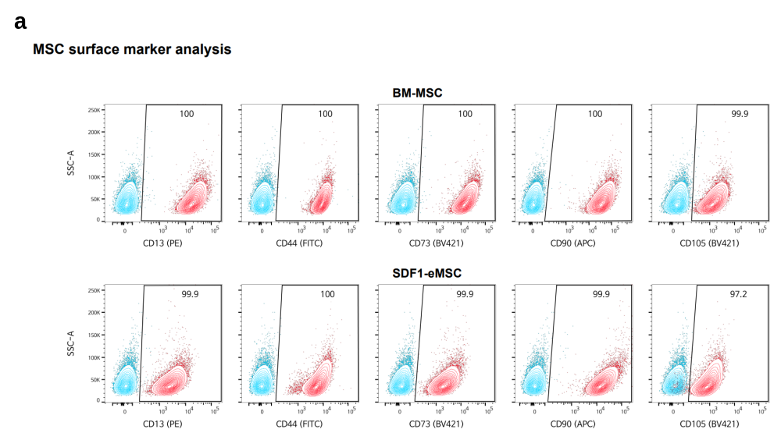

Supplementary Fig 1. Cellular characterization of SDF1α-eMSCs
MSC surface marker expression. a MSC-related surface markers expressed on BM-MSCs. b MSC-related surface markers expressed on SDF1α-eMSCs

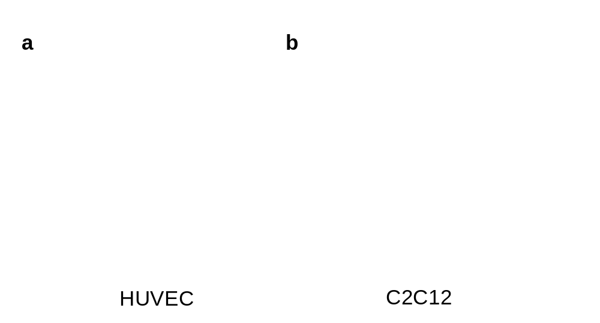
Supplementary Fig 2. Cytoprotective effects of SDF1α against starvation simulating ischemic insult.
Cell viability using a fluorescent LIVE/DEAD™ Viability assay. Green fluorescence (calcein-AM) indicates live cells, and red fluorescence (ethidium homodimer-1) indicates dead cells. a Area of live HUVEC cells b Area of live C2C12 cells after 24 h in serum-free media. Scale bars =100 μm. * p < 0.05 versus starvation group; † p < 0.05 versus BM group; $ p < 0.05 versus SDF group; n = 3 for each group. Data are presented as the mean ± SEM.

Supplementary Fig3. Laser Doppler image and optical image of all group
a Laser Doppler perfusion imaging (LDPI) and optical image of ischemic hindlimb at Day 28 after implantation

