Supplementary figure 1
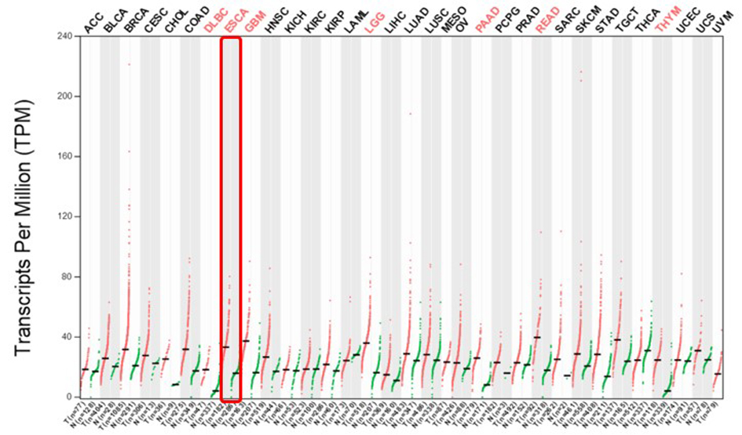
Supplementary figure 2

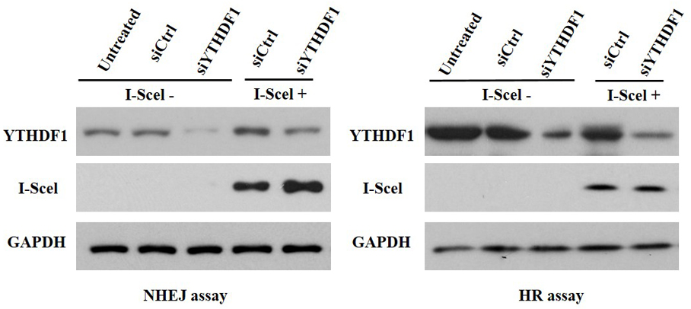
Supplementary Table 1
Clinical characteristics of locally advanced ESCC and adjacent tissue samples

No. | Age | Sex | Organ | LNM | distant metastases | Grade | Radiotherapy Technology
01 | 66 | F | Esophageal | 4 | 0 | Ⅲ | 3DCRT
02 | 73 | M | Esophageal | 2 | 0 | Ⅱ | 3DCRT
03 | 69 | M | Esophageal | 1 | 0 | Ⅰ | 3DCRT
04 | 75 | F | Esophageal | 2 | 0 | Ⅰ | 3DCRT
05 | 79 | F | Esophageal | 2 | 0 | Ⅰ | 3DCRT
06 | 77 | M | Esophageal | 1 | 0 | Ⅰ | 3DCRT
07 | 78 | F | Esophageal | 1 | 0 | Ⅰ | 3DCRT
08 | 59 | M | Esophageal | 4 | 0 | Ⅲ | 3DCRT
09 | 77 | F | Esophageal | 1 | 0 | Ⅰ | 3DCRT
10 | 73 | M | Esophageal | 3 | 0 | Ⅱ | 3DCRT
11 | 75 | M | Esophageal | 1 | 0 | Ⅰ | 3DCRT
12 | 67 | M | Esophageal | 2 | 0 | Ⅰ | 3DCRT
13 | 78 | M | Esophageal | 2 | 0 | Ⅰ | 3DCRT
14 | 66 | M | Esophageal | 3 | 0 | Ⅱ | 3DCRT
15 | 72 | M | Esophageal | 4 | 0 | Ⅲ | 3DCRT
16 | 80 | M | Esophageal | 4 | 0 | Ⅲ | 3DCRT
17 | 77 | F | Esophageal | 4 | 0 | Ⅲ | 3DCRT
18 | 76 | F | Esophageal | 2 | 0 | Ⅰ | 3DCRT
19 | 63 | F | Esophageal | 3 | 0 | Ⅱ | 3DCRT
20 | 73 | M | Esophageal | 3 | 0 | Ⅱ | 3DCRT
21 | 73 | F | Esophageal | 2 | 0 | Ⅰ | 3DCRT
22 | 75 | M | Esophageal | 4 | 0 | Ⅲ | 3DCRT
23 | 71 | M | Esophageal | 2 | 0 | Ⅰ | 3DCRT
24 | 73 | M | Esophageal | 2 | 0 | Ⅰ | 3DCRT
25 | 64 | M | Esophageal | 2 | 0 | Ⅰ | 3DCRT

Supplementary Table 2
IHC sample score of esophageal tissues containing locally advanced ESCC and esophageal normal tissue samples
No. | Age | Sex | Pathology diagnosis | Staining of YTHDF1 | Staining of AURKA
01 | 66 | F | ESCC | 8 | 9
02 | 73 | M | ESCC | 6 | 8
03 | 69 | M | ESCC | 4 | 6
04 | 75 | F | ESCC | 9 | 12
05 | 79 | F | ESCC | 4 | 8
06 | 77 | M | ESCC | 12 | 9
07 | 78 | F | ESCC | 0 | 4
08 | 59 | M | ESCC | 9 | 6
09 | 77 | F | ESCC | 8 | 9
10 | 73 | M | ESCC | 4 | 6
11 | 75 | M | ESCC | 6 | 4
12 | 67 | M | ESCC | 8 | 0
13 | 78 | M | ESCC | 6 | 4
14 | 66 | M | ESCC | 9 | 6
15 | 72 | M | ESCC | 6 | 12
16 | 80 | M | ESCC | 0 | 0
17 | 77 | F | ESCC | 4 | 6
18 | 76 | F | ESCC | 12 | 8
19 | 63 | F | ESCC | 9 | 4
20 | 73 | M | ESCC | 8 | 9
21 | 73 | F | ESCC | 6 | 12
22 | 75 | M | ESCC | 0 | 4
23 | 71 | M | ESCC | 9 | 8
24 | 73 | M | ESCC | 12 | 6
25 | 64 | M | ESCC | 6 | 9
01 | 66 | F | Esophageal normal tissue | 2 | 0
02 | 73 | M | Esophageal normal tissue | 0 | 2
03 | 69 | M | Esophageal normal tissue | 1 | 2
04 | 75 | F | Esophageal normal tissue | 1 | 2
05 | 79 | F | Esophageal normal tissue | 0 | 1
06 | 77 | M | Esophageal normal tissue | 2 | 0
07 | 78 | F | Esophageal normal tissue | 1 | 2
08 | 59 | M | Esophageal normal tissue | 1 | 0
09 | 77 | F | Esophageal normal tissue | 1 | 2
10 | 73 | M | Esophageal normal tissue | 2 | 1
11 | 75 | M | Esophageal normal tissue | 2 | 4
12 | 67 | M | Esophageal normal tissue | 0 | 1
13 | 78 | M | Esophageal normal tissue | 1 | 0
14 | 66 | M | Esophageal normal tissue | 2 | 2
15 | 72 | M | Esophageal normal tissue | 2 | 4
16 | 80 | M | Esophageal normal tissue | 0 | 0
17 | 77 | F | Esophageal normal tissue | 0 | 1
18 | 76 | F | Esophageal normal tissue | 1 | 4
19 | 63 | F | Esophageal normal tissue | 0 | 1
20 | 73 | M | Esophageal normal tissue | 1 | 0
21 | 73 | F | Esophageal normal tissue | 2 | 4
22 | 75 | M | Esophageal normal tissue | 1 | 0
23 | 71 | M | Esophageal normal tissue | 4 | 2
24 | 73 | M | Esophageal normal tissue | 0 | 1
25 | 64 | M | Esophageal normal tissue | 1 | 0

Supplementary Table 3
Sequences for siRNA and shRNA

Name | Sequence 5' to 3'
SiYTHDF1-sense-1 | CCUACGGACAGCUCAGUAATT
siYTHDF1-sense-2 | CCUGCUCUUCAGCGUCAAUTT
SiAURKA-sense-1 | AUGCCCUGUCUUACUGUCA
siAURKA-sense-2 | AACGTGTTCTCGTGACTCAGC
Si53BP1-sense-1 | AGAACGAGGAGACGGUAAUAGUGGG
Si53BP1-sense-2 | UAUUACCGUCUCCUCGUUC
SiXRCC5-sense-1 | GGCUCCAAUUUGUCUAUAATT
siXRCC5-sense-2 | GGUGGCCAUAGUUCGAUAUTT
SiControl-sense-1 | ACGCGUAACGCGGGAAUUU
shYTHDF1 | CCGCGTCTAGTTGTTCATGAA

Supplementary Table 4
Antibodies list

Antigen | Catalog number | Source
YTHDF1 | 17479-1-AP | ProteinTech
AURKA | PR5935A | Thermo Fisher Scientific
53 BP1 | NB100-304 | Novus Biologicals
Scel | sc-98269 | Santa Cruz Biotechnology
XRCC5 | 2753 | Cell Signaling
Secondary Antibody to Mouse | ab6728 | Abcam
Secondary Antibody to rabbit | A32731 | Thermo Fisher Scientific
GAPDH | MAB374 | Millipore

human YTHDF1-F | ATACCTCACCACCTACGGACA
human YTHDF1-R | GTGCTGATAGATGTTGTTCCCC
GAPDH-R | TGGACTCCACGACGTACTCA
actin-F | CACCACACCTTCTACAATGAGC
actin-R | AACATGATCTGGGTCATCTTTTC

Supplementary Table 5
Real-time PCR primers

Supplemental Figure 1. Analysis of YTHDF1 expression in common malignant tumors.
Supplemental Figure 2. Effects of YTHDF1 on NHEJ and HR.

Supplementary materials and methods
Cell lines, cell culture and knockdown experiments
Eight ESCC cell lines were selected according to histological grading, from low to high: namely KYSE410, KYSE70, KYSE150, KYSE220, KYSE170, KYSE520, ECA109 and KYSE450 (Shanghai Institute of Biochemistry and Cell Biology, Shanghai, China). Cells were cultured in 1640 medium containing 10% fetal bovine serum and 1% penicillin/streptomycin at 37°C in 5% CO₂. Cells were seeded into 6 cm culture plates and transfected at a final concentration of 50 nm (T-2001-03, Dharmacon, Lafayette, CO) according to the manufacturer's instructions. After 72 h, gene expression was verified by western blot or RT-PCR analysis. All siRNA sequences are listed in Supplementary Table 3.

Immunohistochemistry
After dewaxing and hydration, paraffin embedded sections were rinsed in PBS and blocked in 50 µl of 3% H₂O₂. Sections were probed with the indicated primary antibodies (Supplementary Table 4) at room temperature for 60 min or at 4°C overnight. Sections were washed, and polymer reinforcement solution was added prior to labeling with enzyme-labeled anti-rat/oligomer at room temperature for 30 min. After rinsing in PBS, sections were DAB or AEC stained and observed by microscopy (Gene Technology, San Francisco, CA, USA).

Western blot analysis
Esophageal cancer cells (5 x 10⁵) were seeded into 10 cm culture dishes for 24 h and lysed. Proteins were resolved on through SDS-PAGE electrophoresis (Bio-Rad, CA, USA) and transferred to PVDF membranes. Membranes were blocked in 5% skimmed milk or 2% BSA for 1 h in TBS-T, and labeled with the indicated primary antibodies and HRP-conjugated secondary antibodies. Primary and secondary antibodies used in the study are listed in Supplementary Table 4.

RT-PCR assays
Primer Sequences of RT-PCRs are shown in Supplementary Table 5 and were performed as described (1).

IR
IR was performed as previously described (2).

Cell proliferation and apoptosis assays
ESCA cell lines in the logarithmic growth phase were seeded into 96-well plates at a density of 4 x 10³/ml cells/well. After incubation for 24 and 48 h, CCK-8 (5 g/L) 10 ml was added to each well (Dojindo Molecular Technologies, Tokyo, Japan). After incubation for 4 h, absorbance (OD) values at 490 nm were assessed in the different treatment groups. Cell survival rates were calculated as (drug-addition/no-drug groups)/ (negative control groups) x 100. Measurements were repeated in 5 wells and on a minimum of 3 independent occasions. Apoptosis and EDU assays were performed as previously described (3-4).

Clonogenic assay
Cell suspensions were counted and cells were seeded inversely proportional to the irradiation dose. The number of cells inoculated with different radiation doses were 200, 400, 800, 2000 and 4000 cGy. After 24 h, cells were irradiated with 0, 2, 4, 6 and 8 Gy, respectively, for 14 days. After formaldehyde immobilization, cells were H & E stained. Colonies ≥ 50 cells were counted and analyzed on GraphPad Prism 7.0 to plot survival curves.

Immunofluorescence analysis
Cells plated onto coverslips were fixed in 4% paraformaldehyde and permeabilized in 0.2% Triton X-100. Cells were blocked in 5% BSA in PBS at room temperature for 1 h, and labeled with the indicated primary and secondary antibodies. Cells were DAPI stained, mounted and imaged on a laser scanning confocal microscope.

References
1. Katerndahl CDS, Heltemes-Harris LM, Willette MJL, Henzler CM, Frietze S, Yang R, et al. Antagonism of B cell enhancer networks by STAT5 drives leukemia and poor patient survival. Nat Immunol. (2017) 8:694-704. doi: 10.1038/ni.3716.
2. Wang F, Xia X, Yang C, Shen J, Mai J, Kim HC, et al. SMAD4 Gene Mutation Renders Pancreatic Cancer Resistance to Radiotherapy through Promotion of Autophagy. Clin Cancer Res. (2018) 24:3176-3185. doi: 10.1158/1078-0432.CCR-17-3435.
3. Leszczynska KB, Foskolou IP, Abraham AG, Anbalagan S, Tellier C, Haider S, et al. Hypoxia-induced p53 modulates both apoptosis and radiosensitivity via AKT. J Clin Invest. (2015) 125:2385-98. doi: 10.1172/JCI80402.
4. Zeng C, Pan F, Jones LA, Lim MM, Griffin EA, Sheline YI, et al. Evaluation of 5-ethynyl-2'-deoxyuridine staining as a sensitive and reliable method for studying cell proliferation in the adult nervous system. Brain Res. (2010) 1319:21-32. doi: 10.1016/j.brainres.2009.12.092

