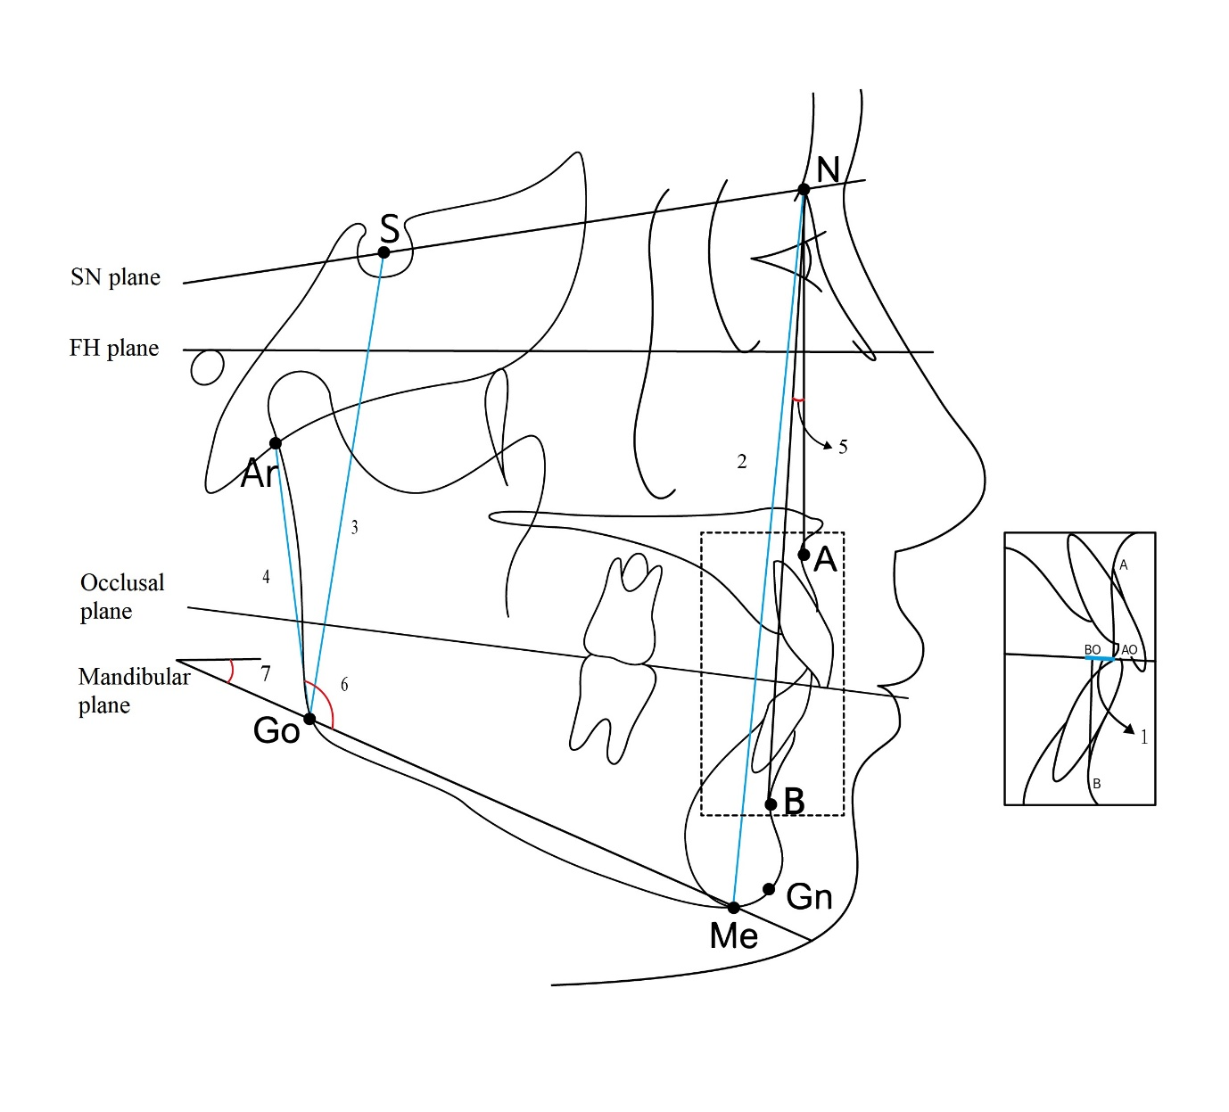

Supplement Fig. 1 Cephalometric measurements used in this study.
N, nasion; S, sella; A, A point; B, B point; Gn, gnathion; Me, menton; Ar, articulare; Go, gonion; AO and BO, perpendicular points drawn from points A and B to the functional occlusal plane, respectively.
1, Wits appraisal, the linear distance between AO and BO; 2, anterior facial height, the distance between N and Me; 3, posterior facial height, the distance between S and Go; 4, ramus height, the distance between Ar and Go; 5, ANB, A point-nasion-B point angle; 6, gonial angle, the angle formed between Ar-Go and mandibular plane; 7, mandibular plane angle, the angle formed between SN plane and mandibular plane.

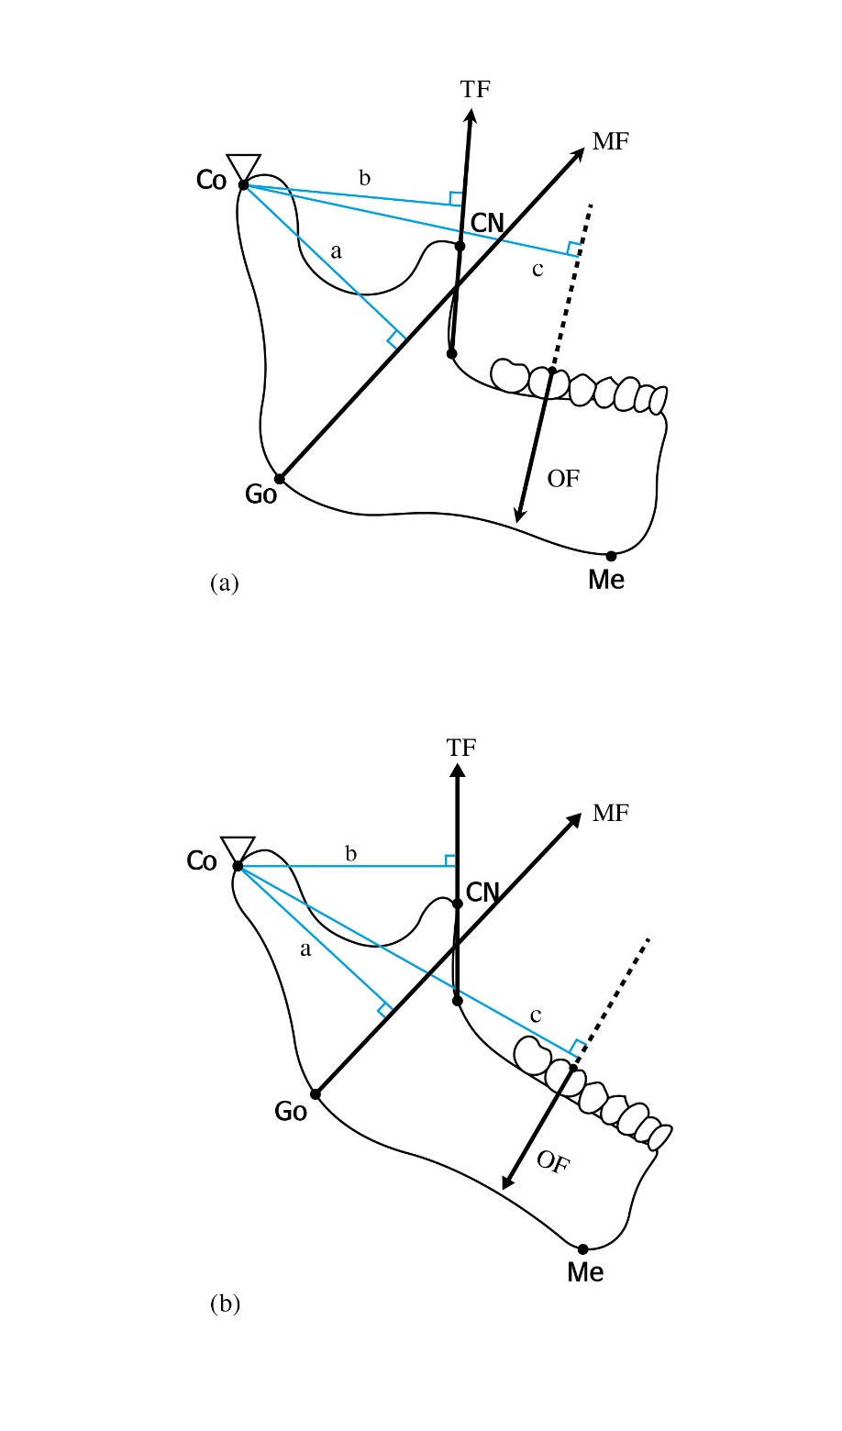
Supplement Fig. 2 Mandibular lever model of the hypodivergent group (a) and hyperdivergent group (b). Please note that the mechanical advantage of a muscle is determined as the ratio of the muscle's moment arm to the moment arm of the occlusal force. Therefore, the hypodivergent group has better mechanical advantage than the hyperdivergent group.
CN, Tip of the coronoid process; Co, condyle and fulcrum; Go, gonion; Me, menton; OF, occlusal force vector; MF, muscle force vector of the masseter; TF, muscle force vector of the temporalis; a, moment arm of the masseter; b, moment arm of the temporalis; c, moment arm of the occlusal force.

