Appendix A: Word cloud of most dominant words before and during Omicron

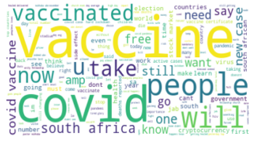 | 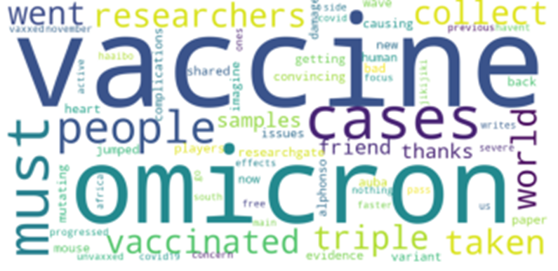
(a) Dominant words before Omicron | (b) Dominant words during Omicron

Appendix B: Trend in tweets with time before and during Omicron

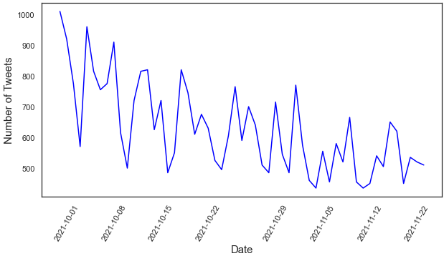 | 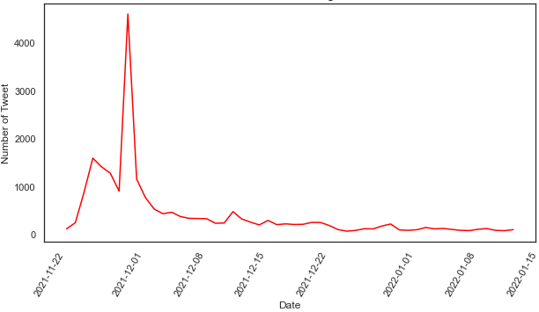
(a) Trends in COVID-19 vaccine related tweets before Omicron | (b) Trends in COVID-19 vaccine related tweets during Omicron

