Supplementary Materials

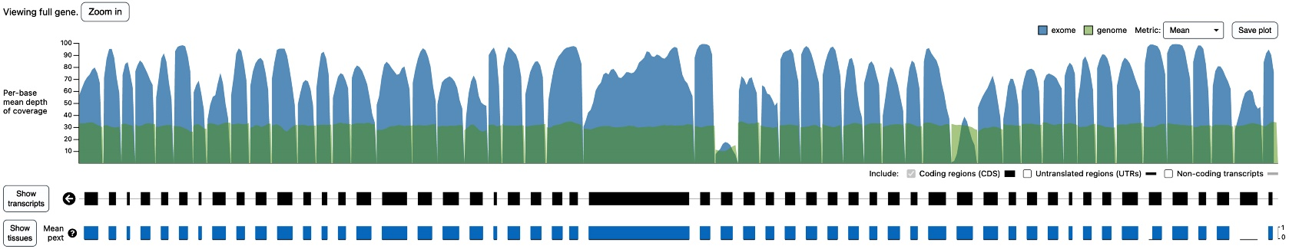

Figure S1. Mean depth of coverage per base of VWF for exome (blue) and genome (green) data of the gnomAD database (https://gnomad.broadinstitute.org/gene/ENSG00000110799?dataset=gnomad_r2_1).

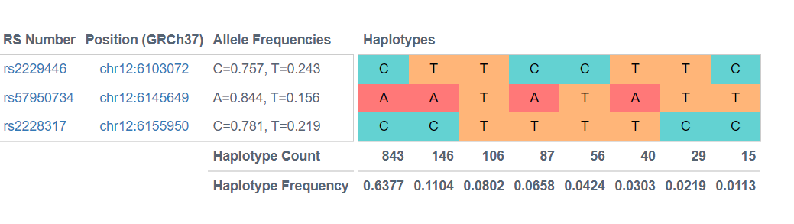
Figure S2. Linkage disequilibrium analysis for the 3 common variants identified in the African/American ethnicity including p.Arg2185Gln (rs2229446), p.Met740Ile (rs2228317) and p.His817Gln (rs57950734).

Table S1. Novel variants found in the gnomAD predicted to be pathogenic.
Table 1 is provided in an excel file.

Table S2. Identified pathogenic variants in the gnomAD that reported to be associated with VWD.
Table 2 is provided in an excel file.

Table S3. Gene constraint of VWF
Type of variant | Expected no. of variants | Observed no. of  variants | Constraint  metric*
Synoymous | 666.3 | 728 | Z= -1.88  o/e= 1.09 (1.03-1.16)
Missense | 1602.5 | 1491 | Z= 0.99  o/e= 0.93 (0.89-0.97)
pLoF | 133 | 64 | pLI= 0  o/e= 0.48 (0.39-0.59)

Table S4. Type of genetic variants in 1026 Individuals who were homozygous for VWF pathogenic variants.
Variant | Protein Consequence | Type of variant | Homozygote Count | Ethnicity (n. of homozygous cases/total n. of cases) | Reported type of VWD variant
c.3101_3103delCCA | p.Thr1034del | Inframe deletion | 3 | African/African American (3/12487) | Type 3
c.3097_3099dupGAC | p.Asp1033dup | Inframe insertion | 1 | Latino/Admixed American (1/17720) | Type 3
c.6187C>T | p.Pro2063Ser | missense | 67 | Latino/Admixed American (2/17720), Ashkenazi Jewish (7/5185), non-Finnish European (10/64603), South Asian (46/15308), Other (2/3614) | Type 1
c.7940C>T | p.Thr2647Met | missense | 6 | Finnish (4/12562), non-Finnish European (2/64603) | Type 1
c.7025G>A | p.Arg2342His | missense | 1 | Ashkenazi Jewish (1/5185) | UC
c.6859C>T | p.Arg2287Trp | missense | 1 | African/African American (1/12487) | Type 1
c.6554G>A | p.Arg2185Gln | missense | 472 | African/African American (465/12487)* | Type 1
c.6104G>A | p.Gly2035Asp | missense | 2 | East Asian (2/9977) | Type 1
c.5793G>C | p.Gln1931His | missense | 2 | South Asian (2/15308) | Type 3
c.5278G>A | p.Val1760Ile | missense | 1 | non-Finnish European ( 1/64603) | Type 1
c.5191T>A | p.Ser1731Thr | missense | 1 | Ashkenazi Jewish (1/5,185) | 2MCB
c.4751A>G | p.Tyr1584Cys | missense | 4 | European (non-Finnish (4/64603) | Type 1
c.3797C>T | p.Pro1266Leu | missense | 1 | Finnish European (1/12562) | Type 2B NY
c.3797C>A | p.Pro1266Gln | missense | 2 | South Asian (2/15308) | Type 2B NY
c.3692A>G | p.Asn1231Ser | missense | 5 | South Asian (5/15308) | Type 2B NY
c.3692A>C | p.Asn1231Thr | missense | 2 | South Asian (2/15308) | Type 2B NY
c.2900G>A | p.Gly967Asp | missense | 15 | African/African American (15/12487) | UC
c.2771G>A | p.Arg924Gln | missense | 33 | non-Finnish European (30/64603), Latino/Admixed American (1/17720)), South Asian (1/15308), Other (1/3614) | Type 1
c.2561G>A | p.Arg854Gln | missense | 5 | non-Finnish (3/64603), Finnish European (2/12562) | Type 2N
c.2451T>A | p.His817Gln | missense | 152 | African/African American (152/12487) | Type 2N
c.2220G>A | p.Met740Ile | missense | 396 | African/African American (391/12487), Latino/Admixed American (3/17720), non-Finnish European (2/64603) | UC
c.1870G>A | p.Gly624Ser | missense | 1 | East Asian (1/9977) | Type 2A
c.1728G>T | p.Met576Ile | missense | 32 | Latino/Admixed American (32/17720) | Type 1
c.385C>A | p.Leu129Met | missense | 1 | African/African American (1/12487) | Type 1

UC, unclassified variant; * remaining count: Latino/Admixed American (n= 1), Ashkenazi Jewish (n= 1), non-Finnish European (n= 1), South Asian (n= 2) and other (n=2).

Table S5. Estimated global prevalence of autosomal dominant von Willebrand disease type 1.
Population | Total number of alleles | Total number of  affected alleles by type 1 variants | Collective frequency of  affected alleles | Heterozygote  frequency | Type 1 VWD prevalence in 1000 individuals (autosomal dominant), n variant (n=78)
All ‡ | 257938 | 9914 | 0.04 | 0.07 | 73.9
Latino/Admixed American | 35440 | 2107 | 0.06 | 0.11 | 111.8
Ashkenazi Jewish | 10370 | 155 | 0.01 | 0.03 | 29.4
East Asian | 19954 | 208 | 0.01 | 0.02 | 20.6
Finnish | 25124 | 785 | 0.03 | 0.06 | 60.5
European (not Finnish) | 129206 | 4767 | 0.04 | 0.07 | 71.1
South Asian | 30616 | 756 | 0.02 | 0.05 | 48.2
Other ethnicities | 7228 | 292 | 0.04 | 0.08 | 77.5
African/African American § | 24974 | 844 | 0.03 | 0.07 | 65.3
‡ The global prevalence of VWD type 1 is calculated after excluding the common genetic variant p.Arg2185Gln identified in the African/American ethnicity. § After excluding p.Arg2185Gln variant.

Table S6. Estimated global prevalence of autosomal dominant von Willebrand disease type 2A.
Population | Total number of alleles | Total number of  affected alleles by type 2A variants | Collective frequency of  affected alleles | Heterozygote  frequency | Type 2A VWD prevalence in 1000 individuals (autosomal dominant), n variant (n=23)
All | 257938 | 374 | 0.0014 | 0.0029 | 2.9
Latino/Admixed American | 35440 | 79 | 0.0022 | 0.0044 | 4.4
Ashkenazi Jewish | 10370 | 2 | 0.0002 | 0.0004 | 0.4
East Asian | 19954 | 104 | 0.0052 | 0.0104 | 10.4
Finnish | 25124 | 19 | 0.0008 | 0.0015 | 1.5
European (not Finnish) | 129206 | 128 | 0.0010 | 0.0020 | 2.0
South Asian | 30616 | 15 | 0.0005 | 0.0010 | 1.0
Other ethnicities | 7228 | 13 | 0.0018 | 0.0036 | 3.6
African/African American | 24974 | 14 | 0.0006 | 0.0011 | 1.1

Table S7. Estimated global prevalence of autosomal dominant von Willebrand disease type 2B.
Population | Total number of alleles | Total number of  affected alleles by type 2B variants | Collective frequency of  affected alleles | Heterozygote  frequency | Type 2B VWD prevalence in 1000 individuals (autosomal dominant), n variant (n=12)
All | 257938 | 434 | 0.0017 | 0.0034 | 3.4
Latino/Admixed American | 35440 | 66 | 0.0019 | 0.0037 | 3.7
Ashkenazi Jewish | 10370 | 55 | 0.0053 | 0.0106 | 10.6
East Asian | 19954 | 2 | 0.0001 | 0.0002 | 0.2
Finnish | 25124 | 92 | 0.0037 | 0.0073 | 7.3
European (not Finnish) | 129206 | 135 | 0.0010 | 0.0021 | 2.1
South Asian | 30616 | 60 | 0.0020 | 0.0039 | 3.9
Other ethnicities | 7228 | 14 | 0.0019 | 0.0039 | 3.9
African/African American | 24974 | 10 | 0.0004 | 0.0008 | 0.8

Table S8. Estimated global prevalence of autosomal dominant von Willebrand disease type 2M.
Population | Total number of alleles | Total number of  affected alleles by type 2M variants | Collective frequency of  affected alleles | Heterozygote  frequency | Type 2M VWD prevalence in 1000 individuals (autosomal dominant), n variant (n=21)
All | 257938 | 792 | 0.0031 | 0.0061 | 6.1
Latino/Admixed American | 35440 | 46 | 0.0013 | 0.0026 | 2.6
Ashkenazi Jewish | 10370 | 220 | 0.0212 | 0.0415 | 41.5
East Asian | 19954 | 8 | 0.0004 | 0.0008 | 0.8
Finnish | 25124 | 124 | 0.0049 | 0.0098 | 9.8
European (not Finnish) | 129206 | 181 | 0.0014 | 0.0028 | 2.8
South Asian | 30616 | 71 | 0.0023 | 0.0046 | 4.6
Other ethnicities | 7228 | 24 | 0.0033 | 0.0066 | 6.6
African/African American | 24974 | 118 | 0.0047 | 0.0094 | 9.4

Table S9. Estimated global prevalence of autosomal recessive von Willebrand disease type 2N.
Population | Total number of alleles | Total number of  affected alleles by type 2N variants | Collective frequency of  affected alleles | Heterozygote  frequency | Type 2N VWD prevalence in 1000 individuals (autosomal recessive), n variant (n=15) | Type 2N VWD carrier prevalence in 1000 individuals, n variant (n=15)
All | 257938 | 1359 | 0.01 | 0.01 | 0.028 | 10.5
Latino/Admixed American | 35440 | 315 | 0.01 | 0.02 | 0.079 | 17.6
Ashkenazi Jewish | 10370 | 10 | 0.001 | 0.002 | 0.001 | 1.9
East Asian | 19954 | 1 | 0.0001 | 0.0001 | 0.000003 | 0.1
Finnish | 25124 | 145 | 0.01 | 0.01 | 0.033 | 11.5
European (not Finnish) | 129206 | 739 | 0.01 | 0.01 | 0.033 | 11.4
South Asian | 30616 | 53 | 0.002 | 0.003 | 0.003 | 3.5
Other ethnicities | 7228 | 59 | 0.01 | 0.02 | 0.067 | 16.20
African/African American | 24974 | 37 | 0.001 | 0.003 | 0.002 | 3

Table S10. Estimated global prevalence of autosomal recessive von Willebrand disease type 3.
Population | Total number of alleles | Total number of  affected alleles by type 3 variants | Collective frequency of  affected alleles | Heterozygote  frequency | Type 3 VWD prevalence in 1000 individuals (autosomal recessive), n variant (n=132)* | Type 3 VWD carrier prevalence in 1000 individuals, n variant (n=132)
All | 257938 | 14123 | 0.0548 | 0.110 | 3 | 104
Latino/Admixed American | 35440 | 2508 | 0.0708 | 0.142 | 5 | 132
Ashkenazi Jewish | 10370 | 417 | 0.0402 | 0.080 | 1.6 | 77
East Asian | 19954 | 220 | 0.0110 | 0.022 | 0.1 | 22
Finnish | 25124 | 836 | 0.0333 | 0.067 | 1 | 64
European (not Finnish) | 129206 | 5950 | 0.0461 | 0.092 | 2 | 88
South Asian | 30616 | 2512 | 0.0820 | 0.164 | 7 | 151
Other ethnicities | 7228 | 414 | 0.0573 | 0.115 | 3 | 108
African/African American | 24974 | 1266 | 0.0507 | 0.101 | 2.6 | 96
* The global prevalence of VWD type 3 was calculated using both type 1 (n= 78) and type 3 (n= 54) variants.

